Leadership for Effective Learning
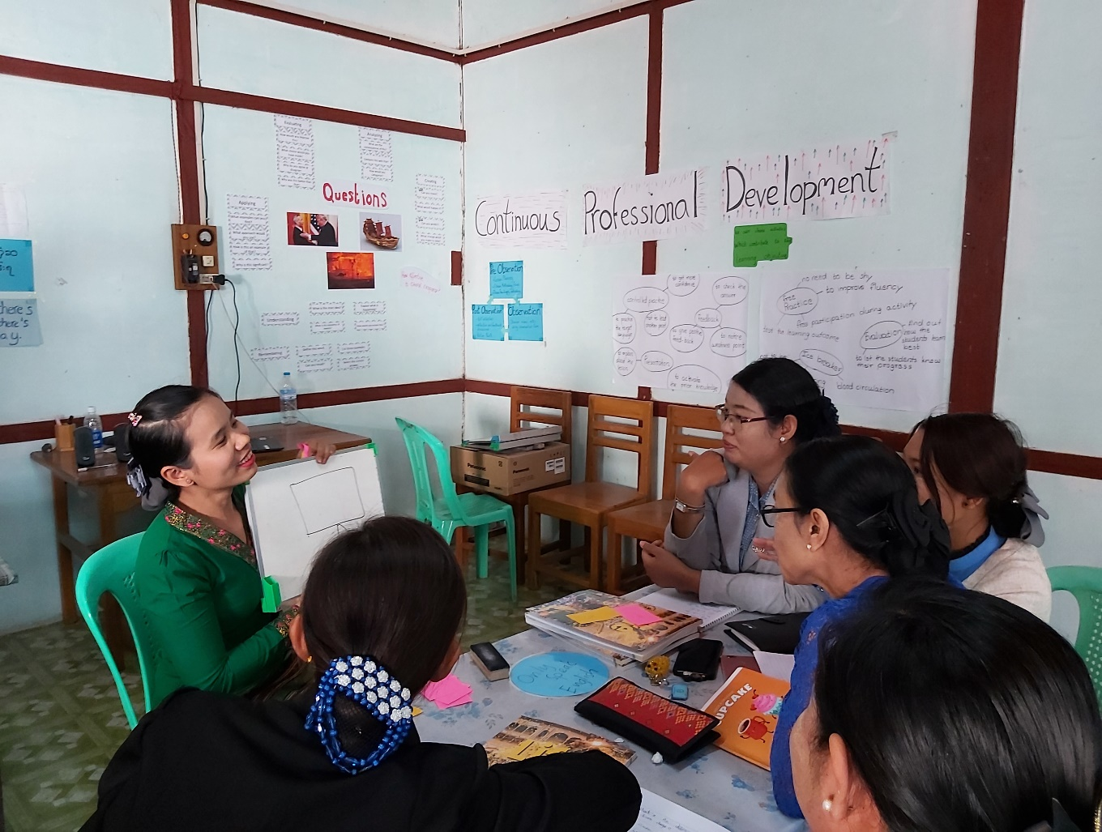
Unit 4: Strategies for Leading for Effective Learning
Trainer’s Guide

Overview
This module considers what effective learning looks like in the context of educational institutions and organisations in Myanmar and how leadership teams of these institutions and organisations can influence attitudes and approaches to effective learning.
The course will consider questions such as:
- Who are our learners?
- What is effective learning?
- Who is responsible for effective learning?
- What leadership approaches and strategies can leaders employ to enable and ensure effective learning in their contexts?
- What skills do leaders require in order to enable and ensure effective learning and how can these be developed?

This is the fourth of five units:
- What is Effective Learning?
- The Learner and Classroom Environment
- Leadership for Effective Learning
- Strategies for Leading for Effective Learning
- Skills for Leading for Effective Learning

Contents
Section | Materials | Timing
Outcomes | Participants’ Book | 5 mins
4.1 Strategies for effective learning | Participants’ Book | 20 mins
4.2 The Continuing Professional Development Framework | Participants’ Book  STEM CPDF if possible | 20 mins
4.3 Teacher competencies | Participants’ Book  STEM TCSF if possible | 20 mins
4.4 The curriculum and syllabus | Participants’ Book  Curriculum and materials if possible | 20 mins
4.5 Activities for continuing professional development: delivery | Participants’ Book | 20 mins
4.6 Supporting leadership | Participants’ Book | 20 mins
4.7 Apply and reflect | Participants’ Book | 15 mins

Outcomes

By the end of this unit, participants will be able to identify and discuss:
- strategies to systematise, share and maximise learning (‘five strands for supporting effective learning’), reflect on these strategies and plan to implement them in their contexts
- their experience of, confidence about and priorities for implementing these strategies
- the aims and components of an effective Continuing Professional Development Framework and how a CPDF can inform planning of effective learning
- plans for implementing use of a CPDF in their contexts
- teacher competencies, how these competencies can be presented in a Teacher Competency Standards Framework and plans to implement a TCSF in their contexts
- features of an effective curriculum and ways of evaluating the curriculum used in their contexts
- activities for Continuing Professional Development for leadership teams and teaching staff and their experience of participating in or leading on these activities.

Learning Outcomes
- Briefly introduce the course overview and answer any questions.
- Explain the outcomes for this unit and check participants understand them.
- Highlight that this unit aims to encourage reflection about learning and leadership, rather than teach facts.

4 Strategies for leading for effective learning

4.1 Strategies for leading for effective learning

4.1 Discuss: strategies for effective learning
- Ask participants to read the introductory text.

- Do not worry about going into too much detail at this stage as key issues are dealt with throughout this unit.

- Ask participants to work in pairs or small groups and, based on their learning from Units 1,2 and 3, work individually and make a list of what they, as leaders, can do to ensure that learning is given high priority and an environment in which learning is developed and which strategies they can adopt to develop a culture of learning.

An example is provided: encourage all staff to actively collaborate in their learning.

- Encourage participants to identify strategies which are practical and realistic. Throughout this unit, they will come across further strategies which they can add to their lists.

- Ask participants to compare responses. Elicit ideas.

4.1 Task: five strands to support effective learning
Step 1

- Ask participants to read the introductory text and identify the five strands.

Step 2
- Ask participants to match a strand 1 to 5 to the description a) to f).

Key:
5 Educational technology and innovation.
a) Technical support (e.g. Zoom training; safeguarding; online safety etc); finding and evaluating digital resources.

2a Implementation of the Teacher Competency Standards Framework
b) Awareness raising of characteristics and abilities of an effective teacher and how these can be demonstrated in the classroom and used for developmental and monitoring and evaluation purposes.
1 Capacity building and development
c) Supporting leadership teams to take on leadership roles beyond traditional management and administration, develop a culture of effective learning and identify and assign leadership roles to the staff they lead; continuous professional development for leadership teams.
4 Research and Learning
d) Awareness raising for, implementation of and achievements in initiatives for action research.
3 Continuing professional development
e) Supporting effective learning through encouragement to teachers and trainers to collaborate together (including through Communities of Practice), engage in direct face-to-face and online training and take a pro-active approach to their own personal and professional development.
2b Implementation of new curricula
f) Understanding and applying new approaches, syllabi and materials for teaching and learning.

4.1 Task: Step 3
Ask participants to work individually and identify:
a) their experience of being involved with one or more of the five strands
b) which strands they feel are most important and relevant for the context they work in/any strands which are not relevant for their context
c) which strands they feel most confident/least confident about implementing in the context they work in.

Further reading
Refer participants to the Tree Leadership Teams: Creating a Culture of Effective Learning document.

4.2 Continuing Professional Development Framework

4.2 Discuss: the Continuing Professional Development Framework
Step 1: CPD
- Ask participants to read the excerpt from the STEM CPDF which states the aim of CPD and the aim of a Continuing Professional Development Framework.
.
Step 2: The CPDF in your context

- Ask participants to work in a pair or small group and share any awareness and experience they have of working with a Continuing Professional Development Framework in their own contexts.

- Elicit any participant awareness and/or experience.

4.2 Task: what does a Continuing Professional Development Framework include?
Step 1: a Continuing Professional Development Framework: aims

- Ask participants to read the aim of a CPDF. Explain to participants that a clear statement of aims is one component of the CPDF document.

Step 2: a Continuing Professional Development Framework: components

- Ask participants to read examples 1, 3, 6 and 9 and explain that these are also components of CPDF.

- Ask participants to identify any other components that can be included in a CPDF.

- Participants compare their answers. Elicit ideas.

Suggested answers:

Note: What is actually included in a CPDF varies from one context to another. Accept any relevant answers from participants.

Suggested answers include:

1 A definition of CPD and a description of why it is important.
2 A description of essential features of CPD.
3 A description of clear aims and goals for the CPDF.
4 A description of how CPD will be planned.
5 Definitions of expectations: the competencies participants are expected to have and/or the standards they are expected to meet as a result of their participation in CPD.
6 Identification of needs which CPD will address.
7 Presentation of national policies which support and/or encourage CPD.
8 Suggestions for specific, context-related activities for CPD.
9 Suggestions for ways in which CPD can be recorded, monitored and used to support participant appraisals and evaluation.
10 Descriptions of the responsibilities of everybody involved.

Further reading

- Refer the participants to the article What is a Continuing Professional Development Framework? in Appendix 1 to this unit.

4.3 Teacher competencies
4.3 Discuss: what competencies do teachers need?

Step 1: Teacher competencies
- Ask participants what they understand by the term teacher competency.

- Ask participants to read the introductory text which defines teacher competencies.
Step 2: Analysing competencies
- Ask participants to decide which of the competencies a) to h) relate mainly to knowledge, which relate mainly to skills and which relate mainly to attitudes.
Key
Answers are fairly open-ended as a number of items a) to h) include a mix of knowledge/skills/attitudes. Accept any relevant answers and focus on how participants justify their answers.
Suggested answers are:
a) demonstrate understanding of different theories of how students learn | mainly knowledge
b) demonstrate understanding of appropriate use of teaching and learning strategies and resources | mainly knowledge
c) demonstrate capacity to teach subject-related concepts and content clearly and engagingly | mainly skills
d) demonstrate good lesson planning and preparation in line with students’ learning ability and experience | mainly skills
e) demonstrate capacity to create a safe and effective learning environment for all students | skills and attitudes
f) demonstrate strategies for managing student behaviour | mainly skills, also attitudes
g) demonstrate values and attitudes consistent with Myanmar’s tradition of perceiving teachers as role models | mainly attitudes
h) demonstrate understanding of the underlying ideas that influence one’s practice as a professional teacher. | mainly knowledge

4.3 Discuss: Step 3 Further competencies
- Ask participants to identify and add any other competencies they think are demonstrated by an effective teacher.
4.3 Task: the Teacher Competency Standards Framework

Step 1
- Ask participants to read watch the example of a Teacher Competency Standards Framework, the STEM TCSF for Basic Education , in Appendix 2 and answer the questions.
Key
1 How many domains are there? | Four
2 Which domain deals with skills? | Domain B
3 Which domain deals with educational technology? | Domain A
4 Which domain encourages teachers (and Teacher Educators) to work together and collaborate? | Domain D
5 Which domain includes respecting diversity and learners’ cultures? | Domain C

Step 2: Why use a Teacher Competency Standards Framework?

- Explain to participants that the Teacher Competency Standards Framework is a document which we can use for different purposes and from which we can develop different strategies.

- Ask participants to read the purposes of a Teacher Competency Standards Framework listed in this step.

- Ask participants to work in pairs and small groups and identify further ways in which a Teacher Competency Standards Framework can be used. Elicit ideas.

Further reading
- Refer participants to the version of the TCSF for Basic Education adapted from the STEM Practicum booklet in Appendix 2 to this unit. Ask participants to compare their answers.

- Participants can also find further information in the 2017 Teacher Competency Standards Framework (TCSF), listed in Further Reading and References in this unit.

4.4 The curriculum and syllabus

4.4 Discuss: what makes an effective curriculum and syllabus?
Step 1
- Ask participants to match the items a) to c) to definitions 1 to 3. Elicit answers.
- Ask participants if they have experienced any introductions of new curricula, syllabuses or materials.
Key

1 Curriculum | c) A set of subjects for an educational institution, or a set of subjects within a course
2 Syllabus | b) A document that describes the course contents, the order in which they will be delivered and often statements about beliefs about teaching and learning
3 Materials | a) Any resources including student coursebooks and teacher guides which support teaching and learning

Step 2

- Ask participants to think about the features of an effective curriculum/syllabus for the context they work in.
- Elicit a few examples. Ask participants to work in small groups and list features.
- Elicit ideas and provide feedback.
Key

Activity 4.4 Task: evaluating your curriculum and syllabus

Activity 4.4 Task provides a list of features as identified by writers of STEM materials (2019).
Step 1 Criteria for evaluation
- Ask participants to read the list of features of the curriculum, syllabus and materials.
- Explain that these are features identified by the writers of STEM materials (2019).
- Discuss any ideas which may new or unfamiliar to participants.

Step 2 Evaluation
- Organise participants in pairs or small groups.
- Ask participants to think about the curriculum, syllabus or student coursebooks/teacher guides which are relevant for the context they work in. If possible, ask participants to consult any relevant documents they have during the activity.
- Ask participants to assess to what extent each feature listed in Step 2 is reflected in the materials.
- Ask participants to identify any areas for improvement.
- Elicit any other comments participants may have on the curriculum, syllabus or student coursebooks/teacher guides they work with.

To complete a full evaluation of curriculum/syllabus/materials is a lengthy process and one which participants may not complete during the session itself.

This activity can be easily adapted as a follow-up task, in which the activity is set up during the session, with initial reactions shared, and further evaluation taking place after the session itself.

4.5 Activities for continuing professional development: delivery

4.5 Discuss: CPD activities

Step 1
- Ask participants to read the three examples of CPD.
- Discuss the three examples with participants.
Step 2
- Organise participants in pairs or small groups.
- Ask participants to think of as many different types of CPDs they can which are relevant to the context they work in.
- Elicit two to three examples.
- Ask participants to work together and list as many CPD activities as they can.
- Ask pairs/groups to share ideas with colleagues.
- Ask participants to identify which of the activities they have listed are most effective for their context.
Although not exhaustive, a range of CPD activities is listed in Activity 4.4 Task.
Further reading
Refer participants to the guiding principles for effective CPD activities (adapted from the STEM Continuing Professional Development Framework) presented in Appendix 4. These can be read after the session.
4.5 Task: CPD activities in your context
Ask participants to work individually.
Participants complete the table of CPD activities indicating if:
- the initiative has been delivered in their context
- they have direct experience of this initiative as a leader/presenter/trainer/mentor
- they have direct experience of the initiative as a participant
- the initiative has not been delivered in their context but they would like to see it implemented
- they do not feel the initiative is relevant for the context they work in.
Answers will vary from participant to participant.
Ask participants to share ideas.
Comment as appropriate.

4.6 Supporting leadership

4.6 Discuss: CPD on leadership for effective learning
This activity addresses the area in which participants take part themselves as participants rather than lead or organise: capacity building for leadership teams. The 4.6 Discuss activity therefore asks participants to comment on the extent to which they have taken part in initiatives and on the design of this course. The 4.6 Task activity asks participants to prioritise topics for their own CPD.

Step 1
- Ask participants to read the CPD initiatives for leadership teams.

Step 2
- Ask participants to complete the table indicating their participation to date.
- Ask participants to share experiences.

Step 3
- Ask participants to read and answer questions about the Leading for Effective Learning course.

- Ask participants to compare and record ideas (e.g. in Chat)

- Elicit feedback.

4.6 Task: key areas
- Ask participants to read the topics/skills a) to j) recommended as those which CPD needs to address by the STEM CPDF.

- Participants work individually and score each area 1 to 4 as detailed in the Participants’ Book.

- Encourage participants to compare ideas

- Elicit feedback – be diplomatic, as participants are asked to identify areas they do not feel confident about.

4.7 Apply and reflect

This activity aims to summarise the strategies which have been discussed in the unit and to provide a basis for participants to begin action planning in order to introduce these strategies into their contexts. It is not expected that all this process will be completed during the session itself and the task can easily be adapted as a follow-up activity.
- Organise participants in small groups, ensuring that participants in each group are from the same context.
- Ask participants to read the the strategies for systematising, sharing and maximising learning.
- Ask participants to discuss and record the extent to which strategies have been implemented in their context so far and plans and priorities for the future.
- If possible, ask groups to share reflections with colleagues.
- Remind participations that this activity is a ‘work in process’ and a basis for planning they will undertake at their own institutions.

Further reading and references

1 Key documents

STEM (2017) Teacher Competency Standards Framework (TCSF)
Available online at:
www.lextutor.ca/myanmar/TCSF_v2.pdf

STEM (2019) Student Teacher Textbook Year 1: Preface

STEM (2019) Year 1 Practicum Booklet

STEM (2019) Continuous Professional Development Framework

TREE Project (2019) Leadership Teams: Creating a Culture of Effective Learning

2 Academic sources
Kennedy, A. (2006) Models of Continuing Professional Development: a Framework for Analysis. In Journal of In-service Education, 31:2, 235-250
Available online at:
https://www.tandfonline.com/doi/abs/10.1080/13674580500200277

3 Links to further examples of Continuing Professional Development Frameworks
3a British Council Continuing Professional Development Frameworks
British Council Continuing Professional Development (CPD) Framework for teachers
https://www.teachingenglish.org.uk/sites/teacheng/files/CPD%20framework%20for%20teachers_WEB.PDF

British Council Continuing Professional Development (CPD) Framework for teacher educators
https://www.teachingenglish.org.uk/sites/teacheng/files/teacher_educator_framework_final_webv1_0.pdf

3b CPDFs from other countries
Cambodia: Continuous Professional Development Framework for Teachers and School Directors 2019-2023 (2019) Ministry of Education, Youth and Sport:
www.unesco.org/new/fileadmin/MULTIMEDIA/FIELD/Phnom_Penh/pdf/MoEYS_CPD_Framework_FD06_AJ_140919_en_clean.pdf

Ireland: Cosán: Framework for Teachers’ Learning (2016) The Teaching Council
www.teachingcouncil.ie/en/publications/teacher-education/cosan-framework-for-teachers-learning.pdf

Rwanda: The National Teacher CPD Framework (2019) Rwanda Education Board:
www.eenet.org.uk/resources/docs/THE_NATIONAL_TEACHER_CPD_FRAMEWORK-Booklet-B5Size.pdf

