Inclusive Teaching Practice
Facilitator’s Guide

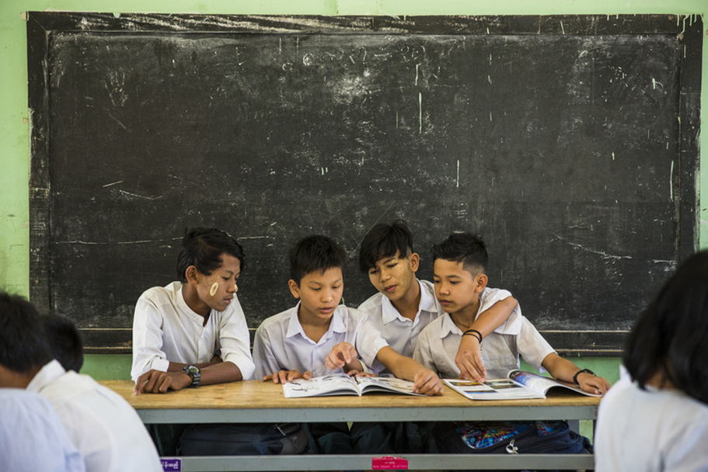
Source: VSO Image library

Module 4:
Participating Through Learner Centred Approaches

Module 4: Participating through learner centred approaches.

Overview
This is the fourth of fifteen modules that looks at how we create a positive Inclusive Learning Environment for all. You will see how inclusive teaching practices encourage, develop and use the 21st century skills of critical thinking, communication, collaboration and creativity. These modules are for the Leadership Teams and Teacher Educators in the educational institutions across Myanmar.

Module number | Module title
1 | What is an Inclusive School, Classroom and Teacher?
2 | Knowing your learners
3 | Planning learning outcomes for all
4 | Participating through learner centred approaches
5 | Creating a positive learning environment
6 | Effective questioning and feedback
7 | Active participation
8 | Peer, co-operative and collaborative learning
9 | Supporting students’ emotional and social wellbeing
10 | Legal framework and policies around Inclusion in Myanmar
11 | Supporting all students through differentiation
12 | Identifying specific learning difficulties
13 | Supporting all learners with differences or disabilities
14 | Positive behaviour management
15 | Assessment for student achievement

Learning Journal
Please ensure all participants are aware of the learning journal and its purpose for the module. Point them to the advice given in their participants’ copy of the best way to complete. All answers to activities need to be written in their journal. Remember, reflection is an important part of the learning process and a worthy activity alone. Encourage participants to make a note of new and interesting words/phrases/terms as they make their way through the module.

Study tips
It is important to explain how to approach completing the module. Participants need to take their time, develop a suitable timetable and where possible check their answers with colleagues. The use of think / pair / share is a good way for them to collaborate, share ideas, ask questions, check their work, and give feedback.

Background to the Inclusive Practice CPD modules.
There are 3 key themes explored in the modules that reflect the educational reform taking place in all education settings: Inclusion, Gender Equity and 21st century skills. These themes are key in all areas of curriculum, and vital not only for Myanmar’s educational ambitions and sustainable development but equally vital for the global future.
This course has been designed to help participants engage in this discussion by challenging their beliefs and attitudes about their own teaching, their students’ learning and the impact their educational institution has on inclusion. It is expected that as a facilitator, you will challenge their beliefs and attitudes throughout the modules.
It is also important for you as a facilitator to embed many of the teaching and learning techniques associated with inclusion in education into this course. Encourage participants to work at their own pace and consider their own abilities, interests and skills.
The modules look at how we create a positive Inclusive Learning Environment for all. You will see how inclusive teaching practices support gender equity and encourage, develop and use the 21st century skills of critical thinking, communication, collaboration and creativity.
Each module is made up of a series of activities participants can work through at their own pace. Once they have completed the module, they will have a multiple-choice quiz to complete.

Learning outcomes for Module 4
By working through this module, participants will be able to:
- recognise the key elements of learner-centred approaches (LCA) to learning and teaching.
- compare the key elements of LCA to the features of Inclusive practice and the 21st century skills.
- demonstrate understanding of 2 or 3 key elements of LCA, their implementation in an inclusive classroom and how they help develop 21st century skills.
- describe how to organise group work activities that are effective and inclusive.

The previous module (module 3) explored how effective learning outcomes can be used to support inclusive practice. It also discussed how ‘step by step’ learning can be used to include all learners in their own learning – where they can stop anywhere in the learning process and start again when they are confident to move on.
This fourth module introduces the key elements of a learner-centred approach (LCA) in the classroom. It encourages all learners to participate in activities and take responsibility for their own learning. Links are also made between LCAs and the development of 21st century skills. The last section considers group work and how this can be used to support all learners in collaborating with colleagues no matter what their style of learning, interests or learning difficulties or disabilities.

Extra instructions for the activities in module 4

Activity | Additional points to consider
Prior knowledge assessment of module 3 | The first task is a recap assessment of module 3. This reminds the learner of the previous module contents and helps them to recall important information in preparation for this module. After the first attempt, suggest that the learners refer back to the 3rd module to check their answers.
2. Learner centred approaches for 21st century skills | Encourage all learners to read the following article by Beas Dev Ralhan.  https://yourstory.com/2019/11/student-centered-learning-approach-21st-century
1st Self- assessments  LCA understanding  and  Effective group work | Some participants may need encouragement to be honest in their self-assessment. Ensure that they know it is the 4th of 15 modules around inclusive practice and their understanding and confidence will develop over time. There are two separate self-assessments (The 1st is about their understanding of the LCA and the 2nd is about their understanding of effective groupwork). The results from these self-assessments will be compared to the self-assessment at the end of module 4, allowing participants to make comparisons and reflect on their learning.
Activity 4.1 – Vocabulary | Participants are encouraged in this activity to think about the vocabulary involved throughout the module. They are asked to match the vocabulary words to the definitions (using the numbers). All participants are encouraged to try and give definitions of the words before they read the answers. As an extension activity they are all asked, if confident, to identify One important word, linked to the 21st Century Skills, that is missing. The answer is ‘communication.’
Activity 4.2 - 2 videos about the Learner-Centred Approach | Participants are asked to watch two videos and list, in their learning journal, some of the things they can do to make learning more learner centred. As they watch they need to make notes about the questions posed. Ensure they know they can turn on subtitles to each video and open the transcript to read at their own pace. This allows for the different learning needs of individuals. They can watch in pairs or small groups if easier to access using technology. Participants need to make notes in their learning journal of any new terminology. If possible, discuss the new concepts or terminology as a group to ensure understanding.  The second part of this activity asks them to reflect on their own lessons and estimate the percentage of time they spend in class explaining, demonstrating, talking, lecturing etc? The third part asks what percentage of the time do their learners spend on activities where THEY have to think and work together? This will be a best guess following their reflections.
Activity 4.3 - 21st Century Skills comparison  Traditional v 21st Century | This activity asks the participants to reflect on the information about teacher centred versus learner centred teaching. They then need to respond to the prompts in the table and compare what it was like in their classroom before to what it needs to be now – it may be the same. Write in your learning journal.
Activity 4.4 – The Learner-Centred Approach (self-assessment against 15 key features). | Participants are asked to read each of the 15 key elements (a-o) of a LCA and think carefully about the classes they teach. They are then asked to self-assess their practice against each statement. They need to use the checklist to think carefully about themselves as an inclusive teacher who uses the LCA. The results can be used to inform and develop their CPD plan. This activity introduces them to the features of a LCA. They are also encouraged to identify some of the words within the statements from activity 4.1 (which is where the vocabulary words were taken from). If there are any words or phrases they do not understand, go back to activity 4.1 and review the definitions.  LJ
Activity 4.5 – The Learner-Centred Approach (true or false). | Using the elements of a LCA in activity 4.3, participants are asked to read the statements and identify whether they are true or false. This activity is a way to consolidate the previous ideas raised in the self-assessment exercise.
Activity 4.6 – 21st Century Skills analysis of current use. | After reading the section on the 8 features of an inclusive classroom (previously studied in module 1) and the section about 21st Century Skills the participants are asked; 1. What they think are the most important 21st Century Skills (e.g. 4 Cs) that all educators need to develop in their classrooms (minimum of 2 examples for each ‘C’)? And then to think about the skills they identified and how much they believe they currently develop them with their learners in class. They are asked to give a percentage for each ‘C’. Emphasise how the 8 features of an inclusive classroom and the 15 features of LCA can help to develop 4Cs of 21st century skills and are closely linked.
Activity 4.7 – Developing a learner centred approach in their classroom. | This activity asks participants to apply the knowledge learnt in the previous activities. They are asked to carefully reflect on the answers they gave for activity 4.3 where they completed a self-assessment against the 15 key features of the LCA. They need to choose 2 or 3 key elements they want to learn more about. Encourage them to choose ones they find interesting or need more support with (not because they are easy). They must describe how they would use them in their classroom and explain why they have chosen those key elements. They need to choose a method of presentation, but it should fit on one side of A4 maximum / 1 PPT slide / 1 poster / 1 list / 1 mind map / 1 flow chart (choose one only). This activity is about developing their practice around the LCA but also shows how to give choice to learners.
Activity 4.8 – Importance of Co-operative learning (groupwork) | This activity moves learning forward by exploring effective groupwork practices. Effective groupwork is essential for LCAs. Participants need to watch the video and take notes in their learning journal, giving three reasons why cooperative learning is important. They then need to complete the table about how to ‘group’ learners for cooperative learning. They are encouraged to add any of their own examples. This gives participants ideas they can use immediately and explores some of the difficulties and methods of overcoming problems with groupwork in their own classes. Appendix 1 gives examples of individual responsibilities during group work, which is an effective way to ensure all the group members are engaged and take part. These can be printed out or copied onto paper. They can be given to individual learners working in groups.
Wrap up | A consolidation of the module and key points. There is no activity here.
End of module 4 quiz | This is a multiple-choice questionnaire that tests participants’ understanding of the module. Encourage participants to self-assess and revisit their answers as many times as needed to achieve 100%.
Answers to the end of module 4 quiz | Participants should revisit the questions until they achieve 100%. Remind them that some questions require more than one answer.
Activity 4.9 - Improving your own teaching practice | This activity provides a scenario for participants to consider. It asks them to complete one statement provided by their head of department (HoD). The HoD is keen to understand their teachers’ plans to improve the use of LCAs in their 21st Century classrooms. The statement reads “I plan to develop/improve learner centred learning in my class by doing the following 3 things…“ The participants need to think of three most useful, important or significant ways that will have most impact on improvement. Invite participants to role play and share their experiences with the group. Ask participants how confident they felt when giving their responses. Encourage them to make notes in their learning journal.
Activity 4.10 - 2nd Self-assessment | The self-assessment duplicates the first self-assessment. Ask participants to reflect on their confidence and discuss comparisons between scores.
The 4th promise | Ask participants to think of one thing they will take away from module 4 and make a promise to their learners about what they will improve. Ask them to evaluate that promise and recognise changes (after x weeks). Encourage participants to reflect on any impact that change has had on teaching and learning and how to improve it further. This reflects the beginning of the action research cycle and can be built on in future modules to create an ongoing action plan for development. Participants are encouraged to make a section in their learning journal entitled ‘Promises’. There will be a total of 15 promises.

End of module 4 quiz - Answers
Participants can attempt the questions as many times as they like to reach 100% pass. This allows them the opportunity to become confident. (Answers in bold)

Q1 - 21st century learning is about;
- Absorbing information
- Developing skills

Q2 - Which of the 4Cs of 21st century skills involve problem solving, reasoning, developing arguments, analysing information, adapting to new situations?
- Critical thinking
- Communication
- Collaboration
- Creativity

Q3 - Which of the 4Cs of 21st century skills involve working together through cooperation, being flexible, showing leadership, being responsible and respectful to others, giving and accepting constructive feedback?
- Critical thinking
- Communication
- Collaboration
- Creativity

Q4 - Which of the 4Cs of 21st century skills involve listening, talking, presenting, reading, writing, drawing, discussing, acting?
- Critical thinking
- Communication
- Collaboration
- Creativity

Q5 - Which of the 4Cs of 21st century skills involve new ideas, developing ideas, being open to exploring and new discoveries, making new solutions, doing things in new ways?
- Critical thinking
- Communication
- Collaboration
- Creativity

Q6 - In a learner centred approach the teacher’s role’s are (choose 2)
- A facilitator
- An instructor
- A trainer
- A guide

Q7 - Which of these are key elements of a learner centred approach? (Choose 4)
- Peer communication.
- Learners listening to the teacher and writing down information to remember.
- Inquiry-based learning, cooperative and collaborative learning, activity-based learning.
- Learners reflecting on what they are learning and how they are learning it.
- Learners speaking together to answer the teacher or repeat what the teacher said.
- Learners making decisions about what they will learn and how.

Q8 - Which method of putting students into study groups involves the teacher knowing how well the students are learning, their abilities, their preferred way of learning or showing what they have learnt, or their interests?
- Homogenous – similar performance, abilities, interests
- Heterogenous – different performance, abilities, interests
- Harmony
- Random

Q9 - Which method of putting students into study groups involves the teacher knowing which students work well together or letting the students choose who they want to work with in a group?
- Homogenous – similar performance, abilities, interests
- Heterogenous – different performance, abilities, interests
- Harmony
- Random

Q10 - Which method of putting students into study groups involves the teacher mixing up the students into groups by using methods such as numbers or coloured cards?
- Homogenous – similar performance, abilities, interests
- Heterogenous – different performance, abilities, interests
- Harmony
- Random

Q11 - Which method of putting students into study groups involves the teacher knowing how well the students are learning and making groups of differences?
- Homogenous – similar performance, abilities, interests
- Heterogenous – different performance, abilities, interests
- Harmony
- Random

