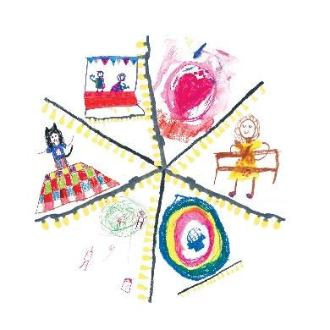
CC-BY-NA-SA Logo with thanks to Ayla (images) and Alex Fox (graphic design)

Confident
Very confident
Slightly confident
How confident are you about climate change?
Unconfident
ACTING
INFLUENCING
UNDERSTANDING
EXPLAINING

