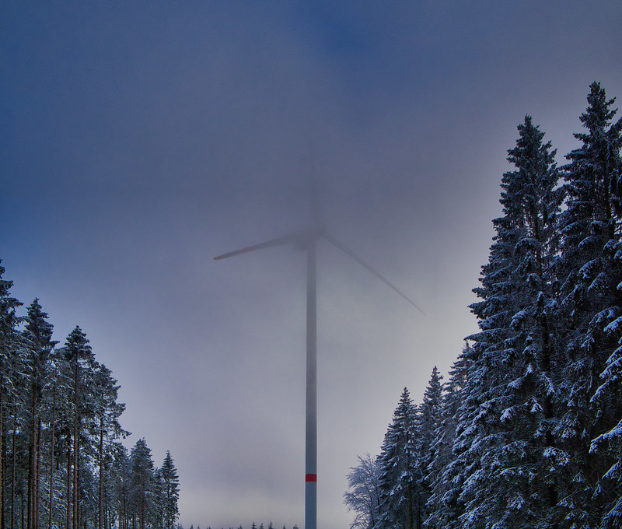

What is the Digital Energy Transition?

How this course works 1
Learning outcomes 2
Introduction 2
The energy transition in Europe 3
Digital technologies 3
The potential of the digital energy transition 4
Conclusion 5
Additional resources 5
Acknowledgements 6
Image attributions 6

How this course works

This short 30-minute course explains what the digital energy transition is and how the transition is taking place.

You might be interested in consuming less energy and understanding what practical steps you can take to improve your energy consumption and potentially save money.

Or are you curious about how new technologies are making a difference to how we produce and consume energy, and how we can use energy more effectively? You may also be concerned about climate charge or rising energy costs and how to better manage your energy usage at home.

This course will give you a better understanding of the digital energy transition and help get you started on your own digital energy journey! It is part of the suite of 12 courses called Digital Energy Essentials, developed by the Every1 project which aims to enable and empower everyone’s engagement in the energy transition. You can find out more about the project by going to https://every1.energy.

At the end of the course, we suggest some further learning materials for you to explore. This includes the course Why Digitalise Energy? which explores why the digital energy transition is important and some of the benefits and challenges.

This is a Word version of the original English language version of the course, which includes an opportunity to complete a short quiz and earn an Every1 digital badge.

This project has received funding from the European Union’s Horizon Programme for Research and Innovation (2021-2027) under grant agreement No 101075596. The sole responsibility for the content of this course lies with the Every1 project and does not necessarily reflect the opinion of the European Union.

Learning outcomes

After studying this short course, you should be able to:

- Describe what the digital energy transition is.
- Give some examples of how energy production and use are digitalised.

Introduction

Digital technologies are everywhere, and affect the way we live, work, travel and play.
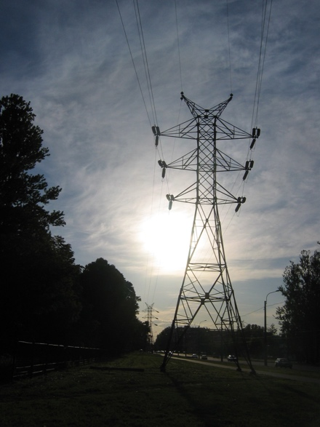
Digital technologies can also improve the way we live. For example, new technologies can help us better understand and reduce our energy consumption. Digital technologies can also support the reduction of carbon emissions and our move away from fossil fuels to more sustainable and clean technologies.

The energy sector has been an early adopter of digital technologies. In the 1970s, power utilities were digital pioneers, using emerging technologies to facilitate grid management and operations.

Oil and gas companies have long used digital technologies to improve decision making for exploration and production assets, including reservoirs and pipelines. In today’s climate emergency - and the shift away from the use of oil, coal and gas - energy digitalisation is key to increasing the effectiveness of technologies such as solar and wind power for producers and consumers.

The digitalisation of energy also has an important role in ensuring the safe and effective operation of energy markets, and networks. For example, by enabling fault detection and ensuring grid stability.

The energy transition in Europe

We need rapid action to tackle climate change and reduce our dependency on fossil fuels.
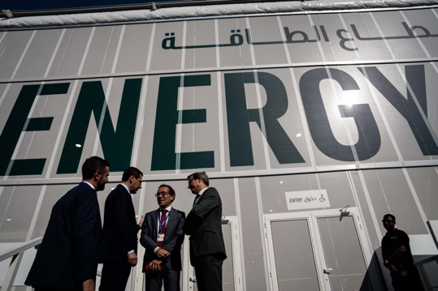
Well known examples of international meetings to coordinate action around the world include November 2023’s COP28 in the United Arab Emirates. Participants negotiated efforts to keep global warming within 1.5 degrees Celsius.

Within Europe, one key initiative is The European Commission’s European Green Deal.

The European Green Deal (2019) aims to significantly reduce the amount of greenhouse gases produced in the European Union (EU) region. The aim by 2050 is to have zero net emissions across the EU. This involves rapidly reducing our dependency on, and use of, fossil fuels and replacing them with green energy sources. The Green Deal also recognises that to do so, the shift away from fossil fuels involves the creation of new industries and economies to support countries and regions’ reliance on fossil fuel economies.

Central to The Green Deal is that “no person and no place is left behind.” Everyone has a role to play in reducing their energy consumption and engaging in the energy transition.

Policies such as the EU’s Digital Strategy support implementation of the European Green Deal through their focus on ensuring practices and infrastructure are fit for purpose and people have the digital skills they need.

In 2023, 92% of the population in the European Union had access to the internet. With widespread access to internet enabled devices, digital technologies have a key role to play in addressing the challenges we face and the success of initiatives such as the European Green Deal.

Digital technologies

What do we mean by digital technologies? Everyday digital technologies that you might use include smartphones and other internet enabled devices, such as your laptop or PC.

Digital technologies can also include watches, home appliances or cars that are connected to communications networks to provide a range of digital services and applications. This is called the Internet of Things (IoT).

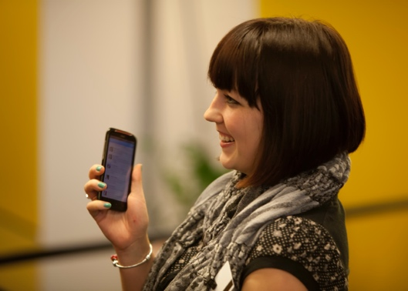
The IoT refers to devices that can transfer data to one another without human intervention and that can provide services such as personal healthcare, smart electricity grids, surveillance, home automation and intelligent transport.

You may already use digital technologies in your own home. For example, you may have a smart or digital meter that monitors your electricity usage and sends updates to your electricity supplier. You might also use apps on your smartphone to:

- Monitor the temperature of different rooms in your house and turn the heating on or off, in different areas of the house, if the temperature changes.
- Control lights (smart bulbs) in your home.
- Charge your electric car at a time that works best for you.

These types of smart devices can enable you to better understand, monitor and reduce your energy consumption. Data on how we use and consume energy can also be of benefit to companies and governments by providing real time insights. These can be used to inform policy or to optimise the energy infrastructure. Other types of digital technologies such as artificial intelligence can also be used by businesses to better understand and support efficient energy production and consumption.

The potential of the digital energy transition

Using digital technologies to better understand and manage your own energy consumption and potentially reduce costs is one aspect of the digital energy transition. However, the greatest transformational potential for digitalisation is how it can optimise the consumption and production of energy. Our transition away from fossil fuels to renewable energy sources by using digital technologies includes the following connected opportunities:
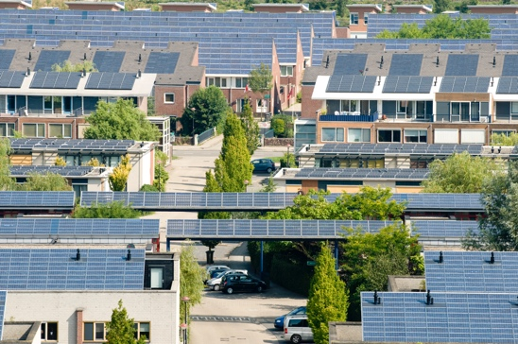
Demand response: One billion households globally and 11 billion smart devices could actively participate in interconnected electricity systems. This would enable households and devices to flexibly draw electricity from the grid. For example, choosing to use appliances at off-peak times, when less electricity is consumed overall, and it is therefore cheaper. This is known as demand response (DR).

Intermittent renewables: Digitalisation can support better integration of intermittent renewables (e.g. energy sources such as solar and wind that often fluctuate throughout the day) by enabling the grid, suppliers, producers and consumers to better match energy production and consumption. This means we can make the most of when renewable sources, such as the sun and the wind, are available.

Smart charging technologies: Rolling out smart charging technologies for electric vehicles.
This could help shift charging to periods when electricity demand is low, and supply is abundant.

Distributed energy resources: Digitalisation can facilitate the development of distributed energy resources (DER), such as household solar panels. For example, you may be able to sell surplus electricity to the grid.

Conclusion

Energy digitalisation can help us better understand and manage our energy consumption.
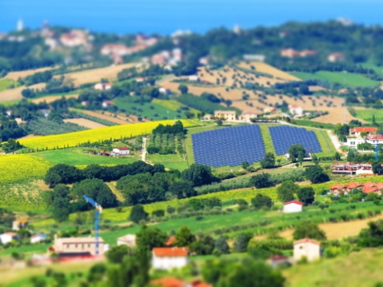
Digital technologies can provide insights into our own behaviour and enable us to make meaningful changes. Digital technologies can also benefit businesses and governments by providing real time insights and supporting efficient energy production and consumption.

As we transition to more sustainable sources of energy, digital technologies and digital services offer the potential for energy systems to be more connected, intelligent, efficient, reliable and sustainable.

This course is part of the Digital Energy Essentials series. You may want to explore our course Why Digitalise Energy? to find out more about the potential benefits and challenges of energy digitalisation.

Additional resources

Rozite, V., Miller, J., & Oh, S. (2023) Why AI and energy are the new power couple International Energy Agency (IEA)
Chambers, J., Robinson, C. & Scott, M. (2022) Digital inclusion in the energy system: How do we ensure the opportunities and benefits of digitalisation can be accessed by everyone? Policy Bristol / University of Bristol
European Commission (n.d.) Digitalisation of the energy system. European Commission.
Saini, H. (2023) What is digital energy? Learn about its benefits, the different types, and what the future holds. ET Edge Insights.

Acknowledgements

What is the digital energy transition? is an adaptation of selected material from the International Energy Agency (IEA) Digitisation and Energy report (2017) (the ‘Original Work’) which is licensed CC BY 4.0. This adaptation is made and published by the Every1 Project (the ‘Adapter’) and licensed CC BY-SA 4.0, unless otherwise stated. This is a work derived by the Every1 project from IEA material and the Every1 project is solely liable and responsible for this derived work. The derived work is not endorsed by the IEA in any manner.

The Adapter modified the Original Work in the following respects:
- Selected excerpts from the report were revised (e.g. examples added, reworded), reordered and reworked.
- New material (e.g. on the European Green Deal) was added.

Image attributions

Main course image: Winter Power by Peter Toporowski is licensed CC BY-SA 2.0.
Introduction: Pylon of a high-voltage transmission line by user:Yanachka is Public Domain.
The Energy Transition in Europe: 2023_12_09 Jornada de trabajo en la COP28 de Dubai by Junta de Andalucia is licensed CC BY-SA 2.0.
Digital Technologies: Smartphone by Harry Metcalfe is licensed CC BY 2.0.
The potential of the digital energy transition: Solar energy, Amersfoort by Eneco Group is licensed CC BY 2.0.
Conclusion: Italy, Marche, Recanati - countryside – by Gianni Del Bufalo is licensed CC BY 2.0.

