Energy Flows, Energy Systems

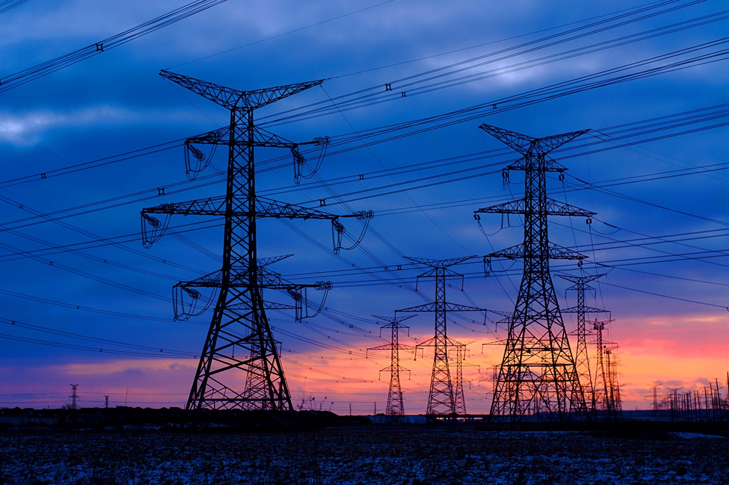

Energy Flows, Energy Systems 1
How this course works 2
Learning outcomes 2
Introduction 2
Energy System Basics 3
Digital Technologies and Energy Systems 3
The impact of digitalisation on how we consume energy 4
Conclusion 6
Additional Resources 6
Acknowledgements 6
Image attributions 6

How this course works

This short, 30-minute course explores digital energy markets and focuses on how digitalisation is impacting on our production and consumption of energy at home and work.

You might be:

- Curious as to how energy systems work.
- Wanting to take a deeper look at how energy digitalisation is making a difference to how we consume energy.
- Interested in how new digital technologies are transforming energy systems.

This course will deepen your understanding of the digital energy transition and support your own digital energy journey! It is part of the suite of 12 courses called Digital Energy Essentials, developed by the Every1 project, which aims to enable and empower everyone’s engagement in the energy transition. You can find out more about the project by going to: https://every1.energy

At the end of the course, we suggest some further learning materials for you to explore. This includes the course What is the Digital Energy Transition? which explores what digital energy is and the reasons behind moving towards digitalising our production and consumption of energy.

This is a Word version of the original English language version of the course, which includes an opportunity to complete a short quiz and earn an Every1 digital badge.
This project has received funding from the European Union’s Horizon Programme for Research and Innovation (2021-2027) under grant agreement No 101075596. The sole responsibility for the content of this course lies with the Every1 project and does not necessarily reflect the opinion of the European Union.

Learning outcomes

After studying this short course, you should be able to:

- Explain the different stages of an energy system.
- Understand how and why our energy systems are changing.
- Explain how energy digitalisation is transforming the way we consume energy.

Introduction

Energy systems have been fundamental to human development, evolving from simple fire-based energy sources to complex modern grids that power our daily lives. Historically, energy systems were straightforward: energy was generated at a central location, transported via transmission lines, distributed through local networks, and finally used by households or businesses, e.g. to power appliances, or heat or cool buildings. This linear flow ensured that energy moved in one direction—from generation to consumption.

In this course we take a closer look at how energy systems are changing with the digitalisation of energy. How are digital technologies ensuring more efficient, secure and flexible energy systems? And how do digital technologies support household generation and use of renewables?

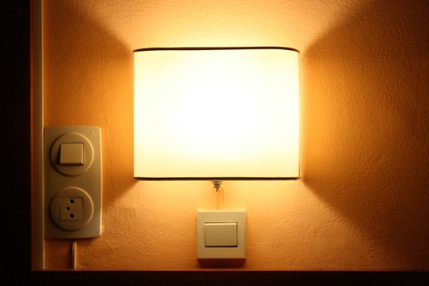
Energy System Basics

An energy system is divided into four main stages. Let’s explore each one in turn:

- Generation: This is the process of producing energy from various sources, including fossil fuels, nuclear power, and renewables such as wind, solar, and hydroelectric power.
- Transport: Also known as transmission, this segment involves the high-voltage transfer of electricity from power plants to substations near populated areas.
- Distribution: At this stage, electricity is distributed at lower voltages from substations to homes, businesses, and other end-users.
- Consumption: The final stage, where customers and businesses utilise the electrical energy for various applications, from powering household appliances to industrial machinery.

Over time, technological advancements have drastically transformed the energy landscape. The traditional model, where energy flows solely from large-scale generators to passive consumers, is being reshaped. The rise of renewable energy sources, such as solar and wind, has made a more decentralised approach to energy generation possible.

Additionally, the concept of "prosumers" has emerged, where individuals and businesses not only consume energy but also produce it, often feeding excess energy back into the grid. This bidirectional flow of energy represents a significant shift from the past.

Digital Technologies and Energy Systems

In recent years, digitalisation of the energy system has become a critical area of focus.

Digital technologies are being integrated across energy systems, enhancing efficiency, reliability, and sustainability. Smart grids, for instance, use sensors, advanced metering infrastructure (e.g. smart meters), and automation to optimise energy distribution and manage the complexities introduced by renewable energy sources and prosumers.

Digitalisation impacts energy systems at every stage. For example, the integration of Artificial Intelligence (AI) and data analytics at the generation level marks a significant step towards the digitalisation of the energy system. These technologies not only enhance efficiency and reliability but also support the transition to a more sustainable and resilient energy infrastructure. By harnessing the power of digital technologies, energy generation can become more adaptive, predictive, and optimised, paving the way for a smarter energy future.

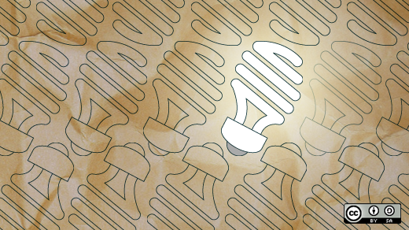
The digitalisation of transmission and distribution through machine learning and automation is also transforming the energy system into a more resilient, efficient, and intelligent network. These technologies enhance grid management, improve reliability, and support the integration of renewable energy sources. By leveraging the power of machine learning and automation, the transmission and distribution levels are becoming more adaptable and capable of meeting the evolving demands of the modern energy landscape.

Although digitalisation impacts energy systems at every stage, in this course we will focus on the impact of digitalisation at the consumption stage. This will help you better understand how digital technologies are supporting you in your consumption - and potentially production if you are a prosumer - of energy.

The impact of digitalisation on how we consume energy

As we saw earlier in the section Energy System Basics the consumption stage of an energy system traditionally focused on the end-use of electricity by households, businesses, and industry.

However, with the introduction of Distributed Energy Resources (DER) such as rooftop solar panels, home battery storage, and electric vehicles (EVs), households or businesses may also be producers as well as consumers of energy. As more and more households and businesses become prosumers, this blurring of roles adds complexity to the system, requiring more sophisticated management to ensure efficiency and reliability.

The Internet of Things (IoT) involves the interconnection of devices and systems, allowing them to communicate and exchange data. In the context of energy consumption, the IoT contributes in the following ways:

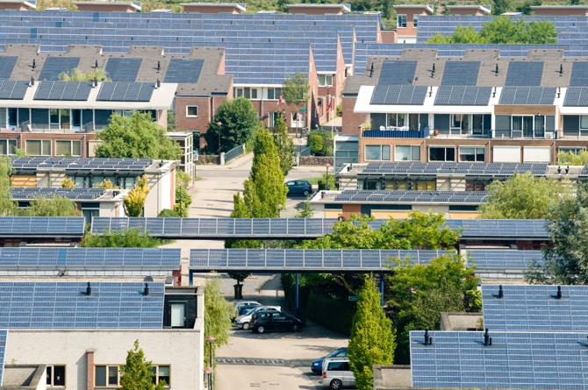
Smart Meters. Providing real-time data on energy usage, smart meters allow consumers and utilities to monitor consumption patterns accurately. These meters can also communicate with the grid to optimise energy distribution. Smart meters can improve energy management, enable more accurate billing and support demand response (see below), which enables electricity companies to offer lower cost energy at periods of reduced demand.

Home Energy Management Systems (HEMS). These systems use IoT devices to monitor and control energy use within homes. They can automate appliances, manage heating and cooling systems, and optimize the use of DERs like solar panels and battery storage. HEMS can increase energy efficiency, reduce costs, and support the better integration of renewable energy.

Demand Response Programs: IoT-enabled devices can participate in demand response programs, where you can reduce or shift your energy during peak periods, in response to signals from your energy supplier. Demand response helps balance supply and demand through enhancing grid stability, reducing stress at times of increased energy consumption and provides financial incentives for consumers. You can find out more about how demand response works in our course Electricity Markets: Demand Response.

Distributed Ledger Technology (DLT). DLT provides a secure and transparent way to record transactions and manage data. Blockchain is an example of a DLT. DLT supports the consumption and distribution of energy by consumers in three ways.

- For prosumers, DLT enables peer-to-peer energy trading platforms where excess energy from DERs (e.g. solar panels) can be bought by, and sold directly to, others. Blockchain enables transactions to be recorded securely. Peer-to-peer energy trading increases participation in energy markets, optimises the use of local renewable resources and provides potential cost savings for consumers.

- DLT supports the secure data management of energy data by ensuring the secure and transparent recording of energy data, such as consumption patterns, generation details from DERs, and transaction histories. This enhances data integrity and trust, improves data security, reduces the risk of fraud and increases consumer trust in energy systems.

- DLT also supports localised energy grids that can operate independently or in conjunction with the main grid. These are called microgrids and decentralised energy systems and support the co-ordination of energy production, storage, and consumption among multiple participants. The use of microgrids enhance resilience, support the adoption of renewable energy and optimise local energy use.

Conclusion

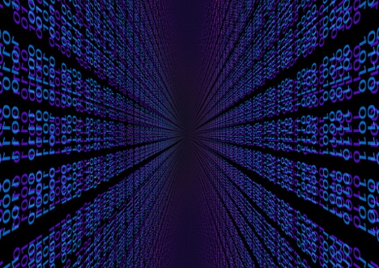
The use of IoT and DLT for the management and use of energy by prosumers and consumers has transformed the energy landscape.

IoT enables smarter, more efficient energy use, while DLT provides secure and transparent mechanisms for energy transactions and data management. Together, these technologies support the integration of DERs, enhance grid resilience, and empower consumers to take a more active role in the energy ecosystem. As the energy landscape continues to evolve, digitalisation at the consumption level will be key to achieving a more sustainable and efficient energy future.

Additional Resources

- Take a closer look at some of our other Digital Energy Essentials courses including Clean Energy for Households and Smart Devices and Digital Energy Technology.
- Read more about the impact of renewables on energy prices in The causes and effects of negative power prices: https://www.cleanenergywire.org/factsheets/why-power-prices-turn-negative and Europe’s surging solar sector set for cannibalization risk: https://www.reuters.com/markets/commodities/europes-surging-solar-sector-set-cannibalization-risk-2023-07-10/
- Explore International Energy Agency (IEA) resources on different facets of energy systems: https://www.iea.org/energy-system

Acknowledgements

Energy Flows, Energy Systems was created by the Every1 project and is licensed CC BY-SA 4.0, unless otherwise stated.

Image attributions

Main course image: Line ‘Em Up by Ian Muttoo is licensed CC BY-SA 2.0.
Energy System Basics: I know another place to be by Jorge Franganillo is licensed CC BY 2.0.
Digital Technologies and Energy Systems: Open Innovation: The new bright idea by opensource.com is licensed CC BY-SA 2.0.
The impact of digitalisation on how we consume energy: Solar energy, Amersfoort by Eneco Group is licensed CC BY 2.0.
Conclusion: digitalisation by Chambre des Députés is licensed CC BY-ND 2.0.

