Why Digitalise Energy?

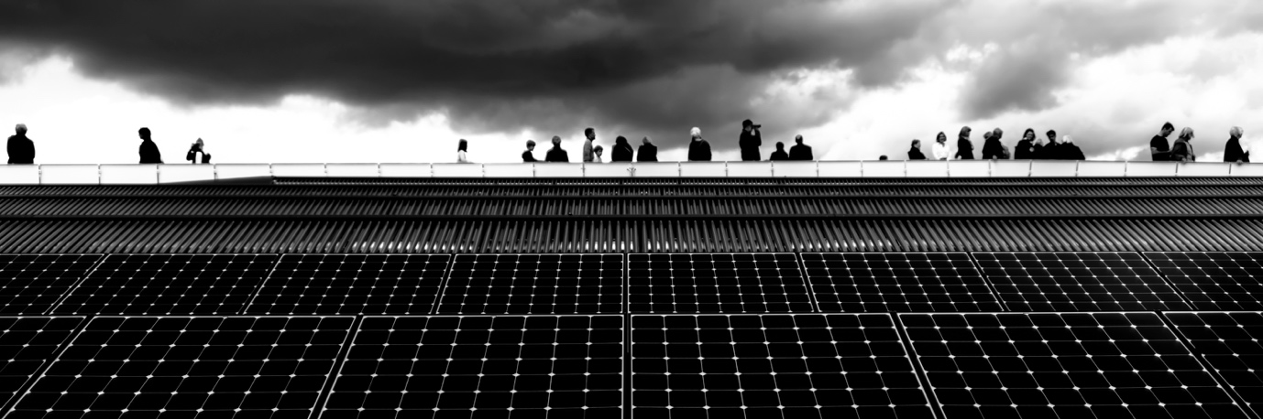

Why Digitalise Energy? 1
How this course works 1
Learning outcomes 2
Introduction 2
The Benefits of Energy Digitalisation 3
Challenges of Energy Digitalisation 3
Challenges and Opportunities: Solar Panels 5
Conclusion 5
Further Resources 6
Acknowledgements 6
Image attributions 6

How this course works

This short 30-minute course explains why the way we produce and consume energy is now focused on digitalisation and explores some of the benefits and challenges.

The course also gives you some practical examples to help you understand how energy digitalisation might benefit you. You might be:

- Thinking about how to save money by making your home more energy efficient.
- Curious as to how energy digitalisation might impact on the way we live and work.

This course will deepen your understanding of the digital energy transition and support your own digital energy journey! It is part of the suite of 12 courses called Digital Energy Essentials, developed by the Every1 project, which aims to enable and empower everyone’s engagement in the energy transition. You can find out more about the project by going to: https://every1.energy

At the end of the course, we suggest some further learning materials for you to explore. This includes the course What is the Digital Energy Transition? which explores what digital energy is and the reasons behind moving towards digitalising our production and consumption of energy.

This is a translation of the original English language version of the course, which includes an opportunity to complete a short quiz and earn an Every1 digital badge.

This project has received funding from the European Union’s Horizon Programme for Research and Innovation (2021-2027) under grant agreement No 101075596. The sole responsibility for the content of this course lies with the Every1 project and does not necessarily reflect the opinion of the European Union.

Learning outcomes

After studying this short course, you should be able to:

- Understand some of the benefits and challenges of energy digitalisation.
- Be aware of how benefits for some groups of people may present challenges for others.

Introduction

The digital energy transition is changing the way we produce and consume energy. In this course we explore some of the main benefits and challenges associated with the digital energy transition. The digital energy transition involves and impacts on us all in different ways. As we will see what benefits one group can surface challenges or opportunities for others.

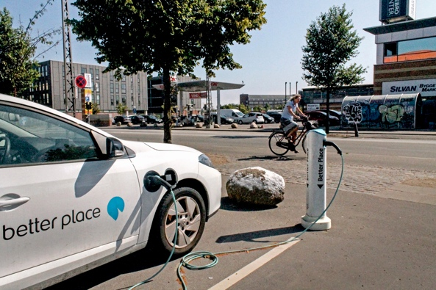
The digitalisation of energy and increase in clean technologies is important for several reasons, including ensuring that we have a range of reliable sources of energy and reduce our dependency on fossil fuels. However, whether we can engage with, and benefit from, the digital energy transition is dependent on a variety of factors.

As we will explore in this course, our access to, experiences and perceptions of digital technologies play a key role. Enabling everyone to be part of the digital energy transition presents both challenges and opportunities.

The Benefits of Energy Digitalisation

There are an increasing number of different electrical appliances at home and in the workplace. Many of these appliances have digital capabilities which enable us to better understand how and when we use energy.

If these appliances are connected to the internet they can also communicate with other devices to provide us with a variety of services. This is called the Internet of Things (IoT).

Making use of digital technologies to better understand our energy consumption at home or work can provide real-time insights as to what appliances are consuming energy and when. This understanding of how we use energy can provide a range of benefits.

Support informed choices
Understanding how and when we use energy, can help us make more informed decisions about our energy use. We could choose to reduce our energy consumption or use certain appliances at times when there is less demand. For example, it may be more cost saving to run a washing machine overnight when there is an off-peak energy tariff available.


Reduce costs and increase savings
Informed decisions about energy use can reduce costs and increase savings. Using our household appliances less can also be beneficial as there is less wear-and-tear to appliances. This can result in appliances lasting longer and reducing the need for repairs as unnecessary or extensive use is limited.

Reduce carbon emissions
Reducing our energy consumption reduces our carbon emissions. We could also reduce our impact on the environment by using or buying electricity produced by clean technologies such as solar or wind. Reducing our energy use enables the energy grid to respond more effectively to changes in our needs, therefore enhancing energy efficiency and reducing environmental impact. Similarly, adjusting our energy needs during peak demand periods can reduce the need for relying on fossil fuels for back-up generation of electricity.

Challenges of Energy Digitalisation

Now that we’ve looked at some of the benefits of energy digitalisation, let’s take a closer look of some of the challenges faced by both producers and consumers of energy.

Inclusion and Access
An important focus of The European Commission’s European Green Deal is ensuring that everyone, no matter where they live or who they are, is engaged in the digital energy transition. This is why policies such as the EU’s Digital Strategy aim to ensure that the infrastructure, skills and technologies needed are in place.

Ensuring that everyone has access to, and the skills to use, digital technologies is vital. Research by The University of Bristol highlights five key areas that should be addressed to ensure that the digital energy transition is for everyone:

- Whether people feel safe and comfortable using digital technologies.
- The cost and availability of digital technologies.
- Whether some energy users are excluded from energy saving initiatives such as dynamic pricing (where energy costs less when there is less demand and vice versa) because of their type of energy contract.
- The need for jargon-free explanations, in a range of online and offline formats, to ensure that everyone has access to information they need.
- An awareness that there is often a range of factors and needs as to why individuals and communities may be excluded currently from engaging in the digital energy transition.

Ensuring that the digital energy transition is accessible, understandable and works for the benefit of everyone is critical.

Cybersecurity and Energy Security
As we have seen, and as our world becomes increasingly digitalised, it is vital that people feel comfortable and safe using digital technologies for everyday tasks. To increase cybersecurity means we need to ensure that our data and systems are safe and secure. Minimising the risk of hacking, data breaches and malicious attacks is essential. It is an ongoing effort to ensure that our energy infrastructure is secure and that risks are minimised. This involves everyone in the energy infrastructure, from energy consumers to producers.

Digitalisation is also important to energy security, which focuses on minimising disruption to energy production and supply. The war in Ukraine is an example of where energy security was impacted, with price rises and disruption to the availability of energy. Ensuring that countries have a range of different sources for their energy needs or are not overly reliant on one source of energy (e.g. coal or gas) requires flexibility that only digitalisation can provide.

Challenges and Opportunities: Solar Panels

One example that illustrates both the benefits and challenges of the digital energy transition, is the increase in the installation of solar panels on individual homes or businesses.

Producing your own energy from clean technologies such as solar panels is becoming more popular and accessible as the cost of these technologies decrease. However, the possibility to invest for longer-term benefit (for example, by installing your own solar panels or heat pump) may only be open to a limited number of people who can afford the initial cost of installation. Certain types of home, such as flats, might have limited opportunities for solar panel installation. If you rent your home, you may not have much control over your energy supply or supplier.

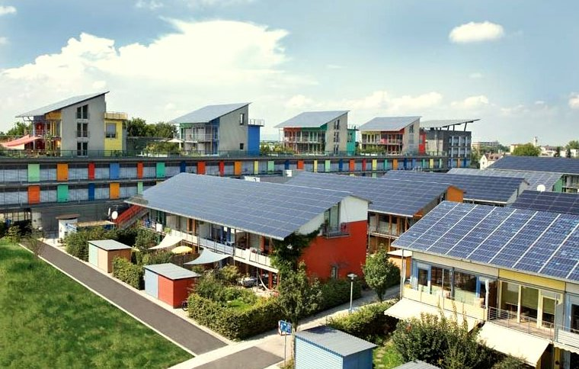
Locally produced energy, where individual businesses or homes are producing their own energy for all or part of the time, is an example of decentralised energy production. If excess energy is produced this may be stored (e.g. in a battery) or sold back to an energy company. Additional energy may need to be purchased if not enough energy is produced. This type of technology (solar, wind) is called an intermittent renewable.

Whether our energy comes from clean technologies or from other sources, ensuring that we have a constant energy supply is a key concern for both individuals, businesses and energy companies. The ability to draw on different sources of energy at different times requires energy companies to be flexible and responsive. Digital technologies support this more complex way of producing and consuming energy by providing real-time data on what electricity is needed where and when (supply and demand). Digital technologies also enable communication between people that are both producing and consuming energy (prosumers), energy companies and consumers. This ensures that we have a reliable and consistent energy supply.

Conclusion

There are many benefits to the digitalisation of energy. The digitalisation of energy enables us to better understand our own energy use, reduce costs and lower carbon emissions. We can also use different types of energy more effectively and ensure a constant energy supply to our homes and work.


However, although there are many benefits to the digitalisation of energy, there are also a range of issues that need to be addressed, including the cost, availability and the perception of digital technologies. Addressing these challenges and ensuring that everyone is able to engage and be part of the digital energy transition is essential to its success.

This course is part of the Digital Energy Essentials series.

You may want to explore our course What is the Digital Energy Transition? to find out more about what the digital energy transition is and how this transition is taking place.

Further Resources
International Energy Agency (IEA) (n.d.) Energy Security. https://www.iea.org/topics/energy-security
International Energy Agency (IEA) (n.d.) Analysing the impacts of Russia’s invasion of Ukraine on energy markets and energy security: Russia’s war on Ukraine. https://www.iea.org/topics/russias-war-on-ukraine
Digitization and Energy: A new era in energy? https://www.youtube.com/watch?v=oxD4Wv74G4Q

Acknowledgements

Why digitalise energy? was created by the Every1 project and is licensed CC BY-SA 4.0, unless otherwise stated.

Image attributions

Main course image: Solar farming meet sightseeing by mini_malist (see you soon) is licensed CC BY-ND 2.0
Introduction: EON kober Better Place elbil ladestander 20130722_01 by News Oresund is licensed CC BY 2.0.
The benefits of energy digitalisation: 10¢ Costs me $70… And I am Glad by Alan Levine is licensed CC BY 2.0.
Challenges of energy digitalisation: Engaged Hands by Kenneth Lui is licensed CC BY 2.0.
Challenges and opportunities: Solar Panels: Clean energy at work for earthday! by naturalflow is licensed CC BY-SA 2.0.
Conclusion: School diversity many hands held together by Wonder woman0731 is licensed CC BY 2.0.

