Energy Communities

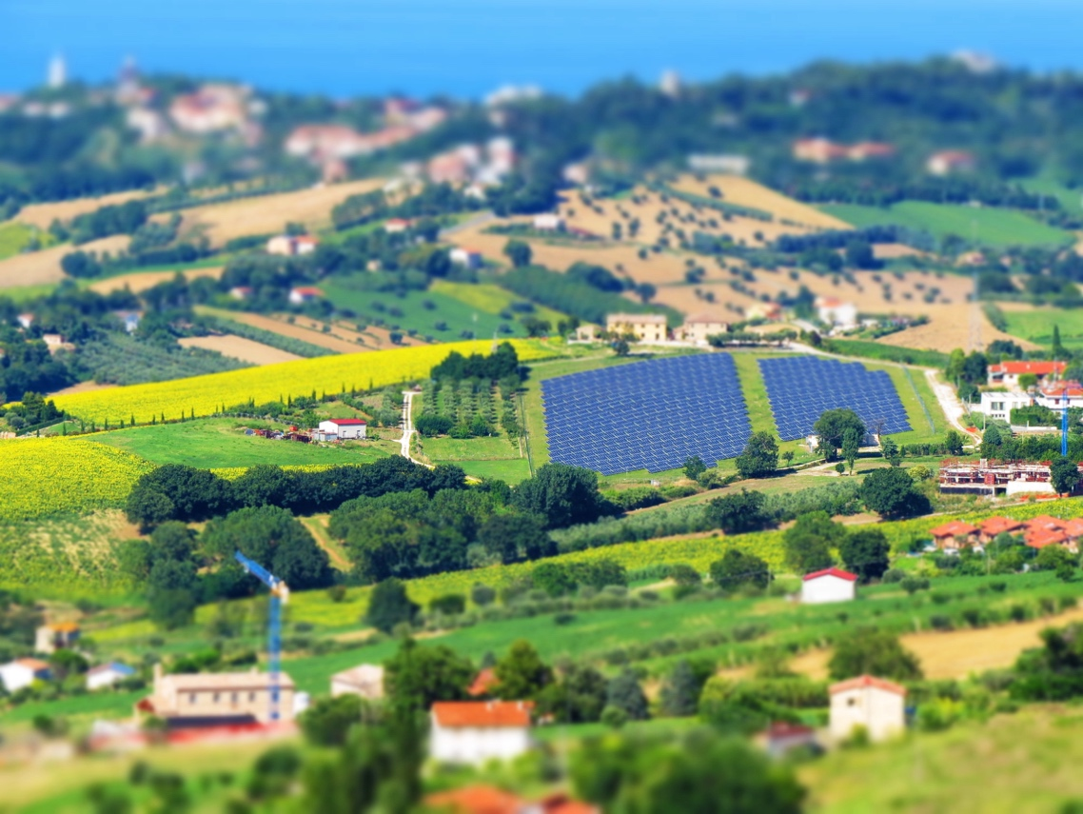

Energy Communities 1
How this course works 2
Learning outcomes 2
Introduction 3
What is an energy community? 3
Energy communities within the European Context 4
Benefits of an energy community 4
Conclusion 5
Additional Resources 5
Acknowledgements 5
Image attributions 6

How this course works

This short, 30-minute course explores what an energy community is, why they are important and the benefits of being part of one.

You might be:

- Curious as to what an energy community is and how it could benefit you and your household.
- Interested in reducing your energy consumption and saving costs.
- Part of a household which both consumers and produces energy and has an interest in community energy.
This course will deepen your understanding of the digital energy transition and support your own digital energy journey! It is part of the suite of 12 courses called Digital Energy Essentials, developed by the Every1 project, which aims to enable and empower everyone’s engagement in the energy transition. You can find out more about the project by going to: https://every1.energy
At the end of the course, we suggest some further learning materials for you to explore. This includes the course What is the Digital Energy Transition? which explores what digital energy is and the reasons behind moving towards digitalising our production and consumption of energy.
This is a translation of the original English language version of the course, which includes an opportunity to complete a short quiz and earn an Every1 digital badge.
This project has received funding from the European Union’s Horizon Programme for Research and Innovation (2021-2027) under grant agreement No 101075596. The sole responsibility for the content of this course lies with the Every1 project and does not necessarily reflect the opinion of the European Union.

Learning outcomes

After studying this short course, you should be able to:

- Explain what an energy community is and their role in Europe’s digital energy transition.
- Understand the benefits of an energy community for both individuals and the wider community.

Introduction

Energy communities are local initiatives that can help everyone engage with the digital energy transition.

In this course we take a closer look at what energy communities are and what their role is within the European digital energy transition.

We look at why you might want to get involved and join an energy community. You might want to save money, are interested in connecting with others interested in the same topics or be an energy prosumer (e.g. be both a consumer and producer of energy).

What is an energy community?
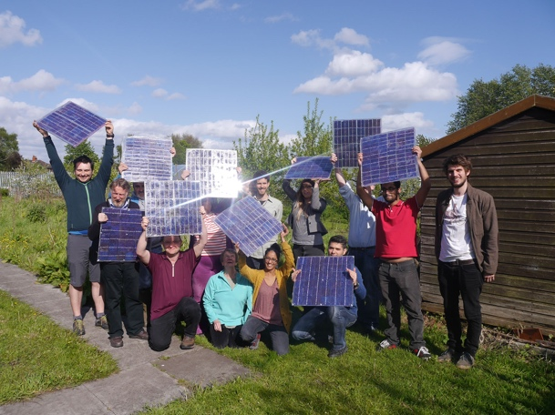
In this article In focus: Energy communities to transform the EU’s energy system energy communities are described as “legal entities that empower citizens, small businesses and local authorities to produce, manage and consume their own energy.”

Anyone can become involved in an energy community. Energy communities can also take different forms, depending on their members’ needs.

For example, some energy communities might focus on the production of energy, whilst others might focus on the storage or distribution of energy. There are a range of different energy related services that might also be provided to energy community members.
Across Europe, there are three common models for energy communities. These models can be described as follows:
- Direct agreement with an electricity generator (rather than electricity supplier, which usually provides household electricity supplies) which enables the energy community to buy energy directly and in bulk. These are sometimes called Power Purchase Agreements (PPA).
- Using membership fees to fund the production of energy by providing financial support for production installations.
- Linking energy consumers and producers in the same region so that individual households can buy and sell energy, according to their national legislation.
Different models may also be combined depending on member needs.
Under EU law, energy communities can take the form of any legal entity including an association, a cooperative, a partnership, a non-profit organisation or a limited liability company.

Digitalisation enables and supports energy communities. For example, digital technologies have an important role to play in managing the buying and selling of energy generated by renewables such as household solar panels.

National legislation is also key to determining what form an energy community can take.

Energy communities within the European Context

The article In focus… reports that “…as much as 83% of all EU households could contribute to renewable energy production, demand response and/or energy storage in 2050.”
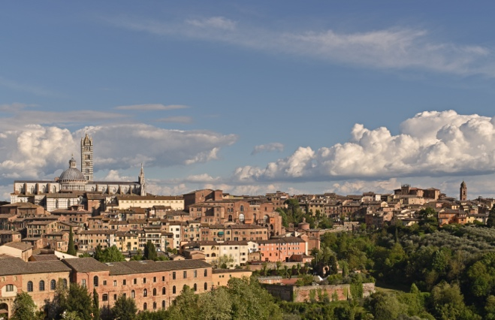
As seen in the last section, energy communities can empower individuals and households to be involved in different aspects of energy production.

Consequently, energy communities have a specific and important role in the European digital energy transition.

There are a range of European directives that support energy communities across the bloc. Central to these is The Clean Energy for all Europeans package from 2019 which gives consumers the right to choose and take energy supply, production and storage into their own hands, either individually as prosumers, or collectively through energy communities.

In May 2022 the European Commission launched its REPowerEU Plan which aims to reduce reliance on fossil fuels from Russia. As part of this initiative the EU aims to achieve one energy community per municipality with a population of more than 10,000 by 2025.

Benefits of an energy community

In energy communities, citizens can access low-cost renewable energy by taking ownership of production installations, as well as access information on how to increase energy efficiency in their households. Reliable and up-to-date information on energy efficiency can help you to better understand and control your energy usage and bills while keeping individual investments affordable.

At a local level, energy communities can contribute to the creation of jobs opportunities and enhance social cohesion through annual general assemblies and local activities.

Energy communities can also contribute to increasing public acceptance of renewable energy projects and make it easier to attract private investments in the clean energy transition.

Energy communities can be an effective means of re-structuring our energy systems, by empowering citizens to drive the energy transition locally and directly benefit from better energy efficiency, lower bills, reduced energy poverty and more local green job opportunities.
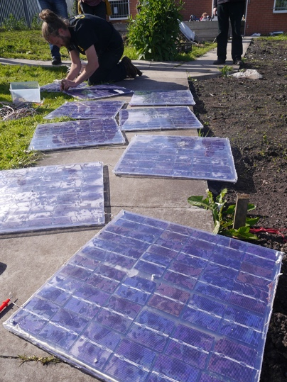
Energy communities can also empower local communities to join forces and invest in clean energy.

As seen earlier on in the course, acting as a single entity means energy communities can access all suitable energy markets on a level-playing field with other market actors.

Conclusion

Energy communities support an increase in clean technologies, enable individual households to engage in the digital energy transition and empower communities.

They have a central role to play in Europe’s digital energy transition and have the potential to involve large numbers of individuals and households across Europe.

Additional Resources

- Review some European Commission reports, key figures and examples of Energy Communities in Europe in Energy Communities Repository products.
- Read some further Every1 learning materials on energy communities: https://every1.energy/knowledge-hub
- Take a deeper look at different types of energy community in this academic article by Koltunov, M., Pezzutto, S., Bisello, A., Lettner, G., Hiesl, A. van Sark, W., Louwen, A. & Wilczynski, E. (2023) Mapping of Energy Communities in Europe: Status Quo and Review of Existing Classifications Sustainability, 15, 8201.

Acknowledgements

Energy Communities is an adaptation of selected material from Energy Communities (n.d) by the European Commission and In focus: Energy communities to transform the EU’s energy system (13 December 2022) by Directorate-General for Energy (the ‘Original Works’) both of which are licensed CC BY 4.0. This adaptation is made and published by the Every1 Project (the ‘Adapter’) and licensed CC BY-SA 4.0, unless otherwise stated.
The Adapter modified the Original Work “Energy Communities” in the following respects:
- Selected excerpts from the article were used (e.g. REPowerEU text on municipality energy community targets, the introduction statement on the format of an energy community was added to What is an energy community?) and revised (e.g. energy community benefits text was reworked/reframed as community benefits in the associated course section).
The Adapter modified the Original Work “In focus: Energy communities to transform the EU’s energy system” in the following respects:
- Selected excerpts from the article were used (e.g. definition of energy community, text from the EU legal framework section) and integrated into course.
- Selected excerpts from the article were revised and adapted (e.g. text from the sections Choosing an energy community model and What is an ‘energy community’?).

Image attributions

Main course image: Italy, Marche, Recanati – countryside – by Gianni Del Bufalo is licensed CC BY 2.0.
What is an energy community: Moss Community Energy launch (DIY Solar Panel Workshop) by 10 10 is licensed CC BY 2.0.
Energy communities within the European Context: Italy – Tuscany – Siena – Duomo by Harshil Shah is licensed CC BY-ND 2.0.
Benefits of an energy community: Moss Community Energy launch by 10 10 is licensed CC BY 2.0.

