Energy Anxiety

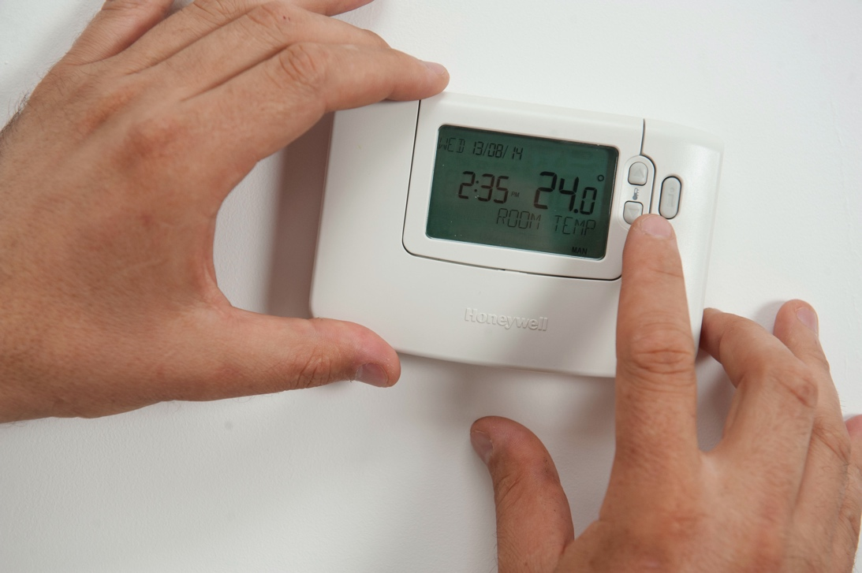

Energy Anxiety 1
How this course works 2
Learning outcomes 2
Introduction 3
How do we define energy anxiety? 3
Identifying energy anxiety 4
What can we do about energy anxiety? 4
How can energy digitalisation reduce energy anxiety? 6
Conclusion 6
Additional Resources 6
Acknowledgements 7
Image attributions 7

How this course works

This short, 30-minute course explores what energy anxiety is and its main causes. The course also explores how energy digitalisation can help address energy anxiety, and where you can find support and resources to help yourself and others. You might be:

- Worried about your own or others’ energy use.
- Interested in how energy digitalisation can help address energy anxiety.

This course will deepen your understanding of the digital energy transition and support your own digital energy journey! It is part of the suite of 12 courses called Digital Energy Essentials, developed by the Every1 project, which aims to enable and empower everyone’s engagement in the energy transition. You can find out more about the project by going to: https://every1.energy

At the end of the course, we suggest some further learning materials for you to explore. This includes the course What is the Digital Energy Transition? which explores what digital energy is and the reasons behind moving towards digitalising our production and consumption of energy.

This is a translation of the original English language version of the course, which includes an opportunity to complete a short quiz and earn an Every1 digital badge.

This project has received funding from the European Union’s Horizon Programme for Research and Innovation (2021-2027) under grant agreement No 101075596. The sole responsibility for the content of this course lies with the Every1 project and does not necessarily reflect the opinion of the European Union.

Learning outcomes

After studying this short course, you should be able to:

- Describe what energy anxiety is.
- Understand the main causes of energy anxiety.
- Be able to find, or direct others to, resources and support to combat energy anxiety.
- Understand how energy digitalisation can address energy anxiety.

Introduction
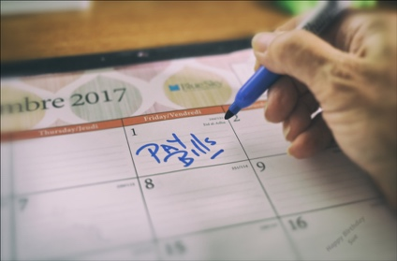
Worries about energy can focus on, and manifest themselves in, different ways. In this course we explain what is meant by the term “energy anxiety” and explore the different causes of this phenomenon.

You might have concerns about rising energy prices or be worried about paying your household bills. Or you might have family members, friends or neighbours that have concerns about how they will keep warm during the winter or keep cool during the summer heat.

How does energy anxiety affect us and, most importantly, what positive steps can we take to address our concerns?

How do we define energy anxiety?


Energy anxiety is a term used to describe worries or stress related to a range of energy issues. Anxiety about energy can also manifest itself in a range of ways. You might recognise these behaviours in yourself, or in friends, family, colleagues, neighbours or people you work with, although people who have energy worries may not openly discuss them with others.

For example, you may have:

- Worries about rising energy bills and the potential impact on personal or household finances. This might be particularly acute if you are responsible for the main household income. You might also worry about which bill payment to prioritise, if you cannot afford to pay all your household bills. You can read more on this topic in Are high energy bills affecting your mental health? from the UK Energy Saving Trust.
- Fears about the environmental impact of your energy use, including pollution and contribution to climate change. You might feel hopeless and as if nothing you can do will make a difference. These types of concerns related to the environment can also be connected to other types of related anxiety, such as eco- or climate-anxiety. Find out more in this UK Energy Saving Trust article What is eco-anxiety and how can you cope with it?
- Concerns about potential energy shortages, blackouts or disruptions in energy supply. You might be worried about energy security or have concerns about the impact of conflict on the cost of energy.

The ongoing energy and cost of living crisis across Europe, in conjunction with climate breakdown and climate change, means that energy anxiety could be caused by a range of different factors. As we will see, energy anxiety also, unfortunately, impacts many people across the European Union.

Identifying energy anxiety

Energy anxiety covers many different concerns and worries about energy consumption and production. But what kind of behaviours might indicate energy anxiety? Some of the ways in which energy anxiety might manifest itself include:

- Avoiding activities that consume energy (e.g. not switching the heating on or restricting its use) for fear of high costs or perceived impact on the environment. This can impact on your health and wellbeing. For example, your home may become damp if it’s not heated and ventilated properly. This could cause health issues or make living in your home uncomfortable.
- Constantly checking your energy usage or energy bills. If you are worried about the cost of energy you might find yourself preoccupied with how much energy you are consuming. You might find yourself checking your electricity usage or your energy bills frequently. Or you might find that you are excessively searching for information about energy prices and comparing energy tariffs to see if you have the best deal.
- Getting irritated and frustrated. You might find yourself becoming annoyed with others in your household (e.g. housemates or family members) if they appear not to be as concerned with their energy usage as you are. For example, your housemates leave the lights on and use a lot of appliances unnecessarily, without thinking about the cost of these activities.
- Becoming withdrawn. You could find that you withdraw from social interactions or are unable to afford social activities that involve using energy. For example, you may have previously invited friends or neighbours for coffee, or your family for dinner, but are concerned that your house is too cold, or you can’t afford to use your oven for cooking.
- Feeling overwhelmed, guilty or distracted. You might be frustrated about energy prices, policies and the inability to control energy expenses and not sure what you can do to change your situation. For example, if you live in rented accommodation, you may have no control over the level of insulation in your home, or whether a heating or cooling system is efficient.
You may find yourself distracted by energy related worries and unable to concentrate on other tasks, or unable to sleep at night.

Energy worries and concerns can cause a range of behaviours and physical symptoms, which if they persist over time may indicate energy anxiety.

What can we do about energy anxiety?

Worries about energy are widespread.


Energy anxiety related to energy costs, for example, is often a consequence of energy poverty. Energy poverty is “…a household’s lack of access to essential energy services, such as heating, hot water, cooling, lighting and energy to power appliances … driven by three underlying causes, namely high-energy expenditures in proportion to household budget, general low levels of income and low energy performance of buildings” (EU Science Hub, 2024). In September 2024, European Union (EU) Science Hub research estimated that energy poverty is a significant issue affecting between 8-16% of citizens in the European Union.

To help combat energy poverty, the EU has several pieces of legislation in place that attempt to minimise the impact of fluctuating energy prices on consumers, for example the Gas and Electricity Directives. Other legislation such as the European Green Deal, which supports the EU’s journey to net zero by 2050, have specific strands of activity, for example focused on improving insulation in buildings, that mitigate against causes of energy poverty. You can read more about energy poverty in this article Energy Poverty in the EU.

Whilst governments might pass legislation to help reduce the cost of energy and the potential impact of conflict, such as that in the Ukraine, on consumers, what other steps could you take to support yourself or others with worries or concerns about energy? Here are some ideas you might find helpful:

- If energy anxiety is affecting your physical or mental well-being, it’s important to get support. You may want to discuss your concerns with a medical practitioner or other qualified person. They can help support you and put you in touch with organisations that can help.
- There may be organisations in your local community that you can get involved in, or who might be able to support you. Talking with others who have an interest in energy related issues may help you feel that you’re not the only person worried about some of the issues we’ve discussed in this course. For example, there may be non-governmental organisations (NGOs), warm spaces or energy communities, which can connect you with likeminded citizens who are interested in energy related issues and taking positive action to address these. You can also find out more about the latter type of organisation in our course Energy Communities.
- There may be national level organisations which can support and advise you. In the UK there is the Citizens Advice Bureau for example, which provides support and advice on a range of issues, for anyone who needs it.
- You may find it helpful to talk about your concerns with family, friends, neighbours or colleagues. As you can see, energy issues affect lots of people, in different ways. If you live with others, you may want to have a conversation about energy usage, to find solutions to energy related issues together.
- If you are worried about the cost of energy, and how to pay your energy bills, you might want to discuss this with your energy supplier. They should be able to support you, for example, by providing you with a payment plan (and may in some countries, such as the UK, be legally obliged to do so) or advise on government help to support with the cost of bills.

Although it may be difficult initially, it’s important to talk with different people and organisations, who may be able to help with energy anxiety or energy related concerns.

How can energy digitalisation reduce energy anxiety?

Digital technologies have a critical role in the digital energy transition and enable us to optimise the way we produce and consume energy. If you haven’t already done so, you may want to explore the course What is the digital energy transition? to find out more. The digitalisation of energy also helps to balance supply and demand more effectively and strengthen energy security by ensuring we are less vulnerable to fluctuations in supply.

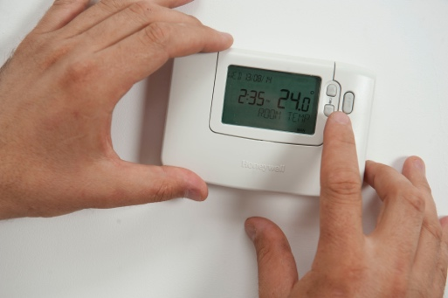
For the consumer, energy digitalisation enables you to better understand your energy usage through the use of digital technologies. You can find out more in our course Smart Devices and Digital Energy Technology. However, whilst real-time insights into energy usage might be helpful in some cases, if you are already checking your energy usage and bills regularly, using digital technologies for this purpose may need to be considered carefully.

In addition to insights into your energy usage, you may also want to look at different types of electricity tariff that support reduced cost electricity at off-peak times. See our course Energy Markets: Understanding Prices and Tariffs for more on how electricity markets work and different types of electricity contract.


Conclusion

Energy anxiety is caused by a range of factors that are largely out of our control. However, by talking to others, supporting each other and making use of digital technologies appropriately, we can potentially alleviate some of our concerns and take positive action to combat our energy related worries.

Additional Resources

- Read the End Fuel Poverty Coalition’s Rising energy debt creates mental health crisis for households.
- What to do if you’re struggling to pay your energy bills from Money Saving Expert provides UK focused advice, which may also be useful in other contexts. Similarly, within the UK context Energy Anxiety is on the rise, but you’re not alone offers advice and support.
- Read this article from Dissent on Germany, the impact of conflict in the Ukraine and Energy Anxiety.

Acknowledgements

Energy Anxiety was created by the Every1 project and is licensed CC BY-SA 4.0, unless otherwise stated.

Image attributions

Main course image: adjust thermostat by CORGI HomePlan is licensed CC BY 2.0.
Introduction: Our Daily Challenge: On the First by Sue Thompson is licensed CC BY-ND 2.0.
How do we define energy anxiety?: Worry by Icare Girard is licensed CC BY 2.0.
What can we do about energy anxiety?: School diversity many hands held together by Wonder woman0731 is licensed CC BY 2.0.
How can energy digitalisation reduce energy anxiety?: adjust thermostat by CORGI HomePlan is licensed CC BY 2.0.
Conclusion: Cup of tea by oatsy40 is licensed CC BY 2.0.

