Smart Devices and Digital Energy Technology

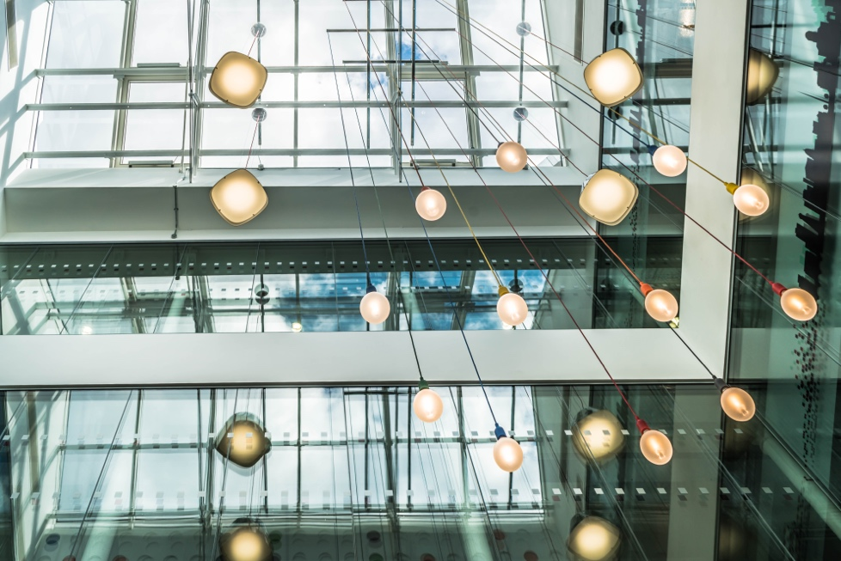

Smart Devices and Digital Energy Technology 1
How this course works 1
Learning outcomes 2
Introduction 4
Digital Meter or Smart Meter? 4
Features of smart appliances or smart devices 5
Smart meters in Europe 6
Conclusion 7
Additional Resources 7
Acknowledgements 7
Image Attributions 8

How this course works

This short, 30-minute course explains what smart devices are and how they support a better understanding of how and when we consume energy. Through a better understanding of our own energy use we can make informed decisions to reduce our energy use. This can save money and help reduce our environmental impact.

You might be:

- Looking to better understand how and when you are using energy at home.
- Considering ways to make your home more energy efficient and save money.
- Interested in new technologies, such as smart meters, and their role in the digital energy transition.

This course will deepen your understanding of the digital energy transition and support your own digital energy journey! It is part of the suite of 12 courses called Digital Energy Essentials, developed by the Every1 project, which aims to enable and empower everyone’s engagement in the energy transition. You can find out more about the project by going to: https://every1.energy

At the end of the course, we suggest some further learning materials for you to explore. This includes the course What is the Digital Energy Transition? which explores what digital energy is and the reasons behind moving towards digitalising our production and consumption of energy.

This is a translation of the original English language version of the course, which includes an opportunity to complete a short quiz and earn an Every1 digital badge.

This project has received funding from the European Union’s Horizon Programme for Research and Innovation (2021-2027) under grant agreement No 101075596. The sole responsibility for the content of this course lies with the Every1 project and does not necessarily reflect the opinion of the European Union.

Learning outcomes

After studying this short course, you should be able to:

- Name the main features of a smart device.
- Understand how different smart devices and digital energy technologies can help you make more informed choices about your energy use.
- Appreciate the role smart meters play in the digital energy transition.
- Understand the differences between digitisation and digitalisation.

Introduction

- Are you looking to better understand your energy use?
- Do you want to understand how you can make energy savings and efficiencies through smart technologies?
- Are you curious about the role of new technologies in the digital energy transition?

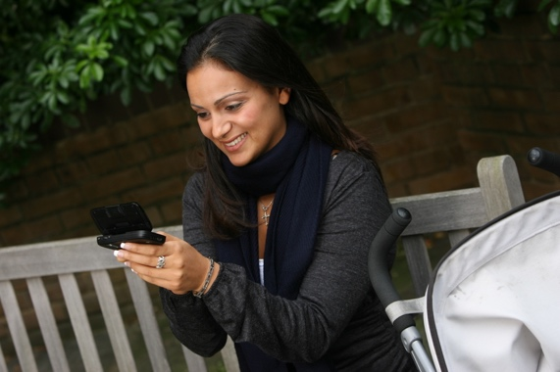
This course explores different types of smart devices and digital energy technologies.

As the way we produce and consume energy is increasingly digitalised, we take a deeper look at what the digitalisation of energy means for you, what digital technologies are available to help you better understand your energy consumption, make efficiencies and potentially save money.

We focus particularly on the difference between digital and smart meters and explore some of the benefits and challenges.

Finally, we look at the role smart devices and appliances, and in particular smart meters, play within the digital energy transition in Europe.

Digital Meter or Smart Meter?

Let’s take a closer look at how we monitor and record our energy consumption at home by comparing how a digital meter and smart meter work. Digital meters and smart meters have different purposes and functionality.

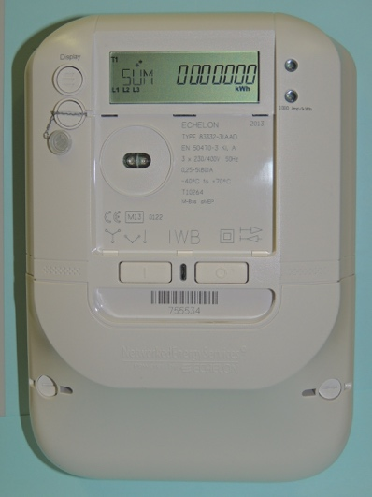
You might have a digital meter installed, which measures and displays your use of utilities such as electricity, water or gas. A digital meter is an example of digitisation. Some digital meters can store and transmit data for monitoring purposes, for example to transmit data to utility companies or a central display within the home.

Alternatively, you might have – or be considering installing - a smart meter which also records and displays your use of utilities, but also includes advanced features such as remote control, automation and connectivity features.

What makes this type of meter smart?

A smart meter can receive and send data to the utility provider, via wireless networks or power line communication. This means that a smart meter can provide remote readings, conduct software updates etc. without needing someone from the utility firm to visit your home.

Smart meters have cyber security measures in place to protect the data they transmit and receive, ensuring your privacy and system integrity.

You can see real-time information on your energy consumption and detailed reports on how you are using energy. A better understanding of your own energy consumption enables you to make more informed decisions about where efficiency savings could be made.

A smart meter can also enable you to utilise multiple tariffs, so you can be charged different rates at different times of the day or year. This can help support the use of off-peak energy, when there is less demand.

Smart meters also have further benefits for utility providers as each smart meter is connected to what is called a smart distribution grid. The information supplied by smart meters from homes and businesses enables a better understanding of how utilities are being used and supports demand response. Power outages can also be easily identified and fixed through constant monitoring of the electricity grid.

Smart appliances such as smart meters are an example of the digitalisation of energy.

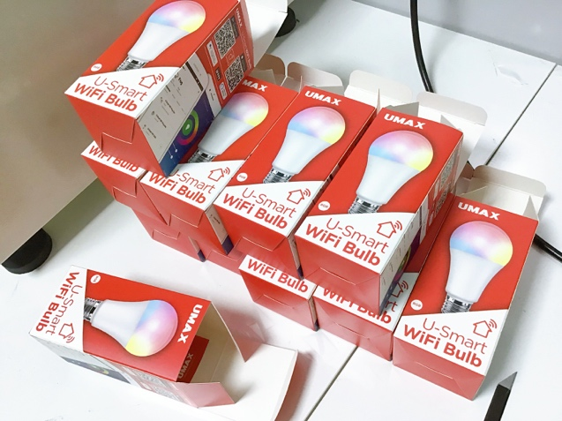
Features of smart appliances or smart devices

In addition to smart meters, there are many other different types of smart appliances that you could use in your home or at work.

Let’s take a closer look at four examples.

These four examples have been selected as they relate to activities in the home where we often use the most energy, and therefore could potentially make the most savings.

- Smart Thermostats: These devices can learn your heating and cooling preferences and adjust the temperature automatically. Smart thermostats can be controlled remotely and may help save on energy bills.
- Smart Ovens and Stoves: Cooking appliances that can be preheated remotely, follow programmed cooking modes, and sometimes integrate with recipes to adjust cooking times and temperatures automatically.
- Smart Lighting: LED bulbs and lighting systems that can be controlled via smartphone apps or voice commands, allowing you to change the colour and intensity of the light, and schedule when lights turn on and off.
- Smart Washers and Dryers: Laundry appliances that can be started remotely, send notifications when cycles are complete, and optimise cycles based on the load. They can also be scheduled to run during off-peak energy periods.

As highlighted in these examples, smart appliances offer advanced features, typically enabled by internet connectivity and sometimes artificial intelligence (AI).

In comparison with digital appliances, smart appliances can be controlled remotely (for example by using your smartphone) and you can also automate tasks. Smart appliances can also interact with you in a more intuitive way, for example by learning from how you use a particular device or by sending reminders or alerts directly to your smartphone.

As one smart appliance can also be connected and integrated with other smart devices, we can also connect multiple smart appliances to create what is known as a smart home.

Smart meters in Europe

Smart meters have an important role in the digital energy transition and potentially provide a range of benefits to both energy providers and consumers.

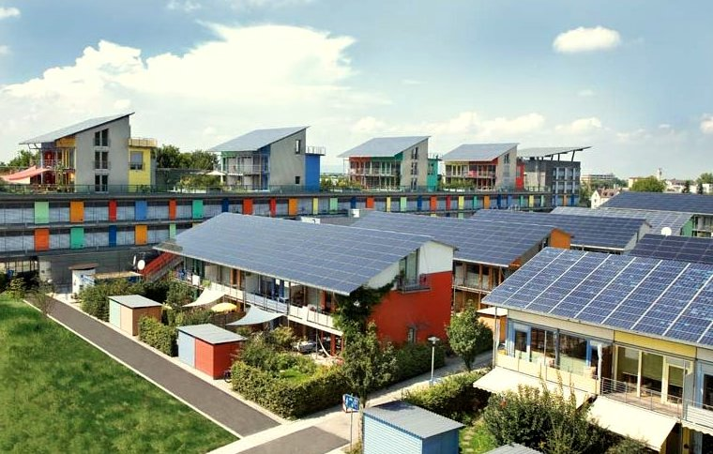
To support the use of smart meters, increase efficiencies and enable the seamless integration of energy from clean technologies such as solar panels or wind turbines, we also need the appropriate infrastructure or a smart grid or distribution system in place. This requires commitment, policy and funding at the national and regional levels.

As part of its commitment to the digital energy transition, the European Commission aimed to have 80% of electricity consumers using smart meters by 2020.

European countries such as Sweden and Spain have already achieved 100% digital meter installation, although uptake varies widely across the bloc. You can find out more about progress to date, and the approach of different countries, in this Power Technology article EU smart meter optimism dampened by slow uptake.

As this article notes, aside from the appetite of individual countries to champion their installation and despite Europe wide legislation to address concerns, challenges around data privacy, the potential of digital appliances to be hacked and digital appliance installation and longevity remain.

We will return to look in more depth at the issue of data privacy in our course Privacy, Safety and Security in the Digital Energy Landscape.

You can find out more about the importance of infrastructure, and the work required across the bloc, in this article from The European Commission Smart grids and meters.

You can also find out more about policies which are part of the European Green Deal and also support the move away from fossil fuels in this European Council article on Fit for 55.

Conclusion

Although challenges remain, smart devices and appliances, such as smart meters, have a key role to play in the digital energy transition.

Whilst smart meter roll-out in Europe continues, and different countries take different approaches to supporting households, a better understanding of our own energy consumption enables us to make changes and potentially save energy and money.

Smart technologies also support the integration of clean technologies and our move away from fossil fuels.

This course is part of the Digital Energy Essentials series.

You may want to explore our course What is the Digital Energy Transition? to find out more about what the digital energy transition is and how this transition is taking place.

Additional Resources

- Read more about the European Commission’s plans for energy digitalisation in Digitalisation of the energy system.
- Look at different countries smart meter take-up in Statista’s Share of household consumers equipped with a smart meter in Europe in 2022…
- Read the EU Science Hub’s Saving the environment and shifting to renewables drives new energy technologies development.

Acknowledgements

Smart devices and digital energy technology was created by the Every1 project and is licensed CC BY-SA 4.0, unless otherwise stated.

Image Attributions

Main course image: The grainstore opens at the digital hub… by William Murphy is licensed CC BY-SA 2.0.
Introduction: Woman using Windows Mobile device in park with child by gail is licensed CC BY-ND 2.0.
Digital Meter or Smart Meter?: Smart meter “Echelon” by Patrik Tschudin is licensed CC BY 2.0.
The features of smart appliances or smart devices: UMAX U-Smart WiFi Bulb by Jirka Matousek is licensed CC BY 2.0.
Smart meters in Europe: Clean energy at work for earthday! by naturalflow is licensed CC BY-SA 2.0.

