Electricity Markets: Understanding Prices and Tariffs

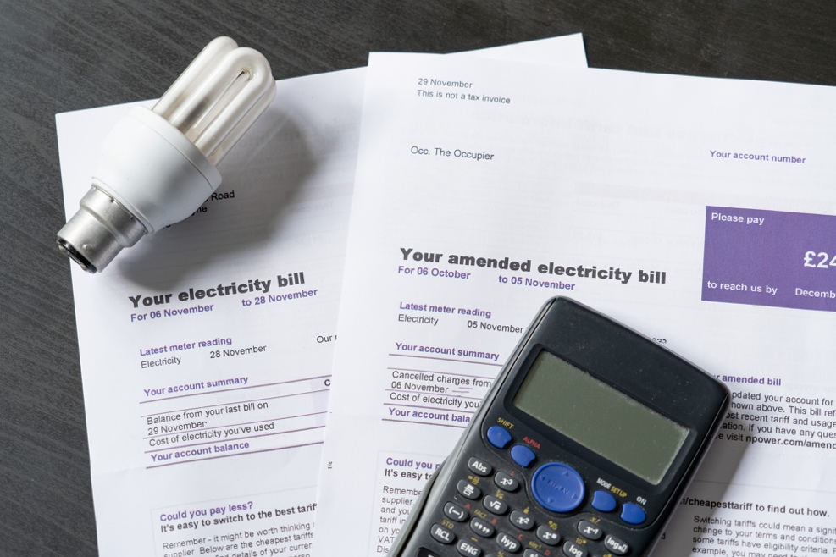

Electricity Markets: Understanding Prices and Tariffs 1
How this course works 1
Learning outcomes 2
Introduction 2
What factors influence electricity prices? 3
Your electricity contract 4
The role of digitalisation in electricity markets 5
Conclusion 5
Additional Resources 6
Acknowledgements 6
Image Attributions 6

How this course works

This short, 30-minute course explores some of the different factors impacting the price of electricity. The course also helps you understand the basics of how the electricity market work. You might be:

- Curious as to how electricity markets work and why the price of electricity fluctuates.
- Interested in how to reduce your energy consumption and saving costs.
- Excited to learn more about the role digitalisation plays in electricity markets.

This course will deepen your understanding of the digital energy transition and support your own digital energy journey! It is part of the suite of 12 courses called Digital Energy Essentials, developed by the Every1 project, which aims to enable and empower everyone’s engagement in the energy transition. You can find out more about the project by going to: https://every1.energy

At the end of the course, we suggest some further learning materials for you to explore. This includes the course What is the Digital Energy Transition? which explores what digital energy is and the reasons behind moving towards digitalising our production and consumption of energy.

This is a translation of the original English language version of the course, which includes an opportunity to complete a short quiz and earn an Every1 digital badge.

This project has received funding from the European Union’s Horizon Programme for Research and Innovation (2021-2027) under grant agreement No 101075596. The sole responsibility for the content of this course lies with the Every1 project and does not necessarily reflect the opinion of the European Union.

Learning outcomes

After studying this short course, you should be able to:

- Understand the fundamentals of how electricity markets work.
- Explain the main factors that impact on electricity costs.
- Be aware of different type of electricity contracts and their pros and cons.

Introduction

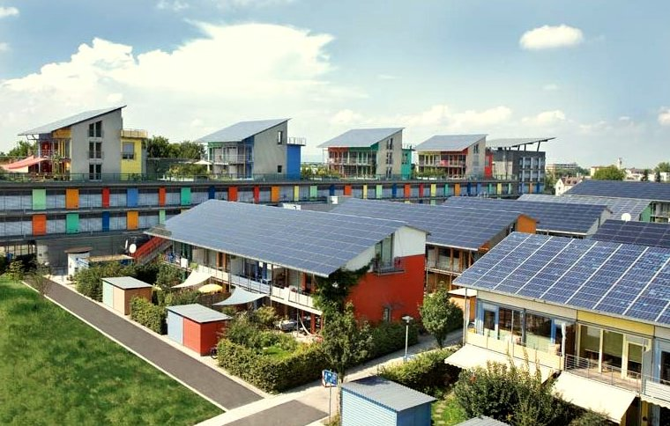
This course looks at what factors influence the cost of our energy, how electricity markets work and what you can do to reduce the cost of your energy bills.

Electricity comes from three primary energy sources: fossil fuels (coal, natural gas and oil), nuclear power and renewable energy sources (solar, wind, hydro and biomass).

As we move away from the use of fossil fuels for electricity generation, there is a growing emphasis on increasing the production from renewable and clean technologies (such as solar, wind and hydro). This will reduce our impact on the environment and achieve sustainability goals.

In 2022 renewable sources provided nearly 40% of the European Union’s electricity consumption, with around 40% of energy coming from fossil fuel sources and 20% from nuclear energy.

Increasing electricity production from clean technologies to decrease emissions is a key aspect of the digital energy transition and European policy.

You can find out more about how electricity is produced and consumed in our course Energy Use.

What factors influence electricity prices?

The price of your electricity is impacted by a range of factors, including demand from consumers, generation capacity and type of technology available, the weather, and availability of power transmission and distribution capacity, etc.

For example, the war in Ukraine led to a reduction in gas supply from Russia, which impacted on the availability and cost of gas, significantly raising the cost of gas-powered electricity, thereby raising overall electricity prices.

The power market is divided into wholesale and retail segments. The wholesale market focuses on bulk trading between energy producers and businesses that supply energy to your home, such as your electricity provider. The wholesale market is directly impacted by the global energy landscape and uses economies of scale and a range of financial tools to maximise profit through predicting retail market needs.

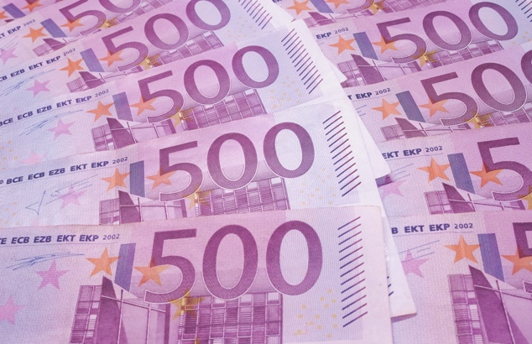
Policy making aims to protect consumers from volatility in the wholesale market.

Your electricity supplier, and other retailers, are an intermediary between you and the European wholesale market. Your electricity supplier ensures a reliable supply by purchasing electricity from wholesale markets. Retailers of electricity also include a variety of additional charges to consumers, to cover electricity transportation and distribution, metering and billing.

Taxes and levies vary by country and may fund renewable energy, energy efficiency, or other government programs.

Retailers manage billing, payment collection, and offer customer support.

They often also provide value-added services like energy efficiency and other sustainable energy practices advice, and renewable energy options, including advising on renewable systems such as rooftop solar panels.

Today, they also promote smart meter installation for real-time data enabling dynamic pricing, while their digital platforms help consumers monitor energy usage and manage accounts. They support prosumers (households that both consume and produce energy by, for example, having their own solar panels or wind turbine) by buying excess power generated and integrating this into the grid. In all these regards, retailers, however, must comply with national and EU regulations, ensuring consumer protection and pricing transparency.

As we will see in the next section, electricity suppliers offer various pricing plans to consumers, including fixed and variable rates, to attract and retain customers.

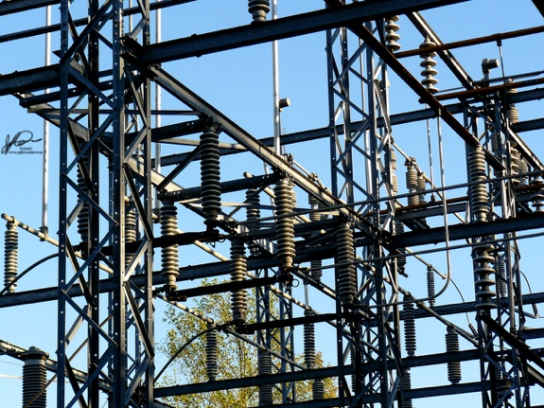
To manage price volatility, your electricity supplier will use strategies, such as advance purchasing energy based on data forecasting of consumer use. Europe’s energy markets enable customers to switch providers and choose the best suited energy provider.

Your electricity contract

There are lots of considerations when choosing an electricity contract.

Let’s take a closer look at some of the pros and cons of different types of common electricity contract:

- Fixed-rate contracts provide price stability and help with budgeting. They also protect you against market fluctuations but may lead to higher costs if market prices drop, and often involve long-term commitments. This type of contract offers stability and predictability in billing and are ideal for homeowners, retirees and small businesses.
- Variable-rate contracts are based on long-term (over months) market conditions. This type of contract offers flexibility and potential savings when market prices are low. However, there is little protection from price volatility, and this can result in budget challenges. You can manage your electricity usage, for example by using electricity during low-price periods. This type of contract may work well for renters or people with flexible lifestyles.
- Time-of-use contracts offer incentives for energy conservation, with different rates based on the time of day. This type of contract can lead to cost savings but require behaviour changes (such as running or charging appliances during low-cost periods e.g. at nights or weekends) and may be complex to manage. These contracts are best for eco-conscious households and businesses willing to adjust their energy usage for lower off-peak rates.
- Real-time pricing contracts change continuously or frequently in response to market conditions such as electricity demand and supply, weather or other events. Prices are typically declared the day before, in hourly segments.

To help you choose the best electricity tariff for your needs, you should consider your energy consumption patterns, appetite for risk and, if you are considering a flexible contract, whether you could afford any future rapid increase in the cost of energy.

The role of digitalisation in electricity markets

Digitalisation enables us to better understand and manage our energy consumption so that we can take advantage of off-peak rates.

Examples of digitalisation include:

- The use of digital platforms and comparison tools for easy offer comparison, online account management, and automated notifications.
- The provision of dynamic-pricing data, which provides information on when energy demand is lower. This information enables those on variable-rate contracts make informed decisions.
- Smart meters that enable real-time usage tracking.
- Digital platforms facilitate demand response programs and allow consumers with dynamic pricing contracts to use smart home integration, smart technologies and apps for real-time monitoring and cost optimisation.

Digitalisation enhances transparency and flexibility, providing information to support better decision making and cost optimisation for all contract types.

You can find out more about smart technologies that can support your energy usage in Smart Devices and Digital Energy Technology.

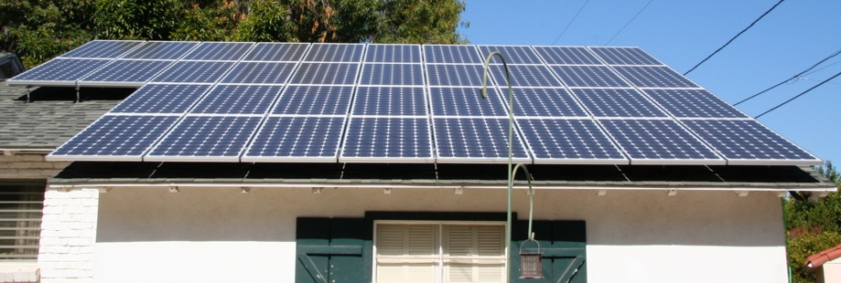
Conclusion

There are a range of factors to consider when choosing your electricity contract, and when and how you make use of electricity at home or work.

The digitalisation of energy has a critical role to play in supporting informed decision making for energy providers and suppliers, as well as consumers.

In Electricity Markets: Demand Response we take a closer look at our role in the electricity market and how demand response is enabled by digitalisation. We look at how digitalisation enables consumers and electricity providers to make informed decisions and integrate clean technologies into the grid.

Additional Resources

- Read the news article from the European Commission on Protecting and empowering energy consumers: https://energy.ec.europa.eu/news/focus-protecting-and-empowering-energy-consumers-2024-06-18_en
- Read the news article in the UK’s The Guardian newspaper Is Europe’s energy crisis over? Falling gas prices conceal wider problems https://www.theguardian.com/business/2024/apr/04/is-europes-energy-crisis-over-falling-gas-prices-conceal-wider-problems
- Find out more about Europe’s energy mix in this article from the European Union How is EU electricity produced and sold? https://www.consilium.europa.eu/en/infographics/how-is-eu-electricity-produced-and-sold/#:~:text=In%202022%2C%2039.4%25%20of%20electricity,Coal%3A%2015.8%25

Acknowledgements

Electricity Markets: understanding prices and tariffs was created by the Every1 Project and licensed CC BY-SA 4.0, unless otherwise stated.

Image Attributions

Main course image: Electricity bills with lightbulb and calculator by USwitch.com Images is licensed CC BY 2.0.
Introduction: Clean energy at work for earthday! by naturalflow is licensed CC BY-SA 2.0.
What factors influence electricity prices?: 500 euros by Peter Linke is Public Domain.
Your electricity contract: Power grid by Jefferson Davis is licensed CC BY-ND 2.0.
Conclusion: Solar panels all done! by Mike Spasof is licensed CC BY 2.0.

