Electricity Markets: Demand Response

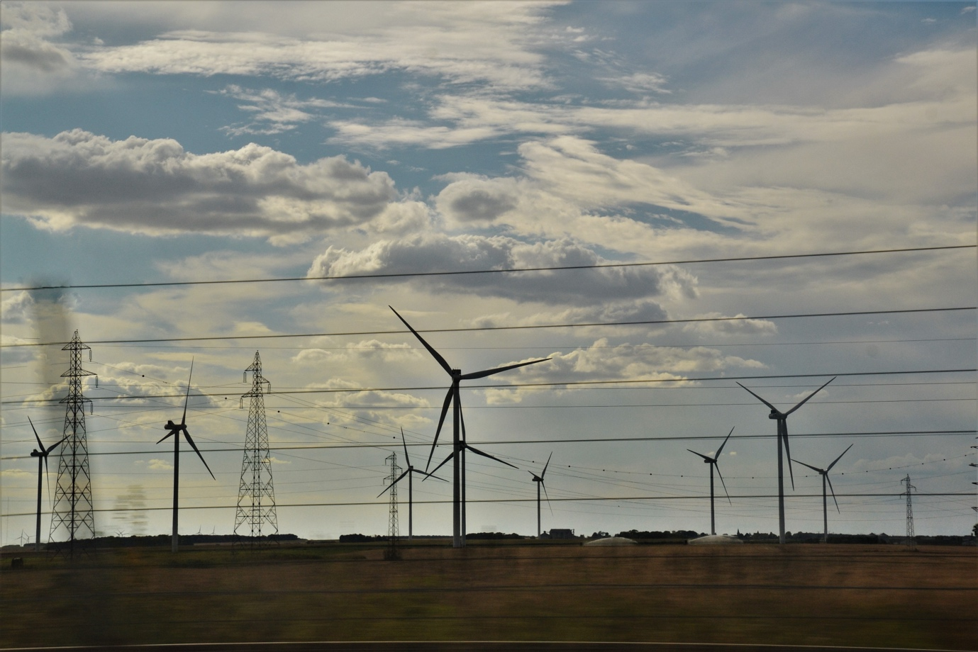

Electricity Markets: Demand Response 1
How this course works 1
Learning outcomes 2
Introduction 4
What is Demand Response? 4
Why demand response? 5
Some examples of demand response 6
Conclusion 7
Additional Resources 7
Acknowledgements 7
Image Attributions 7

How this course works

This short, 30-minute course introduces demand response and how using energy at specific times can save money. The course also explores how digitalisation enables us to work with our energy suppliers to support efficient electricity generation and transmission.

This course complements Electricity Markets: Understanding prices and tariffs and takes a deeper look at our role in the electricity market and how digitalisation enables consumers and electricity providers to make informed decisions.

You might be:

- Wanting to make the most of digital technologies to help you take advantage of reduced price or incentivised energy.
- Interested in the digital energy transition and how this can benefit energy suppliers and consumers.
- Curious as to how electricity providers manage fluctuations in energy use.

This course will deepen your understanding of the digital energy transition and support your own digital energy journey! It is part of the suite of 12 courses called Digital Energy Essentials, developed by the Every1 project, which aims to enable and empower everyone’s engagement in the energy transition. You can find out more about the project by going to: https://every1.energy

At the end of the course, we suggest some further learning materials for you to explore. This includes the course What is the Digital Energy Transition? which explores what digital energy is and the reasons behind moving towards digitalising our production and consumption of energy.

This is a translation of the original English language version of the course, which includes an opportunity to complete a short quiz and earn an Every1 digital badge.

This project has received funding from the European Union’s Horizon Programme for Research and Innovation (2021-2027) under grant agreement No 101075596. The sole responsibility for the content of this course lies with the Every1 project and does not necessarily reflect the opinion of the European Union.

Learning outcomes

After studying this short course, you should be able to:

- Understand what demand response is and why it’s important.
- Describe the relationship between demand response and digitalisation.
- Be aware of the different ways demand response can reduce your energy use and help save you money.

Introduction

When lots of people use energy at specific times of the day, ensuring that our electricity supply is constant, reliable, and uninterrupted is of critical importance.

Understanding when we are more likely to be using more electricity is therefore of key importance for energy suppliers. Households often use more energy when people return home from work, or when large numbers of people are using similar appliances at the same time.

In the UK, a well-known example of this was the spike in electricity use during television advertising breaks. When large numbers of people were watching a particular programme (e.g. an international football game or popular series or drama), many households would boil water for tea or coffee simultaneously during the commercial breaks.

This intermittent increased pressure on the electricity grid, albeit for a short period, as hundreds of thousands of people made a hot drink, is known as TV pick-up. You can read more about this phenomenon in 9 of the biggest TV moments in electricity history.

Can you think of other examples of when a lot of people increase their energy use or use the same type of appliance simultaneously?

Conversely, whilst electricity suppliers need to predict and manage our use of energy, as we move away from fossil fuels to clean technologies, they also need to support the integration of excess energy generated from household solar panels and wind turbines.

With households becoming energy providers too, how can electricity grid operators and suppliers manage this additional energy effectively?

Digitalisation of the energy sector enables us all to better understand how and when we are using energy, and to manage this more efficiently. This can result in cost savings and supports grid stability for electricity suppliers and operators. Let’s take a closer look at how this works in practice.

What is Demand Response?

Demand response is one way electricity companies can manage consumer energy use and provide opportunities for lower cost energy during periods of reduced demand.

Demand response is voluntary and enables you to choose when to reduce or increase your energy use, for financial incentives.
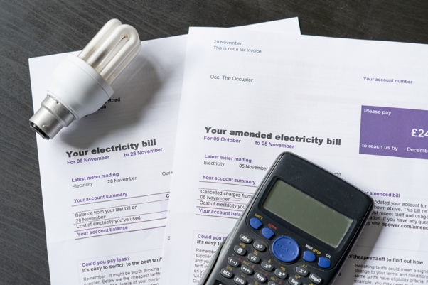
Digitalisation supports this process by sharing real-time information from your electricity supplier about when you could use energy for a reduced cost or another incentive.

Smart appliances and apps enable us to respond to these opportunities by allowing us, or third parties, to programme our smart appliances to turn on/off at specific times.

Digital appliances have a critical role in demand response as these enable us to use real-time information and make immediate adjustments to our own electricity consumption (e.g. choosing to reschedule our laundry cycle to an off-peak, and less costly, time). Smart appliances and apps, including smart meters also enable electricity companies to better understand how and when electricity is being consumed and to plan for times of peak use.

Why demand response?

By using energy during periods where there is less demand, we are contributing to the effective management of the electricity grid. Demand for energy is increasing, and regardless of whether that energy comes from fossil fuels or clean technologies such as solar and wind, we need the infrastructure to support that increased usage.

Investing in essential infrastructure takes time and money. Whilst these upgrades are happening, demand response is one solution to support this increased demand.

Demand response ensures a stable and efficient electricity supply by reducing or shifting energy use during peak times. This helps prevent blackouts, can reduce energy costs, and supports the integration of renewable energy sources.

As a consumer you might benefit from demand response by saving money on your electricity bills through incentives and lower rates for off-peak usage.

As well as improving the reliability of the power grid, you are also supporting environmental sustainability by reducing the need for additional power plants and enabling the grid to better integrate surplus energy produced by household clean technologies, such as solar panels.

Some examples of demand response

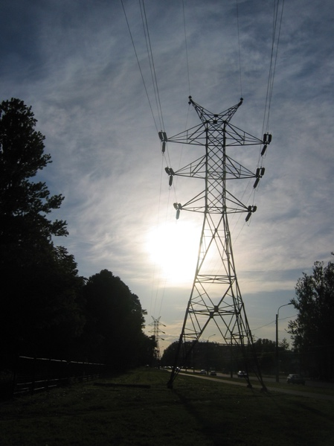
If you’ve worked through the course Electricity Markets: Understanding Prices and Tariffs, or have looked at different electricity provider offers, you will have probably seen that some of the electricity tariff examples (e.g. variable rate and time-of-use) offer opportunities for electricity users to modify their energy use and reduce energy costs.

The latest types of contracts offer detailed insights into when energy is cheaper.

Digitalisation enables us to respond to these opportunities when there is a price signal or offer of cheaper energy.

If you use smart appliances and apps to monitor and control your energy use, there are several different ways you could adjust your energy use and potentially save money.

These opportunities include:

- Making ongoing decisions about when to make changes to your energy use. For example, your smartphone app informs you that there is a low-cost energy period at a particular time, and you to choose to change your washing machine cycle to run, or your electric car to charge, during these hours.
- Having pre-agreed preferences for when and how you use energy. These preferences are shared with a third party, which facilitates your use of electricity and can control your smart devices as needed, to help you get the best from what your electricity supplier is offering.
By agreeing how and what smart devices a third party can control remotely, you don’t have to make constant decisions about how and when to use energy. This means that your electric vehicle could automatically charge at times when energy is cheaper, as it’s pre-programmed or re-programmed to take advantage of this opportunity.

Both above examples can be achieved through demand response. There are two categories of demand response:

- Implicit or price-based demand response: when you choose to use electricity during low-demand periods and subsequently lower your energy costs.
- Explicit demand response: when you receive payments from your electricity supplier to change your energy use. This can involve using less or more energy when required.

Demand response contributes to ensuring that our electricity supply is stable and that the energy that is being used, and generated, is well matched. It means that when we switch on the lights, boil a kettle or turn on a fan, even if hundreds of thousands of people are doing the same simultaneously, our electricity supply is constant and continual.

Conclusion

Energy digitalisation has a critical role to play in enabling energy producers and consumers manage how and when energy is being used.

Demand response provides opportunities for us to make the most of lower cost, lower energy use periods.

Additional benefits of demand response include a more stable electricity grid, environmental benefits and the ability to integrate excess energy produced by household clean technologies such as solar panels and wind turbines.

Additional Resources

- Want to take a deep dive on demand response? Read Everything you always wanted to know about Demand Response: https://cdn.eurelectric.org/media/1940/demand-response-brochure-11-05-final-lr-2015-2501-0002-01-e-h-C783EC17.pdf
- Find out more about Demand Response in this International Energy Association (IEA) article, which includes insights on how different countries and regions are supporting demand response in their energy digitalisation plans: https://www.iea.org/energy-system/energy-efficiency-and-demand/demand-response

Acknowledgements

Electricity Markets: Demand Response was created by the Every1 Project and licensed CC BY-SA 4.0, unless otherwise stated.

Image Attributions

Main course image: electricity by Jeanne Menjoulet is licensed CC BY 2.0.
Introduction: Giggly, smiling, surprised, 4 friends watching TV together, Wedgwood, Seattle, Washington, USA by Wonderland is licensed CC BY 2.0.
What is demand response?: Electricity bills with lightbulb and calculator by USwitch.com Images is licensed CC BY 2.0.
Why demand response?: Energy by Maria Eklind is licensed CC BY-SA 2.0.
Some examples of demand response: Pylon of a high-voltage transmission line by user:Yanachka is Public Domain.

