Modelling for Fossil Fuel Decommissioning: Fossil Fuel Retirement Model :

Hands-on Lecture 1: Downloading FFRM
Section Title |  | Contents
1. | Downloading FFRM from GitHub | Instructions for users to access and download the FFRM model
2. | Navigating FFRM’s Model Excel Input File | Overview of the purpose and function of each of the tabs within the FFRM model input file

Learning Objectives
By the end of this exercise, you will be able to:
- Download and access the FFRM Python model from GitHub
- Create a clean Python environment and install required packages
- Navigate the FFRM input file and understand the core purpose of each tab within the input model

Requirements
FFRM is a Python-based model. You will need:
- A supported Python version (recommended: 3.10+)
- Git (recommended) or the ability to download a ZIP from GitHub
- Excel installed (the workflow depends on Excel inputs/exports)
- A solver installed (as required by your modelling setup)

1. Downloading FFRM
- To download the FFRM model from GitHub, open your web browser and go to the FFRM Python repository on GitHub using the link here. You should see a GitHub repository page displaying the repository name, the list of files and folders, and a green Code button.
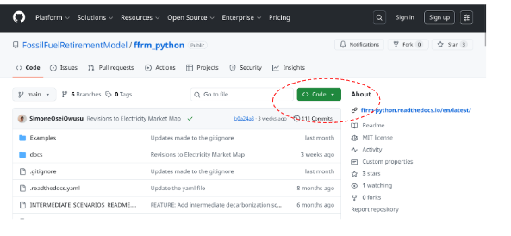
- To copy the repository URL, select the green Code button, ensure that HTTPS is selected, and then click the copy icon to copy the repository link.
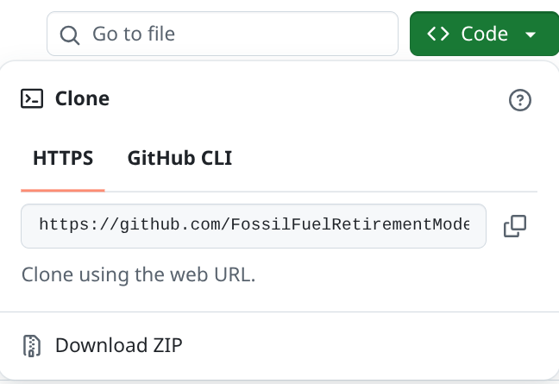
- To clone the repository to your computer, open a terminal (Command Prompt or PowerShell on Windows, or Terminal on macOS/Linux), navigate to the folder where you want to store the model (for example, Documents), and then run the following command.
Optional note for learners: If you do not have Git installed, you will need to install it before continuing. Instructions on how to install Git can be found here.
git clone https://github.com/FossilFuelRetirementModel/ffrm_python.git
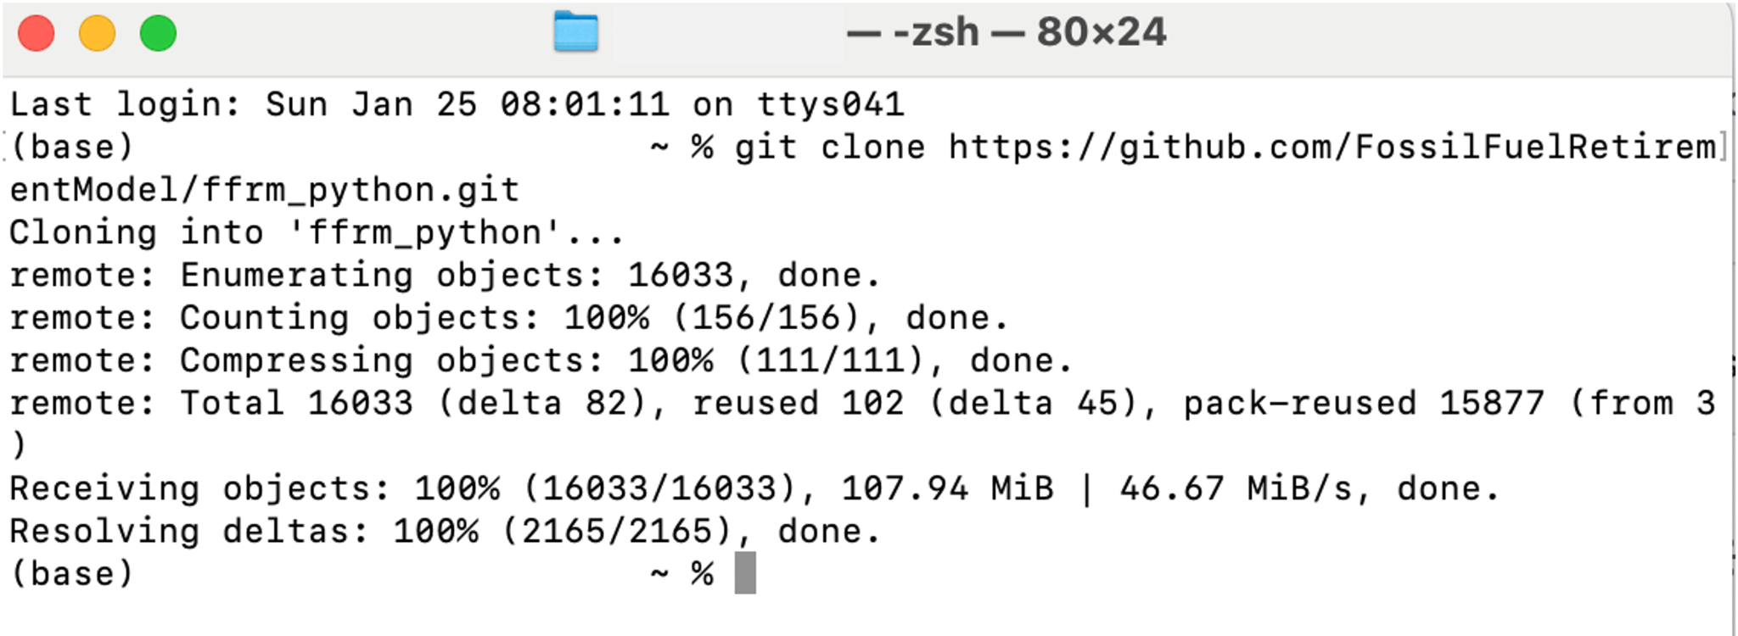
- To move to the FFRM folder, run the following command below:
cd ffrm_python
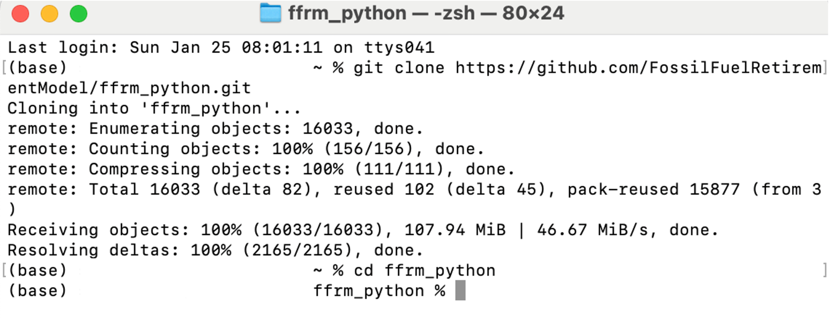

Confirm the download has worked, run ls on macOS/Linux or dir on Windows to list the files. The folder should contain key files such as README.md, requirements.txt and model.py as illustrated below.
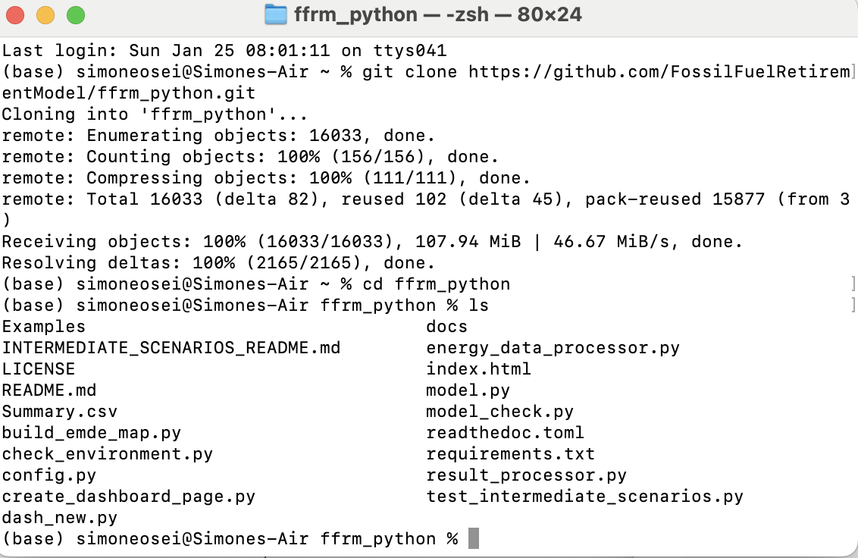

2. Create a clean Python environment and install required packages
You can find instructions for installing Python on Windows and macOS/Linux here found here for both a Windows and Linux/Mac environment. To avoid conflicts with other projects, set up a fresh virtual environment for FFRM and install the dependencies. Using the following commands, for On Linux/Mac, use as illustrated on the image below:
python -m venv venv
source venv/bin/activate
Or on Windows, use:
python -m venv venv
venv\Scripts\activate

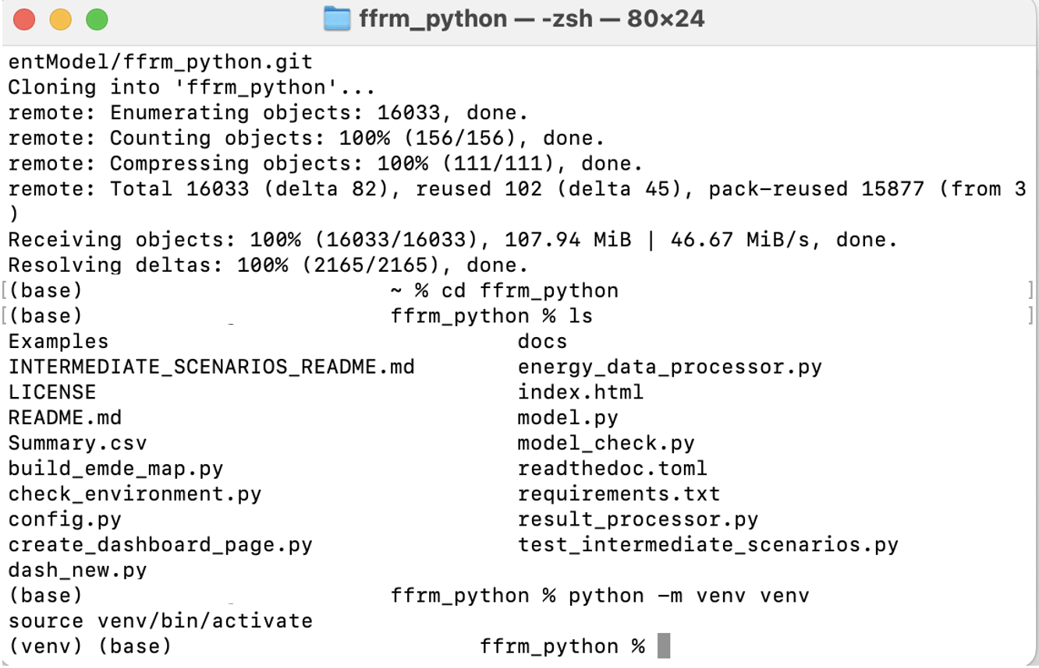
Once the virtual environment has been set up, to install the required packages to use model, please run the following command:
pip install -r requirements.txt

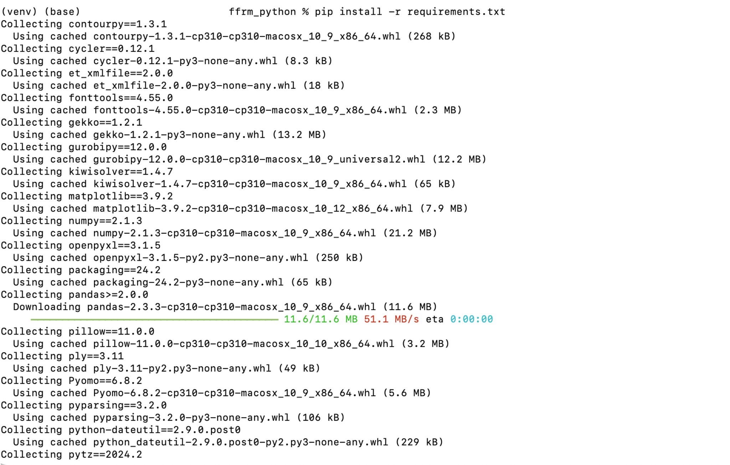
Once the required dependencies and packages have been set up, next you are required to install a solver to finalise the model set up. FFRM is compatible with two primary solvers, Gurobi and GLPK. Installations on how to install the solvers can be found using the following link here. Please note that the GLPK solver does not require a commercial or academic license.
Once your preferred solver has been installed, FFRM is now ready to be used.

3. Navigate the FFRM input file and understand the core purpose of each tab within the input model
To complement the FFRM Python model, FFRM uses an Excel input file. The first tab in FFRM, “Definitions”, provides an overview of definitions and a brief description of the model. The purpose of the sheet is twofold, firstly it serves to inform users about the meanings of the different inputs in FFRM, secondly this is where users will define the technologies and scenarios for the analysis.
The second tab in FFRM, “Other” is where variables that can be defined for different fossil fuel technologies are required to be defined. They primarily fall within three categories: financing assumptions such as interest rate, loan term and discount rate. Cost and escalation assumptions, such as capital expenditure per kW, cost escalation rates applied depending on the asset age and operational constraints, such as minimum and maximum plant load factor and the maximum technical plant lifespan.
The third tab in FFRM, “Plant Data,” contains plant-level inputs such as costs, capacity, and start year. It also includes market prices and PPA prices, depending on the applicable market regime.
The fourth tab in FFRM consists of “FC_PPA” consisting of data under PPAs reflecting fixed cost at 85% of the plant load factors, expressed in $/MW/year.
The fifth tab in FFRM consists of “Price_Gen” containing the projected electricity generation limits applied to each fossil fuel technology.
The sixth and final tab in FFRM consists of Price_Distribution, which shows the price schedule of the electricity prices for the market regime that break each year into types of hours, such as peak, shoulder and off-peak to reflect that electricity is not the same price all year, whereby some hours more expensive than others.

