Modelling for Fossil Fuel Decommissioning: Fossil Fuel Retirement Model :

Hands-on Lecture 2: Calibrating Technical and Economic Parameters within FFRM
Section Title |  | Contents
1. | Calibrating Technical Parameters | Instructions for users to provide data for the technical parameters for the model
2. | Calibrating Economic Parameters | Instructions for users to provide data for the technical parameters for the model

Learning Objectives
By the end of this exercise, you will be able to:
- Enter and validate the technical inputs required by FFRM (capacity, start year, plant load limits and lifetime).
- Enter and validate the economic and financial inputs required by FFRM (such as OPEX, CAPEX and if applicable discount rate, loan term and depreciation).
This hands-on exercise uses the Philippines as a case study, with a proxy dataset developed from publicly available sources. Because data transparency can be limited in EMDEs, inputs and assumptions are simplified for learning purposes, and results should be treated as illustrative.
To begin calibrating the FFRM, you first need to identify which pricing regime(s) apply in your country. For the Philippines case study, we use a mix of PPA and Market regimes.
- Hand On Task: Open the FFRM Read the Docs documentation (link here) and navigate to the Electricity Structure Map. In the search bar, type Philippines. A pop-up box will appear showing the potential pricing regimes that exist within the country.

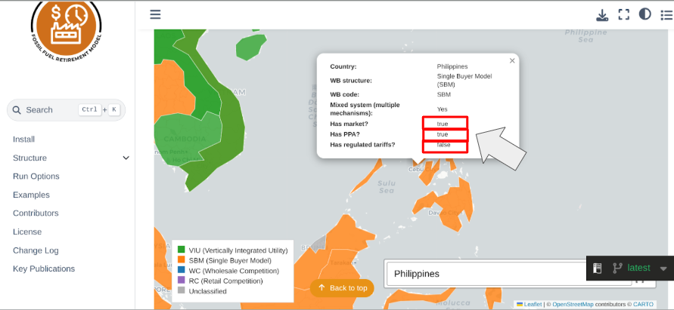
Based on the above, the electricity market structure map for the selected case study country the Philippines shows a hybrid design, combining both PPA-based and market-based regimes (as highlighted in the red box).
The next step is to identify the fossil fuel power plants operating there. Global Energy Monitor is a useful source for this exercise.

1. Calibrating Technical Parameters
When calibrating for technical inputs, you have to consider the fossil fuel plants physical and operational characteristics, which includes capacity, commissioning year and efficiency. These inputs in the model determine how much electricity each fossil fuel technology generates.

- Hands-On Task: Open Global Energy Monitor and click circled tabs, Global Coal Plant Tracker and Global Oil and Gas Plant Tracker.
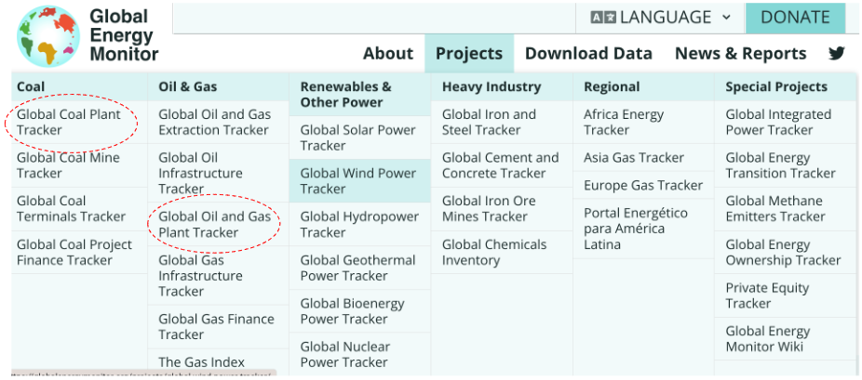

Once you click on the Global Coal Plant Tracker and the Global Oil and Gas Tracker (circled in red), scroll down to the Open the interactive map button
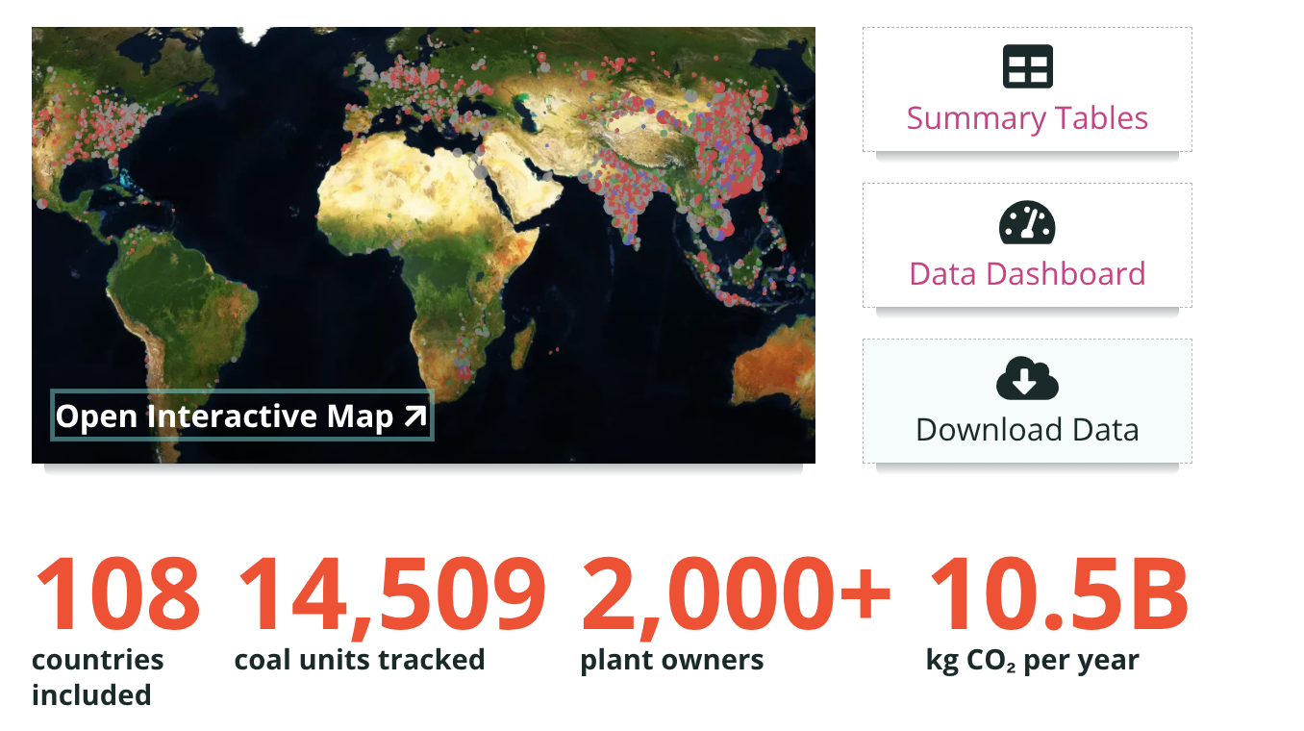

After opening the map, you can use the search bar to find your country of choice, which would be the Philippines in this case.
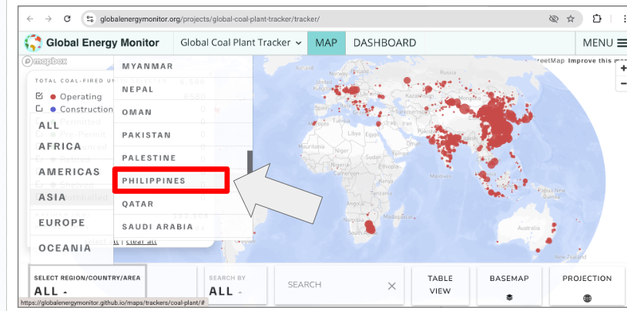

Please note under Total Coal Fired Units Selected, only select Operating, as this will only highlight existing powerplants.

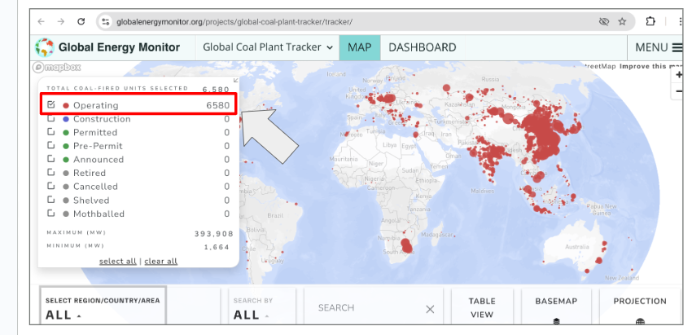

Once these options have been selected, you will see a list of operating powerplants within the region of choice, you also have the choice to display these plants as a summary table. In order to calibrate the technical parameters needed for FFRM, please copy and paste the following circled entries:
- Plant Name (you can also document the unit if applicable)
- Capacity in MW
- Start Year

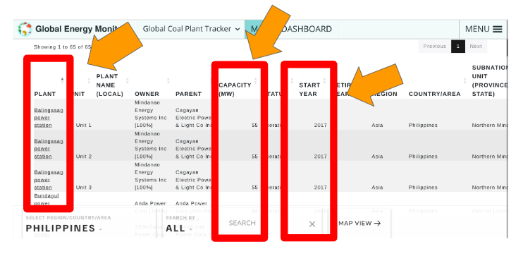

To assist with this process, a Philippines data collection file is available here. Use it for this hands-on exercise by copying and pasting the following three columns:
- Name of PowerPlant
- Capacity (MW)
- Start year
- Enter PWRCOA001 in the Plant Type column when referring to coal plants.
Note: The Philippines currently has 65 coal plants, so you will need to copy/paste all 65 rows into the Plant Data tab of the FFRM input file.
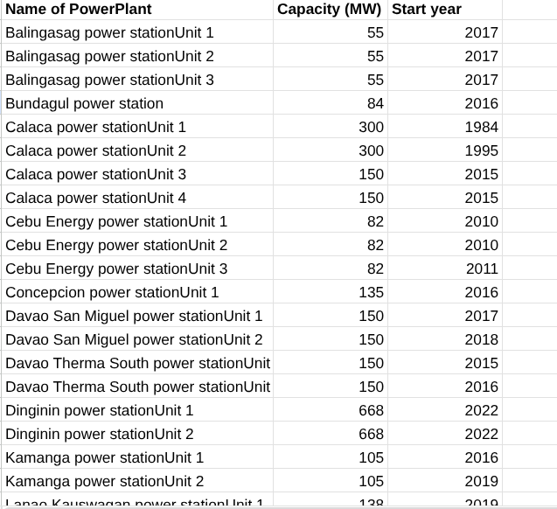
Once those entries have been copied, please add the following values to the corresponding column in the Plant Data tab. The Plant Data tab reflects Plant-level characteristics, such as capacity and commissioning (start) year of the fossil fuel powerplant.

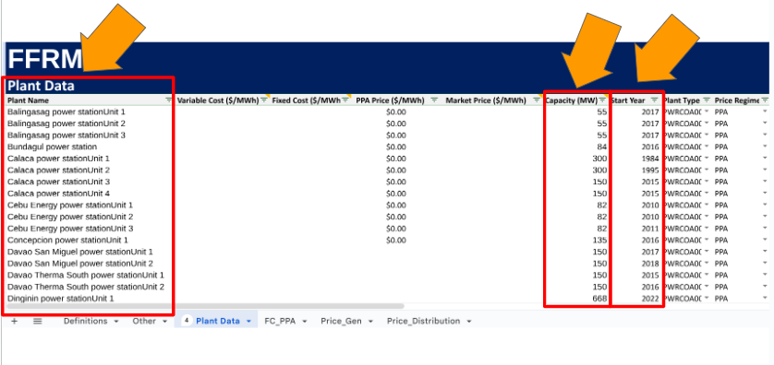

- Hands-On Task: Using the same process as in the Global Coal Tracker exercise (search, filter, and record the required fields). To assist with this process, a Philippines data collection file is available here. Use it for this hands-on exercise by copying and pasting the following three columns using the Gas Plant Tabs:
- Name of PowerPlant
- Capacity (MW)
- Start year
- Enter PWROHC001in the Plant Type column when referring to oil plants in the FFRM Input file Plant Data Tab.
Note: The Philippines currently has 24 oil fueled gas plants, so you will need to copy/paste all 24 rows into the Plant Data tab of the FFRM input file.
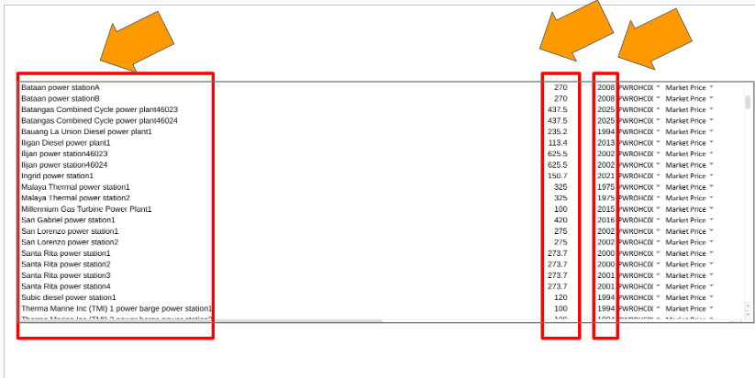
- Hands-On Task: In the Plant Data tab, update the cost assumptions using the CCG Starter Data Kit for your case study country (used for FFRM).
For example, for the Philippines, source Variable Cost, Fixed Cost, and where available PPA Price if publicly available from the relevant Climate Compatible Growth Starter Data Kit file using the following file found here for Fixed Cost and the following file here for Variable cost. Enter all values in FFRM using $/MWh.
Variable Cost ($/MWh) : Plant-specific variable costs (operations, maintenance, and fuel). The CCG Variable Costs data is expressed in GJ. The value is $/GJ of electricity output, then:
Using the Variable Cost Starter Data Kit file, filter Light Fuel Oil Imports, for this exercise we use 2025 Light Fuel Oil Import value. Using the equation, convert $16.49/GJ in $/MWh as illustrated below.
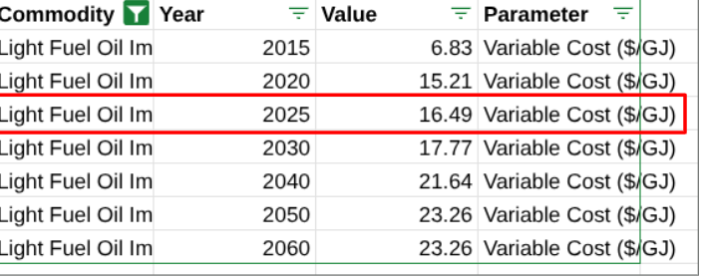
Variable Cost ($/MWh) = Variable Cost ($/GJ) × 3.6.
59.364 = 16.49 x 3.6
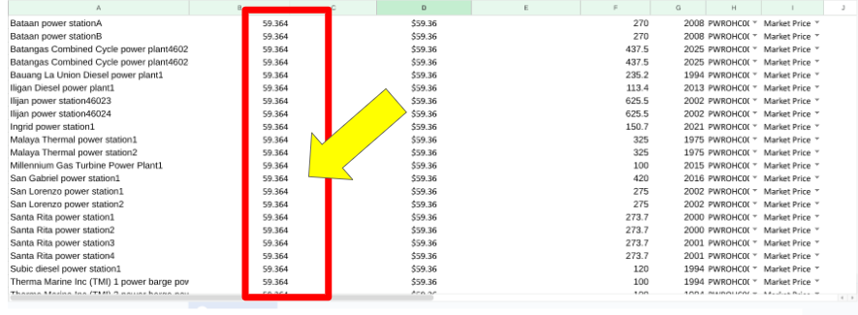
Using the Variable Cost Starter Data Kit file, filter Coal Imports, for this exercise we use 2025 Coal Imports value. Using the equation, convert $3.09/GJ in $/MWh as illustrated below and paste value 11.124 into the Variable Cost column in the Plant Data Tab.
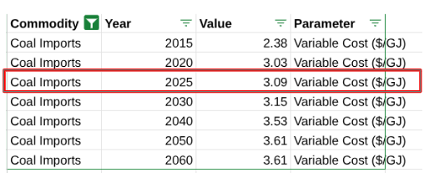
Variable Cost ($/MWh) = Variable Cost ($/GJ) × 3.6.
11.124 = 3.09 x 3.6
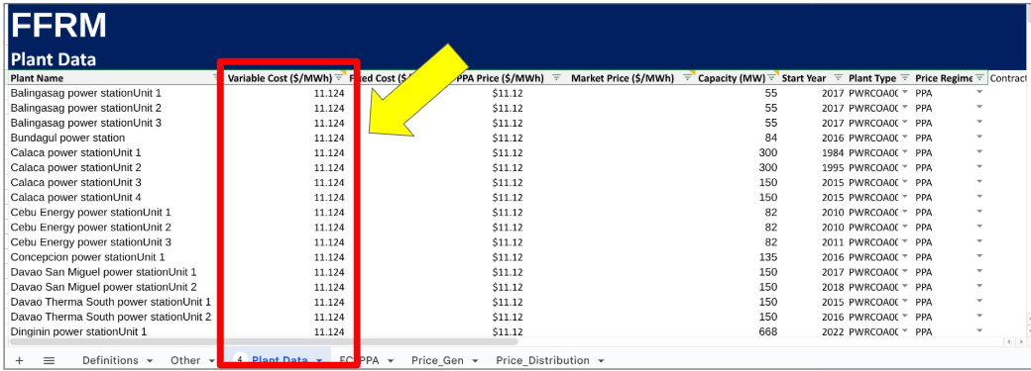
- Fixed Cost (convert from $/kW to $/MWh): The Starter Data Kit reports fixed costs in $/kW. Convert this to $/MWh before entering it in FFRM using the plant’s capacity factor.
Using the Fixed Costs Starter Data Kit file, filter Coal Power Plant, for this exercise we use the Fixed Cost Value of $52kW per year and the Average Capacity Factor of 0.75. Using the equation, convert $52kW per year in $/MWh as illustrated below and paste value 7.914 into the Variable Cost column in the Plant Data Tab.

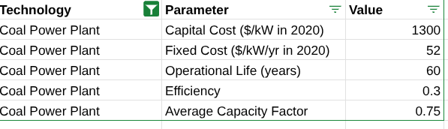
Fixed Cost ($/MWh) = Fixed Cost ($/kW-year) ÷ (8.76 × Capacity Factor)
7.914= 52 ÷ (8.76 x 0.75)
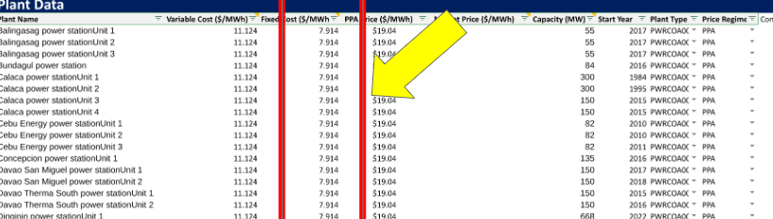
- PPA Price ($/MWh): If a PPA price cannot be sourced, estimate PPA Price ($/MWh) = Variable Cost ($/MWh) + Fixed Cost ($/MWh). This is represented as a formula in the input file where the calculation

Using proxy values where data are not publicly available
For the parameters below, proxy values will be used when plant-specific or publicly available data cannot be sourced. These fields will already be populated in your FFRM input file for this exercise. The definitions below explain what each parameter represents.
- Market Price: This column needs to be populated for the market regime. The market price is defined as the wholesale electricity price the plant actually receives when it sells output into the market. We can use Dual Values (shadow prices) sourced from capacity expansion models like OSeMOSYS if this information isn’t available open source.

- Price Regime: This column specifies whether fossil fuel technology is contracted under which regime. This can either be the PPA, market or cost of service regime.
- Contracted Price: This refers to a capacity payment, which unit of measurement is USD per MW. This can be applied to any regime and appears as a separate revenue stream from the energy price. If data is not publicly available, this column should be zero.

Within the ‘Other’ Data Tab, the following data is organised by Variable, Technology and Value. Inputs related to technical parameters relate to the following.

- Plant Load Factor: the share of a plant’s maximum possible output that it actually generates over a period. Within the input file, you can specify the maximum plant load factor (MaxPLF) and minimum plant load factor (MinPLF) as illustrated below.
- Max Life: The maximum operating lifetime assumed for the plant after it is commissioned.
- MinCapacity: this refers to the minimum installed capacity a plant must have to be eligible to be included in the analysis. Units below this threshold are excluded.

2. Calibrating Economic Parameters
When calibrating economic inputs, you have to consider fossil fuel plants’ financial characteristics, including fixed costs, variable costs, and discount rates. These inputs also influence generation decisions under FFRM’s profit-maximisation framework.

Please note because plant-level financial data (e.g., loan terms, interest rates, depreciation schedules) is often not publicly available especially in EMDE contexts. This exercise uses simplified proxy assumptions where needed. When a value is not available for the Philippines case study, use the proxy value provided below and note it as an assumption.

- Hands-On Task: Enter the proxy values below into the Other tab, matching each variable to the correct technology code

This relates to the following variables in the ‘Other’ Tab:
- Interest: In a scenario, where fossil fuel technology is financed using a loan. The interest represents the percentage rate charged on the outstanding loan principal. This is expressed as a percentage and is applied on an annual basis.
- Loan Term: This represents the number of years from loan start to final scheduled repayment.
- Discount Rate: The annual rate used to convert future costs or revenues into today’s value (present value). This is expressed as a percentage.
- Straight line depreciation: A fixed percentage of the asset’s initial cost is depreciated each year, whereby the same rate is applied every year over the modelling period.

Escalation rates are also applied to the increase in cost each year as the asset ages. This is segmented into three main categories:
- CostEsc_Lessthan10: Annual cost escalation rate applied to assets with age < 10 years.
- CostEsc_10-30years: Annual cost escalation rate for assets aged 10–30 years.
- CostEsc_30+: Annual cost escalation rate for assets aged > 30 years.

