Modelling for Fossil Fuel Decommissioning: Fossil Fuel Retirement Model :

Hands-on Lecture 3: Pricing Assumptions within FFRM
Section Title |  | Contents
1. | Calibrating PPA Regime | Instructions for users to provide data to reflect a PPA regime
2. | Calibrating Market Regime | Instructions for users to provide data to reflect a Market Regime

Learning Objectives
By the end of this exercise, you will be able to:
- Identify the key inputs that define the PPA and the Market regime
- Determine where the relevant corresponding inputs are entered in the FFRM input file to represent each regime.

1. Calibrating PPA Regime
To calibrate FFRM for the PPA regime, you will update two tabs: Plant Data and FC_PPA. In this hands-on, you will apply the PPA regime to the Philippines proxy plants identified in Hands-on Exercise 2.
Building a case study from scratch:
Plant-level contract information is not consistently available in public sources. In many countries, PPAs are commercially confidential, and only partial details may be disclosed through regulators, utilities, or investor documents.
For this hands-on exercise we use a proxy classification (PPA vs Market), which can be found here. When developing a new country case study, you would typically:
(i) identify the market structure;
(ii) classify plants using the best available evidence (e.g., regulatory approvals/filings, utility procurement documents, annual reports); and
(iii) document any assumptions where contract details cannot be verified.
Hands-On Task: In the Plant Data tab, identify the Philippines proxy plants assigned to PPA and ensure that the following fields have been completed:
- Plant Name: The name of the power plant.
- Variable Cost: Plant-specific variable costs (operational, maintenance, and fuel costs) in $/MWh.
- Fixed Costs: Plant-specific fixed costs in $/MWh.
- PPA Price: This is the PPA price expressed in $/MWh for the electricity sold. If a PPA price cannot be sourced, PPA costs can be proxied by summing Variable Cost + Fixed Cost.
- Price Regime: This column specifies the commercial regime for the plant. For the PPA plants in the Philippines proxy dataset, select PPA.
These plant-level fields were entered in Hands-on Exercise 2. To build upon this, you now need to update the FC_PPA tab. Alongside the Plant Data tab, the FC_PPA tab needs to be populated to reflect the PPA regime. The FC_PPA tab is calibrated based on the data collected from the Plant Data tab:
Hands-On Task: Hands-On Task (FC_PPA): Open the FC_PPA tab and enter values in $/MW/year for each plant assigned to PPA (from the Plant Data tab) for the years the PPA is active. If a fixed capacity payment is not available, calculate a proxy fixed payment using the 85% PLF benchmark:
FC_PPA ($/MW/year) = PPA Price ($/MWh) × 0.85 × 8,760
Please note, FC_PPA active years = years when (PPA is active) AND (plant is still operating/available).

- The values represent the PPA fixed cost at 85% of the plant load factor (PLF), expressed in $/MW/year.
- 85% PLF is a standard benchmark.
- Plants decide operation and retirement based on profits. Given that a PPA has a fixed availability component, it needs to be represented as a fixed annual $/MW stream.
- Values should be displayed for the years during which the PPA is still active.
- FC_PPA is the fixed yearly payment part of a PPA, written in a standard unit: $/MW/year (per MW of capacity, per year).
- In a PPA, a power plant often gets paid even if it doesn’t run much, as long as it is available.
- Because FFRM is profit-maximising, in the PPA regime revenue is reflected as a fixed payment plus any energy-related payment.

2. Calibrating Market Regime
As previously mentioned in Hands-on Exercise 2, you will use the Plant Data tab to represent plants operating under the Market regime.
Hands-On Task (Plant Data – Market plants): In the Plant Data tab, identify the Philippines proxy plants assigned to the Market regime and ensure the following fields are completed:
- Plant Name: The name of the power plant.
- Market Price (Average): The wholesale electricity price the plant receives when it sells output into the market. For this hands-on, use the Philippines proxy Market Price values provided in the course dataset. If building a new case study from scratch, you may use wholesale market prices or proxy values such as shadow prices/dual values from capacity expansion models (e.g., OSeMOSYS) where open-source market price data is not available.
- Price Regime: This column specifies the commercial regime for the plant. For the Market plants in the Philippines proxy dataset, select Market.
Alongside the Plant Data tab, the Price Distribution tab is used to reflect the Market regime. This sheet “splits” one yearly average electricity price into a set of price blocks (e.g., peak and off-peak). FFRM uses these blocks to reflect that plants earn more during peak-price hours and less off-peak.
Hands-On Task (Price Distribution): Open the Price Distribution tab and enter the Philippines proxy multipliers provided in the course dataset for each price block (e.g., peak/off-peak). These multipliers are applied to the annual average Market Price to compute block prices.
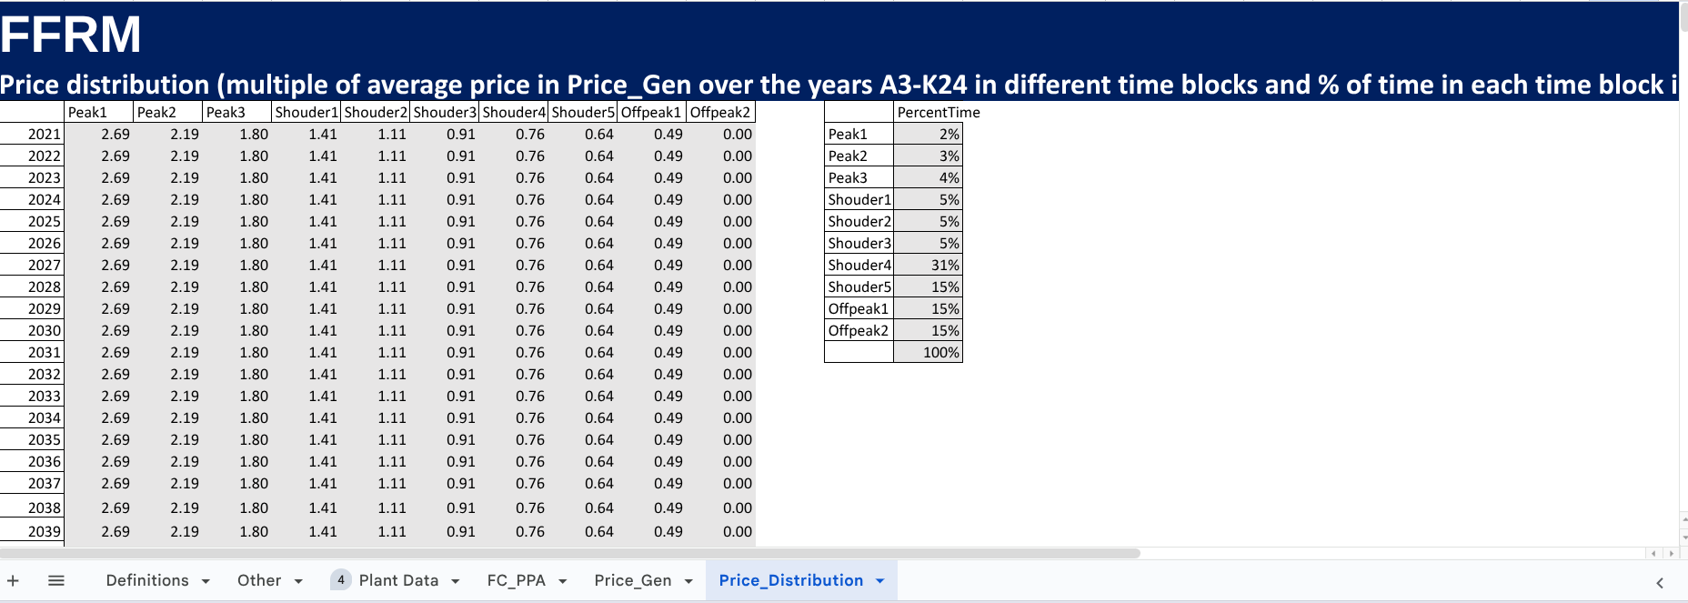

- To determine price distribution when developing a new case study from scratch, use each country’s hourly price data to calculate the average price within each time block, then express each block as a multiple of the annual average price:
multiplier = (average block price) ÷ (annual average price).

