Energy Use

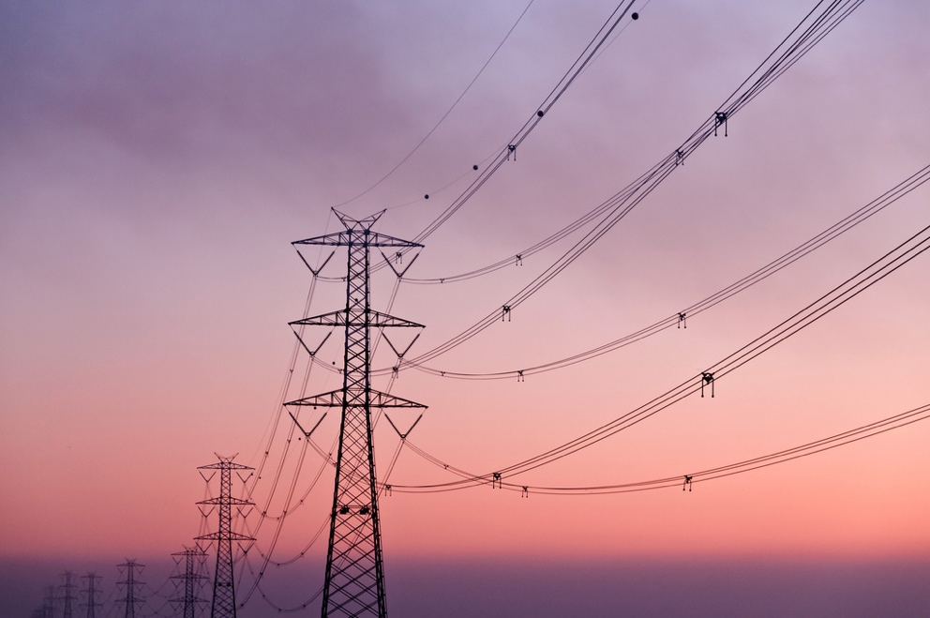

Energy Use 1
How this course works 1
Learning outcomes 2
Introduction 2
Energy creation and consumption 3
A closer look at how we use energy at home 4
How to save energy 5
Conclusion 7
Additional Resources 7
Acknowledgements 8
Image Attributions 8

How this course works

This short, 30-minute course explores different ways energy is used and helps you to identify and understand your own energy consumption patterns. The course also shares some ideas for how you can reduce your energy consumption.

You might be:

- Interested in better understanding how energy is produced and consumed.
- Thinking about how to save money by reducing your energy consumption.
- Curious as to what the digitalisation of energy really means.

This course will deepen your understanding of the digital energy transition and support your own digital energy journey! It is part of the suite of 12 courses called Digital Energy Essentials, developed by the Every1 project, which aims to enable and empower everyone’s engagement in the energy transition. You can find out more about the project by going to: https://every1.energy

At the end of the course, we suggest some further learning materials for you to explore. This includes the course What is the Digital Energy Transition? which explores what digital energy is and the reasons behind moving towards digitalising our production and consumption of energy.

This is a translation of the original English language version of the course, which includes an opportunity to complete a short quiz and earn an Every1 digital badge.

This project has received funding from the European Union’s Horizon Programme for Research and Innovation (2021-2027) under grant agreement No 101075596. The sole responsibility for the content of this course lies with the Every1 project and does not necessarily reflect the opinion of the European Union.

Learning outcomes

After studying this short course, you should be able to:

- Understand how energy is produced and consumed.
- Better understand your own energy consumption at home.
- Identify ways you could reduce your use of energy.

Introduction

Do you know where the energy you use comes from?

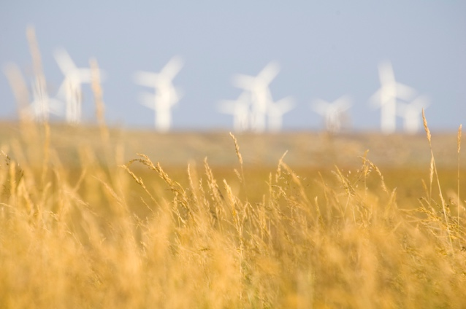
Understanding which sources of energy are used to produce the things we need and provide energy in the home or at work can help us to better understand the impact of the choices we make. Digital technologies support our understanding through providing detailed real-time insights into how and when we use energy.

This course takes a broader look at how we use energy: at the European level, country or regional level, and within our own households.

Europe’s energy sector has undergone profound changes following the Russia’s invasion of Ukraine. Since the war triggered an energy crisis that sent prices to record highs, European countries have put energy security at the top of their political agendas, dramatically reducing fuel imports from Russia on which they had previously relied.

European countries have substantially raised their clean energy ambitions, aiming to further diversify their energy mixes while making progress towards climate targets.

Energy security, which ensures that we have a diverse range of energy sources, whilst reducing our reliance on oil, gas and coal is therefore a critical part of the digital energy transition.

Energy creation and consumption

We use energy in different ways. We use energy to heat or cool buildings and to run lights, devices, and appliances.

We use energy to power vehicles such as cars, buses, boats or planes. Machines and factories also use energy.

However, have you ever thought about where your energy comes from and what types of energy were used to produce the energy or objects that you use? Let’s look at the journey of energy creation and consumption in more depth.

Fossil fuels such as coal, oil and natural gas can be burned to generate electricity and heat.

Renewable sources such as sunlight and wind can also be used to produce electricity. These energy sources are called primary energy, as they don’t need to be modified or processed before they are used in energy production.

Electricity is called secondary energy as it has been produced from primary energy sources. Primary energy sources, such as fossil fuels, are often transformed into more useful or practical forms before being used. For example, crude oil is refined into many different types of fuels and products.

Final energy is how energy is made available to us, as consumers, so that we can make use of it. For example, electricity is provided directly to our home from a power plant via a grid system.

Useful energy is the term used to describe the intended outcome of our energy use. For example, using energy sources such as electricity to power appliances or produce heat for cooking or warmth.

To help illustrate the journey from primary energy to useful energy, let’s take a closer look at some examples of how we produce and consume energy in this diagram The four ways of measuring energy.

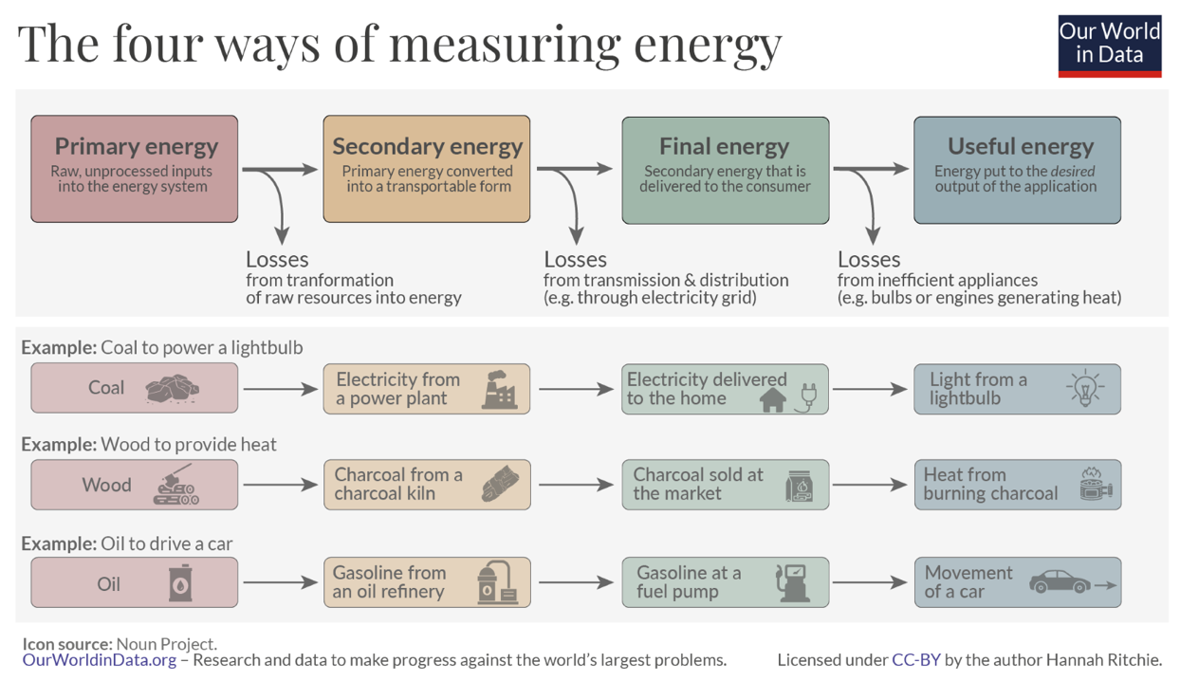
As you can see in the above diagram, at each stage energy is lost as it is transformed, transported or used.

We can not only make decisions about where our final energy comes from (e.g. choose clean energy sources, where possible) but also prevent energy being wasted through how we consume it. For example, we might be able to use energy efficient lightbulbs, or energy saving devices to reduce our energy consumption at home or work. If we use a car, we can reduce our fuel consumption through changing the way we drive or decluttering our car boot, so we are not carrying so much weight.

A closer look at how we use energy at home

Look at this Eurostat graphic Energy consumption in EU households.

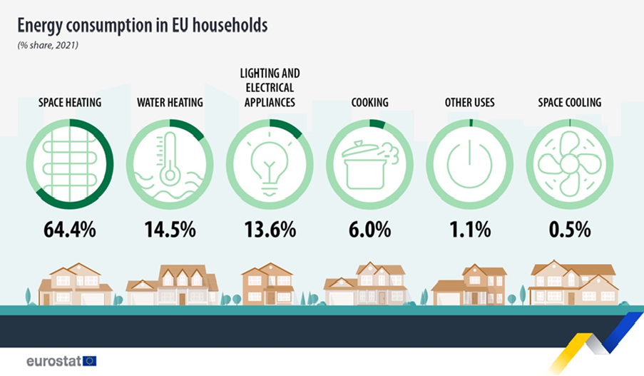

It outlines what activities use energy in homes across the European Union.

Does anything about these figures surprise you? How do you think this compares with your individual or household energy consumption?

Across Europe we also have different energy demands and needs, depending on where we live. Factors such as economy, geography and history can greatly impact a country’s energy needs and which energy sources it relies on to meet those needs – such as fuelling automobiles, heating or cooling homes or running factories.

If you live in Northern Europe where the weather is colder you may consume more energy for space heating, for example, compared with homes in Southern European countries where the weather is often warmer.

Looking at individual country energy consumption can give us a very different picture of energy use.

If you are interested in exploring different country’s energy patterns, and understanding more about where you live, you can use IEA tools to compare where you live with other countries across Europe.

How to save energy

When we consider how to reduce our energy consumption, we also need to consider how we can use energy more efficiently.

You can see some ideas for how to save energy in this International Energy Agency (IEA) 7 ways to save energy graphic. It also has an accompanying article Things you can do to use less energy and cut your bills.

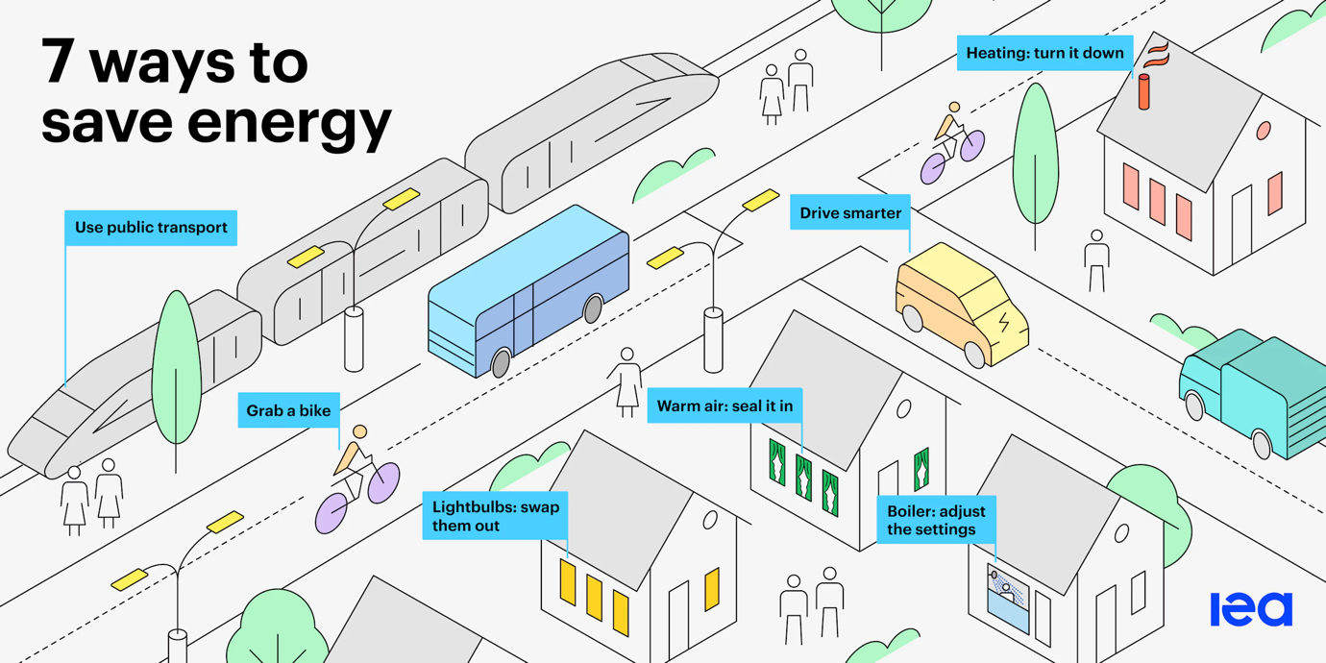

We could save energy by:

- Reducing waste: We can reduce our energy consumption in a variety of ways including insulating roofs or switching off appliances when not in use.
- Changing our behaviour: When we understand how we use energy around the home, we can choose to use it more efficiently. For example, by only boiling the amount of water you need for a hot drink or deciding to walk or cycle to work rather than drive a car.
- Making our appliances more efficient: For example, we may be able to install a heat pump, install energy saving lightbulbs or devices, update our heating system or use low-temperature heating such as underfloor heating systems.

We can also reduce specific types of energy consumption. For example, although we may not consume less energy unless we make changes like those suggested above, we can reduce our consumption of energy from fossil fuels by choosing energy from clean technologies.

For more advice on how to save energy, you might want to explore the Energy Saving Trust (UK) article Quick Tips to Save Energy. Although produced for the UK context there are useful tips that can make a real difference to your energy consumption, wherever you’re based.

Finally, whilst we may choose to use energy more efficiently, switch to energy from clean technologies or make use of energy saving devices, it’s important that we don’t unintentionally change our behaviour to negate any benefits and therefore increase our overall energy consumption!

We need to remain vigilant for what is described as the rebound effect.

For example, you may save money through reducing your use of electricity by using energy efficient devices and lightbulbs. However, your overall energy consumption may remain the same or increase as you now no longer routinely switch off lights or appliances when they are not needed. Although you may still be saving money, any actual energy saving is effectively cancelled out.

Conclusion

Energy production and consumption is a complex picture. It is impacted by a variety of factors including geography, history and economy.
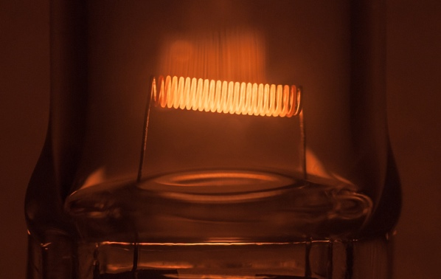
The decisions we make about how we use energy in our own homes also have a key role to play in the digital energy transition and the increased use of clean technologies.

We can be more conscious of our energy use by reducing our use of energy, making different choices (for example by switching to clean technologies) and better manging our energy use. Digital technologies support these activities whilst increasing energy security, comfort, protecting the environment and potentially saving money.

This course is part of the Digital Energy Essentials series.

You may want to explore our course What is the digital energy transition? to find out more about what the digital energy transition is and how this transition is taking place.

Additional Resources

The short video Energy Slaves explains how much energy is needed for different activities in the home and introduces the openly licensed course from TU Delft in the Netherlands Zero Energy Design: An approach to make your building sustainable.

For a more in-depth look at energy use in the European Union, try this Eurostat course Shedding light on energy in the EU: A guided tour of energy statistics.

If you would like to, you can experiment with this IEA Energy Mix tool to see how much energy we use for different purposes.

Acknowledgements

Energy Use includes adaptations of selected material from the International Energy Agency (IEA) [name] (the ‘Original Work’) which is licensed CC BY 4.0. This adaptation is made and published by the Every1 Project (the ‘Adapter’) and licensed CC BY-SA 4.0., unless otherwise stated. This is a work derived by the Every1 project from IEA material and the Every1 project is solely liable and responsible for this derived work. The derived work is not endorsed by the IEA in any manner.

The Adapter modified the Original Work in the following respects:

- The section Energy Transformation was used in the course section What types of energy do we use?
- The introduction to Energy System of Europe was used in the course Introduction and What types of energy do we use?

Image Attributions

Main course image: Diminishing Perspective by Umberto Salvagnin is licensed CC BY 2.0.
Introduction: Energy field by Damien McMahon is licensed CC BY 2.0.
Energy creation and consumption: The four ways of measuring energy by Hannah Ritchie for Our World in Data is licensed CC BY 4.0.
A closer look at how we use energy at home:
Energy consumption in EU households by Eurostat is reproduced in accordance with the requirements of the following Copyright Notice: https://ec.europa.eu/eurostat/statistics-explained/index.php?title=Statistics_Explained:General_disclaimer
How to save energy:
7 ways to save energy by the International Energy Agency (IEA) is licensed CC BY 4.0.
Conclusion: Energy by Umberto Salvagnin is licensed CC BY 2.0.

