Privacy, Safety and Security in the Digital Energy Landscape

Privacy, Safety and Security in the Digital Energy Landscape 1
How this course works 2
Learning Outcomes 2
Introduction 3
Digital technologies and the digital energy transition 3
Cybersecurity in the Energy Sector 4
Enhancing Your Energy Privacy, Safety and Security 5
Conclusion 6
Additional Resources 6
Acknowledgements 7
Image attributions 7

How this course works

This short, 30-minute course explains what privacy, safety, and security mean in the context of energy digitalisation. The course also addresses concerns about using smart energy technologies.

You might be:

- Interested in using smart technologies to better understand your energy use but uncertain how to secure your personal information.
- Curious about how your personal information is used and shared when using digital technologies.
- Wanting to better understand privacy, safety, and security in the context of energy digitalisation.

This course will deepen your understanding of the digital energy transition and support your own digital energy journey! It is part of the suite of 12 courses called Digital Energy Essentials, developed by the Every1 project, which aims to enable and empower everyone’s engagement in the energy transition. You can find out more about the project by going to: https://every1.energy

At the end of the course, we suggest some further learning materials for you to explore. This includes the course What is the Digital Energy Transition? which explores what digital energy is and the reasons behind moving towards digitalising our production and consumption of energy.

This is a translation of the original English language version of the course, which includes an opportunity to complete a short quiz and earn an Every1 digital badge.

This project has received funding from the European Union’s Horizon Programme for Research and Innovation (2021-2027) under grant agreement No 101075596. The sole responsibility for the content of this course lies with the Every1 project and does not necessarily reflect the opinion of the European Union.

Learning Outcomes

After studying this short course, you should be able to:

- Distinguish between privacy, safety, and security in energy digitalisation.
- Understand the main challenges in ensuring privacy, safety, and security when using digital technologies for energy.
- Be aware of your rights under the General Data Protection Regulation (GDPR) in relation to energy data.
- Apply practical advice to protect your data and enhance your digital energy security.

Introduction

As digital technologies become integral to our lives, the privacy, safety, and security of our personal information in the context of energy digitalisation are increasingly important.

Smart meters, mobile apps, and other digital devices collect and share data to enhance energy efficiency, but this can also raise concerns about data privacy and security.
Before we get started, let’s take a closer look at what we mean by data privacy, safety and security. These are interconnected but distinct concepts:

- Privacy relates to the protection of personal information.
- Safety involves ensuring that the use of digital technologies does not pose physical or psychological harm.
- Security focuses on protecting data from unauthorised access or attacks.

In this course we will not only look at different challenges for our energy privacy, safety and security but actions you can take to protect yourself. We will also look at how governments and energy suppliers are protecting you and your data, as well as the infrastructure that enables the use of digital technologies for energy production and consumption.

Digital technologies and the digital energy transition

As you may have seen in the course Smart Devices and Digital Energy Technology, which explores different types of smart device in more depth, there are a range of digital technologies which support energy digitalisation.

The digital energy landscape is a complex ecosystem of interconnected technologies and stakeholders. Key components include:

- Smart Meters: Devices that automatically collect and transmit data about energy usage to energy providers. Smart meters offer more accurate billing, insights into consumption patterns, and the ability to participate in demand response programs, where you can adjust your energy usage based on demand and pricing signals.
- Smart Grids: Modernised electrical grids that use digital technologies to monitor and control the flow of electricity. They enable two-way communication between the utility and the consumer, allowing for real-time monitoring of energy consumption and the integration of renewable energy sources.
- Internet of Things (IoT) in Energy: Network of connected devices (thermostats, appliances, EV chargers) that collect and exchange data, enabling remote control and optimisation of energy use.

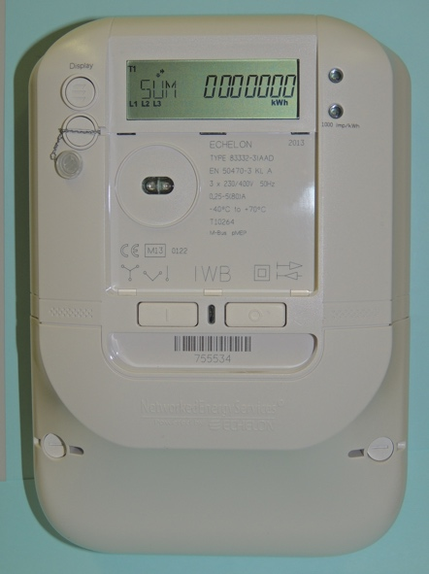
Data on energy can include consumption patterns, time-of-use data, appliance-level details, and even behavioural data inferred from usage. This data can help you to understand your own energy use, potentially save money and make informed choices. It can also help energy providers (such as your electricity supplier) to optimise the grid, offer you personalised services and detect fraud.

Your energy data is typically collected by your energy provider, but it may also be shared with or accessed by meter operators, data aggregators, third-party service providers, and potentially government agencies. Energy data is useful for policymakers, for example, by supporting the development of effective energy policies and regulations.

Data on energy use can include sensitive information. As a range of different organisations could have access to your data, and use it in different ways, this may raise concerns. We’ll suggest some ways you can enhance your energy privacy, safety and security later in the course. Let’s first look at some common cyber threats and what is being done to ensure the safety of digital systems.

Cybersecurity in the Energy Sector

The digital transformation of the energy sector has made it a target for cyber-attacks, which can disrupt energy supply and compromise sensitive information. Common cyber threats include:

- Malware (malicious software that can harm computer systems and data).
- Ransomware (a type of malicious software that encrypts your files, making them inaccessible, and demands a ransom payment to restore access).
- Denial-of-service attacks (these attacks aim to overwhelm a system or network with traffic, making it unavailable to legitimate users).
- Phishing scams (fraudulent attempts to obtain sensitive information, like passwords or credit card details, by pretending to be a trustworthy entity).

Protecting critical infrastructure requires measures like network segmentation, which is the practice of dividing a larger network into smaller, isolated segments. This limits the spread of cyberattacks and contains potential damage, limits access to controls, detects and prevents intruders and enables customised access to controls.

The EU Cybersecurity Act enhances cybersecurity across the EU and sets rules for certifying the security of products and services. Ensuring the safety of digital energy systems is crucial. This involves:

- Cyber-Physical Systems: Protecting these systems, where physical infrastructure is managed digitally, from cyberattacks that can have real-world consequences.
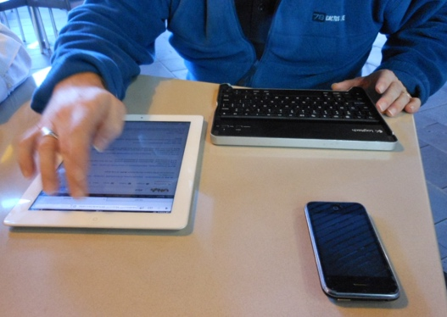
- Safety Standards: Adhering to EU safety standards for digital devices and energy systems to ensure their safe use and maintenance.

The General Data Protection Regulation (GDPR) gives you specific rights regarding your personal data, including energy data. These rights regarding your personal data include:

- Right to Access: You can request a copy of your energy data from your provider.
- Right to Rectification: You can request that any inaccurate or missing data is corrected or updated.
- Right to Erasure: You can request the deletion of your data under certain circumstances.
- Right to Restrict Processing: You can limit how your data is used.
- Right to Data Portability: You can receive your data in a transferable format.

Enhancing Your Energy Privacy, Safety and Security

As energy digitalisation and the use of digital technologies to manage our consumption, and production, of energy become commonplace, here are a few tips to help you enhance your energy privacy, safety and security.

- Secure Your Smart Devices: Use strong passwords, enable two-factor authentication, and keep software updated.
- Protect Your Network: Secure your Wi-Fi network, avoid public Wi-Fi for sensitive activities, and consider using a firewall.
- Control Your Data: Review privacy policies carefully, exercise your GDPR rights, and opt out of data sharing if uncomfortable.

The digital energy landscape is constantly evolving, with new technologies and threats emerging regularly. Staying informed about these trends is important to ensure your privacy, safety and security.

Here are some examples of new technologies which are, or could be in the future, play a more central role in energy digitalisation:

- Blockchain Technology: Blockchain, a decentralised ledger technology, has the potential to revolutionise energy data management by providing a secure, transparent, and tamper-proof way to track and share data.
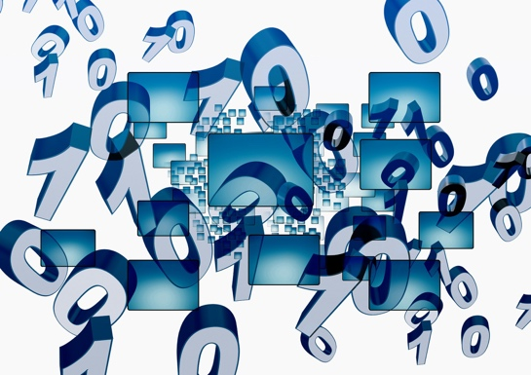
- Artificial Intelligence (AI) and Machine Learning (ML): AI and ML algorithms can be used to analyse energy data, detect anomalies, and predict potential security threats, enhancing the overall security of energy systems.
- Quantum Computing: While still in its early stages, quantum computing has the potential to disrupt existing encryption methods, posing a new challenge for data security in the energy sector.

Conclusion

The digital transformation of the energy sector offers immense promise for a more sustainable, efficient, and customer-centric energy system. However, the benefits of this transition can only be fully realised if we actively and continuously engage with the challenges of energy privacy, safety, and security.

As energy consumers, we have a vital role to play in shaping a secure digital energy future. By understanding our rights under the GDPR, taking proactive steps to protect our data, and choosing energy providers and service providers who prioritise privacy and security, we can ensure that our personal information remains safeguarded. Additionally, by staying informed about cybersecurity threats and best practices, we can help protect the energy infrastructure that we all rely on.

The transition to a digital energy system is not just about technology but also about empowering individuals and communities to actively participate in the digital energy transition. By embracing digital tools and making informed choices, we can contribute to a cleaner, more reliable, and more equitable energy future.

Additional Resources

- Read more about your rights under EU data protection rules in What are my rights? https://commission.europa.eu/law/law-topic/data-protection/reform/rights-citizens/my-rights/what-are-my-rights_en#:~:text=object%20to%20the%20processing%20of,controller%20(‘data%20portability’)%3B
- Find out more about The EU Cybersecurity Act and how it protects you https://digital-strategy.ec.europa.eu/en/policies/cybersecurity-act
- Review a Data Protection Impact Assessment (DPIA) for smart grid and smart meters. https://energy.ec.europa.eu/topics/markets-and-consumers/smart-grids-and-meters/data-protection-impact-assessment-smart-grid-and-smart-metering-environment_en
- Find out more about how the European Commission is protecting us in this article on Critical infrastructure and cybersecurity. https://energy.ec.europa.eu/topics/energy-security/critical-infrastructure-and-cybersecurity_en

Acknowledgements

Privacy, Safety, and Security in the Digital Energy Landscape is an adaptation of selected material from the International Energy Agency’s (IEA) "Data Privacy in the Digital Energy Era" https://www.iea.org/reports/digitalisation-and-energy and "Enhancing cyber resilience in electricity systems" https://www.iea.org/reports/enhancing-cyber-resilience-in-electricity-systems, (the ‘Original Works’) which are both licensed CC BY 4.0. This adaptation is made and published by the Every1 Project (the ‘Adapter’) and licensed CC BY 4.0., unless otherwise stated. This is a work derived by the Every1 project from IEA material and the Every1 project is solely liable and responsible for this derived work. The derived work is not endorsed by the IEA in any manner.

The Adapter modified the Original Works in the following respects:

- The adaptation focuses specifically on the energy privacy, safety, and security aspects of the Original Works.
- Technical language has been simplified for a general audience.
- Practical tips have been added.
- New information from European Commission sources has been incorporated to cover GDPR and the EU Cybersecurity Act.

Image attributions

Main course image: Untitled by Mike Fritcher is licensed CC BY-SA 2.0.
Introduction: Woman using Windows Mobile device in park with child by Gail is licensed CC BY-ND 2.0.
Digital Technologies and the digital energy transition: Smart meter “Echelon” by Patrik Tschudin is licensed CC BY 2.0.
Cybersecurity in the Energy Sector: Mobile Worker by Michael Coghlan is licensed CC BY-SA 2.0.
Enhancing your Energy Privacy, Safety and Security: data by Arismendy Polanco is shared on a Public Domain Mark 1.0.

