Energy Information and Critical Literacy

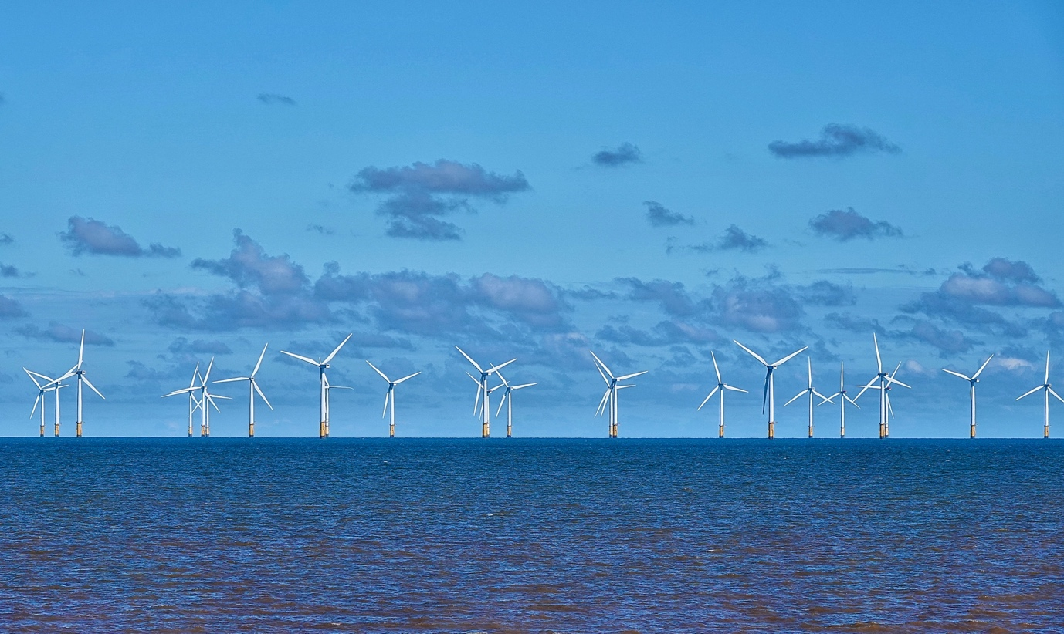
Energy Information and Critical Literacy 1
How this course works 1
Learning Outcomes 2
Introduction 2
What is Energy Information? 3
What is Critical Literacy? 3
Evaluating Energy Information 4
Conclusion 6
Additional resources 6
Acknowledgements 6
Image Attributions 7

How this course works

This short, 30-minute course empowers you to navigate the complex world of energy information, make informed decisions, and contribute to a sustainable energy future within the European Union. The course will help equip you with essential skills to decipher, evaluate, and apply critical thinking to energy issues.

You might be:

- An engaged citizen seeking to understand energy sources, technologies, and policies.
- A concerned consumer wanting to make informed choices about your energy consumption.
- A critical thinker interested in evaluating information and challenging misinformation.

This course will deepen your understanding of the digital energy transition and support your own digital energy journey! It is part of the suite of 12 courses called Digital Energy Essentials, developed by the Every1 project, which aims to enable and empower everyone’s engagement in the energy transition. You can find out more about the project by going to: https://every1.energy

At the end of the course, we suggest some further learning materials for you to explore. This includes the course What is the Digital Energy Transition? which explores what digital energy is and the reasons behind moving towards digitalising our production and consumption of energy.

This is a translation of the original English language version of the course, which includes an opportunity to complete a short quiz and earn an Every1 digital badge.

This project has received funding from the European Union’s Horizon Programme for Research and Innovation (2021-2027) under grant agreement No 101075596. The sole responsibility for the content of this course lies with the Every1 project and does not necessarily reflect the opinion of the European Union.

Learning Outcomes

After studying this short course, you should be able to:

- Define energy information and critical energy literacy within the European Union context.
- Use different strategies and approaches to assess the credibility of energy information sources and recognise potential biases.

Introduction

The European Union (EU) is undergoing a profound energy transformation, driven by the urgent need to combat climate change, reduce dependence on fossil fuels, and create a more sustainable and secure energy system.

Citizens play a vital role in this transition. By understanding energy information and applying critical literacy skills, we can make informed choices, participate in policy debates, and contribute to a cleaner energy future.

What is Energy Information?

Let’s take a closer look at what we mean by the term energy information.

Energy information can refer to a wide range of data, knowledge, and perspectives related to:
  - Energy Sources: Fossil fuels, renewable energy (solar, wind, hydro, geothermal, biomass), nuclear energy.
  - Energy Technologies: Power generation, transmission, distribution, energy efficiency, and energy storage.
  - Energy Issues: Climate change, energy security, energy access, energy poverty, and the social and economic impacts of energy choices.
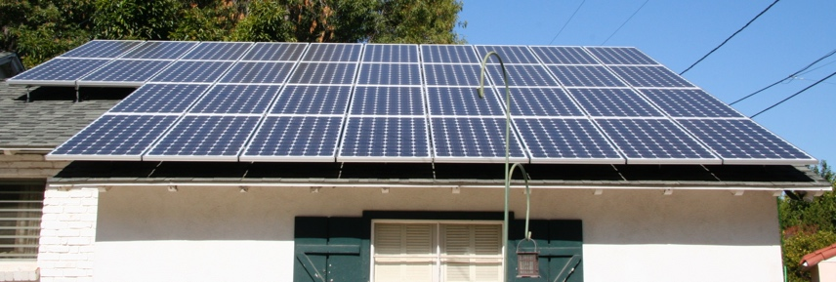
Energy information is important as it enables us to:

  - Make informed decisions: Whether you're choosing an electricity provider, considering home energy upgrades, or voting on energy policies, sound decisions rely on access to accurate and unbiased information.
  - Understand the big picture: Understanding the complexities of the energy system empowers you to grasp its implications for the environment, economy, and society as a whole.
  - Actively participate in conversations about the digital energy transition: Being energy literate enables you to engage in meaningful discussions, advocate for responsible policies, and hold decision-makers accountable.

What is Critical Literacy?

In this course we describe critical literacy as active engagement with information. This means that we actively question, analyse, and evaluate information rather than passively absorbing it.

Let’s take a closer look at some examples of how we might critically engage with energy information. We might:

  - Identify sources & biases by scrutinising the origin of information and recognising potential influences. Is the source credible? Are there any vested interests?

  - Assess accuracy & completeness by examining information for factual accuracy, logical consistency, and potential omissions. Does the information align with other reliable sources? Are there any gaps in the data or arguments presented?
  - Identify misconceptions by recognising common logical fallacies and misleading arguments often used in energy debates. Is the reasoning sound? Are there any unsupported claims or exaggerations?
  - Discern propaganda by identifying attempts to manipulate or distort information to promote a particular agenda. Is the information presented to you in a balanced and objective manner, or is it designed to sway your opinion?
  - Consider social and political contexts by understanding how energy issues are intertwined with power dynamics, social justice, and economic inequality. Who benefits from certain energy choices? Who bears the costs?

You might recall examples of when you critically engaged with energy information. However, you might have also been not quite sure as to what you were hearing or reading was true. If you’d like to explore some examples of common misconceptions or misunderstandings about energy, you may want to explore this International Energy Agency’s article on …three myths about today’s global energy crisis or the World Economic Forum’s Renewable energy: common myths debunked.

Evaluating Energy Information

To effectively navigate the abundance of energy information available, it's essential to critically evaluate sources and the information they provide. Let’s take a deeper look at some ways in which you can critically engage with energy information.

Take a deeper look at the source and author(s):

  - Conducting a credibility check: Assess the source's authority, expertise, and potential biases. Is it a reputable scientific organisation, a government agency, an industry group, or an individual blogger?
  - Checking funding & affiliations: Understanding the source's funding and affiliations can reveal potential conflicts of interest or agendas that might influence the information presented.

What kind of perspectives, motivations and qualifications might the author(s) have?

  - Look beyond the words: Consider the author's background, qualifications, and potential motivations. Are they an expert in the field? Do they have any affiliations that might influence their viewpoint?

Assess the accuracy and completeness of the information:

  - Challenges in the Digital Age: The abundance of information available online can be overwhelming, and not all sources are created equal. Additionally, the lack of standardisation in energy data collection and reporting can create inconsistencies and complicate comparisons.
  - Strategies for verification: Cross-referencing information with multiple reliable sources, seeking expert opinions, and checking for citations and supporting evidence are crucial steps in assessing accuracy.

Look out for bias and misinformation:

  - Red flags: Watch out for emotional language, exaggerations, cherry-picking of data, one-sided arguments, and logical fallacies. If something seems too good to be true or overly alarmist, it warrants further scrutiny.
  - Critical analysis: Apply critical thinking skills to evaluate the evidence presented and the conclusions drawn. Are there alternative explanations or perspectives?

Evaluate website credibility:

  - Beyond the surface: A visually appealing website doesn't guarantee reliable information. Consider factors like the domain name, ownership, author credentials, transparency about funding and affiliations, and the presence of a clear editorial policy. Look for references and citations to support claims.

Adopting a critical approach can also help you make informed energy choices by enabling you to better understand:

  - Your options: Explore the different energy sources and technologies available to you as a consumer in the EU. Consider factors such as cost, environmental impact, and reliability.
  - Energy efficiency: Learn about energy-efficient appliances, home energy upgrades, and behavioural changes that can help you reduce your energy consumption and save money.
  - Renewable energy: Explore options for using renewable energy sources, such as solar panels, wind turbines, or green electricity tariffs.


Conclusion

An energy-literate society is better equipped to understand the complexities of the energy system, engage in meaningful policy debates, and make choices that prioritise long-term sustainability.

By applying critical literacy skills to energy information, you can become an active and informed participant in the EU's energy transition.

Additional resources

- Find out more about the digital energy transition in our What is the digital energy transition? course. If you’ve already completed this course, read the European Commission article on Digitalisation of the energy system.
- Read the UK National Grid’s Clean Energy Myths: is it really too expensive and not reliable? Although aimed at the UK context, the myths explored here are relevant to many other contexts.
- Read the Energy Saving Trust’s article Debunking Solar Myths.

Acknowledgements

Energy information and critical literacy is an adaptation of selected material (‘The original works’) as follows:

Kellberg, S., Keller, M., Nordine, J., Moser, S. & Lewalter, D. (2024) Energy literacy for all? Exploring whether prior interest and energy knowledge mediate energy literacy development in a modern socio-scientific museum exhibition International Journal of Science Education, Part B: Communication and Public Engagement. 1-22. This paper is licensed CC BY 4.0.
Nature of Adaptation of the Original Work: This course integrates findings from this research on how prior knowledge and interest influence energy literacy development.

The International Energy Agency’s (IEA) World Energy Employment 2022 report which is licensed CC BY 4.0.
Nature of Adaptation of the Original Work: This course utilises data and insights from this report to highlight the employment implications of the energy transition in the EU.
This is a work derived by the Every1 project from IEA material and the Every1 project is solely liable and responsible for this derived work. The derived work is not endorsed by the IEA in any manner.

The European Commission’s Energy Efficiency is licensed CC BY 4.0.
Nature of Adaptation of the Original Work: This course incorporates information on EU energy efficiency policies and directives to provide a regional context for critical energy literacy.

The European Commission’s Digitalisation of the energy system is licensed CC BY 4.0.
Nature of Adaptation of the Original Work: This course integrates information on the EU's approach to digitalising the energy sector, highlighting the role of digital technologies in the energy transition.

This adaptation is made and published by the Every1 Project (the ‘Adapter’) and licensed CC BY-SA 4.0, unless otherwise stated.

Image Attributions

Main course image: Wind turbines! By Nina_Ali is Public Domain.
What is energy information?: Solar panels all done! by Mike Spasoff is licensed CC BY 2.0.
What is critical literacy?: Conectado by Esther Vargas is licensed CC BY-SA 2.0.
Evaluating energy information: Smartphones at Fashion Week by Melissa BARRA is licensed CC BY-SA 2.0.
Conclusion: Engage by Portland Seminary is licensed CC BY-SA 2.0.

