Assessment

Supporting students to reflect on personal actions to support a Sustainable Development Goal
Sustainability connections are threaded throughout B100, a core undergraduate module for Level 1 Business students. There are several activities where students explore different sustainability aspects — e.g. a guided exploration of the environmental impacts of a small business. In their first summative assessment, students are asked to provide an example of an action they could take in their own work, private life, or studies, that would support one specific Sustainable Development Goal (SDG) and to explain how it would do so. Activities in the run-up to the assessment use a video to introduce the relevance of the SDGs for business and asks students to choose a business or organisation and reflect on how they could help to achieve any of the SDGs. Students are then encouraged to share their ideas with their peers in a dedicated forum space. This builds students familiarity with the SDGs and develops reflective skills ahead of the assessment. Students are also provided with a template which outlines what they should cover in their 350 word answer e.g. a brief explanation of what the SDGs are, specific detail of the sustainability benefit of their action.
Author: The Open University's Responsible Futures Audit 2024
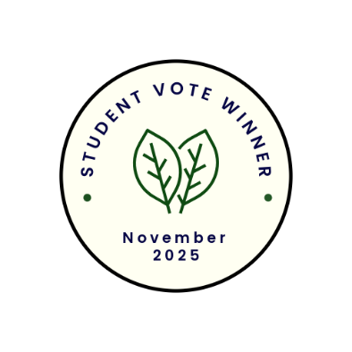
Student quotes
"I chose this because the text highlights a thoughtful and practical integration of sustainability into business education. B100 doesn’t just teach business—it cultivates responsible, globally-minded professionals. By linking sustainability to personal and professional contexts, it empowers students to see themselves as contributors to a better future from day one."

"This is something that can be personalised and people would feel that they are able to make a difference to sustainability through their own actions."

