Competencies in the curriculum

Threading Educating for Sustainable Development through thinking about educating the next generation.
The MA level 1 module EE830 – Learning and teaching – educating the next generation problematises education, asking how can today’s learners be prepared for an increasingly uncertain world? Education for sustainable development (ESD) was a natural part of the module, seeing ESD as the responsibility of everyone who works to facilitate learning, not just Geography and Science teachers. We introduced ESD ideas of care and compassion for all actors in the world, human and non-human, through videoed interviews with authors including Paul Warwick, allowing students to visualise the people advocating radical change. We asked the students to consider Warwick’s butterfly model, setting out six necessary dimensions in Education for Sustainability, and within module activities to apply these dimensions to their own contexts and professional practice. Other activities which ask for reflection and for plans for action and sustainable change are positioned throughout the module, as the students consider how to educate the next generation to act sustainably. ESD is seen as part of learning not a one-off event. Beyond the module, student engagement with the ideas included a social media campaign capturing students' changes in practice, and a student-staff research project exploring these changes, leading to a joint publication.
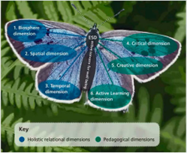
Figure 1: Visualisation of Warwick's butterfly model.
Author: Clare Lee, Open University, Senior Lecturer Education, WELS school of ECYS.
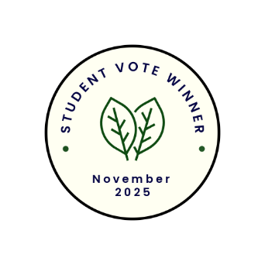
Student quotes
"As I am looking at going into the teaching profession this resonated with me as I think it is important for children to know about sustainability."
"It helps to teach educators about embedding sustainability, so that young children grow up with it at the forefront of their minds."
"It is only by understanding the past that one can pass that knowledge on to future generations. Yes, people may look at the past in different ways, but that is really relevant. It provides future generations with a wide range of opinions and options to move things forward. Without that ability, and to be frank, there would be no future."

Sustainability Pedagogies

Creating a free sustainable pedagogies course
A pan-university group was created in 2021 to discuss different themes and associated papers/publications and look at opportunities for co-creation and collaboration. One of the outcomes of this group was the development of a free course titled Sustainable pedagogies which was first published in 2024. The course is aimed at all educators who want to develop their professional practice to prepare their students to become agents for sustainability in a world that urgently needs to become sustainable.
The course focuses on the central role that education can and should play. It helps to enact what being sustainable means, no matter the subject, and is focused on how to do this through pedagogies – ways of facilitating learning – to help position students to grow the skills, attitudes and ways of being in the world to contribute to a globally sustainable future. Sustainable pedagogies is an educational response to international recognition that finite resources, economic development and population growth will challenge current and future generations. Participants are encouraged to participate and bring the learnings to their own context through reflection, forums and 'explore' activities.
Author: The Open University's Responsible Futures Audit 2024
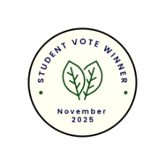
Student quotes
"Targeted teaching is a good way forward, and an OpenLearn course on this would be interesting to many students. It could be part of the welcome week, highlighting how the OU remains a sustainable institution with forward-thinking for the planet."
"This is a course I would want to do."
"It offers a compelling example of strategic educational innovation with global relevance. This initiative positions education not just as a tool for knowledge transfer, but as a driver of cultural and systemic change. By equipping educators with sustainable pedagogical practices, it builds capacity for long-term transformation across sectors and generations."

