Staff Development, training and resources

Embedding sustainability within the Open University’s Inclusive Curriculum Tool
The Inclusive Curriculum tool (ICT) is, at its simplest, a reflective tool to support colleagues to consider if the course material that they are creating embodies EDIA principles and Sustainability in the context of assessment and the broader learner journey. The ICT's three aims:
- To make material accessible to diverse groups of students (not just in terms of accessibility for disabled students but also in terms of the language and images used)
- To represent diverse groups of students in the material
- To equip students to participate in a global and diverse world
The ICT is designed to support deeper consideration and discussion of inclusion when designing and creating learning materials or reviewing existing module material. The ICT is not a checklist. It provides prompts to help colleagues reflect but does not give answers. Guidance Notes with examples are included for the prompts and there is space for colleagues to record issues that they notice about the course material they are reflecting on, suggest actions, and note good practice as they work through their learning materials. Examples of two of the prompts can be found within the linked example.
Author: The Open University's Responsible Futures Audit 2024
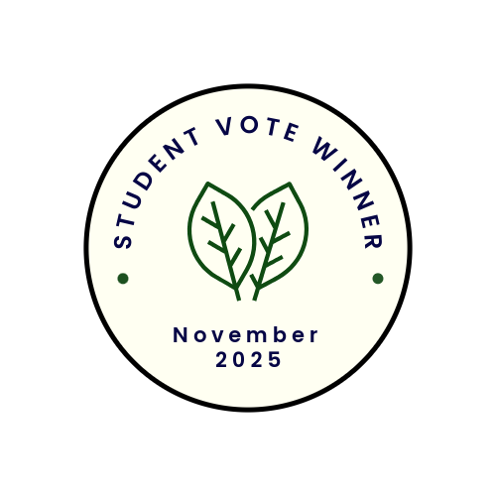
Student quotes
"Students want to be able to see themselves in module materials and that EDIA and Sustainability is incorporated into the teaching and learning which starts with the module materials."

"Sustainability is a must for a university. For a university to be sustainable and recognise its impact both ecologically, environmentally and globally it first must realise that not everyone has the same opportunities, resources or abilities."

Subliminal curriculum
Hedgehog Friendly Campus
The Open University Student Union and The Open University got students, volunteers and staff involved in nature and conservation initiatives through Hedgehog Friendly Campus. This was started through a student volunteer request and it gave us the push we needed to provide staff capacity to support this project since it's something that students wanted to see happen. The Estates team helped immensely with campus improvements but also paying for the accreditation which provides us with a framework for getting this work done (including litter picks engaging students and staff, organising community events, building bug hotels and running awareness campaigns). The impact was a positive one - we raised £282 through campus and wider community initiatives, including vegan bake sales and volunteer hedgehog crocheting. We raised awareness through various comms throughout the year as well as Hedgehog Awareness Week in May. We submitted enough evidence to be accredited silver status.
Author: Ciara Linehan, Open University, OpenSU projects officer.
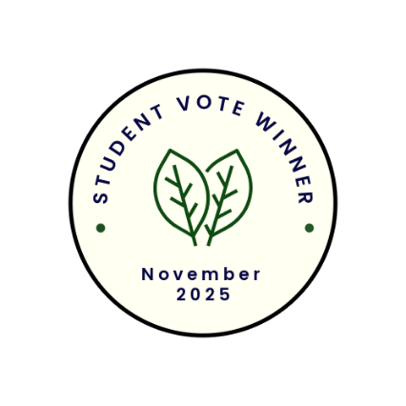
Student quotes
"If students could learn about ecosystems, environments through hedgehogs, it would not only benefit the science students but students who wish to study animals, environmental laws, health as well as the sciences."
"I chose this because the initiative is a brilliant example of grassroots sustainability, student-led action, and institutional responsiveness. This initiative shows how sustainability can be joyful, student-driven, and institutionally supported. It blends ecological care with creativity, community, and recognition—making it a model for inclusive environmental action."

