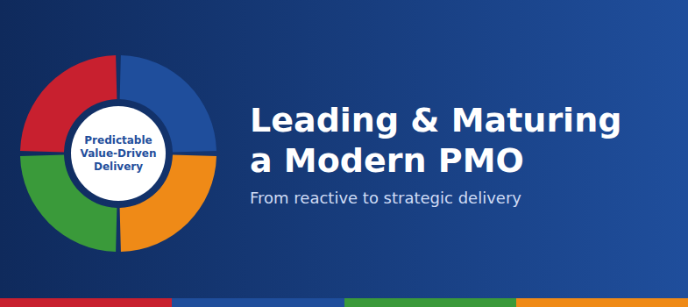

Why every PMO needs a strategy, not just a process
Many PMOs drift into reporting and firefighting. This article shows how the PMO Operating Model Wheel, a maturity model and continuous improvement help a PMO deliver predictable, value-driven results.
A PMO without structure tends to become reactive. It spends its time collecting reports and chasing updates instead of helping projects succeed. A modern PMO does something different: it acts as a strategic partner that enables predictable, value-driven delivery.

Why PMOs struggle
The same patterns appear again and again:
- no clear governance
- inconsistent delivery
- low stakeholder confidence
- a “supplier versus client” mindset
- a breakdown in culture
Each one makes the PMO harder to trust, and a PMO that isn't trusted is rarely asked to influence decisions.

A model for the whole PMO
The PMO Operating Model Wheel gives a PMO four connected domains, all centred on predictable, value-driven delivery:
- Governance & Assurance: confidence, consistency and control.
- Planning & Control: structure, visibility and predictability.
- People, Skills & Culture: capability, collaboration and leadership.
- Value, Strategy & Outcomes: alignment, measurement and improvement.
Weakness in one domain undermines the others, so the domains need to be developed together.

Knowing where you stand
The maturity model describes five levels:
- Reactive: firefighting, no governance.
- Structured: governance begins to take shape.
- Proactive: the PMO enables delivery rather than just observing it.
- Strategic: the PMO influences decisions.
- Enterprise: the PMO drives organisational change.
Rating each Wheel domain against these levels, with evidence, shows where to focus first.

Improving continuously
A PMO that doesn't evolve becomes irrelevant. The continuous improvement cycle (Assess, Improve, Measure, Embed) turns one-off fixes into daily practice. Embedding is the step most often skipped.

A turnaround in practice
In one documented case, a PMO was failing its SLAs and KPIs, with revenue down 10%. A delivery model reset, a governance redesign and cultural change led to a 30% improvement in delivery. Customer satisfaction rose from 3 to 7, revenue moved from -10% to +15%, SLA achievement reached 100%, and most projects moved from red to green.

Where to start
- Assess your PMO's maturity in each of the four domains.
- Pick one domain to strengthen first, usually governance.
- Set measures such as CSAT, SLA compliance and ROI, then review them regularly.
To work through these tools step by step, take the free course Leading and Maturing a Modern PMO.
Author: [your name]
[Short author bio]
Image credit: [course banner, created for this course; add any AI image prompts here if applicable]

