Inclusive Teaching Practice
Participant’s Book

Source: VSO Image library

Module 12:
Identifying specific learning difficulties.

Module 12: Identifying specific learning difficulties.

Overview
This is the twelfth of fifteen modules that look at how we create a positive Inclusive Learning Environment for all. You will see how inclusive teaching practices encourage, develop and use the 21st century skills of critical thinking, communication, collaboration and creativity. These modules are for any educators or those studying in education in Myanmar. The terms student and learner are used interchangeably throughout the module.

Module number | Module title
1 | What is an Inclusive School, Classroom and Teacher?
2 | Knowing your learners
3 | Planning learning outcomes for all
4 | Participating through learner centred approaches
5 | Creating a positive learning environment
6 | Effective questioning and feedback
7 | Active participation
8 | Peer, cooperative and collaborative learning
9 | Supporting students’ emotional and social wellbeing
10 | Legal framework and policies around Inclusion in Myanmar
11 | Supporting all students through differentiation
12 | Identifying specific learning difficulties
13 | Supporting all learners with differences or disabilities
14 | Positive behaviour management
15 | Assessment for student achievement

This module looks at definitions and examples of learning difficulties. It focuses on identifying specific learning differences that may act as barriers to learning in the classroom; for example communication, social, emotional, physical and cognitive. The following module (13) will explore ways in which teachers can respond and support any needs they have identified. The two modules should be used together.

You will be asked to record your reflections in a learning journal, so it is important to make detailed notes and think carefully and deeply about your current and future practice. This CPD module also encourages you to develop communities of practice between yourself and your colleagues. This will support and extend your own use of inclusive practices in your teaching and will help your student teachers build on inclusion in their learning and future professional practice.

Learning Journal
It will be useful to record your reflections in a learning journal throughout the module.
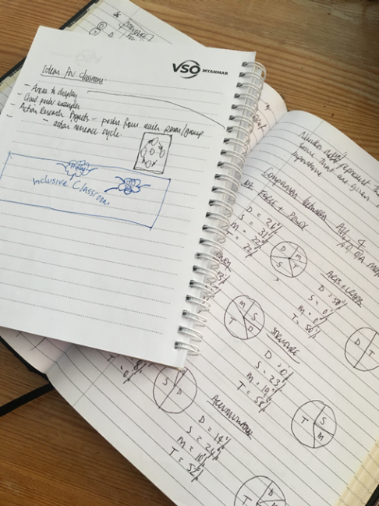
A learning journal can be digital (e.g. using Word or Google Docs) or on paper. You can also take photos of your learning journal pages if you want to share your thoughts with others. It is important that you record your thoughts and ideas so that you can remember and use them later in activities and in your own teaching.

Here are some useful tips for a good learning journal:
- Use headings and dates for all your journal entries.
- Use the activity number for reflections linked to that activity, e.g. Activity 1.1
- Add references to any other resources you find that help you.
- Record answers to activities.
- Write reflections about your learning.
- Make notes of new vocabulary.
- Identify topics you want to learn more about.

Source: Rose, N. (2018) Personal Learning Journals

The important thing is that it is easy for you to use. You can take notes which answer simple questions like these:

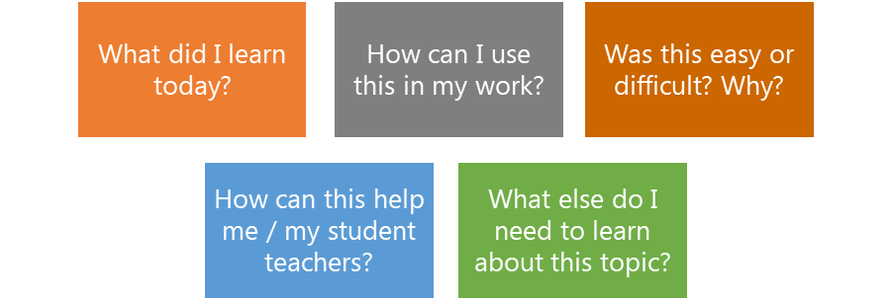

These questions follow the LEARN- APPLY- REFLECT model which is used in education globally. You can return to this journal as you progress through your CPD journey and reflect on your progress.

Study tips
Take your time to work through the activities, rather than trying to complete the whole unit at once. Set yourself a timetable and choose a time to work through the tasks, then check and compare ideas with colleagues. Finally, remember to make notes in your learning journal as you go. This will help you remember more about the skills and knowledge you develop as you complete these units.

Working alone or with colleagues
This unit is designed for self-study. The answers can be found after each activity. However, if possible, we recommend working in a pair or group so you can share ideas, ask questions, check your work, and give feedback.

If you work in a pair or group, we recommend using Think / Pair / Share for each activity.
Discuss your ideas in a group, and then check the answers on the next page(s) together.
Check your answers with your partner.
Work alone and make brief notes of your own ideas.

Learning outcomes for module 12
Learning outcomes:
By working through this module, you will be able to:
1. Identify and describe what learning difficulties are.
2. Explore the different categories of learning difficulties. e.g communication, social and emotional, sensory and physical, cognitive, etc.
3. Demonstrate an understanding of the impact of learning difficulties in the classroom.
4. Explore the Universal Design for Learning approach to plan how you represent, express and engage learners.
6. Reflect on the steps to take if you have concerns about a student.

Introduction
The previous module 11 looked at how to use differentiation to support Inclusion. We explored using differentiation strategies, such as graphic organisers, writing frames and other multisensory activities to support learning.
This module 12 focuses on identifying specific learning differences that may act as barriers to learning in the classroom. e.g., communication, social, emotional, physical and cognitive. We will explore how these difficulties can impact the progress that students make and suggest ways for educators to support them in class using inclusive strategies.
You will be asked to:
- Read various texts about the topic.
- Watch videos and provide some analysis.
- Complete activities either alone, in pairs or in small groups.
- Think about key questions.
- Reflect on your experience and knowledge.

The module will take approximately 6 hours to complete. We hope you have an enjoyable learning experience.

Key to symbols
Activity – this is work you need to complete.

Question/s – please answer the questions.
Reflection – think carefully about how you feel about this.
Learning Journal – please write your answers in your learning journal.
Read – please read the text provided. Make any notes you like.

Activity 12.1 Self-assessment
REFLECTION: How well do you think you are equipped to identify students with learning difficulties? Look at the scale below and choose the number that best describes you now. Answer in your learning journal.
VERY well
NOT well
You will be asked to do this again at the end of the module.

    - Link to previous learning – Module 11 (Supporting all students through differentiation)
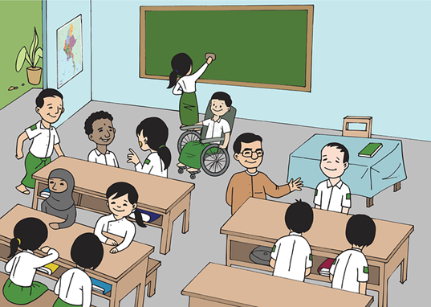
Think back to module 11. If you were thinking about differentiating the learning for students, what are some of the factors you might consider?
Look at the subheadings below and describe in your learning journal why you might need to consider them when differentiating learning.
Age/Grade
Learning styles

Inclusion
Social skills

Number of students
Image Source: https://pixabay.com/images/search/burma/?pagi=2& (free)

Academic readiness

1.1.2 Suggested answers
Social skills | Can students work together? Do they get along with each other or do you know that some students work better together than others? Some students may need support organising and managing themselves in a group. Do you need to have a discussion with the class about any problems or challenges they might face?
Academic readiness | Understanding the student’s current level of understanding. Think about if they are similar or if you can group students who have similar understanding. You might decide mixed groups are more effective so that students can support each other.
Inclusion | Can ALL students participate and achieve? Do any students need further support? How will they contribute to the team performance, or can other students offer support?
Age/Grade | Younger learners may need more support or need concepts breaking down into small steps. Where you have classes of mixed ages or grades, you will need to think about how your expectations might need to change according to what they are able to do.
Learning styles | Do all students learn in the same way? Using different multi-sensory styles make activities more engaging and varied.
Number of students | The amount of students in your class will affect the success of group work. Think about the size of groups and individual learners within them. If students do not have lots of experience of working in a group, you might start with smaller sizes and build up.

- What is a learning difference, difficulty, or disability?
A learning difference or difficulty can cause an individual to experience problems in a traditional classroom learning context. It may interfere with literacy skills development and maths and can also affect memory, ability to focus and organisational skills. A student with a learning difficulty may require additional time to complete tasks; however, they can benefit greatly from inclusion strategies. No two individuals with a learning difficulty are the same and many conditions, such as dyslexia, attention deficit disorder (ADD) and attention deficit hyperactive disorder (ADHD), can exist on a wide-spectrum from mild to severe. Other difficulties, such as dyspraxia, a motor-skills difficulty can affect a student’s ability to write by hand. Learning difficulties and motor-skills difficulties can be present together.
Learning difficulties are sometimes referred to as learning disabilities. You may also encounter the terms learning differences or special educational needs. The differences between these labels can seem subtle but may have implications for how an individual with a learning difficulty views themself. The word disability can be a sensitive word as it can imply a person is not able. It can also suggest they are in a permanent state of disadvantage.
On the other hand, a learning difference implies that a person simply learns in a different way from others and often their brains work differently. The term difficulty can also mean challenges, describing difficulties a student might face in a typical educational setting but that can be overcome.
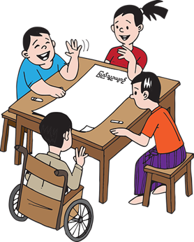
Everyone is different and words that are comfortable for some may not be okay for others. There is general agreement on some basic guidelines about words to use and avoid. If you are in direct contact with someone affected by disability, ask the person to tell you which words and phrases they are comfortable with.
Avoid passive, victim words such as phrases like ‘suffers from’ which suggest discomfort, constant pain and a sense of hopelessness. People who use a wheelchair may not view themselves as ‘confined to’ a wheelchair so instead try think of it as a mobility aid. Use language that respects people with disabilities, differences, and difficulties as active individuals with control over their own lives. We should also avoid saying ‘dyslexic students’, or ‘autistic students’, but students with dyslexia or autism so the focus is not on the disability, but the person. For further guidance on language see Appendix 1.

Activity 12.1 – Learning difficulty or disability? (20 minutes)

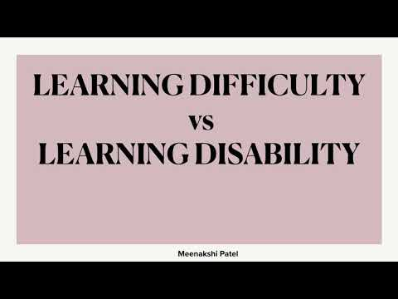
Learning disabilities are often confused with learning difficulties.
https://www.youtube.com/watch?v=I-xA9B_U1JU

- Watch the video below to help understand the difference.
- Read the summary below in each box
- Write down the examples of learning difficulties described in the video. We will explore these in more detail in this module.
Learning disability | “A learning disability constitutes a condition which affects learning and intelligence across all areas of life.”  Examples of a learning disability:  - Down’s syndrome – it can affect all areas of an individual’s life including their health, physical condition and life skills.  - Autism Spectrum Disorder (ASD) – it can affect all areas of an individual’s life including social interaction and communication.
Learning difficulty | “A learning difficulty constitutes a condition which creates an obstacle to a specific form of learning, but does not affect the overall IQ of an individual.”  Example of a learning difficulty:  - Dyslexia – it can affect a specific area of an individual’s life and does not necessarily hinder their life skills. In this example, dyslexia impacts upon the ability to read, write and spell, but the individual can otherwise function without the need for ongoing care and support (for this specific condition).  - Dyspraxia – it can affect a specific area of an individual’s life with the coordination of muscles. Holding a pen for example could be painful.

Foundation for People with Learning Disabilities (2021)

Discussion – Learning difficulty or disability? (20 minutes)

Learning disabilities are often confused with learning difficulties.

- As with learning disabilities and learning difficulties can exist on a scale.
- A person might have a mild learning difficulty or a severe learning difficulty. The same is true of learning disabilities.
- A learning difficulty usually presents in childhood and can cause a person to experience challenges in a traditional classroom setting.
- It is possible for a person to have both a learning disability and a learning difficulty.

2.1 Different categories of learning difficulties
For this section we will focus on learning difficulties under the following 4 categories;
- Cognitive and learning difficulties
- Sensory and physical
- Social and emotional
- Communication

We will look at specific learning difficulties under these terms and support educators in identifying any behaviours that closely link to these difficulties in attempt to understand and learn how best to support students.
It is important to remember that only professional health practitioners and people who are trained in testing and diagnosing specific learning difficulties can provide a label, such as dyslexia. When we get to know learners, it is easy to make judgements and assume students may fit a certain label, but this can have negative consequences on how students learn and our expectations of them.
In this module, we hope that a better understanding of some of these difficulties will help you support them in an effective way, rather than label them as having a difficulty.

2.2 Cognition and learning difficulties
Cognition is 'the mental action or process of acquiring knowledge and understanding through thought, experience, and the senses.’ Camcog (2015) The ability to perceive and react, process and understand, store and retrieve information, make decisions and produce an appropriate response can often be a challenge. Cognition and learning difficulties can be quite general and be either moderate or severe. These sorts of difficulties are often referred to as profound and multiple learning difficulties or specific learning difficulties.
Profound and multiple learning difficulties is when a person has a severe disability that significantly affects their ability to communicate and be independent. They may have difficulties seeing, hearing, speaking or moving.
Specific learning difficulties include: dyslexia, dyscalculia and dyspraxia. It is very common for students to have one or more specific learning difficulties and have areas of strength and competencies with areas of need at the same time.

Activity 12.2 – Dyslexia (10 minutes)

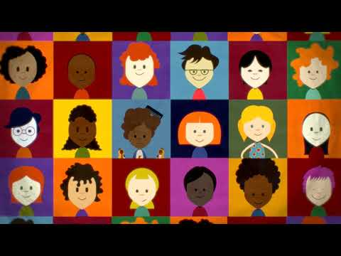
Watch the short video about dyslexia and think about the students you teach. Reflect on the questions below and make some notes in your learning journal.

- How do you support students who find reading and writing challenging?
- Chat to your colleagues if you can about what strategies they use to support students.
https://www.youtube.com/watch?v=11r7CFlK2sc

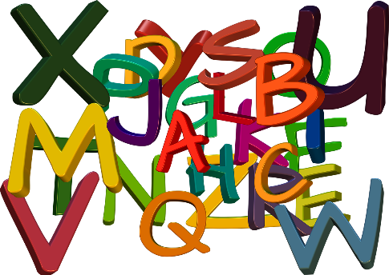
Dyslexia is a common learning difficulty. It is estimated that between 5-10% of the population has dyslexia, but this number can also be as high as 17%. It can affect the way people break down words, making reading and writing challenging and a significant difficulty as they are central to most of the school curriculum. Difficulty with writing can sometimes be referred to as dysgraphia but it is also commonly referred to as dyslexia.
Dyslexia is not associated with lower intelligence, but language difficulties can cause children to believe they are less intelligent than their peers and result in low-confidence and a poor self-image. There are many benefits of dyslexia, including the ability to think differently, see patterns more easily and imagine models in their head, often seeing the bigger picture. Often dyslexic people enjoy creative tasks and can add a different viewpoint in group discussions to their peers.
Image source: https://pixabay.com/illustrations/abc-alphabet-letters-read-to-learn-916665/ (free)

Note: Some of the factors below, may also be part of the process of learning. For example, young children often reverse letters and numbers when they are learning how to write.
What might it look like? | How to support students
- Difficulties in decoding words when reading, spelling and writing.  - Students may not feel confident to read aloud  - Inconsistent spellings or sometimes illegible handwriting.  - Losing place on a page when reading  - Letter reversals  - General dislike & lack of motivation to read and write  - Students may lose focus easily  - Writing can take a long time which can cause frustration | - Provide modifications to break texts down into shorter passages of text.  - Allow students to explain their answers instead of always having to write.  - Encourage students to work with others  - Ensure instructions are clear  - Use clear fonts and sizing of text  - Provide models for handwriting or spellings  - Using multi-sensory learning techniques  - Provide differentiated tasks for students to build on their existing level.  - Suggesting that students leave spaces between lines they are writing, making it easer to read back and edit their work.  - Avoid asking students to model writing in front of the class if they don’t feel comfortable to.

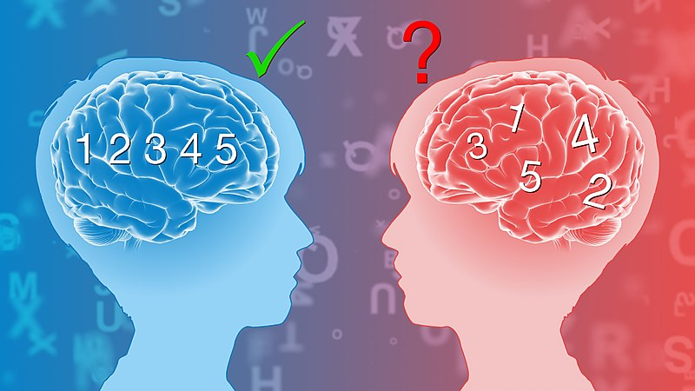
Dyscalculia involves processing numbers. Children with dyscalculia can have trouble with simple arithmetic and maths problems, balancing equations, grouping numbers, and performing the right order of operations. Students might display high levels of anxiety during maths lessons or tasks. In contrast students with dyscalculia often thrive in strategic thinking, practical ability and problem-solving tasks. When dyslexia and dyscalculia are present together, reading word problems or drawing graphs can be difficult.
Image source: https://commons.wikimedia.org/wiki/File:Dyslexia.jpg (free)
What might it look like? | How to support students
- Counting can be a struggle  - number reversals may be frequent.  - difficulty remembering facts such as number bonds (pairs of numbers that make 10) or multiplication.  - Can take longer than others to solve calculations.  - Mental arithmetic can be challenging  - Difficulty in understanding place value.  - Addition can often the default operation to use as it is the easiest. | - When appropriate, allow students to use a calculator to support their learning.  - Regular opportunities to practice number facts such as multiplication.  - Breaking learning down into smaller steps.  - Provide concrete and pictorial examples before abstract. E.g. use stones to add or draw circles rather than presenting an equation 5+3 =  - Provide opportunities to practice skills with others before being asked to do it independently.

2.3 Sensory and Physical difficulties
Difficulties that are sensory can be visual impairment, hearing impairment, as well as physical conditions such as cerebral palsy. These students will often need specific support, which could be a combination of education and health. Students with sensory and physical difficulties do not necessarily have a learning difficulty but sometimes their impairment or condition can affect their ability to learn, particularly if they are in a traditional classroom environment.
Dyspraxia is a motor skills difficulty that affects the planning and coordination of muscles. Holding a pencil can be painful, so writing may contain more spelling errors and be illegible. In cases of verbal dyspraxia, the muscles of the face, mouth and throat are affected, limiting spoken language production. People with dyspraxia may also walk differently to their peers, have trouble using a paintbrush, experience difficulties playing a musical instrument, and coordinating movements in sports. Sometimes students with dyspraxia can face difficulties with processing information, needing more time to complete tasks and recall things.
What might it look like? | How to support students
- Students may appear clumsy or have poor balance  - Handwriting may not be illegible  - Students may appear tired  - Can often need support with general organisation | - May need specialist exercises to stretch their muscles regularly  - Students may need adaptations made to the physical environment to move easily around the setting  - Opportunities to work with others and perhaps peers scribing or supporting

2.4 Communication and interaction

Difficulties with communication can often be identified at an early age and are usually referred to as Speech, language and communication difficulties. Sometimes students can have difficulties with speech production, the understanding of language, the expression of language or a combination. Students with a diagnosis of Autistic Spectrum Disorder (which can include Asperger’s Syndrome) can have needs in this area. It is important to note that students who find communication challenging may not have learning difficulties.

Autism is a lifelong developmental disability which affects how people communicate and interact with the world. One in 100 people are on the autism spectrum. Being autistic does not mean you have an illness or disease. It means your brain works in a different way, much like the other difficulties that have been described. It is something you are born with or first appears in very young children. Autism is not a medical condition with treatments or a "cure". Autism is a spectrum. This means everybody with autism is different. Some autistic people need little or no support. Others may need help every day.
What might it look like? | How to support students
- Students may find it hard to communicate and interact with other people  - They may find it hard to understand how other people think or feel  - Bright lights or loud noises may be overwhelming, stressful or uncomfortable  - Students may get anxious or upset about unfamiliar situations and social events  - It may take longer to understand information  - Sometimes students may do or think the same things over and over | - Establish routines with students  - Consider if the learning environment is calm or if it is too busy/over whelming  - Manage transitions between lessons or changes to schedules. Give students to time to adjust and talk through any changes  - Communicate clearly  - Try to integrate their interests into learning  - Work closely with students’ parents/carers to help understand the most effective ways to support students

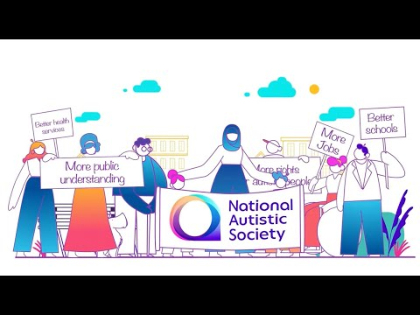
Activity 12.3 – Understanding Autism (20 minutes)
Watch the video to understand more about Autism and how best to support students who face similar difficulties. The video talks about getting specialist support. This might not always be easy so it is helpful for us to think about what we can do support students with Autism.
Video: https://www.youtube.com/watch?v=Lk4qs8jGN4U
Watch and listen to the whole video, then play it again to fill in the gaps in the sentences below.
- Autism is a lifelong disability which affects how people like me …… and ……………… with the world.
- We also engage in …………….. …………………, doing or thinking the same thing over and over.
- Autistic people can also find unexpected …………, however small, very …………………
- All these challenges can make the world feel ………… ………………. and ……… …. ………………….

Activity 12.3 answers
1.Autism is a lifelong disability which affects how people like me communicate and interact with the world.
2.We also engage in repetitive behaviour, doing or thinking the same thing over and over.
3.Autistic people can also find unexpected changes, however small, very distressing.
4. All these challenges can make the world feel very scary and hard to understand.

2.5 Social and Emotional difficulties
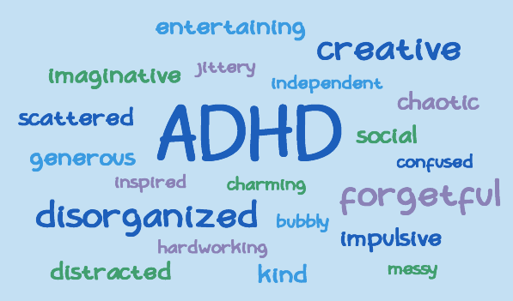
Challenging behaviours are displayed for many reasons, which may or may not indicate an underlying social and emotional difficulty such as anxiety, depression or attachment needs.
Some students have conditions such as Attention deficit disorder (ADD) and attention deficit hyperactive disorder (ADHD) which affects how they behave.

We will explore this further in the next module, but it is crucial to look for any underlying causes of any behaviour or emotional states, and aim to support them, rather than deal with the presenting behaviour. For some students with social and emotional difficulties, the nature of these difficulties mean they may have learning difficulties, either temporarily or in the long term. Around 5.4 million children (8.4%) currently have a diagnosis of ADHD.
Image source: https://commons.wikimedia.org/wiki/File:ADHD_Word_Cloud_in_Blue.png (free)
Both ADD and ADHD are often characterized by difficulties maintaining focus over extended time periods. Students with ADHD are often easier to identify in a classroom than a student who has ADD (without the hyperactivity), as ADD learners may not call attention to themselves, so the learning difficulty can go unnoticed. Sometimes, ADD students may seem to not be trying hard enough. Benefits students may encounter are high energy and enthusiasm for learning, confidence and ease in conversational tasks and often courage, willing to take risks with their learning.

What might it look like? | How to support students
- Difficulties in maintaining focus  - Children can have poor impulse control and be fidgety (ADHD)  - Written work can be messy.  - High energy and excitement (ADHD)  - Students may need support with their general organisation  - Can appear lazy or tired (ADD) | - Clear instructions and routines  - Using students’ names before giving an instruction  - Multi-sensory learning strategies  - Keeping learning environments calm & being patient  - Breaking down learning into small steps  - Encouraging collaborative work and peer study  - Providing students opportunities to talk and discuss their learning

- Teacher expectations
Research shows that children live up to their teachers’ expectations. Low expectations lead to low academic achievement and poor behaviour. When teachers have high expectations, student achievement and behaviour soar. There is a danger that in beginning to understand the needs of students that may face difficulties that they overcompensate and make work too easy. It is important that educators have high expectations of students with specific learning difficulties and disabilities. High expectations establish a culture of success and ensures that students aren’t left behind.
“Positive beliefs and high expectations of adults and pupils alike may well be the most important factor in ensuring that vulnerable pupils achieve.” Rowland (2017)

Activity 12.4 – Learning difficulties – names and definitions (20 minutes)
  - Read the names and descriptions and try to match them. The first one has been done for you.

1.A common learning difficulty usually affecting the way students break words down, causing difficulties in decoding reading, spelling, and writing.
Attention disorder

2. Students can have trouble with simple arithmetic and maths problems, grouping numbers and performing the right order of operations.
Dyslexia

3. A motor skills difficulty that can affect the planning and coordination of muscles, including those of the hand.
Hyperactivity

4. Often students experience difficulties maintaining focus over extended time periods. Sometimes students can have poor impulse control, be fidgety.
Dyscalculia

5. This type of learning difficulty can go unnoticed until it results in incomplete tasks and often poor performance on tests.
Dyspraxia

  - Think about the students you teach and if any of them have similar difficulties with their learning.

Activity 12.4 answers
Attention disorder | Dyslexia | Hyperactivity | Dyscalculia | Dyspraxia
5 | 1 | 4 | 2 | 3

- Learning difficulties in a traditional learning environment
Traditional teaching is generally lecture style, teacher focussed and a one-size-fits-all approach. Specific learning difficulties like dyslexia and dyscalculia can sometimes provide huge challenges for students in a traditional classroom environment, as drill exercises such as asking students to learn through memorization can make it impossible for children to achieve the same results.
It is important that we try to understand any behaviours such as avoiding learning or where students are generally not very motivated. Is the learning too easy or too difficult? Do they understand what has been asked of them? Often students with ADHD are disciplined for being disruptive but when we adapt the way we speak to them or allow time for them to discuss, practice and apply their learning, it can make a big difference. We will explore behaviour in more detail in Module 14.
Teachers have a role to ensure that students have a positive self-image of themselves as learners and this means ensuring that they can achieve. Traditional education can move students forward even when they haven't learned what was expected and might not let them move beyond their grade level. For students who grasp concepts quickly and have a high IQ, teachers might notice a similar dip in motivation or a change in behaviour, if they start to switch off without the excitement of new learning and challenge. Accommodating the needs of learners, narrows learning gaps and, over time, makes it increasingly easier for children to progress.
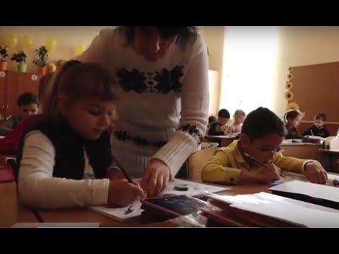
Activity 12.5 – Understanding needs (20 minutes)
Watch the video to watch different strategies to identify students that’s need support.
Video: https://www.youtube.com/watch?v=ENvkE_0N3jo

  - Can you think of a way you can facilitate the learning to observe any students that are struggling to participate and learn?

  - Write down an idea in your learning journal that you have taken away from this video to try. If you can, discuss it with a colleague and ask them if they have tried it.

- Universal Design for learning
You may have noticed by now some patterns in what is suggested to support students with a variety of learning difficulties and disabilities. Strategies such as multi-sensory learning approaches, working with others, being patient, adapting or modifying tasks have been suggested for a range of needs.
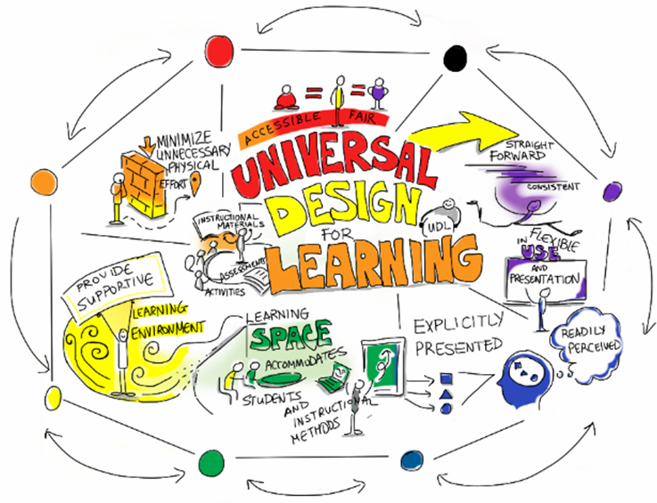
A Universal Design for Learning (UDL) approach means teaching in ways that benefit the widest variety of learners. For example, designing lessons that support all learners, including students who have dyslexia and/or other learning disabilities. A teacher using UDL may give students a choice of how they complete their learning, be flexible and supportive or offer a variety of materials to support students.
The main principles are;
- Representation - to offer multiple ways of the content rather than just a textbook. This could be audio, visual representations or more practical ways of learning.
- Expression – to allow students options on how they express their learning. Some may complete a written test and others may have an oral exam.
- Engagement – offering different ways for students to engage in their learning.
Image source: https://www.flickr.com/photos/gforsythe/8527950743 (free)
Think back to previous modules and notice how this links to them. In module 3 we focused on planning and how that linked to creating a class profile. In module 2 we discussed the importance of knowing your learners, their strengths, weaknesses, etc. to plan SMART learning outcomes for them. In module 11 we looked at differentiation and how UDL and differentiation compliment each other. With UDL, teachers provide regular feedback. Teachers may talk with individuals about lessons or they are encouraged to reflect on their learning, if they have achieved their goals and encouraged to think about what might have helped them.

Activity 12.6 – UDL task (20 minutes)

In a traditional classroom, there may be only one way for a student to complete a task. This might be following a textbook or completing a worksheet.

When teachers use UDL, they provide multiple options. For instance, students may be able to create a poster or a video to show what they know. They may even be allowed to draw a comic strip. The focus is on the result, to meet the learning outcomes, and students have some choices on how the achieve it. This can be particularly effective when a teacher would like students to show what they have understood at the end of a unit of work.

Create and describe a repeated pattern

- Plan different ways for students to meet the same outcome.
- Copy the grid below into your learning journal and think of ideas to engage learners.
- Write down how students with difficulties might approach these tasks.

Task | How it supports students’ strengths
Using musical instruments students sing a song with a repetitive beat.
Students use stones and twigs in the outside area to create a pattern.

- Consider a child with an attention difficulty. How will this style of learning suit them?
- Have you tried this approach before?
- What are the benefits and challenges of teaching in this way?

Activity 12.6 answers
Potential benefits and challenges of using the UDL approach

Benefits | Challenges
- A greater opportunity for learners to more fully demonstrate knowledge  - Learning is adjusted to suit different learning styles  - Learning is presented in different ways  - Students are given an equal chance to succeed  - Students learn at their own pace  - Students are motivated  - Freedom from one size fits all approach  - Builds confidence  - Stimulates curiosity | - Can take longer to plan learning outcomes and tasks for lessons  - It is important to know learners well to understand how to make adaptations.  - Organising multiple tasks can be difficult, particularly time management.

- Why is it hard to identify some learning difficulties?
Teachers are often the first to notice that a child finds certain areas difficult. Sometimes the signs are easy to see, like a student who isn’t making a similar amount of progress as their peers. Or a child who is working hard and focussed but isn’t retaining the information. Sometimes the signs are harder to see and that can mean children who need extra support go unnoticed.
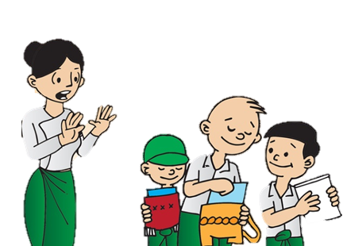
In the examples of learning difficulties shared already in this module, it would be quite common for a student to be a confident and able writer but struggle with basic maths. Or for a student to give great answers in class discussions but can’t get their ideas down on paper. These gaps often cause students with learning difficulties or disabilities to be labelled as lazy or told to just try harder, or they receive more work to try and fill the gaps when they might just need that information presented in another way. Knowing what to look for can help teachers support students in providing the help they need.
Students might learn how they can go unnoticed in a classroom situation. If they seem shy, they may be trying to hide a learning issue. Equally if they are loud and act out to draw attention to themselves this could be to distract attention away from difficulties they may be experiencing. Students might pretend to not care about school, skip lessons, or say they feel “sick” regularly.
General signs should educators be looking for?
- Poor performance
- Learners who appear to pick up concepts at a lower pace than their peers
- Students who need constant reminders of what to do next
- Learner who have trouble with transitions or seem disorganized.
- Difficulty following directions
- Difficulty focussing
- Avoidance behaviours
- Lack of motivation or overzealous behaviour

Activity 12.7 – Identifying difficulties and supporting students (20 minutes)

- Read the case story below
- Suggest ways the teacher can support the student with his learning.

You might find it useful to make some notes and reflect in your learning journal or discuss this scenario with a colleague.

Case story

The teacher has noticed that Aung Htin has been finding certain tasks difficult in class.
He always looks disappointed when there are reading tasks and often loses his place when the students are listening and reading aloud. The teacher wants to make sure that all children get the opportunity to read aloud so it is fair, but Aung Htin gets embarrassed about this. His homework is always completed to a very high standard so the teacher is not sure how she can help him.

Activity 12.7 answers

Suggestions on how to support Aung Htin in class. You may have other ideas based on what you already do to support students in your class.

- The teacher could talk to the student and ask him if there is a specific area he finds hard, e.g. following the text when it is read aloud, reading the words, punctuation marks, etc. This would allow the teacher to support in the best way.
- If it is about following the text, the teacher could suggest Aung Htin uses his finger to trace under each word as it is spoken or use a sheet of paper to cover up the text below and as it is being read lower the page.
- Ask students how they feel about being asked to read aloud and provide less threatening (perceived) opportunities to read aloud. This could be in a smaller group or with a peer.
- The teacher should ask Aung Htin about his homework. It is a possibility that he is receiving help from a sibling or parent if the work he is producing isn’t consistent with what the teachers sees at school. There may be an opportunity here to speak to Aung Htin’s parents about how best to support him at home too.

- What to do if you suspect a student has a learning difficulty
Depending on the challenges a student is experiencing will affect how you respond. They may not be performing in a way that you would expect or their behaviour may seem out of character.
It is important to remember that everyone will experience events in their life that may affect their usual temperament. It maybe that a student will display learning difficulties during a challenging point in their life and they need some extra support during that time.
However, if you identify early signs of a possible learning difficulty or disability, it is important that you seek support. This could be from a medical professional or a more senior colleague. Early intervention can have a big impact on the support the student receives moving forward. For example, a student who is finding basic maths challenging is likely to continue to find maths difficult as the curriculum expectation widens.
- If you suspect a learning difficulty, you could talk to any other teachers that may also teach that student and ask if they have similar concerns.
- You might decide to speak to the student’s parents to understand their behaviour outside of school.
- Consider the age of your student and if the concern is outside of what is expected to be typical for their developmental milestone.
- It may be appropriate to rule out vision or hearing problems as these could be underlying reasons for difficulties in class.

Activity 12.8 – Supporting a student with a visual impairment (20 minutes)

Discuss the way we describe pupils – not to say dyslexic pupils, or autistic pupils, but pupils with dyslexia or autism as otherwise the focus is on the disability, not the person.
When someone has difficulty seeing or hearing we say that they have a visual or hearing impairment.

- Imagine you have a student in your class with a visual impairment.
- What barriers to learning do you think they will experience?
- Think of the last lesson that you taught. What adaptations would you need to make to ensure this student can achieve?

Make some notes in your learning journal and discuss the questions with a colleague if you can.

Activity 12.8 answers
This activity is to help you to start thinking about how to support students – we will explore this further in the next module.
- Find out about the student’s difficulty and ask them what they feel they need support with.
- They may benefit from sitting at the front of the class.
- The student may benefit from using some visual aids/resources that have been prescribed (e.g. glasses, magnifiers, big-print books, etc).
- Make sure lighting is suitable, e.g. eliminating the risk of glare from the desk or board.
- Spend time walking around the room, allowing the student to become familiar with the layout. You might consider using something around the room that they can touch to help them find their way.
- Do not relocate objects or furniture without telling the student.
- Find out if there are resources available in braille and how to support the student to use it. Large print may be more appropriate to use.
- Make adaptations using audiotapes, electronic text and oral testing/scribing where possible.

- Wrap up
In this module you have:
1. Identified and described what learning difficulties are.
2. Explored the different categories of learning difficulties. e.g communication, social, emotional, physical, cognitive, etc.
3. Demonstrated an understanding of the impact of learning difficulties in the classroom.
4. Explored the Universal Design for Learning to plan how you represent, express and engage learners.
5. Reflected on the steps to take if you have concerns about a student.

Key points from this module:
- How to identify pupils with difficulties in the classroom.
- Often similar strategies can be used to support different learning difficulties.
- Clarity about the difference between specific and general learning difficulties.
- The importance of having high expectations of students with specific learning difficulties.
- Universal design for learning approaches ensure that students with learning difficulties can access the same learning opportunities as their peers.

Reflection
To help you remember and think about the topics introduced in this module, try to answer the following questions. Use your learning journal to make a note of your reflections.
- What specific learning difficulties can you now name and can you define them?
- How can you recognise learners who find learning difficult? (e.g. students who find it difficult to sit still, anxious students, or students with repetitive behaviour, etc.)
- What barriers to learning have you observed among the students in your class?
It can be helpful to understand the difficulties and the barriers without labelling, e.g. understanding the autism spectrum.
- How are children screened or supported in your setting?
- End of module 12 quiz
Please answer the following questions in your learning journal. You can attempt as many times as you like to reach 100% pass. Some questions require more than one answer.
Q1 – Select the specific learning difficulties from the list below. (Choose 2 answer)
- dyslexia,
- dyscalculia
- lazy
- depressed

Q2 – How would you identify a student with possible signs of dyslexia? (Choose 2 answer)
- They have trouble holding a pencil so writing is difficult.
- Coordination is a struggle, the student often bumps into furniture when walking in class.
- They often spell common words incorrectly.
- The student has had trouble with letter reversals.

Q3 – Identify the physical difficulty from the list below (Choose 1 answer)
- Autism
- Dyspraxia
- ADHD
- Dyslexia
- ADD

Q4 – What does UDL stand for? (Choose 1 answer)
- Universal Design for life
- Understand Diverse Learning
- Understand Difficulties for Learning
- Universal Design for Learning

Q5 – If you identify a student that is having difficulties you should; (Choose 1 answer)
- Tell them to work harder and concentrate more
- Give them more work to try and catch up
- Try to understand the area of difficulty and how best they can support the student
- Sit the student with other students who can complete the work for them

Q6 – Which of the following is correct? (Choose 1 answer)
- Learning disabilities only occur in childhood
- There is only one type of learning disability
- Learning disabilities are lifelong
- You cannot give students with learning disabilities tests or exams

Answers – end of module 12 quiz
Answers in bold

Q1 – Select the specific learning difficulties from the list below. (Choose 2 answer)
a) dyslexia,
b) dyscalculia
c) lazy
d) depressed

Q2 – How would you identify a student with possible signs of dyslexia? (Choose 2 answer)
a) They have trouble holding a pencil so writing is difficult.
b) Coordination is a struggle, they often bump into furniture when walking in class.
c) They often spell common words incorrectly.
d) The student has had trouble with letter reversals.

Q3 – Identify the physical difficulty from the list below (Choose 1 answer)
a) Autism
b) Dyspraxia
c) ADHD
d) Dyslexia
e) ADD

Q4 – What does UDL stand for? (Choose one answer)
a) Universal Design for life
b) Understand Diverse Learning
c) Understand Difficulties for Learning
d) Universal Design for Learning

Q5 – If you identify a student that is having difficulties you should; (Choose 1 answer)
a) Tell them to work harder and concentrate more
b) Give them more work to try and catch up
c) Try to understand the area of difficulty and how best they can support the student
d) Sit the student with other students who can complete the work for them

Q6 – Which of the following is correct? (Choose 1 answer)
a) Learning disabilities only occur in childhood
b) There is only one type of learning disability
c) Learning disabilities are lifelong
d) You cannot give students with learning disabilities tests or exams

- Improving teaching and learning

Activity 12.9 Improving your own teaching practice. (30 minutes)

It is important to reflect on the answers to the activities you have completed earlier.

Scenario – Your Head teacher asks to meet you to ask about the students you teach and if there are any that you have identified that have any difficulties with their learning.
LJ
Make notes in your learning journal:

- How do your students cope with lessons or skills they find difficult?
- How do they feel or behave when they feel they can’t do something?
- How do you encourage your students, with or without learning difficulties?

Activity 12.10 Self-assessment
REFLECTION: How well do you think you are equipped to identify students with learning difficulties? Look at the scale below and choose the number that best describes you now. Answer in your learning journal.
NOT well
VERY well

Compare your first self-assessment score at the beginning of this module to this one. In your learning journal provide a short analysis of your thoughts about any differences.

Your 12th PROMISE to your STUDENTS

1
3
2

Review

Do

Plan

Please add your 12th promise to the section in your learning journal entitled ‘Promises.’
Each module contains one promise you will make to your learners: you will make 15 promises in total.

Appendix 1
Guidance Inclusive language: words to use and avoid when writing about disability

Avoid | Use
(the) handicapped, (the) disabled | disabled (people)
afflicted by, suffers from, victim of | has [name of condition or impairment]
confined to a wheelchair, wheelchair-bound | wheelchair user
mentally handicapped, mentally defective, retarded, subnormal | with a learning disability (singular) with learning disabilities (plural)
cripple, invalid | disabled person
spastic | person with cerebral palsy
able-bodied | non-disabled
mental patient, insane, mad | person with a mental health condition
deaf and dumb; deaf mute | deaf, user of British Sign Language (BSL), person with a hearing impairment
the blind | people with visual impairments; blind people; blind and partially sighted people
an epileptic, diabetic, depressive, and so on | person with epilepsy, diabetes, depression or someone who has epilepsy, diabetes, depression
dwarf; midget | someone with restricted growth or short stature
fits, spells, attacks | seizures

Gov.UK (2021)

References

British Dyslexia Association (2018) See dyslexia differently
https://www.youtube.com/watch?v=11r7CFlK2sc

What is cognition? (2015)
https://www.cambridgecognition.com/blog/entry/what-is-cognition

Child counseling & Special needs education (2020) Difference between learning disability and learning difficulty.
YouTube https://www.youtube.com/watch?v=I-xA9B_U1JU

EENET - Enabling Education Network (2017) Programme 6 ~ Understanding learners needs
https://www.youtube.com/watch?v=ENvkE_0N3jo

Gov.UK (2021) Guidance Inclusive language: words to use and avoid when writing about disability
https://www.gov.uk/government/publications/inclusive-communication/inclusive-language-words-to-use-and-avoid-when-writing-about-disability

National Autistic Society (2019) What is Autism?
https://www.youtube.com/watch?v=Lk4qs8jGN4U

Rowland, M (2017) Learning Without Labels

Teachings in Education (2018) Students with Disabilities: Special Education Categories
https://www.youtube.com/watch?v=cFtg2xub10E

TEDx Talks (2017) ADHD from the inside | Toby Shaw | TEDxYouth@ISPrague
https://www.youtube.com/watch?v=VOZyzoj7eh8

Touch-type Read & Spell (2021) 5 Types of learning difficulties
https://www.readandspell.com/types-of-learning-difficulties

