Review of the OER Development Activity Phase 2 –Tutor Notes
Andy Lane

Introduction
These notes need to be read in conjunction with the OER Development Activity Phase 2 document sent to participants and the Guide to OER mentoring and development document. Susan is the only one not to have been a mentor so this mostly applied to her. Suffice to say that the activity has not gone smoothly and which led to me sending out the following email to all teams in late April:
-------------------------------------------------------------------------------------------------------------------------------------
Dear TIDE Participants,

It has become clear that many issues have led to delays in you, in your teams, and your mentors, being able to complete the different parts of this activity within the deadlines set out in the OER Development Phase 2 activity document. These issues include busy workloads by all involved and not always having a clear appreciation and understanding of what needs to be done.

In hindsight both the activity itself, and the instructions I wrote in that document, made too many assumptions as to what could be done in this period. I thank you all for what you have been able to do so far in completing Part 1 (selecting part of a course to adapt) and Part 2 (completing the given template explaining why you made this selection and what you would change to make this part of the course suitable for your students). The original deadline for completing Part 3 (marking up and/or making changes to a word version of the part of the course) was the 17th April.

This third part of the activity seems more challenging as few of you are used to creating or adapting these forms of distance learning material (a skill that will become more essential as more of you become responsible for developing and running distance learning courses under the one campus two systems model). I have therefore decided to allow more time for you to complete part 3 by changing this deadline for submitting part 3 to the 3rd May. This deadline also gives enough time for mentors to provide feedback on these submission before you attend the May residential school in Yangon. If your submission of part 3 comes later than this we cannot guarantee that the mentor can provide feedback before the residential school.

This change also means that I do not expect you to do part 4 of the activity.

It also means that we will need to reflect on the scope and nature of this activity at the residential school (we already have one session planned for this but may do more) so that we can better understand what you are able to so that we can design a better Phase 3 activity for the time between the May and the November residential school.

To finish, I want to elaborate on what you need to do for Part 3 of the activity. You should remember from the November 2018 residential school that we got you to work through a printed copy of an online course in the Adapting Educational Resources activity. In that case you wrote on, or used highlighter pens, to mark-up parts of this teaching text that you thought needed adapting for use in Myanmar and then gave short presentations to other teams on what you would change. For this part 3 of the activity I want you to do something similar but this time by downloading a word version of the online course and then digitally writing on (using the comments function in Word) and highlighting what you would change. These comments should also indicate what material you would take out and what new material you might add in and from where you would take that new material. And please also carefully read the specific comments that your mentor has made so far.

In the end we want to make sure that what TIDE does is of use to you either now or in the future as your universities adapt to the changes underway within the higher education sector.

With best wishes

Andy Lane
TIDE Academic Director
------------------------------------------------------------------------------------------------------------------------

The residential school activity
As the preceding activity to this session has had it troubles the main task for this session is to de-brief and get fulsome feedback from the teams as possible. To that end it is more difficult to precisely structure the activity. I have added a fourth slide to the presentation that participants will not have seen that sets out three steps to follow:
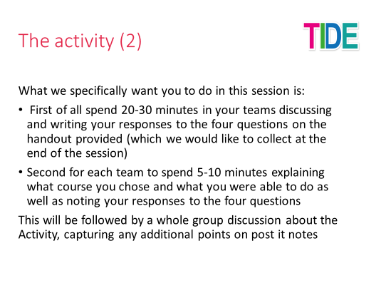
This is something we could change if you feel we need to. You will also see that I talk about a handout with four questions which is given here as an Annex. Again you may feel we should be using different questions. However, whatever structure and questions we might use a key factor is wanting to have as much written or otherwise recorded feedback as possible for me to subsequently evaluate and think about for the forthcoming Phase 3 activity for the 2018 cohort and in revising the Phase 2 activity for the 2019 cohort (which thankfully they will not do until early 2020).

Review of the OER Development Activity Phase 2 – Team Feedback

Team name:

What parts of the instructions for the activity were clear for you?

What parts of the activity were not clear for you?

What parts of the activity were you able to do well?

What parts of the activity were you not able to do well?

Other comments

