Inclusive Teaching Practice
Facilitator’s Guide
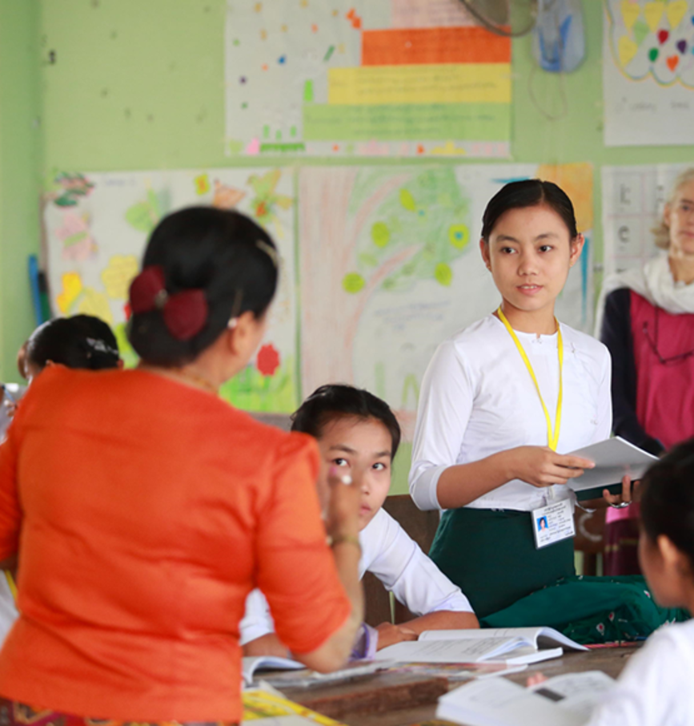

Source: VSO Image library

Module 1:
What is an Inclusive School, Classroom and Teacher?
Module 1: What is an Inclusive School, Classroom and Teacher?

Overview
This is the first of fifteen modules that look at how we create a positive Inclusive Learning Environment for all. You will see how inclusive teaching practices encourage, develop and use the 21st century skills of critical thinking, communication, collaboration and creativity. These modules are for any educators or those studying in education in Myanmar. The terms student and learner are used interchangeably throughout the module.
Module number | Module title
1 | What is an Inclusive School, Classroom and Teacher?
2 | Knowing your learners
3 | Planning learning outcomes for all
4 | Participating through learner centred approaches
5 | Creating a positive learning environment
6 | Effective questioning and feedback
7 | Active participation
8 | Peer, co-operative and collaborative learning
9 | Supporting students’ emotional and social wellbeing
10 | Legal framework and policies around Inclusion in Myanmar
11 | Supporting all students through differentiation
12 | Identifying specific learning difficulties
13 | Supporting all learners with differences or disabilities
14 | Positive behaviour management
15 | Assessment for student achievement

Learning Journal
Please ensure all participants are aware of the learning journal and its purpose for the module. Point them to the advice given in their participants’ copy of the best way to complete. All answers to activities need to be written in their journal. Remember, reflection is an important part of the learning process and a worthy activity alone. Encourage participants to make a note of new and interesting words/phrases/terms as they make their way through the module.

Study tips
It is important to explain how to approach completing the module. Participants need to take their time, develop a suitable timetable and where possible check their answers with colleagues. The use of think / pair / share is a good way for them to collaborate, share ideas, ask questions, check their work, and give feedback.

Welcome to the Inclusive Practice CPD modules.
Before participants attempt module 1 it is necessary for them to read the ‘course overview’ booklet which locates the importance of inclusive practice in their educational system. There are 3 key themes explored in the modules that reflect the educational reform taking place in all education settings: Inclusion, Gender Equity and 21st century skills. These themes are key in all areas of curriculum, and vital not only for Myanmar’s educational ambitions and sustainable development but equally vital for the global future.
This course has been designed to help participants engage in this discussion by challenging their beliefs and attitudes about their own teaching, their students’ learning and the impact their EDC or school has on inclusion. It is expected that as a facilitator, you will challenge their beliefs and attitudes throughout the modules.
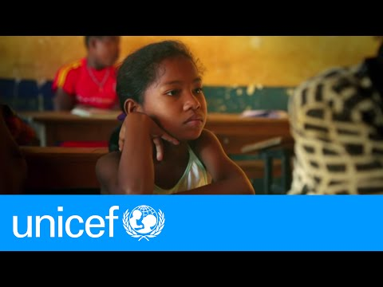
It is also important for you as a facilitator to embed many of the teaching and learning techniques associated with inclusion in education into this course. Encourage participants to work at their own pace and consider their own abilities, interests and skills. Encourage them to watch the first video as an introduction. https://youtu.be/Un5msddQl6U
The modules look at how we create a positive Inclusive Learning Environment for all. You will see how inclusive teaching practices support gender equity and encourage, develop and use the 21st century skills of critical thinking, communication, collaboration and creativity. Each module below is made up of a series of activities participants can work through at their own pace. Once they have completed the module, they will have a multiple-choice quiz to complete.

Learning outcomes for Module 1
By working through this module, participants will be able to:
- explain the basic principles of inclusion.
- discuss reasons why inclusion is important.
- explain what makes an Inclusive school.
- explain what makes an Inclusive classroom.
- explain what makes an Inclusive teacher.

In this first module encourage the participants to think about what inclusion means to them, why we need inclusion and what the features are of an inclusive educational institution and teacher. The activities in the module will take them approximately 7 hours to complete. This module will help participants think about the basic principles of Inclusion and the features of an Inclusive School, Classroom and Teacher.

Extra instructions for the activities in module 1

Activity | Additional points to consider
Introduction | Encourage participants to read a full version of the reading extract as an extension activity only. https://unesdoc.unesco.org/ark:/48223/pf0000137522_bur.
- –  Self- assessment | Some participants may need encouragement to be honest in their self-assessment. Ensure that they know it is the start of 15 modules around inclusive practice and their understanding and confidence will develop over time. The results from this self-assessment will be compared to another self-assessment at the end of the module 1, allowing participants to make comparisons and reflect on their learning.
- - What does Inclusion mean to you? | This identifies what inclusion is more generally, outside of teaching. Introduce the use of a learning journal and advise participants how they can use it as a reference for their learning and note new terminology.
- - Definition of  inclusion | Participants should copy the answer table into their learning journal. The second part of the activity is the first chance for them to think of a definition for inclusion. Encourage discussions amongst participants to fine tune their definition.
1.4 - Feeling valued | Encourage participants to think of occasions in their private lives, (not educational), when their presence, participation and achievements were valued. How did it make them feel? What impact did it have?
1.5 - The  importance of inclusion | Ask participants to watch the videos (in pairs if easier) and make notes of key points. This activity helps to show the breadth of inclusion. Encourage participants to discuss and draw an analysis of key messages. Their answers can be written in their learning journal.
- - What makes  an inclusive educational institution? | This activity gives real life examples and would be best used as a large-scale sorting activity in groups. It encourages participants to think about the practical nature of inclusion and how it can be applied at the broad school level. Participants need to start using their own senses to think about inclusion for different students’ needs
1.7- How inclusive is your educational institution? | Ask participants to reflect broadly on their own educational institution and how inclusive it is. Allow time for discussion before you ask participants to record and share their answers.
- - What makes an  inclusive classroom? | This activity focuses on how inclusive participants’ classrooms are. They need to sketch their own classroom and firstly think about the physical features of the room.
- - How inclusive  are our current classrooms? | Encourage participants to think about their classroom/context. Encourage them to use their senses, identify key sights, sounds, feelings and ask them to reflect on what impact they may have on teaching and learning. For example, do all children have a good view of the teacher/board? Is the classroom accessible for all learners? Are any children with visual or auditory impairment sat in the most appropriate place to enable them to access the learning? Do the size of the groups allow all children to participate? Ask participants to present their plans and reflections with the group.
- - Making  improvements to your classroom | Ask participants to identify improvements or make suggestions to each other following their presentations. Challenge them to think carefully and broadly.
1.11 - What makes  an inclusive  teacher? | Focus on the importance of attitude in individual teachers and the impact that has on students. Participants need to use their notes from previous activities. Inclusive practice can be achieved with a warm, caring, diligent teacher with the right attitude. Invite participants to share examples of how they have shown this in their teaching and the impact that had on teaching and learning. Ensure that participants understand that resources are not needed to be an inclusive teacher.
1.12-  Self-assessment | This is a key activity which needs to be considered carefully. Ask participants to answer questions and reflect on their own teaching practice. Participants may reflect further by giving examples that link to the score they have given themselves. Ask them what they might need to shift some of the inclusive behaviours closer to ‘All of the time’? It may help to give participants time to talk through their score with their colleagues. This activity should help them to select a promise at the end of the module when they are prompted to.
1.13 - How inclusive  are you? | This activity uses the answers to activity 1.11 and asks participants to write a brief analysis of their inclusive practice.
Wrap up | A consolidation of the module and key points. There is no activity here.
End of module 1 quiz | This is a multiple-choice questionnaire that tests participants’ understanding of the module. Encourage participants to self-assess and revisit their answers as many times as needed to achieve 100%.
Answers to the end of module 1 quiz | Participants should revisit the questions until they achieve 100%. Remind them that some questions require more than one answer.
1.14 - Improving  your own  teaching  practice | This activity provides a scenario for participants to consider. It asks them to respond as though they are replying to questions from their head of department applying previous knowledge learnt. Invite participants to role play and share their experiences with the group. Ask participants how confident they felt when giving their responses. Encourage them to make notes in their learning journal.
1.15 -  2nd Self-assessment | The self-assessment duplicates the first self-assessment. Ask participants to reflect on their confidence and discuss the difference in scores.
The promise | Ask participants to think of one thing they will take away from module 1 and make a promise to their students about what they will improve. Ask them to evaluate that promise and recognise changes (after x weeks). Encourage participants to reflect on any impact that change has had on teaching and learning and how to improve it further. This reflects the beginning of the action research cycle and can be built on in future modules to create an ongoing action plan for development.

End of module 1 quiz - Answers
Participants can attempt the questions as many times as they like to reach 100% pass. This allows them the opportunity to become confident. (Answers in bold)

Q1- Inclusion is…
- just about thinking how to teach children with disabilities.
- a process that enables all children regardless of any difference to learn and grow together.

Q2 - Inclusion happens when we value every learners'…
- presence, performance and ability.
- progress, participation and ability.
- presence, participation and achievement.
- personality, progress and achievement.

Q3 - The biggest barriers to inclusion are… (choose 2)
- if we think a learner's difficulties stops them from learning.
- if a learner has a physical difference such as being blind.
- if a learner comes from a poor family and has to work.
- if we create a learning environment that makes it difficult for a learner to participate.

Q4 - Which of these are features of an inclusive school? (Choose 2)
- Specialist teachers for disabilities
- Everyone feels welcome.
- Students are equally valued.
- Computers available for learning.

Q5 - Which of these are features of an inclusive classroom? (Choose 2)
- Lessons encourage the participation of all students.
- Every learner has a textbook.
- Teaching is planned with all students in mind.
- Class size less than 30 learners.

