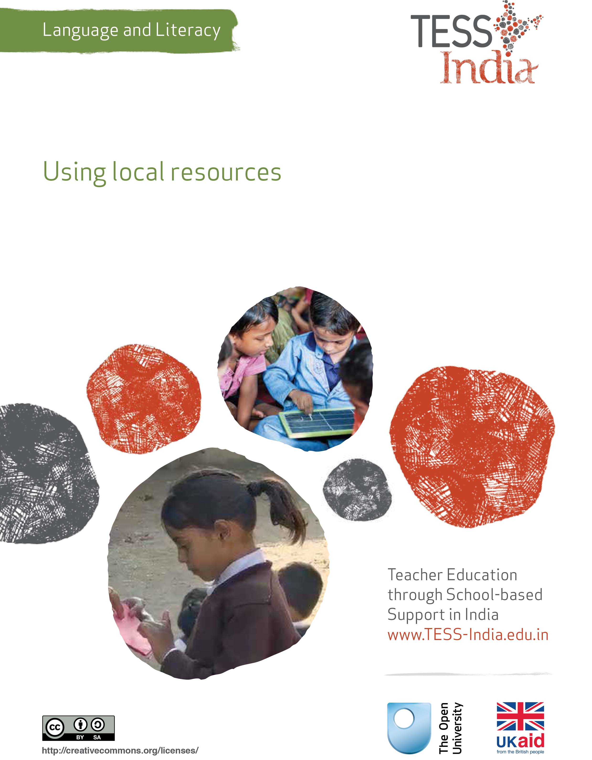
TESS-India (Teacher Education through School-based Support) aims to improve the classroom practices of elementary and secondary teachers in India through the provision of Open Educational Resources (OERs) to support teachers in developing student-centred, participatory approaches. The TESS-India OERs provide teachers with a companion to the school textbook. They offer activities for teachers to try out in their classrooms with their students, together with case studies showing how other teachers have taught the topic and linked resources to support teachers in developing their lesson plans and subject knowledge.
TESS-India OERs have been collaboratively written by Indian and international authors to address Indian curriculum and contexts and are available for online and print use (http://www.tess-india.edu.in/). The OERs are available in several versions, appropriate for each participating Indian state and users are invited to adapt and localise the OERs further to meet local needs and contexts.
TESS-India is led by The Open University UK and funded by UK aid from the UK government.
Video resources
Some of the activities in this unit are accompanied by the following icon: . This indicates that you will find it helpful to view the TESS-India video resources for the specified pedagogic theme.
The TESS-India video resources illustrate key pedagogic techniques in a range of classroom contexts in India. We hope they will inspire you to experiment with similar practices. They are intended to complement and enhance your experience of working through the text-based units, but are not integral to them should you be unable to access them.
TESS-India video resources may be viewed online or downloaded from the TESS-India website, http://www.tess-india.edu.in/). Alternatively, you may have access to these videos on a CD or memory card.

Version 2.0 LL10v1
All India - English
Except for third party materials and otherwise stated, this content is made available under a Creative Commons Attribution-ShareAlike licence: http://creativecommons.org/licenses/by-sa/3.0/

What this unit is about
In this unit you will explore the use of easily available local resources to supplement the textbook in the language and literacy classroom. Whether they involve examining writing in the environment, listening and speaking to members of the community, or using the locality as a prompt for discussion, the advantage of such resources is that they represent and generate authentic language use.

What you can learn in this unit
- How to use freely available print-based material as the basis of language awareness activities.
- How to plan a series of lessons around a guest visit to the classroom.
- How to use your students’ journey to school as a resource for developing their language and literacy skills.

Why this approach is important
Students learn best when they are engaged in practical, purposeful activities that relate to their everyday lives. They respond well to a variety of different stimuli that engage their senses and curiosity, both inside and outside the classroom. The school textbook cannot offer such a range of learning opportunities, so it is important to supplement it with a range of complementary activities. This unit shows you how to do so by drawing on the supply of authentic resources that are available in the local environment.
Start by reading Resource 1, ‘Using local resources’.
Video: Using local resources
http://tinyurl.com/video-usinglocalresources

1 Print-based local resources
You will begin by considering ways of using print-based local resources to enhance your language classroom.
Case Study 1: Using food packaging in the language and literacy classroom
Mr Deo, an elementary teacher in Madhya Pradesh, describes how he uses food packaging to develop language awareness among his Class VI students.
Apart from the textbooks, I have few resources in my classroom. Last year I realised that the slogans, lists of ingredients and instructions on food packets lent themselves well to language-based activities.
I therefore started to collect empty, clean food packets and cartons and cans, and asked my relatives and neighbours to keep theirs for me too. Many packages were illustrated with colourful words, phrases and pictures [Figure 1].
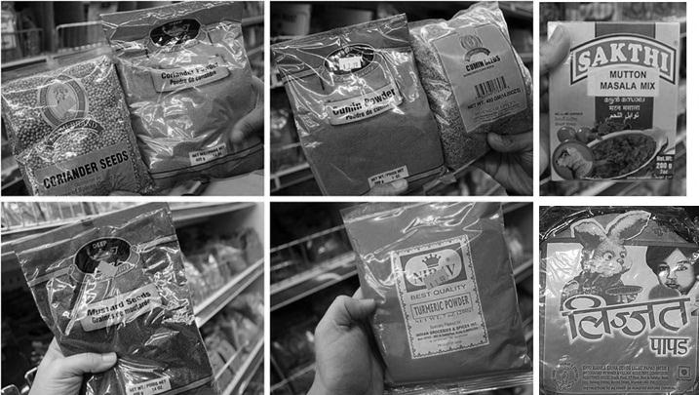
Figure 1 Examples of writing on food packaging.
I brought the packaging into class and selected one to show one to my students. It was a mango drink carton. Several of my students recognised it as they drink it themselves.
I asked my students what ingredients they thought it contained. I invited a volunteer to read out the ingredients: ‘Water, mango, sugar, artificial flavouring, preservative’. I asked another to read out the slogan on the front, ‘For good health’. We discussed the ingredients and whether they were as healthy as the slogan claimed.
We looked for other writing on the carton. There was an instruction to serve the drink cold, and a request that the carton be disposed of carefully. I wrote the key words and phrases on the blackboard.
Next, I asked my students if they remembered what an adjective was. From the words written on the blackboard, I helped them identify some examples from the packaging (such as ‘good’, ‘artificial’ and ‘cold’). I asked the additional language speakers in my class how they said these adjectives in their home language.
I then organised my students into groups of three or four and asked them to examine the packet or carton they had been given, copy out the key words and phrases, discuss their meanings, and identify any adjectives among them.
We finished with a whole-class feedback session, during which each group called out the adjectives they had found in their allocated packaging. I listed these on the blackboard for everyone to copy. The one or two examples that were not in fact adjectives allowed for helpful clarification.
I have since repeated the activity, redistributing the packaging among the groups. However, on one occasion I asked my students to focus on verbs, and on another occasion, nouns. In each case, I began by inviting examples of these word forms from the mango drink packaging, before asking groups to look for examples on the packets they had been allocated.
The feedback sessions proved very interesting in clarifying my students’ conceptualisation of language. In the case of the verbs, for example, we noticed that these often took the form of imperatives (such as ‘serve’ and ‘dispose’). In the case of the nouns, we noticed that some were singular (‘carton’), some were plural (‘ingredients’), some were concrete and tangible (‘sugar’ or ‘water’), and some were abstract (‘health’).
Even now, my students sometimes present me with another example of an adjective, verb or noun that they have found on food packaging at home.

Pause for thought
- What language learning opportunities did Mr Deo’s activity contain?
- How could you adapt or extend it to suit your students?
- What other kinds of print-based resources would lend themselves to this kind of activity?
In this activity, students talked about the words that are listed as ingredients on food packaging (i.e. nouns) and the descriptive words on the packaging (i.e. adjectives). You could also ask students to write their own recipes or slogans for their favourite foods. There are several other resources that you could use for these kinds of activities – for example, bus schedules, cinema tickets, or advertisements from a magazine.

Activity 1: Using print-based resources with your students
Look ahead at the aspects of language that you are due to cover in your Hindi textbook. Consider how you could complement one of these by drawing on print-based resources from the local environment. Take account of their suitability for your students and the ease with which you can collect them. Alternatives to food packaging include, for example, advertisements from magazines, instructions for products or processes, and leaflets announcing local events.
Collect a sufficient number of examples to distribute among the groups of students. Check the material to ensure that it contains suitable examples of the language you wish to focus upon.
Outline the different parts of your lesson, along with their timings. Bear in mind that you may need to do extension activities on a subsequent day.

Pause for thought
After you have tried out the activity, reflect on how it went.
- What language learning was achieved in the lesson?
- To what extent were you able to monitor and assess your students’ speaking, listening, reading and writing skills?

2 Speech-based local resources
Your locality also offers many speech-based resources that can contribute to your students’ learning.
Case Study 2: A visit from a cotton weaver
Ms Hena, an elementary teacher in Uttar Pradesh, describes a visit from a guest speaker that she organised for her Class IV students.
One of the textbook chapters that we had been working on was on the subject of cotton-growing. We have an artisan weaving and printing collective in our village. I thought it might be interesting to invite one of the workers to the class to talk to my students about his craft.
One day, after school, I visited the collective and discussed my idea with Mr Arun, the head weaver [Figure 2]. He was very happy to oblige. I explained to him the ages of the students and the kinds of things
they would be interested in. I suggested he bring with him various samples of cloth, different coloured dyes, and some small loom-related items, such as a shuttle, to show them during his talk.
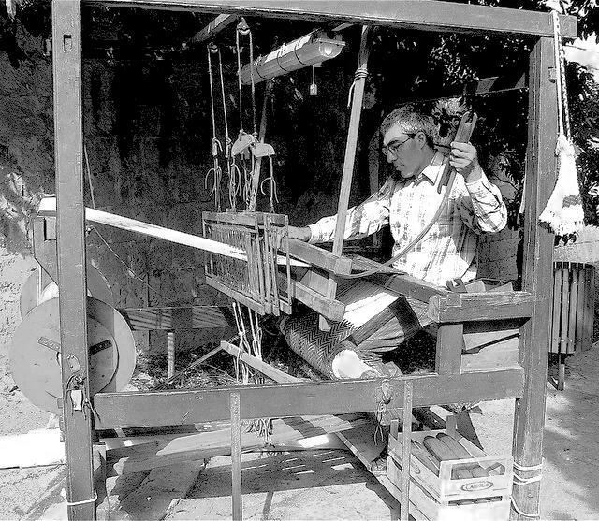
Figure 2 A weaver.
I then informed my students of Mr Arun’s forthcoming visit. They were very excited. To prepare for the visit, I organised my students in groups of four and asked them to think of two questions that they wished to ask Mr Arun about his work and write them in their exercise books. I noticed that my students were very talkative during this activity. This talk was not limited to agreeing the questions, but also involved discussing how best to write them out.
When they had finished, I asked the groups to nominate a member to share their proposed questions with the rest of the class. Rather than write the questions on the blackboard myself, I asked if anyone would like to do so. There were so many offers! I will try to incorporate opportunities for others to do this in my future lessons.
At the end of the feedback session, we had a long list of possible questions. Together, we identified and crossed out any that were very similar and organised the remaining eight into a suitable sequence. To finish, I asked my students to copy the final list of questions into their exercise books.
Some of my students were very keen to ask Mr Arun a question; others seemed shyer. Rather than allocate the questions to particular students in advance, I suggested that all of them prepare to be asked any of the questions by Mr Arun himself during his visit the next day. My students took their homework very seriously that evening.
Mr Arun’s visit proved to be a great success.. He started with an introduction to his weaving and printing work, illustrating this with samples of cloth and letting my students hold his tools. He then invited random students – some of them more confident, some less so – to ask questions. Because he had already answered some of their anticipated questions during his introductory presentation, some of those that my students had prepared were no longer appropriate. One or two students asked him unplanned questions instead.

Pause for thought
- What language learning was achieved:
- in preparing for Mr Arun’s visit?
- during his visit?
- Did it matter that some of the questions the students had planned were no longer relevant?
There are many people in the local and wider community who you could invite to talk to your students about their knowledge, skills and experiences – particularly those that relate to the topics you are covering in class.
Consider asking members of the local government or the police force, district health workers, vendors in nearby shops or market stalls, crafts people, mechanics, artists, musicians, farmers or cooks, for example.
Parents or grandparents have much to contribute as well. By talking about what they remember about the past, they can provide students with valuable insights into the history and culture of the area.
Ask your colleagues for suggestions and contacts as well.

Activity 2: Inviting a guest speaker into your classroom
Plan a class visit from a member of the local community. Approach the speaker in person, by phone or in writing, to invite them. If they agree, follow this up with a more detailed discussion about the kinds of things that would interest your students. Agree a date for the visit.
Let your students know about the guest speaker’s visit to the school in advance and set aside time for them to prepare some questions that they would like to be answered (see Case Study 2).
Think ahead to the kinds of activities that could usefully follow up the guest speaker’s visit. How could you reinforce your students’ learning of any new vocabulary associated with the speaker’s occupation, for example?
Make sure your students write a thank you letter to the guest speaker afterwards.

Pause for thought
- What language learning opportunities arose as a result of the guest speaker’s visit?
- What kinds of follow-up activities could you do with your students after the visit?
Visits such as these may be followed by individual or group writing tasks. Your students could write an illustrated account of the visit in their exercise books. Alternatively, they could describe ‘a day in the life’ of the guest speaker, on the basis of the information they have gleaned about their work. In the case of visitors who talked of life in the past, students could write a descriptive piece comparing this with the present.
As an alternative or follow-up to having a guest speaker in the classroom, older students might be encouraged to identify members of the community to interview in the locality, making audio recordings of such encounters on a mobile phone or other device, if available. By combining the answers from a series of small-group interviews of a complementary range of people, your students could write a class project considering a local issue from a range of perspectives. You may wish to approach a local newspaper to see if they would consider publishing some of this student work.
Students could also follow up guest visits or interviews with role plays. Working in pairs, one person could take the role of the interviewer, and the other, the interviewee. The role plays could be either unscripted or written out beforehand. They could be performed to classmates or to other classes within the school. Where facilities allow, photos, audio recordings or video recordings are excellent ways of capturing these student performances.
For more information on role play, read the key resource ‘Storytelling, songs, role play and drama’ (http://tinyurl.com/kr-ssrpd).
Video: Storytelling, songs, role play and drama
http://tinyurl.com/video-ssrpd

Pause for thought
Consider the follow-up activities proposed above.
- For each one, indicate with the letter ‘S’, ‘L’, ‘R’ and ‘W’ whether they involve speaking, listening, reading or writing, or a combination of these skills.
- What other skills do they incorporate?

3 Local resources around the school
You can find many language and literacy related learning opportunities in the environment around the school.
Case Study 2: The journey to school
Mr Manik, an elementary school teacher from Mayurbhanj, teaches Classes IV and V. Here he describes how he used his students’ journey to school as the basis of some talk-related activities in his classroom.
I introduced the topic by telling my students about my own usual journey to school. I had made some notes and practised what I would say the evening before, to ensure that it included plenty of interesting details. I spoke slowly and clearly, with as much expression as possible, pausing between sections and checking that all my students were following.
I mentioned where I started from, what time I left home, how long the journey normally took, what forms of transport it included, what landmarks I passed, what I found attractive on the way, who I often saw, who I generally spoke to and what languages I used to do this. I finished by talking about the effect of the changing seasons on my journey, such as use of different forms of transport and the transformation of the scenery.
I followed this up by asking my students one or two things about their own journeys to school. I then told everyone to pay special attention to their journey into school the next morning.
The following day, I organised the class into groups of four and asked them to tell one another about their journeys into school, using the following questions as prompts:
- Where do you start your journey?
- What transport do you use?
- How long does the journey take? Does it take longer depending on the season?
- What are your favourite places on the way?
- Who do you usually see?
- Who do you talk to? What languages do you use to speak to them?
Whether they shared this information in their home language or the school language, all of my students seemed to have plenty to say.
Finally, as a class, we established which students lived furthest away, which of them spoke to the most people, and which of them met up with one another during their journey to school.

Pause for thought
- In what ways could Mr Manik’s students be organised for the group discussions?
- What kinds of activities can you think of that could follow the discussions?
The groups could be organised according to who lives in similar places, or who travels together, or in mixed groups.
Suggested follow-on activities could involve:
- drawing a picture of something the students see on their route
- drawing an illustrated and annotated map of their journey
- writing a description of their journey
- writing a poem about their journey
- undertaking a class project analysing the differences and similarities among the school journeys taken by students within the class.
You can extend this activity by revisiting it a few weeks or months later and asking your students what has changed on their journey. It might be that the road has been improved, new buildings have been built or the people they meet have changed. In addition, the crops may have been harvested, certain fruits may be in season or part of the path may have been washed away, for example.

4 Summary
This unit has demonstrated how drawing on readily available resources can complement and enhance the language and literacy activities in your school textbook. Whether such resources involve print, speech or local places, all can provide your students with motivating opportunities to listen, speak, read and write in meaningful ways. Increasing the amount of local resources you use in your classes over time will ensure that your students are engaging with the kind of authentic and meaningful texts that they will encounter outside school.

Resources
Resource 1: Using local resources
Many learning resources can be used in teaching – not just textbooks. If you offer ways to learn that use different senses (visual, auditory, touch, smell, taste), you will appeal to the different ways that students learn. There are resources all around you that you might use in your classroom, and that could support your students’ learning. Any school can generate its own learning resources at little or no cost. By sourcing these materials locally, connections are made between the curriculum and your students’ lives.
You will find people in your immediate environment who have expertise in a wide range of topics; you will also find a range of natural resources. This can help you to create links with the local community, demonstrate its value, stimulate students to see the richness and diversity of their environment, and perhaps most importantly work towards a holistic approach to student learning – that is, learning inside and outside the school.

Making the most of your classroom
People work hard at making their homes as attractive as possible. It is worth thinking about the environment that you expect your students to learn in. Anything you can do to make your classroom and school an attractive place to learn will have a positive impact on your students. There is plenty that you can do to make your classroom interesting and attractive for students – for example, you can:
- make posters from old magazines and brochures
- bring in objects and artefacts related to the current topic
- display your students’ work
- change the classroom displays to keep students curious and prompt new learning.

Using local experts in your classroom
If you are doing work on money or quantities in mathematics, you could invite market traders or dressmakers into the classroom to come to explain how they use maths in their work. Alternatively, if you are exploring patterns and shapes in art, you could invite maindi [wedding henna] designers to the school to explain the different shapes, designs, traditions and techniques. Inviting guests works best when the link with educational aims is clear to everyone and there are shared expectations of timing.
You may also have experts within the school community (such as the cook or the caretaker) who can be shadowed or interviewed by students related to their learning; for example, to find out about quantities used in cooking, or how weather conditions impact on the school grounds and buildings.

Using the outside environment
Outside your classroom there is a whole range of resources that you can use in your lessons. You could collect (or ask your class to collect) objects such as leaves, spiders, plants, insects, rocks or wood. Bringing these resources in can lead to interesting classroom displays that can be referred to in lessons. They can provide objects for discussion or experimentation such as an activity in classification, or living or not-living objects. There are also resources such as bus timetables or advertisements that might be readily available and relevant to your local community – these can be turned into learning resources by setting tasks to identify words, compare qualities or calculate journey times.
Objects from outside can be brought into the classroom – but the outside can also be an extension of your classroom. There is usually more room to move outside and for all students to see more easily. When you take your class outside to learn, they can do activities such as:
- estimating and measuring distances
- demonstrating that every point on a circle is the same distance from the central point
- recording the length of shadows at different times of the day
- reading signs and instructions
- conducting interviews and surveys
- locating solar panels
- monitoring crop growth and rainfall.
Outside, their learning is based on realities and their own experiences, and may be more transferable to other contexts.
If your work outside involves leaving the school premises, before you go you need to obtain the school leader’s permission, plan timings, check for safety and make rules clear to the students. You and your students should be clear about what is to be learnt before you depart.

Adapting resources
You may want to adapt existing resources to make them more appropriate to your students. These changes may be small but could make a big difference, especially if you are trying to make the learning relevant to all the students in the class. You might, for example, change place and people names if they relate to another state, or change the gender of a person in a song, or introduce a child with a disability into a story. In this way you can make the resources more inclusive and appropriate to your class and their learning.
Work with your colleagues to be resourceful: you will have a range of skills between you to generate and adapt resources. One colleague might have skills in music, another in puppet making or organising outdoor science. You can share the resources you use in your classroom with your colleagues to help you all generate a rich learning environment in all areas of your school.

Additional resources
- Gillis, C. (1991) The Community as Classroom: Integrating School and Community Through Language Arts. Portsmouth, NH: Boynton/Cook. This activity-filled book suggests ways that students can develop their language skills through community-based learning experiences.
- Kenner, C. (2000) Home Pages: Literacy Links for Bilingual Children. London: Trentham Books.
- National Council of Teachers in English (NCTE) (undated) ‘Supporting linguistically and culturally diverse learners in English education’ (online). Available from: http://www.ncte.org/cee/positions/diverselearnersinee.
- Prior, J. and Gerard, M.R. (2004) Environmental Print in the Classroom: Meaningful Connections for Learning to Read. Newark, DE: International Reading Association.
- Siegel, M. (2006) ‘Rereading the signs: multimodal transformations in the field of literacy education’, Language Arts, vol. 84, no. 1, pp. 65–77.
- Moll, L.C., Amanti, C., Neff, D. and Gonzalez, N. (1992). ‘Funds of knowledge for teaching: using a qualitative approach to connect homes and classrooms’, Theory into Practice, no. 31, pp. 132–41.
- Azim Premji Foundation’s research studies: http://www.azimpremjifoundation.org/Research_Studies

References/bibliography
Center for Ecoliteracy (undated) ‘Teach: place-based learning’ (online). Available from: http://www.ecoliteracy.org/strategies/place-based-learning (accessed 18 November 2014).
Promise of Place (undated) ‘Research & evaluation’ (online). Available from: http://www.promiseofplace.org/Research_Evaluation (accessed 18 November 2014).

Acknowledgements
Except for third party materials and otherwise stated below, this content is made available under a Creative Commons Attribution-ShareAlike licence (http://creativecommons.org/licenses/by-sa/3.0/). The material acknowledged below is Proprietary and used under licence for this project, and not subject to the Creative Commons Licence. This means that this material may only be used unadapted within the TESS-India project and not in any subsequent OER versions. This includes the use of the TESS-India, OU and UKAID logos.
Grateful acknowledgement is made to the following sources for permission to reproduce the material in this unit:
Figure 1: various images made available in Flickr under http://creativecommons.org/licenses/by/4.0/.
Figure 2: © Peter Grima in Flickr made available under https://creativecommons.org/licenses/by-sa/2.0/deed.en_GB.
Every effort has been made to contact copyright owners. If any have been inadvertently overlooked the publishers will be pleased to make the necessary arrangements at the first opportunity.
Video (including video stills): thanks are extended to the teacher educators, headteachers, teachers and students across India who worked with The Open University in the productions.

