OnSSET/Global Electrification Platform
Hands-on 1: Exploring electrification investment scenarios using the GEP Explorer
Useful links:
- The Global Electrification Platform – Explorer (GEP Explorer)

Learning outcomes
By the end of this exercise, you will be able to:
1) Explore electrification scenarios on the GEP Explorer
2) List a few key parameters affecting the costs in the scenarios

Global electrification platform
In this exercise, you will explore electrification investment scenarios using the Geospatial Electrification Platform (GEP) – Explorer. The GEP Explorer allows the user to browse least-cost electrification strategies around the world, interact with country contextual data and many different investment scenarios. Find and access the GEP Explorer here.

How to use
From the landing page, click on START EXPLORING to go to the country selection.
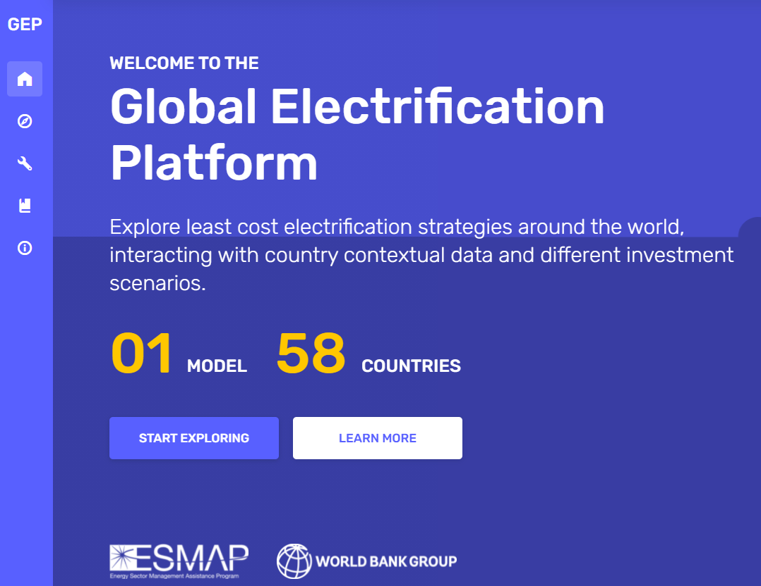
Next, click on the country for which you wish to browse electrification investment scenarios. In this exercise, we will be exploring Angola.
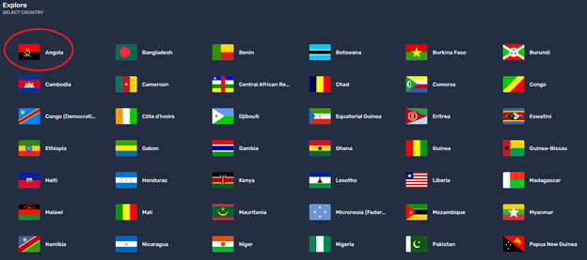

On the country page, there are several things to explore. In the middle are the results for each cluster in the country, the colour indicating the least-cost electrification technology in the cluster. To the right are the summaries for the whole country, displaying the people to receive electricity from each technology, the investments required, and the new capacity required for that scenario. On the left, you can change the scenario. There are 6 Levers available, each with two or three lever options. To change to a different scenario, select another lever option, then press APPLY.
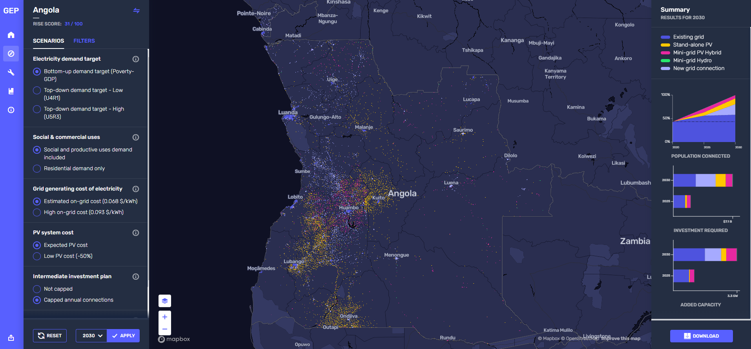
Each scenario is run in two time-steps, from 2020 to 2025, and from 2025 to 2030. Next to the APPLY button you can set the year for which you want to see the results, either 2025 or 2030. Remember to press APPLY to load the new results if you change the year.
Finally, you can also apply a number of filters, e.g., which technology options to display are shown in clusters with specific population ranges and so on. Again, click APPLY to apply the filter.

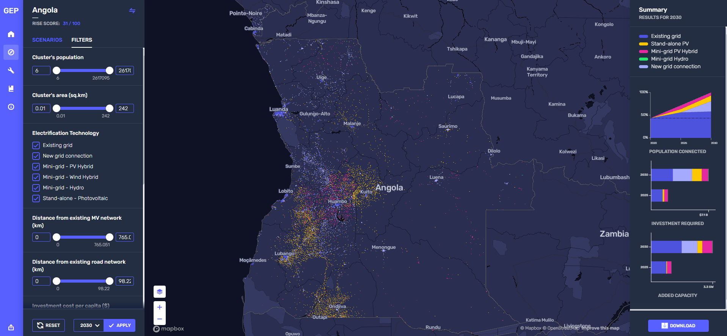

Your task
You will adopt two roles in this exercise: First Type A – The national electrification analyst; and Second Type B – the PV mini-grid developer. You will answer three questions in total.
Type A – The national electrification analyst
Task: In this exercise you are an energy analyst working for the Energy Ministry. One of your co-workers has developed a number of electrification scenarios and published them online.
Find the correct answer for the following questions (these will appear in the MCQ section):
Q1: Which two lever combinations lead to the highest cost of achieving universal access to electricity in Angola by 2030 (see the quiz question for the three options)?
Q2: What are the total investment costs required in Angola from 2020 - 2030 to provide universal access to electricity in this scenario: Bottom-up demand target (Poverty - GDP), Social and productive uses demand included, Estimated on-grid cost, Expected PV cost, Not Capped, Nationwide Least Cost approach)?
Type B – The PV mini-grid developer
Task: In this exercise you are an international solar PV mini-grid developer who is considering expansion of your business to the country. You have found the electrification scenarios online and want to use them to see how large the market for PV mini-grids may be.
Find the correct answer for the following Question (this will appear in the MCQ section):
Q3: Changing which Lever can lead to the largest share of population connected to PV mini-grids in Angola by 2025 (change only one at a time, with all other levers set to default values (Bottom-up demand target, Social and productive uses demand included, Estimated on-grid cost, Expected PV cost, Capped annual connections, Nationwide Least Cost approach)?

This exercise is an exercise adopted from: Korkovelos, A., Sahlberg, A., Khavari, B., 2019 Exercise 1: Exploring electrification investment scenarios using the Explorer [WWW Document]. OnSSET Teaching Kit. URL https://onsset.github.io/teaching_kit/courses/module_1/Excercise%201/ (accessed 2.18.21). All images are screenshots from https://electrifynow.energydata.info/ with permission from World Bank to use for this hands-on.

