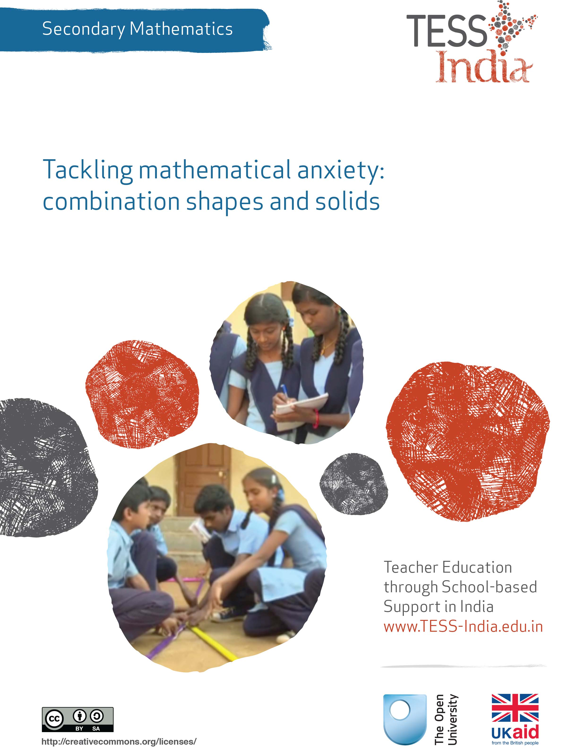
TESS-India (Teacher Education through School-based Support) aims to improve the classroom practices of elementary and secondary teachers in India through the provision of Open Educational Resources (OERs) to support teachers in developing student-centred, participatory approaches. The TESS-India OERs provide teachers with a companion to the school textbook. They offer activities for teachers to try out in their classrooms with their students, together with case studies showing how other teachers have taught the topic and linked resources to support teachers in developing their lesson plans and subject knowledge.
TESS-India OERs have been collaboratively written by Indian and international authors to address Indian curriculum and contexts and are available for online and print use (http://www.tess-india.edu.in/). The OERs are available in several versions, appropriate for each participating Indian state and users are invited to adapt and localise the OERs further to meet local needs and contexts.
TESS-India is led by The Open University UK and funded by UK aid from the UK government.
Video resources
Some of the activities in this unit are accompanied by the following icon: . This indicates that you will find it helpful to view the TESS-India video resources for the specified pedagogic theme.
The TESS-India video resources illustrate key pedagogic techniques in a range of classroom contexts in India. We hope they will inspire you to experiment with similar practices. They are intended to complement and enhance your experience of working through the text-based units, but are not integral to them should you be unable to access them.
TESS-India video resources may be viewed online or downloaded from the TESS-India website, http://www.tess-india.edu.in/). Alternatively, you may have access to these videos on a CD or memory card.

Version 2.0 SM10v2
All India - English
Except for third party materials and otherwise stated, this content is made available under a Creative Commons Attribution-ShareAlike licence: http://creativecommons.org/licenses/by-sa/3.0/

What this unit is about
Figure 1 The Taj Mahal
Feeling comfortable with working on combination shapes and solids is important, both in school mathematics and in real life. Buildings, chairs, cutlery, rangoli patterns, mosques and temples all consist of not one shape or solid, but of several put together. People are familiar with combinations of shapes, solids and volumes, but students often find it a difficult topic to deal with in school mathematics.
One of the reasons for this might be that the chapters on volume and surface area are perceived by the students to be about a series of procedures to be followed and complicated formulae to be memorised. This encourages the students to become passive learners and they might experience mathematics as something that is ‘done to them’, without any possibility for developing their own thinking and being creative. This can result in students feeling powerless, disengaged and despondent about learning mathematics.
In this unit you will focus on how to teach composing and decomposing combination solids and shapes, and the mathematical thinking involved in this process. Through activities you will also think about how to develop students’ capacity to make choices and play a more active role in their own learning.

What you can learn in this unit
- How to engage students in thinking about composing and decomposing simple solids into complex solids and vice versa.
- Some ideas on how to support students in developing and valuing their own thinking and learning in mathematics.
- How to facilitate students’ reflection on their learning.
The learning in this unit links to the NCF (2005) and NCFTE (2009) teaching requirements as specified in Resource 1.

1 Issues with learning mathematics
‘Mathematical trauma’ sounds rather dramatic. However research suggests that some students experience real stress while studying mathematics (Lange and Meaney, 2011). These students feel and believe that they are unable to act or think for themselves when learning mathematics. It may seem easy to dismiss or ignore this and say, ‘Well, these students just do not get it’, or ‘They should study harder and practise more’. But there are real reasons to believe that this trauma is stopping some students understanding and then using mathematics in their everyday lives, with many negative consequences to them and society as a whole.
Mathematical trauma can have serious consequences for students who are affected. They may reject mathematics as something that they are not able to do and will never be capable of doing. Students may get into a spiral of self-fulfilling prophecies, because the moment they cannot make sense of an area of mathematics, they believe it is because they simply do not, and never will, understand the topic. This can also affect their belief in themselves as being able to do other areas of mathematics as well. They begin to feel they have no choice or control.
One of the aspects of mathematics that can bring on mathematical trauma is the language of mathematics itself – both the symbolic representation and mathematical vocabulary, which can feel very alien and hard to connect to existing language knowledge and structures.
Activity 1 aims to help you address the issue of how to deal with mathematical vocabulary with your students. It requires the students to devise their own mathematical dictionary with:
- the word
- the official explanation
- their own explanation
- an illustration of what the word means.
Although in this case it is related to the vocabulary encountered in the chapter on surface area and volume, this approach can be taken for all topics in the mathematics curriculum.
In Part 2 of Activity 1, students are asked to reflect on their learning in Part 1. This is repeated in most of the activities in this unit. The purpose of this is for students to become more aware of what makes them learn and to become more active in their learning. This will give them a sense of choice and control over their learning.
Before attempting to use the activities in this unit with your students, it would be a good idea to complete all (or at least part) of the activities yourself. It would be even better if you could try them out with a colleague, as that will help you when you reflect on the experience. Trying the activities yourself will mean that you get insights into a learner’s experiences that can in turn influence your teaching and your experiences as a teacher.
When you are ready, use the activities with your students. After the lesson, think about the way that the activity went and the learning that happened. This will help you to develop a more learner-focused teaching environment.

Activity 1: Making your own mathematical dictionary
Students may do this activity individually or in pairs. It may well be an activity that is repeated with new topics, building over time, or it may be used as a revision activity. Students may even develop their own dictionaries in a separate notebook, or you may develop a class dictionary where students write entries that are then put on display and maybe reworked over time.
Part 1: Making the dictionary
Tell your students to look at the chapter in their textbook about area, volume or surface area, before doing the following:
- Make a table with at least four columns. (Make sure the students read through all the instructions before they decide on the layout of their table.)
- Identify any unfamiliar or unusual words, and write these down in the first column of your table; for example, ‘volume’, ‘capacity’, ‘surface area’, ‘cone’, ‘frustum’, etc.
- In the second column, write down your own explanation for the word that makes sense to you. It does not have to be complete yet, or entirely correct, as you will be able to make changes to it as your understanding grows.
- In the third column, write down the explanation that the book or your teacher gives for the word.
- In the final column, make a drawing or sketch of what the word means that makes sense to you. Again, it does not have to be complete yet, or entirely correct, as you will be able to make changes to it as you develop your understanding.
Part 2: Reflecting on your learning
Tell your students that this part of the activity asks them to think about their learning so that they can become better at learning mathematics and feel better about it.
- What did you find easy or difficult about Part 1 of this activity?
- What did you like about this activity?
- What mathematics did you learn from this activity?
- What did you learn about how you (could) learn mathematics?

Case Study 1: Mrs Chadha reflects on using Activity 1
This is the account of a teacher who tried Activity 1 with her secondary students.
When I read about mathematical trauma, I could immediately think of several students who might be experiencing this. I also have to admit that until now I have taken the stance that some students ‘get it’ and others do not. Perhaps this is because I have never struggled with mathematics that much – which is why I became a mathematician and a mathematics teacher. So before starting on this activity, I made myself promise I would really try to support students in making their own choices.
I had expected this activity to require quite a bit of prompting by me to get them to engage, but they all got busy over their books and started finding words. It seemed they knew exactly where to look!
After a few minutes, Mina asked whether they had to identify only the ones that they did not clearly understand. Because I wanted them to make their own choices, I suggested that they could do what they felt was best and that it would be nice if we all could share their ideas, thoughts and descriptions about the words they had selected. This sharing of ideas led to interesting mathematical discussions. It also brought out some of the misconceptions that the students had and made it possible to discuss those in an informal way.
For example, we had a great conversation about the term ‘volume’: Rohit described volume as what can be put inside a figure; Sohan said volume is what a solid is made of; Rina said volume is the amount of liquid it can hold. The discussion that followed was lively with students willing to share their ideas and I was pleased to see that students did not appear to be crushed by others commenting on their ideas or suggesting other descriptions. Several concepts were talked about and clarified in the process.
Reflecting on your teaching practice
When you do such an exercise with your class, reflect afterwards on what went well and what went less well. Consider the questions that led to the students being interested and being able to get on and those where you needed to clarify. Such reflection always helps with finding a ‘script’ that helps you engage the students to find mathematics interesting and enjoyable. If they do not understand and cannot do something, they are less likely to become involved. Use this reflective exercise every time you undertake the activities, noting, as Mrs Chadha, did some quite small things that made a difference.
Pause for thought
After the lesson, think about these questions:
- How did it go with your class?
- What responses from your students were unexpected? Why?
- How did this activity help you assess your students’ understanding of the topic?
- What points did you feel you had to reinforce?

2 Many ways to get to an answer
Working with combined shapes and solids is a good application of using analytical and logical thinking – which is a very mathematical activity in its own right. Composing and decomposing combined solids and shapes is also great for valuing students’ contributions and thinking, because there are normally many ways to get to an answer! This means that:
- the students can be creative in their thinking
- there are choices to be made
- the students will experience a sense of being able to be in control of their own thinking and learning.
Activity 2 asks your students to bring their own examples from home and think about different ways to work on the mathematics involved. It requires students to exchange their ideas with other students. They could be working in pairs or small groups.
Activity 2: Composing and decomposing familiar combined shapes and solids
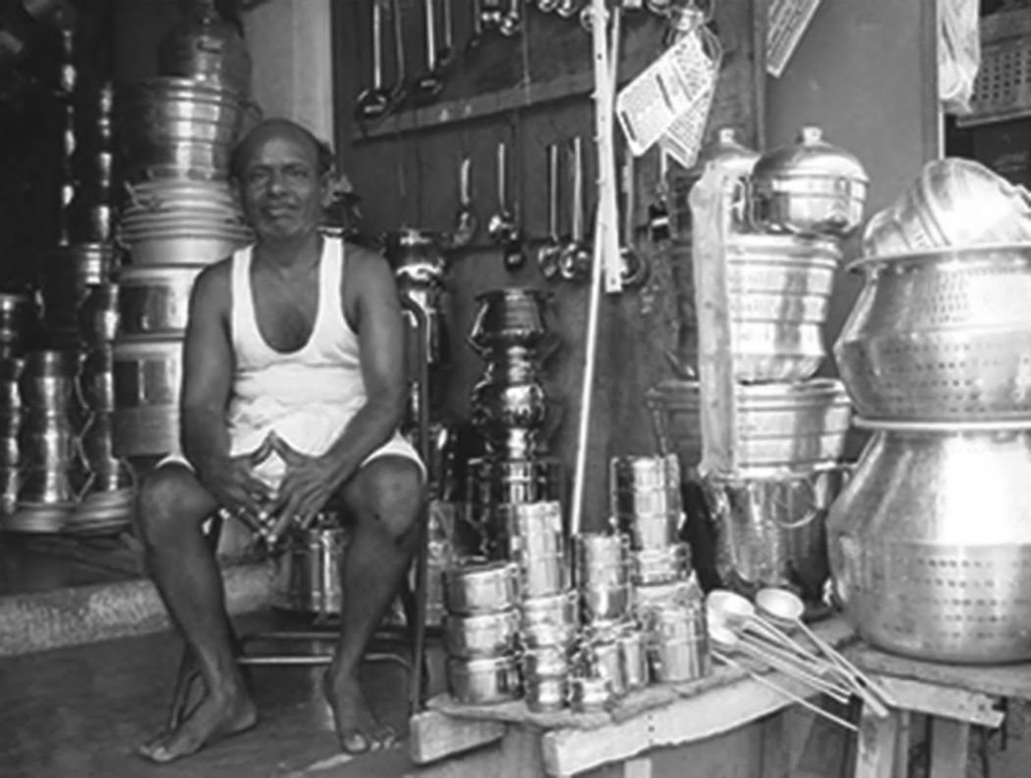
Figure 2 A man sitting on a chair in his shop,
surrounded by pots, pans and other kitchen utensils.
Ask each student to bring any one utensil to class (for example, a spoon, glass, bowl (katori), container (of any shape), bottle, serving spoon (karchi), wok, pan, etc.). It is a good idea to bring in a few examples yourself so that you have enough utensils for everyone.
Part 1: The mathematical activity
Tell your students the following:
- Imagine you have to recreate the utensil you have brought using some commonly known shapes and solids. In how many ways could you do this? For example, one way to make a hollow rectangle like the one in Figure 3 would be to make the shape of the larger rectangle and then cut out the smaller rectangle, leaving the hollow rectangle.
Figure 3 A hollow rectangle.
- As in the example above, describe how you could recreate the utensils shown in Figures 4 and 5 using some commonly known shapes and solids.
Figure 4 A set of spoons. Figure 5 An idli maker.
- Work out the surface area of the object you brought to the class in at least two different ways. You should get the same surface area in all cases.
- Do the same for the volume of the object. You should get the same volume in all cases.
Part 2: Reflecting on your learning
Tell your students that this part of the activity asks them to think about their learning so that they can become better at, and feel better about, learning mathematics.
- What did you find easy or difficult about Part 1 of this activity?
- What did you like about this activity?
- What mathematics did you learn from this activity?
- What did you learn about how you (could) learn mathematics?

Video: Using local resources
http://tinyurl.com/video-usinglocalresources
You may also want to have a look at the key resource ‘Using local resources’ (http://tinyurl.com/kr-usinglocalresources).
Case Study 2: Mrs Chadha reflects on using Activity 2
This activity made me realise how much more students engage with their learning when they use something that they bring to school. It seems it gives them automatic ownership of their learning! There was excitement when the students entered the classroom, showing the objects they had brought with them and wanting to know what exactly they were expected to do with them.
When the activity was given, they were grouped in fours so that they could have a variety of objects to investigate. I told them they were to pool their objects, but that I first wanted them to think about the questions individually. They were asked to each keep notes to talk about their thinking later in the group discussion. I insisted on this individual work because I wanted them to become aware of their own mathematical thinking power, and develop and value their own ideas. I wanted them to feel in control of their own thinking. If they were stuck with thinking about one object, they could select another one.
After about ten minutes I asked them to talk to each other about their answers. I told them that at this point they did not actually have to find the areas or volumes – they just had to talk about what shapes they could identify, or decompose their object into, in order to find the area or volume. I did not want them caught up in calculations and getting stressed about not remembering formulae. I wanted them to think about the thinking process involved in working with combined solids.
The discussion over the idli maker became rather intense, because some decided that they were hemispheres and there were a few who said that they were not exactly half-spheres – they felt they were parts of spheres. I noticed that some of the students were bridging the gap between their concrete understanding about shapes, solids, volumes and area by explaining their thinking while feeling and touching the utensils.
I was especially glad to hear the way that the students listened to each other. For some of the objects, the task was more difficult. One student who is otherwise quite quiet and reticent in class offered up a helpful idea in her group about two semi-circles actually making up a whole sphere, and I could see her pleasure when the other students praised her contribution – perhaps this will help her build her belief that she can do mathematics.

Pause for thought
- What responses from students were unexpected? Why?
- What questions did you use to probe your students’ understanding?
- Did you feel you had to intervene at any point?
- How did the students respond to the reflection questions?

3 Coping with daunting mathematical writing
When students look at solved examples of mathematics problems in a textbook, they can look daunting. To students, they may look like a string of alien symbols that are supposed to make sense – a feeling that can be very intimidating. This is not restricted to the chapters on calculating area, volume and surface area of combined solids and shapes! The examples do make sense once you engage with the writing and the deciphering of the mathematical symbols.
To help students overcome any sense of feeling overwhelmed by the symbolic notation of mathematics, it may help if they can identify what makes an example easy or difficult, and then make their own easy and difficult examples. Doing this can demystify the mathematical writing of symbols and offer them a gentle way into making sense of mathematical symbols. Making up their own examples also lets the students create mathematics themselves, which gives them some control over their own learning and thus creates a sense of ownership that can increase engagement and participation. Another added benefit is that, as a teacher, you end up with lots of examples to work with and exchange in the classroom!
Activities 3, 4 and 5 ask students to identify, characterise and devise easy and difficult examples. This approach works in any area of mathematical learning. The topic of combined shapes and solids has its own particular challenge of having to use rather complicated formulae for calculating the area and volume of specific shapes and solids.
To prepare and support students with the specific symbolic writing demands of this, Activity 3 asks them first to write their own formulae booklet with illustrations. The students could add to this booklet any other formulae they come across in their mathematics learning, in which case it might be good to work on loose paper sheets that can then be added to and re-ordered when appropriate. Having formulae to hand also reduces the stress students might be experiencing in having to remember formulae and can let them focus on the thinking process that is required for their calculations.

Activity 3: Making your own formulae booklet
Advise your students that this activity is similar to Activity 1 but they are now being asked to focus on mathematical formulae rather than words. They should have a page for each formula as they will be adding pages and will want to organise the formulae over time into an order that makes sense.
Tell your students:
- Look at the chapter in your textbook about area, volume and surface area.
- Design a page with at least four sections. (Read through this activity before you decide on the layout of the page.)
- Identify any formulae you come across and write them near the top of the page.
- Above this, write down what this formula is for.
- In the second column, write down the explanation that the book or your teacher gives for why or how this formula works.
- Now write down your own explanation that makes sense to you in the third column. Use language and examples that make sense to you in the third column. It does not have to be complete yet, or entirely correct, because you will be able to make changes to it as your understanding grows.
- Now make a drawing or sketch to give an illustration of what the word means that makes sense to you in the fourth column. Again, it does not have to be complete yet, or entirely correct, because you will be able to make changes to it as you gain confidence.

Activity 4: What makes a question easy, average or difficult?
Organise your class into groups of three where each of them works on one example, but where they discuss what they are doing.
Part 1: The mathematical activity
Tell your students in their groups to look at the solved examples and questions in the chapter in their textbook about volume and surface area of combined solids, and to do the following:
- Identify and agree on one easy, one average and one difficult solved example.
- Draw the objects you chose. State in your own words what shapes and solids this object consists of (that is, decompose the combined solid into single solids).
- Look at your formulae booklet, your dictionary and the drawing. Can you identify which parts of the worked out example relate to the parts of your drawing?
- When you have all discussed and recorded your thoughts about the three worked out examples, think about what is the same and what is different between an easy, an average and a difficult example. What is it that makes an example easy or difficult? Make a note of your thoughts.
- Look at your difficult example. Work together to make it even harder by adding or changing something.
Bring the class back together and discuss the last two points to find out how far students have been able to articulate what factors make an example easy or difficult, and what inventive ideas they have about making an example even harder. You could get the class to vote on which example is the most difficult and then set that for homework!Part 2: Reflecting on your learning
Tell your students that this part of the activity asks them to think about their learning so that they can become better at, and feel better about, learning mathematics.
- What did you find easy or difficult about Part 1 of this activity?
- What did you like about this activity?
- What mathematics did you learn from this activity?
What did you learn about how you (could) learn mathematics?

Video: Involving all
http://tinyurl.com/video-involvingall
You may also want to have a look at Resource 2, ‘Involving all’, to find out more.

Activity 5: Making your own mathematical examples
Part 1: The mathematical activity
Ask the students to imagine that they are a writer of questions for mathematics examinations and they have been asked to devise three questions on the topic of surface area and volume of combined solids: one easy, one average and one difficult question. Give them the following instructions:
- Write the questions. Remember you have to provide solutions as well!
- Exchange your examination questions with another student in the classroom and solve each other’s questions. Check the answers against the solutions.
- Discuss with your partner what makes a question easy or difficult. Discuss with your partner good methods to tackle such questions. Write these methods down.
Part 2: Reflecting on your learning
Tell your students that this part of the activity asks them to think about their learning so that they can become better at, and feel better about, learning mathematics.
- What did you find easy or difficult about Part 1 of this activity?
- What did you like about this activity?
- What mathematics did you learn from this activity?
- What did you learn about how you (could) learn mathematics?

Case Study 3: Mrs Meganathan reflects on using Activities 3–5
Activity 3 was given to the students as an independent exercise and I went around observing how they were able to do it. They identified almost all the formulae well and wrote down the shapes that they represented, but when it came down to drawing and writing down in their own words what it meant to them, they had some problems. To help them become more aware of their own learning, and to be able to pinpoint what it was they were stuck on, I asked the students to note down their thoughts about their problems at whatever point they were, so that they could contribute to a discussion. The main issue appeared to be about drawing three-dimensional solids. Because I wanted the students to know that there is not just one correct way of doing this, I called the students who had been able to draw a certain figure to come and draw it on the blackboard.
Once the students had some ideas about how to draw a three-dimensional solid, and had practised it themselves, we went on to discuss the explanations given. I asked all those who had different explanations about a certain formulae to share their thoughts and ideas so that all of the students could hear ideas and think about what makes a question easy or difficult.
We did Activity 4 over two periods because they got so engaged with the activity. They worked on their own but talked to a classmate about the choices they had made. They used their dictionary and formulae booklet without prompting and I did notice students using their fingers to point and keep track of what part of the example related to which formula. I also saw students covering up part of the drawings in order to ignore the bits they were not working on, so that they could focus on the parts the calculations were about.
Mona said if only they could take such a dictionary and formulae booklet into the exam! We then had a discussion about how to try to remember the formulae using logical thinking. Sushant suggested that it could be helpful to think of a cylinder whose lateral surface area would be the circumference (that is, the perimeter for a circle) multiplied by its height and its volume the base area multiplied by its height. Sushant then said that you could then think about how the solid you were working with was different from the cylinder and adapt the formulae accordingly. We also discussed how this relates to going from two to three dimensions, and why some questions were difficult for some and why others were easier. Ramona said they were all easy, so I asked her to work on the last question to try to make it harder.
I gave them the first part of Activity 5 as a homework assignment and I told them that they had to prepare the test questions for their classmates, although who would get to solve whose would be a mystery. They came back the next day enthusiastically with their questions, happy that they – rather than me, or an examination board – were setting the test. The next day I distributed their questions randomly, although I did try to match the difficulty level to individual students’ attainment. I had to swap two papers when I got to the end as I found that I was giving Mona her own question back, and a couple of students had to double up as that day there were more students in class. They settled down to work on the problems. The class especially liked that the test was marked by the originator of the questions and they enjoyed doing the marking.
The activity allowed them to pinpoint what made a question hard. Instead of saying the whole topic was difficult to do, they agreed it was only the questions involving a frustum – and not because of its shape but because of its complicated formula, which is nearly impossible to memorise! We discussed how we could avoid memorising the formula, especially as so many mistakes are made with writing it down from memory. We talked about how the formula was derived from other, simpler formulae, and that working through that logical process means you do not have to memorise the impossible-to-remember formula. I think this helped some students, but there still were those who insisted on learning the formula.
Doing all these activities did take a considerable amount of time, but I think it was well worth it. The students learned a lot of mathematics, seemed more relaxed and in control of their learning, and engaged actively with the tasks. All students, whatever their attainment, could do the task and could learn at their own pace and level. They had to think, be creative and make their own decisions. They really seemed to enjoy doing the mathematics and there were smiling faces and even laughter in the classroom – which I absolutely loved. I think they will also remember the mathematics they have learned more, which will save me time in the long run because I will not have to revisit the topic as often!

Pause for thought
- What questions did you use to probe your students’ understanding?
- Did you feel you had to intervene at any point?
- What points did you feel you had to reinforce?
- Did you modify the task in any way like Mrs Meganathan did? If so, what was your reasoning for doing so?

4 Summary
This unit has asked you to explore how your students find the volumes of combinations of solids. It discussed ways for you to use to make students feel more involved in the process of learning mathematics, and how they can understand that mathematics is about real-life ideas, not just formulae in a textbook. You have learned how to support students in making choices in mathematics that can allow them to feel in control of their learning: choices about how to solve problems and how to explain ideas in their own words. Making choices means that they have to think through these ideas, which makes them learn more effectively and own that learning. They no longer feel that they are doing something that really has nothing to do with them.
These approaches are important, because many students find learning mathematics so traumatic that they simply do not want to think about it. They worry so much about using the one right process to get the one right answer that they are not able to think about the mathematics. They worry that they will look foolish if they give the wrong answer so they would rather not try. Overcoming these widely held beliefs will take time and persistence, but making sure that your students are involved in their lessons using the ways described in this unit will help them believe that they can do mathematics.
Pause for thought
Identify three ideas that you have used in this unit that would work when teaching other topics. Make a note now of two topics you have to teach soon where those ideas can be used with some small adjustments.

Resources
Resource 1: NCF/NCFTE teaching requirements
This unit links to the following teaching requirements of the NCF (2005) and NCFTE (2009), and will help you to meet those requirements:
- View students as active participants in their own learning and not as mere recipients of knowledge; how to encourage their capacity to construct knowledge; how to shift learning away from rote methods.
- Let students see mathematics as something to talk about, to communicate through, to discuss among themselves, to work together on.
- Let students use abstractions to perceive relationships, to see structures.
- Engage with the curriculum, syllabuses and textbooks critically by examining them rather than taking them as ‘given’ and accepted without question.

Resource 2: Involving all

What does it mean to ‘involve all’?
The diversity in culture and in society is reflected in the classroom. Students have different languages, interests and abilities. Students come from different social and economic backgrounds. We cannot ignore these differences; indeed, we should celebrate them, as they can become a vehicle for learning more about each other and the world beyond our own experience. All students have the right to an education and the opportunity to learn regardless of their status, ability and background, and this is recognised in Indian law and the international rights of the child. In his first speech to the nation in 2014, Prime Minister Modi emphasised the importance of valuing all citizens in India regardless of their caste, gender or income. Schools and teachers have a very important role in this respect.
We all have prejudices and views about others that we may not have recognised or addressed. As a teacher, you carry the power to influence every student’s experience of education in a positive or negative way. Whether knowingly or not, your underlying prejudices and views will affect how equally your students learn. You can take steps to guard against unequal treatment of your students.

Three key principles to ensure you involve all in learning
- Noticing: Effective teachers are observant, perceptive and sensitive; they notice changes in their students. If you are observant, you will notice when a student does something well, when they need help and how they relate to others. You may also perceive changes in your students, which might reflect changes in their home circumstances or other issues. Involving all requires that you notice your students on a daily basis, paying particular attention to students who may feel marginalised or unable to participate.
- Focus on self-esteem: Good citizens are ones who are comfortable with who they are. They have self-esteem, know their own strengths and weaknesses, and have the ability to form positive relationships with other people, regardless of background. They respect themselves and they respect others. As a teacher, you can have a significant impact on a young person’s self-esteem; be aware of that power and use it to build the self-esteem of every student.
- Flexibility: If something is not working in your classroom for specific students, groups or individuals, be prepared to change your plans or stop an activity. Being flexible will enable you make adjustments so that you involve all students more effectively.

Approaches you can use all the time
- Modelling good behaviour: Be an example to your students by treating them all well, regardless of ethnic group, religion or gender. Treat all students with respect and make it clear through your teaching that you value all students equally. Talk to them all respectfully, take account of their opinions when appropriate and encourage them to take responsibility for the classroom by taking on tasks that will benefit everyone.
- High expectations: Ability is not fixed; all students can learn and progress if supported appropriately. If a student is finding it difficult to understand the work you are doing in class, then do not assume that they cannot ever understand. Your role as the teacher is to work out how best to help each student learn. If you have high expectations of everyone in your class, your students are more likely to assume that they will learn if they persevere. High expectations should also apply to behaviour. Make sure the expectations are clear and that students treat each other with respect.
- Build variety into your teaching: Students learn in different ways. Some students like to write; others prefer to draw mind maps or pictures to represent their ideas. Some students are good listeners; some learn best when they get the opportunity to talk about their ideas. You cannot suit all the students all the time, but you can build variety into your teaching and offer students a choice about some of the learning activities that they undertake.
- Relate the learning to everyday life: For some students, what you are asking them to learn appears to be irrelevant to their everyday lives. You can address this by making sure that whenever possible, you relate the learning to a context that is relevant to them and that you draw on examples from their own experience.
- Use of language: Think carefully about the language you use. Use positive language and praise, and do not ridicule students. Always comment on their behaviour and not on them. ‘You are annoying me today’ is very personal and can be better expressed as ‘I am finding your behaviour annoying today. Is there any reason you are finding it difficult to concentrate?’, which is much more helpful.
- Challenge stereotypes: Find and use resources that show girls in non-stereotypical roles or invite female role models to visit the school, such as scientists. Try to be aware of your own gender stereotyping; you may know that girls play sports and that boys are caring, but often we express this differently, mainly because that is the way we are used to talking in society.
- Create a safe, welcoming learning environment: All students need to feel safe and welcome at school. You are in a position to make your students feel welcome by encouraging mutually respectful and friendly behaviour from everyone. Think about how the school and classroom might appear and feel like to different students. Think about where they should be asked to sit and make sure that any students with visual or hearing impairments, or physical disabilities, sit where they can access the lesson. Check that those who are shy or easily distracted are where you can easily include them.

Specific teaching approaches
There are several specific approaches that will help you to involve all students. These are described in more detail in other key resources, but a brief introduction is given here:
- Questioning: If you invite students to put their hands up, the same people tend to answer. There are other ways to involve more students in thinking about the answers and responding to questions. You can direct questions to specific people. Tell the class you will decide who answers, then ask people at the back and sides of the room, rather than those sitting at the front. Give students ‘thinking time’ and invite contributions from specific people. Use pair or groupwork to build confidence so that you can involve everyone in whole-class discussions.
- Assessment: Develop a range of techniques for formative assessment that will help you to know each student well. You need to be creative to uncover hidden talents and shortfalls. Formative assessment will give you accurate information rather than assumptions that can easily be drawn from generalised views about certain students and their abilities. You will then be in a good position to respond to their individual needs.
- Groupwork and pair work: Think carefully about how to divide your class into groups or how to make up pairs, taking account of the goal to include all and encourage students to value each other. Ensure that all students have the opportunity to learn from each other and build their confidence in what they know. Some students will have the confidence to express their ideas and ask questions in a small group, but not in front of the whole class.
- Differentiation: Setting different tasks for different groups will help students start from where they are and move forward. Setting open-ended tasks will give all students the opportunity to succeed. Offering students a choice of task helps them to feel ownership of their work and to take responsibility for their own learning. Taking account of individual learning needs is difficult, especially in a large class, but by using a variety of tasks and activities it can be done.

Additional resources
- A newly developed maths portal by the Karnataka government: http://karnatakaeducation.org.in/KOER/en/index.php/Portal:Mathematics
- Class X maths study material: http://www.zietmysore.org/stud_mats/X/maths.pdf
- National Centre for Excellence in the Teaching of Mathematics: https://www.ncetm.org.uk/
- National STEM Centre: http://www.nationalstemcentre.org.uk/
- OpenLearn: http://www.open.edu/openlearn/
- BBC Bitesize: http://www.bbc.co.uk/bitesize/
- Khan Academy’s math section: https://www.khanacademy.org/math
- NRICH: http://nrich.maths.org/frontpage
- Mathcelebration: http://www.mathcelebration.com/
- Art of Problem Solving’s resources page: http://www.artofproblemsolving.com/Resources/index.php
- Teachnology: http://www.teach-nology.com/worksheets/math/
- Maths is Fun: http://www.mathsisfun.com/
- National Council of Educational Research and Training’s textbooks for teaching mathematics and for teacher training of mathematics: http://www.ncert.nic.in/ncerts/textbook/textbook.htm
- LMT-01 Learning Mathematics, Block 1 (‘Approaches to Learning’) Block 2 (‘Encouraging Learning in the Classroom’), Block 6 (‘Thinking Mathematically’): http://www.ignou4ublog.com/2013/06/ignou-lmt-01-study-materialbooks.html
- Learning Curve and At Right Angles, periodicals about mathematics and its teaching: http://azimpremjifoundation.org/Foundation_Publications
- Central Board of Secondary Education’s books and support material (also including the Teachers Manual for Formative Assessment – Mathematics (Class IX)) – select ‘CBSE publications’, then ‘Books and support material’: http://cbse.nic.in/welcome.htm

References/bibliography
Boaler, J. (2009) What’s Math Got to Do With It? How Parents and Teachers Can Help Children Learn to Love Their Least Favourite Subject. New York, NY: Penguin.
Lange, T. and Meaney, T. (2011) ‘I actually started to scream: emotional and mathematical trauma from doing school mathematics homework’, Educational Studies in Mathematics, vol. 77, no. 1, pp. 35–51.
National Council of Educational Research and Training (2005) National Curriculum Framework (NCF). New Delhi: NCERT.
National Council of Educational Research and Training (2009) National Curriculum Framework for Teacher Education (NCFTE). New Delhi: NCERT.
National Council of Educational Research and Training (2012a) Mathematics Textbook for Class IX. New Delhi: NCERT.
National Council of Educational Research and Training (2012b) Mathematics Textbook for Class X. New Delhi: NCERT.
Watson, A., Jones, K. and Pratt, D. (2013) Key Ideas in Teaching Mathematics. Oxford: Oxford University Press.

Acknowledgements
Except for third party materials and otherwise stated below, this content is made available under a Creative Commons Attribution-ShareAlike licence (http://creativecommons.org/licenses/by-sa/3.0/). The material acknowledged below is Proprietary and used under licence for this project, and not subject to the Creative Commons Licence. This means that this material may only be used unadapted within the TESS-India project and not in any subsequent OER versions. This includes the use of the TESS-India, OU and UKAID logos.
Grateful acknowledgement is made to the following sources for permission to reproduce the material in this unit:
Figure 1: Taj Mahal © Andrew Gray/Flickr: http://creativecommons.org/licenses/by-sa/2.0/deed.en.
Figure 2: Photo by Adam Jones, adamjones.freeservers.com: http://commons.wikimedia.org/wiki/File:Seller_of_Pots_and_Pans_-_Tiruvannamalai_-_India.JPG. This file is licensed under the Creative Commons Attribution-Share Alike 3.0 Unported licence.
Figure 4: © Saharasav, http://commons.wikimedia.org/wiki/File:Keiryo_spoons.jpg. This file is licensed under the Creative Commons Attribution-Share Alike 3.0 Unported licence.
Figure 5: Bhaskaranaidu, http://commons.wikimedia.org/wiki/File:Idli_coocker.JPG. This file is licensed under the Creative Commons Attribution-Share Alike 3.0 Unported licence.
Every effort has been made to contact copyright owners. If any have been inadvertently overlooked the publishers will be pleased to make the necessary arrangements at the first opportunity.
Video (including video stills): thanks are extended to the teacher educators, headteachers, teachers and students across India who worked with The Open University in the productions.

