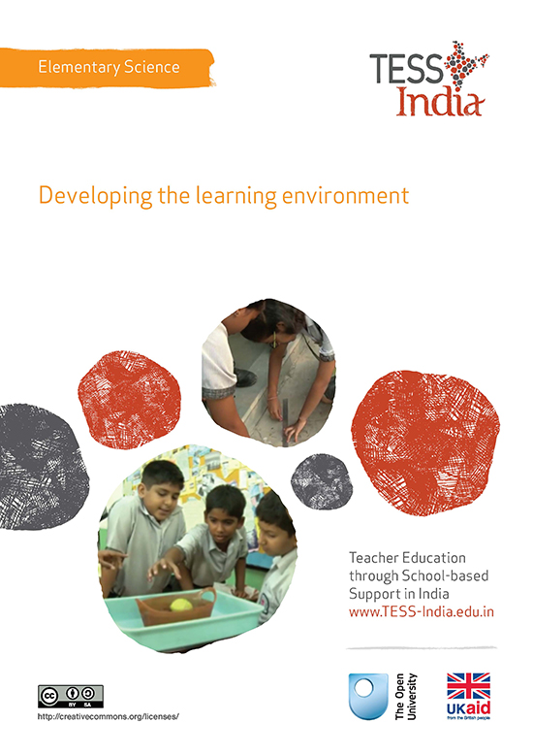
TESS-India (Teacher Education through School-based Support) aims to improve the classroom practices of elementary and secondary teachers in India through the provision of Open Educational Resources (OERs) to support teachers in developing student-centred, participatory approaches. The TESS-India OERs provide teachers with a companion to the school textbook. They offer activities for teachers to try out in their classrooms with their students, together with case studies showing how other teachers have taught the topic and linked resources to support teachers in developing their lesson plans and subject knowledge.
TESS-India OERs have been collaboratively written by Indian and international authors to address Indian curriculum and contexts and are available for online and print use (http://www.tess-india.edu.in/). The OERs are available in several versions, appropriate for each participating Indian state and users are invited to adapt and localise the OERs further to meet local needs and contexts.
TESS-India is led by The Open University UK and funded by UK aid from the UK government.
Video resources
Some of the activities in this unit are accompanied by the following icon: . This indicates that you will find it helpful to view the TESS-India video resources for the specified pedagogic theme.
The TESS-India video resources illustrate key pedagogic techniques in a range of classroom contexts in India. We hope they will inspire you to experiment with similar practices. They are intended to complement and enhance your experience of working through the text-based units, but are not integral to them should you be unable to access them.
TESS-India video resources may be viewed online or downloaded from the TESS-India website, http://www.tess-india.edu.in/). Alternatively, you may have access to these videos on a CD or memory card.

Version 2.0 ES13v1
All India - English
Except for third party materials and otherwise stated, this content is made available under a Creative Commons Attribution-ShareAlike licence: http://creativecommons.org/licenses/by-sa/3.0/

What this unit is about
As a teacher, you want your students to achieve the best possible outcomes from their science education. This will provide them with insights and opportunities to extend their life chances and experiences. Many students may be the first in the family to go to school, which is both exciting and daunting. Having a classroom environment that stimulates their interest and creativity will encourage them to continue to attend and gain a purposeful education.
There are lots of opportunities for you and your students to use the classroom environment more creatively to stimulate their interest and encourage their empathy towards it. This unit explores some of the possibilities to enhance the learning environment using the topic of germination as an example, but you can apply these ideas to any science topic.

What you can learn in this unit
- How and why it is important to develop your classroom learning environment.
- How interactions between you and your students can affect the learning environment and student achievement.
- How to improve your learning environment by being resourceful.

Why this approach is important
The physical environment and the social and emotional climate of the classroom have a significant influence on your students’ learning. Creating a positive learning environment fostered on respect for yourself and your students can be achieved in many ways and with little or no cost.
Learning activities are most stimulating when they engage students actively in either investigating a problem practically or developing thinking skills through problem solving. As the teacher, you have to take the first initiative to set your students on this path, but your students can be closely involved thereafter. You also need to consider very carefully what kind of physical environment you want in your classroom. This may not be easy if you work in a school with few materials, but by being resourceful you can create a colourful and stimulating classroom (Figure 1). This will make a significant difference to the students’ wellbeing, motivation and achievement.
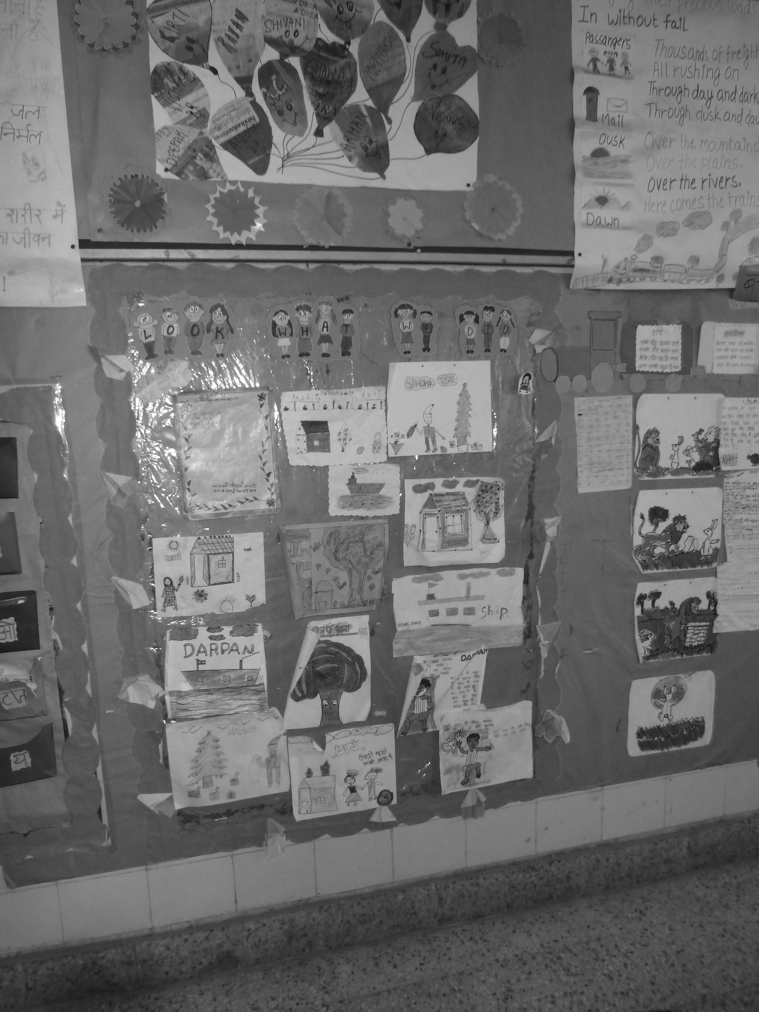
Figure 1 A colourful and stimulating classroom will improve
your students’ wellbeing, motivation and achievement.

1 Developing an inclusive environment
Video: Involving all
http://tinyurl.com/video-involvingall
View the video extract on involving all and, before you do Activity 1, read Resource 1, ‘Involving all’. This will extend your understanding of the key concepts that you need to be consider when you try to make your classroom more inclusive.

Activity 1: My classroom audit
At the end of one day in the next week, take a few minutes to look at the classroom(s) that you teach in. List all the good things about it, for example, whether it is hot or cool, or looks out on the countryside.
Next, list a maximum of ten things that you would like to have immediately for your classroom, for example:
- a table to display things
- some paper for drawing
- chairs and tables for the students.
Which of these are more realistic aims than others? Are there ways that you could acquire these locally for free? And how else could you change and enhance your classroom?
Note down your answers and keep them, as you will need to refer to them later.

Case Study 1: Ms Kabita’s investigations in the classroom
Ms Kabita teaches Class V and is about to investigate germination with them. A few weeks ago she spent some time visiting another school and talking to one teacher, Mr Pathak. She was impressed by his classroom, its impact on his students and her as a teacher. She explains what she then did and why.
I wanted to explore germination with my class using an investigation activity similar to that in the textbook, but I also wanted to use the investigation as the starting point to make my classroom more attractive and colourful for my students to work in. I also wanted to rearrange the room so that when we did group work, which is more often now, the students did not have to move around the classroom as much.
A few weeks ago I visited a school a few miles from my school. I had heard that the teacher, Mr Pathak, had made his classroom more colourful and interesting without having to buy any resources. I looked around his classroom and saw that he had put up on the wall, pictures that he had drawn and his students’ work. He had written labels on the work and put up questions for them to answer as they looked at it. He said the students liked to look at these and often talked about them and their content. He also had resource boxes with recyclable and reusable materials to use in lessons. Over the next few weeks I spent many spare moments looking at my classroom from different perspectives and thinking about what I could do to make it more exciting. A lot of questions came to mind:
- How could I sit my students so that they were all more involved?
- What could I do to make the walls more interesting?
- What resources would I need? Where could I get these?
- What would the students think about any changes I would make?
- Should I involve them in thinking about what we could do? How would I do this?
- How could I start this process with studying germination?
I decided to start my changes by asking my students to help me. I had two large, low, storage boxes under the blackboard that I had not bothered about much. I wanted to move these and use their tops for display, as well as the wall above.
One box would store some of the recyclable and reusable materials that I had been gathering over the months from around the small town where I live. Often shops have old cardboard boxes that are left out and I have asked the shopkeeper for these for school. The man was reluctant at first but when I said it would help the students’ learning, he relented. I had also collected envelopes from the school office when they came and found some big sheets that I could use for posters and for students’ work to do displays and brainstorms, etc. Finally, I decided that I had spent enough time thinking and needed to act if I was going to make a difference to my classroom. At the end of one science lesson I took ten minutes to ask the students three questions about the classroom:
- What do you like about this room?
- What do you not like?
- How do you think we could make it a nicer and more interesting classroom?
As they were used to working in groups, I asked them to talk together and for one person to write their responses and ideas on a small sheet of paper. Each group gave their three responses orally and I listed them on the blackboard. I told them I would read their lists, and in the next lesson we would consider what we will do first and how we will do it, when we began to investigate germination. They left the classroom talking animatedly about what they could do.

Pause for thought
- How do you react to Ms Kabita’s approach and her reasons for making her classroom more enticing?
- How could you try some of her ideas?
By asking her students about the changes, Ms Kabita is making a definite move towards including all of them in exploring what they would like to do with their classroom. So she is not only changing the physical environment, but also the kind of interaction in her classroom. This is telling her students that she respects them as individuals and wants to share ideas with them. This is a big boost for all her students on both counts.

2 Developing a cognitive space
As a teacher, you need to consider the cognitive space necessary for an effective learning environment. This space will be determined by your expectations of what your students can do intellectually within the classroom. Developing an atmosphere that is encouraging and motivating will give your students more responsibility for their learning. Being more aware of your students particular learning needs will help you match your teaching and activities to them and aid their progress more effectively.
Video: Planning lessons
http://tinyurl.com/video-planninglessons
You may want to read key resource ‘Planning lessons’ (http://tinyurl.com/kr-planninglessons) to gain more insight to the importance of good planning and then read Resource 2 about investigations to help you think how and when you could involve your students in planning their investigations.

Activity 2: Making space for thinking
In studying germination, it is important to investigate what conditions support good germination. You are going to set up an investigation with your students to explore what seeds need in order to germinate. You will involve all your students in as many aspects of this investigation as possible. To do this, there is a list of questions below that guide you through the main things you need to think about. You need to read this and then plan what you have to do before the first lesson when you plant the seeds. Think also about how you will follow up the growth (or not) of the seeds over time.
Then, consider these questions:
- What do you want your students to learn about germination?
- How will you start the topic with them?
- How will you organise them during the lesson? In groups?
- How will you introduce them to the idea of developing the classroom learning environment with each topic you study?
- What resources do you need? How can you get these?
- How could your students help you?

- How will you ask them to help in a way that will give them responsibility and ownership of the project?
- How long will it take to gather the resources?
- When can you set the date for the first lesson?
- How will you introduce the investigation?
- How will you organise distribution of resources?
- How will you involve your students in the design of the investigation and controlling variables?
Write out your plans and set a date to start the investigation. Explain how you want to develop the classroom by gathering more resources and making it more interesting and colourful.

Pause for thought
- Have you a clear idea in your mind about what you are going to do now?
- Are you prepared to be open to your students’ ideas?
It is important to set realistic goals when developing your classroom with your students. Do not try to do too much at once. If you have a large class, you can still make small changes that will make a big difference to the learning environment and the outcomes for your students. The germination investigation is a good starting point because it impacts on the physical and educational ambiance of the classroom, as well as developing a stronger supportive learning environment. It is also part of the science curriculum, and the new strategies will support the science learning.

Activity 3: Gathering resources and ideas
Before you do this activity, read the Resource 3, ‘Using local resources’, to help you understand more about the various ways you could develop and extend your classroom environment for the benefit of your students.
Set aside about 15 minutes to have the discussion with your class about how they think you could improve the classroom. You may want to refer to your responses to Activity 1 here, to remind you what you thought about what you would like to do.
After introducing your ideas about improving the classroom environment, give your groups time to talk before gathering their ideas from each group spokesperson. List these on the blackboard and then ask the students to prioritise which ones are most important. For example, they may say that gathering resources such as pots for the seeds and some seeds are the first priority and then paper and card for displays. Or if your classroom is better resourced, you may be working at making more advanced displays including models. Alternatively, you may want to arrange your room differently. You could ask your students to help you plan how to change things around, so that if you have a computer, for example, students can use it more easily to write up their work or search the internet and even print out their findings to share with others.
Give the students clear guidance about how to collect resources so that they do not annoy or anger local people. Stress that they must ask and obtain permission to take any resources. Set up some way of storing the resources in your classroom that will keep them safe. Discuss with your students ways to arrange the seating in your classroom so that everyone can see the blackboard and be involved in any discussion or activities.

Pause for thought
- How did your class respond to the project of developing the classroom?
- Were you surprised by their responses? In what way? How successful have you been with collecting extra resources and changing your classroom environment?
- Were all the students engaged in this task?

3 Developing classroom routines to help students feel secure
Effective teachers try to create and implement classroom management practices that cultivate an engaging classroom environment for their students. Two specific areas of cognitive spaces that need to be included in their plans are: setting clear expectations such as rules and procedures for behaviour, and ways of participating. Such rules could be devised together with your students rather than you imposing the rules on them. It is a way of building up a collective responsibility for each other and respecting each person as an individual.
Pause for thought
How can you develop clear expectations with your students of how to interact and listen to each other using the investigation into germination or another investigation you will be doing soon?

Case Study 2: Mrs Yadav investigates germination – a rich task
Mrs Yadav, an elementary science teacher, wanted to inspire her students to devise their own investigation into germination. She needed to give them a task that had relevance to their everyday lives in a rural community. To do this, she decided to read out a letter to her students, pretending that it had been written by a local farmer called Mr Desai (Figure 2).
Figure 2 A letter to Mrs Yadav’s class about germination.
As soon as I had read out the letter to them, my students were most concerned about his situation and very keen to help him.
First, I asked them to think what the essential requirements for successful germination were, which I wrote on the blackboard. I then asked my students, ‘How can we be sure that this information is right? What will happen if we send the wrong information to Mr Desai and his seeds don’t grow properly?’
One of my students suggested that we could buy some seeds and try to grow them under different conditions to ensure that Mr Desai received the correct information. The next day, I brought some seeds into school.
I arranged my students into groups of six and asked them to think about what they wanted to find out and how this would help Mr Desai. I asked them to write down any questions they had about seeds and to think how we could record the results over time as the seeds grew. I told them of my desire to improve the classroom environment and that we needed to share our results from the investigation. How could we share them in a way that would enable us to do so regularly and improve the classroom?
I walked around the class listening to their talk. When I stopped the class and asked them to share their questions I was pleasantly surprised by what they said. One group asked the question, ‘Can seeds die if you give them too much water?’ We discussed how we could investigate these ideas and each group agreed to set up a control seed that had all the necessary conditions for growth. Then each group also sowed a seed that had no light, water, soil, attention or warmth. One group set up a pot with a seed that would have lots of water. Another group set up a seed with all conditions except warmth, putting it in a freezer.
I gave my students a simple chart to record their observations and asked them to look after their seeds and record their observations at least every two days over a period of two weeks [Figure 3]. Some students drew pictures to record their observations; others added labels and captions. All checked for growth and measured it with a ruler.
Figure 3 The seeds without light.
To share their results as they developed, we put all the charts on the wall above each pot. The names of each group were also displayed. This was so that they could ask each other about their plants. I made a poster titled ‘Germination’, wrote out what they had done and displayed this beside the charts. I was surprised by how much they looked at the seeds and talked to each other about what they thought was happening. There was great excitement when the first shoots were seen peeping through the soil. Everyone checked which seed it was.
After three weeks, I asked each group to write a letter back to Mr Desai, explaining what they had done with their seed, what evidence they had collected and what this evidence told them about seed growth. These letters were displayed beside their charts and above their seeds.
I left the charts up on the wall. Later, when we had done some other work on plants, we put it beside the germination display. My plan now is to try to have some display for every big topic we do – not always the students’ work, but sometimes using charts that we have in school.
The students often commented on how they liked stuff on the walls that was interesting to look at. It certainly had stimulated their interest and talk.

Pause for thought
- What did you think made Mrs Yadav’s lesson a successful learning experience for her students?
- Which strategies would you use in your teaching and classroom?

Activity 4: Investigating germination
Using your responses to Activity 2, refine your plan for your students to do the investigation. How will you introduce this to your students? Will you use a letter like Mrs Yadav? How will you encourage and question your students to think about whether their plan will answer the question ‘What are the best conditions for germination?’ Identify where you will keep the plants and where you can display the recording sheets (see Resource 4 for a sample recording sheet). Think how you can develop this display to communicate their findings to a wider audience in the class and school.
Now teach the germination lessons to your students.
Pause for thought
- How did your students respond to the different tasks?
- Were you surprised by any of the students’ ideas?
- Were all the students involved? How well did your students with special educational needs cope with the investigation? Will they need extra support next time? If so, what?
- Were you and your students pleased with the outcomes?
- Has it made the classroom a more interesting and stimulating learning environment?
- What could you do differently next time?

4 Ongoing development of the learning environment
There are many ways to enhance your classroom and make it a more interactive and stimulating learning environment for your students. For example, one good way to keep your students interested in science is to have a news board. Here, you and your students can put up newspaper articles or a comment about something that they have seen about science. Other students look at these and this encourages them to talk and share their thoughts with you and each other. You will be able to think of other ways to make your classroom more interesting and interactive.

5 Summary
This unit has shown how small changes and the introduction of new routines and ways of working can make a big difference to your students. Through investigating the conditions necessary for germination, this unit has explored ways in which you can enhance the learning environment in your classroom. By using the physical environment as part of your teaching approach and making it interesting and stimulating, and by involving your students in enhancing the classroom environment, you have begun to build up a safe secure environment where they can learn effectively. This will build their self-esteem and confidence to tackle any topic.
As a teacher you have a responsibility to provide the best opportunities for learning that you can for your students. Opportunities that are meaningful and relate to your students’ life experiences and abilities are vital in the classroom to enhance learning. It is through using a variety of approaches, including practical investigations, that students will develop many of the essential thinking skills, such as gathering and interpreting evidence. This will contribute to the development of more complex critical thinking for the future.

Resources
Resource 1: Involving all

What does it mean to ‘involve all’?
The diversity in culture and in society is reflected in the classroom. Students have different languages, interests and abilities. Students come from different social and economic backgrounds. We cannot ignore these differences; indeed, we should celebrate them, as they can become a vehicle for learning more about each other and the world beyond our own experience. All students have the right to an education and the opportunity to learn regardless of their status, ability and background, and this is recognised in Indian law and the international rights of the child. In his first speech to the nation in 2014, Prime Minister Modi emphasised the importance of valuing all citizens in India regardless of their caste, gender or income. Schools and teachers have a very important role in this respect.
We all have prejudices and views about others that we may not have recognised or addressed. As a teacher, you carry the power to influence every student’s experience of education in a positive or negative way. Whether knowingly or not, your underlying prejudices and views will affect how equally your students learn. You can take steps to guard against unequal treatment of your students.

Three key principles to ensure you involve all in learning
- Noticing: Effective teachers are observant, perceptive and sensitive; they notice changes in their students. If you are observant, you will notice when a student does something well, when they need help and how they relate to others. You may also perceive changes in your students, which might reflect changes in their home circumstances or other issues. Involving all requires that you notice your students on a daily basis, paying particular attention to students who may feel marginalised or unable to participate.
- Focus on self-esteem: Good citizens are ones who are comfortable with who they are. They have self-esteem, know their own strengths and weaknesses, and have the ability to form positive relationships with other people, regardless of background. They respect themselves and they respect others. As a teacher, you can have a significant impact on a young person’s self-esteem; be aware of that power and use it to build the self-esteem of every student.
- Flexibility: If something is not working in your classroom for specific students, groups or individuals, be prepared to change your plans or stop an activity. Being flexible will enable you make adjustments so that you involve all students more effectively.

Approaches you can use all the time
- Modelling good behaviour: Be an example to your students by treating them all well, regardless of ethnic group, religion or gender. Treat all students with respect and make it clear through your teaching that you value all students equally. Talk to them all respectfully, take account of their opinions when appropriate and encourage them to take responsibility for the classroom by taking on tasks that will benefit everyone.
- High expectations: Ability is not fixed; all students can learn and progress if supported appropriately. If a student is finding it difficult to understand the work you are doing in class, then do not assume that they cannot ever understand. Your role as the teacher is to work out how best to help each student learn. If you have high expectations of everyone in your class, your students are more likely to assume that they will learn if they persevere. High expectations should also apply to behaviour. Make sure the expectations are clear and that students treat each other with respect.
- Build variety into your teaching: Students learn in different ways. Some students like to write; others prefer to draw mind maps or pictures to represent their ideas. Some students are good listeners; some learn best when they get the opportunity to talk about their ideas. You cannot suit all the students all the time, but you can build variety into your teaching and offer students a choice about some of the learning activities that they undertake.
- Relate the learning to everyday life: For some students, what you are asking them to learn appears to be irrelevant to their everyday lives. You can address this by making sure that whenever possible, you relate the learning to a context that is relevant to them and that you draw on examples from their own experience.
- Use of language: Think carefully about the language you use. Use positive language and praise, and do not ridicule students. Always comment on their behaviour and not on them. ‘You are annoying me today’ is very personal and can be better expressed as ‘I am finding your behaviour annoying today. Is there any reason you are finding it difficult to concentrate?’, which is much more helpful.
- Challenge stereotypes: Find and use resources that show girls in non-stereotypical roles or invite female role models to visit the school, such as scientists. Try to be aware of your own gender stereotyping; you may know that girls play sports and that boys are caring, but often we express this differently, mainly because that is the way we are used to talking in society.
- Create a safe, welcoming learning environment: All students need to feel safe and welcome at school. You are in a position to make your students feel welcome by encouraging mutually respectful and friendly behaviour from everyone. Think about how the school and classroom might appear and feel like to different students. Think about where they should be asked to sit and make sure that any students with visual or hearing impairments, or physical disabilities, sit where they can access the lesson. Check that those who are shy or easily distracted are where you can easily include them.

Specific teaching approaches
There are several specific approaches that will help you to involve all students. These are described in more detail in other key resources, but a brief introduction is given here:
- Questioning: If you invite students to put their hands up, the same people tend to answer. There are other ways to involve more students in thinking about the answers and responding to questions. You can direct questions to specific people. Tell the class you will decide who answers, then ask people at the back and sides of the room, rather than those sitting at the front. Give students ‘thinking time’ and invite contributions from specific people. Use pair or groupwork to build confidence so that you can involve everyone in whole-class discussions.
- Assessment: Develop a range of techniques for formative assessment that will help you to know each student well. You need to be creative to uncover hidden talents and shortfalls. Formative assessment will give you accurate information rather than assumptions that can easily be drawn from generalised views about certain students and their abilities. You will then be in a good position to respond to their individual needs.
- Groupwork and pair work: Think carefully about how to divide your class into groups or how to make up pairs, taking account of the goal to include all and encourage students to value each other. Ensure that all students have the opportunity to learn from each other and build their confidence in what they know. Some students will have the confidence to express their ideas and ask questions in a small group, but not in front of the whole class.
- Differentiation: Setting different tasks for different groups will help students start from where they are and move forward. Setting open-ended tasks will give all students the opportunity to succeed. Offering students a choice of task helps them to feel ownership of their work and to take responsibility for their own learning. Taking account of individual learning needs is difficult, especially in a large class, but by using a variety of tasks and activities it can be done.
Resource 2: Pedagogy – using investigations to test ideas fairly and gather data
There are different strategies you can use to help students develop their skills in investigations. The list below summarises the basic steps you might include as you do investigations with your students.
- Thinking about the topic: Use brainstorming or mind mapping to stimulate students’ ideas about your topic. You can do this with the whole class, or begin with groups and then have a whole-class session. The important thing is to make students think actively about the issues being raised and to establish their current knowledge of the topic.
- Defining the focus: A brainstorming session will throw up many different ideas. These can be recorded on the blackboard or on a chart, but you then need to have a clear focus for the students so that they can use the answers they generate to help them understand the topic. You can use a question like ‘What are the ideal conditions for seeds to grow?’ or ‘What is the difference between the rate of epigeal and hypogeal germination?’
- Planning your investigation: All sorts of methods are available to you. It is important that students think about the methods to be used and why. They need to make sure that their testing is fair, which means that only one variable is changed at any time. They need to think how to record their results.
- Carrying out and reporting the investigation: The students then have to carry out the investigation and report on their findings. The report back may be verbal or could be in the form of a chart, table or graph, so that you can show similarities and differences in the findings.
- Interpreting findings: Once the data is recorded and reported , the findings have to be interpreted.
It is very important that you, the teacher, do not dominate discussions initially. Let the students voice their own ideas (in verbal or written forms) before beginning to steer them, perhaps through open questioning, to the key learning interpretations you are looking for and can be made from their findings.
Resource 3: Using local resources
Many learning resources can be used in teaching – not just textbooks. If you offer ways to learn that use different senses (visual, auditory, touch, smell, taste), you will appeal to the different ways that students learn. There are resources all around you that you might use in your classroom, and that could support your students’ learning. Any school can generate its own learning resources at little or no cost. By sourcing these materials locally, connections are made between the curriculum and your students’ lives.
You will find people in your immediate environment who have expertise in a wide range of topics; you will also find a range of natural resources. This can help you to create links with the local community, demonstrate its value, stimulate students to see the richness and diversity of their environment, and perhaps most importantly work towards a holistic approach to student learning – that is, learning inside and outside the school.

Making the most of your classroom
People work hard at making their homes as attractive as possible. It is worth thinking about the environment that you expect your students to learn in. Anything you can do to make your classroom and school an attractive place to learn will have a positive impact on your students. There is plenty that you can do to make your classroom interesting and attractive for students – for example, you can:
- make posters from old magazines and brochures
- bring in objects and artefacts related to the current topic
- display your students’ work
- change the classroom displays to keep students curious and prompt new learning.

Using local experts in your classroom
If you are doing work on money or quantities in mathematics, you could invite market traders or dressmakers into the classroom to come to explain how they use maths in their work. Alternatively, if you are exploring patterns and shapes in art, you could invite maindi [wedding henna] designers to the school to explain the different shapes, designs, traditions and techniques. Inviting guests works best when the link with educational aims is clear to everyone and there are shared expectations of timing.
You may also have experts within the school community (such as the cook or the caretaker) who can be shadowed or interviewed by students related to their learning; for example, to find out about quantities used in cooking, or how weather conditions impact on the school grounds and buildings.

Using the outside environment
Outside your classroom there is a whole range of resources that you can use in your lessons. You could collect (or ask your class to collect) objects such as leaves, spiders, plants, insects, rocks or wood. Bringing these resources in can lead to interesting classroom displays that can be referred to in lessons. They can provide objects for discussion or experimentation such as an activity in classification, or living or not-living objects. There are also resources such as bus timetables or advertisements that might be readily available and relevant to your local community – these can be turned into learning resources by setting tasks to identify words, compare qualities or calculate journey times.
Objects from outside can be brought into the classroom – but the outside can also be an extension of your classroom. There is usually more room to move outside and for all students to see more easily. When you take your class outside to learn, they can do activities such as:
- estimating and measuring distances
- demonstrating that every point on a circle is the same distance from the central point
- recording the length of shadows at different times of the day
- reading signs and instructions
- conducting interviews and surveys
- locating solar panels
- monitoring crop growth and rainfall.
Outside, their learning is based on realities and their own experiences, and may be more transferable to other contexts.
If your work outside involves leaving the school premises, before you go you need to obtain the school leader’s permission, plan timings, check for safety and make rules clear to the students. You and your students should be clear about what is to be learnt before you depart.

Adapting resources
You may want to adapt existing resources to make them more appropriate to your students. These changes may be small but could make a big difference, especially if you are trying to make the learning relevant to all the students in the class. You might, for example, change place and people names if they relate to another state, or change the gender of a person in a song, or introduce a child with a disability into a story. In this way you can make the resources more inclusive and appropriate to your class and their learning.
Work with your colleagues to be resourceful: you will have a range of skills between you to generate and adapt resources. One colleague might have skills in music, another in puppet making or organising outdoor science. You can share the resources you use in your classroom with your colleagues to help you all generate a rich learning environment in all areas of your school.
Resource 4: Recording sheet for seed germination
Table R4.1 Recording sheet for seed germination.
Name
Week | Date | Date | Date | Date | Date
1

2

Resource 5: Investigation planning sheet (for students)
Table R5.1 Investigation planning sheet (for students).
Action | Record your answers
Make a prediction
Plan your investigation
Observe what happens
Record the results
Draw a conclusion

Additional resources
- ‘Classroom management – creating a learning environment, setting expectations, motivational climate, maintaining a learning environment, when problems occur’: http://education.stateuniversity.com/pages/1834/Classroom-Management.html#ixzz38U9nHcd4
- ‘Seeds & germination: science fair projects and experiments’: http://www.juliantrubin.com/fairprojects/botany/seedsgermination.html
- ‘Measuring germination rates’: http://ddl.nmsu.edu/kids/explore/experiments/germination.html
- ‘Inclusive classrooms: achieving success for all students’ by Kathleen G. Winterman: http://ici.umn.edu/products/impact/241/18.html

References/bibliography
Higgins, S., Hall, E., Wall, K., Woolner, P. and McCaughey, C. (2005) The Impact of School Environments: A Literature Review. London: The Design Council. Available from: http://www.ncl.ac.uk/cflat/news/DCReport.pdf (accessed 9 September 2014).

Acknowledgements
Except for third party materials and otherwise stated below, this content is made available under a Creative Commons Attribution-ShareAlike licence (http://creativecommons.org/licenses/by-sa/3.0/). The material acknowledged below is Proprietary and used under licence for this project, and not subject to the Creative Commons Licence. This means that this material may only be used unadapted within the TESS-India project and not in any subsequent OER versions. This includes the use of the TESS-India, OU and UKAID logos.
Grateful acknowledgement is made to the following sources for permission to reproduce the material in this unit:
Figures 1 and 3: Jane Devereux.
Every effort has been made to contact copyright owners. If any have been inadvertently overlooked the publishers will be pleased to make the necessary arrangements at the first opportunity.
Video (including video stills): thanks are extended to the teacher educators, headteachers, teachers and students across India who worked with The Open University in the productions.

