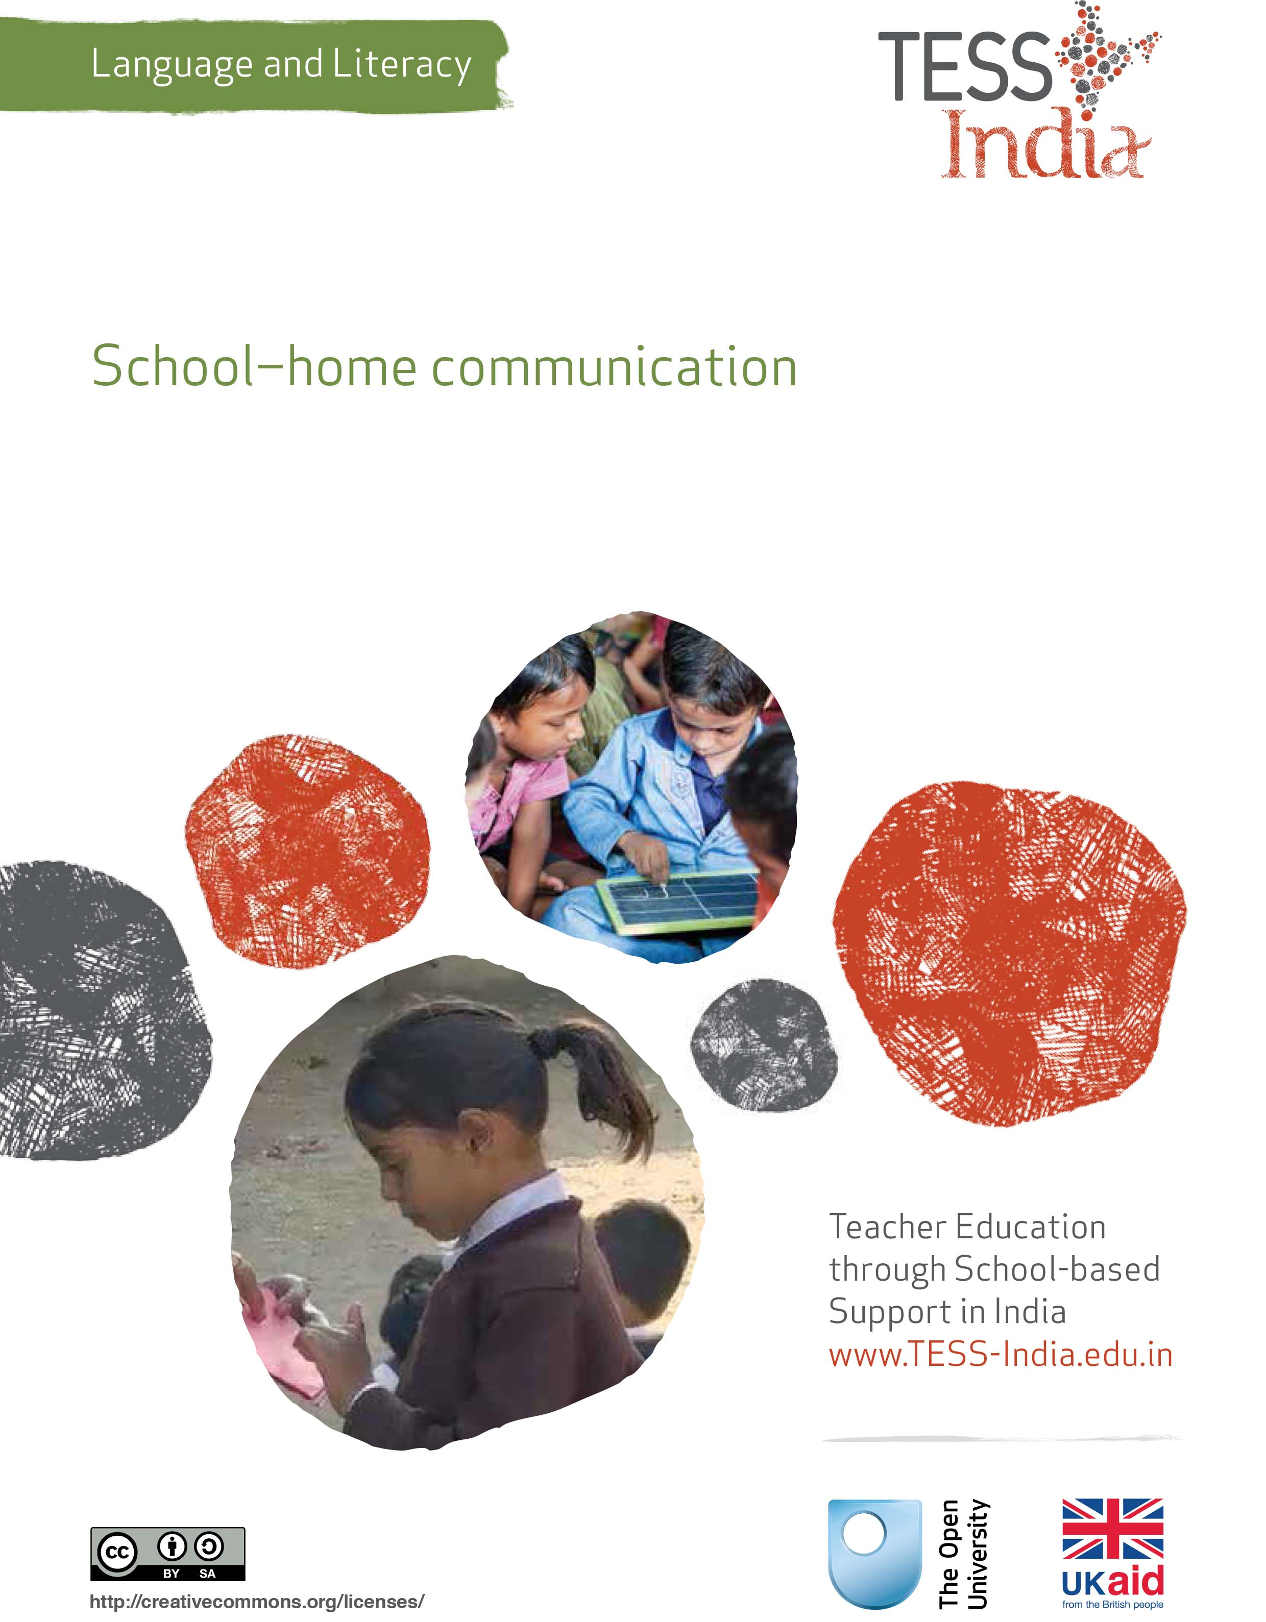
TESS-India (Teacher Education through School-based Support) aims to improve the classroom practices of elementary and secondary teachers in India through the provision of Open Educational Resources (OERs) to support teachers in developing student-centred, participatory approaches. The TESS-India OERs provide teachers with a companion to the school textbook. They offer activities for teachers to try out in their classrooms with their students, together with case studies showing how other teachers have taught the topic and linked resources to support teachers in developing their lesson plans and subject knowledge.
TESS-India OERs have been collaboratively written by Indian and international authors to address Indian curriculum and contexts and are available for online and print use (http://www.tess-india.edu.in/). The OERs are available in several versions, appropriate for each participating Indian state and users are invited to adapt and localise the OERs further to meet local needs and contexts.
TESS-India is led by The Open University UK and funded by UK aid from the UK government.
Video resources
Some of the activities in this unit are accompanied by the following icon: . This indicates that you will find it helpful to view the TESS-India video resources for the specified pedagogic theme.
The TESS-India video resources illustrate key pedagogic techniques in a range of classroom contexts in India. We hope they will inspire you to experiment with similar practices. They are intended to complement and enhance your experience of working through the text-based units, but are not integral to them should you be unable to access them.
TESS-India video resources may be viewed online or downloaded from the TESS-India website, http://www.tess-india.edu.in/). Alternatively, you may have access to these videos on a CD or memory card.

Version 2.0 LL01v1
All India - English
Except for third party materials and otherwise stated, this content is made available under a Creative Commons Attribution-ShareAlike licence: http://creativecommons.org/licenses/by-sa/3.0/

What this unit is about
Children start school with ideas, languages, knowledge, skills and concepts gained through interaction with others at home and in the community. Their formal learning in school will be more effective when you recognise their linguistic and cultural capacities as key resources for their ongoing development.
In this unit you will explore ways to value and draw upon your students’ home and community experiences in your language and literacy teaching.

What you can learn in this unit
- How to incorporate opportunities to learn more about your students into your classroom routines.
- How to plan language lessons that draw upon your students’ out-of-school experiences.

Why this approach is important
Students spend much of their time learning informally at home and in the community. However, the tendency to adhere to the textbook as the main source of instruction means that teachers may overlook the skills, knowledge and experiences that students bring to the classroom.
The unfamiliar people, routines and language that young children encounter when they first come to school can be bewildering. By valuing the diversity of cultural practices and languages that your students know, you can make them feel more secure in this new context.
Children have to cross a bridge between home-based learning and school-based learning every day. This unit suggests activities to ease this transition, for the benefit of teachers and students alike.

1 Students’ learning outside school
Pause for thought
- What skills and knowledge can you think of that your students have acquired outside school?
- Do you think your students’ home or community language and cultural knowledge is useful in their schooling? Why, or why not?
In Case Study 1, a teacher finds out about a pre-school child’s learning experiences.
Case Study 1: Mrs Bhatti reflects on a child’s pre-school knowledge and skills
Mrs Bhatti, an elementary teacher in Bhopal, describes her experience of buying a bowl in a shop that belonged to the parents of one of her Class II students. There she encountered her student’s four-year-old sister Shilpi, who was not yet in school.
Shilpi was sitting on the floor beside a cardboard box. She was taking out packets, counting them, and sorting them into piles. Her father was talking to a customer. I asked Shilpi, ‘Do you sell bowls?’ She called her mother, who appeared from the back of the shop. Pointing to the corner, her mother responded in the child’s home language, but using the Hindi word for ‘bowl’. Shilpi accompanied me to the display of bowls and picked two or three up, showing me the different colours available. I chose the red one, which she carried to the counter. She then took my money and passed it to her mother, who gave her the correct change to hand back to me. Shilpi helped her mother to wrap the bowl in paper before I placed it in my bag. Finally, together with her mother, she thanked me and said goodbye in Hindi.
As I left the shop, I reflected on the knowledge and skills that Shilpi was learning that would benefit her when she started school.
(Adapted from Kenner, 2000)

Pause for thought
- What does Shilpi know about language and communication?
- What other skills does Shilpi demonstrate in the case study?
Compare your ideas with ours.
Shilpi is becoming numerate. She can count, and she is learning how to sort and classify. She is beginning to understand about money and change. She knows how shops work. She can listen, understand a question and get information. She also knows how to interact politely with a customer.
Shilpi talks confidently in her home language. She knows the names of colours, the language of questions, instructions and directions. She can also understand some Hindi, which she uses to say thank you and goodbye. She is becoming aware that people may communicate in different languages.
Through observation, interaction and imitation, Shilpi is acquiring important general knowledge and communication skills. These represent a sound basis for further learning and language development when she goes to school.
Students continue to gain valuable knowledge and skills at home and in the community at the same time as they attend school. Your students may help to bring up their younger siblings, care for their grandparents, look after the family’s animals, help their parents on their market stall, contribute to making meals, have mastered a particular craft or enjoy playing sport. Such activities offer many informal learning opportunities for their language and literacy development, which can be built on within the school setting.

2 Classroom chats
Giving your students opportunities to talk about their interests, activities and commitments will encourage authentic communication in your classroom. It will also enable you to assess your students’ speaking and listening skills. This is especially helpful in the case of those whose home language differs from the school language.
The following practical activities are designed to help you get started.

Activity 1: A daily chat
Over the next school term, initiate a daily routine where you have a brief, informal chat with students, either individually or in a group. This can be at the start or end of the day, or during a break time. Make sure that you communicate with all of your students over time. You can keep a simple tick list to monitor this.
You could ask them whether they enjoyed a recent festival, if they have been affected by recent storms, or are following a particular cricket match, for example. Look for opportunities to link what your students learn outside school with what they are focusing on in the lesson. You might say:
‘I know lots of you helped your parents in the market this month, even in this terrible weather. Well done! In the maths lesson today you can show off your skills, because we are working on adding and subtracting money. How many of you gave change in the market? Did you check your sums with your mother or father?’

Your students’ responses will give you insights into the knowledge and skills that they bring to their learning at school. Keep notes on what you learn about your students, and which of their interests and activities are shared with others.
As you do this throughout the term, refer to your textbook, your syllabus and your teaching plans, looking for possibilities to link upcoming topics with what your students know about or are interested in.
To extend this speaking and listening activity, ask your students to write a weekly ‘diary’ about what they do when they are not in school.
Read Resource 1 for more information on involving all your students in the classroom.
Video: Involving all
http://tinyurl.com/video-involvingall

Activity 2: A class discussion
Plan a class discussion on students’ out-of-school interests and commitments. Use a single focused question as a prompt. Here are some ideas, but you will need to choose questions based on your own context:
- What kinds of things do you do to help at home? What do you like doing best? What do you like doing least?
- What was the best part of your weekend? What didn’t you enjoy so much?
- What will you do during the school holiday?
Write the question on the blackboard. Start by answering it yourself.
Then ask two or three students the question. Extend the exchange by using follow-up questions and prompts such as ‘Really? Where did you learn that?’, ‘What will you do next?’ and so on.
Organise your students into small groups and ask them to discuss the question on the blackboard together. Encourage them to ask one another follow-up questions. As they talk, move around and monitor the groups, ensuring that everyone is participating.
As an alternative to the small group discussions, you could ask your students to interview each other in pairs and then take notes and write a short account of what their partner told them.

3 A class project
In the next case study, a teacher uses her knowledge about students to plan an extended language and literacy project.
Case Study 1: Ms Balema’s language and literacy project about festivals
Ms Balema, a Class V teacher, was prompted by a textbook lesson on festivals.
My students had just completed a textbook lesson describing the main festivals in India, such as Eid and Holi. In our own communities we have many interesting festivals, so I decided to focus on our local ones, several of which were coming up soon.
I began by asking my students what festivals that they had been involved in and wrote their responses on the blackboard.
I then organised my students into groups, each one representing a festival. I gave each group a large piece of paper and explained that they had to write down as many things about their festival as they could: what the festival celebrated, what deities were worshipped, what communities were involved, what rituals were followed, what food was cooked, whether anyone wore special clothing and what activities there were. I told them that they could use their home language for the discussion and their notes if they wished to.
I then asked each group to present their brainstorm to the whole class. I prompted the groups a little by asking them questions such as ‘What time of day does that happen? When you go to the temple, what do you wear? Do your grandparents celebrate?’, and so on.
I then explained that each group would create a poster to represent their festival. For homework, I asked my students to find out more about the festival from their parents, grandparents and anyone else at home or in the community. I gave them some sample questions ‘Has the festival always been celebrated here? Was it always so large? Has the music changed?’ I allocated one lesson a day over a week for my students to work on their posters. I moved from group to group, listening to and observing them, and helping them as necessary.
I explained that they could write in the school language or their home language on the poster, or a mix of the two. This was the first time some of them had written in their home language in the classroom. They were excited as they did so.
When they had finished, each group presented their poster to the rest of the class. The other students and I asked them questions. We all learned so much. I then fixed the colourful posters on the wall for everyone to read and enjoy.

Pause for thought
- What opportunities did Ms Balema have to assess her students in this project?
- How would you adapt this project for younger students?
- For older students, how could the project be extended?
This sequence of activities provided many opportunities for students to develop their language and literacy skills. It involved:
- whole class and small group discussions
- conversations with members of their family and community
- note-taking
- writing
- oral presentations
- active listening
- asking questions.
Throughout, they were encouraged to use both the school and their home languages.
At the heart of the project was the students’ local knowledge. The teacher had time to monitor individuals and groups. She could keep notes or a checklist about students’ skills and participation.
For younger students, speaking and listening should be emphasised in a project such as this. Younger students could also draw pictures or dramatise aspects of a festival. For older students, a written project would be more appropriate, incorporating research and using specialist vocabulary and knowledge about festivals, and drawing on language, history and traditional culture.
The key resource ‘Talk for learning’ (http://tinyurl.com/kr-talkforlearning) contains more ideas on the value of collaborative work among your students
Video: Talk for learning
http://tinyurl.com/video-talkforlearning

4 Summary
This unit has described the importance and value of exploiting your students’ home and community-based experiences in developing their language and literacy skills in school. Your students will feel more confident and motivated to learn in school if they notice that the things that they do and the languages they use outside school are valued by their teachers. You can show that you value your students’ experiences by regularly having chats and discussions with them to find out more about their out-of-school interests.
The unit has also outlined a number of ways that you can make textbook topics more meaningful and relevant to your students by drawing on their knowledge, as well as that of members of their family and community. You can adapt these kinds of activities to any textbook topic, and any level of student.

Resources
Resource 1: Involving all

What does it mean to ‘involve all’?
The diversity in culture and in society is reflected in the classroom. Students have different languages, interests and abilities. Students come from different social and economic backgrounds. We cannot ignore these differences; indeed, we should celebrate them, as they can become a vehicle for learning more about each other and the world beyond our own experience. All students have the right to an education and the opportunity to learn regardless of their status, ability and background, and this is recognised in Indian law and the international rights of the child. In his first speech to the nation in 2014, Prime Minister Modi emphasised the importance of valuing all citizens in India regardless of their caste, gender or income. Schools and teachers have a very important role in this respect.
We all have prejudices and views about others that we may not have recognised or addressed. As a teacher, you carry the power to influence every student’s experience of education in a positive or negative way. Whether knowingly or not, your underlying prejudices and views will affect how equally your students learn. You can take steps to guard against unequal treatment of your students.

Three key principles to ensure you involve all in learning
- Noticing: Effective teachers are observant, perceptive and sensitive; they notice changes in their students. If you are observant, you will notice when a student does something well, when they need help and how they relate to others. You may also perceive changes in your students, which might reflect changes in their home circumstances or other issues. Involving all requires that you notice your students on a daily basis, paying particular attention to students who may feel marginalised or unable to participate.
- Focus on self-esteem: Good citizens are ones who are comfortable with who they are. They have self-esteem, know their own strengths and weaknesses, and have the ability to form positive relationships with other people, regardless of background. They respect themselves and they respect others. As a teacher, you can have a significant impact on a young person’s self-esteem; be aware of that power and use it to build the self-esteem of every student.
- Flexibility: If something is not working in your classroom for specific students, groups or individuals, be prepared to change your plans or stop an activity. Being flexible will enable you make adjustments so that you involve all students more effectively.

Approaches you can use all the time
- Modelling good behaviour: Be an example to your students by treating them all well, regardless of ethnic group, religion or gender. Treat all students with respect and make it clear through your teaching that you value all students equally. Talk to them all respectfully, take account of their opinions when appropriate and encourage them to take responsibility for the classroom by taking on tasks that will benefit everyone.
- High expectations: Ability is not fixed; all students can learn and progress if supported appropriately. If a student is finding it difficult to understand the work you are doing in class, then do not assume that they cannot ever understand. Your role as the teacher is to work out how best to help each student learn. If you have high expectations of everyone in your class, your students are more likely to assume that they will learn if they persevere. High expectations should also apply to behaviour. Make sure the expectations are clear and that students treat each other with respect.
- Build variety into your teaching: Students learn in different ways. Some students like to write; others prefer to draw mind maps or pictures to represent their ideas. Some students are good listeners; some learn best when they get the opportunity to talk about their ideas. You cannot suit all the students all the time, but you can build variety into your teaching and offer students a choice about some of the learning activities that they undertake.
- Relate the learning to everyday life: For some students, what you are asking them to learn appears to be irrelevant to their everyday lives. You can address this by making sure that whenever possible, you relate the learning to a context that is relevant to them, and that you draw on examples from their own experience.
- Use of language: Think carefully about the language you use. Use positive language and praise, and do not ridicule students. Always comment on their behaviour and not on them. ‘You are annoying me today’ is very personal and can be better expressed as ‘I am finding your behaviour annoying today. Is there any reason you are finding it difficult to concentrate?’, which is much more helpful.
- Challenge stereotypes: Find and use resources that show girls in non-stereotypical roles or invite female role models to visit the school, such as scientists. Try to be aware of your own gender stereotyping; you may know that girls play sports and that boys are caring, but often we express this differently, mainly because that is the way we are used to talking in society.
- Create a safe, welcoming learning environment: All students need to feel safe and welcome at school. You are in a position to make your students feel welcome by encouraging mutually respectful and friendly behaviour from everyone. Think about how the school and classroom might appear and feel like to different students. Think about where they should be asked to sit, and make sure that any students with visual or hearing impairments, or physical disabilities, sit where they can access the lesson. Check that those who are shy or easily distracted are where you can easily include them.

Specific teaching approaches
There are several specific approaches that will help you to involve all students. These are described in more detail in other key resources, but a brief introduction is given here:
- Questioning: If you invite students to put their hands up, the same people tend to answer. There are other ways to involve more students in thinking about the answers and responding to questions. You can direct questions to specific people. Tell the class you will decide who answers, then ask people at the back and sides of the room, rather than those sitting at the front. Give students ‘thinking time’ and invite contributions from specific people. Use pair or groupwork to build confidence so that you can involve everyone in whole-class discussions.
- Assessment: Develop a range of techniques for formative assessment that will help you to know each student well. You need to be creative to uncover hidden talents and shortfalls. Formative assessment will give you accurate information, rather than assumptions that can easily be drawn from generalised views about certain students and their abilities. You will then be in a good position to respond to their individual needs.
- Groupwork and pair work: Think carefully about how to divide your class into groups or how to make up pairs, taking account of the goal to include all and encourage students to value each other. Ensure that all students have the opportunity to learn from each other and build their confidence in what they know. Some students will have the confidence to express their ideas and ask questions in a small group, but not in front of the whole class.
- Differentiation: Setting different tasks for different groups will help students start from where they are and move forward. Setting open-ended tasks will give all students the opportunity to succeed. Offering students a choice of tasks helps them to feel ownership of their work and to take responsibility for their own learning. Taking account of individual learning needs is difficult, especially in a large class, but by using a variety of tasks and activities it can be done.

References/bibliography
Austin, R. (ed.) (2009) Letting the Outside In. London: Trentham Books.
BBC News (2013) ‘Is Indian storytelling a dying art?’ (online), 23 March. Available from: http://www.bbc.co.uk/news/world-asia-india-21651933 (accessed 16 September 2014).
Bridges, L. (1995) Creating Your Classroom Community, Portland, ME: Stenhouse Publishers.
Kenner, C. (2000) Home Pages: Literacy Links for Bilingual Children. Stoke-on-Trent: Trentham Books.
Pattanayak, B., Gupta, D. and Singha, S. (undated) ‘Local art education for whole child development: a case of Paitkar painting in Amadubi village’ (online), supported by UNICEF-Jharkhand, JEPC, JTWRI. Available from: http://www.academia.edu/5937590/Towards_holistic_development_of_children_using_local_art_and_culture_in_Jharkhand_India (accessed 18 November 2014). This resource looks at the holistic development of children using local art and culture.
Webster, L. and Reed, S. (2012) The Creative Classroom. London: Collins.

Acknowledgements
This content is made available under a Creative Commons Attribution-ShareAlike licence (http://creativecommons.org/licenses/by-sa/3.0/), unless identified otherwise. The licence excludes the use of the TESS-India, OU and UKAID logos, which may only be used unadapted within the TESS-India project.
Every effort has been made to contact copyright owners. If any have been inadvertently overlooked the publishers will be pleased to make the necessary arrangements at the first opportunity.
Video (including video stills): thanks are extended to the teacher educators, headteachers, teachers and students across India who worked with The Open University in the productions.

