Leadership for Effective Learning
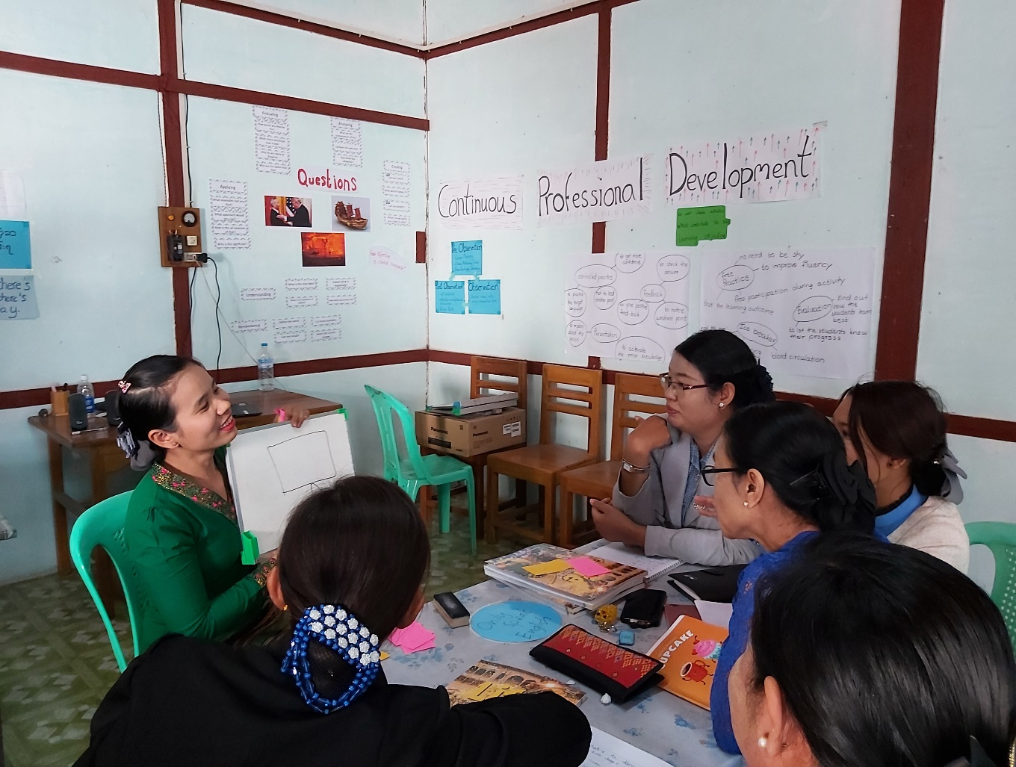
Unit 3: Leadership for Effective Learning
Trainer’s Guide

Overview
This module considers what effective learning looks like in the context of educational institutions and organisations in Myanmar and how leadership teams of these institutions and organisations can influence attitudes and approaches to effective learning.
The course will consider questions such as:
- Who are our learners?
- What is effective learning?
- Who is responsible for effective learning?
- What leadership approaches and strategies can leaders employ to enable and ensure effective learning in their contexts?
- What skills do leaders require in order to enable and ensure effective learning and how can these be developed?

This is the third of five units:
- What is Effective Learning?
- The Learner and Classroom Environment
- Leadership for Effective Learning
- Strategies for Leading for Effective Learning
- Skills for Leading for Effective Learning

Contents

Section | Materials | Timing
Outcomes | Participant Book | 5 mins
3.1 Leading for learning | Participant Book | 20 mins
3.2 Eight key dimensions to successful leadership | Participant Book | 15 mins
3.3 Direct influences: monitoring and evaluation | Participant Book  YouTube video | 20 mins
3.4 Direct influences: continuing professional development | Participant Book | 20 mins
3.5 Direct and indirect influence | Participant Book | 20 mins
3.6 Reflect and apply | Participant Book | 20 mins

Outcomes

By the end of this unit, participants will be able to:
- reflect on actions they currently take and can take in the future to implement leadership for effective learning
- discuss ways they can implement effective procedures for monitoring and evaluation
- identify and discuss ways they can implement effective procedures for professional development for teaching/training staff
- identify and discuss differences between direct and indirect influences leaders demonstrate and how levels of direct and indirect influence can be increased
- discuss impact of leadership strategies on learner outcomes
- begin making an action plan for implementing direct and indirect strategies for leading for effective learning.

Learning Outcomes
- Briefly introduce the course overview and answer any questions.
- Explain the outcomes for this unit and check participants understand them.
- Highlight that this unit aims to encourage reflection about learning and leadership, rather than teach facts.

3 Leading for effective learning

3.1 Leading for learning

3.1 Discuss: the impact of leadership
- Ask participants to read the introductory text.

- Do not worry about going into too much detail at this stage as key issues are dealt with throughout this unit. If participants are unsure about the differences between direct and indirect influences, use the example to clarify but let participants know that these issues are addressed in more detail in Activity 3.5.

- Ask participants to work individually and make a list of what they, as leaders, can make sure that effective learning is taking place at their institutions. Ask participants to compare responses and elicit ideas.

3.1 Task: your working week
Step 1
Ask participants to work individually and list all the activities they undertook in the previous week at their institutions that were related to leading teaching and learning.
Step 2
Ask participants to work in pairs or small groups and think about these questions:
Which activities had the most influence on the quality of teaching and student learning?
In your typical working week, what proportion do you think is spent on leading teaching and learning?
Accept any relevant responses at this stage as all these issues are explored in more detail throughout the unit.
Remind participants that they can refer back to these lists throughout the unit. They can revise and add to their lists as appropriate throughout the unit and their ideas will provide a foundation for the action planning task in Activity 3.6, Step 3.

3.2 Eight key dimensions to successful leadership

3.2 Discuss: successful leadership

This activity aims to encourage participants to discuss Day’s eight key dimensions to successful leadership, to decide how some/all of these can be applied to their own contexts and to revise/add to the lists of effective behaviours they developed in Activity 3.1. A link to Day’s research is included in the References to this unit.

- Ask participants to read the eight dimensions. The dimensions are quite broad and while some are clearly of immediate practical application (e.g. build collaboration internally), others may need more clarification and discussion to help participants to see how these apply to their own contexts.

3.2 Task: eight dimensions and you
- Ask participants to work individually and identify one practical action which participants:
- have taken in the past which reflects this dimension
- could take in the future to reflect each dimension.

- Ask participants to work in pairs or small groups to compare ideas.

- Ask participants to add any relevant ideas to the lists they prepared in Activity 3.1.

- Ask participants if there any further dimensions they would like to add to the list which reflect their context.

Variation:
- Organise participants into four groups.
- Allocate two dimensions to each group.
- Ask groups to work together to identify practical past and future actions which reflect their two dimensions.
- Ask groups to record their answers on a poster.
- When all groups have completed the task, ask groups to stick their posters on the wall.
- Invite participants to walk around and look at their colleagues’ posters and select three actions which they could be apply at their own institution.
- To wrap up, invite two or three participants to share their ideas.

3.3 Direct influences: monitoring and evaluation

For the purposes of this unit, monitoring and evaluation is defined as a direct influence on learning although there are a number of ways in which it can be seen as influencing learning indirectly. The unit aims to emphasise the importance of the leadership team in undertaking some/all of these procedures themselves rather than delegating them to others or not undertaking them at all. It is likely that procedures used and leadership teams’ involvement with them vary very significantly from one context to another. Planning, monitoring, evaluation and reviewing and other M&E procedures are discussed in more detail in CPD Awareness Raising Units 3 and 4.

3.3 Discuss: planning, monitoring, evaluation and reviewing

Organise participants in small groups.

Ask each group to identify as many monitoring and evaluation procedures as they can which would support learning.

Ask groups to identify which of these procedures are currently implemented and which could be implemented in the future.

- Accept any relevant ideas at this stage but encourage participants to focus on practical and feasible procedures which can be implemented.

3.3 Task: procedures for monitoring and evaluation
Step 1: Which monitoring and evaluation procedures can be used in your context?

Organise participants in small groups.

- Ask groups to read the suggested procedures. Clarify any procedures which might be new to participants (e.g. learning walks).

- Ask participants to identify and discuss which procedures they currently follow and which could be implemented in the future.

- Elicit feedback and ask participants to record their ideas, e.g. in Chat.

Note: all procedures are useful and, with appropriate preparation, all could be feasibly implemented at the majority of institutions participants are likely to come from.

Step 2: Follow-up
Refer participants to the YouTube video on learning walks which they can watch following the session.

3.4 Direct influences: continuing professional development

3.4 Discuss: CPD in your context
- Ask participants to work individually and answer these questions.
Encourage participants to record their answers in the box provided.
What types of continuing professional development takes place at your institution at the moment? Who leads this CPD? Who organises it?

What strategies are used at your institution to encourage teachers/trainers (and other staff) to work together?

Do you take part in this continuing professional development yourself? Why do you think it could be important and useful to do so?

- Ask participants to compare responses.

It is likely that the way CPD is organised and ways in which it is implemented vary very significantly from one institution to another.
3.4 Task: creating opportunities for CPD
The criteria collated by Simon Borg are intended to provide a guide for participants as to what really constitutes effective CPD and to give them the opportunity to assess CPD in their own contexts. Borg’s criteria have been slightly adapted for the aim of simplification. A link to the full criteria is included in the references to this unit.
- Ask participants to read the criteria.

- Organise participants into small groups. Ask groups to discuss these questions:

To what extent does CPD at your institution meet these criteria?
How could CPD at your institution be led and organised more effectively?
How could teachers/trainers be encouraged to collaborate more and work together more effectively?
- Elicit responses.

3.5 Direct and indirect influences

3.5 Discuss: are you a leader or are you a boss?
1 Organise participants in small groups.
- Ask groups to use the illustrations to guide them, identifying differences between ‘being a boss’ and ‘being a leader’.
- Elicit and ask participants to record feedback.

2 Ask participants to complete the table with their own ideas.
- Allow time for participants to compare ideas.
- Elicit feedback,

Answers are open-ended but possible answers could include:
A boss | A leader
directs | coaches
tells others what to do | a) guides others
transmits decisions | involves others in the decision making process
demands results | inspires performance
gives answers | b) looks for solutions
talks more than they listen | c) listens more than they talk
d) is confident that they have all the answers | is willing to learn
e) criticises | encourages
focuses on themselves | f) focuses on the team
points out weaknesses | identifies strenghts and potential
defends personal characteristics | g) is honest about personal areas to improve

For further ideas, see for example:
www.villanovau.com/resources/leadership/differences-between-boss-and-leader/
www.rickgoodman.com/whats-the-difference-between-a-boss-and-a-leader/
3 Ask participants to describe any ways they feel they could become more like a leader.
Elicit any examples.
3.5 Task: direct and indirect influence
Step 1
Ask participants to read the definitions of direct and indirect influences.

Step 2
Ask participants to read the examples of direct and indirect influences.
Deal with any unfamiliar concepts or language.
Step 3
- Ask participants to work individually.
- Participants re-read the example of direct and indirect influence.
- Participants discuss and identify any actions which they currently do not take/seldom take and which they could implement in the future.
- Ask participants to compare ideas.
- Ask participants to focus on three actions which are practical and feasible and to add these to the lists which they produced in Activity 3.1.
- Elicit actions identified.

Step 4
The concept presented in this activity may prove to be a little controversial to participants and may result in some heated discussion. Authorities suggest that leadership personnel taking some responsibility for teaching can have a very significant indirect influence on leading for leadership although this may be unusual in some of the contexts participants work in.

3.6 Reflect and apply

This activity aims to summarise learning from this unit and support participants in beginning to develop a simple action plan for implementing some of the actions which have been discussed in the unit.
Step 1
- Refer participants to the lists they developed in Activity 3.1 and which they will have had the opportunity to annotate and revise while working on the unit. At this stage, participants are encouraged to add any actions they have discussed to their lists.

Step 2
- Ask participants to look at the diagram which summarises research by Robinson (2007). Key features of this research are the needs to implement effective continuing professional development and establish clear goals.

- Ask participants to use the diagram for guidance, reflect on learning from this unit and respond to the following questions:

Which actions are you currently involved in?
Which actions could you do more of in the future? Why would this be important?
What challenges are there to implementing these actions in the future? How could you meet these challenges?

- Organise participants in small groups and elicit feedback.

Step 3
Step 3 tasks are intended as an assignment to follow the session.
Participants are encouraged to:
- read the article Leading for Effective Learning in the Appendix to this unit
- make a practical action plan for implementing three of these actions
- keep a journal to describe how effectively they have implemented these actions
- share experiences with a colleague or colleagues.

Further reading and references

ACSD (nd) Leading for Learning
Available online at:
www.ascd.org/publications/newsletters/education-update/jan04/vol46/num01/Leading-for-Learning.aspx

Borg, S. (2015) Contemporary Perspectives on Continuing Professional Development. British Council.
Available online at:
www.britishcouncil.in/sites/default/files/contemporary_perspectives_on_cpd.pdf

British Council, Connecting Classrooms Leading effective teaching and learning
Cambridge Education (nd) The Five Leadership for Learning Principles
Available online at:
www.educ.cam.ac.uk/networks/lfl/about/PDFs/LfL_framework_and_principles.pdf

Daniels, H. and Edwards, A. (2012) Leading For Learning: How The Intelligent Leader Builds Capacity. Nottingham. National College for School Leadership
Available online at:
https://thestaffcollege.uk/wp-content/uploads/Leading_for_learning_-V3_180612.pdf

Dempster, N. (2009) Leadership for Learning: A Framework Synthesising Recent Research
Available online at:
https://core.ac.uk/download/pdf/143858458.pdf

KIPP (nd). Leading for Learning: 8 Actions of Highly Effective School Leaders
Available online at:
www.kipp.org/wp-content/uploads/2016/11/LFL_.pdf

Matthews, P. (2010) How Do School Leaders Successfully Lead Learning? National College for School Leadership
Available online at:
https://dera.ioe.ac.uk/254/1/download%3Fid=23637&filename=how-do-school-leaders-successfully-lead-learning.pdf

Robinson, V. (a) 2007) School Leadership And Student Outcomes: Identifying What Works. Winmalee, Australian Council for Educational Leaders
Available online at:
www.educationcounts.govt.nz/publications/series/2515/60170

Robinson, V. (b) 2007) The Impact Of Leadership On Student Outcomes: Making Sense Of The Evidence.
Available online at:
https://research.acer.edu.au/cgi/viewcontent.cgi?article=1006&context=research_conference_2007

