Contents

Topic 3: Travel and tour operations 2
3.1 Destination management 3
3.2 The tourism destination lifecycle 6
3.3 Sustainable tourism planning 9
3.4 Tour guide profession 13
3.5 Fundamental tasks of a tour guide 16
3.6 Specific tasks of a tour guide 19
Answers to activities 22

Topic 3:
Travel and tour operations 2
This topic looks at destination management, which is a form of tourism planning. It is best achieved through a destination management organisation. Every tourism destination follows a life cycle, which is explored in this topic. Tour guiding is also considered; the characteristics, responsibilities and qualities a tour guide needs. You are invited to consider whether you have the skills to work in this profession and further detail is provided on the fundamental and specific tasks performed by guides.

3.1 Destination management
A tourism destination is a place or area that relies heavily on the economic benefits of tourism. Destinations contain a number of elements which you learned about in Session 1.5, such as access, accommodations, attractions, activities and amenities. Other elements that contribute to creating a tourism destination are price, human resources (its workforce) and image (Figure 3.1.1).
Figure 3.1.1 Elements that contribute to making a tourism destination

Price is an important aspect of the destination’s competitiveness over other destinations, as well as ensuring the tourist gets excellent value. A pricing strategy helps to market a destination to potential visitors and repeat visitors. For example, a resort might offer lots of free activities which the guest might be expected to pay for at other resorts. Or it might offer special family rates for visiting attractions, accommodation and meals, making it more affordable and attractive to families.
A well-trained tourism workforce ensures tourists’ needs are effectively met. It is important to set high standards and keep staff trained in using new technologies, such as for bookings. This, together with ongoing coaching and mentoring, builds staff efficiency, staff morale and improves the guest experience.
The brand image of a destination can be a critical factor in a tourist deciding to visit. It also has an impact on the satisfaction level of the visitor if what they expected is delivered, as you read in Sessions 1.6 and 2.6. If satisfaction is high, visitors are loyal and are likely to recommend the destination to family and friends. They may also return. A destination’s brand identity is the external perception of a brand that is purposefully created by the business stakeholders to promote the product. It is formed through many stakeholders (who have an interest in the destination’s success) working together to create it. How this is interpreted by the public and media creates the brand image for the destination. This is something that is best managed through a destination management organisation.

Destination management organisations
Destination management calls for a group of many organisations and interests (stakeholders) working towards a common goal. The destination management organisation’s (DMO) role is to lead and coordinate activities under a coherent strategy to promote the destination and its sustainability. DMOs include the national tourism authority; regional, provincial and state tourism organisations; and local tourism organisations.
The DMO ensures the quality of every aspect of the visitor’s experience by creating a suitable environment to attract visitors, through marketing and developing the right social, economic and physical environment. This involves planning, infrastructure and human resources development, product development, technology and systems development and development of related industries and procurement. The DMO promotes the brand, organises campaigns to drive business, provides unbiased information services to visitors, facilitates bookings and generally provides good customer relationship management.
Well-managed and sustainable destinations are more likely to attract and maintain investment, see businesses grow and employment increase without having a detrimental effect on the environment or local population. Small- and medium-sized businesses are encouraged, such as community-based arts and crafts enterprises. Tourism allows small- and medium-sized businesses, many of whom are local, access to foreign consumers. Because the tourists come to them, they do not face export barriers or have to invest in an export distribution channel. For tourism goods and services that are supplied locally, tourist expenditures can be retained in the destination, building sustainability.
Planning and good marketing can lengthen the average visitor stay, which increases visitor expenditure. The community can also benefit from the facilities and services developed for tourism, such as road and rail development, an airport, sanitation and solid waste management, entertainment and well-maintained public spaces.
The DMO’s role in maintaining the environmental integrity, resources, and social and cultural character of the destination makes them great places to live, work and visit.
Figure 3.1.2 The advantages of managing a destination through a DMO

Activity 3.1
1. What are three elements that contribute to creating a tourism destination? Select from the following list:
- price
- ground transportation
- beaches
- human resources
- mountains
- image.

2. Are the following statements true or false?
- To deliver excellent value to visitors, it is vital that the various components of the visitor’s stay are managed and coordinated throughout the visit, while ensuring local benefits, through a DMO.
- A DMO builds sustainable tourism.
- A DMO limits the spread of tourism benefits.
- A DMO causes tourism yield to fall.
- A DMO builds strong brand identity, which increases brand loyalty.
Answers to Activity 3.1

3.2 The tourism destination life cycle
This session looks at the tourism destination life cycle. Tourism destinations are constantly changing. This model shows how tourism destinations move through five distinct stages of growth.

Figure 3.2.1 Tourism destination life cycle

- Exploration: A small numbers of visitors are attracted by natural or cultural attractions to visit, although few tourist facilities exist.
- Involvement: There is some involvement by local residents, who provide some facilities for visitors and begin to market their services. Visitors are likely to come from within the state or region, rather than internationally.
- Development: A large numbers of tourists arrive, increasingly from overseas, and external organisations take more of a key role in meeting the needs of the growing number of visitors.
- Consolidation: Tourism becomes a major part of the local economy and of increasing political importance. Rates of visitor growth may level off and some facilities may be in need of upgrading.
- Stagnation: The number of visitors has peaked and the destination may no longer be considered fashionable.
Depending on the response of the DMO to the onset of stagnation, various scenarios – such as decline, stabilisation, rejuvenation or reinvention – are possible. The DMO needs to intervene and take action to avoid decline at the stage of stagnation. To do this, the following model needs to be followed (Figure 3.2.2).
Figure 3.2.2 The DMO model for success

Making the partnership work
Whilst the DMO is critical for ensuring the effective management of a destination, many other groups are involved in supporting the destination. The tourism experience is delivered by a range of partners, including private sector businesses, the public sector and the community at large. For tourism to succeed in the destination, these stakeholders have to work together in accordance with a collective vision. But this is challenging, as all stakeholders need to join forces and work together closely.

Strong leadership is needed
Strong and effective leadership from the DMO is essential for retaining a collective focus, ensuring all stakeholders work to the same end. If there is a lack of coordination and cooperation among the different stakeholders, conflict can arise leading to fragmentation, poor quality control and loss of value for the guest.

Planning to achieve competitive advantage
Successful tourism destinations require a clear, competitive strategy to achieve a competitive advantage. This means following a targeted tourism approach that builds a distinctive identity and brand, and delivers excellent customer value.

Limiting economic leakage
Not all the income generated by tourism stays within the destination. For example, in many all-inclusive package tours, a large percentage of visitor expenditure goes to the airlines, hotels and other international companies who often have their headquarters in the visitor’s home countries. Food and drink may also be sourced from the visitor’s home country. This lost revenue is called economic leakage, and the DMO should seek to minimise this.

Delivering quality
Because the tourism industry is made up of many different companies, quality control is difficult. Value can be substantially reduced by the actions of weak or unscrupulous service providers in the tourism value chain, which can destroy the destination’s reputation. The DMO should agree a framework and standards of quality control for consistent quality to be delivered.

Activity 3.2
You have learned that destinations can stagnate after some time and that their future can follow one of four pathways: decline, stabilisation, rejuvenation and reinvention. Match the stages with the explanations of what each of these futures could look like for a DMO.
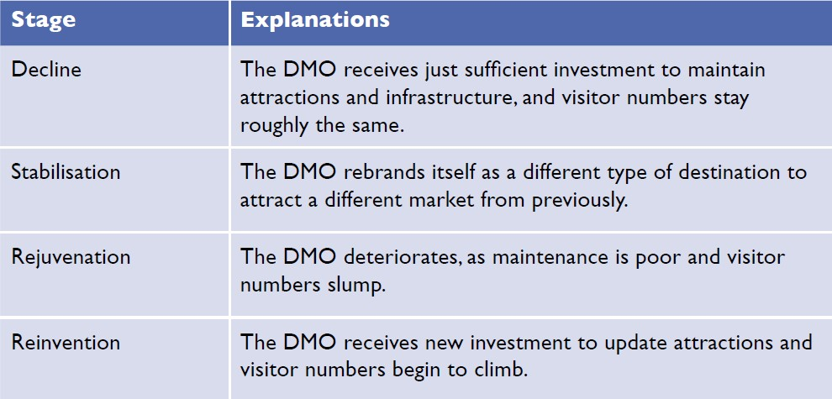
Answers to Activity 3.2

3.3 Sustainable tourism planning
Sustainable tourism planning has evolved over the past 70 years and has a considerable impact on the social, economic and environmental conditions in host destinations. To ensure that tourism brings positive benefits, and to minimise the harm it can cause and be sustainable, a tourism plan is needed. Figure 3.3.1 details the aims sustainable tourism planning seeks to achieve.
Figure 3.3.1 Sustainable tourism planning objectives

Sustainable tourism seeks to promote economic growth by increasing visitor numbers, but to protect the environment and minimise the negative sociocultural impacts of tourism. This is achieved by strategic, long-term planning and stakeholder participation.
Tourism planning today is much more comprehensive and integrated than when it was first introduced in the 1950s. Today it is more inclusive of all stakeholders, who get the opportunity to have their say on how tourism should look in the future.

Benefits of tourism planning
Every destination needs tourism planning and the DMO is at the centre of this. The DMO must be able to clearly articulate the future direction of tourism in their area. Destination tourism planning produces clear overall directions for all stakeholders on how tourism will be developed and progressed in future years.
Initiating and conducting planning tends to draw greater attention and focus to tourism within the destination, as it provides a vision and goals for tourism. Targets are set for the destination to achieve within specific time frame. Opportunities are identified that will enhance and improve tourism in the destination. All stakeholders are involved in the planning process, giving rise to a feeling of shared ownership of the plan. The planning process produces steps for implementation and measures for assessing the effectiveness of the plan. The benefits of the tourism planning process are shown in Figure 3.3.2.
Figure 3.3.2 Benefits of the tourism planning process

Types of tourism plans
There are three types of tourism plan.
- Tourism master plan: a long-term plan for ten or more years
- Tourism strategy: a medium-term plan for five to nine years
- Tourism action plan: a short-term plan for two to four years.
You will learn about Myanmar’s tourism planning in Session 6.5.

Outcomes of tourism planning
The DMO and its stakeholders must define the key goals for completing a tourism plan and state the desired outcomes of planning. Tourism planning should have at least five outcomes (Figure 3.3.3).
Figure 3.3.3 Outcomes of tourism planning

Activity 3.3
Consider the outcomes of tourism planning and identify where the following issues would be addressed in the tourism planning process:
- global pandemic, e.g. Covid-19
- high level of cooperation among tourism organisations and businesses
- overcrowding, congestion and traffic problems
- historical monuments and landmarks are regularly cleaned
- attracting different types of visitors through varied marketing approaches
- high level of community awareness of the benefits of tourism
- hostile and unfriendly attitudes of local residents towards visitors
- improving transportation and infrastructure
- global economic slump
- local festivals, events and activities are supported.
Sort the outcomes into the correct rows of the table.
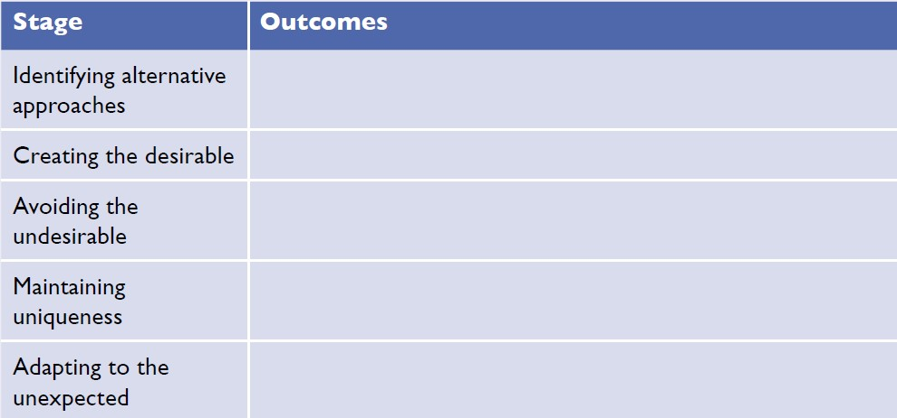
Answers to Activity 3.3

3.4 Tour guide profession
This session looks at the profession of tour guiding. It analyses the characteristics, responsibilities and qualities of a tour guide, and invites you to consider whether you have the skills to work in this profession.
A tour guide is someone who is employed either directly by the traveller, or a tour operator or travel agent to inform, direct and advise the tourist before and during their journey. The role of a tour guide is to accompany visitors to tourist attractions and provide information and insights that enhance the visitors’ experience. Attractions include historic monuments, cultural centres and natural beauty spots. Guides might work with a group of visitors over a number of days, accompanying them to lots of different attractions, organising their meals and overnight accommodation, or they may provide a specialist tour of a particular attraction for day trippers. They may give walking tours, bus tours or even lead tours of rivers and lakes on a boat.

Main characteristics
For many visitors, the tour guide is the only person from whom they learn about the city or attraction and the only local person with whom they have an extended conversation. Throughout the world, the role and responsibility of the tour guide varies, but guides wherever they are share many common traits. They are often generalists, well-read and interested in many branches of knowledge, particularly history, art, architecture and geography. The success of a guided tour depends largely upon how well the tour guide performs his or her job. A visitor’s impression of a foreign country is heavily related to the knowledge of the tour guide.

The role of tour guide
The tour guide serves as interpreter, introducer, educator, companion, host and even ambassador. Tour guides are representatives of their community, country and society, and are entrusted to tell its story. The tour guide plays a very important role – they are the front line of the tourism industry. It is the tour guide whom a visitor first meets on arrival in the country and the last they see on departure (Figure 3.4.1).
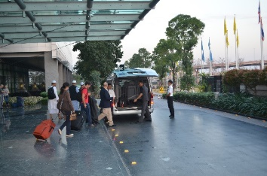
Figure 3.4.1 A tour guide meets the visitors he will be guiding at the airport

The qualities of a tour guide
- Personal characteristics: Smart appearance, pleasant manner, pleasant voice, talent for human relations, enthusiasm, willingness to learn, a positive outlook.
- Knowledge: educated and intelligent, good general knowledge, adequate knowledge of the destination regions (geography, history, cultural heritage of the religions to which he/ she escorts the tourist), fluency in at least one foreign language.
- Social skills: behaves in a friendly and professional manner towards others in different social situations.
- Communication skills: ability to communicate effectively.
- Presentation skills: ability to present information concisely, fluently and in an interesting way.
- Leadership skills: ability and techniques needed to organise and control groups of people tactfully.
- Organisational skills: flexibility and agility to manage itinerary changes and to perform clerical duties.
- First aid skills: knowledge of emergency first aid to tend to sick or injured guests.

Practicalities of guiding
Guiding is strenuous and demanding, requiring a great deal of energy, enthusiasm and patience. A tour guide must have the ability to handle groups of people with courtesy and diplomacy. When delays or problems develop, it is the tour guide who bears the brunt of complaints, so they must know how to deal with difficult tour members.
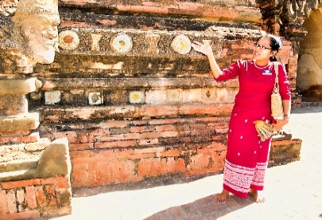
Figure 3.4.2 A tour guide provides a commentary to visitors at a historical site

Tour guides, like all educators, are teachers and students, as they are constantly learning. A good guide reads widely and also seeks every opportunity to attend relevant lectures, classes and programmes to broaden their understanding.

Activity 3.4
Watch part of this video, in which young people from Myanmar discuss the skills and knowledge needed by tour guides. The video is made by the education charity, Mote Oo. Watch from 2 minutes 46 seconds to 5 minutes.
https://www.youtube.com/watch?v=suxh6e07LoI&list=PLjRPoXCoejwYtRXIk9ibQuuRB943Ed7hy&index=1
Now read the following questions and watch the video again to help you answer them.
1. List the skills and knowledge needed by tour guides.
2. From what you have watched and read and drawing on your own knowledge also, what other skills and attributes do you think a tour guide needs?
3. Are you suited to be a tour guide?
Answers to Activity 3.4

3.5 Fundamental tasks of a tour guide
Regardless of the type of tour, there are some tasks that all tour guides have to perform. They are called the fundamental tasks.

Preparing for the tour
Tour guides need to be very organised and have good time managements skills. Checklists are essential for ensuring they remember everything, as is an itinerary of the tour. The guide needs to have organised the commentary materials for all attractions and have liaised with their employer regarding what to expect from the group.

Meeting service on arrival
Before meeting the tour participants, the tour guide needs to check a number of arrangements. They should check that the clients are arriving on time, or if there are any delays in their schedule involving outgoing or incoming transport. The guide needs to make arrangements with porters to support luggage transfer, as well as reconfirming reservations for tour accommodations, attractions and activities.
When meeting the tour participants, the guide needs to greet them with a smile, introduce themselves and help participants with health, immigration and customs formalities. The guide should check the luggage before leaving, making sure to count the participants and bags.
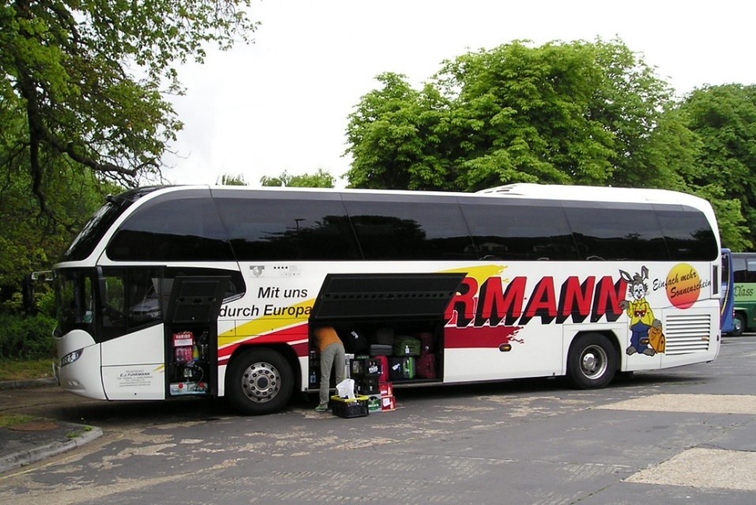
Figure 3.5.1 A tour guide is responsible for making sure all luggage is loaded onto the coach

Check-in at the hotel
On arrival at the hotel, the tour guide should inform hotel staff of the number of bags and notify the hotel reception of any special requirements of tour participants. They should assist the hotel reception staff in handling registration and informing participants of the location of their rooms. They should ask the tour participants to check their baggage, inform them of meal times, describe facilities available in and outside the hotel, and arrange the next meeting with the tour participants. The guide should only leave the hotel lobby after the baggage for the tour members is in order and any unexpected problems have been dealt with.
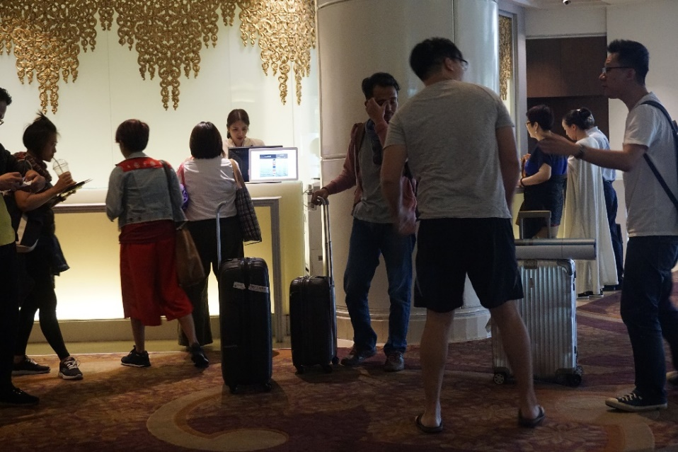
Figure 3.5.2 A tour guide assists guests at hotel check-in

Check-out from the hotel
Checking out from the hotel requires the guide to check the hotel bills and amend any hotel vouchers. They must notify the tour members of the time and place of departure. They should deal with any last-minute problems and check the number of tour participants and their baggage before leaving.

Special problems and situations
Some tour problems are beyond the control of even the most organised and experienced tour guide. However, most problems can be anticipated and avoided. Besides experience and careful planning, tact and common sense are valuable assets, especially when the unexpected occurs. Some of the common problems a tour guide might face are lost possessions, complaints about bad service, delays, accidents/breakdown of vehicles, participant illness, crime and death.

Transfer for departure
On the way to the departure point, the tour guide should wish farewell to the tour participants and ask them to complete an evaluation form, so the guide’s employer can have feedback and comments on the tour. The guide should also inform participants about customs and currency regulations, before thanking the tour participants.

Arriving at the departure point
At the departure point, the tour guide must make sure that participants have not left anything in the vehicle. They should arrange with the porters to send the baggage to the appropriate means of transport, inform the tour participants to check out with the immigration and customs counter in the external lounge, and wish them farewell.

Activity 3.5
Imagine you are the tour guide in the two scenarios and say how you would respond to the problem from the possible responses.
1. Due to a travel delay, visiting one of the most popular destinations on the tour has to be cancelled because there is insufficient time. In this situation, what would be the best solution for the participants?
- Don’t say anything to tour participants.
- Blame the participants for being late.
- Drive to the site and look at it from the outside.
- Apologise to participants, but explain that it is out of your control.
- Apologise to participants and downplay the importance of the site missed.
- Revise the itinerary and visit the site the following day.

2. One of your tour participants has lost their mobile phone while at an attraction and no one has handed it in. What will you do? Choose all the options that apply.
- Tell the participant to take better care of their things.
- Tell the participant that you can’t help.
- Let the participant borrow your phone.
- Empathise with the participant and leave your contact number with the attraction management in case the lost phone is found.
- Support the participant in disabling the phone remotely.
Answers to Activity 3.5

3.6 Specific tasks of a tour guide
In the last session we looked at the fundamental or basic tasks of the tour guide. In this session we will look at the specific tasks that relate to the presentation of points of interest and the art of commentary.
The tour guide utilises a vast amount of technical and cultural knowledge, information and imagination. Before passing information to others, the tour guide must be fully informed. They should know what to emphasise during a tour, selecting the most significant places to visit and giving a methodical presentation about them.
Tour guides are often hired by the visitor’s tour operators and are likely to be residents of the region where they guide. Let’s look at three popular tour types for guiding today.

Historical tour guides
Historical tour guides lead visitors to national monuments, historical sites, historical districts, religious or archaeological sites, and museums. They know the history of the site or monument very well and can talk about the significance the site or monument has today. They may also have some personal stories to tell that can add interest for the visitor. The guide answers visitor questions and keeps the tour organised by ensuring rest breaks. They make sure that is it efficient and running to schedule, as well as conducting a risk assessment to ensure that it is safe.
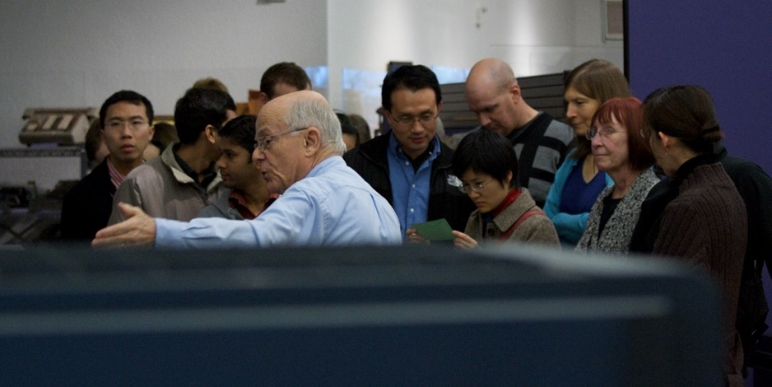
Figure 3.6.1 A historical guide leads a group around a museum

Nature tour guides
Nature tour guides lead visitors to natural attractions and national parks to look at wildlife and scenic locations. These guides are experts in biology, geology, botany or zoology and can talk about the attraction in a way that can be understood by a non-specialist, but still interest the specialist. Nature tours will draw attention to the natural aspects of the area, including a study of its changes from the past to the present, both in terms of the land and human activity. The tour guide helps the visitors to comprehend the beauty and intrinsic value of the area visited.

Eco tour guides
A new type of nature touring is eco tour guiding. This is where a guide leads a small group of visitors to remote or protected sites of natural interest. The guide ensures that the group’s impact on the surrounding environment is minimal. This encourages a sustainable model of tourism that appreciates the natural environment and supports local communities. Guides need to ensure that visitors follow the rules for visiting particular sites.

Activity 3.6
Below is a list of tasks carried out in order by a tour guide who meets their tour group at a museum:
- welcoming participants
- introducing yourself
- checking the number of participants
- introducing the museum
- informing participants of the time allocated for the visit
- informing participants of how to reidentify their vehicle after the visit
- helping participants disembark the vehicle
- arranging any details concerning cameras, tickets and cloakroom facilities
- keeping one’s own tour group separate from other tour groups
- holding the interest of participants by orientating the visit by theme
- selecting the most significant exhibits and commenting on them
- allowing time for participants to contemplate and appreciate what they are viewing
- answering questions about the museum objects
- showing the souvenirs of the museum
- assisting participants into the vehicle
- thanking participants.

Drawing on your learning from this session, as well as Session 3.5, sort each task into the columns in the table as either fundamental or specific tasks.
Answers to Activity 3.6

Answers to activities

Activity 3.1
- a) price, d) human resources and f) image.
- a) true, b) true, c) false, d) false, e) true.

Activity 3.2
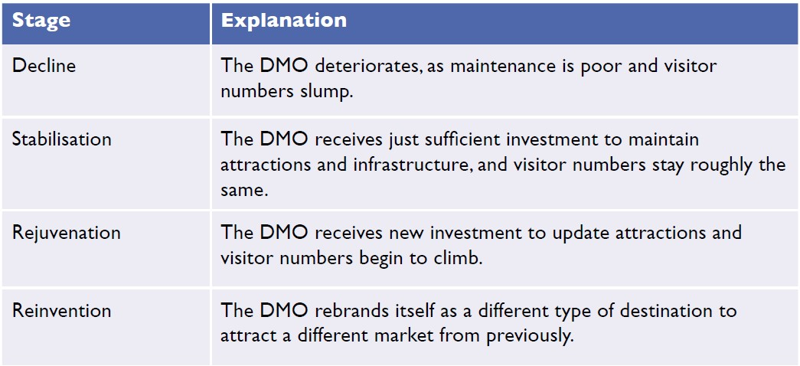

Activity 3.3
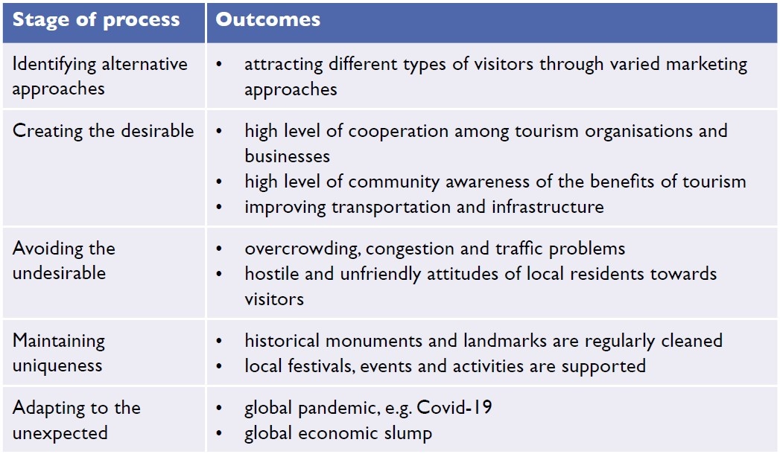

Activity 3.4
- Language skills, communication skills, problem solving skills, presentation skills, motivation skills, sense of humour, first aid skills, camera knowledge and creativity.
- Suggested answers: Friendly, patient, helpful, caring, calm, kind, organised.
- Students’ own answers. With all jobs, you need to start by asking yourself whether you have the necessary skills and, if you don’t, whether you want the job enough to develop those skills.

Activity 3.5
- f) Revise the itinerary and visit the site the following day.
This option may mean not visiting a less popular sight or having less time at the scheduled attractions, but it is likely to be the best outcome for the majority of participants.
- d) Empathise with the participant and leave your contact number with the attraction management in case it is found; e) Support the participant in disabling the phone remotely.
If you also ticked letting the participant borrow your phone, whilst it might seem a generous thing to do, you need your phone at all times to communicate with the head office and to manage changes in the itinerary and emergencies. You should also note that a tour guide can’t solve every problem. But guides can show the participants that they understand their loss and do what they can to try to recover the lost item. By disabling the phone, the guide is preventing further loss for the participant through illegal use and data charges.

Activity 3.6
