Contents

Topic 1: Introduction to tourism
1.1 The history of travel and tourism 3
1.2 Tourism concepts and types of tour 7
1.3 Types of tourism 12
1.4 Sustainable tourism 16
1.5 Components of the tourism destination 18
1.6 The customer journey 21
Answers to activities 24
References 26

Topic 1:
Introduction to tourism
This topic begins with the history of tourism and the types of tours tourists take. It will introduce you to some key tourism concepts and you will learn many more as you study the course. It considers different types of tourism, including what is meant by sustainable tourism, and what makes up a tourism destination. Finally, the stages in a tourist journey are considered and how the internet has transformed the experience.

1.1 The history of travel and tourism
Travel and tourism have become a major part of many countries’ economies and are an important force in globalising our world. But they began a very long time ago.

The Empire Era (900 BCE–300 CE)
While people have always travelled, tourism began to develop during the era of empire with the Greek and Roman Empires. People began travelling in large numbers for commercial, educational and religious purposes. The Greek Empire (900–200 BCE) advanced tourism through its use of a common language improving communications. The Greeks also introduced a common currency, which made purchasing goods and services when travelling easier. The ease of travel made it possible for the first ancient Olympic Games to be held in Greece in 776 BCE and for athletes, sculptors and poets to attend.
The growth of the Roman Empire (500 BCE–300 CE) expanded tourism further. The middle classes and the wealthy travelled for leisure, visiting cultural and historical sites of importance and spa resorts, as shown in Figure 1.1.1. Visiting spa towns was a popular leisure activity in Roman times. They continue to attract tourists today, who come both to learn about their heritage and to enjoy their health and well-being benefits. The Romans built roads and rest houses throughout Europe, which made tourism more accessible. They also developed guidebooks and travel writing.
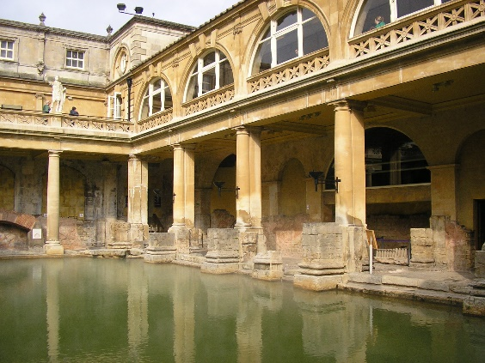
Figure 1.1.1 Roman baths, in the English city of Bath

Outside Europe, pilgrimage became a major reason for travel along defined routes. Pilgrimage to the earliest Buddhist sites by monks and small groups of people began more than 2,000 years ago. This period also saw the beginning of the Silk Road, which was a trade route connecting Asia with the Middle East and Africa. Started by the Chinese, it connected merchants along its route.

The Middle Ages (5th–14th centuries CE)
Travel became much more dangerous and uncomfortable as the Roman Empire crumbled. There were many risks for travellers, from diseases like the plague, to war, famine, violence and extreme weather. Moreover, the provision of hospitality was difficult to find. Only the most adventurous people travelled during this time.

The Renaissance Era (15th–16th centuries CE)
The Renaissance, meaning ‘rebirth’, was a period in European history marking the transition out of the Middle Ages. It was associated with great social change, a thirst for learning and it saw the popularity of travel grow again as people travelled to experience art, culture and science.

The Grand Tour Era (1613–1785)
The Grand Tour marked the height of luxurious travel and tourism activities in Europe. It originated with wealthy, young Englishmen and soon became fashionable among wealthy, young men from other countries, who had time and money. Grand Tour participants travelled throughout Europe experiencing the best of Western civilisation through its arts and sciences (Figure 1.1.2). There was a standard itinerary that served as an educational rite of passage. However, the tradition declined with the advent of accessible rail and steamship travel.
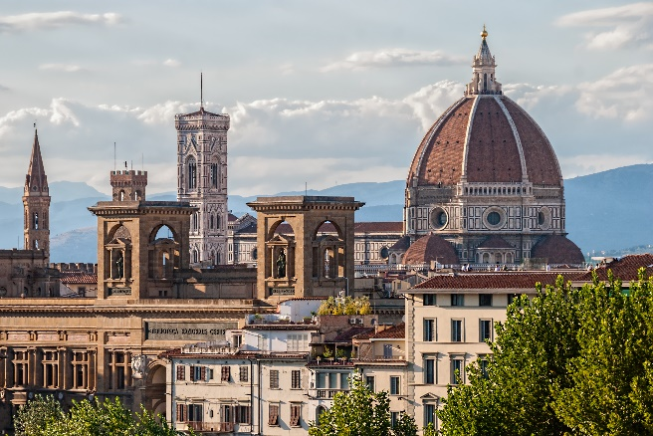
Figure 1.1.2 Florence was frequently visited by young men on the Grand Tour

The Mobility Era (1800–1944)
Growing economic prosperity and the advent of leisure time, as well as the availability of affordable travel, ushered in a new era in the history of tourism. People who were no longer tied to the daily chores of farm life began to search for new ways to spend their precious leisure time away from their jobs in offices, stores and factories. The Mobility Era was characterised by increased travel to new and familiar locations, near and far. Tourism activities began to increase as new roads, stagecoaches, passenger trains and sailing ships became common sights.
An Englishman called Thomas Cook (1800–1892) can be credited with finally bringing travel to the general public by introducing the package tour. Cook organised the first inclusive tour from England to the Paris Exhibition in 1855, with the travel arrangements, accommodation, and transport all part of the package. A further boost to mass tourism was the invention of the motor car – the Model T in 1908 by the American Henry Ford – although it would be many decades before it was affordable by the masses. The car expanded opportunities to travel independently far and wide.

The Modern Era (1945–present day)
Mass tourism received an additional boost after World War II as more hotels were built and jet travel was introduced in the 1950s. Its growing popularity in the 1960s further accelerated growth in domestic and international travel. The first ever credit card was introduced in 1950: the Diners Club card. This meant individuals could buy goods and services with a card, rather than cash, which further facilitated international travel. The growth of mass tourism accelerated over the last quarter of the twentieth and into the twenty-first century, with the growth in commercial airlines (Figure 1.1.3).
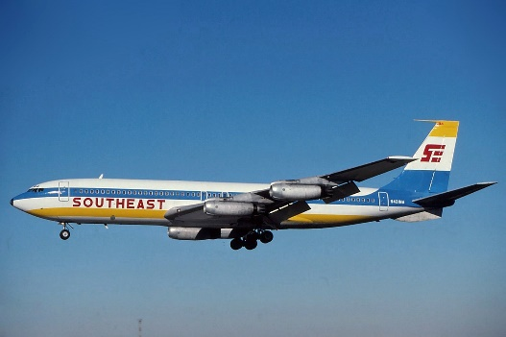
Figure 1.1.3 The Boeing 707 was the first commercial jet airline

Activity 1.1
1. What two things did the Greeks develop that helped increase travel and tourism:
- common culture
- common language
- common currency
- common land
- common uniform?

2. What two things did the Romans develop that helped increase travel and tourism:
- roads
- rest houses
- underfloor heating
- mosaics?

3. Select the correct word(s) to complete the sentence.
The Grand Tour was a journey undertaken by wealthy young men to understand _____ civilisation through its art and sciences.
- Eastern
- Chinese
- African
- Western

4. Select the correct word(s) to complete the sentence.
Thomas Cook organised the first inclusive tour in 1855 to the _____.
- Expo
- Olympic Games
- Paris Exhibition
- World Cup
Answers to Activity 1.1

1.2 Tourism concepts and types of tour
Tourism is defined as the movement of people from their normal place of residence to another place (with the intention to return) for a minimum period of 24 hours to a maximum of one consecutive year for different purposes (Figure 1.2.1). Tourism takes people out of their familiar environment to experience new environments. It involves travel and a stay and can be for business, leisure or bleisure (travel for a blend of business and leisure).
Figure 1.2.1 Tourism involves travel and a stay away from home

Tourists travel to visit friends and relatives, for entertainment, to attend conventions, for business meetings and for outdoor recreation. Tourism involves travel and hospitality. Hospitality is the friendly and generous reception and entertainment of guests, visitors or strangers. You will learn more about hospitality in Topics 4 and 5.

Key concepts for understanding tourism
Concepts are chunks of knowledge and understanding that make communication easier. For example, when the concept ‘tourism’ is used, you now know what is meant, so it isn’t necessary to give the meaning every time. Reading would become very dull and time-consuming if it was. Read the following two sentences to experience this for yourself.
- Tourism is a global phenomenon today.
- The movement of people from their normal place of residence to another place with the intention to return for a minimum period of 24 hours to a maximum of one consecutive year for different purposes is a global phenomenon today.
Do you see?
All subjects have their key concepts that make studying that subject easier and allow students to dive deeper with their learning. Concepts are the building blocks of all thinking and learning. Some of the key concepts for travel and tourism are now explained, although you will be introduced to many more throughout the course.
Tourism can be divided into domestic tourism and international tourism. Domestic tourism is where the residents of one country travel within that country for the purposes of tourism. International tourism is travel to another country, which can be broken down into inbound and outbound tourism (Figure 1.2.2).
Figure 1.2.2 International tourism can be divided into inbound and outbound tourism

Travel can be divided into leisure travel and business travel (Figure 1.2.3).
Figure 1.2.3 The definitions of leisure and business travel

Tourists travel to a tourism destination to enjoy tourist attractions (Figure 1.2.4).
Figure 1.2.4 The definitions of tourism destination and tourist attraction

For convenience, tourists often use a tour operator or travel agent to create and book their holiday (Figure 1.2.5).
Figure 1.2.5 The definitions of tour operator and travel agent

A tour package can consist of transport, accommodation, food, attraction entrance tickets and other services. Other distinguishing characteristics of the tour package are shown in Figure 1.2.6.
Figure 1.2.6 Characteristics of a tour package

The five main types of tours are independent, escorted, hosted, incentive and freedom. The details of each are shown in Figure 1.2.7.
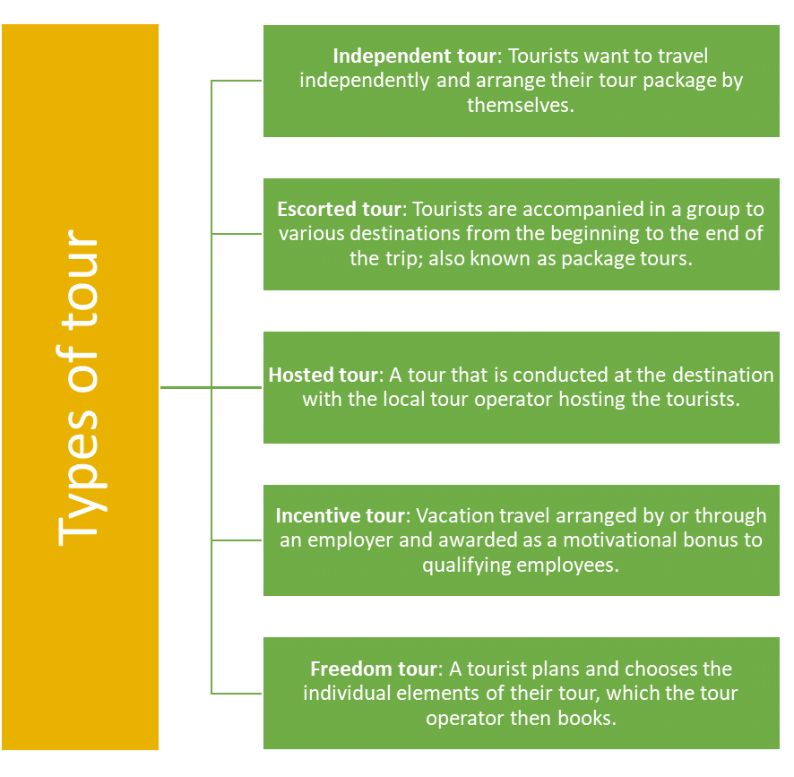
Figure 1.2.7 Main types of tours
Activity 1.2
1. Select the correct concepts to complete the diagram.
Hospitality, Escorted tour, International tourism, Hosted tour, Inbound tourism, Excursion
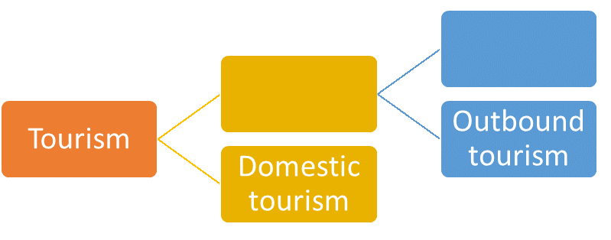
2. Read the profiles of some different travellers and match them with the type of tour package that would best suit them.
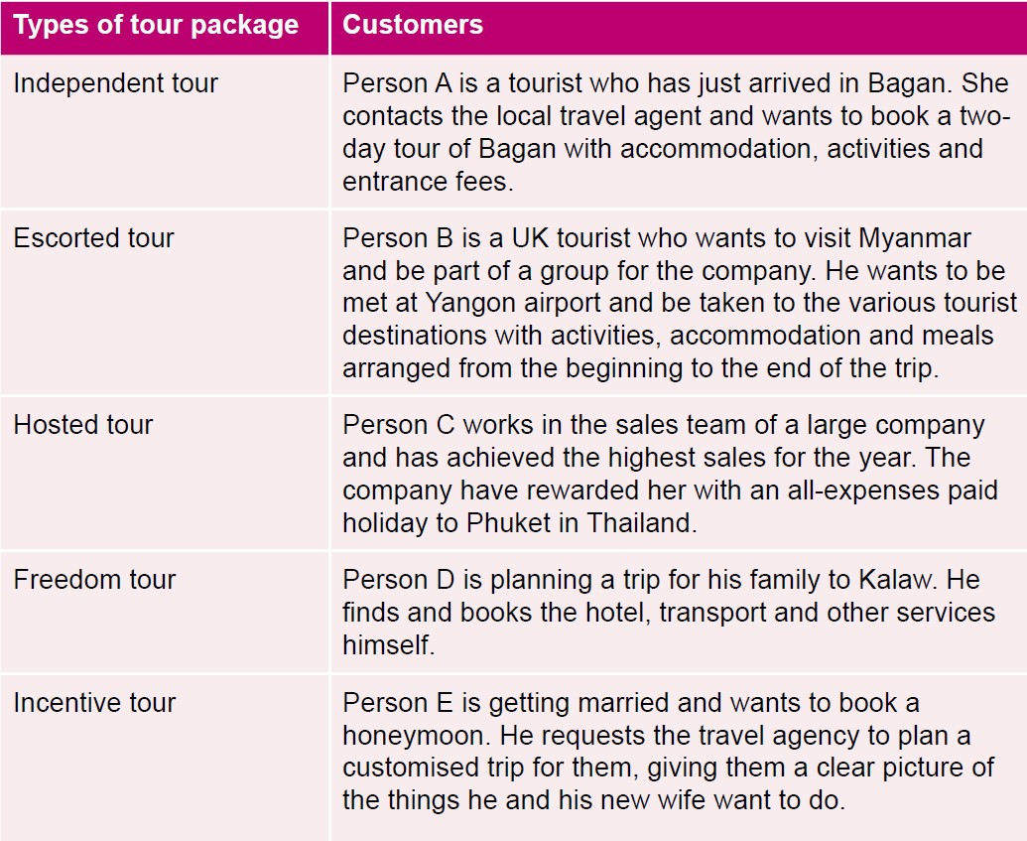
Answers to Activity 1.2

1.3 Types of tourism
There are many different types of tourism. Here is a selection based on recent trends, but it is not a comprehensive list. There is currently a lot of interest in sustainable tourism, community-based tourism (CBT), responsible tourism and ecotourism (Figure 1.3.1). What is common about these four types of tourism is that they have a strong ethical underpinning and are increasingly highly desirable, becoming the gold standard for tour companies.

Sustainable tourism |  | Community-based tourism |  | Responsible tourism |  | Ecotourism
Tourism that protects natural environments, provides an authentic tourist experience that celebrates and conserves heritage and culture, and creates socio-economic benefits for communities |  | Travel in which visitors are given the chance to meet local people and experience authentic cultural exchange, as well as providing employment and income-earning opportunities for the local community |  | Both visitors and hosts are mindful of developing tourism in a way that makes better places for people to live in and visit |  | Travel to natural areas that conserves the environment, wildlife and natural resources; sustains the well-being of the local people; involves interpretation and education

Figure 1.3.1 Types of ethical tourism

Another form of tourism focuses on health and wellness. This is travel for the purpose of medical treatment, to enhance personal well-being or which is accessible for anyone, regardless of physical impairments. This can be divided into medical tourism, wellness tourism and accessible tourism (Figure 1.3.2).
Figure 1.3.2 Types of health and wellness tourism

Some forms of tourism are more niche or specialised. Specialised tourism is travel for a special purpose, which appeals to a small sector of the market, such as disaster tourism, which is visiting locations that have experienced a natural or man-made disaster (Figure 1.3.3).
Figure 1.3.3 Some specialised forms of tourism

There are also forms of action tourism, which is travel for the purpose of sport, extreme sport or adventure (Figure 1.3.4).
Figure 1.3.4 Some forms of action tourism

Activity 1.3
1. Match the types of tourism with the images:
- wildlife tourism
- sport tourism
- dark tourism
- religious tourism
- adventure tourism
- accessible tourism.

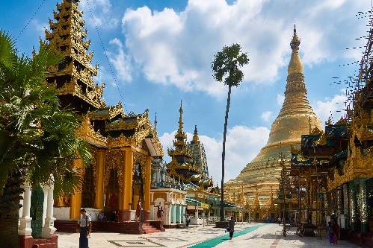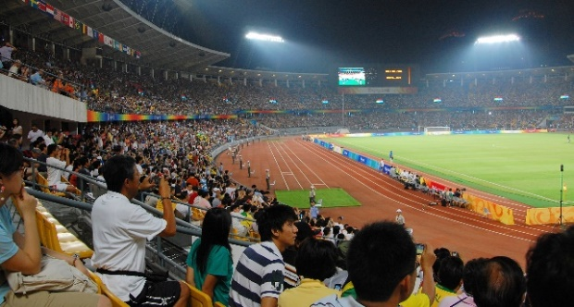
(i) (ii)
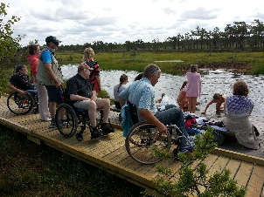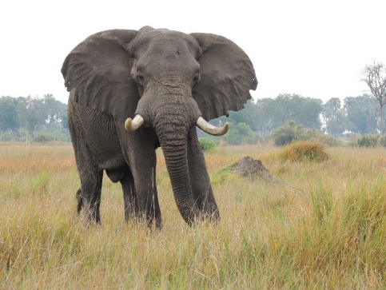
(iii) (iv)
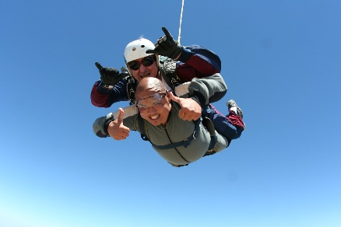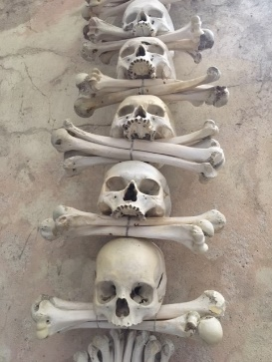
(v) (vi)
Answers to Activity 1.3

1.4 Sustainable tourism
Tourism brings together tourists, tourism suppliers, host governments, host communities and the surrounding environment. According to the World Tourism Organization (UNWTO), sustainable tourism is ‘Tourism that takes full account of its current and future economic, social and environmental impacts, addressing the needs of visitors, the industry, the environment, and host communities,’ (UNWTO, 2021). The concept of sustainable tourism has been advancing for over 20 years, becoming increasingly relevant in national and international agendas. The United Nations (UN) General Assembly has adopted several resolutions acknowledging its importance as a tool for development, poverty eradication and environmental protection. This culminated in the UN declaration of 2017 as the International Year of Sustainable Tourism for Development.
Sustainable tourism principles and practices are applicable to all forms of tourism in all types of destinations, including mass tourism and the various niche tourism segments discussed in Session 1.3. They place the environment, economy and sociocultural dimensions at the centre of tourism development, and strive for a harmonious balance between these three dimensions that guarantees sustainability over the long term.
Figure 1.4.1 The three dimensions of sustainability

Environmental resources – such as nature and stunning vistas – are a key element in tourism development, as they are what many tourists come to enjoy. For sustainability, the essential ecological processes that created and conserve the rich natural heritage and biodiversity need to be maintained.
Respecting sociocultural heritage is important, as it is the authenticity of host communities that many tourists wish to see. Tourists wish to understand the lived experience of traditional ways of life and the values that underpin it. In the process of exchange, better understanding and tolerance grows, which is beneficial for all.
Ensuring sustainable economic growth contributes to poverty alleviation. Socio-economic benefits can result for all stakeholders, in the form of stable employment, income-earning opportunities, and health and education services to host communities.
For sustainable tourism to develop, all relevant stakeholders need to be consulted and involved. Strong political leadership is needed to ensure that all stakeholders are meaningfully involved and that a consensus about the future direction of development is reached. This is not a one-off process, but a continuous process that requires constant monitoring of impacts, so that preventive and/or corrective measures can be taken when necessary. When sustainable tourism is done well, it delivers a high level of tourist satisfaction and a meaningful experience for the tourist. It also raises tourist awareness of sustainability issues, which in turn further promotes sustainable tourism practices and principles (UNWTO, 2021).

Activity 1.4
Watch the video ‘Sustainable Tourism in Myanmar’ and answer the following questions.
https://www.youtube.com/watch?v=OgRO-sOxoxI
1. What are the problems of becoming a mass tourism destination for Inle Lake?
2. Who benefits from sustainable tourism?
3. What Shan traditional crafts have been revived by a sustainable tourism approach?
4. What benefits does the Pa-O community hotel bring to the community:
- education
- employment
- health
- collective identity
- preserves cultural heritage?
Answers to Activity 1.4

1.5 Components of the tourism destination
This session analyses what makes up a tourism destination in order to better understand how to meet tourists’ needs.
The basic components of a tourism destination are access, accommodations, attractions, activities and amenities (Figure 1.5.1).

Figure 1.5.1 Basic components of a tourism destination

Access refers to the ease of reaching the destination, which requires good transport and communications links, such as an airport, highway and railway station. It also includes the ability of the destination to cater for visitors with disabilities such as mobility, vision, hearing and cognitive impairments.
Accommodations means having sufficient quantity and quality of accommodation options in the destination to meet tourist numbers, tourist budgets and tourist needs.
Attractions are often the focus of visitor attention and provide the initial motivation for the tourist to visit the destination. They vary widely among destinations and can be people, places, things or experiences that attract visitors (Figure 1.5.2).

Figure 1.5.2 Types of attractions

Activities are becoming more popular as tourists look for experiences in the destination. Packaging attractions as activities means that they can command a higher price. For example, if the cuisine of the local area is an attraction, offering food tours and cooking classes is a way of leveraging the attraction to reach a specific market.
Amenities means the basic facilities provided in a tourist destination, which are sometimes referred to as the ‘pleasantness’ of a place. They include basic signage, public toilets, paths, internet access, restaurants, money-changing facilities and safe drinking water. They play an important role in shaping the visitor experience.
Thinking about all five of these dimensions and how they integrate is important for ensuring a good tourist experience. Developing the infrastructure, facilities, events, activities and accommodation together will distinguish the destination and make it uniquely attractive to the tourist.
Tourism is a unique product because the tourists (buyers) go to the destination communities (sellers). What the tourists come to see is not used up either. For example, a scenic view remains after the tourists visit. It is also labour intensive, offering continuous employment, and is people oriented, enabling the tourist and local communities to connect and benefit from the interaction.

Activity 1.5
1. Select the five basic components of a tourism destination from the list below:
- aeroplanes
- cruises
- access
- railways
- accommodations
- roads
- attractions
- weather
- activities
- amenities.

2. Tourism is a unique product because of four characteristics shown in the diagram. Match the description to each characteristic.
(i) Tourism is about connecting with different people.
(ii) The tourist has to purchase and travel to the tourist site (the product they have bought).
(iii) Tourism continuously employs lots of people.
(iv) Tourism does not exhaust the country’s natural resources.
Answers to Activity 1.5

1.6 The customer journey
The customer journey is a helpful framework for understanding the experience of the tourist customer. It encompasses the time between them first beginning to think about a trip to recalling the experience after they have returned home, as shown in Figure 1.6.1.
Figure 1.6.1 The customer journey

Dreaming
The customer journey begins when the customer is considering a vacation and looking for ideas and recommendations. Decision-making will probably begin at the national level, as different countries are considered and a choice made.

Planning
The customer decides on the country to be visited and will then look for specific information. The decision-making may be narrowed down to regions and/or destinations in the country of choice.

Booking
The customer makes comparisons of different tourism products. They will search for the best value for their budget and preferences. The booking may be made through an intermediary, such as a travel agent or tour operator, or directly with individual providers.

Experiencing
This stage will include everything from the welcome the customer receives on arrival, the standard of the facilities, the quality of the attractions, accommodation and other amenities, and the information that visitors receive.

Remembering
On their return home, the customer will recall their journey and will assess whether it was good or bad.

Changes in the customer journey
All stages of the customer journey have been transformed over the past 20 years by the internet and social media. For example, when dreaming, customers are likely to undertake internet searches of countries in order to determine where to go. When planning they look at social media and review destination websites. Research suggests people increasingly choose destinations based on a photo or video seen online, such as Facebook, YouTube and Instagram (White, 2018).
Word of mouth is also a significant influencer. As people travel more today, it is likely that the customer will know someone who has visited the place and from whom they can ask for advice. At the booking stage, customers compare the price competitiveness of different tour operators online and may delay booking some tourism products until they are in the country. This is because ease of access to mobile internet makes it possible to book later.
When it comes to experience, the research done before travelling is highly significant in influencing the customer’s overall experience. Indeed, it is estimated that half the evaluation is based on the physical value of what the customer experiences. The other half is the emotional experience they have which is informed by their initial research (Rowett, 2020).
Finally, remembering is enhanced by social media. Customers share their memories through sites such as Facebook and review sites, such as TripAdvisor, providing feedback to a broader audience.
Figure 1.6.2 People carry out independent online research on their holidays today

Tour operators, destinations and tourism-related businesses are realising that today’s tourist is more astute and discerning than in the past. They purchase tourism products differently, making many more critical decisions on their tourism journey. Thus, tourism brands need to be smarter in marketing to new tourists.

Activity 1.6
The internet has transformed the way customers experience the different stages of the tourist journey. Match the changes brought by the internet to each stage of the customer journey.
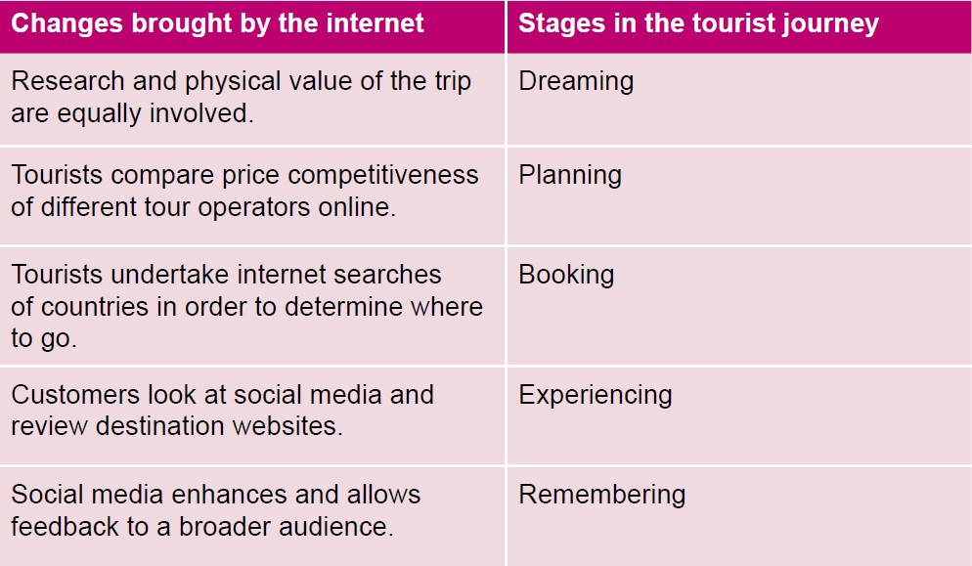
Answers to Activity 1.6

Answers to activities

Activity 1.1
- b) common language, c) common currency
- a) roads, b) rest houses
- d) Western
- c) Paris Exhibition.

Activity 1.2

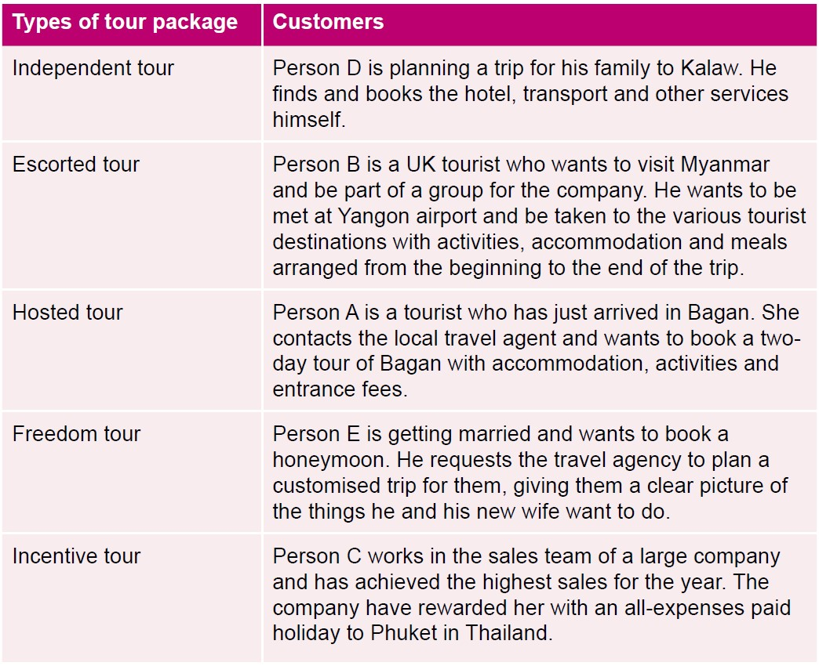

Activity 1.3
- a) iv, b) ii, c) vi, d) i, e) v, f) iii.

Activity 1.4
- Deforestation, sewage run-off, overuse of chemical pesticides and fertilisers on farms, and land grab and loss of traditional ways of life.
- It benefits local people, nature and animals.
- Paper making, ceramics, fabric weaving and woodworking.
- All answers a)–e).

Activity 1.5
- c) access, e) accommodations, g) attractions, i) activities, j) amenities.

Activity 1.6
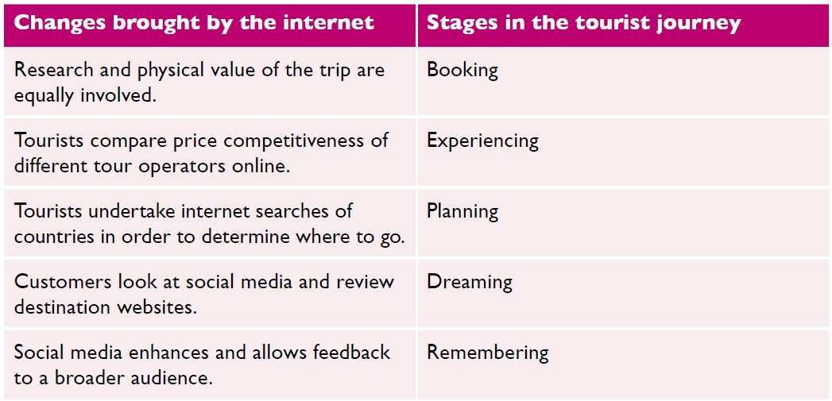

References
Rowett, P. (2020) Customer Journey Mapping for Tourism Brands.
Available at: https://tourismeschool.com/blog/customer-journey-mapping-tourism-brands/ (Accessed: 19 February 2021).

UNEP and UNWTO. (2005) Making Tourism More Sustainable: A Guide for Policy Makers.
Available at: https://www.sustainablesids.org/wp-content/uploads/2016/11/UNEP-WTO-2005-Making-tourism-more-Sustainable-A-guide-for-policy-makers.pdf (Accessed: 21 February 2021).

White, R. (2018) Story Ideas that Attract and Convert Your Ideal Customers.
Available at: https://tourismeschool.com/blog/tourism-content-marketing-themes/ (Accessed: 19 February 2021).

