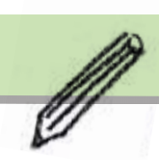 | Dexterity and Manipulation (fine motor) Skills  Edinburgh Version (3.1) CIRCLE Collaboration2015 All rights reserved
Supports and Strategies Planning Page
Pupil Name: |  | Date of Birth: |  | Completed by:
 |  | Class: |  | Position:
Summary of Concerns from Classroom Learner Participation Scale (CLPS) |  |  | Learners’ Views
Most successful strategies used |  |  | Learners’ Views
Strategies to implement or use more frequently |  |  | Learners’ Views
Plan: What? How? Who? When? |  |  | Learners’ views

