OnSSET/Global Electrification Platform
Hands-on 3: Working with raster data
NOTE1: These exercises are supposed to be done in QGIS 3.10. If you use any other version there may be issues. Please follow the instructions in the link to install QGIS 3.10.
- Follow the instruction “QGIS 3.10 Installation Instructions” to install QGIS 3.10 to your computer if do not have this version of QGIS.

Learning outcomes
By the end of this exercise, you will be able to:
1) Import raster data to QGIS
2) Perform different key processes (such as projecting, clip) with raster data
3) Perform resampling and reclassification on the raster data

Data Acquisition
Download and unzip the folder named “Benin_raster” available here. Within this folder there is a number of additional folders and files. For this exercise make sure that the following files/folders are included:
- A folder named “Administrative_Boundaries”. Within this folder there should be files named Administrative_boundaries.
- A folder named “Wind_Capacity”. In this folder there are two wind capacity maps named Benin_windcap_north and Benin_windcap_south.

Note! It is good practice to use underscore (_) when naming folders or datasets in GIS (instead of space) in order to avoid unexpected errors while processing.

Working with rasters
NOTE : An extensive tutorial of QGIS is available here.
Import
- In the initial step of the exercise, you will import the two wind capacity maps.
- Importing rasters can be done in two different ways; either simply drag the raster file onto your map canvas, or go to the top roll-down menu and click on Layer → Add Layer →Add Raster Layer… (For rasters we usually work with the .tif-file).
For now you will need only the wind capacity maps, so leave the administrative boundaries.
Raster properties
- Next, it is time to examine the properties of the rasters.
- By right-clicking on your raster layer you will be able to examine and/or change properties of your raster files.
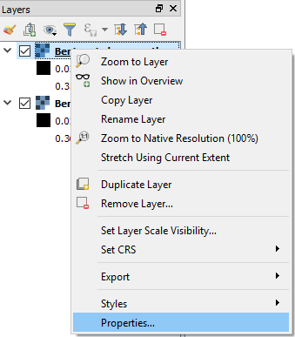
- First, click on the Information tab. Here you will find general information about your layer, which can provide more in-depth knowledge of the data that you are working with.
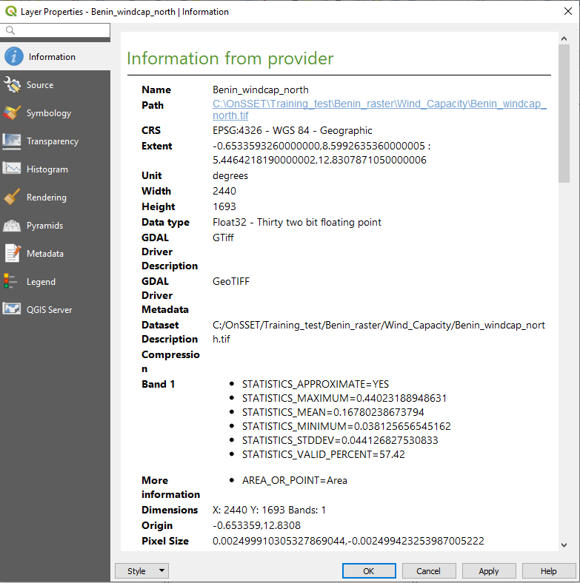
- One of the most important tabs for the appearance of your dataset is the Symbology tab. Here you can change the colour, style, and legend range of the raster, which is very useful when you wish to highlight different aspects of your data.
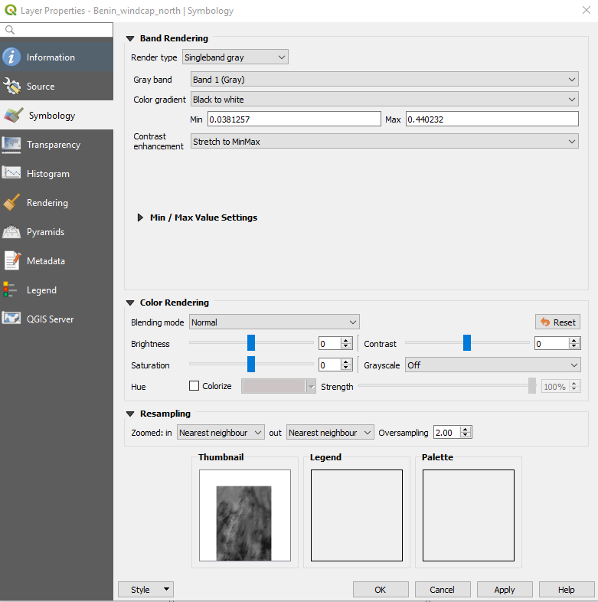

- Next, we will move on to the tab named Histogram. Here you will be able to examine the number of occurrences for the different values in your data. This may be very useful when you want a summary of your raster data or to identify outliers. Click on compute histogram to see the below figure.
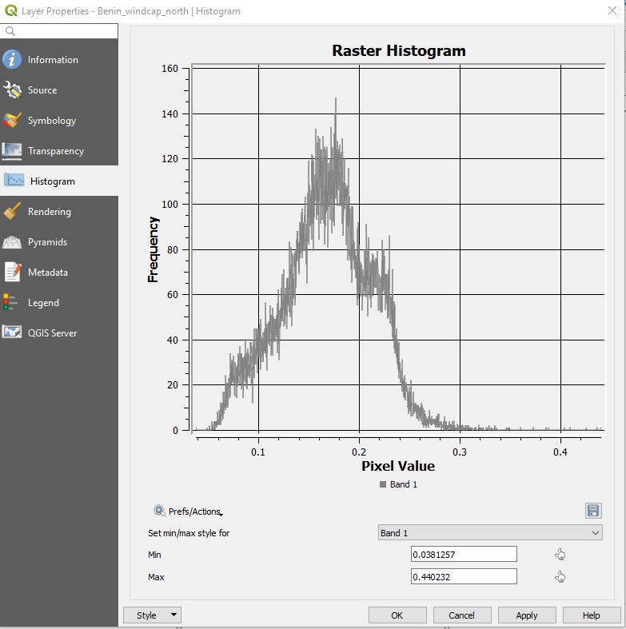

Merging Raster layers
Sometimes you have several rasters that are representing the same type of data in different parts of your study area. In these situations, it is often useful to merge the rasters into one dataset. To do this, you can use a tool called Merge. The wind capacity map for Benin has been given to you in two pieces. Now, you will use the Merge tool to merge these datasets into one raster.

- Make the tool bar visible by going to the roll-down menu and click on Processing → Toolbox.
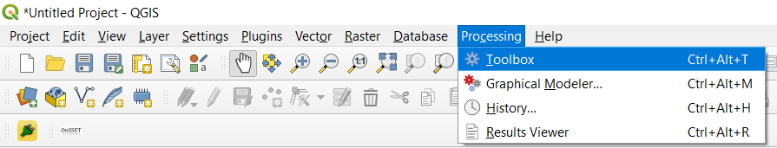
This opens up the toolbox on the right-hand side of the QGIS interface. In this toolbox you can search for all the tools that you need.
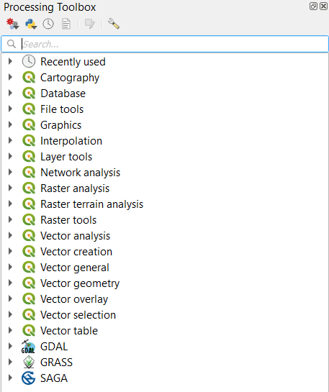
- Now, search for “merge”. This will show all the tools containing the word “merge”.
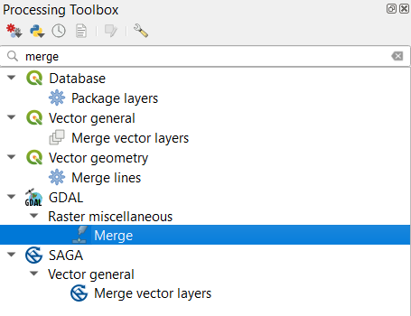
- Select the merge tool within the GDAL-package (the one highlighted in the image above).

- In the window that opens up, choose the two datasets that you wish to merge in the field that says “Input layer” by clicking on the three dots at the right-hand side of the field. The rest you can leave as they are. Click Run to execute the tool. When your layers have been successfully merged you can remove the two original maps from the QGIS interface.
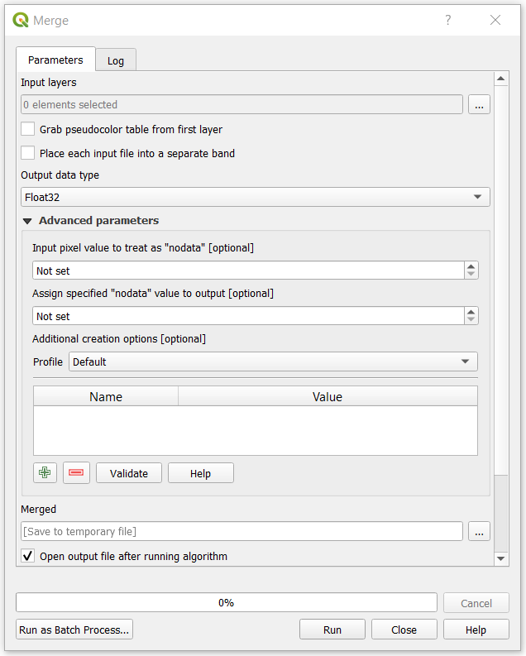
Clip
You will now notice that the dataset covers an area much larger than the study area. We will fix this by clipping this raster with the administrative boundaries of Benin. In order to do so we are using the Clip Raster by Mask Layer.
- Import the administrative boundaries of Benin that you were given in the Benin_raster folder. Do this by directly dragging the .shp file onto the map canvas.
- Search for Clip Raster by Mask Layer in the Toolbox. Select the tool included in the GDAL-package (the one highlighted below).
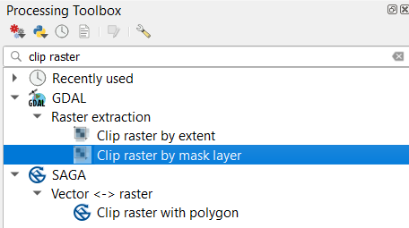

- As an “Input layer” enter the raster that you want to clip (in this case the merged wind capacity map you created in the previous step). As “Mask layer” enter the polygon you want to clip by. Since we want the wind capacity in Benin we choose the administrative boundaries of the country. In the field that says “Assign a specified nodata value to output bands”, enter “0”. This will make sure that all the values that are not a part of Benin are set to no data. The rest you can leave as it is. Click on Run to run the tool.
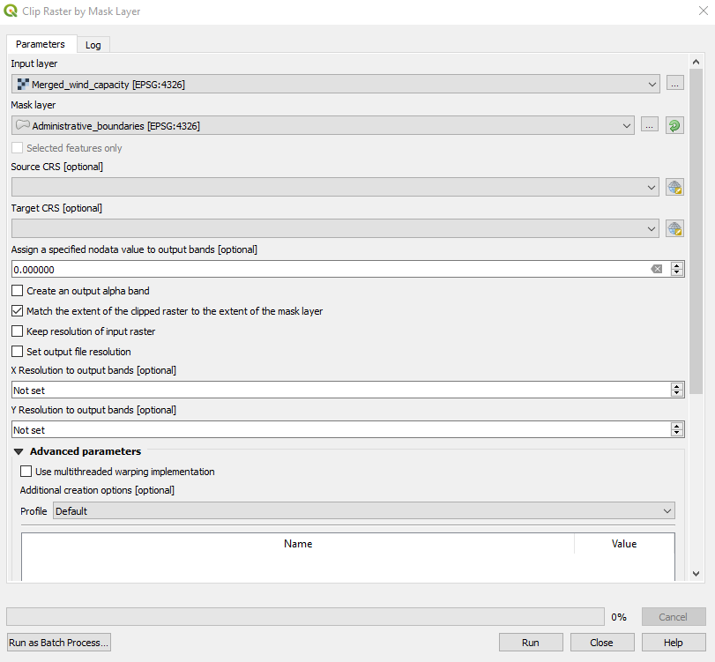
NOTE: In order to see your clipped wind capacity map, uncheck all of the other layers in the table of contents. Also note that both the layer created after the merge and after the clipping is called “OUTPUT”. It might be good to rename layers after running tools. This you can do through the source tab in the properties.
Projecting rasters
The coordinate system is very important when representing data. When projecting an area onto a map there will always be a certain distortion. When choosing the coordinate system, it is important to compromise and choose the system that gives the least distortion. For this exercise you will have to choose a coordinate system that works for Benin, as that is the current study area. In this case, choose the coordinate system named WGS 84/UTM zone 31N. Now, you should project the wind capacity map that was clipped in the previous step. To reproject raster files you can use a tool called “Warp”.

- In the toolbox search for “warp” and double-click on it to use the tool (in the GDAL-package).

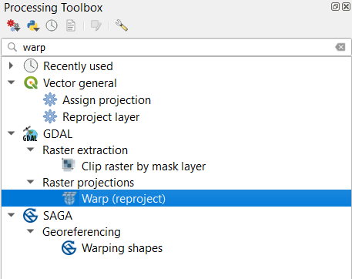
- First, in the “Input layer”-field choose the dataset that you wish to project (this will be the clipped wind capacity map from the previous step).
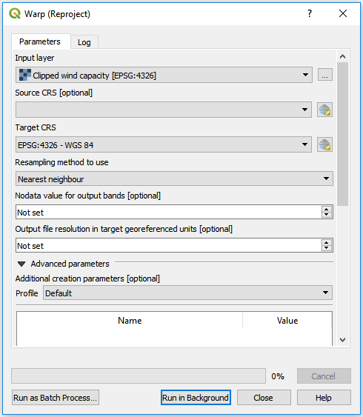
- You do not need to specify the current projection system used for the raster, so the second field (“Source CRS [optional]”) can be left empty.
- Now, click on the button next to the field named “Target CRS”.
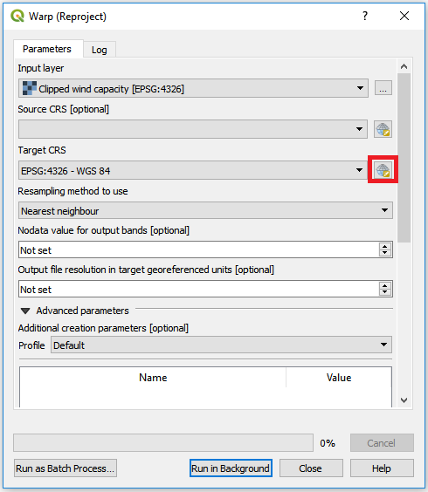
This will open the following window:
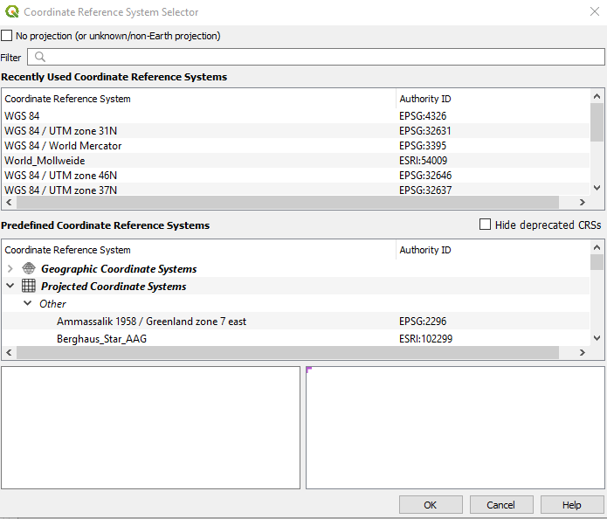
If this window is greyed out make sure to un-check the box reading “No projection (or unknown/non-Earth projection) at the top of the window.
Now, in the filter field start typing the name of the coordinate system you want to use (”WGS 84/UTM zone 31N”):
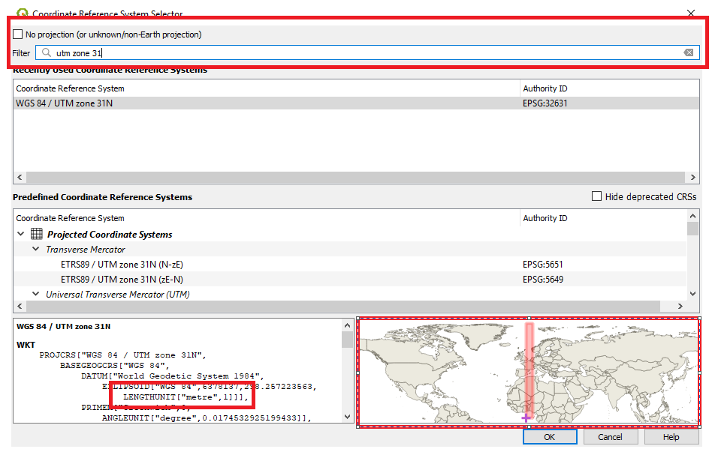
Click on OK to pick this coordinate system
NOTE: For future studies the following site https://epsg.io/ can be used to determine which coordinate system to use.

- Set the resampling method to nearest neighbour and leave the rest as it is.
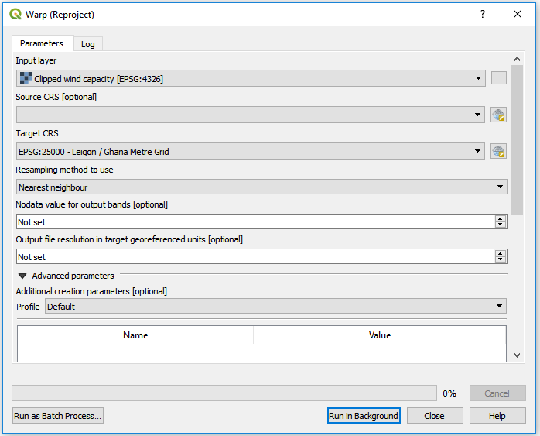

- Execute the tool by clicking Run.

Note: As you may have noticed by now, QGIS selects a default name to the output layers of each tool in cases where a name is not given by the user it-self. This can lead to several different layers having the exact same name. In order to avoid confusion you are recommended to either change the name of the output layers after running a tool or exporting under a new name (see more about exporting layers below).

Export
- You will now export the reprojected wind capacity layer to the folder named wind_capacity. This is necessary when you want to save manipulated data on your computer for usage in other programmes or at a later point.
- Right-click on the wind capacity layer that you just projected and click on Export → Save As…

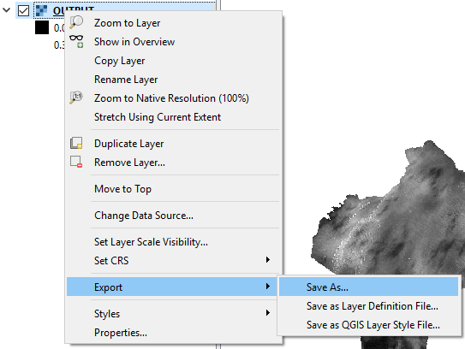
- Choose to export your raster file as GeoTiff and click on “Browse” next to filename and navigate to the wind_capacity folder that you received. Name your layer “Wind_capacity”. Make sure that the box saying Add saved file to map is checked (see figure below).

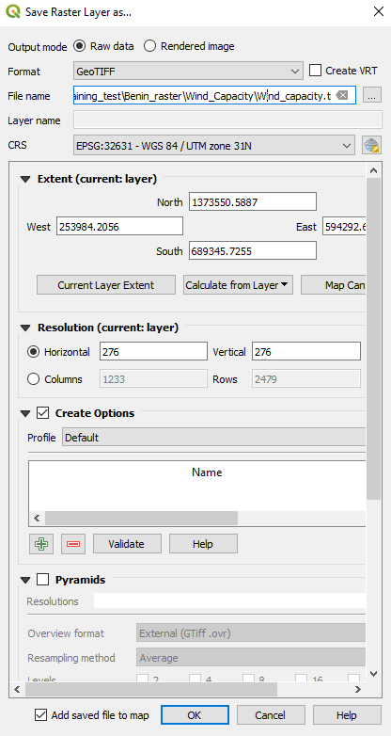

- Keep the rest as given in default.

NOTE: As in the case of vectors, if you do not export the maps they will only be saved in memory and not exist next time you restart the program.

Resample and reclassify

Resample
If you open the Properties of the wind capacity layer (by right-clicking) and go to Information, you will be able to see the spatial resolution of the wind capacity raster. It is stated that the pixel size is approximately 276.
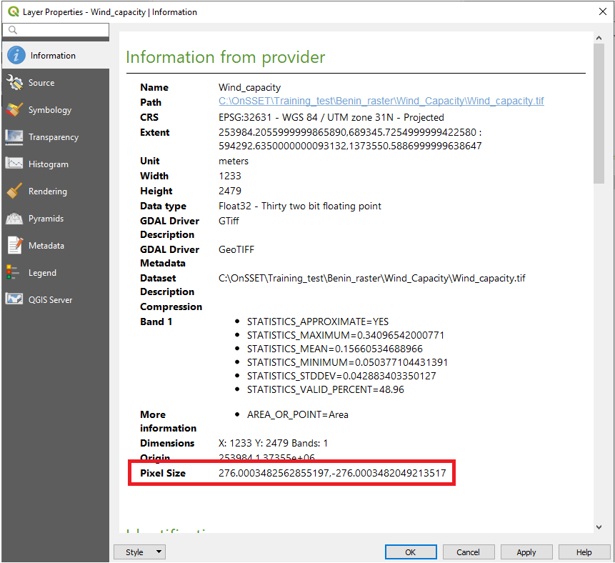
As the unit of the coordinate system is in meters, this is equivalent to a spatial resolution of 276 m x 276 m. We want the spatial resolution to be 1 km² (1 km x 1 km), in other words, we want the wind capacity raster to have a cell size larger than the one we have now. This can be done by resampling the map, using a tool named r.resamp.stats.
- Search for “r.resamp.stats” in the Toolbox (the tool that you will use is a part of the GRASS-package).
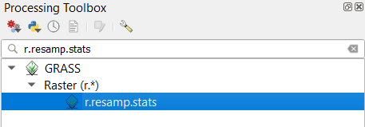
- When opening the tool you will see the following screen:
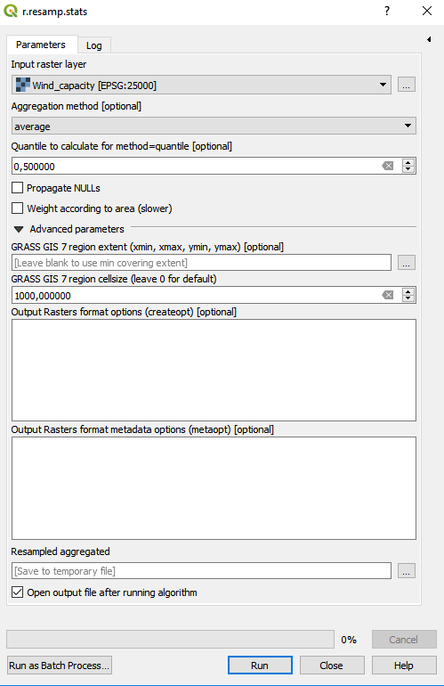
As Input layer enter the dataset that you wish to resample (in this case the wind capacity map that you exported previously).

As aggregation method choose “average”. This field determines how the resampling is done. By putting “average” we are telling QGIS that the cells with the size of 1 km² should have the average value of all the cells with cell size 276 that overlaps it.
In GRASS GIS 7 region cellsize (leave 0 for default) enter 1000. This tells QGIS that we want cells that are 1000 m x 1000 m (1 km²). Note that this field reads the value in the unit that the coordinate system is in and we reprojected in the previous steps to a coordinate system with unit of meters.
Leave all other fields as they are, and click on Run to execute the tool.

- Next, open the properties of the resampled layer and check that the cell size is now approximately 1000m x 1000m.
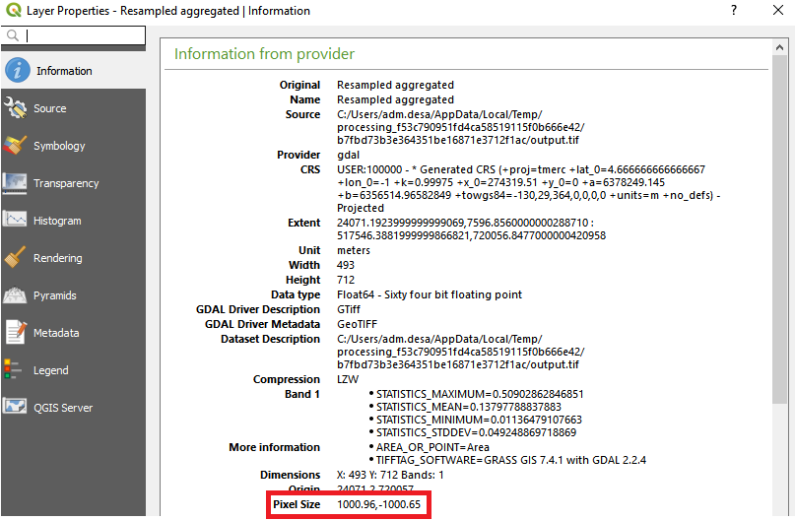

Reclassify values
Reclassifying raster files is a common practice. It is useful when you wish to either create classes within your datasets or to change values of different classes. Reclassifying a raster can also be useful if you wish to highlight any specific areas based on different characteristics. In this exercise we will use the resampled wind capacity layer and reclassify it. The purpose is to highlight areas that have high capacity factors.
The wind capacity factor is measured in percentages. As you can see in the QGIS window the minimum is around 0 and the maximum around 34%.
In this example, we would like to install our wind turbines in areas where the wind capacity resources are favourable. We are interested in areas with at least 20% wind capacity factor. Therefore, we will turn all values between 0 and 20 to 0, and keep the rest as they are.
- In the toolbox search for “reclassify by table”.
- Amongst the tools that appears choose Reclassify by table in the QGIS-package.
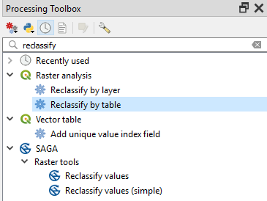

- When you open the tool, the following screen will be displayed:

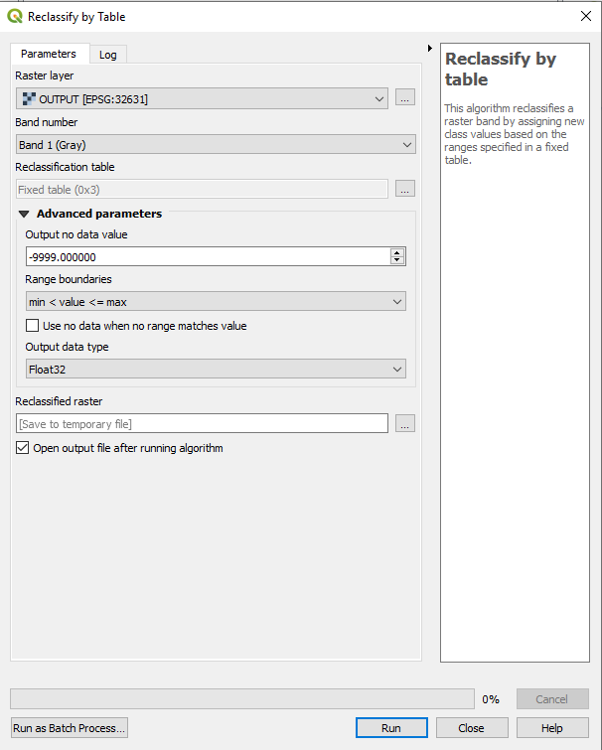
In Raster layer choose the resampled wind capacity map from the previous step.
Next, click on the three dots next to the field called Reclassification table. This will open up the following window:
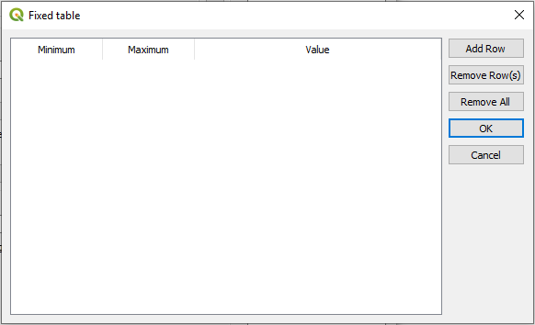
Click on Add Row and enter 0 as Minimum, 0.2 as Maximum and 0 as Value. The first two values (minimum and maximum will determine the range to be reclassified and value will determine the new value. By following these instructions, we ensure that all the values between 0 and 0.2 are changed to 0. Once you have entered your row click on OK to close this window.
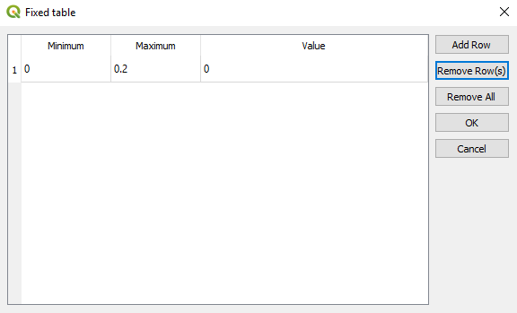

- Back at the main window make sure that the Range boundaries are “min <= value < max”. This ensures that 0.2 is not reclassified but all values lower are.
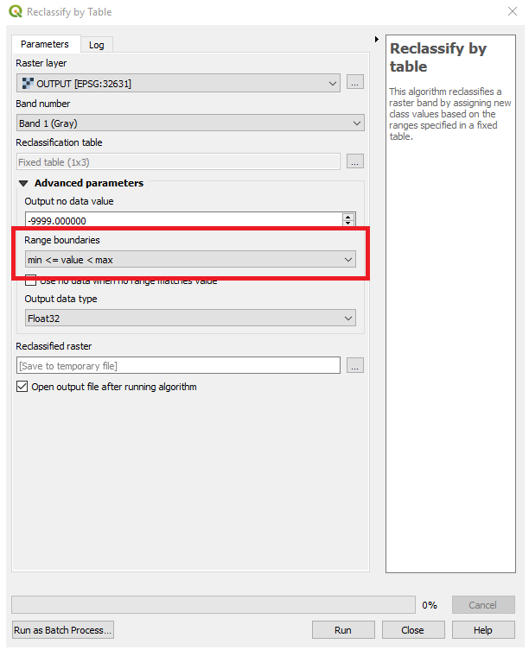
- Now run the tool by clicking on Run.
- Export this layer in the same way we did previously into the folder named “wind_capacity”. Name the dataset “modified_wind_capacity”.

Extract values to point
Extract raster values to points
Thus far we have made sure that the wind capacity map is covering Benin, that it has the right coordinate system and cell size, and that it highlights areas with favourable capacity factors. Raster data might sometimes be difficult to properly examine and work with due to the data missing attribute tables and discrete boundaries. Therefore, it is often useful to transform the raster data to point layers or extract the raster values to existing point layers.
At the end of the vector exercise (Hands-on 2), you were left with a point layer with the distances to the current and planned transmission lines. Import this point layer by dragging it onto the map canvas. To make it easier to keep track of everything, first remove all layers except for the modified_wind_capacity layer.
In this exercise you will export the raster values from the modified wind capacity layer to the distance layer. In this way, you will have two types of information in every location.
- Right-click on the distance point layer and open the attribute table.
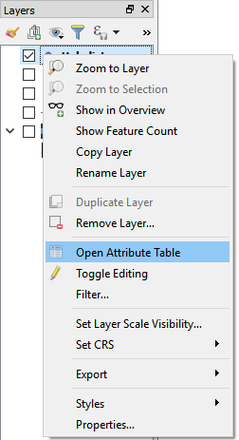
- In the attribute table you will see column named “HubDist”. This is the distance between the transmission lines and every point of the country.
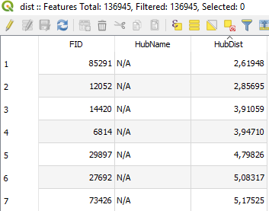

You will now add the values from the modified wind capacity raster to this attribute table.

- Close the attribute table of the distance map.
- Go to the tool bar and search for “add raster values to features”. You will be using the tool that comes in the SAGA-package.
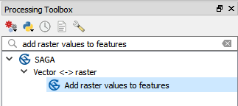

- When you open the tool, you will see the following screen.

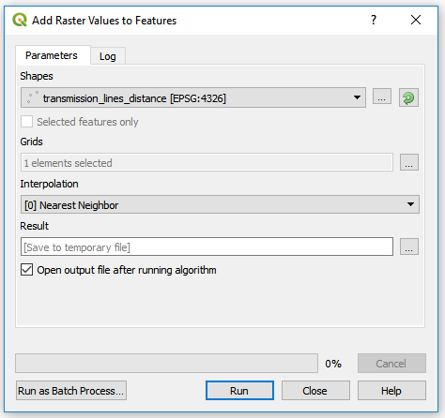

In the field “Shapes”, enter the distance point layer. This is the vector file which the attribute table will be used as base for the analysis.
In the field named “Grids”, select the modified wind capacity layer.
Leave everything else as it is and click on “Run”.

- After the tool is finished you will have a new point layer named “Result”. If you open the attribute table on this layer, you will see that apart from the distance column, there are also wind capacity values and coordinates.
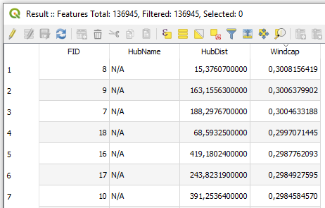

This means that you have now combined the wind capacity layer with the distance layer that you had originally.

Export a layer as csv
We will now export the point layer in which we combined the wind capacity factor and the distance to transmission lines as a csv-file.
      - Right-click on the clipped layer and click on Export → Save Features As...
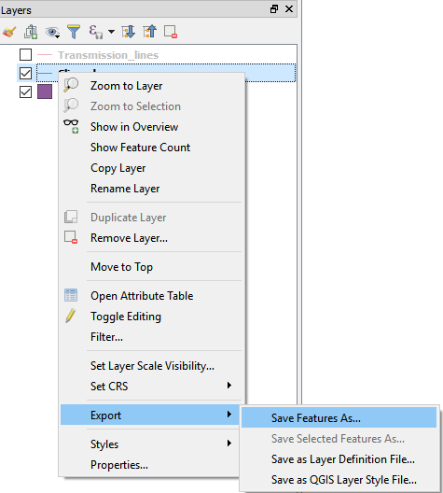
      - Choose to export your vector files as Comma Separated Value file (CSV). Click on “Browse” next to filename and navigate to the folder you wish to save the layer in. Name your file “distance_to_grid_and_capacity”. Click “OK” to export (make sure that “Add saved file to map” is NOT checked).
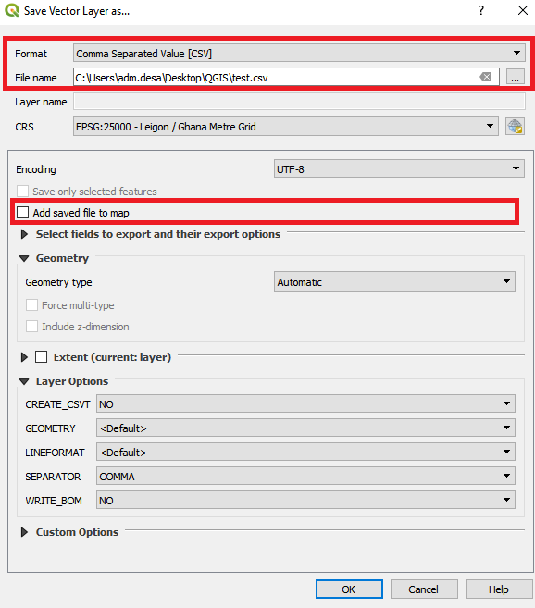
Finally, locate the new csv-file that you created and open it.
This completes the last part of this exercise.

This exercise is an exercise developed by Khavari, B., 2019. Exercise 3: Working with raster data [WWW Document]. OnSSET Teaching Kit. URL https://onsset.github.io/teaching_kit/courses/module_1/Excercise%203/ (accessed 2.18.21). All images are screenshots from QGIS 3.10, which is licensed under Attribution-ShareAlike 3.0 Unported (CC BY-SA 3.0) unless stated otherwise.

