Inclusive Teaching Practice
Participant’s Book

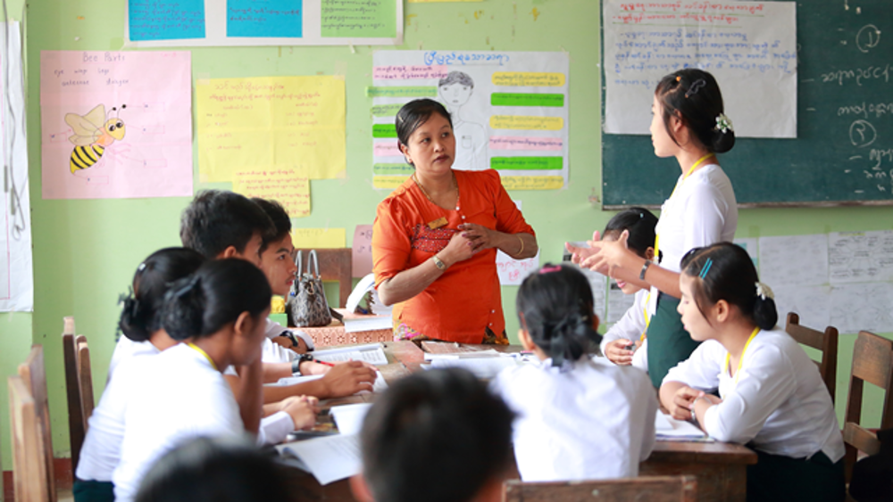
Source: VSO Image library

Module 2:
Knowing your learners

Module 2: Knowing your learners.

Overview
This is the second of fifteen modules that look at how we create a positive Inclusive Learning Environment for all. You will see how inclusive teaching practices encourage, develop and use the 21st century skills of critical thinking, communication, collaboration and creativity. These modules are for any educators or those studying in education in Myanmar. The terms student and learner are used interchangeably throughout the module.

Module number | Module title
1 | What is an Inclusive School, Classroom and Teacher?
2 | Knowing your learners
3 | Planning learning outcomes for all
4 | Participating through learner centred approaches
5 | Creating a positive learning environment
6 | Effective questioning and feedback
7 | Active participation
8 | Peer, co-operative and collaborative learning
9 | Supporting students’ emotional and social wellbeing
10 | Legal framework and policies around Inclusion in Myanmar
11 | Supporting all students through differentiation
12 | Identifying specific learning difficulties
13 | Supporting all learners with differences or disabilities
14 | Positive behaviour management
15 | Assessment for student achievement

This module helps you to think about how much you know about your learners, inclusive resources and multisensory learning.

You will also be asked to record your reflections in a learning journal, so it is important to make detailed notes and think carefully and deeply about your current and future practice. This CPD module also encourages you to develop communities of practice between yourself and your colleagues. This will support and extend your own use of inclusive practices in your teaching and will help your student teachers build on inclusion in their learning and future professional practice.

Learning Journal
It will be useful to record your reflections in a learning journal throughout the module.
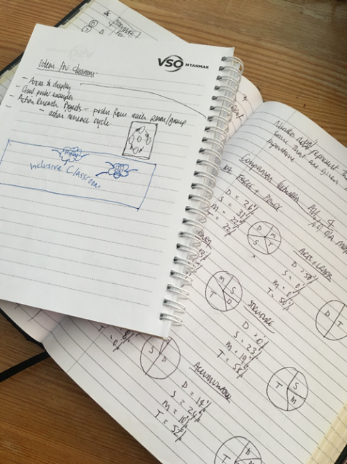
A learning journal can be digital (e.g. using Word or Google Docs) or on paper. You can also take photos of your learning journal pages if you want to share your thoughts with others. It is important that you record your thoughts and ideas so that you can remember and use them later in activities and in your own teaching.

Here are some useful tips for a good learning journal:
- Use headings and dates for all your journal entries.
- Use the activity number for reflections linked to that activity, e.g. Activity 1.1
- Add references to any other resources you find that help you.
- Record answers to activities.
- Write reflections about your learning.
- Make notes of new vocabulary.
- Identify topics you want to learn more about.

Source: Rose, N. (2018) Personal Learning Journals

The important thing is that it is easy for you to use. You can take notes which answer simple questions like these:

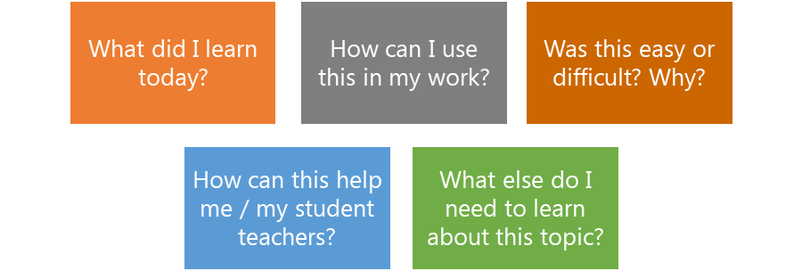

These questions follow the LEARN- APPLY- REFLECT model which is used in education globally. You can return to this journal as you progress through your CPD journey and reflect on your progress.

Study tips
Take your time to work through the activities, rather than trying to complete the whole unit at once. Set yourself a timetable and choose a time to work through the tasks, then check and compare ideas with colleagues. Finally, remember to make notes in your learning journal as you go. This will help you remember more about the skills and knowledge you develop as you complete these units.

Working alone or with colleagues
This unit is designed for self-study. The answers can be found after each activity. However, if possible, we recommend working in a pair or group so you can share ideas, ask questions, check your work, and give feedback.

If you work in a pair or group, we recommend using Think / Pair / Share for each activity.
Discuss your ideas in a group, and then check the answers on the next page(s) together.
Check your answers with your partner.
Work alone and make brief notes of your own ideas.

Learning outcomes for module 2
By working through this module, you will be able to:
- explain why it is important to know your learners.
- discuss ways of knowing your learners.
- decide if a teaching resource is inclusive.
- explain the importance of multi-sensory learning.
- adapt lesson plans to include multi-sensory learning.

Introduction
The previous module introduced the concept of inclusion and what inclusion meant to you. You analysed whether your educational institution, your classroom and you as a teacher were inclusive in your teaching practices. This second module introduces why it is vital to ‘know your learners’ and how inclusive resources can help support their individual needs. The final section explores multisensory learning and how this can be used to effectively support the different needs of your students.
You will be asked to:
- Read about ‘knowing your learners’, inclusive resources and multi-sensory learning.
- Watch videos and provide some analysis.
- Complete activities either alone, in pairs or in small groups.
- Think about key questions.
- Answer an end of module quiz.
- Reflect on your experience and knowledge.
- Make a promise to your learners.

The module will take approximately 8 hours to complete. Take your time to ensure it is an enjoyable learning experience.

Key to symbols
Activity – this is work you need to complete.

Question/s – please answer the questions.
Reflection – think carefully about how you feel about this.
Learning Journal – please write your answers in your learning journal.
Read – please read the text provided. Make any notes you like.

Link to previous learning – module 1 (Inclusion)
Think back to module 1. Fill in the missing words to the following statements about inclusion. One example has been given.
Missing words
exclusion | families | removing | Process | healthy environments
learn | ALL | excluded | participation | all learners are welcome

- 'Inclusion is a 1) process . It is about always being conscious of finding better ways of responding to student differences.
- Inclusion is about finding and 2) barriers that make it difficult for children to learn.
- Inclusion is about valuing the presence, 3) and achievement of 4) students.
- Inclusion involves giving special attention to groups of learners who are at risk of marginalization, or 5) e n or underachievement. Everyone needs to be involved in making schools inclusive: teachers, 6) , communities, political and religious leaders and education officers.
- Inclusive schools are: 7) , protective of all children and gender responsive.
- Inclusive schools make sure that no child is 8) from friendship.
- Inclusive schools are places where 9) .

- Answers
- process | - removing | - participation | - ALL | - exclusion
- families | - healthy environments | - excluded | - all learners are welcome

Knowing your learners
Inclusion is about ensuring all students participate effectively in every lesson. This can be achieved by a) removing any barriers that stop them from learning and b) by identifying the things in their life that interests and engages them. Knowing student’s names, their family backgrounds and which assignments they have passed is nice but gives limited information to be able to plan inclusive lessons. There are many other important pieces of information about leaners that can help to maximise learning for all.

2.1 Self-assessment
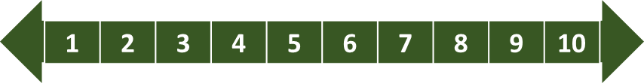
REFLECTION: How well do you think you ‘know your learners’? Look at the scale below and identify the number that best describes YOU. Answer in your learning journal.
VERY well
NOT well
You will be asked to do this again at the end of the module.

2.1.1 Why it is important to ‘know your learners.’
Think: why is it important to know your learners? There are many benefits for you as a teacher and for them as a student and these will be explored. The next activity asks you to watch a video about ‘knowing your learners.’

Notes about watching the videos on YouTube.
We all learn in different ways; some like to watch, some like to listen and some like to read. Usually, it’s a mix of all three. Therefore, when watching videos, the subtitles can be turned on so you can read what is being said, instead of just listening. Also, there are transcripts that can be read either before or after the video – giving you time to reflect and absorb the information. The images below show how you do this.

Subtitles on YouTube videos
Turn subtitles on in a YouTube video

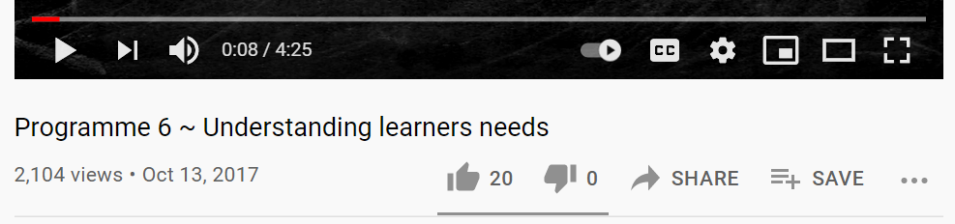

2.1.3 Transcripts on YouTube videos

Read the transcript for a YouTube video. Click 3 dots.

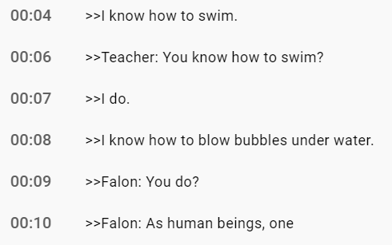
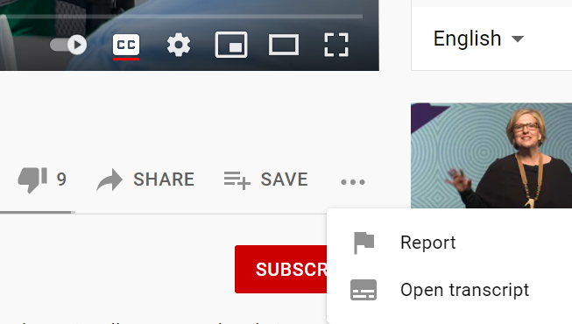
Click ‘open transcript’

Activity 2.1 – Benefits of ‘knowing your learners’ part 1 (15 minutes)

Watch the following short video and think about the benefits of getting to know learners. Reflect on;
Q
- why it is important for teachers to know their learners.
- why it is important our teaching resources show different people and customs.
- the different ways students learn.

Write your thoughts in your learning journal. You will use your ideas later in this module.

There are subtitles for the video if you prefer to read what is being said. You can also open a transcript for the video if you need more time to read.
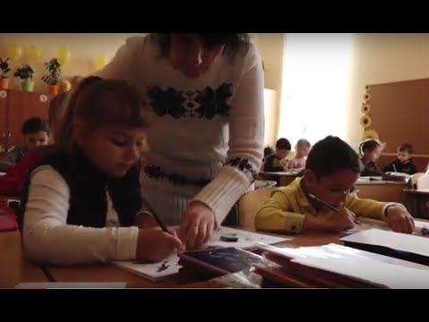

Video - Understanding learners’ needs.
www.youtube.com/watch?v=ENvkE_0N3jo

Activity 2.2 – Benefits of ‘knowing your learners’ part 2 (15-30 minutes)

After watching the videos, read one of the following two texts. The first text is a shortened version of a book chapter – it is easier to read. The second text is for those who can read English more easily or those who like a challenge.
Make notes in your learning journal of any new terminology particularly about the benefits of ‘knowing your learners.’

Text 1 (easier version) - Adapted passage from ‘How to Teach Now’ by William Powell and Ochan Kusuma-Powell. (15-minute read) – This can be found in Appendix 1 at the end of this module

And / or

Extension activity (if confident)
Text 2 (Difficult version) - www.ascd.org/publications/books/111011/chapters/Knowing-Our-Students-as-Learners.aspx (30-minute read)

http://www.ascd.org/publications/books/111011/chapters/Knowing-Our-Students-as-Learners.aspx

Discussion – Benefits of ‘knowing your learners’

The key benefits are important to know so that you can encourage ALL of your learners;

- to create a safe environment for every learner in your class and help them feel more confident.
- to understand each learner’s “readiness to learn” (how ready and motivated they are to learn?)
- when you know your learners’ interests, their experiences and the way they think, you can identify different ways to introduce a subject.
- to respond and interact with your learners in a caring and understanding way.
- to appreciate and learn from the diversity (the differences) in your classroom.
- to plan your teaching so it is most effective for your learners’ learning.

Activity 2.3 – Benefits of ‘knowing your learners’ part 3 (15 mins)

The list below on the left (numbered 1 – 6) identifies the main benefits of ‘knowing your learners (look at the discussion in previous section). Notice there are six categories.

Think about what this might look like in your classroom. Two examples are given. Write in your learning journal.

What this generally means in class?
Benefits of knowing learners.

This could be about ensuring no physical danger. It could also mean keeping students psychologically safe.
1
Safe environment

Being able to recognise each student’s ‘ability’ to be able to challenge them sufficiently.
2
“Readiness to learn”

3

Identify different ways to introduce a subject

4

Plan your teaching so it is most effective

6
5
Appreciate and learn from the diversity
Respond and interact

Activity 2.4 – Benefits of ‘knowing your learners’ part 4 (30 minutes)

In Activity 2.3, you gave an example of what having a ‘safe environment’ might look like in your class. Use the answers given above and expand them. The list below on the left reminds you of the main benefits of why it is important to ‘know your learners.’

Think about how you will achieve each of the six benefits in your class. Two examples are given. Write in your learning journal.
Benefits of knowing learners.
How will you achieve this in your class?

Ensure equipment is safely stored. Ensure all students feel safe to ask a question without fear of being wrong.
1
Safe environment

Be aware of student’s strengths and difficulties with activities and plan for them.
2
“Readiness to learn”

3

Identify different ways to introduce a subject

4

Plan your teaching so it is most effective

6
5
Appreciate and learn from the diversity

Respond and interact

Activity 2.3 example answers – Benefits of ‘knowing your learners’
1 | Safe environment | No physical danger, psychologically safe
2 | “Readiness to learn” | Recognise learners’ ability
3 | Identify different ways to introduce a subject | Use the learners’ personal interests to engage them
4 | Respond and interact | Be approachable and caring in class. Use names
5 | Appreciate and learn from the diversity | Explore and celebrating difference
6 | Plan your teaching so it is most effective | Ensure learning is planned to enable all achieve

Activity 2.4 example answers – Benefits of ‘knowing your learners’

1 | Safe environment | Ensure equipment is safely stored. Ensure all students feel safe to ask a question without fear of being wrong.
2 | “Readiness to learn” | Be aware of student’s strengths and difficulties with activities and plan for them.
3 | Identify different ways to introduce a subject | Know learners’ interests and plan for them to be able to incorporate that in their activities.
4 | Respond and interact | Use student names, encourage making mistakes, give constructive feedback.
5 | Appreciate and learn from the diversity | Know the diverse nature of each learner and ensure all resources are inclusive.
6 | Plan your teaching so it is most effective | Know learners’ traits, barriers and interests. Ensure there is a range of activities and resources for pitched at the right level for everyone.

Discussion 2.3 and 2.4

There are numerous benefits why teachers should ‘know their learners.’ Each of the six benefits help to support both you and your learners in class. Learners who are engaged on a personal level will respond much more effectively. The goal is to make each learner feel valued, be excited to attend school, enjoy learning and be able to achieve. This in turn makes the process of teaching, rewarding, stimulating and interesting for all.

How to get to ‘know your learners.’
Section 2.1 explored WHY it is important to ‘know your learners’ and the benefits this brings to the teachers and the learners. This section gives examples of HOW to find out all about your learners and how you can use this information to ensure you plan to have an inclusive class.

Information about classes with large numbers of learners can prove difficult to manage. Think for a few minutes about one of your student’s lives and how much you really know about them.

BEFORE
How much you really know about learners now!
Your Learner’s Life

THE FUTURE
How much you could know about learners to help you teach inclusively.
Your Learner’s Life

Discussion - the information you need to know about your learners.

You may know very little information about all of your learners. You may know some information about most of your learners. Your aim is to know the right amount and type of information about ALL of your learners.

Useful information falls into five main factors (categories). Each can impact on another.

FACTORS

Biological

Cultural and community

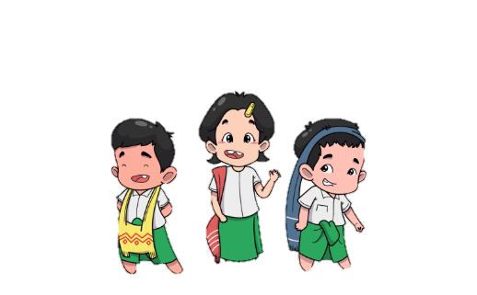

Academic readiness
Emotional and social

Source: www.myanmargraphic.com (free use)

How they learn best

Adapted from Powell, W and Kusuma-Powell, O (2011) How to Teach Now

The next activity begins to explore the types of information that will help you ‘know your learners.’

Discussion - reminder of the key factors and the types of questions you can ask your learners.
It is important to think carefully about all learners, their needs and abilities. Each learner will have a unique set of traits and circumstances. Until these are identified, understood and used during planning, your lessons will very rarely be inclusive. The key factors are:

- Biological Factors  - gender  - age  - physical development  - physical difficulties  - health  - motor skills (large and small movement skills)  - co-ordination  - learning difficulties | - Cultural and Community Factors  - learner’s economic status  - ethnic and racial background  - cultural identity  - language  - religion  - customs and values  - gender expectations
- Emotional and Social Influences  - family structure  - family history  - recent change or loss in the family  - attitude  - personality  - the learner’s status in their class group  - self-esteem | - Academic Readiness  - evidence of learner's thinking skills  - attention and concentrate skills  - past learning success  - reading skills  - spoken language development  - written language skills  - sequencing skills  - categorising skills  - skills in identifying logical arguments
- How they learn best
- interests
- intelligence strengths
- learning styles
- production styles
- environmental influences

Adapted from Powell, W and Kusuma-Powell, O (2011) How to Teach Now

Activity 2.5 – Categorising information about learners (40 minutes)

This activity will help to identify traits or circumstances that could affect learners’ learning. It introduces the types of questions you could ask your learners whilst getting to know them.

Read the following two case studies and identify, from the text, things that could impact on Thu Thu and Min Kyaw’s learning linked to the key factors. Draw and complete the table in your learning journal. Think, pair, share if you can.

Thu Thu Kyi is 11 years old and lives in the Shan State with her mother and father in a rural farming community. She had an accident when she was 7 and lost some of the hearing in her left ear. People who know her always stand or sit to her right side so that she doesn’t miss any of the conversation. Her father has suffered with arthritis for the last six years and is unable to tend his small farm. Her mother juggles with housework, caring for her husband, the farm and Thu Thu. Thu Thu is expected to help with chores, cooking and the farm. The small community where they live is very supportive but elderly and they try to help each other. The family and some of her close neighbours are Muslim. At school, Thu Thu is always very interested in the activities and has good reading competency. She loves activities that are creative. Although she is tired throughout most of the school day.

Min Kyaw is 15 years old and has a love of cooking for his extended family. He would like to be a chef one day as he helps in a local restaurant most evenings. He lives with his mother who is an administrator at his school and a younger, 5-year-old sister. His father passed away when he was 11 – he was also a chef. They live in central Mandalay on a busy, noisy street. The family rely on Min Kyaw’s small wage from the restaurant to help pay the rent on the house. He doesn’t really like any subjects at school that are maths or science related. He sits back in group activities and never answers any questions in class. He is often late for class because he likes to watch the cooks at school preparing lunch in the kitchens.

Factors | Thu Thu Kyi | Min Kyaw
Biological | 11 years old  Mild hearing loss

Cultural and Community

Emotional and Social
Academic readiness |  | Doesn’t engage in activities
How they learn best |  | Anything about food. Practical.

Activity 2.5 answer examples
Factors | Thu Thu Kyi | Min Kyaw
Biological | Mild hearing loss in left ear. | Vibrant young male.
Cultural and Community | Muslim.  Farming family. | Lives on noisy street.
Emotional and Social | Dad immobile.  Always tired. | Father passed away 4 years ago.  Needs to work in the evening.
Academic readiness | Engages well.  Good reader. | Doesn’t engage in activities.
How they learn best | Kinaesthetic  Loves creating things | Anything about food. Practical.

Activity 2.6 – Types of information that could be used to plan classes. (30 minutes)

Think about the activities above: 1. how much you know about a learner, 2. how much you could know about a learner, 3. the five factors of information and 4. the reading earlier - ‘Know your learners’. Write in your learning journal. Think, pair and share your answers if you can. One example is given.

List 6-10 questions you could ask your learners that would help you know them better. Think about any barriers to their learning and how they might learn best.

Biological

Cultural and community
FACTORS

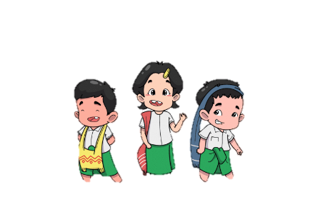

Question/s

Question/s

Academic readiness
Emotional and social

Source: www.myanmargraphic.com (free use)

How they learn best
Question/s

Question/s
- What are their reading skills?
- Do they enjoy reading/school?
- Their attention and concentration skills

Question/s

Discussion - 2.6 Types of information that could be used to plan classes.

Teachers work with learners of different ages and abilities. Not all information will be easy to gather about individuals. You could observe them, interview them, give them a survey, speak to family members etc. You will compile much of the knowledge about students implicitly, meaning you will know much more about them than your records show.

Given that contexts change for different teachers, the following example shows how you might work with younger children to get to ‘know them.’ If teachers are finding out about the learners in their classes, younger children may need some support in identifying how they learn best. A teacher may set up a carousel with different ways to learn using the same objective and observe how the children learn best. Also, with ‘academic readiness’, a teacher might ask the children if they enjoy reading/school, etc to get an understanding of their attitude towards learning and school. A creative approach in ‘getting to know’ learners will be beneficial.

2.2.1 Learning profiles
The information you gather about individual learners can be collated in a learning profile.

A learning profile helps you ‘know your learners’ in detail. A useful learning profile therefore contains information about the 5 different aspects of a learner previously discussed. You can collect this information as you get to know your learners. Use this information to help plan inclusive classes.

For classes with lots of learners it is important to keep accurate records and notes in a central, secure place. These are private and sensitive documents that need to be reviewed and adapted regularly to ensure you monitor your learners’ changes in circumstances. It can also be a useful tool when students have a new teacher and you are asked to handover information. It will provide a new teacher with helpful information rather than just looking at names and test scores.

Table 1: Example of a learning profile template for a class (add names according to group size).

Name | Biological | Culture/comm | Emotion/soc | Academic R | Learn best
Thu Thu Kyi
Min Kyaw
Su Mon Hnin
Aung Min Tho
Yayling Lin

Activity 2.7 – Writing Learning Profiles (40 minutes)

This activity provides an example of how to compile a learning profile.

This could be from memory or from one of your own classes.

- Choose 5 students you teach or have taught from one class.
- Make sure they have differences. One might be excellent at maths, one might not be.
- From the questions you thought of in activity 2.7, write example answers for each learner. One example is given.
Name | Biological | Culture/comm | Emotion/soc | Academic R | Learns best
1 Thu Thu Kyi | Mild hearing loss | Muslim  Farming family | Dad immobile  Always tired | Engages well  Good reading | Kinaesthetic  Loves creating
2
3
4
5

Write in your learning journals and think, pair share if you can.

These learning profiles will be used later in the module.

Using learner information to plan for inclusive learning.
Gathering learners’ individual information is very important. Equally important though is what you do with the information you have collected. It needs to be used to help you think and plan about teaching and learning and select the most appropriate resources used in class to ensure ALL students can access learning suitable to their individual needs and achieve their goals.

The following example begins to demonstrate how the information about a learner can be used by the teacher to think about and plan inclusive learning opportunities.

Thu Thu Kyi - teaching and learning considerations.

Factors | Individual traits | Possible teaching and learning considerations
Biological | - Mild hearing loss in left ear | - Encourage her to sit near the teacher or the teacher stands near her when giving instructions.  - Ensure work partners sit to her right.
Culture and community | - Muslim  - Farming family | - Consider how prayer times might affect the day.  - Consider a place to pray.  - Check canteen for food options.  - Think about how learning may be affected during a month of fasting.  - Muslim religion is represented in resources.  - Might not attend because of farming commitments.  - Catch up resources required.
Emotional and social | - Dad immobile  - Always tired | - She’ll be working hard at home.  - Speak to parents about this.
Academic Readiness | - Engages well  - Good reader | - Stretch her to lead groups/activities.  - Ensure any reading has extension activity.  - Encourage her to support other students.
Learns best | - Kinaesthetic  - Loves creating things | - Range of activities to include practical tasks.  - Adapt activity to encourage creative responses.

The examples provided of ‘possible teaching and learning considerations’ are brief. It is important to note how the ‘individual traits’ of each learner can effect what you do in the classroom. When students experience being fully included in class, they will be able to participate and achieve with confidence.

It is important to recognise the difficulties involved with trying to do this for every learner in this much detail. It would be challenging for any teacher to maintain this amount of information. Certain information about learners is crucial; physical difficulties/disabilities, learning difficulties, specific likes/interests etc. You will quickly identify similarities between some learners’ needs that can be planned for generally i.e., ‘hands-on’ learners, those who need more praise, those who might need to sit nearer the white board etc. This reduces the amount of organisation required to support all needs in class.

Activity 2.8 - Applying teaching and learning considerations (30 minutes)
This activity begins to explore how learner profiles can be used to think about and adapt teaching and learning activities / resources.

- Choose 2 learners from activity 2.8 (please use learners with different profiles)
- Using the example of Thu Thu above, identify how you might support both of your learners’ individual needs in class.

Write in your learning journals and think, pair share if you can.

Discussion - Knowing your learners

- When you know your learners, it demonstrates that you value their presence in the classroom.
- When you know your learners’ interests, motivation and any difficulties, it helps you plan effective learning activities specific to individual needs so all can achieve.
- When you use your knowledge about your learners to plan effective learning activities for them, it demonstrates that you value their participation and achievements.
- You must keep information about your learners private and only share with other teachers to help the students.

Are Learning Resources Inclusive?
Learning resources need to reflect and encourage inclusive practices. Once teachers have a better understanding of their learner’s needs they can carefully select the most appropriate resources to support their learning. Teachers must also be careful to check all resources are inclusive and do not discriminate against or reinforce stereotypes (for example, showing only images of male teachers). Resources need to reflect the diversity of the world, country, school, class and learner wherever possible.

3.1 What is a learning resource?
Learning resources might mean different things to different people. A resource is any material (written, audio, visual, physical activity, object, toy, tool, device, app, classroom setting and display) that you use for ideas, for teaching, to illustrate your content, or that is available for learners to use or look at. It is important to identify what is meant by the terminology used. The table below provides a description of each resource from activity 2.10 (below). Note: there are many more examples than the ones provided.

Learning Resource Type | Description of resource
Written …………………………. | Handouts, books, journals articles, magazines
Audio …………………………… | Recorded stories, sound on video, listening comprehension tasks
Visual …………………………… | Video, art, magazines, books etc with images
Physical activity …………… | Games, playtime, physical hands-on activity
Object …………………………. | Piece of equipment, pencil, book, flower, football
Toy ………………………………. | A toy dinosaur, furry rabbit, plastic dice
Tool ……………………………... | Computer, data projector, hand trowel, stapler
Device …………………………. | Android phone / tablet / iPad
App ……………………………… | Moodle, Facebook
Classroom setting ………… | Reading corner, pet corner, computer area, comfort areas
Display…….…………………… | Wall display – learner work, notices, alphabet, numbers

Activity 2.9 – Identifying learning resource types. (10 minutes)

Think about your classroom. Review the list of learning resource types below. Write in your learning journal.

In column 1 (things you use now in class) place a tick () next to the resource you currently use.

In column 2 (resources you would like to explore in the future) place a tick () next to the resource you would like to explore further.

Learning Resource Type | I use now | I will explore this in the future
Written ………………………….
Audio ……………………………
Visual ……………………………
Physical activity ……………
Object ………………………….
Toy ……………………………….
Tool ……………………………...
Device ………………………….
App ………………………………
Classroom setting …………
Display…….……………………

3.2 Is a learning resource inclusive?
It is important that resources are inclusive and support the learning and well-being of ALL students.
See a simple checklist (below) to identify whether a resource is inclusive, linked specifically to the five factors previously studied: biological factors, cultural and community factors, emotional and social Influences, academic readiness and how they learn best. Use these questions to check whether a resourse is inclusive.

- Biological factors |  | / X
 | Does this resource show all genders as equally important and valued?
 | Is this resource suitable for the age group you are teaching?
 | Does this resource show people with a range of health conditions, height, weight, physical abilities, motor skills, learning differences as equally important?
 | Can this resource be used easily by students who have differences?
- Cultural and community factors
 | Will students understand the language of the resource? Is it in the native language(s) of your student(s)? If not, can you translate it for them?
 | Does your resource show people of different ages, ethnic backgrounds, religions and social status as equally important and valued?
 | Does the resource match the cultural values of your students and their local communities?
- Emotional and social factors
 | Are different types of families and communities represented respectfully in the resource?
 | Could the resource be upsetting for some students because of their experiences? Are you ready to support their emotions and reactions?
 | Does the content and the people, ideas and values represented in the resource help your students feel they belong to the school community?
- Academic readiness of the age and any learning differences of your students:
 | Will the resource keep the students’ attention?
 | Is the text easily readable? Is the information arranged well on the page so it is easy to read?
 | Are the key points easily identified and understood?
- How students learn best:
 | Is the resource interesting and engaging for your students?
 | Do they know how to use it effectively?
 | Is it / can it be supported by multisensory activities?
 | Does it build on students’ strengths, and previously learned knowlege and skills?
 | Does the resource challenge, inspire, motivate? Does it stimulate higher level thinking, expression and creativity?

One example of how to assess a resource, using the checklist, to judge if it is inclusive.
Resource - Image of a family used as a poster in class.

The image below was used to teach a Myanmar language basic education class in Yangon about staying safe during Covid19. The teacher was very pleased with their choice of image (do you agree?). Section 1 of the checklist will be used as an example of how to assess if it is inclusive. Teacher comments in blue.

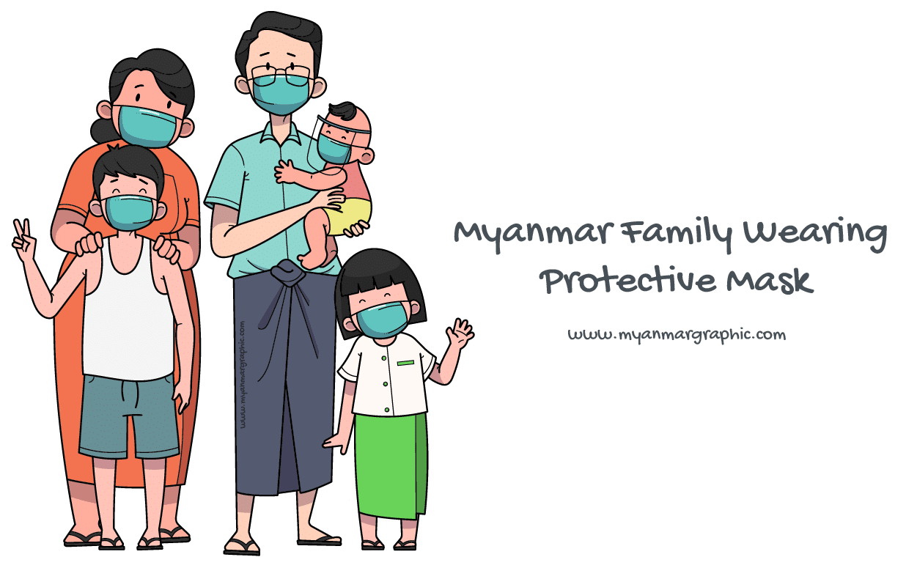
Source: www.myanmargraphic.com (free use)

- Biological factors | / X
Does this resource show all genders as equally important and valued? There is a mix of male and female, younger and older.
Is this resource suitable for the age group you are teaching? Yes, it’s simple and friendly.
Does this resource show people who are different from the average (health condition, height, weight, physical abilities, motor skills and coordination, learning differences) as equally important? No – the image seems to show an ’average’ family with no differences. | X
Can this resource be used easily by students who have differences? Learners with a visual impairement might not be able to use this. It might work if it was made larger for the learner. | X

Even though there are two ticks and two crosses, this resource could still be called inclusive. This will depend on your learners’ needs (using the learning profile details). You might consider using other representations of families in other lessons or situations. It is important that children can identify with images of people that are shown in resources so that they feel a sense of belonging in the educational setting. Consider this when selecting resources for the students you teach.

Activity 2.10 – Assessing whether resources are inclusive. (30 minutes)

- Identify 3 different resources you use in your teaching.

Resource 2 =
Resource 3 =
Resource 1 =

- Choose 1 resource to review from the above 3 resources.

Your choice

- Complete the full checklist of factors 1 – 5 using a or X. Make brief notes for each point (see example above) about why it is or is not inclusive.

Example of the brief comments and analysis (blue) and the or X

- Biological factors | / X
Does this resource show all genders as equally important and valued? There is a mix of male and female, younger and older.
- In two or three sentences, make a statement about the suitability of the resource.
Write in your learning journal and think, pair, share if you can.

Discussion - Inclusive resources

- Inclusive resources show different people having equal importance and opportunities.
- Using inclusive resources shows you know and respect your students’ differences, and that you value their presence.

Effective use of inclusive resources
So far we have explored the different types of resources used in teaching and learning and introduced the idea that they also need to be inclusive. We must also think about whether we use the resources effectively – to be inclusive. Consider the following scenarios.

Activity 2.11 - Effective use of teaching and learning resources (30 minutes)

This activity begins to explore whether resources are used effectively to support inclusion.

- Read the statements and say whether the resource is being used to effectively support inclusion or not.
- Please explain your answers.

This is a phonics poster showing letters used with a class of 50 students aged between 5 and 8. The poster is three years old, has faded and has ripped corners.

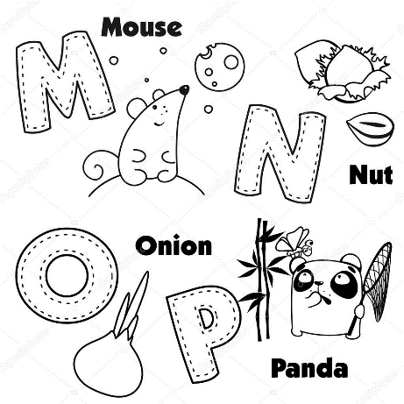
Resource used effectively for inclusion? | Yes | No
Scenario - Please or X
- The poster is placed on the back of a closed cupboard door.
- The poster is placed on the class wall at waist height. Easily visible to the whole class.
- 78% of all children can see it clearly in class.
- One child can’t read it because the font and images are too small.
- The poster is placed high up on the class walls near the ceiling.

Source: https://depositphotos.com/97048548 (Creative Commons)

Write in your learning journals and think, pair share if you can.

2.11 answers

Resource used effectively for inclusive? | Yes | No | Comments
Scenario - Please or X
- Poster placed on the back of a closed cupboard door. |  | X | No one can see the resource unless the cupboard is open.
- Poster placed on the class wall at waist height. Easily visible to the whole class. |  |  | The whole class can easily see the poster. It is at the correct height so they can refer to it as they sit and work.
- 78% of children can see it clearly in class. |  | X | Some of the children cannot see this during the class. They feel left out, and the resource cannot be used to support their learning.
- One child can’t read it because it’s too small. |  | X | This child feels excluded because she cannot read the poster at all. Make the poster larger – this will also benefit other students in class.
- Poster placed on the class walls near the ceiling. |  | X | The children in class are small and would have difficulty reading the poster.

To start, the poster has letters missing and causes problems for learners trying to read. Teachers need to think carefully about each resource they use and whether it is being used effectively. Teachers also need to ensure that learners do not feel singled out in class (example 4) because they are the only ones using a specific resource. Think about how the resource could be used by some or all others in the class. Simply by making the poster larger and considering where it will be best placed, the whole class can use the same resource.

Consider if the children will need to be shown how the resource can help them and plan that into your lesson, modelling how to use the resource effectively so children will use it in their independent work.

4.Multisensory Learning

Activity 2.12 – Multisensory Learning (15 minutes)

Watch the video which is about learning through all our senses – multisensory learning.
Answer the following questions in your learning journal.
- What strategy is used to support number recognition?
- What example is given to aid memorising spellings?
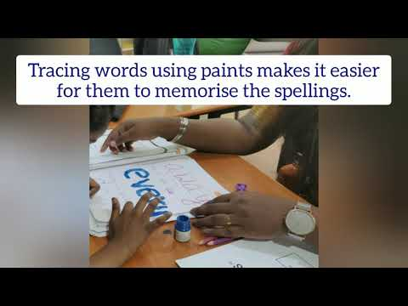
https://www.youtube.com/watch?v=GR1P7vwGeDo

Think about your childhood. Think of as many different ways you learnt about a tree. Draw the tree below in your learning journal and create a mind map of ideas, linking to the video. Two examples are given.
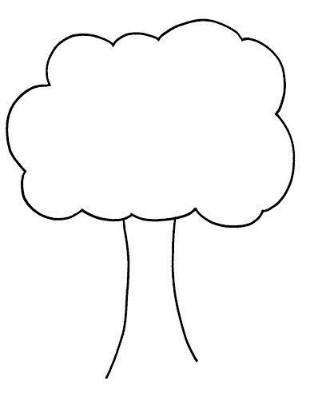
By touching a tree
When walking around a tree
How does a child learn about a tree

Branches, leaves, flowers
and fruit

trunk

Hearing the wind move the branches and leaves. Listening to people talking about the tree.

Touching the trunk, leaves, flowers and fruit. Feeling different textures (rough, smooth).

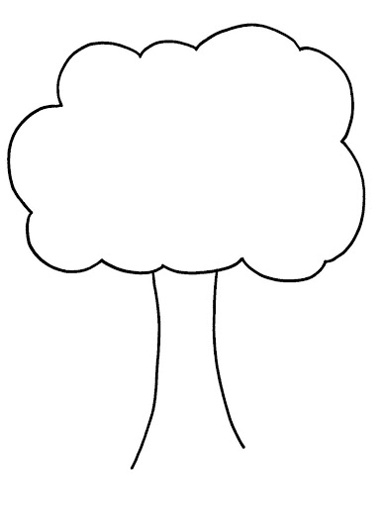
2.12 Answers
Branches, leaves, flowers and fruit
trunk

How does a child learn about a tree?
Looking at the branches, trunk, leaves, flowers and fruit.
Seeing different shapes and colours.

Walking around the trees.

Climbing or swinging on the tree.

Smelling the leaves, flowers and fruit.

Having time to sit quietly under the tree and feel emotions.

Tasting the fruit

The answers in 2.12 identified that people learn by using all of their senses. The more the senses are used to learn a topic the stronger the link to long term memory.
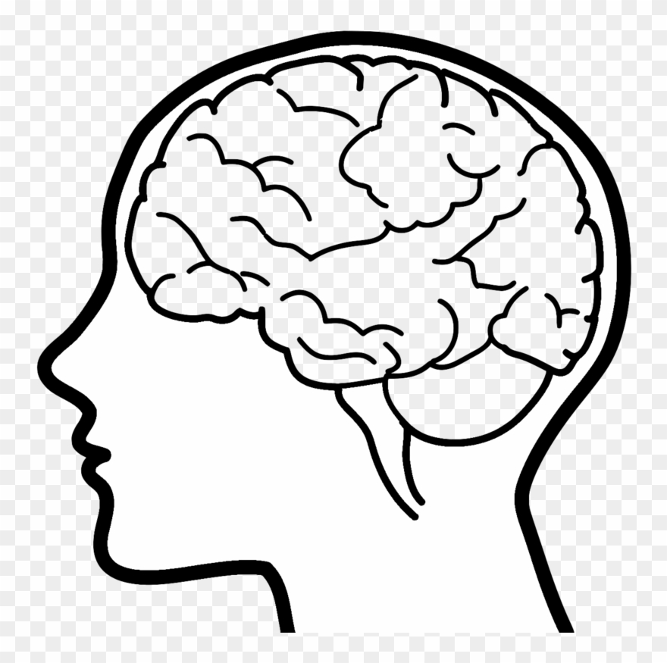
Multisensory learning
Source: Megapixl.com. braininhead (Creative Commons)

see
hear
smell
taste
feel
touch
move
balance
Long term memory
Brain works with information from all senses

Activity 2.13 – multisensory learning (20 minutes)

Linking learning from earlier activities. 1) Think how you learnt about trees as a child. 2) Think about how we all learn differently and have different needs. 3) Think about how we use resources effectively to support inclusive practices.

Scenario – You arrive in a classroom (pupils aged 5) and find the only resource you have available to teach your subject is a football. You have a wide range of learners, each with a different set of interests, learning styles and difficulties.

- Choose a topic from your subject (e.g. counting 1 – 10 in maths).
- Produce a mind map showing the different ways the resource can be used to engage learners in different ways for that topic. A few examples have been given.
- How many different ways of learning did you generate?

Measure distance – kicking, throwing, rolling
Use targets to aim for - letter sounds or skittles to count – subtraction/addition
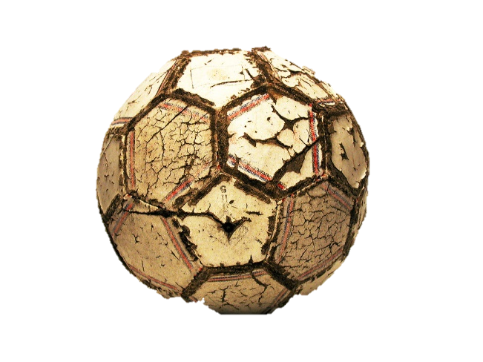
Identifying patterns, tessellations, etc.

Team games – learning how to take turns.

Source:https://www.flickr.com/photos/25911674@N04/4689758013 (creative commons)
- Think about the 5-year-olds in your class; some like to write, whilst others don’t. Some like to solve problems on paper and some like to physically solve problems. Think of different ways to engage individual learners using the table below.

Learners’ needs, interests, dislikes | The lesson topic | How could the toy be used?
Dislikes writing | Instruction writing | Use the ball to play a game and ask children to write instructions on how to play the game to teach younger children.
Dislikes maths | Counting 1 - 10 | Throw the ball counting forwards or backwards with a class. They could count in steps of 2, 5, etc.
Auditory learner | Science | Predict if the ball will sink or float. Draw up a science experiment and test it with the class.
Likes being creative | Communication
Visually impaired

Activity 2.13 Discussion - multisensory learning

- Consider that some types of resources might be helpful at the start of a learning process. Some students might benefit from time using concrete or visual representations before they move onto more abstract learning, like in maths when calculating answers in their heads.

- Other examples could be by using a toy or object to introduce a written task to children. They could describe it using adjectives which could be really engaging to a visual learner.

- Also, young children will need teaching how to use a resource. If we want students to use a resource independently, we might need to model how to use it as part of our instruction.

General discussion - multisensory learning

- We all learn through all our senses;
  - Seeing
  - Hearing
  - Moving and balancing
  - Touching
  - Feeling
  - Smelling
  - Tasting
- Most of us are stronger in one or more senses when we are learning.
- If we know our students, we can know the senses they use to learn best.
- If students work with all their senses to learn, they can strengthen all their senses.
- Using different senses to learn about something helps us remember better.

Activity 2.14 - Applying multisensory learning (45 minutes)

In this activity, apply the idea of multisensory learning to a simple learning activity from one of your classes. Think: there are more than three senses.
Look | Feel | Sound
Source: https://pixabay.com (free) | Source: commons.wikimedia.org/ (free) | Source: https://pixabay.com (free)

- Think of one activity from one of your lesson plans. Try to choose a topic your leaners usually find difficult.

- Redesign how you plan to teach the activity using as many of the senses as you can.

- Share your new plan with a partner or small group and ask for feedback about whether,
- they understand better using more than one sense.
- they remember your activity any better.
Write in your learning journals and think, pair share if you can..

Wrap up
In this module you have: 1. explained why it is important to know your students. 2. discussed ways of knowing your students. 3. decided if a teaching resource is inclusive. 4. explained the importance of multi-sensory learning. 5. adapted lesson plans to include multi-sensory learning.

Key points from this module:
- Knowing your learners as individuals can have a massive impact on improving their learning.
- Leaners will feel valued and included which will result in their participation and achievement.
- Being able to recognise your learners’ individual needs means you can adapt your teaching.
- Ensuring resources are inclusive means learners will feel valued and represented in class.
- Using a multisensory approach means all learners can participate no matter what their learning style.

End of module 2 quiz
Please answer the following questions in your learning journal. You can attempt as many times as you like to reach 100% pass. Some questions require more than one answer.
Q1 - Why should you know your learners? (Choose 2 answers.)
- to tell your family and friends about them.
- to understand how your learners learn best.
- to find out about their interests and difficulties.
- to tell other learners about them.

Q2 - When you know your learners, you demonstrate that you value their;
- presence in your classroom.
- popularity in your classroom.
- status in your classroom.

Q3 - When you use your knowledge about your learners to plan learning activities, you demonstrate you value their (choose 2 answers)
- opinion of you as a 'fun' teacher.
- participation in the lesson.
- achievements in learning.
- opinion of you as a hardworking teacher.

Q4 - What is an inclusive resource? (choose only 2 answers)
- something that shows lots of people with differences.
- something that shows people with differences having equal importance, status and opportunity.
- something that shows your students respect for their differences.
- something that shows you how to include learners with disabilities.

Q5 - What is multisensory learning?
- using all our senses at the same time to learn.
- using our different senses in different activities to learn.

Q6 - What are the benefits of multisensory learning? (Choose 3 answers)
- using different senses to learn shows us how people with disabilities can learn.
- using all our senses to learn helps us strengthen all our senses so we can learn more from them.
- using different senses to learn reminds us of when we were children learning.
- using different senses to learn makes our brain work more so we remember more.
- using different senses to learn lets us use our stronger senses to learn.

Answers - end of module 2 quiz
Answers in bold

Q1 - Why should you know your learners? (Choose 2 answers.)
- to tell your family and friends about them.
- to understand how your learners learn best.
- to find out about their interests and difficulties.
- to tell other learners about them.

Q2 - When you know your learners, you demonstrate that you value their
- presence in your classroom.
- popularity in your classroom.
- status in your classroom.

Q3 - When you use your knowledge about your learners to plan learning activities, you demonstrate you value their (choose 2 answers)
- opinion of you as a 'fun' teacher.
- participation in the lesson.
- achievements in learning.
- opinion of you as a hardworking teacher.

Q4 - What is an inclusive resource? (choose only 2 answers)
- something that shows lots of people with differences.
- something that shows people with differences having equal importance, status and opportunity.
- something that shows your students respect for their differences.
- something that shows you how to include learners with disabilities.

Q5 - What is multisensory learning?
- using all our senses at the same time to learn.
- using our different senses in different activities to learn.

Q6 - What are the benefits of multisensory learning? (Choose 3 answers)
- using different senses to learn shows us how people with disabilities can learn.
- using all our senses to learn helps us strengthen all our senses so we can learn more from them.
- using different senses to learn reminds us of when we were children learning.
- using different senses to learn makes our brain work more so we remember more.
- using different senses to learn lets us use our stronger senses to learn.

Improving teaching and learning

Activity 2.15 Improving your own teaching practice. (30 minutes)

It is important to reflect on the answers to the activities you have completed earlier.

Scenario – Your Head of Department asks to meet you to ask about how well you know your learners and how multisensory your teaching and learning activities are. They ask you to complete the following statements. Make notes in your learning journal:

- I plan to use multisensory learning activities in my teaching by…?

- I will help my learners use multisensory learning activities in practicum by?

Activity 2.16 - Self-assessment (10 minutes)
REFLECT: How well do you think you ‘know your learners’ right NOW? Look at the scale below and choose the number that best describes YOU.
VERY well
NOT well
Compare your first self-assessment score at the beginning of this module to this one. In your learning journal provide a short analysis of your thoughts about any differences.

Your 2nd PROMISE to your STUDENTS

1
3
2

Review

Do

Plan

Please add your 2nd promise to the section in your learning journal entitled ‘Promises.’
Each module contains one promise you will make to your learners: you will make 15 promises in total.

References

EENET - Enabling Education Network (2017) Programme 6 – Understanding learners needs
YouTube - https://www.youtube.com/watch?v=ENvkE_0N3jo

Powell, W. & Kusuma-Powell, O. (2011) How to Teach Now
Available online at:
http://www.ascd.org/publications/books/111011/chapters/Knowing-Our-Students-as-Learners.aspx

Special Wing Chennai (2020) Academic activity – Multisensory Learning
YouTube - https://www.youtube.com/watch?v=GR1P7vwGeDo

UNESCO (2015) Embracing Diversity: toolkit for creating inclusive, learning-friendly environments – Booklet 4.
Available online at:
https://unesdoc.unesco.org/ark:/48223/pf0000137522_bur

Appendix 1 - Knowing your learners.

Text 1 (easier version) - Adapted passage from ‘How to Teach Now’ by William Powell and Ochan Kusuma-Powell. (15-minute read)

Why should you know your learners?
- To make a safe environment for every learner and help them feel more confident.
- To understand each learner’s “readiness to learn” (how ready and motivated they are to
learn).
- When you know your learners’ interests, their experiences and the way they think, you can
identify different ways to introduce a subject.
- To respond and interact with your learners in a caring and understanding way.
- To appreciate and learn from the diversity (the differences) in your classroom.
- To plan your teaching so it is most effective for your learners’ learning.

Learning Profiles
A learning profile helps you know your learners. A useful learning profile contains information about 5 different aspects. You can collect this information as you get to know your learners.
- biological factors
- cultural and community factors
- emotional and social factors
- academic readiness
- how they learn best

- Biological Factors
gender
age
physical development
physical difficulties
health
motor skills (large and small movement skills)
co-ordination
learning difficulties

Some biological factors can be a barrier to learning. It is important that we know of possible barriers to a learner’s learning so we can create an inclusive learning environment and provide support. We can stop factors from being a barrier.
We can get this information from the learner's medical history, family history and from how they have developed and are developing.

- Cultural and Community Factors
learner’s economic status
ethnic and racial background
cultural identity
language
religion
customs and values
gender expectations

Community factors like conflict, economic prosperity or poverty have a huge influence on the availability, quality, and type of learning a learner can access. Cultural identity can affect the learners’ and their families’ expectations and values, and can affect how your learners think.

- Emotional and Social Influences
family structure
family history
recent change or loss in the family
attitude
personality
the learner’s status in their class group
self-esteem – we encourage, praise etc

Emotional experiences will affect how a learner can be present and participate in school. If we know our learners and their family, we can find ways to help them so that they can keep on learning.
In a classroom, even in primary school, learners usually put themselves and each other in order of:
- how successful they see themselves and each other as learners (academic status),
- how attractive they see themselves and each other,
- how popular they see themselves and each other (peer status).
A learner who is low down this order (low status) can think they cannot learn, and they can lose motivation. If we know our learners and understand that a learner thinks they are low status, we can find opportunities to show that the learner is important and valued.

- Academic Readiness
evidence of learner's thinking skills
attention and concentrate skills
past learning success
reading skills
spoken language development
written language skills
sequencing skills
categorising skills
skills in identifying logical arguments

Academic readiness, or readiness for school learning, is something that can be developed by effective teaching. It can vary depending on the situation, topic or subject, and a learner's stage of development. More effective learning happens when the learning task matches a learner's level of academic readiness. Learners who are working at an early level of academic readiness need very clear step by step instructions. Learners who are at a higher level of academic readiness learn more from tasks that are open-ended.

A learner’s attitude to learning and what they can achieve depends a great deal on our ability to know our learner’s skill levels and give them appropriate tasks.

- How they learn best
interests
intelligence strengths
learning styles
production styles
environmental influences

If you know your learners’ interests, you can link the curriculum to their interests. This means you can use the learners’ own motivation to help them learn. This is one of the most powerful strategies we can use to create enthusiastic lifelong learners.

Knowing the intelligence strengths of your learners can help you decide on the best learning tasks. Robert Sternberg (1985) explains three intelligence types: analytical, practical, and creative.

- Analytical intelligence. Learners with strong analytical intelligence learn well with tasks such as organizing information, understanding cause and effect, analysing things logically, note taking, and recognising implications.
- Practical intelligence. Learners with strong practical intelligence need to solve problems in a real-life context. They learn best when teachers make connections with the real world outside the classroom.
- Creative intelligence. Learners with strong creative intelligence often think in different ways. They prefer to experiment with ideas and create rather than "work" like everyone else.
Our learners have, and use, all three intelligences, but often have strengths in one or more, and often learn best using the intelligence that is stronger. Sometimes learners can learn better in one style in one situation but in a different style in another situation. Knowing which learning style your learners prefer can help you decide on different learning activities.

Production styles are the ways your learners prefer to express their learning. It may be through speech, through written language, through movement, or through different visual ways.
Environmental influences in the classroom can affect learning. Does the learner become distracted when the classroom is too warm or too cold? Does the learner do the best thinking in the morning or afternoon? Knowing these things can help us prepare how best to teach.
We can obtain information about our learners as learners in different ways. Three of the most common ways are looking at past records, interviewing the learner and/or their parents, and observing the learner.

Adapted from – ‘How to Teach Now’ by William Powell and Ochan Kusuma-Powell (text 2)
www.ascd.org/publications/books/111011/chapters/Knowing-Our-Learners-as-Learners.aspx

