Inclusive Teaching Practice
Participant’s Book
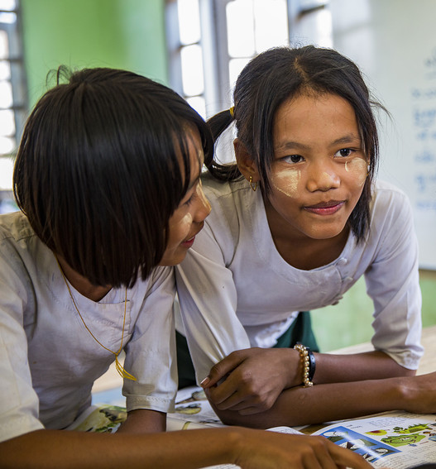

Source: VSO Image library

Module 13:
Supporting all learners with differences or disabilities.
Module 13: Supporting all learners with differences or disabilities.

Overview
This is the thirteenth of fifteen modules that look at how we create a positive Inclusive Learning Environment for all. You will see how inclusive teaching practices encourage, develop and use the 21st century skills of critical thinking, communication, collaboration and creativity. These modules are for any educators or those studying in education in Myanmar. The terms student and learner are used interchangeably throughout the module.

Module number | Module title
1 | What is an Inclusive School, Classroom and Teacher?
2 | Knowing your learners
3 | Planning learning outcomes for all
4 | Participating through learner centred approaches
5 | Creating a positive learning environment
6 | Effective questioning and feedback
7 | Active participation
8 | Peer, cooperative and collaborative learning
9 | Supporting students’ emotional and social wellbeing
10 | Legal framework and policies around Inclusion in Myanmar
11 | Supporting all students through differentiation
12 | Identifying specific learning difficulties
13 | Supporting all learners with differences or disabilities
14 | Positive behaviour management
15 | Assessment for student achievement

This module looks deeper at what educators can do to support students who have been identified with difficulties or disabilities. The module builds on the previous one, exploring barriers to learning in the classroom, for example with communication, social, emotional, physical and cognition. It explores ways in which teachers can respond and support learning needs when they have been identified. We look more deeply at UDL as an effective approach to address any barriers to learning for all students.
You will be asked to record your reflections in a learning journal, so it is important to make detailed notes and think carefully and deeply about your current and future practice. This module also encourages you to develop communities of practice between yourself and your colleagues. This will support and extend your own use of inclusive practices in your teaching and will help your student teachers build on inclusion in their learning and future professional practice.

Learning Journal
It will be useful to record your reflections in a learning journal throughout the module.
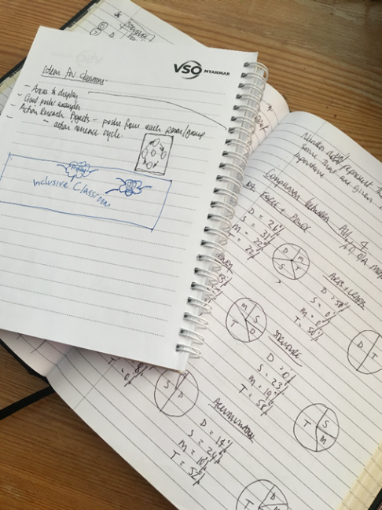
A learning journal can be digital (e.g. using Word or Google Docs) or on paper. You can also take photos of your learning journal pages if you want to share your thoughts with others. It is important that you record your thoughts and ideas so that you can remember and use them later in activities and in your own teaching.

Here are some useful tips for a good learning journal:
- Use headings and dates for all your journal entries.
- Use the activity number for reflections linked to that activity, e.g. Activity 1.1
- Add references to any other resources you find that help you.
- Record answers to activities.
- Write reflections about your learning.
- Make notes of new vocabulary.
- Identify topics you want to learn more about.

Source: Rose, N. (2018) Personal Learning Journals

The important thing is that it is easy for you to use. You can take notes which answer simple questions like these:

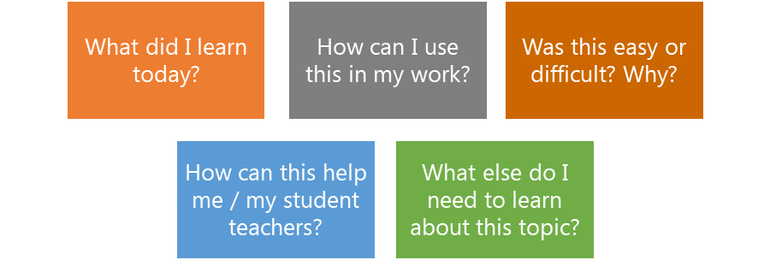

These questions follow the LEARN- APPLY- REFLECT model which is used in education globally. You can return to this journal as you progress through your CPD journey and reflect on your progress.

Study tips
Take your time to work through the activities, rather than trying to complete the whole unit at once. Set yourself a timetable and choose a time to work through the tasks, then check and compare ideas with colleagues. Finally, remember to make notes in your learning journal as you go. This will help you remember more about the skills and knowledge you develop as you complete these units.

Working alone or with colleagues
This unit is designed for self-study. The answers can be found after each activity. However, if possible, we recommend working in a pair or group so you can share ideas, ask questions, check your work, and give feedback.

If you work in a pair or group, we recommend using Think / Pair / Share for each activity.
Discuss your ideas in a group, and then check the answers on the next page(s) together.
Check your answers with your partner.
Work alone and make brief notes of your own ideas.

Learning outcomes for module 13
By working through this module, you will be able to:

- Demonstrate an understanding of various difficulties and disabilities.
- Understand how to incorporate the key principles of UDL and inclusion in lesson planning.
- Discuss what schools or settings can do to support students with identified difficulties or disabilities.
- Describe and discuss effective classroom strategies to support students with identified difficulties with their learning.

- Introduction
The previous module 12 looked at how to identify specific learning differences that may act as barriers to learning in the classroom. e.g., communication, social, emotional, physical and cognitive.

This module 13 focuses on how to support those needs once they have been identified. It looks at some learning and teaching tools that focus on supporting specific learning difficulties because of disabilities (e.g. SEN, Disabilities, high IQ) in the classroom. We look at how to assess and adjust learning for our different learners and their multiple needs in an inclusive environment.
- Read various texts about the topic.
- Watch videos and provide some analysis.
- Complete activities either alone, in pairs or in small groups.
- Think about key questions.
- Reflect on your experience and knowledge.

The module will take approximately 7 hours to complete. We hope you have an enjoyable learning experience.

Key to symbols
Activity – this is work you need to complete.

Question/s – please answer the questions.
Reflection – think carefully about how you feel about this.
Learning Journal – please write your answers in your learning journal.
Read – please read the text provided. Make any notes you like.

Activity 13.1 Self-assessment
REFLECTION: How well do you think you are equipped to support students with learning difficulties? Look at the scale below and choose the number that best describes you now. Answer in your learning journal.
VERY well
NOT well
You will be asked to do this again at the end of the module.
    - Link to previous learning – Module 12 (Identifying specific learning difficulties)

Link the learning disability or learning difficulty to the correct definition. It might help to copy the definition into your learning journal and list the examples underneath.

Autism
Learning disability

“A learning disability constitutes a condition which affects learning and intelligence across all areas of life.”

Learning difficulty

“A learning difficulty constitutes a condition which creates an obstacle to a specific form of learning, but does not affect the overall IQ of an individual.”

Dyscalculia

Dyslexia

Dyspraxia

Down’s syndrome

Foundation for People with Learning Disabilities (2021)

    - Answers
Examples of a learning disability:
- Down’s syndrome – it can affect all areas of an individual’s life including their health, physical condition and life skills.
- Autism Spectrum Disorder (ASD) – it can affect all areas of an individual’s life including social interaction and communication.

Example of a learning difficulty:
- Dyslexia – it can affect a specific area of an individual’s life and does not necessarily hinder their life skills. In this example, dyslexia impacts upon the ability to read, write and spell, but the individual can otherwise function without the need for ongoing care and support (for this specific condition).
- Dyspraxia – it can affect a specific area of an individual’s life with the coordination of muscles. Holding a pen for example could be painful.
- Dyscalculia – it can affect a specific area of an individual’s life with the processing of numbers, simple arithmetic and maths problems.

Activity 13.2 – Recap from previous module

Learning difficulty or disability? (20 minutes)
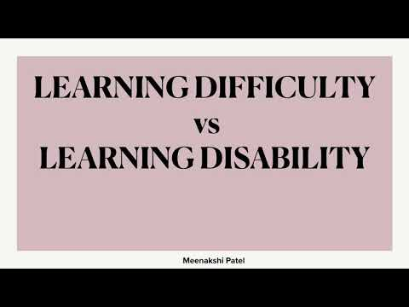
Learning disabilities are often confused with learning difficulties.
https://www.youtube.com/watch?v=I-xA9B_U1JU

- Watch the video below to remind yourself of the differences.
- Revisit the previous module to read about the challenges in identifying some learning difficulties.

- Supporting all learners
If we look at the first part of the title of this module, ‘Supporting all learners with differences or disabilities’, it might be helpful to revisit definitions of inclusive education discussed in the first module.
Inclusive education is about much more than ensuring all learners are in (present) school. By them being in school does not automatically mean the school is inclusive. This is integration, where learners with disabilities might be in school, but not necessarily receive the support they need to access the learning. Think about this difference between integrated education and inclusive education.
Everyone should be able to take part and be involved (participating) in all learning and social activities related to school and achieve academically and socially.
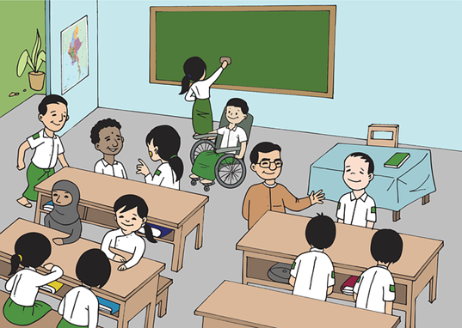
With integration, the onus is on the learner to survive and get on with it in an unchanged and potentially unwelcoming learning environment. We have discussed the need for a sense of belonging in previous modules and how important that feeling is to academic success. Many learners with disabilities who experience integrated education do not thrive (achieve) or complete their education.
In an inclusive school, changes are made – to the physical environment, teaching and learning practices, people’s attitudes, the resources that are used, and the policies that are in place. These changes may happen gradually, so inclusive education is an ongoing transformative process, not something we can put in place over night.
In this module we look at how changes or adaptations can be made to remove barriers to presence, participation and achievement for all learners, rather than the learners having to change and fit into the system or the context they are learning in. We will also give specific attention to support that can be given to meet individual children’s learning needs, particularly those with learning difficulties and disabilities.

Activity 13.3 – Inclusive Education – True or False? (20 minutes)
Read the sentences in the boxes below and decide which are True or False when describing Inclusive Education.
Write True or False next to the number of the box in your learning journal and compare it to the answers given.
- Inclusive Education is a vital part of a wider process of developing inclusive societies. It is a flexible approach that finds adaptive solutions.
- Inclusive Education is all about having specialist classrooms that support students to meet their individual needs.
- Inclusive Education seeks to remove exclusion, segregation, and discrimination on the grounds of disability, gender, ethnicity, language, religion, poverty, age, health status, refugee status, among others.
- Inclusive Education focuses on identifying and removing barriers, helping to ensure that all students can access, participate in, and achieve within and benefit from quality education.
- Inclusive Education should only be available when the school is ready and has everything in place to meet the needs of all students.
- Inclusive Education can be a long-term process of changing attitudes, policies, and practices.

Activity 13.3 answers
1 | 2 | 3 | 4 | 5 | 6
True | True | False | False | True | True

Note:
3 - Students who may be working at a different level to their peers do not need to be taught separately. The teacher plan lessons to ensure all students can access the learning. A separate learning space may be useful for working with a group of students on a specific area for example if they need to revisit a learning outcome from a previous lesson or where a group of students might need specific speech and language support, but the students should still spend most of their school day in class with their peers.

4 - Education settings may not necessarily be able to immediately offer every learner the ideal support they need and some of the changes needed might not happen straight away, but settings should continue to understand the needs of the students and how they can best support them.

- Universal Design for Learning (UDL)
In the previous module (12) we looked at identifying student’s learning needs and introduced Universal Design for Learning – what it is and how educational settings can use it as a tool. In this next section we will take a closer look at UDL and think about how we can use it as another way of structuring your teaching and planning lessons. In particular we will look at it to;
• consider specific measures schools can take to support individual needs;
• address the need for diverse assessments and making reasonable adjustments;
• meet the needs of learners with multiple impairments or difficulties.

The definition from UNCRPD (Article 2)
“’Universal design’ means the design of products, environments, programmes and services to be usable by all people, to the greatest extent possible, without the need for adaptation or specialized design. ‘Universal design’ shall not exclude assistive devices for particular groups of persons with disabilities where this is needed.”
There are three principles of teaching and learning practices, that we looked in module 12. When you read through the descriptions this time, think about the teaching and learning practices in your school or setting, and think about any changes you might need to make to become more inclusive.
 | Engagement and motivation  Why are we learning? | Representation  What are we learning? | Action and expression  How are we learning?
 | - Learning is interesting  - Learners have a say in what they learn & how.  - Learners understand why they are learning and have good attention and focus  - Learners take responsibility for their own learning | - Teaching and learning is presented in different ways  - Information is accessible  - Language is at the right level for learners  - Learners have support to understand | - Learners are supported with learning materials or different ways of learning  - Learners are asked or supported to understand how they learn best
Reflect on the questions linked to each principle | - How can I engage all students in my class?  - In what ways do I give students choice and autonomy?  - How can I present information in ways that reach all learners? | - How can I present information in ways to reach all learners?  - Have I considered options for how printed texts, pictures, and charts are displayed?  - What options do I provide for students who need support engaging with texts and/or with auditory learning? | - How can I offer purposeful options for students to show what they know?  - When can I provide flexibility with timing and pacing?  - Have I considered methods aside from paper-and-pencil tasks for students to show what they know?

Activity 13.4 – UDL video (20 minutes)
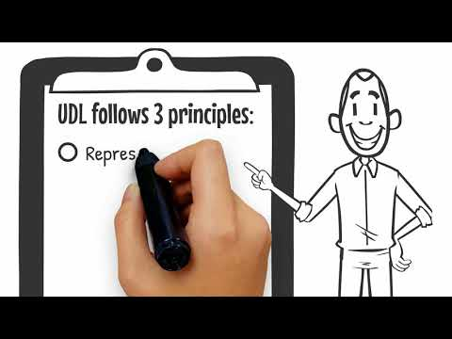
Use the link below to watch the video on UDL
  - Write a summary in your learning journal or describe the 3 principles.
https://www.youtube.com/watch?v=Ih0QVKjYvG4

  - 1. Give some examples of motivation and engagement to sustain student’s interest.

  - 2. Give some examples of what is meant by multiple means of representation in UDL.

  - 3. Give examples of how learners can interact with the material to show what they know.

Activity 13.4 answers
1. Engagement | 2. Representation | 3. Action and expression
- Let students make choices  – Find out about students’ interests & strengths.  - Give lessons that feel relevant to students’ lives  - Make lessons fun and interesting  – Give opportunities for learners to get up and move around | - Textbooks  - Audio  - Partnered reading  - Video  - Hands-on-learning  - If possible, enable students to adjust font sizes and background colours using technology | - Create a poster  - Draw a mind map  - Giving an oral report  - Making a video or a comic strip  - Doing a group project

3.1 What schools and settings can do
It would be easy to provide a list of recommended actions that schools, and settings can follow to ensure they are taking measures to be inclusive but, it will depend on the learners in that setting and their unique needs. Changes and adaptations to help students access school, participate and learn will require settings to reflect critically on their own experiences and contexts and to think creatively about the types of measures that could be taken.
Making changes should not be about buying expensive equipment and materials or employing specialist staff – although if there funding is available these could be an option.
It is important that we think about individual students’ needs and adaptations that may be required throughout a school day, not just in the classroom;

At the heart of all these needs is the student and if we think in a positive way ‘solutions focused’ adaptations can often be incredibly simple. For example, writing out the text you will use in a lesson in a larger font may be the difference as to if a student can read it or not and therefore engage in the lesson you have planned. Of course, adaptions can be more complicated, needing extra help from different people.
Think if there are any fundamental barriers to participation and achievement for the students you teach. Perhaps they relate to the curriculum, teaching and learning approaches and materials, or perhaps the expectations on assessment and exams for students. We need to encourage/support education systems and settings to:
• Develop flexible, relevant and engaging curriculums that encourage teachers to make adaptations. Often teachers are instructed, or they assume that they must not deviate from systems that have always been in place.
• Train teachers or encourage them to find effective continuous professional development opportunities to learn and practice using diverse teaching and learning approaches.
• Encourage the use of low/no-cost teaching and learning resources to add more practical and engaging opportunities to learn.
• Be more creative and willing to monitor learners’ progress in different ways rather than through standardizing testing, often denying many students the fair chance to demonstrate what they have learned or see them repeat grades which causes further separation from peers.

3.2 Physical learning environment
To ensure learners with disabilities and difficulties are included in school settings may require changes to the physical environment, teaching and learning materials. The UNCRPD (2011) indicates that we must not wait until we can provide the perfect solution but instead to act now using the principle of ‘reasonable accommodation’.
Definition from UNCRPD (Article 2)
“‘Reasonable accommodation’ means necessary and appropriate modification and adjustments not imposing a disproportionate or undue burden, where needed in a particular case, to ensure to persons with disabilities the enjoyment or exercise on an equal basis with others of all human rights and fundamental freedoms;”
If we wait for more funding, technical expertise or specialist equipment, millions of learners will continue to be excluded from or within education. Reasonable accommodation means acting immediately, with whatever resources and expertise are available in the school community, to make the best adjustments we can to ensure students can be present, participate in and achieve at school.

Activity 13.5 – Physical Learning environment video (20 minutes)

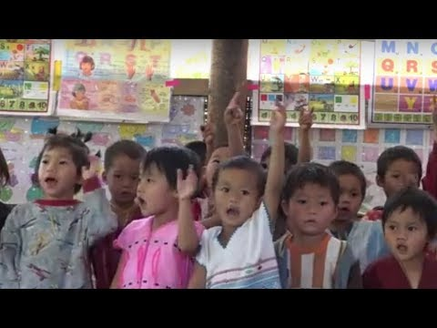
  - Watch the video. Revisit how a positive learning environment can impact students learning at school.

Look for examples shared in supporting children with disabilities and make notes on how they are made to feel included and part of the school community.

Look at the list in the left column in the table below and add ideas of your own or from the video on the potential benefits to students.
  - https://www.youtube.com/watch?v=EsgDZju8FO8

Environment | Benefits
Furniture layout | - Can allow children to see and hear more easily  - Can make the classroom easier to move around, particularly for students with physical impairments.
Organise & label resources
Display areas
Toilets

Note: In the video the environment is changed to benefit all learners. By rearranging the furniture, the classroom is more accessible for all learners rather than clearing one route for a child with a physical impairment to get to their desk.

Schools should ensure that their building is accessible and safe for all students. Is there a way of ensuring steps aren’t too high or a ramp is provided for students (or staff) with a physical impairment? The same applies for toilets, if the facilities do not offer sufficient privacy or amenities for menstruating girls or learners with disabilities, they will simply stop coming to school.
In module 1 you drew a plan of your classroom and thought about ways you could make it more inclusive. Take some time to revisit your notes and add any changes, having now completed 12 more modules on inclusive practice since then.
Examples of universal design for learning in the physical environment might include:
• Buildings are designed with ramps at the entrance – instead of designing a building only with steps and then having to install an extra ramp later;
• Preparing signs in visually accessible print, with Braille, and informative images or symbols – instead of signs that can only be accessed visually;
• Using non-slip and textured materials on surfaces to improve safety and navigation – instead of shiny surfaces or materials that can become slippery.

3.3 Lesson planning
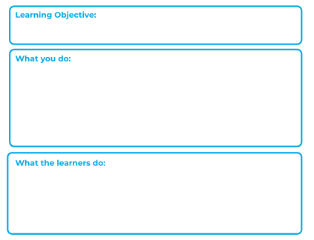
In module 3 we looked at planning inclusive learning outcomes for all and step by step learning. You will be able to use the content from that module here to think a bit more about how you prepare and plan for lessons. We know that students learn in different ways and at different speeds and the need to respond flexibly to meet these needs can be challenging.
There are many ways to plan a lesson. Use the checklist below to help you start thinking about a plan for the lesson you are teaching. You will find a template of a lesson plan with guidance in Appendix 1. This was also shared in Module 8.
Decide what the lesson going to be about (linked to the curriculum)
What do you want students to achieve by the end? What is the learning objective?
Think ahead about what you will teach and the activities you will ask students to do.
Are you prepared? What resources do you need to enable all students to achieve?
Are there opportunities for active engagement? (Look, listen, talk, touch, and move).
Do you need to differentiate learning, or offer a step by step learning approach?
Image source: https://commons.wikimedia.org/wiki/File:Template_-_Lesson_plan_for_remote_learning_using_the_Wikimedia_projects.svg (free)

Every learner has a different background, strengths, needs and interests, which means they have different preferred ways to gain knowledge, skills and motivation for learning. When we consider these factors, it helps to ensure that learning goals, methods, materials and assessments are accessible for everyone, to the greatest extent possible. Teachers who use diverse and flexible approaches are more likely to:
• motivate all learners to learn;
• present information that is accessible to all learners;
• enable learners to express what they are learning.

Activity 13.6 – Preparing lessons video (20 minutes)
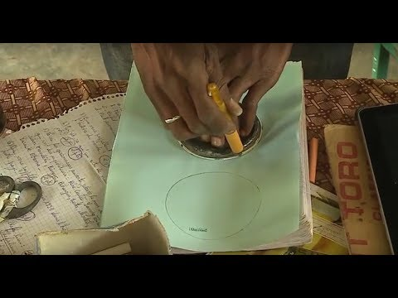
Watch the video and note down examples of what teachers do to prepare for their lessons, e.g. Having resources sorted and ready for students to use in the lesson.

What will you take away from the examples in this video? Write down something you would like to try with the students you teach.

https://www.youtube.com/watch?v=E27Nn_JT1ls

Activity 13.7 – UDL linked to previous modules (1 hour)
- Make poster or a power point to define UDL and present if you can about the benefits of using UDL in an inclusive classroom.
- Think about the how you will incorporate the 3 key principles of UDL in the lesson planning process.
- Link UDL to the following central themes that occur in Modules 1 to 6:
- The concepts of an inclusive school, inclusive classroom, and inclusive teacher (Module 1).
- Knowing your students and multisensory learning (Module 2).
- Learning outcomes and step-by-step Learning (Module 3).
- Learner-centred approaches and inclusive group work (Module 4).
- Creating positive learning environment (Module 5).
- Effective questioning and feedback (Module 6).

Discussion / reflection (20 minutes)
Universal design for Learning helps us to minimise barriers for learners by making all aspects of education provision, teaching and learning as accessible as possible.
Reasonable accommodation means taking immediate action using available resources and expertise to make adjustments and changes that meet individual learners’ needs regarding access, participation, and achievement.
- How much influence do you have as an educator in being able to address systemic changes and ensure individual students’ needs are met?
- What can you do?

- Support is provided when students experience difficulties
It is really important that we understand our role in supporting students with specific learning difficulties and students with disabilities and how to ensure the learning is accessible.
Support may be linked to students having a disability, or their learning needs may not have any link to disability. Some may need occasional support and others may have needs that require ongoing support. If students are having difficulties in class, they may need support or if they learn at a faster rate and grasp concepts quickly, they may also need support.

Remember that students with disabilities do not permanently need support. Many students with disabilities perform well academically and may not require any more support with their learning than their peers. Often students (particularly younger students) may need some initial or occasional support to help them get started or to work more independently. Some students may have more complex needs and require more frequent support, which could be physical, academic and/or emotional.
In module 2, we identified various reasons that students may need support, such as, poverty, abuse, trauma, behavioural and emotional difficulties. When teachers know their learners and understand those needs better, they are less likely to make assumptions about students and support is more effective and appropriate.

Teachers could discuss any concerns they have about the students they teach with other teachers, parents, or specialist staff (where they exist) and of course if it is appropriate with the student themselves. We will explore specific strategies in the next section.
In the previous module we categorized learning difficulties into the following areas and listed strategies that might be useful to support students with some of these difficulties.
• Cognitive and learning difficulties
• Sensory and physical
• Social and emotional
• Communication
4.1 Learning disabilities or learning difficulties linked to cognition
Students who have disabilities or difficulties linked to cognition may find it difficult to perceive and react, process and understand, store and retrieve information, make decisions and produce an appropriate response. These sorts of difficulties are often referred to as profound and multiple learning difficulties or specific learning difficulties.
Profound and multiple learning difficulties | Specific learning difficulties
A person has a severe disability that significantly affects their ability to communicate and be independent. They may have difficulties seeing, hearing, speaking or moving. | A person may experience dyslexia, dyscalculia and dyspraxia. Students could have one or more specific learning difficulties and have areas of strength and competencies with areas of need at the same time.

Activity 13.8 – Learning disabilities or learning difficulties linked to cognition (20 minutes)
Look at the text below and select the most appropriate word that fits into the strategies to support students who may experience cognition and learning difficulties. They can range from moderate or severe.
peers | fonts | verbalise | examples
multi-sensory | modifications | differentiated | instructions

- Modifications to break down texts or maths problems can be helpful when a student is experiencing difficulty when reading or solving maths problems.
- Students could be given opportunities to _________ and justify their answers rather than having to always write them down.
- Students might find it useful to work with their ______ and practice skills before being asked to do it independently.
- Teachers should ensure that the ______________ are always clear.
- Where possible use clear ________ and make adjustments to the size and colour of the text.
- Teachers should try to engage learners using _________________ learning strategies.
- Teachers could use models for spelling or provide a word bank for students or pictorial __________ in maths .
- Teachers can provide ____________ tasks for students to build on their existing level.

Activity 13.8 answers
- Modifications | - verbalise | - peers | - instructions
- fonts | - multi-sensory | - examples | - differentiated

Role play can be a great tool to engage students, particularly those who need more of a visual representation. For example, it can be useful when explaining subtraction in maths, if we roleplay students getting on and off a bus (chairs in a line). It can also be an effective strategy to support students with their writing to help them generate ideas or see different perspectives of characters in a text.
Read through the text in Appendix 2, outlining strategies to supporting students with their writing.
Image source: https://pixabay.com/vectors/drama-theatre-mask-theater-2301579/ (free)

4.2 Sensory and physical disabilities and difficulties
Students with sensory difficulties often need specific support with a particular impairment, such as a visual or hearing impairment. They do not necessarily have a learning difficulty but sometimes their impairment or condition can affect their ability to learn. Students with physical conditions such as cerebral palsy might require adaptations to a traditional classroom environment.
In the previous module we talked about dyspraxia in this section too, which is a motor skills difficulty affecting the coordination of muscles. Students with dyspraxia may require physical support in a range of subjects, depending on the severity of their condition.
Depending on your situation or where you are, you may be able to seek specialist advice or support about specific difficulties or disabilities. Specialists may support educators with suggestions that might improve students’ physical skills, for example if they are experiencing difficulties when writing. A speech and language specialist can help to address language skills and specific difficulties with speech. If you do not know how to find a specialist to ask for advice, you could look online for further information and any digital resources. There may also be charities that you can reach out to, to ask for information or support.

Activity 13.9 – Strategies for sensory and physical disabilities and difficulties (20 minutes)

Read the difficulties that some students face below and suggest suitable strategies to support them in class. You might decide that more than one may be appropriate and effective.
Write down your ideas in your learning journal

Strategies
- Provide a visual resource to support organisational skills.
- Consider if students need adaptations to the physical environment.
- Students may benefit from exercises to stretch their muscles regularly.
- Ask students where the best place is for them to sit in class.
- Plan opportunities to discuss the instructions and what to do first.
- Students may benefit from opportunities to work with others.
- Use a step by step approach to teaching.
- Students may need adaptations to resources.
- Teacher speaks to other colleagues about the needs of the students and discusses ways to best support them.
Win Aye has a known physical disability. She does not have use of her left arm which can cause difficulties in some lessons.

The teacher is concerned about Aung’s vision. He often squints and seems to misjudge the space around him.

Naing Myat finds general organisation difficult, getting started on tasks and knowing what to do.

Activity 13.9 answers
Suggested strategies;
Naing Myat: 1, 4, 5, 6, 7, 8, 9
Asking Naing Myat where he would find it best to sit may help him focus.
Win Aye: 2, 4, 6, 8, 9
It is likely that Win Aye will need specific support with some tasks.
Aung: 2, 4, 6, 8, 9
Aung may benefit from sitting closer to the front.

Note: If a student has a severe visual impairment, the educational setting will need to support the student by making changes and adaptations to the physical environment and the resources they use. Such adaptations could consist of tactile pathways – using a different type of paving under foot for the student to sense where there is a step or a crossing or a embossed line along a corridor to guide them around the school.

4.3 Communication and interaction
Difficulties with communication can often be identified at an early age and can relate to;
- Social communication
- Body language (facial expressions, gestures, eye contact, personal space)
- Speech/voice (tone, volume, production of speech & sounds, expression)
- Conversational skills (understanding how we initiate and close conversations, taking turns, asking and answering, topics and relevance, etc)
- Social conventions (politeness, manners, adapting language, cultural awareness and appropriateness).
- Interpersonal skills (making and maintaining friendships, negotiation, etc)
- Emotional intelligence (recognising and identifying emotions, manage them and express them appropriately)

Sometimes students who are academically advanced for their age (often described with a high IQ) can find social communication challenging. In this situation, a teacher might need to think about how they can support the student’s social and emotional communication with their peers by using more collaborative approaches to learning. Students with a diagnosis of Autistic Spectrum Disorder (which can include Asperger’s Syndrome) can find many of the factors above difficult, although it is important to remember that students who find communication challenging may not have learning difficulties.
Autism | Autism is a lifelong developmental disability which affects how people communicate and interact with the world. People with autism find that their brain works in a different way.  One in 100 people are on the autism spectrum. The spectrum means that everybody with autism is different. Some people need little or no support. Others may need help every day. The National Autistic Society (2022)

Students with autism may have some differences in social communication. The aim of teaching social skills is not to make somebody less autistic but to give them social knowledge which will enable them to interact with more confidence. Differences are likely to be different for each individual. Think about the list below and consider if they would have an impact on teaching and learning.
- Students may find eye contact uncomfortable
- differences in facial expression, gestures, needing more or less personal space
- a feeling of sensory overwhelm which can increase anxiety and affect how they communicate
- difficulties in eliminating background noise
- differences in using tone of voice and intonation
- having a literal understanding and use of language - being direct which can appear rude
- finding the dynamics of group conversation difficult
- difficulties in identifying and talking about their own feelings
- lacking in confidence and self-esteem which can affect communication

Activity 13.10 - Strategies for communication difficulties (20 minutes)
By now you will have begun to consider lots of different strategies to support students with specific needs. Use the information you’ve learnt to match the answers to the questions to develop your thinking further. Either draw a line or copy the table at the bottom into your learning journal. One example is given.
Communicate clearly and try to break the learning down in to small manageable steps for the student to follow. Provide opportunities to practice and build on existing knowledge.
How can you support students to communicate and interact with others?

A1
Q1

Establish routines and transitions. Give students time to adjust and talk through changes in schedules or events happening so they know what to expect and what might be different.

A student finds it hard to understand how others think or feel. How can you support them?
A2
Q2

Work closely with students’ parents/carers to understand the students behaviour and discuss the most effective ways to support. Help other students to understand the behaviour of others and how it helps them to learn in a calm way.

What can you do if a student reacts to bright lights or loud noises?
Q3
A3

How can you support students who get anxious or upset about unfamiliar situations and events?
Q4
Try to integrate students interests into learning. Provide them tools or a visual prompt to aid their discussion. Working in 3s rather than pairs can take the pressure off students. Don’t expect eye contact if it is uncomfortable.

A4
What can you put in place for a student who may take longer to understand information?

Consider if the learning environment is calm or if it is too busy/over whelming. Keep classroom noise at an appropriate level and think about lighting. Use a calm voice with a neutral tone. Some students may need time and space to recover from social interaction.

Q5

A5
You have noticed a student likes to repeat certain behaviours. His peers have started to make comments. What should you do?

Q6
Speak about the feelings of others and talk about all feelings being acceptable and valid. Social stories can help – When you do throw things it makes me sad and sometimes scared.
A6

Answers
Q1 | Q2 | Q3 | Q4 | Q5 | Q6
 |  |  |  | A1

Using the information and answers above, answer the question below in your learning journal. Discuss your answers with a colleague if you can.
How can I support students who face difficulties when communicating?

Answers to Activity 13.10 - Strategies for communication difficulties

Q1 | Q2 | Q3 | Q4 | Q5 | Q6
A4 | A6 | A5 | A2 | A1 | A3

4.4 Social and Emotional difficulties
Social and emotional difficulty such as anxiety, depression or attachment needs can affect students for a range of reasons. These were explored in detail in Module 9.
Some students have conditions such as Attention deficit disorder (ADD) and attention deficit hyperactive disorder (ADHD) which can affect how them social and emotionally. It is often seen in moderate to challenging behaviour. In this section we will look at mild to moderate social and emotional difficulties and explore behaviour later in the module.
Students with social and emotional difficulties may;
- have difficulties maintaining focus
- have poor impulse control and be fidgety (ADHD)
- have difficulty presenting work in an orderly way (such as neat handwriting)
- have high energy and excitement (ADHD)
- find organising themselves difficult
- appear lazy or tired (ADD)

Both ADD and ADHD are often characterized by difficulties maintaining focus over extended time periods. It is important that we consider how long we are expecting students to stay focussed for and the effect this will have on their ability to learn effectively. This will vary depending on the age of students but even as adults, we can recognise dips in focus when we are expected to concentrate for long periods of time.

Activity 13.11 - Strategies for social and emotional difficulties (20 minutes)
Read through the list of strategies below to support students with social and emotional difficulties. They should provide a useful reminder to Module 9, where we focused specifically on the support you can give students with their social and emotional wellbeing.
Use the list to tick strategies you have tried in the past. The effectiveness and appropriateness of each strategy will depend on the student, how well you know them and your relationship.

Strategy | Have you tried it?
Clear instructions and routines so students understand what is expected.
Use students’ names before giving an instruction to help them tune in.
Use multi-sensory learning strategies to engage students.
Keep learning environments calm and be patient.
Allow time for students to check in/talk about their day.
Use stories to teach about lessons, actions and consequences.
Teach students how to work together and provide opportunities for collaboration.
Break the learning down into small steps.
Providing students opportunities to talk and discuss their learning.
Model self-help strategies to deal with feelings of overwhelm such as mindfulness.
Develop a sense of community, appreciation, and kindness in class.
Discuss emotions and build social/emotional vocabulary.
Teach about friendship and how to support others.
Use roleplay or teach students how to negotiate and mediate.
Provide ‘brain breaks’ – opportunities to change the way students are learning, move around, etc.
Talk about how we feel when we make mistakes and celebrate them as part of the learning process. Praising effort over results will value the effort put it in.
Speak to students about how they feel or if there is an issue, listen to it rather than assume what has happened.
Have visuals in the classroom that gives students tips on what respectful behaviour looks and sounds like.

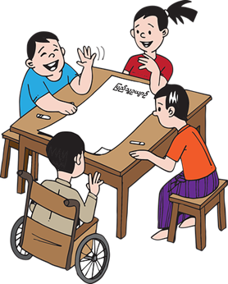
4.5 Learners with multiple impairments or difficulties
Whether students have one or a combination of multiple impairments, or a combination of impairments and other factors, they will all have unique needs. To be fully included, we must find out as much as we can about any difficulties or impairments to find out what the greatest barriers to learning are. For example, if a student has a visual and physical impairment, it is likely that the biggest barrier for them in the classroom maybe their visual impairment and accessing the learning materials.
It is important that we don’t assume what a student’s experience is like, this can be overcome by speaking with the student and perhaps their parents or caregivers.
Think about what you do as an educator and how you can ensure students are actively involved in lessons. If we are modelling writing on the board, consider the colour of the pen we use, the size of the writing and how clear it is to read. Often, students with visual impairments will rely on the shape of the words when they are reading, so it is important to not write using block capitals when writing in English. Look at the examples below and discuss them with a colleague.
LEARN
learn
learn
The use of a small white or black board, or even a sheet of paper may be a huge support to a student who has difficulties to communicate.

Knowing your students well, means that you can plan to their strengths. Every student with multiple impairments or difficulties will have their own set of skills, strengths, and learning needs, along with every other student in the class. Learning more about each impairment or difficulty will help you understand how much your students CAN do and how to address their learning needs as part of everyday practice.
It is quite possible that you will need to make certain modifications within the classroom. Think about how all children can benefit so the student doesn’t feel singled out. For example, there may be other students who would benefit in writing down ideas to communicate more effectively. Encourage all student’s to be independent. We are supporting them to be confident learners and develop critical life skills. We looked at these in Module 4 (Creativity, Communication, Collaboration and Critical thinking). It is natural to want to help students who face difficulties, especially when you know there’s a disability involved. Support students appropriately with their learning whilst developing their independent skills.
  - Behaviour
Students’ behaviour can be affected by having difficulties and disabilities, especially when there is a combination as discussed in the previous section. of disabilities.
It is quite common that when students are faced with difficulties, it has an impact on how they feel and their behaviour. We explore this in more detail in the next module (14) looking at potential causes of undesirable behaviour and provide strategies and ideas to support students. Some students with disability may sometimes present challenging behaviour. This could be related to frustration, low self-confidence, and increased levels of anxiety. Some common types of behaviour are shown in the table below. Look at the basic overview of behaviour types below and read some suggested strategies to support children with mild disabilities or impairments. The behaviours listed below should not be seen as a diagnosis of disability. As stated in the previous module, all students will have different experiences.

Type of disability | Common types of behaviour | Strategies
Physical impairment | Some children with physical disabilities may show behaviours such as inattention, not following instructions, disorganization and show general displays of feeling overwhelmed by emotion. | For most children with a physical disability, consider access to the classroom and the layout of the class to ensure they can fully participate in learning activities.
Visual impairment(seeing) | Squinting of eyes, head turning, rocking, swaying. Limited participation in class activities. | For most children with a mild visual impairment, encourage students to sit close to the blackboard, increase the font size for learning materials and try to minimize noise and disturbances in the classroom as the child will rely heavily on verbal instructions and information.
Auditory impairment (hearing) | Children may become socially isolated, experience difficulty in communicating with others, have low self-esteem and confidence. Not attentive or able to participate in class. | For most children with a mild hearing impairment, encourage them to sit at the front of the class and minimize background noise as much as possible. Be mindful to speak clearly if students are lip reading.
Cognitive or language impairment | High levels of anxiety and stress, mood swings, aggression, poor organisation. Cognitive learning difficulties may be specific so students may behave differently when presented with a reading task if for example they have dyslexia. | For most children with mild cognitive difficulties, minimize noise and disturbances in the classroom, establish clear routines and provide clear, concrete instructions.
- Building self -confidence and self-esteem

Focusing on students’ strengths and developing their independence will give them confidence in their abilities. Educators can support students in recognizing their strengths by providing praise and discussing what they are good at or areas where they are improving. This will have a positive impact on learning, both in and outside of school.
Strengths
Poor performance issues can often be attributed to learning styles and lessons that are not appropriate for students, rather than to a failure to try hard enough or a lack of ability. By recognizing differences in students, we can help to build their self-esteem and provide opportunities for them to build up their self-confidence. Whilst it is important to have high expectations of all students we teach, if we continuously ask students to do things in class that they are not capable of it is unfair and not inclusive. Think carefully about your expectations and what you are asking of all your students. Is it appropriate?
Expectations
Some students will need more time and repetition of material or learning to achieve the same results as their peers. Typically, students with dyslexia, benefit from “over-learning” new material so try and be flexible in the way you teach, giving some students opportunities to revisit learning before moving on too quickly or break complex tasks into smaller and more manageable steps.
Flexible
Provide genuine praise and encouragement for effort over performance by using specific language. Teachers might praise a student’s strategy or approach to a task rather than how many answers they got correct. We explored this in Module 6. Try to avoid making negative comments. Receiving praise will help students to start thinking about themselves and their abilities in a positive way. When praise is exaggerated or doesn’t feel genuine to a student, it can feel like the person is just saying it to make them feel good and can damage to a student’s self-esteem.
Praise
The more students enjoy success in academic tasks, the more confident they will become.
Images sources: https://freesvg.org/dumbbell-weight http://clipart-library.com/clipart/stretching-cliparts_19.htm https://www.pinclipart.com/maxpin/JhbT/ (free)
5.1 Representation and role models.
It is important that all students feel that they are represented. In previous modules we have talked about ensuring that learning materials are inclusive or whether they fall on typical stereo types in the examples or pictures that are shown in textbooks for example.
Look at the image used here and think about how the students and adults are shown.
Reflect: Do you think your students would feel represented in this image if you used it in your teaching?

Activity 13.12 – Role models (30 minutes)
Spend some time researching famous figures that students might have heard of or people they can relate to. These might include athletes, historical figures or singers, who may have worked hard to overcome challenges posed by learning difficulties. This can be a motivator to find out that people you admire, may have also faced similar difficulties as they grew up.
Daniel Radcliffe the actor who plays Harry Potter has a form of dyspraxia. As a child he said, he struggled with handwriting and tying his shoelaces.
- How might you use this information?
- How do you think students would respond to the examples?
Image source: https://simpsonswiki.com/wiki/Daniel_Radcliffe (free)

Note: Be careful when using the term ‘inspirational’. It is often a word used in stories written about people with learning difficulties that some people find offensive. Of course, there are many inspirational stories about people learning difficulties, but often if they are going about their everyday life, making adaptations to the way they live, they do not want to be referred to as inspirational.
Sharing the experiences of others or your own with students can help them relate to different aspects of the learning process. It might be helpful to explain how you (or others) dealt with your least favourite subjects or how you handled challenging work. Sharing your experiences also helps to build a relationship with your students, making it easier for them to talk to you about their own challenges and the support they might need.

- Early support
Early identification of a students’ disability or difficulty means they are more likely to receive the support they need from an early age. It also helps them to start their time in educational settings with good self-esteem and belief in what they can do. Inclusive education opportunities enable students to value and accept diversity and difference among their peers and if this can be started in early years provision, it can only have positive impact on students as they grow.

If students are starting in a new school, it might be helpful to try and contact the staff or teacher of the place they have been to previously.

For example, when a student moves onto a secondary school, you might be able to learn about effective systems and approaches that have worked for that student and replicate or scale them up in the new school or higher grades.

Activity 13.12 Action planning (45 minutes)
Start to think about your own action plan to improve practice for students with disabilities or difficulties. A few ideas have been listed below to help you get started.
Copy the table into your learning journal and reflect on;
- Where you want to get to – Goal
- Where you are currently – what does it look like now?
- Steps you can take to get to the goal – How can I get there?

You might decide not use the examples provided. Choose your own goals based on the learning you have taken from this and previous modules.
Goal | What does it look like now? | How can I get there?
Create a culture of listening to students; making them feel welcome and included. |  | - Orientate staff on inclusion & create networks for  teachers to share experiences, ideas & resources.  - Teachers plan time for students to talk in class &  work together.  -Teachers talk to students (& parents if  appropriate) about what support they need.
Support students with low/ no-cost reasonable accommodations or adaptations to the environment. |  | -Think about the layout of classrooms, learning  spaces and entrances.  - Check that all students can access the resources  you are using in lessons.  - Plan for long-term improvements using universal  design learning principles  - Explore the idea of classroom assistant volunteers  if class sizes are large and a student needs  specific support.

- Possible ideas for action research projects
In module 6, you were introduced to the idea of carrying out small-scale action research projects.
The diagram below shows the action research cycle.

1) decide on the question,
2) plan how to answer it,
3) carry out the research – observe, question, etc.
4) review the data
5) plan if/how to improve.

The cycle then continues until you are confident with the changes you have made.
Action Research
Cycle
- Question
5. New plan

4. Review
2. Plan

3. Do

Suggestions:
- Investigate how you and your colleagues identify and use strategies available in supporting specific learning difficulties because of disabilities or others (e.g., SEN, Disabilities, high IQ), identified differences or difficulties in learning.
- Investigate your colleagues responses to the benefits of UDL in lesson planning and lesson delivery (how useful is UDL to them as an inclusive education tutor or lecturer?)

- Wrap up

In this module you have:
- Demonstrated an understanding of various difficulties and disabilities.
- Identified and described the 3 key principles of UDL.
- Incorporated the key principles of UDL in lesson planning.
- Described and discussed effective strategies in supporting, identified differences or difficulties in learning.

Key points from this module:
- The difference between inclusive education and integration, where learners with disabilities might be in school, but not necessarily receive the support they need to access the learning.
- To ensure educators are meeting the needs of students with disabilities or difficulties, they may need to alter the;
- Physical environment
- Method of teaching or the materials used
- Process of the task or how it is presented
- level of support given
- Reasonable accommodation means acting immediately, with whatever resources and expertise are available in the school community, to make the best adjustments for students to be present, participate and achieve in school.
- Students with disabilities and difficulties do not permanently need support. Educators should think about how they can also support the development of independent skills as well as academic skills.
- Many strategies are effective with all students – such as ensuring instructions are clear and routines are established so students understand what is expected.
- The importance of developing confidence and self-esteem in students and the impact this has on academic achievement.

Reflection
To help you remember and think about the topics introduced in this module, try to answer the following questions. Use your learning journal to make a note of your reflections.
- What is a universal design for learning (UDL)?
- How do you demonstrate your understanding of UDL? Demonstrate understanding of Universal Design for Learning (UDL).
- What can your school or setting do to support students with difficulties or disabilities?
Think about your lessons:
- How can you incorporate the 3 key principles of UDL in your lesson planning?
- How beneficial is the UDL to you in your lesson planning?
- State and discuss strategies available in supporting, identified differences or difficulties in learning
Think about the steps in instructional adaptation for an inclusive classroom.

- End of module 13 quiz
Please answer the following questions in your learning journal. You can attempt as many times as you like to reach 100% pass. Some questions require more than one answer.
Q1 – Select the 3 key principles for Universal Design for Learning; (Choose 1 answer)
- 1. Engagement & motivation, 2. Representation, 3. Action & expression
- 1. Presence, 2. Participation, 3. Achievement
- 1. Effective questioning, 2. Step by step learning, 3. Cooperation

Q2 – Allowing students to make choices, finding out about their strengths and interests and making lessons fun are part of which UDL principle? (Choose 1 answer)
- Engagement & motivation
- Representation
- Action & expression
Q3 - Reasonable accommodation means; (Choose 1 answer)
- waiting until you have all the resources and adjustments in place before students can attend.
- acting immediately, with whatever resources and expertise are available in the school.
- Putting a plan in place and discussing what you will do to meet the needs of students.

Q4 - Teachers should try to engage learners using _________________ learning strategies. (Choose 1 answer)
- traditional
- the same
- multi-sensory

Q5 – Difficulties or differences in body language, including facial expressions, gestures, eye contact and personal space are related to which learning difficulty? (Choose 1 answer)
- Cognitive and learning difficulties
- Sensory and physical
- Social and emotional
- Communication

Q6 – Students with disabilities or difficulties may need: (Choose 2 answers)
- Constant support
- Occasional support
- Ongoing support

Answers – end of module 13 quiz
Answers in bold

Q1 – Select the 3 key principles for Universal Design for Learning; (Choose 1 answer)
- Engagement & motivation, 2. Representation, 3. Action & expression
- 1. Presence, 2. Participation, 3. Achievement
- 1. Effective questioning, 2. Step by step learning, 3. Cooperation

Q2 – Allowing students to make choices, finding out about their strengths and interests and making lessons fun are part of which UDL principle? (Choose 1 answer)
- Engagement & motivation
- Representation
- Action & expression

Q3 - Reasonable accommodation means; (Choose 1 answer)
- waiting until you have all the resources and adjustments in place before students can attend.
- acting immediately, with whatever resources and expertise are available in the school.
- Putting a plan in place and discussing what you will do to meet the needs of students.

Q4 - Teachers should try to engage learners using _________________ learning strategies. (Choose 1 answer)
- traditional
- the same
- multi-sensory

Q5 – Difficulties or differences in body language, including facial expressions, gestures, eye contact and personal space are related to which learning difficulty? (Choose 1 answer)
- Cognitive and learning difficulties
- Sensory and physical
- Social and emotional
- Communication

Q6 – Students with disabilities or difficulties may need: (Choose 2 answers)
- Constant support
- Occasional support
- Ongoing support

- Improving teaching and learning

Activity 13.13 Improving your own teaching practice. (30 minutes)

It is important to reflect on the answers to the activities you have completed earlier.

Scenario – Your Head of Department asks to meet you to ask about how you adapt learning to meet the needs of the students you teach. They ask you to complete the following statement.
Make notes in your learning journal:
- I plan to support students with specific differences and disabilities in my class by doing the following 3 things…
LJ
  - …
  - …
  - …

Activity 13.14 Self-assessment

REFLECTION: How well do you think you are equipped to support students with learning difficulties? Look at the scale below and choose the number that best describes you now. Answer in your learning journal.
VERY well
NOT well

Compare your first self-assessment score at the beginning of this module to this one. In your learning journal provide a short analysis of your thoughts about any differences.

Your 13th PROMISE to your STUDENTS

1
3
2

Review

Do

Plan

Please add your 13th promise to the section in your learning journal entitled ‘Promises.’
Each module contains one promise you will make to your learners: you will make 15 promises in total.

References

CBM (Christian Blind Mission) Inclusive Education Training Guide (2021)
www.cbm.org

Child counseling & Special needs education (2020) Difference between learning disability and learning difficulty.
YouTube https://www.youtube.com/watch?v=I-xA9B_U1JU

EENET - Enabling Education Network (2017) Programme 4 ~ Preparing lessons
https://www.youtube.com/watch?v=E27Nn_JT1ls

EENET - Enabling Education Network (2017) Programme 5 ~ Improving the learning environment
https://www.youtube.com/watch?v=EsgDZju8FO8

Foundation for People with Learning Disabilities (2021)
https://www.learningdisabilities.org.uk/

Muhammad, M. 35 Strategies To Support Weak Writers
https://www.scribd.com/document/237271764/35-Strategies-to-Support-Weak-Writers

NRC CILT (2018) Universal Design for Learning
https://www.youtube.com/watch?v=Ih0QVKjYvG4

The National Autistic Society (2022)
https://www.autism.org.uk/advice-and-guidance/what-is-autism

UN Convention on the Rights of Person with Disabilities (2011) Article 2 https://www.un.org/development/desa/disabilities/convention-on-the-rights-of-persons-with-disabilities/article-24-education.html

Appendix 1

Lesson Plan template

Class/Grade: | Topic: | Duration of lesson:
Prior learning: What do students already know? Can you make any links to their current knowledge and understanding to build on?

Learning objective: Decide what the lesson going to be about (linked to the curriculum)

Materials/resources needed:
Are you prepared? What resources do you need to enable all students to achieve?

Outline of activity: (What will the students do & How will I enable them to be able to achieve?)
What do you want students to achieve by the end? What is the learning objective?
Think ahead about what you will teach and the activities you will ask students to do.

Are there opportunities for active engagement? (Look, listen, talk, touch, and move).
Do you need to differentiate learning, or offer a step by step learning approach?

Assessment: (How will I know/the students know if they have been successful?)

Appendix 2

Strategies for Supporting Students with their Writing

1. Oral rehearsal - Provide warm-up opportunities. Talking before writing helps weaker writers to have something to say – often they can compose a sentence in their head but not on paper. Key words are more likely to be taken into pupils’ long-term vocabulary if spoken.

2. Drama - Role play can help weak writers to generate ideas, especially when asked to write from another person’s point of view. Debate can be used to generate for and against arguments. Key words and sentence starters can be given for oral activities.

3. Visual stimuli - Visual stimuli can help to prompt pupils who struggle to generate vocabulary and ideas. Images can be printed on writing frames, postcards, OHTs etc. Key words are more effective when displayed with icons.

4. Props - Objects can stimulate ideas and writing e.g. WW1 memorabilia. ‘Story-sacks’ (bags of items revealed one by one) might be used in English, History, Drama.

5. Exemplar pieces - Ensure pupils have an idea about what the written outcome should resemble – show examples of that type of writing. Shared reading of an OHP often found to be more effective than copies in front of pupils. Time needs to be built into lessons for this.

6. Sequencing activities - These encourage pupils to do the thinking and help weaker writers to organise their ideas. Strips containing words, phrases or whole sentences are ordered by pupils. These can either be expanded into a full answer or stuck down as an alternative to handwriting.

7. Key words - Developing a useful subject vocabulary that aids learning is more of a priority than spelling for weak writers. Lesson starters are a good place to play key words definition games and activate pupils’ prior learning. Constant recap is vital to extending vocabulary.

8. Drawing - Some weak writers have been found to perform better if they draw illustrations or cartoons alongside their work.

9. Rereading - Weak writers rarely read back over what they have written. Encourage students to read work aloud to check for missing words, wrong words, etc.

10. Praise - Weaker writers do respond to praise but are hard to motivate. Opportunities for success in writing activities in order help to develop a ‘can do’ mentality. Try to make writing tasks progressively demanding so that pupils can build up skills.

Adapted from: https://www.scribd.com/document/237271764/35-Strategies-to-Support-Weak-Writers

