Leadership for Effective Learning
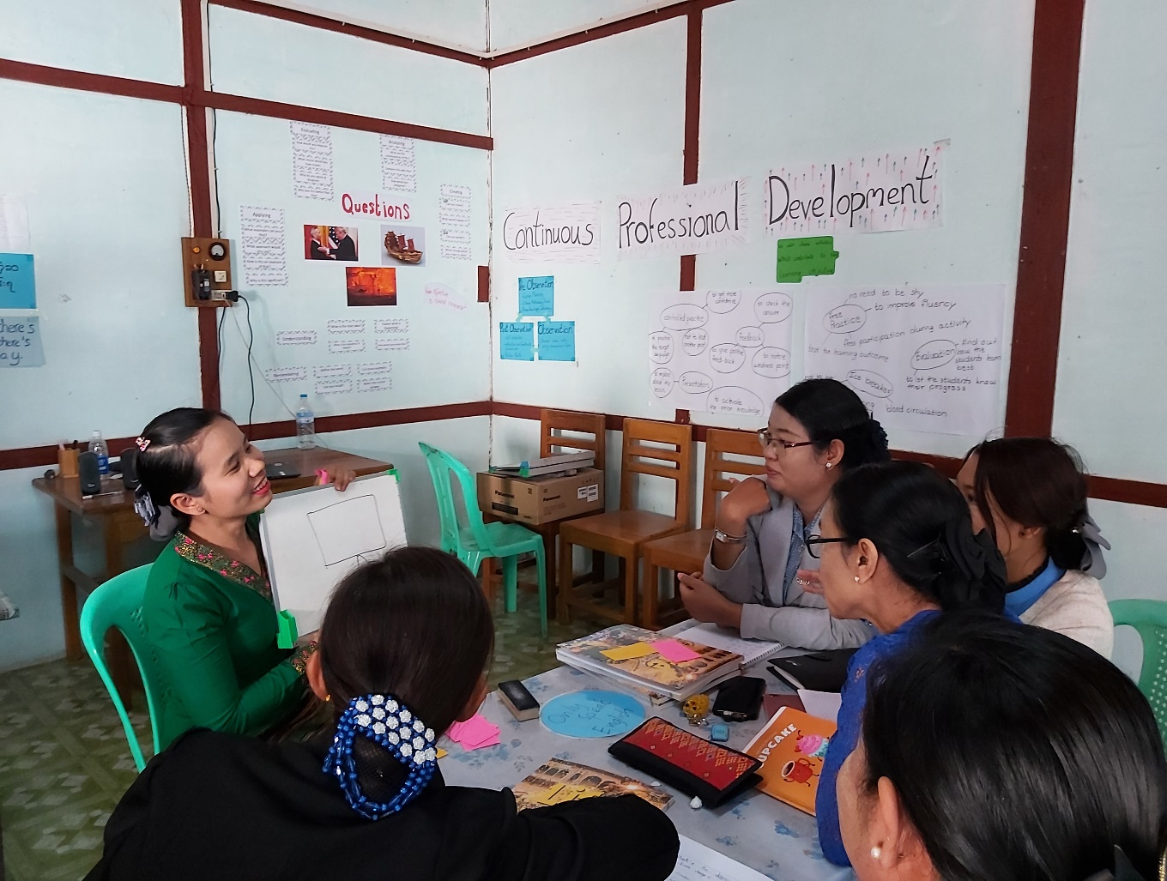
Unit 1: What is effective learning?
Participants’ Book

Overview

This module considers what effective learning looks like in the context of educational institutions and organisations in Myanmar and how leadership teams of these institutions and organisations can influence attitudes and approaches to effective learning.
The course will consider questions such as:
- Who are our learners?
- What is effective learning?
- Who is responsible for effective learning?
- What leadership approaches and strategies can leaders employ to enable and ensure effective learning in their contexts?
- What skills do leaders require in order to enable and ensure effective learning and how can these be developed?

This is the first of five units:
- What is Effective Learning?
- The Learner and Classroom Environment
- Leadership for Effective Learning
- Strategies for Leading for Effective Learning
- Skills for Leading for Effective Learning

Contents

Overview 2
Contents 3
Outcomes 4
1.1 What does effective learning look like? 5
1.2 The role of leadership in effective learning 6
1.3 What other factors influence effective learning? 7
1.4 Principles of effective learning 9
1.5 Our principles 11
1.6 Reflect and apply 12
Appendix 1: What makes great pedagogy? 13
Further reading and references 14

Outcomes

By the end of this unit, participants will be able to:

- reflect on and share ideas about what effective learning looks like
- describe the role of leadership in facilitating effective learning in educational institutions
- describe what factors have the greatest impact on effective learning in educational institutions
- agree on principles of effective learning in educational institutions.

1.1 What does effective learning look like?

1.1 Discuss: What does effective learning mean to you?
1.1 Task: Look at the six pictures below. For each picture, answer these questions:
- Who are the learners?
- Where are they?
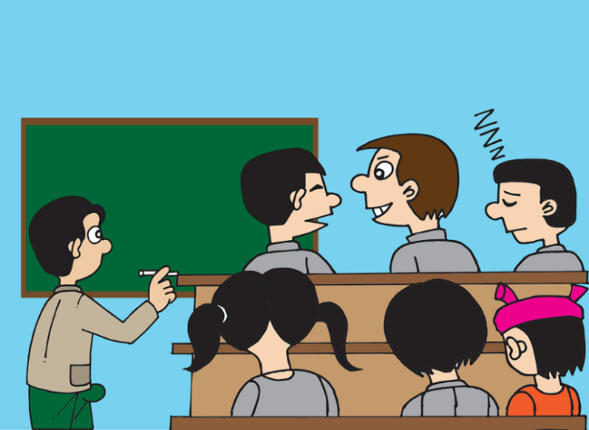
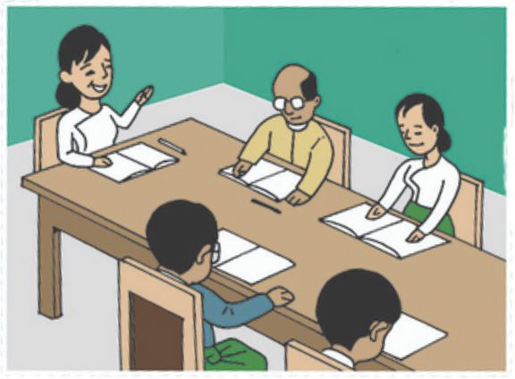
- Is this effective learning? Why/why not?
a
b

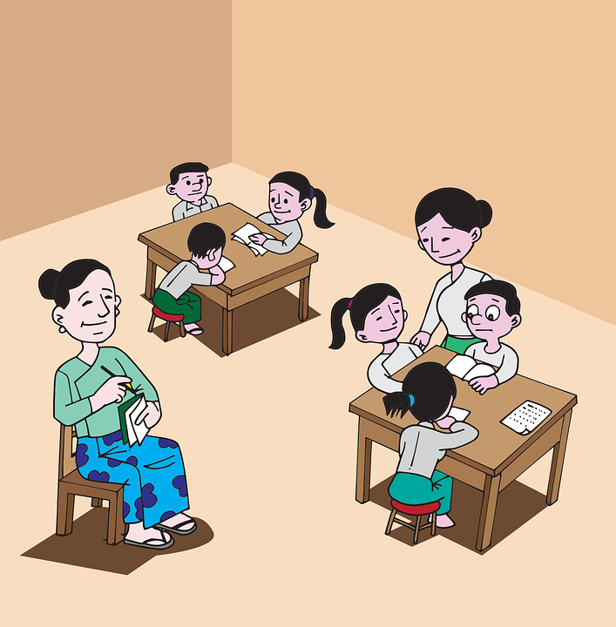
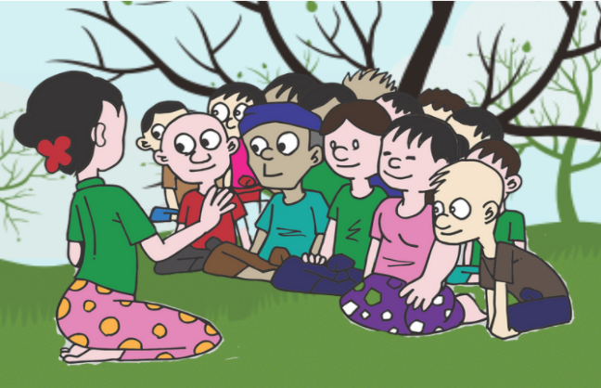
d
c

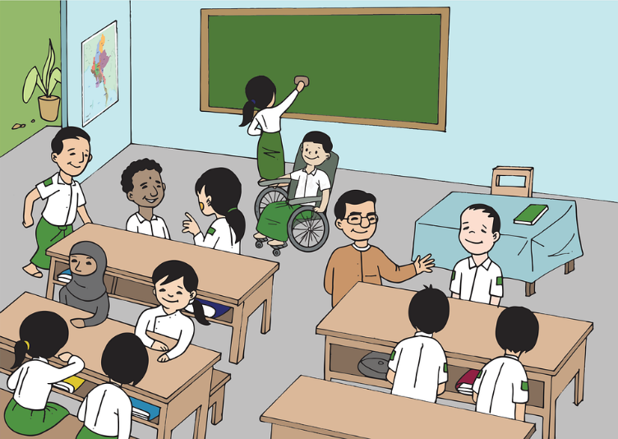
f
e

1.2 The role of leadership in effective learning

1.2 Discuss: What is your role in supporting effective learning in your context?
1.2 Task: Read the following quotes and underline the key words. Check the meaning of new words with your partner or facilitator.
Do you agree (✓) or disagree (✗) with the quotes. Why / why not?

Student achievement in a school almost never exceeds the quality of its leadership and management and improvements in performance almost never occur in the absence of good leadership.
F. Wheelan, 2009

The impact of teachers and leaders on student outcomes: 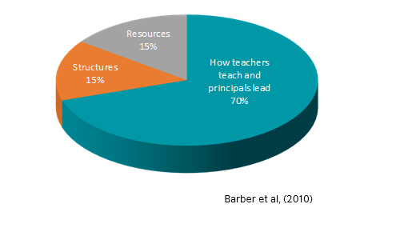
School leadership is second only to classroom teaching as an influence on student learning.
K. Leithwood, et al, 2008

Successful school leaders improve teaching and learning and thus pupil outcomes… most powerfully through their influence on staff motivation, commitment, teaching practices and through developing teachers’ capacities for leadership.
C. Day, et al, 2010

1.3 What other factors influence effective learning?

1.3 Discuss: factors influencing effective learning
The three quotes above all suggest that effective leadership and classroom teaching both have a significant role to play in influencing effective learning.
Answer this question:
- What other factors influence effective learning?
Compare your ideas with a colleague or colleagues.

1.3 Task: which factors are most important?
Step 1
Here are some suggested factors that influence effective learning. Read the factors:
  - the learners
  - the teachers
  - the classroom
  - the institution or organisation
  - learning outcomes
  - the curriculum
  - assessment
  - relationships
  - education policy
  - leadership

Step 2
In groups, arrange the ten factors in order, using the pyramid on the next page.

Put the factors you think have the most impact at the top of the pyramid, and those with the least impact at the bottom of the pyramid.

Share the reasons for the choices you have made with a colleague or colleagues.

Step 3
Answer these questions:
- Is there anything not included in the list that you think has an important impact on effective learning?

- As a leader, how much influence do you have over the ten factors listed above?

1.4 Principles of effective learning

1.4 Discuss: what is a principle?

Step 1

Answer these questions;

- What is a principle? Can you give any examples?

- Why are principles important?

Step 2

Read the text below.

Answer these questions:

- Are the ideas the same as your answers?

- Are there any ideas which are new for you?

- Do you agree with these ideas?

Why are principles important?

Principles are statements that people believe in and live by.

They guide and inform our actions to make sure we are working towards our shared goal.

1.4 Task: principles of effective learning

Here are some principles of effective learning based on classroom research.

Read them and discuss the questions below.

Principles of Effective Learning
- Learning is not necessarily an outcome of teaching.
- What students learn is influenced by their existing ideas and knowledge.
- Progression from learning is usually from the concrete to the abstract.
- Learning experiences should be constructed (scaffolded) to aid understanding of complex concepts.
- Effective learning requires both verbal and written feedback.
- Expectations – teachers’ and students’ – affect performance.
- Mindset plays a key role in learning.

1 Do you agree or disagree with these principles? Why?
2 Which of these principles do you think are the most challenging to follow for leaders in the context you work in? Why?
3 Does your institution or organisation have a set of formal principles for effective learning?
If so, share them with a colleague or colleagues.

Further reading
You can find more ideas about teaching and learning in the article ‘What makes great pedagogy?’ in Appendix 1 to this unit.

1.5 Our principles

1.5 Discuss: a request from the community
A group of parents of learners in the context you work in have selected a representative to talk to your institution and to you as leaders.
Here is their request:
We would like to request leaders of your institution to write some principles of effective learning.

These can be shared with parents through letters and by displaying them on classroom walls.
How would you respond to this request?
1.5 Task: writing your principles
- Work with a colleague or colleagues.

- Think about the institution you lead.

- Think about the people, the culture, the strengths, the needs, and your vision for the future.

- What are the essential principles for effective learning needed to achieve this?

- Make a list of five principles you think are important.
.
Notes

1.6 Reflect and apply

Task: Look back at what was covered in this session. Write notes about each of the following topics from this session to help you remember the main points.

If you have any question, ask your facilitator or other participants.
Why are principles important?
Who are your learners?

What impacts effective learning?

Follow-up
Interview a teacher or trainer in the context you work in to find out their ideas about the following topics:
- What does effective learning look like in your classroom?
- What is an ‘effective learner’?
- What is the role of leaders in ensuring effective learning in your context?

Appendix 1: What makes great pedagogy?

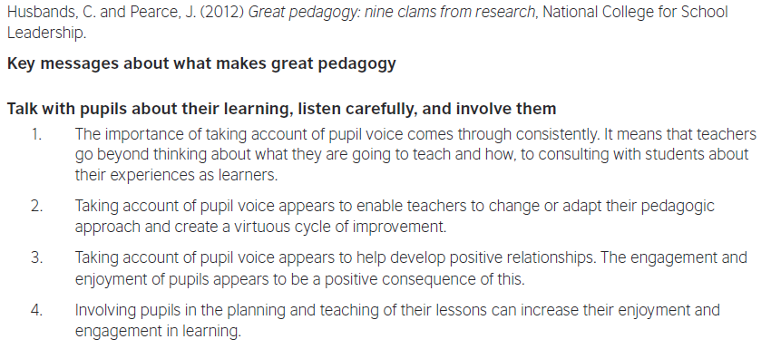
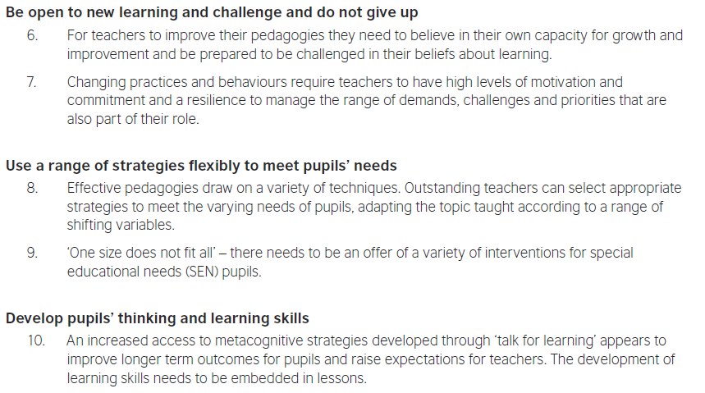
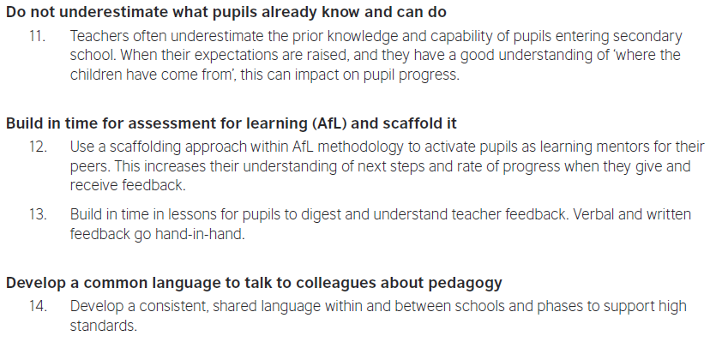

Further reading and references

Barber, M. et al. (2010) Capturing the Leadership Premium. National College for School Leadership
British Council, Connecting Classrooms Leading Effective Teaching and Learning
Day, C. et al. (2010) Ten Strong Claims about Successful School Leadership. National College for School Leadership
Dweck, C. (2006) Mindset: the New Psychology of Success. New York: Random House
Hattie, J. (2010) Visible Learning for Teachers. London: Routledge
Husband, C. and Pearce, J. (2012) Great Pedagogy; Nine Claims from Research. National College for School Leadership
Leithwood, K et. al. (2008) Investigating the Links to Student Learning. University of Minnesota

British Council Connecting Classrooms: Leading effective teaching and learning

