Leadership for Effective Learning
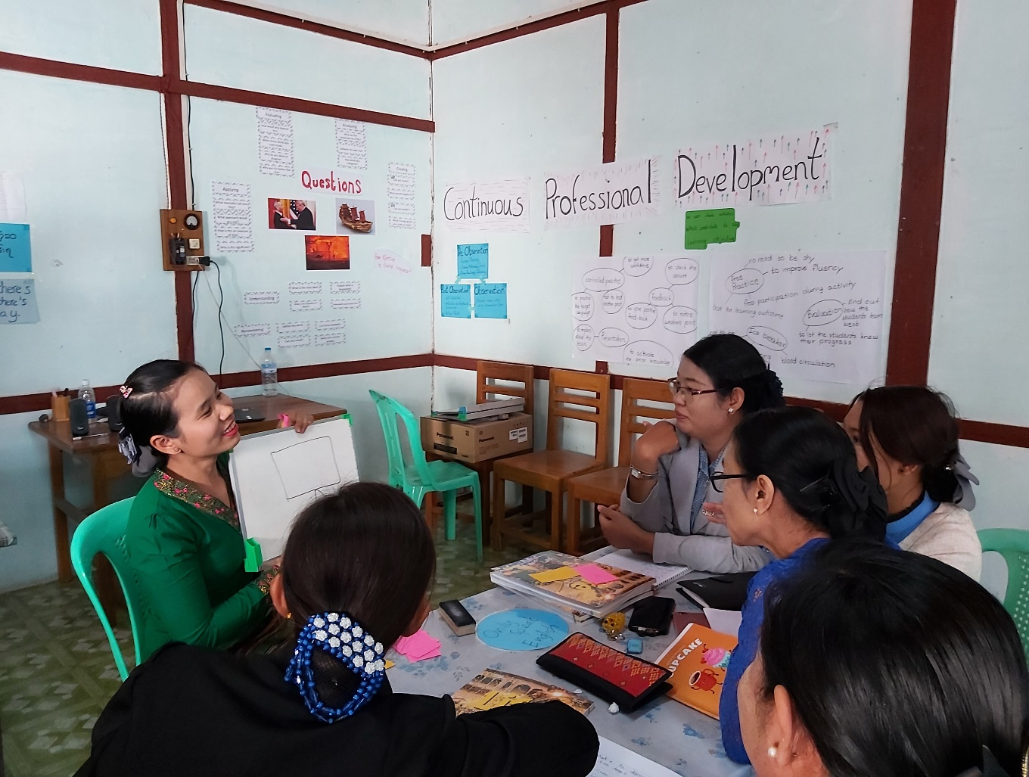
Unit 3: Leadership for Effective Learning
Participants’ Book

Overview
This module considers what effective learning looks like in the context of educational institutions and organisations in Myanmar and how leadership teams of these institutions and organisations can influence attitudes and approaches to effective learning.
The course will consider questions such as:
- Who are our learners?
- What is effective learning?
- Who is responsible for effective learning?
- What leadership approaches and strategies can leaders employ to enable and ensure effective learning in their contexts?
- What skills do leaders require in order to enable and ensure effective learning and how can these be developed?

This is the third of five units:
- What is Effective Learning?
- The Learner and Classroom Environment
- Leadership for Effective Learning
- Strategies for Leading for Effective Learning
- Skills for Leading for Effective Learning

Contents

Overview 2
Outcomes 3
3.1 Leading for learning 4
3.2 Eight key dimensions to successful leadership 5
3.3 Direct influences: monitoring and evaluation 7
3.4 Direct influences: continuing professional development 8
3.5 Direct and indirect influences 10
3.6 Reflect and apply 13
Appendix: leading for effective learning 14
Further reading and references 18

Outcomes
By the end of this unit, participants will be able to:
- reflect on actions they currently take and can take in the future to implement leadership for effective learning
- discuss ways they can implement effective procedures for monitoring and evaluation
- identify and discuss ways they can implement effective procedures for professional development for teaching/training staff
- identify and discuss differences between direct and indirect influences leaders demonstrate and how levels of direct and indirect influence can be increased
- discuss impact of leadership strategies on learner outcomes
- begin making an action plan for implementing direct and indirect strategies for leading for effective learning.

3.1 Leading for learning

3.1 Discuss: the impact of leadership
Read the text below.

The evidence is clear: the quality of leadership has a very significant impact on student learning. Sometimes, this influence is direct. For example, it may include direct organisation of professional development opportunities for the people you lead or it may involve developing and carrying out monitoring and evaluation procedures of teaching and learning. Sometimes this influence is indirect: as a leader, you are a role model for everybody you lead. Leaders need to keep the core purpose of their institution – teaching and learning – at the heart of their thinking and make sure that the institution is always focused on the right priorities.
British Council, Connecting Classrooms (adapted)
What can you do as leaders to ensure that effective learning is taking place in the context you work in?
3.1 Task: your working week
Step 1
Work individually. List all the activities you undertook last week in your work that were related to leading teaching and learning.

Step 2
Work in a pair or a small group. Compare your lists. Answer these questions:
Which activities had the most influence on the quality of teaching and student learning?
In your typical working week, what proportion do you think is spent on leading teaching and learning?

3.2 Eight key dimensions to successful leadership

3.2 Discuss: successful leadership
A team of researchers led by Professor Christopher Day have formulated eight key dimensions to successful leadership.

Successful leaders:

- define their values and vision to raise expectations, set direction and build trust
- reshape the conditions for teaching and learning
- enhance the quality of teaching and learning
- restructure and redesign leadership roles and responsibilities
- enrich the curriculum
- enhance teacher quality
- build collaboration internally
- build strong relationships outside the school community.

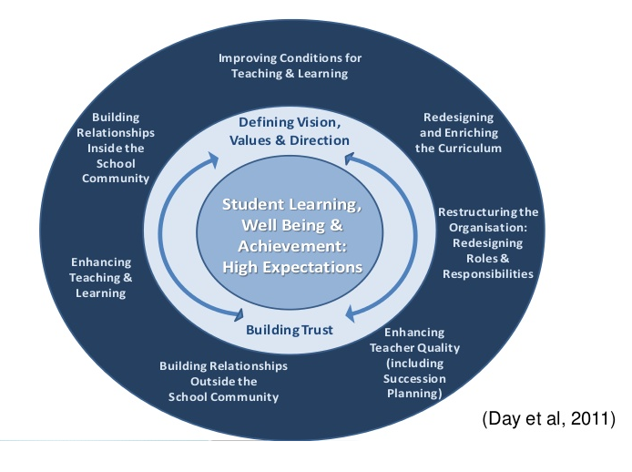

3.2 Task: eight dimensions and you
Step 1
For each dimension:
- think of one action that you have taken in the past which reflects this dimension
- think of one action you could take in the future to reflect each dimension.

Dimension | Past action | Future action
1
2
3
4
5
6
7
8

Step 2
Think about the eight dimensions. Are there any dimensions you would like to add to the list which reflect your context?

3.3 Direct influences: monitoring and evaluation

3.3 Discuss: planning, monitoring, evaluation and reviewing
Educational institutions and organisations need to plan, monitor, evaluate and review.

You can find out more about these processes in CPD Awareness Raising Units 3 and 4.
As a leader, how can you implement effective monitoring and evaluation procedures in your context?
3.3 Task: procedures for monitoring and evaluation
Step 1: Which monitoring and evaluation procedures can be used in your context?
Read the monitoring and evaluation procedures below.
As a leader, which procedures do you currently implement in your context?
Which procedures could you implement in the future?
- observing lessons
- learning walks
- review of learners’ workbooks
- reports from heads of department or other senior staff
- analysis of school and class data
- learner questionnaires
- discussions with learners – focus groups and individuals
- discussions with senor staff and teachers/trainers about teaching and learning

Step 2: Follow-up
You can find out more about learning walks by watching this video after this session:
https://www.youtube.com/watch?v=pjxg6-fxW2Q

3.4 Direct influences: continuing professional development

3.4 Discuss: CPD in your context
An important leadership role at any institution is encouraging continuing professional development.
Work individually and answer these questions:
- What types of continuing professional development take place at your institution at the moment? Who leads this CPD? Who organises it?

- What strategies are used at your institution to encourage teachers/trainers (and other staff) to work together?

- Do you take part in this continuing professional development? Why do you think it could be important and useful to do so?

Compare your responses.
Notes:

3.4 Task: creating opportunities for CPD
The writer Simon Borg has collated a set of criteria for effective CPD.
Read the criteria and discuss these questions with a partner or partners:
- To what extent does CPD at your institution meet these criteria?

- How could CPD at your institution be led and organised more effectively?

- How could teachers/trainers be encouraged to collaborate more and work together more effectively?

Effective continuing professional development:
- acknowledges and challenges teachers’ prior beliefs, knowledge and experience
- provides opportunities for active experiential teacher learning
- is seen by teachers to be relevant to their needs
- promotes collaborative teacher learning
- takes place within the institution and is linked to teachers’ direct work
- is aligned with the broader system teachers are part of
- promotes inquiry-based learning through reflection and teacher research
- takes place over time rather than a one-off training event.
(Borg, 2015, slightly adapted)
Notes:

3.5 Direct and indirect influences

3.5 Discuss: are you a leader or are you a boss?
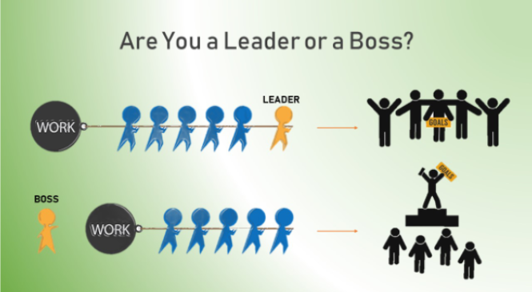
Source: https://nascenia.com/are-you-a-leader-or-a-boss/
1 What differences do the illustrations show between ‘being a boss’ and ‘being a leader’?
2 Complete the table to show the differences between a boss and a leader.
A boss | A leader
Directs | Coaches
Tells others what to do | a) ………………………………………………………………
Transmits decisions | Involves others in the decision making process
Demands results | Inspires performance
Gives answers | b) ………………………………………………………………
Talks more than they listen | c) ………………………………………………………………
d)……………………………………………………………… | Is willing to learn
e) …………………………………………………………….. | Encourages
Focuses on themselves | f) ………………………………………………………………
Points out weaknesses | Identifies strenghts and potential
Defends personal characteristics | g) ………………………………………………………………

3 At the moment, are you more like a boss or a leader? How can you become more like a leader?

3.5 Task: direct and indirect influence
Step 1
Read the definitions of direct and indirect influences.
As leaders, we sometimes exert a direct influence. For example, we design a policy which everybody must follow. We instruct and direct our staff to take actions which are obligatory and we check that they have been completed.
We also exert an indirect influence. We can become role models and lead by example so that people we lead take actions not because we tell them to do so but because we inspire them to do so through our own actions. We coach and guide people so that they can take their own decisions and not simply follow the instructions we give them.
Step 2
Read the examples of direct and indirect influences below (British Council Connecting Classrooms)
Effective leaders for learners directly influence classroom and lesson practice:
- through strategic thinking and decision making
- by creating a culture of high expectations and can-do mindset
- in the way staffing and resources are secured and allocated
- by ensuring learners are safe and supported
- by setting priorities for action and improvement
- in how the institution is organised – curriculum, timetable, staffing, etc.
- through developing the institution’s policy.
- observing lessons and giving teachers/trainers accurate, constructive feedback
- using assessment data to track progress and identify priorities for improvement
- identifying where teachers/trainers can support and learn from each other.

Effective leaders for learners indirectly influence classroom and lesson practice:
- leading by example and demonstrating that teaching and learning is a priority
- working with staff to plan, evaluate and monitor the curriculum
- promoting and participating in discussions about learners and teachers’/trainers’ learning and development
- knowing how individual learners are progressing
- visiting lessons, showing an interest in students’ learning, talking to learners about what helps them learn
- encouraging colleagues to talk about teaching and learning
- focusing on teaching and learning at staff meetings
- encouraging teachers to plan lessons together
- encouraging teachers to try new approaches and evaluate their impact.
Step 3
Choose three forms of direct or indirect influencing that you can do more of as a leader for learning.
What can you do in practical terms to increase your influence?
Notes:
Step 4
How well do you know the learners at your institution? How much contact do you have with your learners?
Peter Matthews suggests:
The heads of successful schools inject energy through leading by example. Many of them, and their senior colleagues, teach and set themselves very high standards in doing so. Many of the secondary heads make timetabled curriculum contributions, often with harder to teach classes. Leaders are likely to be aware of individual children’s needs and problems, and to engage with the variety of projects going on. The energy, enthusiasm and personal interest shown by these leaders is highly motivational, creating a climate of initiative, innovation and success.
(Matthews, P. p14)
As a leader, how often do you engage with learners through direct teaching?
If you do not teach, would this be a useful strategy to help you be more aware of learners’ needs and to lead by example (modelling)?

3.6 Reflect and apply

Step 1
Look back at the lists which you made in Activity 3.1.
After working with this unit, are there any actions you would like to add to your lists?

Step 2
Look at the diagram below which shows the impact (the effect size) of leadership actions on learner outcomes.
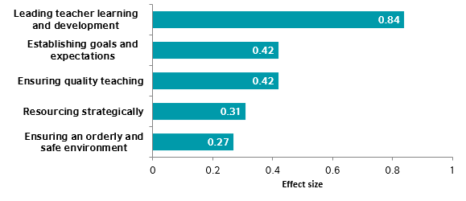
Think about these questions:
Which actions are you currently involved in?
Which actions could you do more of in the future? Why would this be important?
What challenges are there to implementing these actions in the future? How could you meet these challenges?
Work in a pair or a small group and share your ideas.
Step 3
Assignment
After this session:
- make a practical action plan for implementing three of these actions
- keep a journal to describe how effectively you have implemented your actions
- share your experiences with a colleague or colleagues.

Appendix: leading for effective learning

Setting effective goals

Effective leaders for learning set clear goals and directions and build a comprehensive vision of where they want their school to be. They identify and implement clear purposes and set targets for improvement. ‘School leaders are not there to make students’ lives worse; they are there to see that their schools concentrate on improving students’ learning and ultimately their achievement’. They have high expectations themselves of all the people they lead including teachers and learners and build a culture which reflects these high expectations. Institutions with effective leaders are clear about their missions and proactive about their futures.

Successful leaders prioritise effectively. They are able to identify which challenges need to be addressed first and which are the most important barriers to progress. They understand and adapt to the contexts they work in. They are confident about taking different approaches in different situations while always keeping in mind key principles of care, equity and performance.

These goals and expectations are clarified and shared consistently with everybody and everyone’s agreement is secured so progress can be made.

Being an effective role model

Effective leaders are inspiring role models. They lead by example. They regularly model good practice and are respected by people they lead for not asking anything of them they would not do themselves.

They show the enthusiasm, commitment, passion, hard work and energy they expect from the people they lead and (often accompanied by a sense of humour) motivate people they lead through displaying these characteristics. They have a deep understanding of teaching and learning processes and regularly show this understanding through their actions.

They build close relationships with learners as well as staff. They regularly interact formally and informally with learners and show them that they respect and value them and know their names and backgrounds. They are aware of individual learners’ needs and problems. They may do this through organised classroom teaching (especially of classes which are more difficult to teach) or providing direct support to learners who are not making progress or are significantly challenged. Research has shown that the more ‘hands-on’ the approach of a headteacher or principal is, the more effective the institution which they lead.

Focusing on learning: professional development

Effective leaders recognise that everybody involved at the institution they lead (teachers, trainers, learners, other staff – and themselves) have the need, potential and in the right circumstances, the motivation to learn and they work to develop a culture which supports everyone’s learning. They develop a safe and secure environment in which everyone feels free to identify what they need to learn, experiment, take risks and share learning with other people.

‘The three pillars of reform are continuous professional development (CPD), continuous professional development and continuous professional development’. Effective leaders organise regular opportunities for CPD. They make sure that CPD they organise is a good match for the needs and wants of teachers and the context they work in. They design and implement learning systems to support their staff and participate in those systems themselves.

Successful leaders do not only model skills as classroom practitioners but also demonstrate attitudes as ‘leading learners’ in their institutions. They hold regular formal and informal meetings with their staff and participate actively in teacher learning and teacher development not only as leaders but also as learners. They are seen as a resource for learning by the people they lead. They also recognise and celebrate everyone’s learning achievements.

Making use of evidence

Leaders for learning take approaches which are based on evidence. They put into action monitoring and evaluation processes to gather this evidence which look at both how effectively teachers teach and how effectively students learn. These processes can include observations and regular visits to classes, giving teachers formative and summative feedback informally and through appraisals and looking regularly at learners’ work and results. They encourage people they lead to be involved in these processes, through encouraging peer observations for example. They carry out these processes in a way which is motivating and helpful for teachers and which is not threatening. They make sure they have a clear understanding of what is going on in lessons, and are good at evaluating and analysing what needs to be improved

Effective leaders also regularly reflect on their own performance and encourage other people to reflect. They make time to reflect, keeping a journal for example. They develop a culture in which everyone (leaders, teachers, learners) self-evaluate and in which everyone feels responsible for making progress. They are also able to deal sensitively with teachers who are in need of improvement, who may be resistant to change or may be uncertain and unconfident.

Planning, coordinating and evaluating teaching and the curriculum

Leaders for learning actively lead on curriculum development throughout the institution in all subjects and at all year levels. They also involve everybody in this development and delegate responsibilities for specific areas to specific members of staff. They make sure that there is a match between the curriculum, the needs of learners and the goals of the institution.

Encouraging collaboration

Effective leaders understand that they cannot make change happen without the involvement, support and agreement of the people they lead. They are very empathetic in the way they interact with these people. They develop strong communication skills which help them relate to teachers and learners, win people’s trust and build their confidence and support changes which they are introducing. They encourage a culture of shared leadership and shared responsibility.

They also encourage collaboration beyond the institution they manage. They engage successfully with parents, build links with the community and secure the support of those with knowledge, experience and skills which may be useful for the institution. They build and participate in networks which help to share knowledge and expertise developed at the institution. and bring new knowledge and expertise from outside. They encourage dialogue in which everybody involved feels free to share learning, ideas and suggestions from their different perspectives.

Creating favourable learning conditions

In whatever context they work in, effective leaders develop an orderly and supportive environment. This can include managing classroom control, reducing the stress experienced by the people they lead, and dealing with the pressure of policy and stakeholders. They manage and allocate resources strategically and appropriately and recognise that managing human resources is just as important as managing materials or equipment.
The diagram on the next page shows just one way of summarising all these ideas – although there are many other possible frameworks.

Text prepared by Andy Keedwell, TREE Facilitator

Leading Learning – A Framework

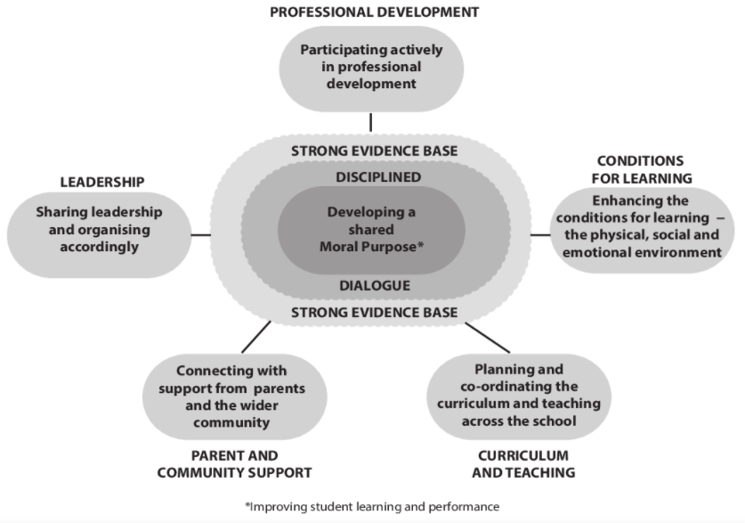

Further reading and references

ACSD (nd) Leading for Learning
Available online at:
www.ascd.org/publications/newsletters/education-update/jan04/vol46/num01/Leading-for-Learning.aspx

Borg, S. (2015) Contemporary Perspectives on Continuing Professional Development. British Council.
Available online at:
www.britishcouncil.in/sites/default/files/contemporary_perspectives_on_cpd.pdf

British Council, Connecting Classrooms Leading effective teaching and learning
Cambridge Education (nd) The Five Leadership for Learning Principles
Available online at:
www.educ.cam.ac.uk/networks/lfl/about/PDFs/LfL_framework_and_principles.pdf

Daniels, H. and Edwards, A. (2012) Leading For Learning: How The Intelligent Leader Builds Capacity. Nottingham. National College for School Leadership
Available online at:
https://thestaffcollege.uk/wp-content/uploads/Leading_for_learning_-V3_180612.pdf

Dempster, N. (2009) Leadership for Learning: A Framework Synthesising Recent Research.
Available online at:
https://core.ac.uk/download/pdf/143858458.pdf

KIPP (nd). Leading for Learning: 8 Actions of Highly Effective School Leaders
Available online at:
www.kipp.org/wp-content/uploads/2016/11/LFL_.pdf

Matthews, P. (2010) How Do School Leaders Successfully Lead Learning? National College for School Leadership
Available online at:
https://dera.ioe.ac.uk/254/1/download%3Fid=23637&filename=how-do-school-leaders-successfully-lead-learning.pdf

Robinson, V. (a) 2007) School Leadership And Student Outcomes: Identifying What Works. Winmalee, Australian Council for Educational Leaders
Available online at:
www.educationcounts.govt.nz/publications/series/2515/60170

Robinson, V. (b) 2007) The Impact Of Leadership On Student Outcomes: Making Sense Of The Evidence.
Available online at:
https://research.acer.edu.au/cgi/viewcontent.cgi?article=1006&context=research_conference_2007

Dempster, p2
Robinson, p7
Matthews, p17
Dempster, p8

