FINPLAN
Hands-on 1: Installing FINPLAN
Useful references:
- Video Tutorials
- FINPLAN Google Group

Learning outcomes
By the end of this exercise, you will be able to:
1) Install FINPLAN
2) Access additional FINPLAN information
Note: The current FINPLAN software is only compatible with a Windows 10 machine. The software is not compatible with iOS/Mac operating systems.

Activity 1
Install FINPLAN: To download the software you must complete this Google Form.
Try it:
- Click on the Google Form link. You will see the following page.
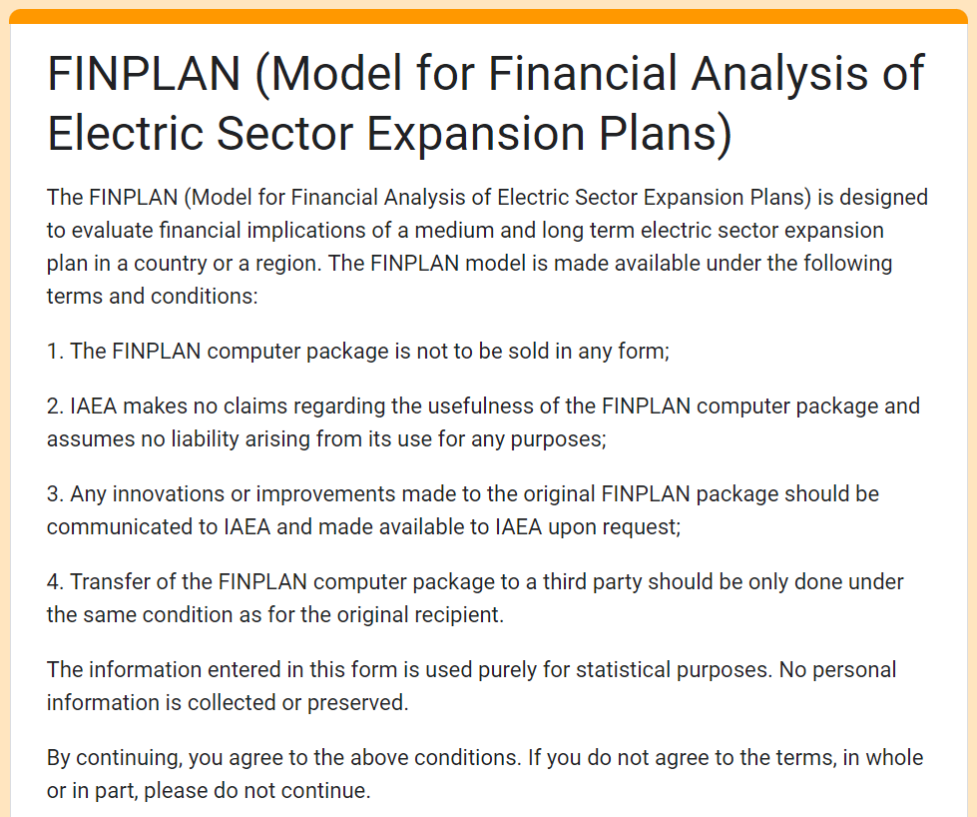
- As the consent form states, data on your country and affiliation are collected for statistical purposes. If you agree to these terms, complete the survey, and click on “Submit”.
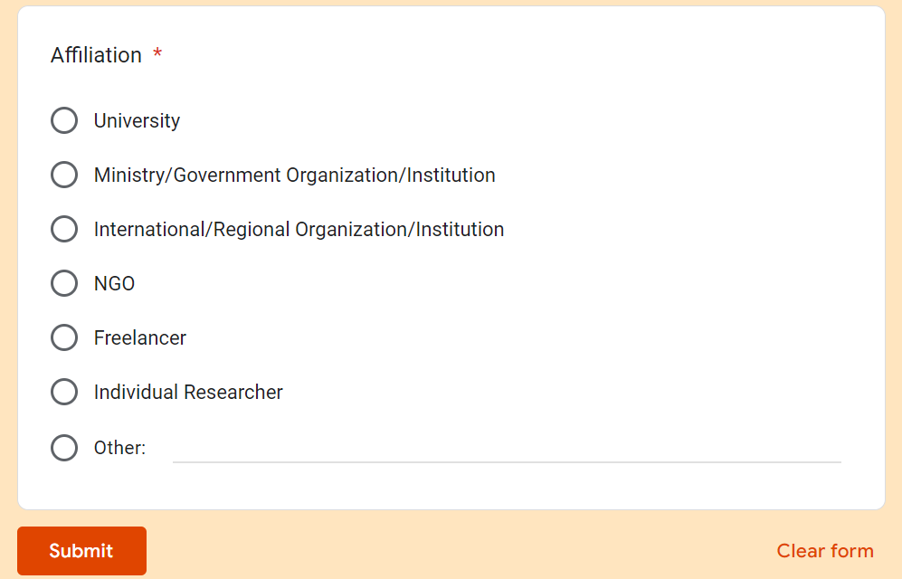
- Once submitted, you will see a confirmation message with the link to the FINPLAN executable. Click on the link.
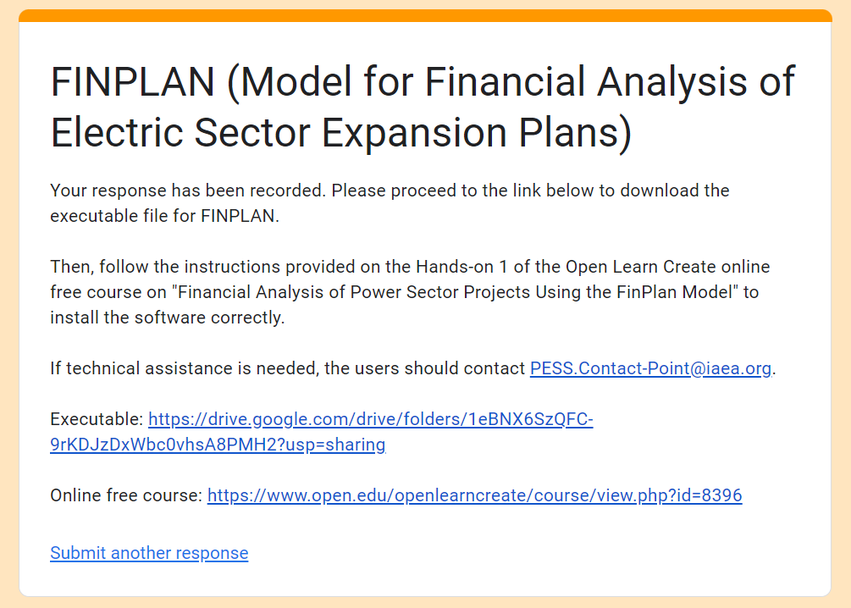
- You will be directed to a Google Drive folder, where you can see the FINPLAN executable (FINPLAN.4.0.3.exe). Download this file onto your machine by right-clicking it.
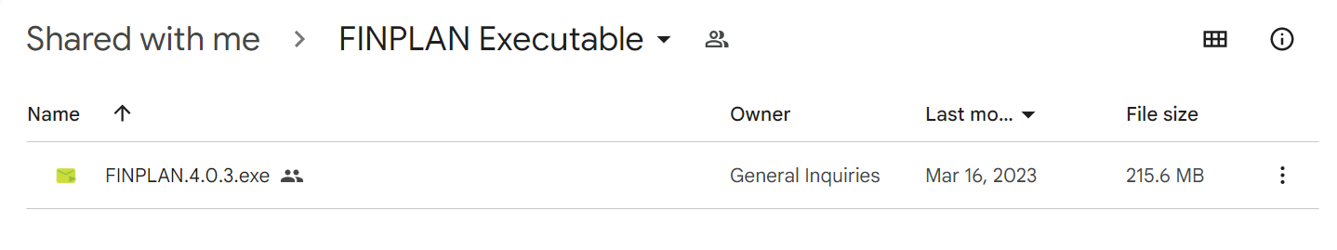
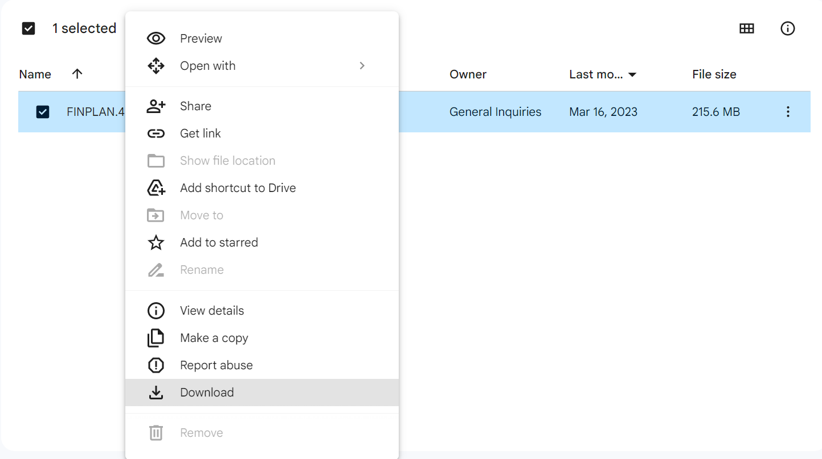
- A prompt may show up. Click on “Download Anyway”.
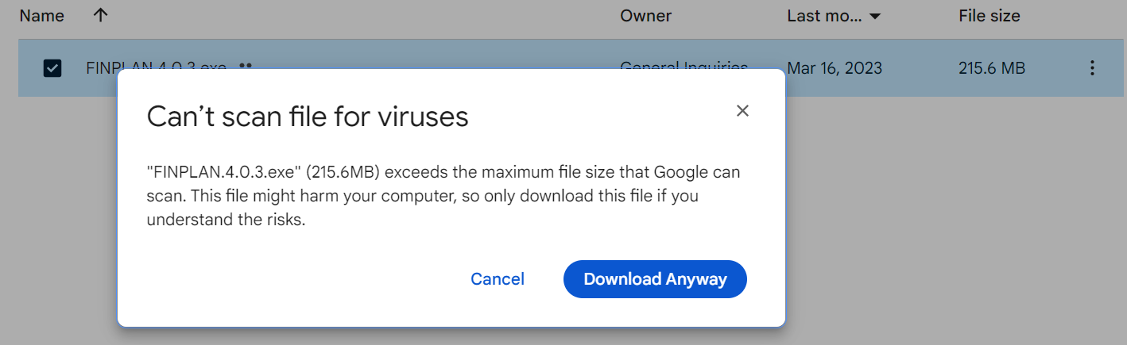
- Once downloaded, you will see the FINPLAN executable file. Double click on it.
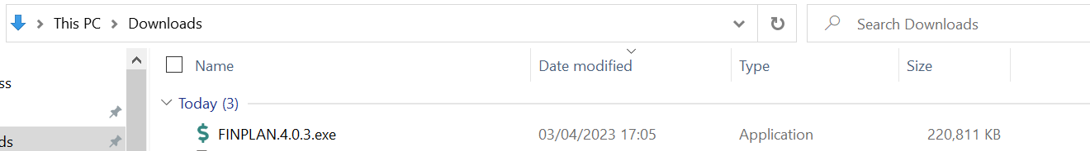
- A pop-up will show. Click on “More info”, then click on “Run anyway”. This will install FINPLAN on your computer.
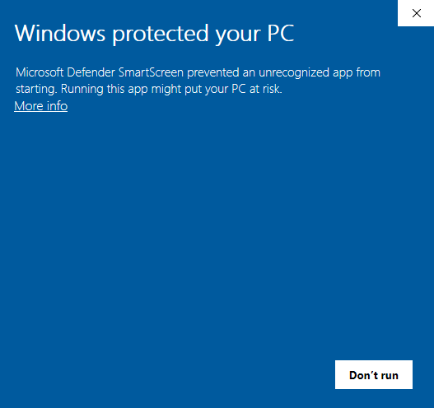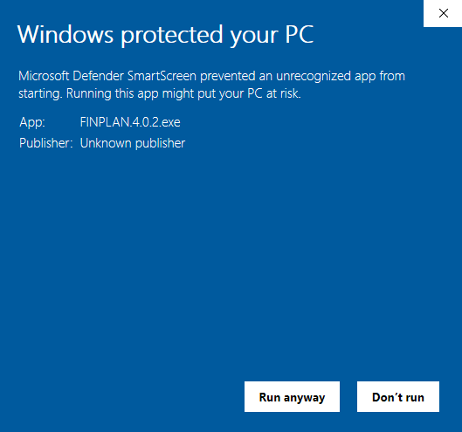
2
1
- FINPLAN will now be ready to run. A window like the one below will appear.
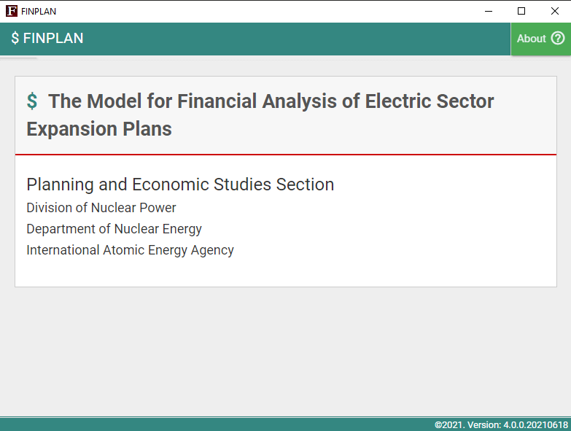
- Ensure your page is maximized to full screen to view all the contents of FINPLAN.
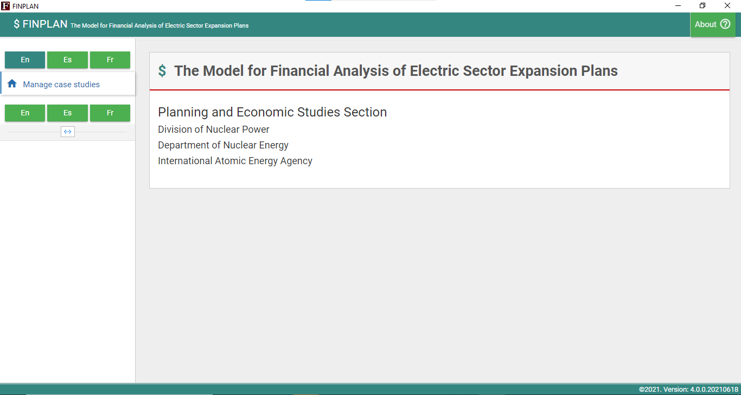
- A shortcut to FINPLAN has also been automatically created on your desktop, like below. Make sure you always start FINPLAN by clicking on this shortcut (and not the installation file you downloaded). It is recommended to delete the installation file from your Download folder.
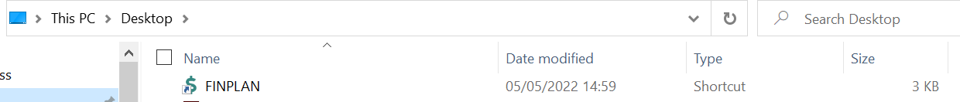
Well done! You now know how to install FINPLAN and open it.
Note: every time you download FINPLAN, your previous data files will be deleted. Thus, should you reinstall FINPLAN, do not forget to export your case studies to somewhere easily accessible, like your Desktop.

Activity 2
In addition to this hands-on, there are two other documents that are available for more information on FINPLAN. They are:
- Introduction to FINPLAN
- Glossary of Financial Terms
Please download these files, have a look at them and keep them accessible, as you will also need them for the upcoming hands-on exercises.
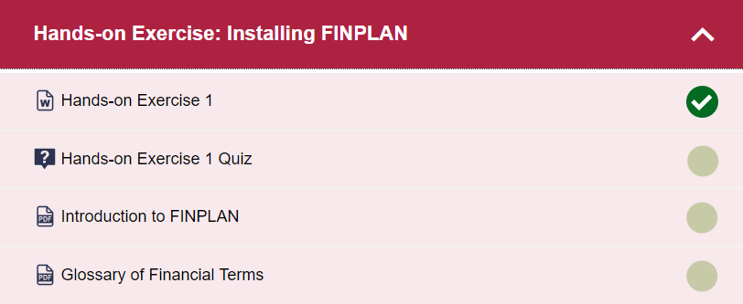

Note: There is also a FINPLAN Google Group for further support. Please sign up to the group and ask or answer any FINPLAN-related questions here.

