Inclusive Teaching Practice
Participant’s Book

Source: VSO Image library

Module 3:
Planning learning outcomes for all

Module 3: Planning learning outcomes for all

Overview
This is the third of fifteen modules that look at how we create a positive Inclusive Learning Environment for all. You will see how inclusive teaching practices encourage, develop and use the 21st century skills of critical thinking, communication, collaboration and creativity. These modules are for any educators or those studying in education in Myanmar. The terms student and learner are used interchangeably throughout the module.

Module number | Module title
1 | What is an Inclusive School, Classroom and Teacher?
2 | Knowing your learners
3 | Planning learning outcomes for all
4 | Participating through learner centred approaches
5 | Creating a positive learning environment
6 | Effective questioning and feedback
7 | Active participation
8 | Peer, co-operative and collaborative learning
9 | Supporting students’ emotional and social wellbeing
10 | Legal framework and policies around Inclusion in Myanmar
11 | Supporting all students through differentiation
12 | Identifying specific learning difficulties
13 | Supporting all learners with differences or disabilities
14 | Positive behaviour management
15 | Assessment for student achievement

This module helps you to think about learning outcomes for all students to achieve and the effectiveness of step-by-step learning linked to inclusive practice.

You will also be asked to record your reflections in a learning journal, so it is important to make detailed notes and think carefully and deeply about your current and future practice. This CPD module also encourages you to develop communities of practice between yourself and your colleagues. This will support and extend your own use of inclusive practices in your teaching and will help your student teachers build on inclusion in their learning and future professional practice.

Learning Journal
It will be useful to record your reflections in a learning journal throughout the module.
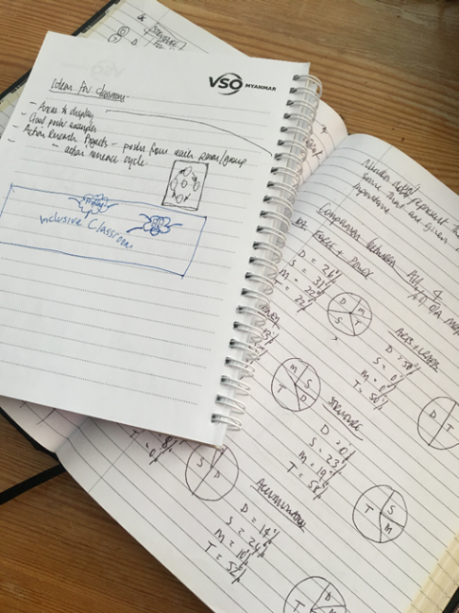
A learning journal can be digital (e.g. using Word or Google Docs) or on paper. You can also take photos of your learning journal pages if you want to share your thoughts with others. It is important that you record your thoughts and ideas so that you can remember and use them later in activities and in your own teaching.

Here are some useful tips for a good learning journal:
- Use headings and dates for all your journal entries.
- Use the activity number for reflections linked to that activity, e.g. Activity 1.1
- Add references to any other resources you find that help you.
- Record answers to activities.
- Write reflections about your learning.
- Make notes of new vocabulary.
- Identify topics you want to learn more about.

Source: Rose, N. (2018) Personal Learning Journals

The important thing is that it is easy for you to use. You can take notes which answer simple questions like these:

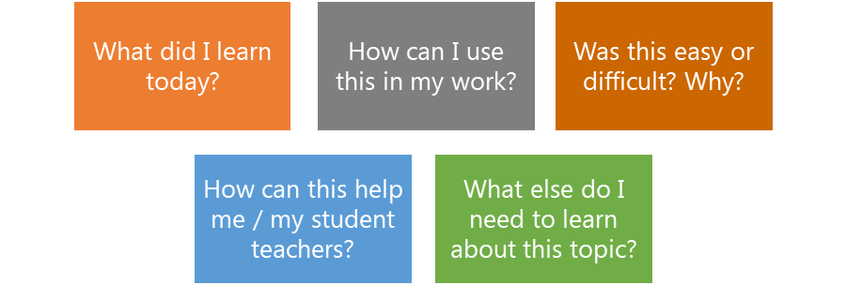

These questions follow the LEARN- APPLY- REFLECT model which is used in education globally. You can return to this journal as you progress through your CPD journey and reflect on your progress.

Study tips
Take your time to work through the activities, rather than trying to complete the whole unit at once. Set yourself a timetable and choose a time to work through the tasks, then check and compare ideas with colleagues. Finally, remember to make notes in your learning journal as you go. This will help you remember more about the skills and knowledge you develop as you complete these units.

Working alone or with colleagues
This unit is designed for self-study. The answers can be found after each activity. However, if possible, we recommend working in a pair or group so you can share ideas, ask questions, check your work, and give feedback.

If you work in a pair or group, we recommend using Think / Pair / Share for each activity.
Discuss your ideas in a group, and then check the answers on the next page(s) together.
Check your answers with your partner.
Work alone and make brief notes of your own ideas.

Learning outcomes for module 3
By working through this module, you will be able to:
- summarise what makes a good learning outcome.
- recognise thinking action verbs.
- contrast lower and higher thinking actions.
- write learning objectives using thinking action verbs.
- divide a task into small steps of learning.
- produce a lesson plan using step by step learning.

Introduction
The previous module focused on the importance of knowing your learners and the impact of using multi-sensory learning approaches. You reflected on your own experience and knowledge and were encouraged to get to know all your students to understand their learning needs more effectively. This third module introduces the need for effective learning outcomes for all learners to enable them all to achieve. It also breaks down learning into steps, to explain how learners build on prior and existing knowledge.
You will be asked to:
- Read about planning inclusive learning outcomes for all and step by step learning.
- Watch videos and provide some analysis.
- Complete activities either alone, in pairs or in small groups.
- Think about key questions.
- Answer an end of module quiz.
- Reflect on your experience and knowledge.
- Make a promise to your learners.

The module will take approximately 6 hours to complete. Take your time to ensure it is an enjoyable learning experience.

Key to symbols
 | Activity – this is work you need to complete.
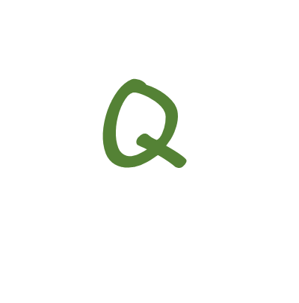 | Question/s – please answer the questions.
 | Reflection – think carefully about how you feel about this.
 | Learning Journal – please write your answers in your learning journal.
 | Read – please read the text provided. Make any notes you like.

Link to previous learning – module 2 (Knowing your learners)
Think back to module 2 and the information you need to know about your learners and how this links to inclusion. Using the words in the table below, put them in the factor (category) that you feel fits best. This is a revision task from the previous module. The first word has been done for you.
language | physical development | age | learning styles | gender
self-esteem | customs and values | personality | religion | interests
reading skills | recent change or loss in the family | Concentration | Attitude | Creative skills

Biological
Cultural and community
Language

FACTORS

Academic readiness

Emotional and social

Source: www.myanmargraphic.com (free use)
How they learn best

Adapted from Powell, W and Kusuma-Powell, O (2011) How to Teach Now

  - Answers
Academic readiness | Cultural & Community | Biological | Emotional & Social | How they learn best
Concentration | religion | age | self-esteem | learning styles
Attitude | customs and values | gender | personality | interests
reading skills | language | physical development | recent change or loss in the family | Creative skills

Learning Outcomes
A learning outcome is a statement that will indicate the end result for a learner, what the difference will be and what they will have learnt following a learning activity, e.g. to identify and describe 3 parts of a plant. It is helpful to think of it as what students will do differently as a result of the learning process.
There is a lot of confusion around different words used in education to describe a learning outcome within a lesson. Some of these are lesson aims, lesson objectives, learning goals or learning objectives. These terms all describe what educators want students to do within a lesson. In this module, when an educator is planning learning, we will suggest they write a learning objective and we will use the term learning outcome to focus on what students will learn as a result of that lesson and what the outcome will be (what they should be able to do at the end of an activity or lesson).
All groups of learners have a range of knowledge and skills. Trying to write a learning objective that suits the needs of all learners is a challenge but is an essential part of inclusive practice in education, ensuring that all learners can participate effectively and achieve the intended outcome in every lesson.

See the definition below. Refer to these if you need to when you are working through the module. It might be helpful to record these definitions in your learning journal.

Learning objectives | are statements that an educator uses to define the expected goal for students so that they that understand what is expected of them as a result of instruction.  Example – Identify and describe 3 bones in the human body.  (What you share with students. Today we are learning to ……)
Learning outcomes | are statements that an educator may write on a plan to describe the knowledge or skills students should acquire as a result of instruction. This could be by the end of a particular assignment, class, course, or program.  Example – Students will be able to identify and describe 3 bones in the human body.  (What you plan for students to achieve by the end of the lesson)

2.1 Self-assessment
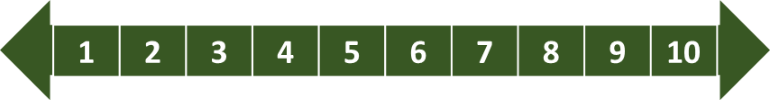
REFLECTION: In the last 10 lessons you have taught, identify the number of learning objectives or outcomes you have used (e.g if you select 10, you used a learning objective in every lesson, if you select 5, you included a learning outcome for half of the lessons you last taught. Look at the scale below and identify the number that best describes YOU.
NOT well
VERY well
In your learning journal, think about if all children access the learning outcome in all lessons?
You will be asked to do this again at the end of the module.

2.1.2 Why are learning outcomes important for good quality teaching and learning?
Students may be learning about a topic or a subject broadly, such as Biology in Science and the learning outcome breaks that down to focus on a specific part so that students know what is important for that particular period of learning.
If learners do not know the learning outcome of a lesson, they may not be sure or understand what to expect, which can make them lose interest or not see why the learning is important to them. Learning outcomes are important for effective teaching:
- Teachers and learners have a common understanding about the purpose and goals.
- It is easier to plan the lesson for all learners.
- Teachers are clear on the specific learning outcome and therefore teaching is more focused.
- Learners know what the teachers expect from them and can work towards that goal.
- Learning outcomes help give a lesson direction.
- Teachers and learners can make clear assessment decisions.
- Teachers and learners can measure if they have understood the learning/task and may be able to identify next steps or gaps in their learning.

2.1.3 What makes up an effective learning objective?
How a learning objective is written will have an impact on the learning outcome, its effectiveness and therefore the success rate at which learners can achieve the outcome.

- It should reflect the end of a learning process e.g. By …. (this time) the learner will be able to …..
- It focuses on the results of the learning experience not the means or the process.
- It should reflect the knowledge or skills needed.

If a learning objective is too general, for example, ‘Learn about bones in the human body’ it will be difficult for a teacher and a student to measure the learning outcome (the success of the lesson and the learning that has taken place).

If the learning objective is more specific, e.g. ‘Identify and describe 3 bones in the human body.’ the learning outcome is clear to both the teacher and the student and both will be able to say if the learner has achieved that by the end of the lesson. The instruction is specific and measurable.
Identify and describe 3 bones in the human body.

Learn about the bones in the human body.

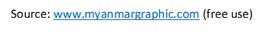

Learning objectives should be SMART: specific, measurable, achievable, relevant and timed.
State clear and specific objectives
Specific
Define the learning objective as clearly as possible with age-appropriate language. What will the skill be? What are students learning? Is it meaningful for students? Make it clear what you expect from learners.

Objectives can be measured through assessment
Measurable
Use a thinking action verb (we will look at these in the next section) or skill that allows it to be seen/the learning to be visible. This will allow you to carry out some form of assessment to check the learning objective has been met. How much, how many, etc.

Is the level of learning appropriate for all learners?
Achievable
Do you have the resources, the knowledge, the time and the right space? By knowing your learners, you can write learning objectives that allow all of them to achieve.

Does the lesson link to the subject/ course of study?
Relevant
Write your learning objective so that it is short and precise. This helps the learners understand the purpose of learning activities and the direction of the lesson. It should be relevant to the topic of the lesson and to your learners. It might be appropriate to link the learning to real life examples and how it links.
Can the learning/activity be achieved in the time available? Sufficient time should be allowed to achieve the objective. Always say what the learners will be able to do by the end of the lesson. This helps give clear expectations of time to complete a task or activity, purpose and direction.
Timely

Activity 3.1 – SMART learning objectives (25 minutes)

- Draw a grid in your learning journal with the acronym SMART. Write a short description next to each word. This will be useful in the planning stage later in the module.
Specific | Measurable | Achievable | Relevant | Timely

- Read the learning objectives below and decide if they are SMART. Explain to a colleague or justify in your learning journal why you have decided if learning outcomes are SMART or not.
Learning objective | SMART – Yes or No?
- By the end of the lesson - Identify definitions for 6 different words about plant Earth.
(Learners are studying Space this term).
- Understand the main features of a news report.
(Learners have been reading a variety of newspaper reports).
- By the end of the lesson - Learn about climate change.
(Learners have been exploring the imapct of climate change).

Q

- Think back to a learning objective that you have used in a lesson.
- Do you think that it was specific, measurable, achievable, relevant and timely?
- How could you change the language in the statement to give more clarity and include the parts in the SMART method?

Activity 3.1 answers
See the answers below and explanation of why they do or do not meet the SMART criteria.
Specific
Measurable
Achievable
Timely
Relevant
Learning objective | SMART  Yes or No?
- By the end of the lesson - Identify definitions for 6 different words about plant Earth.
(Learners are studying Space this term).
- Understand the main features of a news report.  (Learners have been reading a variety of newspaper reports). | x
- By the end of the lesson - Learn about climate change.  (Learners have been exploring the imapct of climate change). | x

NOTICE in example 1:
- There is a clear time frame and expectation for how long the task should take.
- The words ‘identify’ and ‘definitions’ ensure that the instruction is specific.
- By providing a number (6) of words required, the learner and teacher can measure if the learner has achieved the outcome.
- The teacher had asked for the definitions to be focussed on one plant. This seems achievable and as the learners are studying space, we can assume that they will go on to learn or have already learnt about other planets.
- We know the lesson is relevant based on the context provided in brackets.

NOTICE in examples 2 and 3:
- The words ‘understand’ and ‘learn’ are hard to measure.
- The learning outcome is not specific which makes it difficult to know if it is achievable.

The next section will focus on more appropriate words to replace ‘understand’ and ‘learn’ when writing a learning objective and the impact that will have on teaching and learning.

2.1.4 The 7 steps of setting a SMART outcome
When thinking about and writing learning outcomes, it is helpful to consider the following question words.

WHO – WHAT – WHERE – WHEN – HOW

It may seem a lot to think about, but the more you use them, the easier the process will become.
Read the next section to expand on these questions words.

- What is the outcome that you want to achieve?
  - Imagine that your activity has finished and it was successful. What new information do your students know now? What have they understood? What can they do now?
  - Can ALL your students achieve it?
  - If no, how can you make the learning easier or harder?

- Who will do it?
  - Students or you? I? They? We?
  - How old are they? Which grade are they?
  - What is learners’ previous knowledge? What is the next step?
  - Do the outcomes fit and link?
  - What are the special, unique needs of individual students?

- What will the result be? How can you measure it? What will show you that learners have achieved it?
  - Numbers? Amount? Content? Quality?
  - What will the result look like? What will it contain? How will it sound? How will it feel? How will your classroom look/sound like? What do students` notebooks look like? What will students say? What will they be able to explain as a result of the lesson?
  - Can EACH student participate in creating it?
  - Does the learning need adapting so EACH student can acheive? How? How will this come together into a common achievement?

- How many? / How much of it do you want students to do to show you they understand? How will they acheive the outcome?
  - What size? What shape? How long? How loud? How many letters/words/paragraphs?
  - Do students need to complete a whole page of writing or a few sentences to show their understanding?
  - Can EACH student participate in achieving this number or quality?

- When do you want the task to be completed? How much time do students need?
  - Is the time allocated realistic?
  - Can students suggest how much more time they might need?
  - How much time does EACH student need to achieve it?

- Build your objectives and outcomes.
- Build 1-3 sentences to answer WHO – WHAT – WHERE – WHEN – HOW

- Cross-check, and keep adjusting and rewriting your outcome until all your answers are YES. Fill in your Lesson Plan Template, continue and enjoy planning.

Is it SPECIFIC?
Is it MEASURABLE?
Is it ACHIEVABLE?
IS it RELEVANT?
IS it TIMED?

Activity 3.2 – SMART learning outcome examples (15 minutes)
Match the speech bubbles to the correct part of the SMART method. The first one has been done for you.

By the end of the 45-minute lesson, students will be able to label the parts of a plant and describe the functions of those parts.

Specific

I can see how I can use this information to help me in the next lesson.

Measurable

What exactly will I learn from this lesson and what will I need to do to show I understand?

Achievable

Is what I am asking possible within the time we have and the resources available?

Relevant

How much of this can the students do? Is it too hard or easy for some?

Timely

Activity 3.2 answers

Specific | Measurable | Achievable | Relevant | Timely
3 | 5 | 4 | 2 | 1

2.1.5 Differentiating Learning objective and outcomes
If we look at the ‘Achievable’ part of the SMART model, it forces us to think about how inclusive our learning outcomes are and to be certain that all learners achieve what is being asked of them.
Some learners may need a task to be simplified and others may require an extension. We call this differentiation.

Some teachers write a learning objective using the terms ‘all learners will’, ‘most learners will’ and ‘some learners will’ to differentiate the task.

There can be benefits and draw backs by using this strategy. Whilst an easier task for some children might break down the learning into a manageable/achievable activity, for others it could hold them back and keep them in a comfort zone. The teacher might not encourage these students to take risks or see what a student is capable of. This is where knowing your individual learners (module 2) is crucial.

To differentiate is to provide different activities or questions to meet the needs of all learners. For example, you might ask learners who are at the start of a learning process to show you the pattern when looking at a multiplication sequence or ask another child who has a deeper understanding to explain the pattern.

We will discuss the progression of these verbs and how they translate into learning in the next section. To differentiate a lesson is to ensure that all learners can meet the learning objective. The learning outcome may be the same for all learners but the process (task) may differ, providing students with flexible options to meet the objective. In the example below, read the objective and the possible ways for learners to meet it and measure their success.

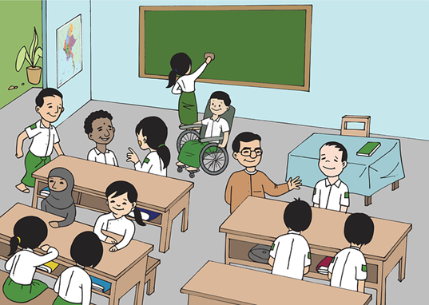
This group of learners could look at 100 square and look for patterns.
Identify and describe the sequence when counting in 5s.

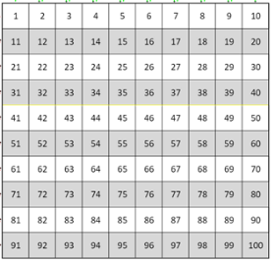
5 | 10 |  | 20 | 25

This group of learners might be familiar with the pattern or grasp it quickly. They might be asked to find missing numbers within a pattern and justify why a certain number fits.

Image source: https://commons.wikimedia.org/wiki/File:100_Number_Square.svg (free use)
Image source: https://pixabay.com//illustrations/burma-myanmar-classroom-boy-girl-5204371/ (free use)

3.Thinking action verbs.
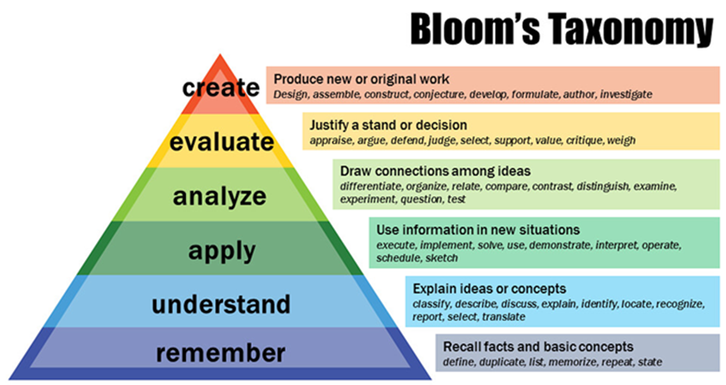
Bloom’s taxonomy is a framework of thinking skills. We will refer to it in future modules, so it is worth spending time at this stage to explore it and begin to look at all of its parts. It was originally created in 1956 and then revised in 2001.
Source: https://www.flickr.com/photos/vandycft/29428436431 (Creative Commons)
Look at the words in the boxes on the right side under the subheadings. These are all thinking action verbs. Notice that in the section linked to remember are words such as define, duplicate (copy), list, memorise, repeat and state. If you use these words in a learning objective, you may want learners to remember multiplication facts, historic names, timelines, repeat a pattern. These skills are considered to require a low level of thinking.
As we move up the pyramid, you will notice thinking action verbs, such as explain, demonstrate, and design. These require more thinking from learners and are called higher order thinking skills.
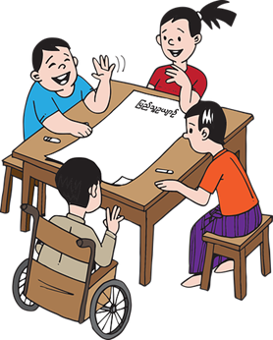
The more we think and apply our understanding and knowledge – the more we learn and remember. Lessons may use thinking action verbs from different areas of thinking (remember, apply, etc). The more thinking action verbs are used from the higher thinking skills (analyzing, evaluation and creating) – the more thinking is required from learners, the more they need to participate in the activity and the more actively involved they will be in their learning.
When you write your learning objective using a thinking action verb, learning becomes visible and you can see if the learner has achieved the objective. You cannot see if a learner understands or knows something, but you can see if the learner describes or demonstrates. This is the start of a plan for your lesson because you have said what the learners will be doing.
Source: https://pixabay.com/images/search/burma/?pagi=2& (free use)

Thinking action verbs for writing learning objectives.

More thinking and so more deep learning
Remembering | Understanding | Applying | Analysing | Evaluating | Creating
to name  to label  to recite  to match  to recall  to define  to describe  to select  to list  to tell  to identify  to state | to outline  to summarise  to explain  to rephrase  to predict  to extend  to show  to translate  to infer  to estimate  to classify  to illustrate | to organise  to demonstrate  to solve  to prepare  to use  to model  to transfer  to choose  to select  to interview  to construct  to plan | to classify  to simplify  to examine  to outline  to compare  to contrast  to discover  to categorise  to divide  to deduce  to illustrate  to debate | to compare  to defend  to justify  to support  to contrast  to explain  to decide  to recommend  to prove  to conclude  to prioritise  to judge | to design  to plan  to produce  to adapt  to compose  to predict  to solve  to discuss  to invent  to change  to imagine  to improve

More participation and more actively involved in learning
Lower to Higher order thinking

Activity 3.3 – Using Blooms Taxonomy ‘thinking action verbs’ (30 minutes)
Link the tasks that have thinking action verbs to the correct part of the Blooms sequence. The first one has been done for you.
Create

Evaluate

Analyse

Apply

Understand

Remember

- Explain ideas or concepts

- Can recall facts and basic concepts

- Produces new or original work

- Uses information in new situations

- Can justify a decision

- Can draw connections from ideas

Adapted from: https://www.myanmargraphic.com/(free)

Activity 3.3 answers

Create | 3
Evaluate | 5
Analyse | 6
Apply | 4
Understand | 1
Remember | 2

Activity 3.4 – Selecting the most appropriate learning objective (45 minutes)
- Further reading: a slightly extended and adapted version of SMART learning outcomes can be found in an article by Blanchard, K., & Johnson, S. (1981). Appendix 1

- Use the information you have read about so far around learning objectives and outcomes to begin to suggest an appropriate learning objective for the activities below. The context here will be important. Students may not be ready to jump straight into the ‘Evaluate’ or ‘Create’ stage if they are being presented with new learning or information. They may need a lesson to embed skills, start to remember strategies and understand them before they are ready to apply them.

Look at the scenarios below and select the most appropriate learning objective for the learners. You might decide to write your own learning objective for the given context.

 | Learning objective A | Learning objective B
Art –  Students have been exploring a range of artwork and sharing their opinions and feelings towards the art.  Students have had a debate previously in an English lesson and understand the structure and protocols. | Debate the statement ‘All Art is subjective.’ | Describe a range of artwork and how they are different.
Maths –  Young students have learnt the multiplication facts (times tables) for 2s and 10s. It is the first time they have been introduced to counting in steps of 5. | Identify and describe the sequence when counting in 5s. | Explain the inverse of multiplication and division using the 5 x table.
English –  Students have written a recount of a class visit to a temple. The teacher would like students to check their sentences and add more detail using conjunctions (words that join sentences together – and, because). Students have previously learnt about conjunction words. | List different conjunctions words to extend, add detail or join ideas together. | Select the most appropriate conjunction to extend, add detail or join ideas together.

Activity 3.4 answers
Art – Learning objective A. Explanation - Students have already had the opportunity to explore their opinions and feelings needed for them to be able to analyse and evaluate the artists work. Learning objective B asks for students to describe the art. They would have already done this to enable them to have opinions and feelings towards them.

Maths – Learning objective A. Explanation – This is the first time students have seen the sequence of counting in steps of 5. They will need time to look at the patterns, identify them, e.g. the answers all end in 0 and 5. They can then describe that pattern. Learning objective B requires the students to have a deeper understanding of multiplication and division.

English – Learning objective B. Explanation – Students have already listed conjunction words and used them in previous lessons. This is the next step to select the most appropriate one for the piece of writing they are working on.

Activity 3.5 – Write your own learning objective (45 minutes)

- Think about a lesson that you have already taught and the context.
What were the learners starting points?
What skills did they need to develop?

- Write a learning objective for that lesson that would have been appropriate for all learners in the lesson. Refer back to the list of ‘thinking action verbs’ to select the ones that fit with the intended learning outcomes for the lesson.

It might be helpful to make a note of these verbs in your learning journal to support your planning in the future.

Activity 3.4 discussion

Reflect: Think about the skills you are developing in class and the progression in ‘thinking action verbs’ and how that relates to the steps in learning a new concept and mastering it.

Good learning objectives and outcomes help you plan effective lessons for all your students.
A learning objective must –
- Be specific to the lesson
- Use a thinking action verb so learning can be observed
- Plan for all students – use ‘all students’, ‘most students’ and ‘some students’.
- Be relevant to students’ lives or what they are learning about more generally.
- Say what the students will be able to do by the end of the lesson.

Thinking action verbs from Bloom’s taxonomy promote higher order thinking skills. (Use lists in pre-reading passage.) Higher thinking skills enable learners to be more actively involved in learning.

When we use effective learning outcomes, we demonstrate that we value:
- presence by knowing our students, their interests and level of learning,
- participation by thinking how to involve all students in active learning,
- achievement by using measurable outcomes that students can achieve.

Activity 3.5 - Self-assessment
REFLECT: How inclusive are the learning outcomes that you set/or will set NOW? Can all children access them in all lessons? Look at the scale below and choose the number that best describes YOU.
VERY well
NOT well

Compare your first self-assessment score at the beginning of this module to this one. In your learning journal provide a short analysis of your thoughts about any differences.

- Step by step learning
In the previous section you have read about the need to break down or differentiate the learning to meet learning objectives, particularly when we think about inclusive practice and access for all learners. If we think about all the steps there are to learn a particular skill or the steps and knowledge that are needed to complete a task, it helps us plan more effectively. In this section attention is given to identifying the steps needed to carry out tasks set. You will explore the benefits and impact of adopting a step by step learning approach and how it links to inclusive practice.

Activity 3.6 Self-assessment
REFLECTION: How often do you break learning down into steps for all children to achieve? Look at the scale below and identify the number that best describes YOU. Answer in your learning journal.
VERY well
NOT well
You will be asked to do this again at the end of the module.

4.1 Step by step learning (task analysis)
For most people, when we walk or write, we don’t think about how we are doing it. We have mastered the skill. To cook a familiar meal, most people would not think about how they are doing it. They have prepared that dish lots of times and do not have to think about each small step. When learning how to cook, they had to be told each small step or action and had to think through each part step by step until they could do it without thinking. To teach someone to cook, you need to think about every small step or action. What do you have to do to teach someone how to cook?
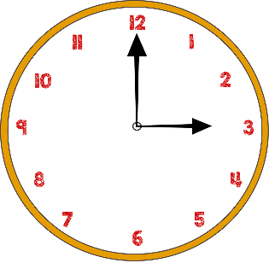
Think about telling the time from a clock. To be able to look at the clock and say it is 3 o’clock, we must know a number of small steps of knowledge. We start with being able to recognize the numbers 1 – 12, and finish with being able to say that at the hour, the hour-hand points to the number so it is ‘that number’ o’clock.
Look at the range of other steps needed to become competent at telling the time. You might add more to the list.

Image sources: https://pixabay.com/illustrations/clock-time-organise-office-minutes-4136662/ (free use)

Recognize the numbers 1 – 12
Order numbers 1 – 12. Place them on a circle – clock template so the places become familiar.
Explain there are 12 hours in the morning and 12 hours in the afternoon/night
Identify the hour hand and the minute hand
Explain that the hands on the clock move clockwise
Explain the minute-hand takes 1 minute to move all the way around the clock
Explain the hour-hand takes 1 hour to move from one number to the next number
Say that at the hour, the minute-hand points to the 12 so it is something o’clock
Say that at the hour, the hour-hand points to the number so it is ‘that number’ o’clock
Describe what is a half and quarter
Describe what ‘past’ (the hour) means
Explain that the minute-hand moves halfway round the clock to point at the 6 when it moves halfway through the hour
Say, when the minute-hand points to 6, it is half past the number the hour-hand has just passed.

When starting at the lowest step to tell the time, we really need to just work on number recognition. There are certainly more steps involved, in mastering telling the time but once you have learnt all the steps you can start to predict time, how much has passed, judge how much time is between certain events and recognize the time on a clock without any numbers.
Image source: https://pixabay.com/vectors/clock-time-icon-hours-minutes-5985786/ (free use)

Progression of learning concepts such as learning to tell the time, are spread over a number of years in a primary curriculum. It would not be expected that you would spend the whole grade/year mastering that skill. For example, in the Early Grade years, teachers might focus solely on number recognition or the concept of half and whole.
Even if we look at the very basic skill of number recognition, if it is a child’s first experience of numbers, a teacher may begin with the numbers 1, 2 and 3 and ensure that they are familiar with these numbers before moving on to recognizing others.

  - The benefits of step by step learning
Our working memory is limited, and we can find it difficult to think of lots of things at once. This can mean we switch off, give up easily or feel stress/pressure. We can achieve more when things are broken down into manageable chunks or steps. One of these steps could be time to discuss ideas before you are asked to contribute or an opportunity to discuss your work during the lesson to check you are in the right track/step. If we ask learners to write an essay, they will need time to organize their thoughts, jot down ideas, begin to order them into a sequence and have time to read through their work and review it. Working step by step can produce a better-quality essay.

Some of the benefits that may be visible in the classroom when using this approach are;
- Teachers can make sure learners can do or know each step before moving on to the next.
- When teachers have identified clear steps for progression, it is easy to make tasks simpler or harder. They are able to quickly differentiate in a lesson, support learners who are struggling at a step or moving learners on who are ready for the next step.
- If a learner is having difficulty, the teacher can go back to a step where the learner felt comfortable and build on the learning from there.
- Teachers can develop confidence in learners by giving them time to practice a step they feel comfortable with before they take on a more challenging step.
- Learners can think about each step at a time, instead of trying the whole skill or task at once.

Activity 3.7 – Trying out step by step learning (20 minutes)
Watch the following short videos that require you to follow simple steps to complete a task. You can decide to choose one or try both.

Watch from 1.44 https://www.youtube.com/watch?v=GFsNnAurVLA

https://www.youtube.com/watch?v=E6IIIMYOPmI

Use your learning journal to reflect on the questions below. Discuss them with a colleague if you can and share ideas around how you relate this information to your own teaching practice.
- Were there any steps missing that you needed to help you do the next step?
- Was it helpful to see the result first?

Relate this to your teaching practice.
- How often do you share the result of the learning outcome with learners?
- What could you do if you are teaching and you realise that learners have missed a vital step?
- Do you think all children need this level of breaking learning into such small steps?

Activity 3.8 ordering the steps needed for learning a new skill
Put the steps in order from 1 – 7.
Can start the bike, ride in a straight line and stop using the brakes.
Not been on a bike before.

Practice
Feel the bike and push it around

Start, get on, sit, stop

Start, get on, sit, pedal, stop

Start and get on
Start, get on, stop
Use the brake

Image source: https://www.maxpixel.net/Bike-Pedals-Handle-Bars-Wheels-Cycling-Bicycle-5549541 (free use)

Activity 3.8 answers

1 | Feel the bike and push it around
2 | Use the brake
3 | Start and get on
4 | Start, get on and stop
5 | Start, get on, sit and stop
6 | Start, get on, sit, pedal, stop
7 | Practice

The ‘practice’ step could be used anywhere within each step or used after each one depending on the confidence of the learner. Also, steps such as ‘Use the brake’ could be broken down into smaller steps, such as;
1. Stand with the bike and pull the brake, check how it works.
2. Walk, push the bike and pull the brake.
3. Start, step on the bike, pull the brake carefully to slow down first, then step down.
4. Start, step on the bike, pull the brake, step down – emergency landing!

It is hard to break down skills, knowledge or tasks into small steps when we know how to do something and we do it without thinking. When planning learning outcomes for students, it is helpful to think of the result first, what you want them to achieve and then think about the steps to get there. If you are a trainee teacher, a student, or new to teaching, you may find the following steps useful.
- Complete the skill or task yourself and think about everything you are doing or thinking. Some steps you may do without thinking, so you must watch and think very carefully.
- Write down your list of steps.
- Ask someone to follow the steps in your list and say what they are thinking – have you missed any steps?
- Carefully watch your learners working through the steps. If they are finding a step difficult, have you missed out a step in between?
Completing one step at a time can help learners think ‘I can’ rather than ‘I can’t’. Learners often say ‘I can’t do that’ or ‘I’ll never be able to do that’ if the skill or knowledge they are being asked to learn, or the task they have to complete looks like a challenge. Small steps help them say ‘I can do that’ and gain confidence as each step is completed.

Discussion
- Breaking down a task, skill or knowledge into small steps of learning helps us plan effective lessons for all students.
- Knowing each step of learning we can support learners where they are having difficulties.
- Working step by step is easier for our working memory.
- Working step by step can build confidence.
- We must think carefully when breaking down a task, skill or piece of knowledge into step by step and test to check we have included every small step.

When we use step by step learning we demonstrate we value:
- presence by thinking about how we can help each learner,
- participation by encouraging and building confidence in all students,
- achievement by providing small steps to success.

5.Wrap up
In this module you have:
- Explained what makes a good learning outcome and objectives for learners.
- Recognized the importance of ‘thinking action verbs’ to ensure learning objectives and outcomes are specific and that learning is progressive.
- Considered if ‘thinking action verbs’ and a learning outcome creates lower or high order thinking using Blooms Taxonomy.
- Produced learning objectives and outcomes using ‘thinking action verbs’.
- Broken learning into parts using the step by step method.
- Adapted lesson plans/tasks to include step by step learning.

Key points from this module:
- Knowing your learners’ academic needs can help to create a learning outcome that is pitched appropriately for all to achieve, supporting inclusion.
- Focusing on skills using ‘thinking action verbs’ ensures that learning objectives are Specific, Measurable, Achievable, Relevant and Timely (SMART).
- Breaking learning down using steps allows all learners to progress at their own pace. Learners will feel valued and included in the process and they can take ownership over the steps, which will result in their participation and achievement.
- When we use good learning outcomes, we demonstrate we value: presence by knowing our students, their interests and level of learning, participation by thinking how to involve all students in active learning, achievement by using measurable outcomes that students can achieve.
- When we use step by step learning we demonstrate we value: presence by thinking about how we can help each learner, participation by encouraging and building confidence in all students, achievement by providing small steps to success.

6.End of module 3 quiz
Please answer the following questions in your learning journal. You can attempt as many times as you like to reach 100% pass. Some questions require more than one answer.
Q1 - Why do we need to write good (SMART) learning objectives? (Choose 3 answers)
- to make our lesson plans look important
- to make it easier to plan an effective lesson
- because we are expected to do so
- to help our learners understand the purpose of the lesson and the learning activities
- to help make clear assessment decisions

Q2 - What does SMART stand for?
- Specific, meaningful, assessed, realistic, transferable
- Specific, measurable, achievable, relevant, timed
- Summary, managed, achievable, reliable, teachable
- Student-focused, monitored, active, relevant, timed

Q3 - How can you write learning outcomes for all learners in your class?
- Write learning outcomes using ‘all learners will’, ‘most learners will’ and ‘some learners will’,
- Write learning outcomes that all your learners can achieve.
- Don’t worry about having a learning objective if it isn’t suitable for all learners.

Q4 - What should you use to write measurable learning objectives?
- The verb ‘know’
- The verb ‘understand’
- Thinking action verbs

Q5 - Using thinking action verbs from the higher thinking skills in Bloom’s taxonomy means
- Learners must remember more information
- Learners must think more, participate more and are more actively involved in their learning
- Learners must study hard on their own

Q6 - Breaking down a task, skill or piece of knowledge into step-by-step learning (task analysis) helps teach all our learners because (choose 3 answers)
- We can make sure they can do each step before moving onto the next
- They can just concentrate on one step at a time
- It gives learners a lot of study or work to do
- Achieving each step builds confidence
- We can test them more

Q7 - To break down a task, skill or piece of knowledge into step-by-step (task analysis) we must
- Think about what we do to complete the activity and then write everything down
- Think about what we do to complete the activity, write everything down, test our list of steps and watch carefully to see what we have forgotten.

Answers - end of module 3 quiz
Answers in bold
Q1 - Why do we need to write good (SMART) learning objectives? (Choose 3 answers)
      - to make our lesson plans look important
      - to make it easier to plan an effective lesson
      - because we are expected to do so
      - to help our learners understand the purpose of the lesson and the learning activities
      - to help make clear assessment decisions
Explanation
Taking the time to write good learning objectives makes it easier to plan the lesson and makes the lesson more effective. Our learners understand what is expected of them and what they are learning. Assessment is completed by being able to see whether our learners have achieved outcomes.

Q2 - What does SMART stand for?
    - Specific, meaningful, assessed, realistic, transferable
    - Specific, measurable, achievable, relevant, timed
    - Summary, managed, achievable, reliable, teachable
    - Student-focused, monitored, active, relevant, timed
Explanation
Outcomes should be Specific to the lesson, Measurable by using a thinking action verb so learning can be observed, Achievable by planning for all students, Relevant to students’ lives and written without too much detail, and Timed by saying what the learners will be able to do by the end of the lesson.

Q3 - How can you write learning outcomes for all learners in your class?
- Write learning outcomes using ‘all learners will’, ‘most learners will’ and ‘some learners will’,
- Write learning outcomes that all your learners can achieve.
- Don’t worry about having a learning objective if it isn’t suitable for all learners.
Explanation
‘By the end of the lesson all learners will’ is used for outcomes that everyone in the class should be able to achieve. ‘By the end of the lesson most learners will’ is used for outcomes that the more able learners should achieve. ‘By the end of the lesson some learners will’ is used for outcomes that the most able learners should achieve.

Q4 - What should you use to write measurable learning objectives?
    - The verb ‘know’
    - The verb ‘understand’
    - Thinking action verbs
Explanation
We cannot see whether our learners know or understand something. We cannot see inside their brain. It is difficult to measure something you cannot see. If we use thinking action verbs, we can see the learners doing the action or we can see the product of that action. It we can see it, we can measure it.

Q5 - Using thinking action verbs from the higher thinking skills in Bloom’s taxonomy means
    - Learners must remember more information
    - Learners must think more, participate more and are more actively involved in their learning
    - Learners must study hard on their own
Explanation
The higher thinking skills such as analyzing, evaluation and creating require far more thinking than just remembering or understanding. When our learners have to do more thinking, they have to be more involved in the learning activity. The more involved they are, the more they will learn and remember.

Q6 - Breaking down a task, skill or piece of knowledge into step-by-step learning (task analysis) helps teach all our learners because (choose 3 answers)
    - We can make sure they can do each step before moving onto the next
    - They can just concentrate on one step at a time
    - It gives learners a lot of study or work to do
    - Achieving each step builds confidence
    - We can test them more
Explanation
They can practice each step until they are confident to move on to the next step.
The teacher can see which step is difficult for the learner and give them some more practice.

Q7 - To break down a task, skill or piece of knowledge into step-by-step (task analysis) we must
- Think about what we do to complete the activity and then write everything down
- Think about what we do to complete the activity, write everything down, test our list of steps and watch carefully to see what we have forgotten.
Explanation
Learning step by step means learners can think about and concentrate on one step at a time. This means that their working memory does not have too many things to do. When we know how to do something, it is difficult to think about every small step of learning. We do many steps without thinking about them. It is important when breaking down learning into step-by-step to always test our list of steps. Ask someone to follow your list exactly and watch carefully to see which steps you have missed out.

- Improving teaching and learning

Activity 3.9 Improving your own teaching practice. (30 minutes)

It is important to reflect on the answers to the activities you have completed earlier.

Scenario – Your Head of Department asks to meet you to ask about the learning outcomes you set for learners and how you break down learning into steps for all learners to achieve. They ask you to complete the following statements. Make notes in your learning journal:

- When I write a learning outcome, I must consider the following …

- I will help my learners by using a step by step approach, here is an idea of how I will do that ….

Activity 3.10 - Self-assessment (10 minutes)
REFLECT: How often do you break learning down into steps for all children to achieve? Look at the scale below and identify the number that best describes YOU.
VERY well
NOT well
Compare your first self-assessment score at the beginning of this module to this one. In your learning journal provide a short analysis of your thoughts about any differences.

Your 3rd PROMISE to your STUDENTS

1
3
2

Review

Do

Plan

Please add your 3rd promise to the section in your learning journal entitled ‘Promises.’
Each module contains one promise you will make to your learners: you will make 15 promises in total.

References

Blanchard, K., & Johnson, S. (1981) The SMART(TT) method of goal setting

Myhowtodraw.com (2014) How to draw a rose - Easy step-by-step drawing lessons for kids
YouTube - https://www.youtube.com/watch?v=E6IIIMYOPmI

Toni art and craft (2020) How To Make Paper gift bag? How To Make Paper Handbag / Origami Paper Bag Tutorial / School hacks
YouTube - https://www.youtube.com/watch?v=GFsNnAurVLA

Appendix 1
Characteristics of good learning outcomes
(Retrieved from https://teaching.utoronto.ca/teaching-support/course-design/developing-learning-outcomes/characteristics-of-good-learning-outcomes/)
Good learning outcomes focus on the application and integration of the knowledge and skills acquired in a particular unit of instruction (e.g. activity, course program, etc.), and emerge from a process of reflection on the essential contents of a course. More specifically, good learning outcomes:
Good learning outcomes are very specific and use active language – and verbs in particular – that make expectations clear. This informs students of the standards by which they will be assessed, and ensures that student and instructor goals in the course are aligned. Where possible, avoid terms like understand, demonstrate, or discuss that can be interpreted in many ways.

Vague outcome
By the end of course, I expect students to increase their organization, writing, and presentation skills.

More precise outcome
By the end of the course, students will be able to:
- produce professional quality writing
- effectively communicate the results of their research findings and analyses to fellow classmates in an oral presentation

Vague outcome
By the end of this course, students will be able to use secondary critical material effectively and to think independently.
More precise outcome
By the end of this course, students will be able to evaluate theoretical and methodological foundations of secondary critical material and employ this evaluation to defend their position on the topic.
- Should be flexible: while individual outcomes should be specific, instructors should feel comfortable adding, removing, or adjusting learning outcomes over the length of a course if initial outcomes prove to be inadequate.
- Are focused on the learner: rather than explaining what the instructor will do in the course, good learning outcomes describe knowledge or skills that the student will employ, and help the learner understand why that knowledge and those skills are useful and valuable to their personal, professional, and academic future.
- Are realistic, not aspirational: all passing students should be able to demonstrate the knowledge or skill described by the learning outcome at the conclusion of the course. In this way, learning outcomes establish standards for the course.
- Focus on the application and integration of acquired knowledge and skills: good learning outcomes reflect and indicate the ways in which the described knowledge and skills may be used by the learner now and in the future.
- Indicate useful modes of assessment and the specific elements that will be assessed: good learning outcomes prepare students for assessment and help them feel engaged in and empowered by the assessment and evaluation process.
- Offer a timeline for completion of the desired learning.

Each assignment, activity, or course might usefully employ between approximately five and ten learning outcomes; this number allows the learning outcomes to cover a variety of knowledge and skills while retaining a focus on essential elements of the course.
When writing your outcomes, keep in mind…

Learning outcomes should be SMART (TT):
SPEAK TO THE LEARNER: learning outcomes should address what the learner will know or be able to do at the completion of the course

MEASURABLE: learning outcomes must indicate how learning will be assessed
APPLICABLE: learning outcomes should emphasize ways in which the learner is likely to use the knowledge or skills gained

REALISTIC: all learners who complete the activity or course satisfactorily should be able to demonstrate the knowledge or skills addressed in the outcome

TIME-BOUND: the learning outcome should set a deadline by which the knowledge or skills should be acquired;

TRANSPARENT: should be easily understood by the learner; and

TRANSFERABLE: should address knowledge and skills that will be used by the learner in a wide variety of contexts

The SMART(TT) method of goal setting is adapted from Blanchard, K., & Johnson, S. (1981). The one-minute manager. New York: Harper Collin

