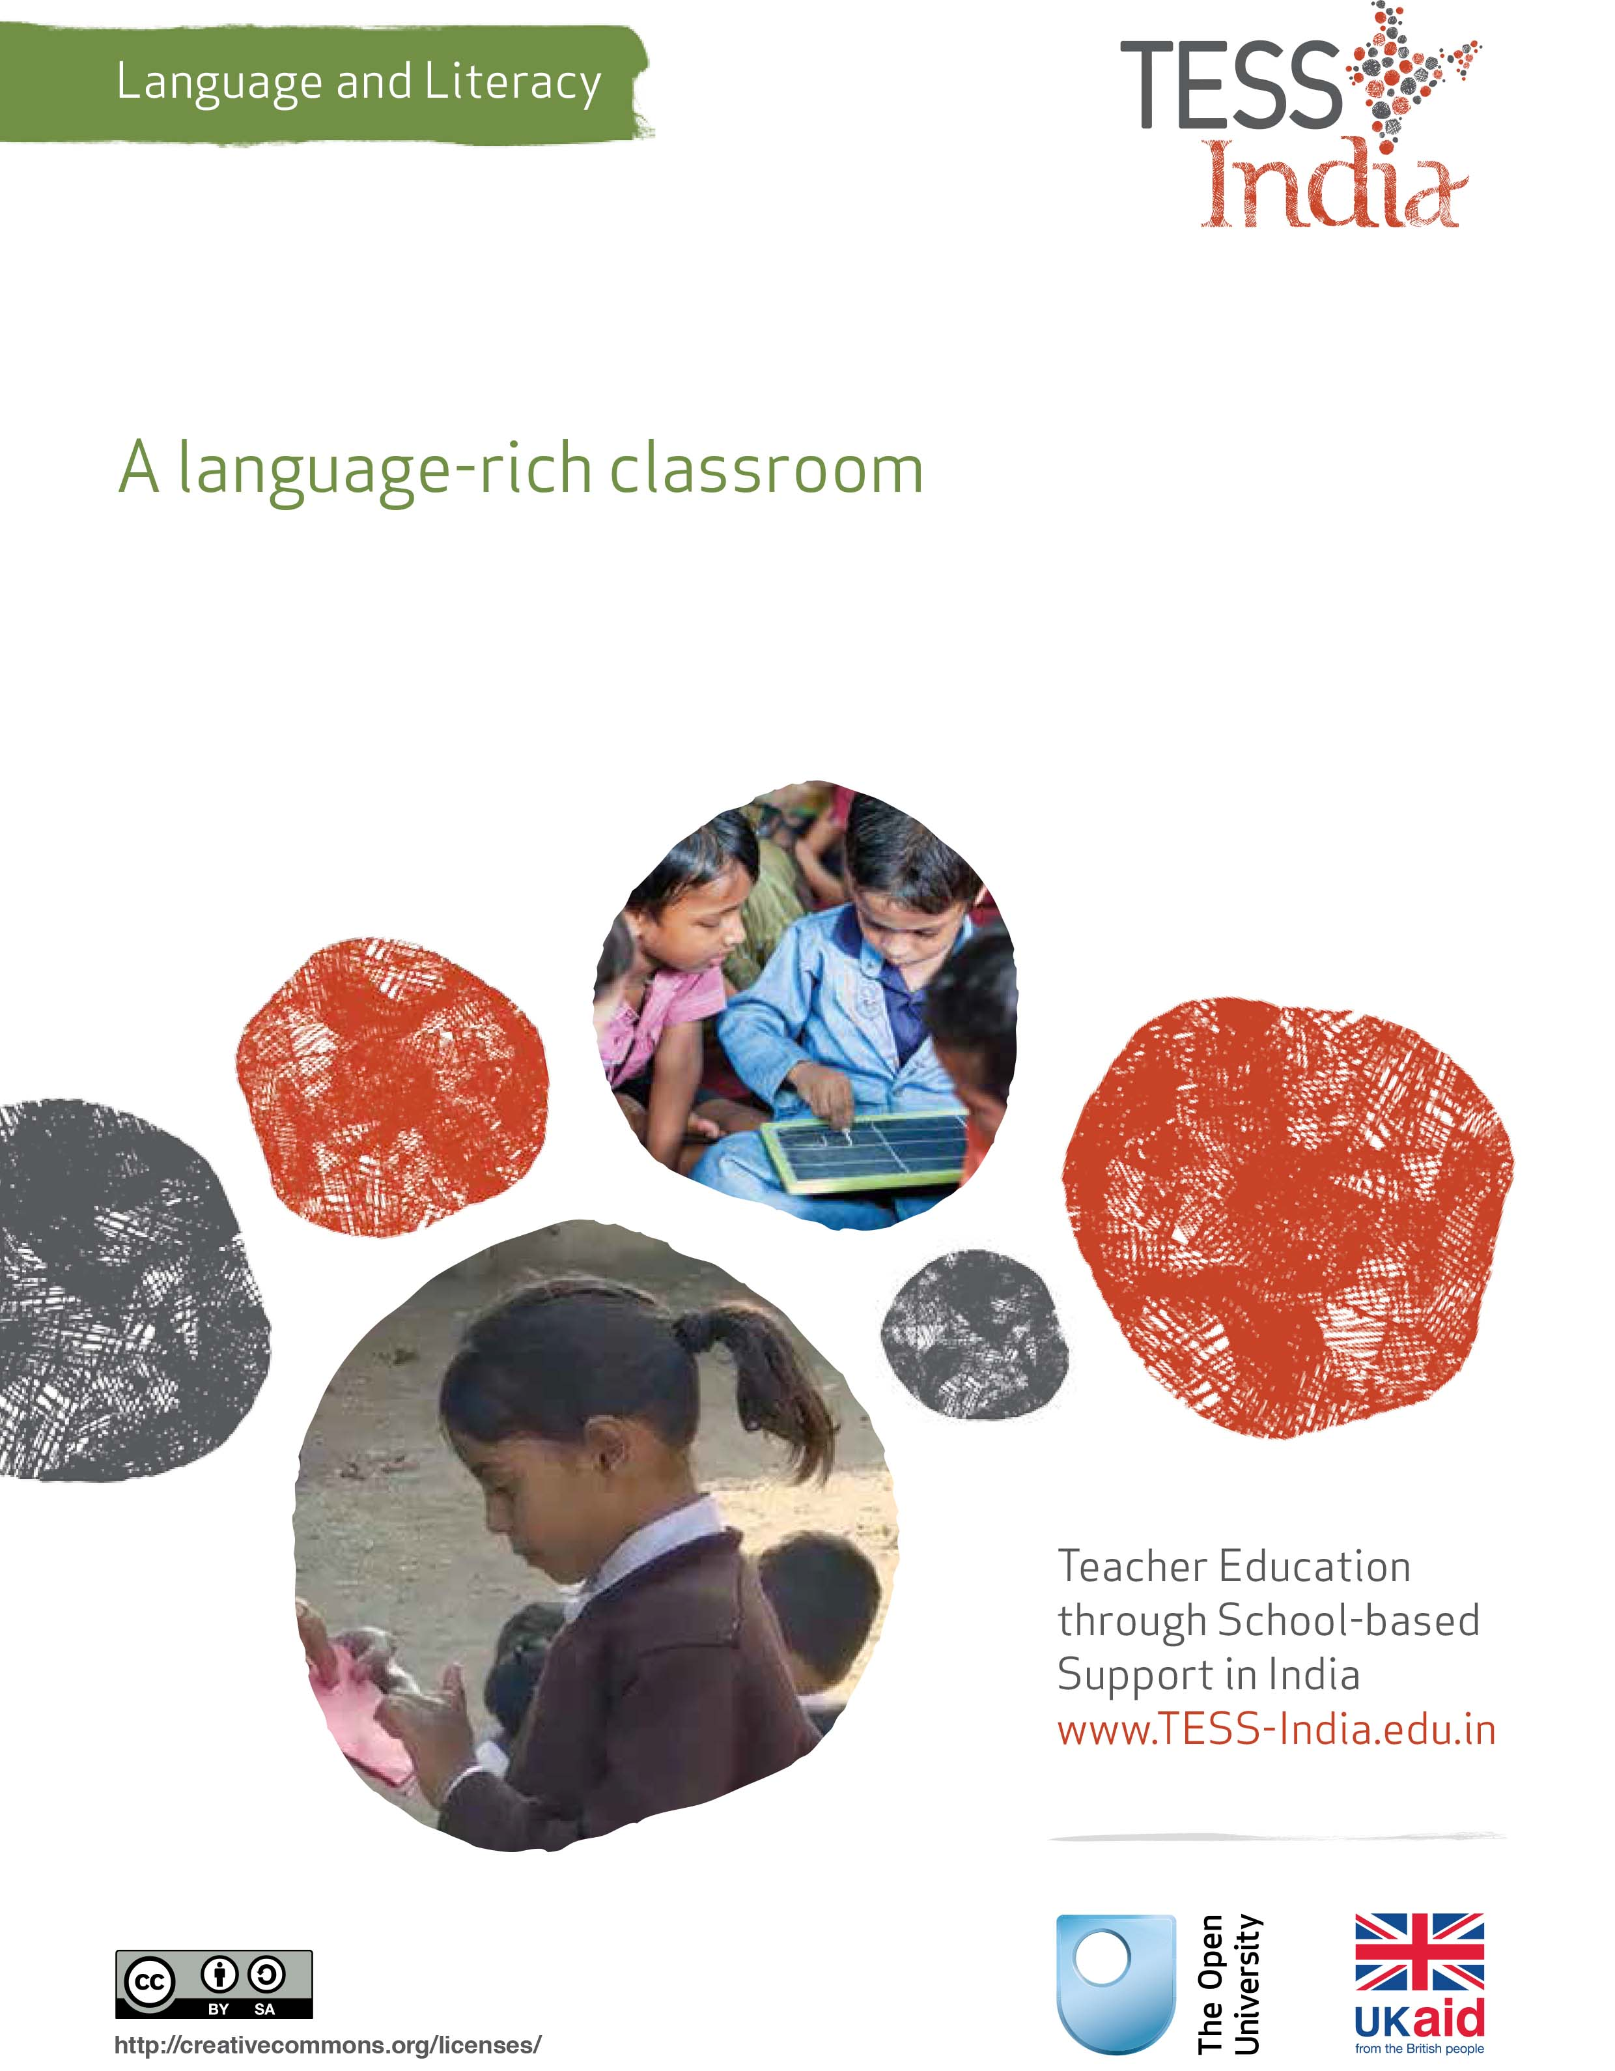
TESS-India (Teacher Education through School-based Support) aims to improve the classroom practices of elementary and secondary teachers in India through the provision of Open Educational Resources (OERs) to support teachers in developing student-centred, participatory approaches. The TESS-India OERs provide teachers with a companion to the school textbook. They offer activities for teachers to try out in their classrooms with their students, together with case studies showing how other teachers have taught the topic and linked resources to support teachers in developing their lesson plans and subject knowledge.
TESS-India OERs have been collaboratively written by Indian and international authors to address Indian curriculum and contexts and are available for online and print use (http://www.tess-india.edu.in/). The OERs are available in several versions, appropriate for each participating Indian state and users are invited to adapt and localise the OERs further to meet local needs and contexts.
TESS-India is led by The Open University UK and funded by UK aid from the UK government.
Video resources
Some of the activities in this unit are accompanied by the following icon: . This indicates that you will find it helpful to view the TESS-India video resources for the specified pedagogic theme.
The TESS-India video resources illustrate key pedagogic techniques in a range of classroom contexts in India. We hope they will inspire you to experiment with similar practices. They are intended to complement and enhance your experience of working through the text-based units, but are not integral to them should you be unable to access them.
TESS-India video resources may be viewed online or downloaded from the TESS-India website, http://www.tess-india.edu.in/). Alternatively, you may have access to these videos on a CD or memory card.

Version 2.0 LL02v1
All India - English
Except for third party materials and otherwise stated, this content is made available under a Creative Commons Attribution-ShareAlike licence: http://creativecommons.org/licenses/by-sa/3.0/

What this unit is about
In this unit you will explore simple yet effective ways of creating an imaginative, language-rich classroom in order to enhance your students’ engagement with different forms of natural speech and writing in the school environment.
You will be introduced to ways of exposing your students to spoken and written resources from outside school, to ideas for using texts on your classroom walls, and to practical, economical suggestions for making a reading corner for your students to enjoy.

What you can learn in this unit
- How to make appealing writing-based classroom wall displays.
- How to establish a reading corner for your students.
- How to use radio as a source of spoken language in the classroom.

Why this approach is important
In traditional classrooms, the teacher is the main source of spoken language and textbooks are the main source of written language. Lack of time and limited resources may discourage supplementing these with alternatives.
Students’ language and literacy development nevertheless benefits enormously from exposure to, and engagement with, varied sources of natural speech and writing. By enriching your students’ input with varied meaningful examples of spoken and written communication you will stimulate their imagination while increasing their understanding and production of words and phrases relating to a range of subjects. If you incorporate examples of your students’ home language into the classroom, you will demonstrate that their additional linguistic resources are valued and provide opportunities for their classmates to appreciate the different cultures and traditions they are associated with. Creating a language-rich classroom will thus have a positive impact on all your students’ learning.
This unit suggests a number of ways in which you can start to make your classroom more language-rich.

1 Examples of writing in the local environment
Children are exposed to a range of written language well before they start school – for example, on vehicles, shop signs, road directions, food packet labels, advertisements, posters, brand names, political slogans and graffiti, and in leaflets, books, newspapers and magazines. The following activity involves collecting examples of familiar forms of writing in the local environment as the basis for a simple reading and discussion activity in the classroom. It is particularly suited to younger students.
Figure 1 Street showing the ubiquity of environmental print.

Activity 1: Using environmental writing in your classroom
Produce a list of writing in your local environment that your students may be familiar with or find interesting. Look out for examples at home, on your journey to work and within the school grounds. Write the words or phrases that you have collected in large letters on strips of paper and fold them up.
Begin by explaining to your students what you have collected. Pair them up and distribute the strips. You may do this randomly, by getting pairs to pick one from a container, or selectively, by allocating strips according to your students’ ability.
Ask the pairs to unfold their strip, hold it up so their classmates can read it and read out what is written on it. In each case, invite a short discussion about where the writing might be found. Some words and expressions may need an explanation or further input from you.
Give each of your students a blank strip of paper and ask them to look for new words or phrases on their way home from school, in their home or in their neighbourhood over the next week. Use these for a similar pair activity or display them on the wall for other students to read and talk about.
Ask your students to bring into class any printed material they find in their home or village that is no longer being used and make a wall display from it.
If you have access to a camera and printer, you could take close-up photos of examples of environmental writing and print out copies to distribute or display.

Pause for thought
- Could you use this activity to assess your students?
- How could you adapt the activity for more advanced students?

2 Examples of writing in the classroom
The classroom can contain many examples of writing for your students to read. Such writing may be on the blackboard, on signs and notices, on charts, posters and labels, and in displays of your students’ work.
Case Study 1: Learning from writing in the classroom
Ms Shruti, a Class I teacher from Indore, shares her approach to creating a writing-rich classroom for her students.
I know that my young students need many opportunities to listen and speak in the classroom. Even though most can’t read and write yet, I recognise the importance of exposing them to different examples of text as well, whether handwritten or in print.
I have a small collection of colourful posters, such as alphabet (Varnamala) and word charts. These I position on the wall at the eye-level of the children.
I make name labels for each child, which I ask them to illustrate. I attach these next to the wall hooks where they store their coats and bags. I also have a set of folded-over cardboard name cards, which I place where I wish students to sit for particular activities, either in pairs or small groups. These labels are useful in helping my students to recognise their names in writing, as well as those of their classmates.
Using coloured paper, I also make labels for the different features of the classroom. These include words like ‘door’, ‘window’, ‘blackboard’, ‘cupboard’, ‘table’, ‘chair’, ‘desk’ and ‘clock’.
I ask my students to help me put the right label on each item. First I read the word aloud, focusing on the letters and matras. Then my students indicate where the label should go. Sometimes my students suggest another classroom item to label. In these instances, I say the names of the letters as I write out their suggestion.
In one part of the classroom, I have created a word wall. This is where I post up the new words that my students have encountered during the week. I also encourage my students to write these words up themselves.
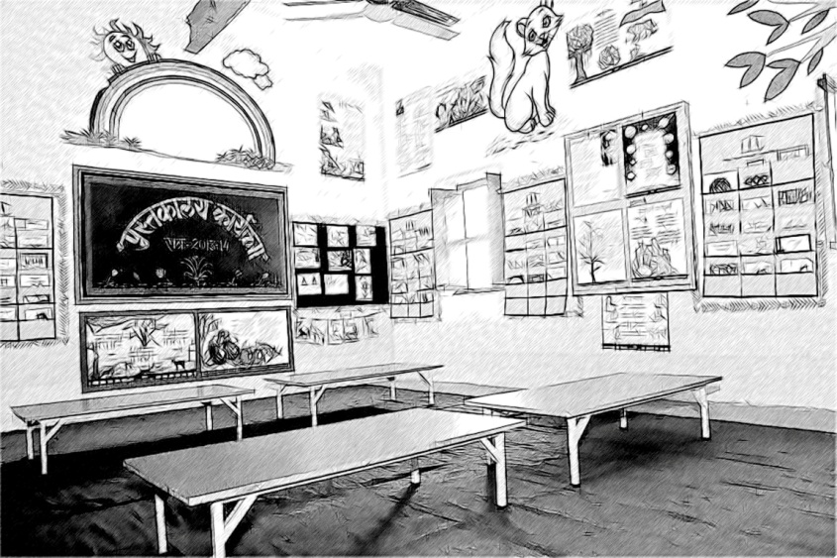
Figure 2 An example of a language-rich classroom.

Pause for thought
- In what ways are Ms Shruti’s ideas contributing to her students’ language and literacy development?
- Which of her ideas could you incorporate into your classroom?

Activity 2: Creating a writing-rich classroom
Set aside 15 minutes to notice ways in which writing currently features in your classroom:
- What form does this take?
- Is it stimulating for your students? How does it contribute to their learning?
- How often it is changed?
- If it includes your students’ work, how inclusive is the selection displayed?
Talk to two of your colleagues. What examples of writing feature on their classroom walls?
How can you increase and vary the range of student work you display in your classroom? How can you use your own writing imaginatively to provide interesting, age-appropriate reading materials for your students? Make a plan of your classroom wall space and consider how you could use it more effectively. Set yourself a commitment to add to or change some of the displays in your classroom every fortnight if possible. Encourage your colleagues to do the same. Visit one another’s classes every so often to view and learn from each other’s wall displays.

3 A classroom reading corner
Having a reading corner in your classroom provides students with a special place where they can hold books and explore their content independently.
It is important to involve students in the design and resourcing of a classroom reading corner. In this way they will want to use and improve it.
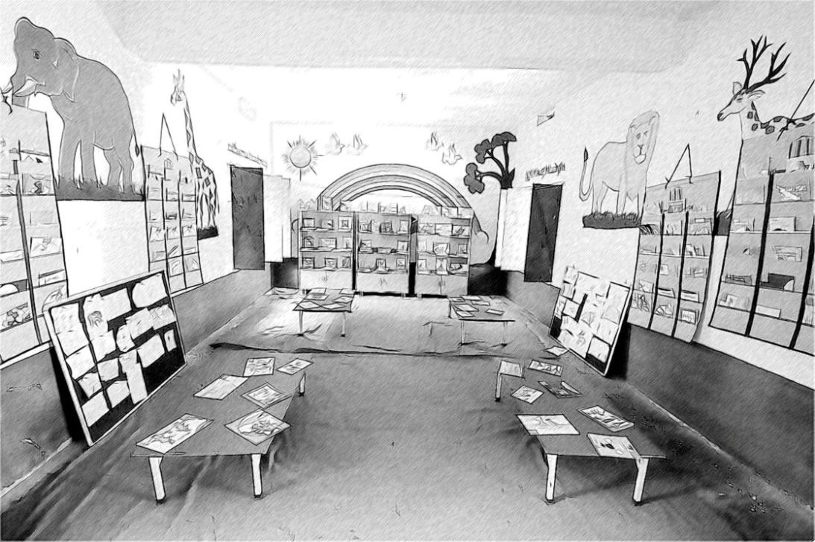
Figure 3 A classroom reading corner.
Case Study 2: Resourcing a classroom reading corner
Mr Dilip teaches Class III in a primary school in Madhya Pradesh. Here he describes how he collected together some books for a reading corner in his classroom.
I know how important it is for students to have the opportunity to handle books from a young age. Although my students enjoyed their textbooks, I wanted to offer them other materials to browse and read. However, funds to buy new books were in very limited supply.
I began by asking relatives and friends with older children if they had any books at home that their children no longer wanted. I wrote to the educational charities I knew and asked if they could contribute in any way. Finally, I used my annual TLM (teaching–learning material) allowance to purchase a few books.
I started my reading corner with just ten books. After two years I have built up a collection of almost 60 fiction and non-fiction books, which are suitable for a range of levels. I also have a range of magazines and newspapers. I now share these with other teachers in the school.

Activity 3: Incorporating a reading corner in your classroom
Working with a colleague if possible, make a plan for a reading corner in your classroom, noting down all the ideas that come to mind. Consider the following:
- What sources for obtaining suitable books and reading material are available to you?
- In what ways could your students contribute to the supply of material (for example, by creating books themselves)?
- Where could you locate a reading corner in your classroom?
- What do you need to set it up (for example, boxes to store the books, a mat for sitting on, etc.)? Where can you locate these items?
- How would you incorporate use of the reading corner into your classroom activities?
Resource 1 provides some useful ideas to help you introduce a reading corner in your classroom.

4 Radio as a classroom resource
Case Study 3: Using radio for language and literacy development
Mrs Rekha is a multi-grade teacher in in a rural primary school in Bihar. Here she describes how she uses radio as a resource in her language lessons.
My school has very few resources apart from the textbooks provided. I listen to the radio a great deal in my free time and have discovered a wide range of interesting programmes. I now regularly use the radio as an additional source of input in my students’ language lessons. I like the way it enables me to expose them to the world outside the classroom.
I use the radio programme guide in the newspaper to identify suitable programmes, based on the topics they will cover. I used to broadcast programmes directly in the classroom so needed to make sure that the timing was suitable, but now I have a radio with a recording facility, so I can select them in advance and replay them later.
I often get my students to listen to especially made educational programmes, because these are clearly presented and include one or two short comprehension tasks or other activities. We always spend time talking about the content of the programme afterwards. This is helpful in clarifying anything that hasn’t been understood. Sometimes we do this as a whole class. Sometimes I group my students and ask them to discuss the programme together. I usually follow up these discussions by asking my younger students to write a short text on the content of the programme and my older ones to write a longer report.
I also broadcast stories, plays and soap operas in the classroom. These lend themselves to discussions about the characters, the issues raised, or what might happen next. I sometimes invite my students to write out dialogues in their own words and act them out in role plays.
I like the way radio programmes expose my students to different voices, new expressions and different registers of language. During the programmes I note down any possible unfamiliar words and ask my students afterwards if they know, or can guess, what they mean. Sometimes they comment on the language they hear, pointing out that the presenter has pronounced a word in a particular way or used a word or expression when they would have used an alternative. Discussing these differences helps raise their awareness of the richness and variety of language.
I have also experimented with broadcasting a short section of a programme in one of my students’ home languages. I asked those who could understand it to explain to their classmates what the speaker said. I then asked them to repeat two or three of the key words that the speaker used and invited the rest of the class to repeat them orally. They wrote the words that they knew in their home language on the board and the rest of the class copied them into their exercise books. Everyone was very absorbed in this lesson.
For my students, using radio broadcasts complements listening to me all the time.

Pause for thought
- What language and literacy development opportunities do Mrs Rekha’s radio-based lessons provide her students?
- Do you foresee any challenges to using radio in the classroom? How might you overcome them?
The key resource ‘Involving all’ (http://tinyurl.com/kr-involvingall) contains more ideas on how to increase student participation in the classroom by valuing their home languages, for example.
Video: Involving all
http://tinyurl.com/video-involvingall

Activity 4: Using radio in your classroom
It is helpful to practise exploiting radio programmes for language and literacy development before you try using them in class.
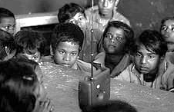
Figure 4 Listening to the radio in the classroom.
Over a period of a week or so, take time to listen to two or three radio programmes that you think could be suitable for your students. As you listen to them, think about what you want your students gain from the broadcast in terms of:
- aspects of its content
- their language and literacy development.
Next, imagine taking the class and rehearse aloud the kinds of questions and discussion points that you might raise with your students after the broadcast, taking into account their knowledge of the subject and their language and literacy levels.
Outline one or two activities that your students could do after the broadcast. These could involve speaking or writing or a mixture of both. Think about how you will organise your students, how long they will need, and how you will draw the class together at the end.
When you have practised this skill a few times, identify a suitable programme to broadcast directly, or to record and replay to your students at a later date. Plan as much of the lesson as you can in advance. Then try it out.

Pause for thought
- Did the lesson go as you expected?
- What would you do differently next time?
For further ideas on creating a language-rich classroom, see Resource 2, ‘Using local resources’.
Video: Using local resources
http://tinyurl.com/video-usinglocalresources

Summary
This unit has shown you some simple and economical ways to make your classroom more language-rich. It has suggested ideas that you can use in the classroom to ensure that your students are exposed to a variety of different sources of speech and writing. These include suggestions for making writing-based wall displays, establishing a reading corner for your students and using the radio in the classroom. Over time, you can build up a set of simple resources and activities to use with students of different levels to enhance lessons from the textbook and motivate them to engage with the writing and speech that they encounter in their environment.

Resources
Resource 1: Creating an appealing reading corner in your classroom
It can be difficult to find reading materials to supplement the school textbooks, but you will want to provide as much as possible that your students will want to read. Here are four ideas from teachers who have been developing their book areas and libraries in school:
- cut out suitable reading texts from colour magazines and paste them into books or on charts
- ask for donations of books and magazines from parents, members of the community or visitors to the school, where appropriate
- get in touch with NGOs such as ‘Room to Read’ and ‘Pratham’, and ask for donations of books
- use your TLM allowance to buy books.
Now think of how you can create a stimulating reading environment. Here are some ideas for you to get started:

Collecting reading resources
Collect as many reading materials as possible so that your collection changes and increases gradually. Ensure that your collection appeals to a range of levels of reading ability. Include a variety of genres among the books available, such as:
- storybooks
- factual books on sport, nature, making things, etc.
- dictionaries and atlases
- poetry
- joke and riddle books
- books in your students’ home languages, if possible.
Collect newspapers, magazines and comics to add to the collection. Encourage your students to find suitable reading materials from their communities.

Bookmaking
Your students can produce a book containing their own poems or short stories. They could write a short play or develop a book about a topic that has been focused on in their lessons. They can design a cover for their book to make others want to read it.

Special displays
Having a themed display on, for example, water or transport, encourages curiosity and discussion and is a good way of encouraging students to find out information for themselves. Book displays can be complemented by posters, pictures and photos on the wall. To maintain your students’ interest, try to vary wall displays every so often and include materials that they have produced themselves.
If you know the reading materials you have available well, you can guide your students to those that will give them the information that they are looking for.

Creating a reading corner
Identify a space in your classroom or school to create a reading area or corner. Put up a large sign so that its purpose is clear. Make an attractive and comfortable space for your students to read in. Put a mat down or add chairs if you can.
Ask for volunteers to act as librarians to look after and keep a record of the collected reading materials. Whether on shelves or in boxes, make sure the reading materials are displayed every day so students can access them easily. Invite different students to put them out and tidy them up on a regular basis. Encourage your students to help mend any books that get damaged or worn. The more your students are involved, the more they will take ownership of this space and its reading function.
Resource 2: Using local resources
Many learning resources can be used in teaching – not just textbooks. If you offer ways to learn that use different senses (visual, auditory, touch, smell, taste), you will appeal to the different ways that students learn. There are resources all around you that you might use in your classroom, and that could support your students’ learning. Any school can generate its own learning resources at little or no cost. By sourcing these materials locally, connections are made between the curriculum and your students’ lives.
You will find people in your immediate environment who have expertise in a wide range of topics; you will also find a range of natural resources. This can help you to create links with the local community, demonstrate its value, stimulate students to see the richness and diversity of their environment, and perhaps most importantly work towards a holistic approach to student learning – that is, learning inside and outside the school.

Making the most of your classroom
People work hard at making their homes as attractive as possible. It is worth thinking about the environment that you expect your students to learn in. Anything you can do to make your classroom and school an attractive place to learn will have a positive impact on your students. There is plenty that you can do to make your classroom interesting and attractive for students – for example, you can:
- make posters from old magazines and brochures
- bring in objects and artefacts related to the current topic
- display your students’ work
- change the classroom displays to keep students curious and prompt new learning.

Using local experts in your classroom
If you are doing work on money or quantities in mathematics, you could invite market traders or dressmakers into the classroom to come to explain how they use maths in their work. Alternatively, if you are exploring patterns and shapes in art, you could invite maindi [wedding henna] designers to the school to explain the different shapes, designs, traditions and techniques. Inviting guests works best when the link with educational aims is clear to everyone and there are shared expectations of timing.
You may also have experts within the school community (such as the cook or the caretaker) who can be shadowed or interviewed by students related to their learning; for example, to find out about quantities used in cooking, or how weather conditions impact on the school grounds and buildings.

Using the outside environment
Outside your classroom there is a whole range of resources that you can use in your lessons. You could collect (or ask your class to collect) objects such as leaves, spiders, plants, insects, rocks or wood. Bringing these resources in can lead to interesting classroom displays that can be referred to in lessons. They can provide objects for discussion or experimentation such as an activity in classification, or living or not-living objects. There are also resources such as bus timetables or advertisements that might be readily available and relevant to your local community – these can be turned into learning resources by setting tasks to identify words, compare qualities or calculate journey times.
Objects from outside can be brought into the classroom – but the outside can also be an extension of your classroom. There is usually more room to move outside and for all students to see more easily. When you take your class outside to learn, they can do activities such as:
- estimating and measuring distances
- demonstrating that every point on a circle is the same distance from the central point
- recording the length of shadows at different times of the day
- reading signs and instructions
- conducting interviews and surveys
- locating solar panels
- monitoring crop growth and rainfall.
Outside, their learning is based on realities and their own experiences, and may be more transferable to other contexts.
If your work outside involves leaving the school premises, before you go you need to obtain the school leader’s permission, plan timings, check for safety and make rules clear to the students. You and your students should be clear about what is to be learnt before you depart.

Adapting resources
You may want to adapt existing resources to make them more appropriate to your students. These changes may be small but could make a big difference, especially if you are trying to make the learning relevant to all the students in the class. You might, for example, change place and people names if they relate to another state, or change the gender of a person in a song, or introduce a child with a disability into a story. In this way you can make the resources more inclusive and appropriate to your class and their learning.
Work with your colleagues to be resourceful: you will have a range of skills between you to generate and adapt resources. One colleague might have skills in music, another in puppet making or organising outdoor science. You can share the resources you use in your classroom with your colleagues to help you all generate a rich learning environment in all areas of your school.

Additional resources
- NCERT’s Department of Education in Languages (look under ‘Activities’ and ‘Publications’, in particular): http://www.ncert.nic.in/departments/nie/del/index_dl.html
- Room to Read, India: http://www.roomtoread.org/india
- TeachingEnglish Radio India: http://www.britishcouncil.in/teach/teachingenglish-radio-india

References/bibliography
Austin, R. (ed.) (2009) Letting the Outside In. London: Trentham Books.
Bridges, L. (1995) Creating Your Classroom Community. Portland, ME: Stenhouse Publishers.
Department for Education and Skills (2006) Learning Outside the Classroom: Manifesto. London: DfES Publications. Available from: http://www.lotc.org.uk/wp-content/uploads/2011/03/G1.-LOtC-Manifesto.pdf (accessed 28 October 2014).
Gregory, M. (undated) ‘Creating a classroom library’ (online), Reading Rockets. Available from : http://www.readingrockets.org/article/creating-classroom-library (accessed 28 October 2014).
National Curriculum Framework 2005 – A Study Guide (2006) ‘Position papers by focus: NCF 2005’ (online). Available from: http://ncf2005.blogspot.co.uk/2009/07/position-papers-by-focus-groups-ncf.html (accessed 28 October 2014).
Webster, L. and Reed, S. (2012) The Creative Classroom. London: Collins.

Acknowledgements
Except for third party materials and otherwise stated below, this content is made available under a Creative Commons Attribution-ShareAlike licence (http://creativecommons.org/licenses/by-sa/3.0/). The material acknowledged below is Proprietary and used under licence for this project, and not subject to the Creative Commons Licence. This means that this material may only be used unadapted within the TESS-India project and not in any subsequent OER versions. This includes the use of the TESS-India, OU and UKAID logos.
Grateful acknowledgement is made to the following sources for permission to reproduce the material in this unit:
Figure 1: http://www.scillytoday.com/2012/08/09/islanders-return-from-doe-trip-to-india/india-street-scene/
Figure 4: https://www.flickr.com/photos/jordibernabeu/15155376815/
Every effort has been made to contact copyright owners. If any have been inadvertently overlooked the publishers will be pleased to make the necessary arrangements at the first opportunity.
Video (including video stills): thanks are extended to the teacher educators, headteachers, teachers and students across India who worked with The Open University in the productions.

