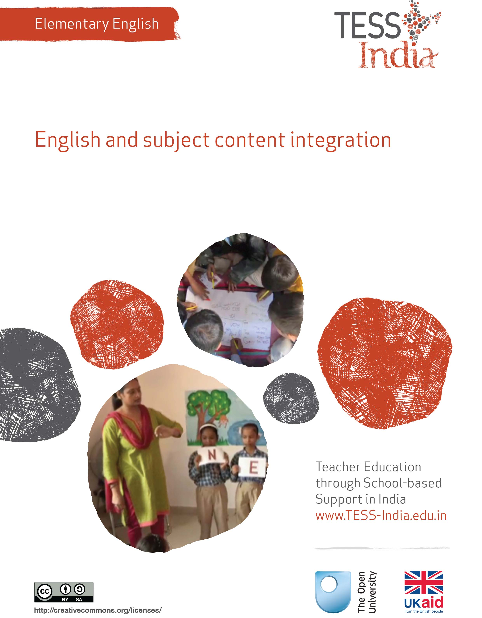
TESS-India (Teacher Education through School-based Support) aims to improve the classroom practices of elementary and secondary teachers in India through the provision of Open Educational Resources (OERs) to support teachers in developing student-centred, participatory approaches. The TESS-India OERs provide teachers with a companion to the school textbook. They offer activities for teachers to try out in their classrooms with their students, together with case studies showing how other teachers have taught the topic and linked resources to support teachers in developing their lesson plans and subject knowledge.
TESS-India OERs have been collaboratively written by Indian and international authors to address Indian curriculum and contexts and are available for online and print use (http://www.tess-india.edu.in/). The OERs are available in several versions, appropriate for each participating Indian state and users are invited to adapt and localise the OERs further to meet local needs and contexts.
TESS-India is led by The Open University UK and funded by UK aid from the UK government.
Video resources
Some of the activities in this unit are accompanied by the following icon: . This indicates that you will find it helpful to view the TESS-India video resources for the specified pedagogic theme.
The TESS-India video resources illustrate key pedagogic techniques in a range of classroom contexts in India. We hope they will inspire you to experiment with similar practices. They are intended to complement and enhance your experience of working through the text-based units, but are not integral to them should you be unable to access them.
TESS-India video resources may be viewed online or downloaded from the TESS-India website, http://www.tess-india.edu.in/). Alternatively, you may have access to these videos on a CD or memory card.

Version 2.0 EE09v1
All India - English
Except for third party materials and otherwise stated, this content is made available under a Creative Commons Attribution-ShareAlike licence: http://creativecommons.org/licenses/by-sa/3.0/

What this unit is about
This unit is about using English for learning in other subjects, and how other subjects can be resources for English language learning. When you combine English language teaching and subject teaching, English is not learned in isolation.
The academic content of the school curriculum is a strong and interesting basis for language learning. It is an effective method that is best done collaboratively with other teachers in your school or in your community, cluster or block.

What you can learn in this unit
- To identify English language learning opportunities in other subjects.
- To plan a thematic unit to use in your classroom.
- To integrate subject content and English language learning in your teaching.

1 One theme, many perspectives
Every subject has its own vocabulary and way of using language. Speaking, reading and writing about social studies is different from speaking, reading and writing about science. In the first case study that you will read, teachers plan a thematic unit that will also develop English.
Case Study 1: Ms Savitha plans a unit on the theme of water
Ms Savitha teaches English for students in Class VIII at a regional medium school in a metropolitan city. They had been facing water shortages and the onset of summer was set to aggravate the problem.
I wanted students to look at the theme of ‘water’ from different perspectives, so I spoke to teachers of other subjects.
- In science, there was a unit on water that the teacher had already planned for that month, so she agreed to team teaching.
- The mathematics teacher said that the students needed reinforcement in volume measurement and felt she could weave that into the theme.
- The regional language teacher was a theatre enthusiast and volunteered to help the students to create a play on water conservation and rain water harvesting, which they could stage in their neighbourhoods.
- The social science teacher did not see a direct relevance between the theme and the textbook he was covering, but he agreed to strengthen students’ map-reading skills. During team planning, this teacher decided that students could learn about the connection between water sources and human settlements.
Here is what we all came up with at first, looking at water from the following perspectives [Figure 1].
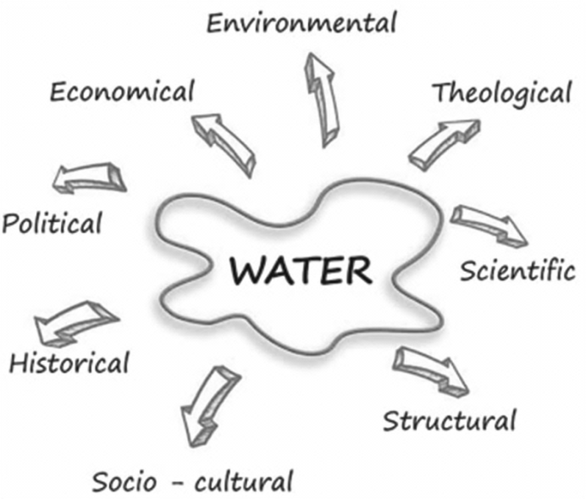
Figure 1 Perspectives on the theme of water.
Then we listed multiple activities relating to a water theme [Figure 2].
Figure 2 Multiple activities related to the theme of water.
I listed the English vocabulary and language structures that I would be focusing on. I also planned to get the students to collect stories and songs related to water in their home languages and dialects. We could later use these for simple translation activities, such as finding English equivalents for a few words, translating simple phrases and sentences, or refrains from songs.
Once we listed all the potential activities, we felt we would need a month to carry them out with our students.

Pause for thought
What English vocabulary and sentences do you think Ms Savitha listed on the theme of water? List your own ideas for some English words and phrases around the theme of water. These words could be linked to:
- poetry and creative writing
- actions (pour, wash, drink, splash)
- environmental campaigns (don’t waste water).
Try to list some words and phrases in English linked to other subjects. In mathematics, for instance, these could be ‘capacity’ and ‘estimate the volume of water in the container’.

Think about your own school. What topics or themes are the other subject teachers doing right now? Are they teaching topics where some English language could be practised? Are there study materials from these topics that you could integrate into your language lesson?

Video: Using local resources
http://tinyurl.com/video-usinglocalresources

2 Using paper as a theme

Activity 1: English in a thematic unit on ‘paper’
Figure 3 shows English-language activities on the theme of paper for middle school students. Note how the teacher has focused on the English-language features within each specific activity.
Figure 3 Multiple English-language activities related to the theme of paper.
Looking at Figure 3, identify the following:
- How each activity listed in the diagram relates to a school subject.
- How much time would be needed to do these activities in a large class.
- What resources would be required.
Whether a single teacher can do all these activities, or should it be a collaboration with other subject teachers.
In the next case study, read about how a teacher plans to develop students’ English through an activity that incorporates mathematics and paper craft.
Case Study 2: Mr Bajwa integrates English and mathematics in paper craft
Mr Bajwa teaches Class VII. Note that a flexagon template is available in Resource 1.
In a thematic unit on paper, I was focusing on English language. I consulted with the mathematics and science teachers, and planned a paper craft activity. Students would make a paper geometric shape that could be used to present science information.
I have a large class of 48 students. The English period was just after lunch. I requested four students to come ten minutes early and asked them to help me place a sheet of paper for each student on their desks. One of the students in my class, Savitha, is blind. I had consulted the special educator when she visited our school the previous week. She suggested that I could give Savitha a sheet of sandpaper for this activity.
I gave the instructions in English. I had practised this before the lesson. This is what I said, slowly, step by step, demonstrating as I went:
We are going to make a flexagon today.
I have given each of you a 20 × 10 square centimetre sheet of paper. Now listen to my instructions carefully. I will demonstrate, and I will repeat everything twice. Please listen to the instructions carefully. You may ask for help after I complete my instructions.
Are you all ready? Shall we begin?
First, firmly crease the middle line of the rectangle along the length, and firmly fold the long edges to this midline.
Second, fold to make eight equal segments along the width. You now have eight rectangles – four along the top of the middle line and four along the bottom of this line.
Next, with a pencil, carefully draw diagonals inside each of the rectangles you have folded. Crease them well. Then, bring the paper’s left and right sides together and insert one side inside the other, making a three-dimensional prism.
Next, gently push in the three triangular areas at the top of each other. Then carefully press all the three top points down and through the centre.
Can you see that the next row of triangles makes a similar shape?
Once again, press all three top points down and through the centre.
Finally, turn the model over and gently push in the three triangular areas at the top of each other.
Your flexagon is now ready. You can use this to show a cycle such as the food chain by drawing a different picture on each of its faces. How many of you were able to complete the flexagon? Who needs help?
I was happy to note that, with a little help from her neighbour, Savitha had also completed her flexagon.

Pause for thought
Mr Bajwa developed a mathematical activity where students were actively involved in listening to English as they made a resource for learning. He started by establishing rules to ensure classroom management during the activity. He repeated his instructions in different ways. The visual aid of the flexagon reinforced all the language learning.
- Identify the English language that Mr Bajwa used that was:
  - mathematical
  - instructional and about sequencing
  - general to classroom management.
- What did he repeat, and why?
- Which words and phrases have similar meanings?
- Can you identify what Mr Bajwa wanted students to learn in the flexagon lesson about mathematics and in English? These were:
  - Mathematics: To develop and use mathematical vocabulary accurately in a practical context – ‘centimetre’, ‘rectangle’, ‘edge’, ‘diagonal’, ‘three-dimensional’, ‘prism’, ‘triangular’.
  - English: To follow a set of instructions in English; to understand and use sequential language (‘first’, ‘second’, ‘next’, ‘then’, ‘finally’); and to hear and respond to imperatives.
- Are there other learning aims you could identify in the lesson for other subjects or for the students’ general development?
- What do you think of Mr Bajwa’s strategy for distributing resources? How would you do it differently?
- Can all the students in the class take part in this activity? Why or why not?

3 English and subject content integration in your classroom

Activity 2: Choose a theme and activities – a planning activity
- With your colleagues, select a theme on any curriculum topic.
- Brainstorm and list activities around the theme you have selected.
- You should then focus on the English language learning in activities. Talk with subject teachers about suitable activities and collectively decide on the vocabulary and communication skills that you want students to develop.
- Estimate the time you would need to implement the activities – would you take a week, or longer?
- Make a list of all the resources and materials you would need.
- Discuss how you will assess students in the topic work, both for English language and for the subject.
See Resource 1 for planning templates to help you and your colleagues organise your ideas.
It is good practice to prepare your students and share the plan with them, especially if they have not done a thematic unit before. Think about how you will introduce the unit and the activities to the class.
When you implement your thematic unit, maintain a diary. Make notes on:
- what worked and why, and what didn’t work and why
- what problems you faced and how you addressed them
- your individual reflections and collective reflections with your colleagues
- students’ responses and opportunities for assessment.
As you do the activities with your students, monitor the new English vocabulary and sentence structures that they are learning. Reinforce the language aspects that students are already familiar with. Give individual attention so that you can track students’ progress in learning English – you can do this with different students over time.
At the end of the thematic unit you can showcase your students’ work to other students in the school and to their parents. The showcase could be a display of their work or a performance.
See Resource 2, ‘Assessing progress and performance’ to learn about methods to evaluate and record student learning in thematic projects.

4 Summary
In this unit we have focused on content and English language integration in thematic units.
A thematic unit involves planning subject and language activities around a common theme for a week or more. How much time you allot for a theme depends on the amount of content you wish to cover, the age group and abilities of your students and, of course, the overall time available to implement the lessons.
Thematic units involve coordination and planning with other subject teachers. But teachers who have tried this approach feel extremely satisfied at the outcomes. Students also find the experience very fulfilling. If you have never tried integrating English with another subject, we hope you now feel confident to try out one or two ideas in your school.
Other Elementary English teacher development units on this topic are:
- Learning English in the creative arts
- Community resources for English
- Planning around a text.

Resources
Resource 1: Planning templates
A graphic organiser is a pictorial way of organising information. There are many different types. It is a useful resource to list language activities around a theme and can be used for clarifying thinking or summarising.
Graphic organisers also help us to remember better (Figures R1.1–5). They can be used by teachers for planning, during teaching and for assessing students. They can be used by students for taking notes, consolidating their learning or as a ready reckoner for recall.

Figure R1.1 Venn: if you are planning across two subjects, such as English and Science.

Figure R1.2 Web: for listing all activities on a theme.

Figure R1.3 Sequence chain: one activity sequentially leads to the next.

Figure R1.4 Pyramid: students must complete ‘baseline’ activities before they
can do the next activities, which will require the baseline knowledge or skills.

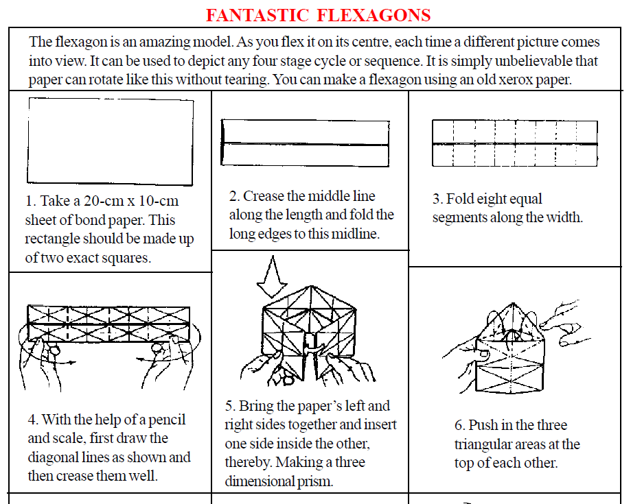
Figure R1.5 Flexagon: see Case Study 2.

Resource 2: Assessing progress and performance
Assessing students’ learning has two purposes:
- Summative assessment looks back and makes a judgement on what has already been learnt. It is often conducted in the form of tests that are graded, telling students their attainment on the questions in that test. This also helps in reporting outcomes.
- Formative assessment (or assessment for learning) is quite different, being more informal and diagnostic in nature. Teachers use it as part of the learning process, for example questioning to check whether students have understood something. The outcomes of this assessment are then used to change the next learning experience. Monitoring and feedback are part of formative assessment.
Formative assessment enhances learning because in order to learn, most students must:
- understand what they are expected to learn
- know where they are now with that learning
- understand how they can make progress (that is, what to study and how to study)
- know when they have reached the goals and expected outcomes.
As a teacher, you will get the best out of your students if you attend to the four points above in every lesson. Thus assessment can be undertaken before, during and after instruction:
- Before: Assessing before the teaching begins can help you identify what the students know and can do prior to instruction. It determines the baseline and gives you a starting point for planning your teaching. Enhancing your understanding of what your students know reduces the chance of re-teaching the students something they have already mastered or omitting something they possibly should (but do not yet) know or understand.
- During: Assessing during classroom teaching involves checking if students are learning and improving. This will help you make adjustments in your teaching methodology, resources and activities. It will help you understand how the student is progressing towards the desired objective and how successful your teaching is.
- After: Assessment that occurs after teaching confirms what students have learnt and shows you who has learnt and who still needs support. This will allow you to assess the effectiveness of your teaching goal.
Before: being clear about what your students will learn
When you decide what the students must learn in a lesson or series of lessons, you need to share this with them. Carefully distinguish what the students are expected to learn from what you are asking them to do. Ask an open question that gives you the chance to assess whether they have really understood. For example:

How can you convince me that you have understood what I have just said?
Who can explain in their own words what we are going to learn and what we have to do today?
Shavi, what do you think you will learn today?

Give the students a few seconds to think before they answer, or perhaps ask the students to first discuss their answers in pairs or small groups. When they tell you their answer, you will know whether they understand what it is they have to learn.
Before: knowing where students are in their learning
In order to help your students improve, both you and they need to know the current state of their knowledge and understanding. Once you have shared the intended learning outcomes or goals, you could do the following:
- Ask the students to work in pairs to make a mind map or list of what they already know about that topic, giving them enough time to complete it but not too long for those with few ideas. You should then review the mind maps or lists.
- Write the important vocabulary on the board and ask for volunteers to say what they know about each word. Then ask the rest of the class to put their thumbs up if they understand the word, thumbs down if they know very little or nothing, and thumbs horizontal if they know something.
Knowing where to start will mean that you can plan lessons that are relevant and constructive for your students. It is also important that your students are able to assess how well they are learning so that both you and they know what they need to learn next. Providing opportunities for your students to take charge of their own learning will help to make them life-long learners.
During: ensuring students’ progress in learning
When you talk to students about their current progress, make sure that they find your feedback both useful and constructive. Do this by:
- helping students know their strengths and how they might further improve
- being clear about what needs further development
- being positive about how they might develop their learning, checking that they understand and feel able to use the advice.
You will also need to provide opportunities for students to improve their learning. This means that you may have to modify your lesson plans to close the gap between where your students are now in their learning and where you wish them to be. In order to do this you might have to:
- go back over some work that you thought they knew already
- group students according to needs, giving them differentiated tasks
- encourage students to decide for themselves which of several resources they need to study so that they can ‘fill their own gap’
- use ‘low entry, high ceiling’ tasks so that all students can make progress – these are designed so that all students can start the task but the more able ones are not restricted and can progress to extend their learning.
By slowing the pace of lessons down, very often you can actually speed up learning because you give students the time and confidence to think and understand what they need to do to improve. By letting students talk about their work among themselves, and reflect on where the gaps are and how they might close them, you are providing them with ways to assess themselves.
After: collecting and interpreting evidence, and planning ahead
While teaching–learning is taking place and after setting a classwork or homework task, it is important to:
- find out how well your students are doing
- use this to inform your planning for the next lesson
- feed it back to students.
The four key states of assessment are discussed below.

Collecting information or evidence
Every student learns differently, at their own pace and style, both inside and outside the school. Therefore, you need to do two things while assessing students:
- Collect information from a variety of sources – from your own experience, the student, other students, other teachers, parents and community members.
- Assess students individually, in pairs and in groups, and promote self-assessment. Using different methods is important, as no single method can provide all the information you need. Different ways of collecting information about the students’ learning and progress include observing, listening, discussing topics and themes, and reviewing written class and homework.
Recording
In all schools across India the most common form of recording is through the use of report card, but this may not allow you to record all aspects of a student’s learning or behaviours. There are some simple ways of doing this that you may like to consider, such as:
- noting down what you observe while teaching–learning is going on in a diary/notebook/register
- keeping samples of students’ work (written, art, craft, projects, poems, etc.) in a portfolio
- preparing every student’s profile
- noting down any unusual incidents, changes, problems, strengths and learning evidences of students.
Interpreting the evidence
Once information and evidence have been collected and recorded, it is important to interpret it in order to form an understanding of how each student is learning and progressing. This requires careful reflection and analysis. You then need to act on your findings to improve learning, maybe through feedback to students or finding new resources, rearranging the groups, or repeating a learning point.
Planning for improvement
Assessment can help you to provide meaningful learning opportunities to every student by establishing specific and differentiated learning activities, giving attention to the students who need more help and challenging the students who are more advanced.

Additional resources
- Teachers of India classroom resources: http://www.teachersofindia.org/en
- ‘Children talk their way into literacy’ by Gordon Wells: http://people.ucsc.edu/~gwells/Files/Papers_Folder/Talk-Literacy.pdf

References/bibliography
Amritavalli, R. (2007) English in Deprived Circumstances: Maximising Learner Autonomy. Department of Linguistics, The English and Foreign Languages University, University Publishing Online: Foundation Books.
Cummins, J. (2000) Language, Power, and Pedagogy: Bilingual Children in the Crossfire. Bristol: Multilingual Matters.
Cummins, J. (undated) ‘BICS and CALP’ (online), Jim Cummins’ Second Language Learning and Literacy Development Web. Available from: http://iteachilearn.org/cummins/bicscalp.html (accessed 2 July 2014).
Gibbons, P. (2002) Scaffolding Language, Scaffolding Learning: Teaching Second Language Learners in the Mainstream Classroom. Portsmouth: Heinemann.
Hastings, S. (2003) ‘Questioning’, TES Newspaper, 4 July. Available from: http://www.tes.co.uk/article.aspx?storycode=381755 (accessed 22 September 2014).
Hattie, J. (2012) Visible Learning for Teachers: Maximising the Impact on Learning. Abingdon: Routledge.
Krashen, S. (1981) Second Language Acquisition and Second Language Learning. Oxford: Pergamon Press.
Krashen, S. (1982) Principles and Practice in Second Language Acquisition. Oxford: Pergamon Press.
Mohan, B. (1986) Language and Content. Reading: Addison-Wesley.
Mohan, B., Leung, C. and Davison, C. (eds) (2001) English as a Second Language in the Mainstream: Teaching, Learning and Identity. New York, NY: Longman.
Wells, G. (2009) The Meaning Makers: Learning to Talk and Talking to Learn, 2nd edn. Bristol: Multilingual Matters.

Acknowledgements
Except for third party materials and otherwise stated below, this content is made available under a Creative Commons Attribution-ShareAlike licence (http://creativecommons.org/licenses/by-sa/3.0/). The material acknowledged below is Proprietary and used under licence for this project, and not subject to the Creative Commons Licence. This means that this material may only be used unadapted within the TESS-India project and not in any subsequent OER versions. This includes the use of the TESS-India, OU and UKAID logos.
Grateful acknowledgement is made to the following sources for permission to reproduce the material in this unit:
RV VSEI Resource Centre (http://www.rvec.in/).
Every effort has been made to contact copyright owners. If any have been inadvertently overlooked the publishers will be pleased to make the necessary arrangements at the first opportunity.
Video (including video stills): thanks are extended to the teacher educators, headteachers, teachers and students across India who worked with The Open University in the productions.

