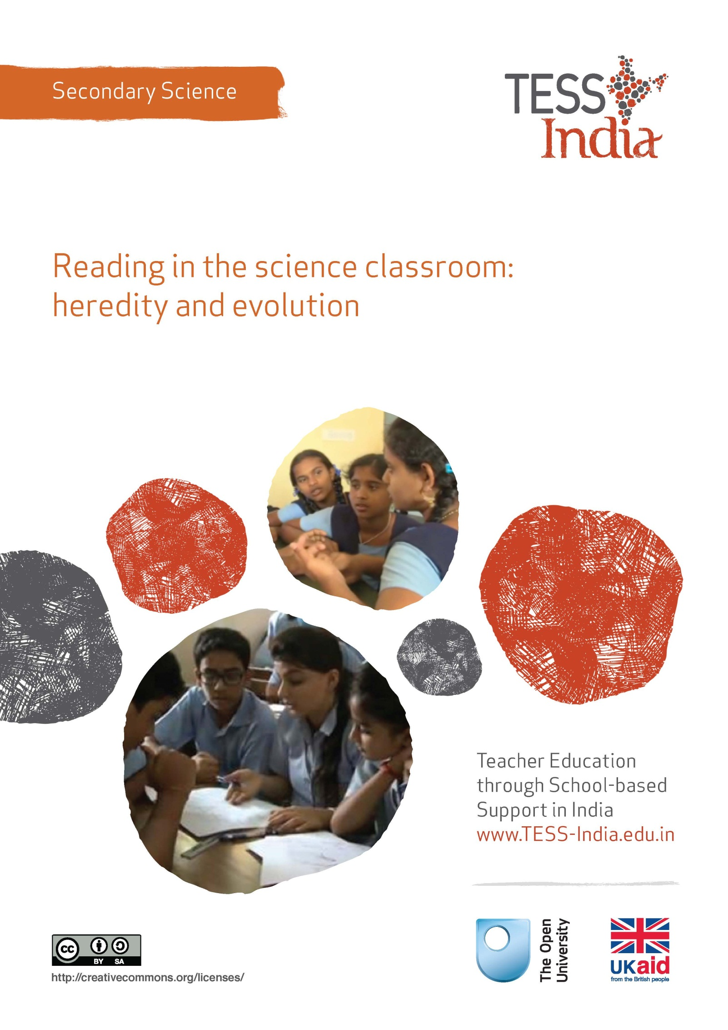
TESS-India (Teacher Education through School-based Support) aims to improve the classroom practices of elementary and secondary teachers in India through the provision of Open Educational Resources (OERs) to support teachers in developing student-centred, participatory approaches. The TESS-India OERs provide teachers with a companion to the school textbook. They offer activities for teachers to try out in their classrooms with their students, together with case studies showing how other teachers have taught the topic and linked resources to support teachers in developing their lesson plans and subject knowledge.
TESS-India OERs have been collaboratively written by Indian and international authors to address Indian curriculum and contexts and are available for online and print use (http://www.tess-india.edu.in/). The OERs are available in several versions, appropriate for each participating Indian state and users are invited to adapt and localise the OERs further to meet local needs and contexts.
TESS-India is led by The Open University UK and funded by UK aid from the UK government.
Video resources
Some of the activities in this unit are accompanied by the following icon: . This indicates that you will find it helpful to view the TESS-India video resources for the specified pedagogic theme.
The TESS-India video resources illustrate key pedagogic techniques in a range of classroom contexts in India. We hope they will inspire you to experiment with similar practices. They are intended to complement and enhance your experience of working through the text-based units, but are not integral to them should you be unable to access them.
TESS-India video resources may be viewed online or downloaded from the TESS-India website, http://www.tess-india.edu.in/). Alternatively, you may have access to these videos on a CD or memory card.

Version 2.0 SS02v1
All India - English
Except for third party materials and otherwise stated, this content is made available under a Creative Commons Attribution-ShareAlike licence: http://creativecommons.org/licenses/by-sa/3.0/

What this unit is about
A very important resource that helps you to teach science to your students is the science textbook. To make the most of their science textbooks your students need to have effective reading skills. Although all of your Class IX and X students can read, many do not always read their textbooks with a good understanding. Teachers make assumptions about the reading skills that their students have. Quite often teachers believe that their students understand more than they actually do. Then teachers may be disappointed with their students’ exam results.
Reading is an important life skill. The ability to be a good reader is a very important skill that every student needs to have to do well at school. Reading in science is an important part of learning to understand science. Because there is a lot of science to teach, reading and the development of reading skills are often neglected in science classrooms.
This unit will help you to make the most of your science textbooks by introducing you to some teaching strategies that will develop the reading skills of your students. These teaching strategies are explained using examples from the Class X topic of heredity and evolution. These ideas can be used anywhere in the science curriculum.

What you can learn in this unit
- The benefits of developing your students’ reading skills.
- How to use a range of activities that will develop your student’s reading skills.
- Strategies that will help your students to actively engage with their textbook as a resource for learning science.

Why this approach is important
Textbooks are a very important resource and all students need to be encouraged to use them productively. When vague, general and individual reading activities are given to students, they read passively. They do not necessarily understand the meaning of the text particularly well. Reading that is done in this way has little benefit to the student. This is true in all curriculum subjects, not just in science.
When reading activities are done in pairs with a clear purpose and the text is discussed, manipulated and reworked, your students are able to take more meaning from what they are reading. These are active reading strategies. By using active reading strategies more often in your science lessons you will find that your students become more critical, reflective and analytical than before. Most importantly, they will understand their science better. You can use these activities to evaluate how your students’ understanding of science and skills are developing.
Pause for thought
- Normally, how much reading do you do with your students in science lessons?
- How well do you think your students can read?
- How could you find out how well your students can read?

Active reading strategies
There are many types of active reading strategies to choose from as a teacher. Active reading strategies can be used anywhere in the science curriculum. This unit will begin by showing you some simple strategies that are available. It will then go on to develop the ideas behind some of the more complex strategies. The main strategies that the unit will cover are:
- underlining key words
- filling in the missing words
- completing the diagram
- unscrambling the text
- applying what you read.

1 Underline key words
This particular strategy is a very straight forward for your students. ‘Underline key words’ involves very little preparation or resources. The main idea behind it is that students search through a piece of text to find a ‘target’. The targets can be words, sentences or phrases. Concepts or ideas can also be used as targets. You decide what the targets are for each piece of text you want to use.
Once your students have found the targets, they can either underline, circle or highlight them. If you are using the textbook, using a pencil to do this means that the marking can be rubbed out. Activity 1 shows you how to carry out an example of this simple activity in the context of codominance with your students.

Activity 1: Underlining key words on codominance
This is an activity for you to do with your students.
Introduce the topic of the activity as codominance and write the words ‘codominance’, ‘phenotype’, ‘allele’, and ‘dominant‘ on the blackboard. Then explain to your students what they are required to do.
- Work with the person sitting next to you.
- Read the information on codominance. (Use the worksheet found in Resource 1 or this section in their textbook.)
- Find and underline in pencil these key words written on the blackboard:
- codominance
- phenotype
- allele
- dominant.
Then ask students to work with the person next to them. Each person uses the text (or textbook) to work out a definition for two of the words. They should then discuss each other’s definitions. Once they have agreed they should write all four definitions into their exercise book.
Then ask some of the pairs of students to share definitions with the whole class so that you can develop a shared set of definitions with the class. Make sure everyone has an accepted set of definitions written in their book.
Finally write some questions on the blackboard that will test their understanding of the definitions. Working with a different partner, they should discuss the answers to the questions before writing their answers.
This activity demonstrates just how simple this type of active reading activity can be to plan and use with your students. Having carried out this activity, there would be many ways in which to then progress with your students. For example, you could ask them if they can give any more examples of codominance in nature.
Many active reading strategies can be done very effectively in pairs – see the key resource ‘Using pair work’ (http://tinyurl.com/kr-usingpairwork).
Video: Using pair work
http://tinyurl.com/video-usingpairwork

2 Fill in missing words
Another simple active reading strategy is ‘Fill in the missing words’. It uses the simple idea of removing some words from a section of text. Your students’ task is to copy out the text correctly predicting and then inserting the missing words. Students usually really like doing this activity. Activity 2 allows you to put yourself in the place of one of a student who is studying inheritance. This way you will be able to see what doing the activity feels like for you.

Activity 2: Fill in the missing words on ‘Mendel’s Laws of Inheritance’
This activity is for you do to on your own.
- Read the text on ‘Mendel’s Laws of Inheritance’ below.
- You will notice that there are some words missing.
- Copy out the text, but insert a word into each gap to make complete sentences.
… was a Czech monk who carried out controlled breeding experiments with mice and pea plants to find out about …. He published his ideas on inheritance in … but they were not very well received because … of the time were not really interested in the mathematical treatment of scientific results, or keen on the idea that there was a ‘… unit’. It was not until … that Mendel’s Laws of Inheritance were accepted by ….
Mendel’s Laws are:
- That a heritable unit called a … is passed on from one generation to the next.
- That genes can exist in different forms that are called alleles.
- That each individual must have two alleles per feature.
- That the sex cells can only have one … per feature.
- One allele can be … over the other.

Pause for thought
- Have you tried something like this before? If so, how did it go?
- How do you think your students will respond to this technique? Where could you use it in your teaching next week?
You can check that you have correctly filled in the missing blanks by looking at the answer which is given as Resource 1.
Activity 2 uses modified text that must be prepared in advance. The level of difficulty of the activity can be changed quite easily – for example, by:
- increasing or reducing the number of missing words
- increasing or decreasing the amount of text
- supplying all, some or none of the missing words
- supplying the first or last letter of the missing words.
Perhaps you can think of some more ways to modify the activity. One important point to note is that if a ‘Fill in the missing words’ activity is not well thought out and checked in advance to make sure that it works, it can go wrong when you use it the classroom.

3 Complete the diagram
‘Complete the diagram’ is a diagrammatic version of ‘Fill in the missing words’. It uses the same idea of getting students to complete something that is incomplete. You can use an incomplete diagram, chart or table. The same kinds of modifications as above can be made to adjust the level of difficulty for your students to this strategy.
Figure 1 is an example of a diagram on a pea plant cross diagram you could ask your students in small groups to complete when you are teaching about rules for the inheritance of traits.
Figure 1 An example of a pea plant cross diagram

4 Unscramble the text
In this strategy, students work to logically reorder some information. The scrambled information can be in the form of pictures, words, sentences or instructions. This is a more complex active reading activity. It requires more preparation from the teacher. It also is more demanding for the student, because the student has to think about both the meaning of the information and also the correct sequencing of it. It is a two-stage thinking process for the student.

Activity 3: Unscrambling the text to learn about fossil formation
This is an activity for you to plan and then do with your class.
Figure 2 is from the Class X textbook. It uses a series of pictures and associated text sections to show how fossils were created and how they can now be found. It is a good resource for an unscrambling activity.
Figure 2 An image of a page from ‘How do fossils form
layer by layer?’, Chapter 9 of the Class X textbook.
There are two basic ways in which this resource can be used to create an unscrambling activity, one where the text can be unscrambled and one where the pictures can be unscrambled. A third complex version would be unscrambling the text and the pictures at the same time. If you don’t have access to a photocopier, the easiest version to plan for is that of unscrambling the text. You could ask your students to close their textbooks and write the sentences that need to be ordered on the blackboard (see Resource 3).
Test your plan with a colleague and adjust it for any feedback received. Use your plan with your Class X students when you are next teaching Chapter 9. This approach could also be used effectively with an experimental method. Write the steps in a random order and ask your students to put them in the correct order.
How did your students react to the activity? What did it tell you about their understanding of the formation of fossils? Do you need to discuss these ideas again?
It would be best not to break up the text into individual sentences as this would provide too complex an unscrambling activity for most students.

5 Applying what you have read
A more complex active reading activity is one where your students have to apply their reading of a section of text.
Case Study 1: Learning about sex determination
Mr Ransat was teaching sex determination to Class X.
This term, I have been doing the chapter on heredity and evolution and had just started teaching sex determination. It is a difficult topic for them all to understand well and I don’t really like teaching it. I wanted to try something different so last week for their homework I gave them a problem to think about. They were quite surprised when I said that all they were to do was to think about Sandhya’s situation as normally they have to do lots of writing for me.
I explained that in some communities in India women are under pressure to produce baby boys rather than baby girls. Sandhya had had two girls and was hoping to get pregnant again. Her family sent her into the mountains to see the Baba. He gave her some special medicine and told her that the medicine would make sure that if she had another baby, it would be a boy. The medicine tasted revolting. She was told that it was a mixture of special volcanic ash and water with various herbs and spices.
In the next lesson I asked my students to read the page in the textbook on sex determination. I then told them: ‘Use what you know about “sex determination” from reading the textbook to write a letter to Sandhya’s family to explain how the sex of her baby will be determined and why the medicine will have no effect.’ I gave them five minutes to think about their response on their own and then allowed them to start writing. When they had finished I asked them swap letters with their partner. I asked them to read each other’s and write one comment on it. There was lots of discussion and they became quite animated.
Afterwards, I asked them to think about how communities could be helped to understand the science behind sex determination rather than relying on superstition.
In Case Study 2, Mrs Nenda differentiates the reading task. Differentiating work is one way of making sure that everybody is involved.
Case Study 2: Mrs Nenda uses an analysis-based active reading strategy
Mrs Nenda has come to end of teaching her Class X students about heredity. She decides to try out the active reading strategy that tests the student’s application of ideas, in this case through the use of a sequence of prepared questions. She differentiates work for students with different attainment levels.
I wanted to check that my students understood fully about basic heredity so I decided to use Strategy 5 from the unit. I particularly liked the idea about getting students to apply their ideas after they have read a section of text.
I looked in the textbook under the section on heredity and found a piece of text about fruit flies’ eyes that explained the basic principles of genetics. It was not very good in terms of its explanations. I knew from experience that my students would not understand it very well. But to save me time to prepare, I thought that I would use it rather than compose my own piece of text. Unfortunately, the questions at the back of the chapter were not very helpful either. I made my own up to go with this section of the textbook. These were:
- What is R?
- What is r?
- What colour eyes will fruit flies with RR or Rr have?
- What colour eyes will fruit flies with rr have?
- Draw a punnet diagram to show the possible offspring for two fruit flies who have the genotype Rr.
- What is the probability that the offspring of these two fruit flies will have red eyes?
- If there are 20 baby flies, how many are likely to have white eyes?
After looking at the questions again, I realised that a small group of low-attaining students might struggle with them. I made up a second set that I thought would still test the same science but that would be more accessible for these students.
- R is the allele for … eyes.
- r is the allele for … eyes.
- Fruit flies with RR or Rr will have … eyes.
- Fruit flies with the alleles rr will have … eyes.
- Complete the punnet diagram to show the possible offspring for two fruit flies who have the genotype Rr.
Alleles  Parents | R | r
R

r

- The probability that the offspring of these two fruit flies will have red eye is …
- … of the 20 baby flies are likely to have white eyes.
I used both sets of questions in class after my students had read the section in the textbook. We marked the answers together so that I could get some instant feedback. I was really pleased with the outcomes. My low-attaining students did just as well on the questions as the rest of the class. I think rephrasing the questions for the lower attaining students was a good strategy. The downside was that I had to spend more time planning, but this saved me time in the lesson as the students did not ask for help. They happily got on with their questions.
The main positive outcome from the lesson was the improvement in the confidence of this group of students. The instant feedback seemed to help all of my students know how well they had done. The lower attaining students realised that they could do the science just as well as everybody else. I knew that all my students had obtained a better understanding of the basic principles of genetics, than if they had just read the textbook. I will use this idea again.

Video: Involving all
http://tinyurl.com/video-involvingall
This approach to writing questions that Mrs Nenda used, minimised the amount of writing that her students needed to do, which may have benefited those students who find writing a challenge. Supporting students in this way is called scaffolding. Low-attaining and less confident students will need more scaffolding than confident and more able students. You will need to use your judgement and knowledge of your students to decide which of your students need their active reading tasks scaffolding and by how much.

6 Individual, paired or group work
Students can undertake active reading strategies on their own, with a partner, or in a group. Any opportunity that enables your students to discuss their ideas and answers will support their learning. The more active the reading, the more your students will learn.
Ideally, all active reading strategies should be done in pairs or small groups. From time to time you may want to use an active reading strategy with individual students. This would still be active reading as long as they have some manipulation or reworking of the text to do. For paired and group work you will need to think about how to organise your students before the lesson in order to get the best out of them. Your decision about individual, paired or group work should be based on your knowledge of your students, your professional judgement and the planned learning outcomes.

7 Further examples active reading strategies
There are many other examples of active reading strategies. Three more are listed below:
- Label the text by adding headings or labels to paragraphs to identify the main ideas or purposes of sections.
- Summarise the information in the text with a diagram, a flowchart or a table.
- Compose questions about a text. These can be questions for other audiences (such as younger students), their peers or you as their teacher, or they can be questions that they themselves would like answers to.
Pause for thought
- Which of the active reading strategies in this unit are you already aware of?
- Which of the active reading strategies would you recommend to your colleagues?

8 Summary
This unit has looked at the importance of using active reading strategies to develop student understanding. You were introduced to types of active reading strategies that will enable you to make the most of science textbooks and other sources of text. You should now find opportunities to practice these strategies for yourself with your students. You were introduced to the notion of scaffolding and shown how to scaffold a question based on an active reading strategy to support the active reading of lower-attaining students. The examples in this unit are related to the active reading of textbooks and student worksheets but you can apply these techniques to any other text based resources that you have in your classroom.
Identify two techniques or strategies you have learned in this unit that you might use in your classroom in the next two weeks.

Resources
Resource 1: Worksheet for Activity 1
Complete dominance occurs where one completely dominant allele overrides the effect of a recessive second allele. The result is that there are only ever two phenotypes present in the offspring. However, codominance occurs where two alleles are expressed in the same phenotype. For example, the carnation plant can have red, white or pink flowers. This is because neither the red nor the white alleles are fully dominant. This means that if a red plant is bred with a white plant, the resulting F1 offspring would have pink flowers. Wherever you find a third phenotype present, this means that there is codominance present.
A further example of codominance can be found in cats. If a black cat and ginger cat mate, the kitten would have both black fur and ginger fur. Codominance can also occur in blood types, Type AB is codominant because both the antigen A and antigen B show up in the genotype.
Resource 2: Answers to Activity 2
Mendel was a Czech monk who carried out controlled breeding experiments with mice and pea plants to find out about inheritance. He published his ideas on inheritance in 1865 but they were not very well received because biologists of the time were not really interested in the mathematical treatment of scientific results or keen on the idea that there was a ‘heritable unit’. It was not until 1903 that Mendel’s Laws of Inheritance were accepted by scientists.
Mendel’s Laws are:
- That a heritable unit called a gene is passed on from one generation to the next.
- That genes can exist in different forms that are called alleles.
- That each individual must have two alleles per feature.
- That the sex cells can only have one allele per feature.
- One allele can be dominant over the other.
Full word list: Mendel, inheritance, 1865, biologists, heritable, 1903, scientists, gene, allele, dominant.
Resource 3: Scrambled text for Activity 3
Students should put these statements in order to show how fossils are formed.
- Again, millions of years later, the bodies of horse-like creatures dying in the area are fossilised in rocks above these earlier rocks.
- Let us start 100 million years ago. Some invertebrates on the sea bed die and are buried in the sand. More sand accumulates, and sandstone forms under pressure.
- Much later, by erosion or water flow, some of the rock wears away and exposes the horse-like fossils. As we dig deeper, we will find older and older fossils.
- Millions of years later, dinosaurs living in the area die, and their bodies, too, are buried in mud. This mud is also compressed into rock, above the rock containing the earlier invertebrate fossils.

Additional resources
- GeneEd, a website with teacher’s resources, virtual labs and research highlights on current genetics research: http://geneed.nlm.nih.gov/ (accessed 20 May 2014)
- A Khan Academy course on heredity and genetics: http://www.khanacademy.org/science/biology/heredity-and-genetics/v/introduction-to-heredity (accessed 20 May 2014)
- DNA from the Beginning is a website that has a series of resources and information on classical genetics, molecules of genetics, and genetic organisation and control from Cold Spring Harbor Laboratory; it includes key concepts, animations, video interviews image gallery, scientist biographies and links: http://www.dnaftb.org/ (accessed 20 May 2014)
- The Charles Darwin & Evolution website, a collection of online resources to support the learning of evolution: http://darwin200.christs.cam.ac.uk/pages/ (accessed 20 May 2014)

References/bibliography
Bulman, L. (1985) Teaching Language and Study Skills in Secondary Science. London, UK: Heinemann.
Davies, F. and Greene, T. (1984) Reading for Learning in the Sciences. London, UK: Oliver and Boyd.
Newton, D.P. (1990) Teaching with Text. London, UK: Kogan Page.
Wray, D. and Lewis, M. (1997) Extending Literacy: Children Reading and Writing Non-fiction. London, UK: Routledge.

Acknowledgements
Except for third party materials and otherwise stated below, this content is made available under a Creative Commons Attribution-ShareAlike licence (http://creativecommons.org/licenses/by-sa/3.0/). The material acknowledged below is Proprietary and used under licence for this project, and not subject to the Creative Commons Licence. This means that this material may only be used unadapted within the TESS-India project and not in any subsequent OER versions. This includes the use of the TESS-India, OU and UKAID logos.
Grateful acknowledgement is made to the following sources for permission to reproduce the material in this unit:
Figure 2: from Class X Science, p. 154. © National Council of Educational Research and Training, 2006, (http://www.ncert.nic.in/).
Every effort has been made to contact copyright owners. If any have been inadvertently overlooked the publishers will be pleased to make the necessary arrangements at the first opportunity.
Video (including video stills): thanks are extended to the teacher educators, headteachers, teachers and students across India who worked with The Open University in the productions.

