Contents

Topic 6: Future of tourism and hospitality in Myanmar
6.1 Myanmar as a tourist destination 3
6.2 Tourist attractions of Myanmar 6
6.3 Myanmar’s tourism performance 10
6.4 Tourism investment opportunities in Myanmar 12
6.5 Challenges to sustainable tourism 15
6.6 The future of tourism in Myanmar 18
Answers to activities 21
References 23

Topic 6:
Future of tourism and hospitality in Myanmar
This topic looks at the future of tourism and hospitality in Myanmar. It begins by introducing the country from the foreign tourist’s perspective and what they like to see and do on their visits. The most frequently visited attractions are then explored, before considering the growth in international visitors to the country. Tourism and hospitality have the potential to make a huge contribution to economic growth and create diversified employment opportunities, but investment is necessary. Tourism investment is considered relative to other Association of Southeast Asian Nations (ASEAN) countries. The challenges of sustainable tourism in Myanmar are explored and, finally, the impact of Covid-19 in 2020–21 and political unrest for the future of tourism in Myanmar are reflected upon.

6.1 Myanmar as a tourist destination

Natural and cultural attractions
Myanmar has an abundance of natural and cultural tourism assets, a distinct cuisine, and diverse architecture. Tourists are attracted to visit the country for this rich natural and cultural heritage. Of particular interest are the different ways of life of Myanmar’s people. Myanmar is an extremely ethnically diverse country with 135 distinct ethnic groups and eight major national ethnic races:
- Barmar
- Chin
- Kachin
- Kayin
- Kayah
- Mon
- Rakhine
- Shan.
There are plans to expand the range of tourist attractions in the country. The government of Myanmar’s Tourism Masterplan, 2013–2020, sees tourism making a positive contribution to the country’s development. Tourism can improve people’s living standards by providing employment and business opportunities. It can contribute to the conservation of the country’s natural and cultural heritage and, by sharing the rich cultural diversity of its people, bring resources into remote areas.
The cultural and ethnic diversity of Myanmar means there are a range of festivals and ceremonies celebrated throughout the year by different ethnic groups in the various states and regions. They include the Manaw Festival in Kachin State, which is an annual dance festival, and the Naga New Year Festival. National festivals, such as the Water Festival of Thingyan (where water is thrown over people in a party atmosphere) and the Lighting Festival of Thadingyut (buildings are festooned with bulbs and candles, and lanterns are released into the sky) are popular with tourists. Festivals are attractive to tourists as they are joyful and they showcase diverse cultures and traditions. Some tourists time their visits to enjoy such celebrations.

Climate
Tourists also want good weather when they travel. Myanmar’s climate varies depending on location and elevation, being much cooler in the highlands in the north. It has a subtropical/tropical climate with three seasons:
- a cool winter from November to February
- a hot summer season in March and April
- a rainy season from May to October, dominated by the south-west monsoon (Figure 6.1.1).
The higher elevations of the highlands are predisposed to heavy snowfall.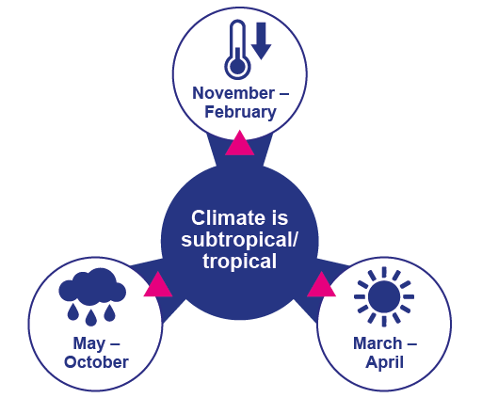
Figure 6.1.1 Climate conditions in Myanmar

The climate of Myanmar has a significant impact on tourist arrivals. Tourists tend to avoid the rainy season and travel in the dry season, which runs between November and April. Peak arrivals occur between December and February.
The impact of global climate change could be quite severe for the country. Myanmar is already one of the most negatively affected countries by natural disasters. Its long coastline makes it subject to tropical storms and cyclones, which are growing in frequency and severity, as shown by the devastation of Cyclone Nargis in 2008. Rising sea levels also threaten parts of the coast with salination as soils and ground water have increasing salt content. The monsoon is starting later and ending earlier, which results in large quantities of rain falling over short periods. This leads to flooding, contamination of water resources and erosion. Climate and temperature are important determinants for tourists in destination selection.
The Covid-19 pandemic has caused tourist numbers to crash, as Myanmar’s borders closed and international flights ceased. The country’s troubled history and ongoing regional conflicts are further deterrents to greater tourist numbers.

Activity 6.1
Watch this video of the Naga New Year Festival and answer the questions that follow.
https://www.youtube.com/watch?v=amNmX67dBXE
1. How did watching this video make you feel? Did you feel proud of the cultural diversity of Myanmar and would you like to attend this festival?
2. Does your area of Myanmar have a colourful festival that you think tourists would enjoy seeing and sharing?
3. Have you ever seen tourists visiting your area of Myanmar? What time of year did they come and what did they see?
Answers to Activity 6.1

6.2 Tourist attractions of Myanmar
This session looks at the most frequently visited attractions in Myanmar. There are five of them: Yangon, Bagan, Inle Lake, Golden Rock Pagoda and Mandalay (Figure 6.2.1). They receive the majority of international visitors and benefit the most from tourism revenues. Most tourists travel around Myanmar on classic sightseeing tours viewing these attractions (Ministry of Hotels and Tourism, The Republic of the Union of Myanmar, 2020, p.25).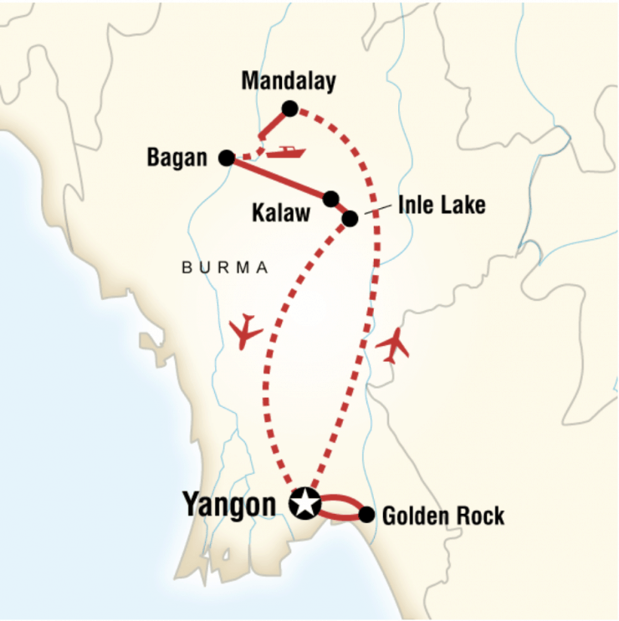
Figure 6.2.1 Map showing the location of the major tourist sites in Myanmar

Yangon
The city of Yangon is the commercial hub of the country and was once the capital of Myanmar. In 1989, the government requested that other countries change their spelling of Rangoon to Yangon to more closely reflect its Burmese pronunciation. In 2005, it lost its position as the capital, which was moved to Nay Pyi Taw in the centre of the country. However, Nay Pyi Taw is mostly an administrative capital and most tourists still fly into Yangon.
Yangon is a vibrant and diverse city, with the most famous pagoda in the country: Shwedagon Pagoda. Of particular interest to tourists are the colonial buildings dating from the British colonial era, a period of rich architectural styles: art deco, Edwardian, Victorian and British-Burmese (Figure 6.2.2). Yangon has the highest density of colonial buildings in South East Asia. The Bogyoke Aung San Market is the best place to explore Myanmar’s traditional arts and crafts, gems and clothing. The Chauk Htat Kyi Reclining Buddha is the third largest in Myanmar. A walk around Kandawgyi Park brings locals and tourists together, as they enjoy the amenities offered by the lake.
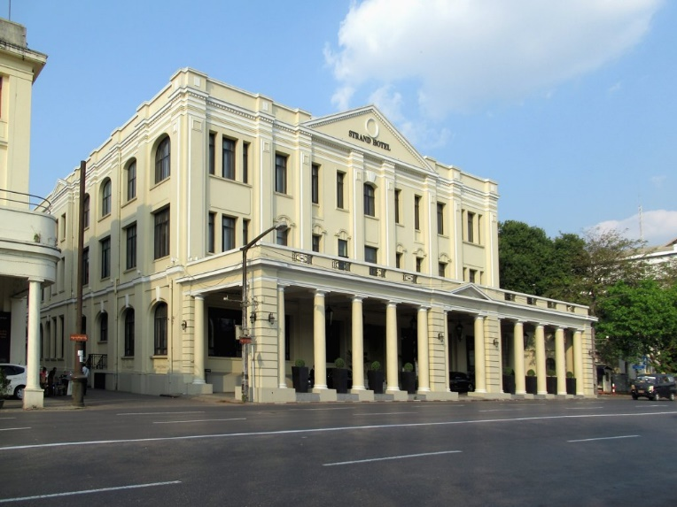
Figure 6.2.2 The Strand Hotel, Yangon is one of the colonial buildings that line Yangon’s waterfront – a heritage feature for tourists

Bagan
Bagan is a sacred landscape, lying on the central plain of Myanmar and features numerous temples, stupas, monasteries and places of pilgrimage. It also has important archaeological remains, frescoes and sculptures showcasing a range of Buddhist art and architecture. The peak of Bagan civilisation was between the eleventh and thirteenth centuries CE, when the site was the capital of a regional empire. It continues to be a place of pilgrimage for Myanmar people today. An activity favoured by tourists is to fly in a hot-air balloon over the temple site at sunrise.

Inle Lake
Inle Lake is best known for its fishermen, with their unique fishing style of rowing their boats with one leg (Figure 6.2.3). Its scenic beauty lies in it being a natural wetland. It has a rich ecosystem, where tourists can observe rare aquatic species, birds and the unique floating farms of local farmers. Along with fishing and farming, traditional handicrafts are a significant part of the local economy, with silk weavers and silversmiths working on the lake.
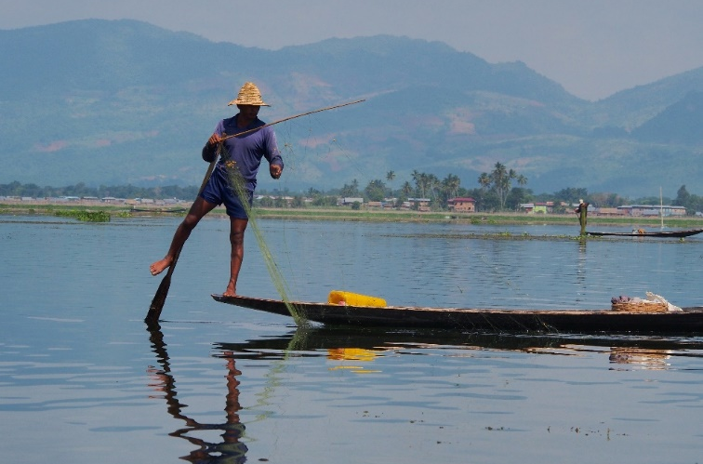
Figure 6.2.3 A fisherman on Inle Lake

Golden Rock Pagoda
Also known as Kyaikhtiyo Pagoda, the Golden Rock Pagoda is said to cover a hair of the Buddha. For Myanmar travellers, the religious significance of the site’s connection with the Buddha is the major attraction. But for tourists, the attraction is the beauty of the golden dome, high up on the mountain and the panoramic views of the surrounding Mon State mountains offered from the summit.

Mandalay
Mandalay is the former royal capital in northern Myanmar and sits on the Irrawaddy River. In the centre of the city is the restored Mandalay Palace from the Konbaung Dynasty, surrounded by a moat. Mandalay Hill provides views of the city from its summit, which is reached by a covered stairway. At its foot, the Kuthodaw Pagoda houses marble slabs inscribed with Buddhist teachings, which are referred to as the world’s largest book. The Zegyo Bazaar is the largest of many markets that attract artisans and farmers from throughout the country. Just outside Mandalay is the U Bein Bridge, which is the longest teak bridge in the world.
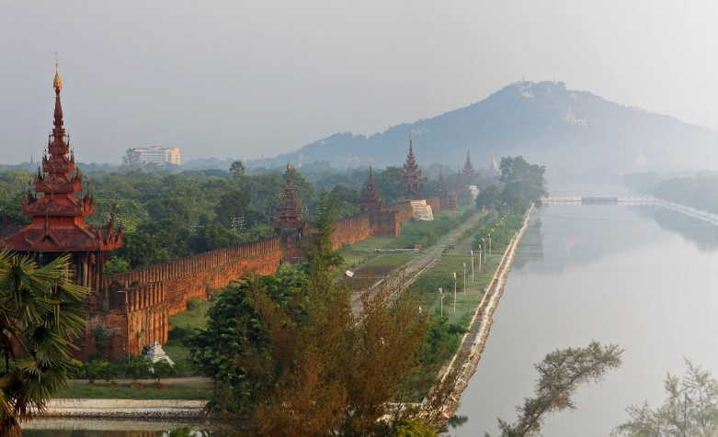
Figure 6.2.4 Mandalay Palace is surrounded by a moat

Problems at attractions
The popularity of these five tourist sites is becoming a problem, because they are being over-visited. For example, the water and sanitation facilities at Inle Lake are under severe strain. To alleviate the pressure on these sites, the government is focusing on developing new destinations within the country, to attract new and repeat travellers. Their vision for the future of tourism is explored in the next session.

Activity 6.2
Select the picture to match the Myanmar attraction based on the descriptions you have read in this session.
1. 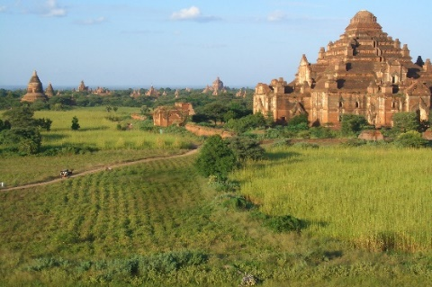 2. 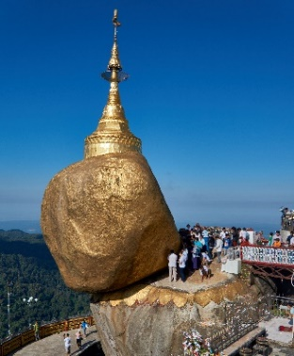
3. 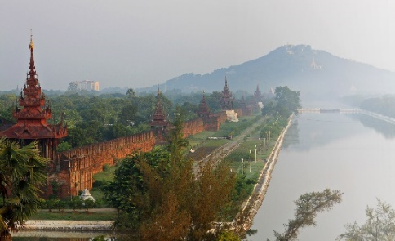 4. 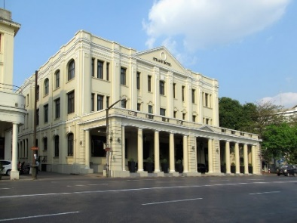
5. 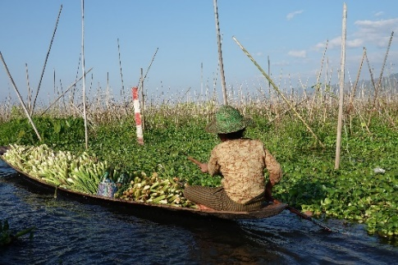
- Inle Lake
- Bagan
- Yangon
- Golden Rock Pagoda
- Mandalay
Answers to Activity 6.2

6.3 Myanmar’s tourism performance
This session considers Myanmar’s recent experience with tourists, focusing on the number of visitors. Tourism numbers have grown steadily since the country opened up to foreign tourists in 2013. The introduction of the e-visa system in 2014 has allowed foreign tourists to apply for a visa online, and improved accessibility to the country. A Tourism Master Plan 2013–2020 was created, targeting 7.5 million arrivals each year by 2020. However, it has been estimated that the annual performance for 2019 was about 4 million arrivals – a long way short of the 2020 target (Thitha, 2020).
Although Myanmar possesses great tourist potential, much of the industry remains underdeveloped. The number of visitors to Myanmar is small compared with her neighbours, even outpaced by Laos. The Tourism Master Plan seeks to maximise the contribution of tourism to national employment and income generation. It aims to ensure equal distribution of tourism’s social and economic benefits (Figure 6.3.1). The government wants to balance its objectives for economic growth with the well-being of host communities. The plan is to minimise any negative impacts on the country’s social, cultural and environmental heritage.
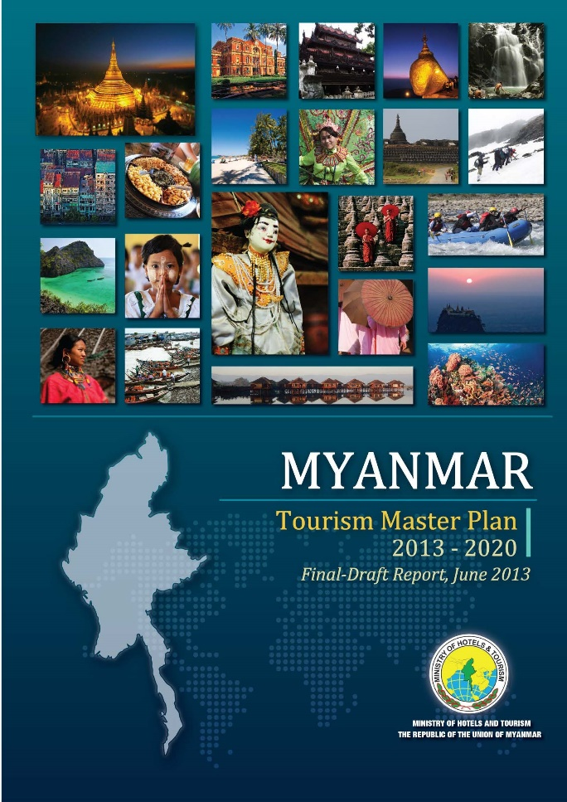
Figure 6.3.1 Myanmar’s Tourism Master Plan, 2013–2020

Encouraging tourists to visit sites other than the popular attractions discussed in Session 6.2 is challenging. However, it is necessary, if the economic benefits of tourism are to be spread more equally. One way to create new attractions is to establish tourism routes, which tie up several attractions that would not have the potential to attract visitors to the area by themselves. The bundling of attractions along a tourist route has greater pulling power, as well as dispersing tourist money across a larger area and more recipients.
Community participation and a pro-poor focus should be at the heart of new route development. Any new routes should provide direct employment opportunities, enterprise opportunities, communal income and livelihood benefits. Establishing links between private sector businesses and neighbouring communities can help produce a unique tourism product, which benefits both stakeholders. Such an alliance will greatly improve the sustainability of tourism (Meyer, 2004).

Activity 6.3
Look at the table of tourist arrivals in Myanmar and answer the following questions.
Source: Ministry of Hotels and Tourism

Where has the information in the table come from?
Why would the creator of the table choose to compare January 2018 with January 2019?
What form of arrival has seen the biggest percentage increase?
What form of arrival has seen the smallest percentage increase?
Answers to Activity 6.3

6.4 Tourism investment opportunities in Myanmar
Tourism and hospitality have the potential to make a huge contribution to economic growth and create diversified employment opportunities in different sectors. This is because tourism includes the industries of transportation, building and construction, accommodation, food and beverage establishments, and many more.
However, Myanmar’s tourism sector is underdeveloped, as shown in Session 6.3. There is insufficient domestic investment to grow the sector quickly, with foreign investment needed for major expansion (World Travel and Tourism Council, 2017). Foreign direct investment refers to the investment in domestic companies and assets of another country by a foreign investor. The government in Myanmar has invited responsible investors to seek business opportunities in Myanmar to accelerate tourism growth. The Foreign Investment Law introduced in 2012 included incentives to encourage foreign investment, such as corporate ownership, tax relief and employment of foreign nationals. Despite this, Myanmar’s travel and tourism sector receives the least investment of all ASEAN members (Figure 6.4.1).
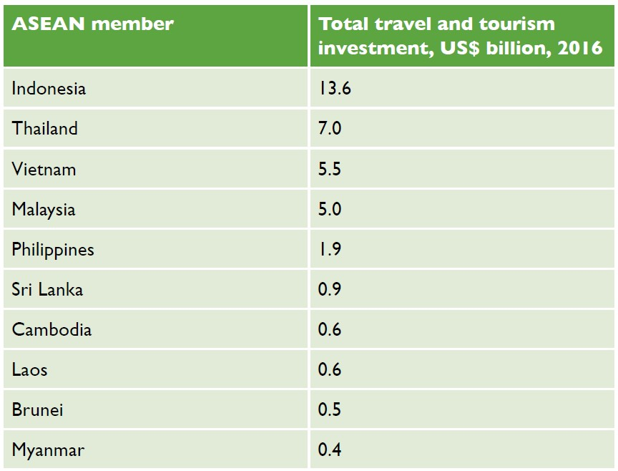
Figure 6.4.1 Investment in Myanmar’s tourism sector is low compared with other ASEAN members

Myanmar’s accommodation facilities are currently concentrated in the cities of Yangon and Mandalay. There is a considerable lack of available accommodation in numerous other locations outside those centres. There is a need for affordable, as well as high-end, accommodation. Under the Foreign Investment Law, foreign investors can own 100% of hotel developments with rankings above three stars. Local investors are encouraged to consider opportunities in budget accommodation, such as guest houses.
Investors are exploring new investment locations in Myanmar, and developing different types of tourism. Investors are considering the opportunities offered by ecotourism, including the development of ecotourism-oriented hotels and lodges, and activities such as trekking routes. Another key area of expansion is cultural and community-based tourism. Investors are developing cultural experiences, exhibitions and workshops to inform visitors, and local shops in which to sell locally produced cultural artefacts (Embassy of the Republic of the Union of Myanmar London, 2021).
However, the sustainability of tourism is being undermined by the lack of investment, which is putting further strain on the most visited sites. There are plans to create destination management organisations (DMOs) to tackle these problems. You were introduced to DMOs in Session 3.1. As you will learn in the next session, the plans to create DMOs seem to be at a relatively early stage.
In addition to investing in tourism and related areas of tourism (such as accommodation and the catering sector), there is also a need to train staff. This would ensure a more coordinated and effective tourist offering, involving both the public and private sectors.

Activity 6.4
Study the graph, which shows the number of tourist arrivals at Myanmar’s three international airports (left) and the total number of hotel rooms (right) in Myanmar from 2008 to 2019. The graph excludes tourists who arrived in Myanmar by crossing a border by land or sea.
Answer the following questions.
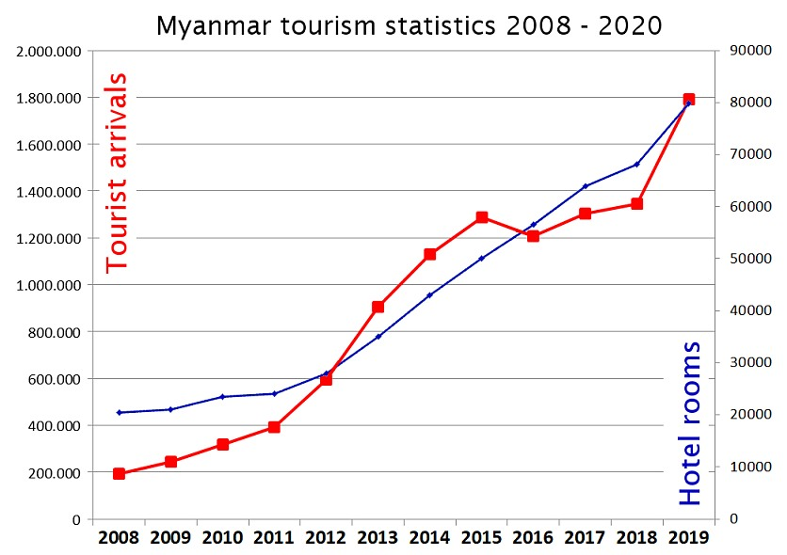
Source: The Tourism Industry of Myanmar

1. When did the number of rooms available first meet the number of tourist arrivals?
2. In what years were there not enough rooms to meet tourist demand?
3. Between 2013 and 2016 was there an oversupply or undersupply of rooms to meet tourist demand?
4. Why do you think the rate of increase of tourist arrivals slowed between 2016 and 2018?
Answers to Activity 6.4

6.5 Challenges to sustainable tourism
As you learned in Session 1.4, sustainable tourism is tourism that protects natural environments, provides an authentic tourist experience that celebrates and conserves heritage and culture, and creates socio-economic benefits for communities. Increasingly it is becoming clear that key destinations within Myanmar, such as Inle Lake, need to be managed sustainably. Inle Lake is experiencing the effects of the overuse of chemical pesticides and fertilisers on its famous floating gardens, which is polluting the lake. As the surrounding forest is cut down for agricultural use, soil is no longer held in place by the trees and it washes into the lake. This is making the lake shallower and threatening livelihoods (Figure 6.5.1).
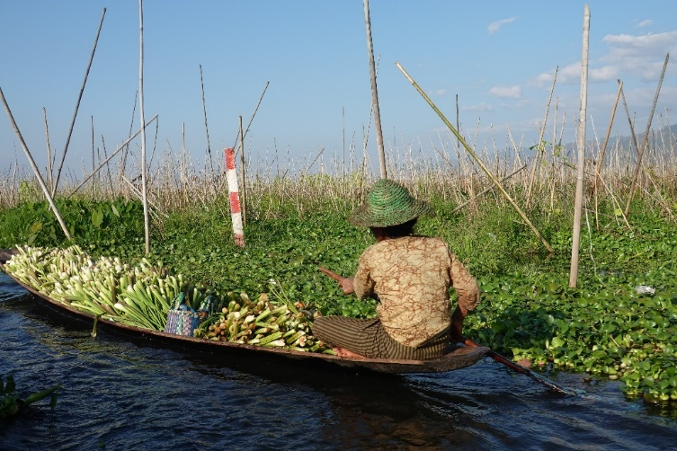
Figure 6.5.1 The floating gardens of Inle Lake, which are used to grow a wide variety of produce, including tomatoes, papayas, onions and chillies

Destination management is a concept that you were introduced to in Session 3.1. It focuses on managing all the elements of a destination, including its environment, tourism assets, skill development and infrastructure. While the Ministry of Hotels and Tourism needs to provide a coordinating role across the country, the state and regional governments should be empowered to manage destinations more sustainably through well-resourced DMOs. In this way, Myanmar can move forward to build a sustainable tourism sector.

The impact of Covid-19
The greatest threat to the sustainability of tourism in Myanmar is the Covid-19 pandemic. The Ministry of Hotels and Tourism has reported that revenue from tourism dropped by more than 80%, or around US$2.3 billion, in response to the pandemic (Hein, 2020). International airlines were suspended from landing in the country from April 2020, leading to an overnight collapse in the number of tourists entering the country. Land and sea borders were also closed. The impacts on hotels, restaurants, shops and transport have been severe. The Ministry of Hotels and Tourism is looking to domestic travellers and expatriate travellers to rebuild the sector as soon as restrictions are lifted. A recovery plan is in place to aid the industry, under which tourism businesses will be permitted to resume operations with Covid-19 prevention measures in place (Figure 6.5.2).
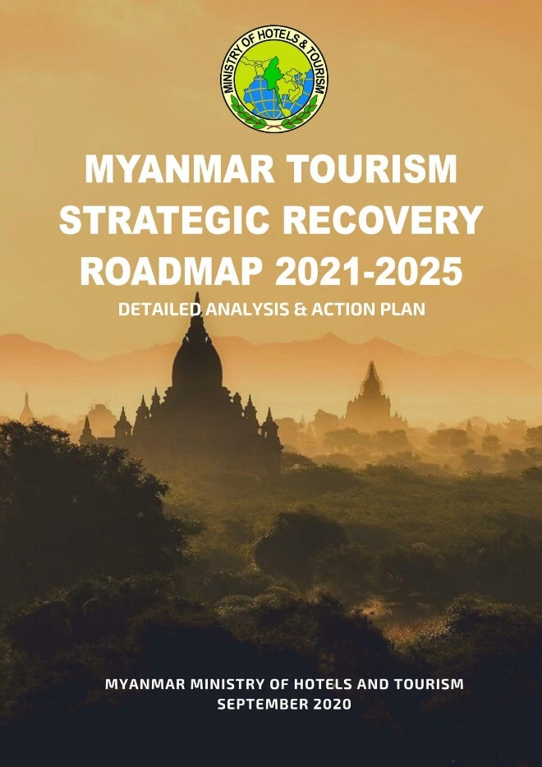
Figure 6.5.2 Myanmar’s tourism recovery plan in response to the Covid-19 pandemic

The Myanmar Tourism Strategic Recovery Roadmap (MTSRR) 2020 is the bridging document between the first Tourism Master Plan 2013–20 and the second Tourism Master Plan 2021–25, which is in the process of being written. The aim of the MTSRR is to recover, reset and restart the tourism industry, but to do this in a sustainable way. Myanmar’s tourism industry was heavily focused on international travellers and there are efforts to broaden the tourism base. To this end, all state and regional tourism committees will develop their own state and regional master plans. Myanmar also plans to create district and township-level destination management organisation committees to create their own destination-specific action plans. These will be incorporated into the state’s and region’s master plans. The challenges may be significant, but sustainability can create jobs, connect tourists with local and diversified supply chains, benefit other sectors, and strengthen the country’s future economy.

Activity 6.5
The MTSRR 2020 sets out three goals for tourism recovery over three time frames. Select one action to support each goal.
1. Realign tourism destinations to the ‘new normal’.
2. Invest in developing and expanding the scope of community-based tourism.
3. Establish Myanmar as a trusted and safe destination.
Answers to Activity 6.5

6.6 The future of tourism in Myanmar
Tourism in Myanmar has suffered a severe setback during the Covid-19 pandemic of 2020–2021. Therefore, this final session focuses on why stability is so necessary for tourism growth.
Figure 6.6.1 shows all international arrivals from 2002 to 2014 globally. During this period there were two health crises: the SARS outbreak in 2002 and the H1N1 outbreak in 2009, which was made worse by the 2008–2009 global economic crisis. While the following year saw a slight downturn in international arrivals, within two years international arrivals had increased past pre-crisis levels. Thus, tourism is an industry that can recover quickly from negative global events.
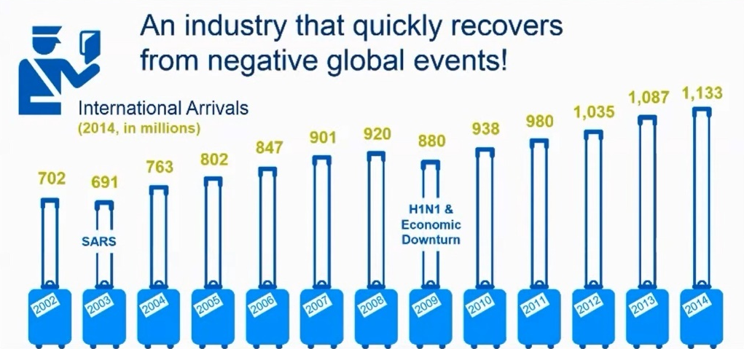
Figure 6.6.1 International arrivals 2002 to 2014 globally

On the evidence presented here, it might be expected that tourist numbers would rebound quickly after the Covid-19 pandemic is over. However, global health events are not the only shocks to negatively impact on tourist visitors, as the following case study from South Africa shows.

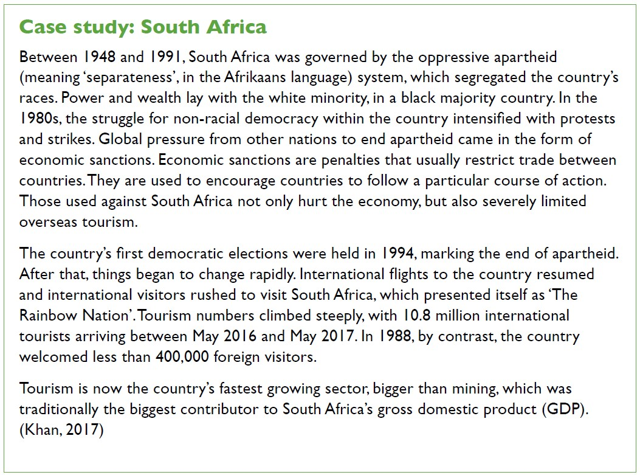
Tourism is prone to many shocks, both global and domestic, but also health, political and economic events.

Activity 6.6
1. Answer the following questions relating to the South Africa case study.
- How long did the apartheid regime rule in South Africa?
- How did citizens struggle for non-racial democratic elections within South Africa?
- How did the international community exert pressure for change in South Africa?
- How did South Africa present itself to the world after apartheid?

2. Study the graph below, which shows international tourist arrivals by air to Myanmar between 2010 and 2018. Why do you think tourist numbers declined sharply in 2018? What might the bar chart look like between 2018 and 2023 and why?
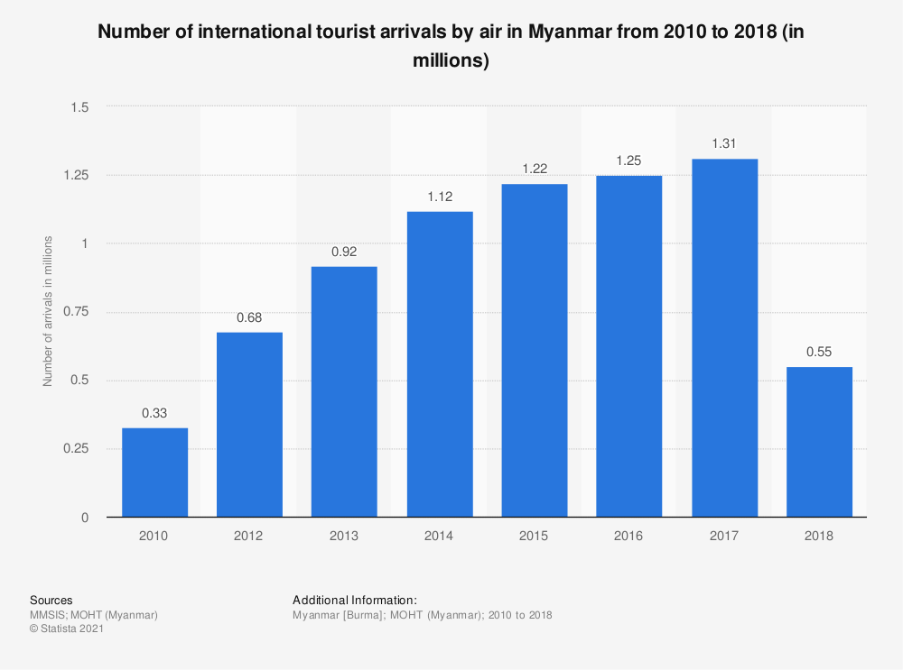
Answers to Activity 6.6

Answers to activities

Activity 6.1
- Students’ own answers.
- Students’ own answers.
- Students’ own answers. However, it is likely that you saw the tourists in winter, as tourists tend to avoid the rainy season and travel in the dry season.

Activity 6.2
- b)
- d)
- e)
- c)
- a)

Activity 6.3
- Ministry of Hotels and Tourism
- By comparing January 2018 and January 2019 it is possible to have a clear understanding of the change year on year. If January 2018 were compared with July 2019, the comparison would not be as useful. As discussed in Session 6.1, tourists like to visit Myanmar in the winter months, when it is cool and dry, which is between November and April. July is not a popular month with tourists because it is hot and wet.
- Arrival by cruise
- Arrival by air

Activity 6.4
- 2012
- 2013 to 2016
- Oversupply
- Due to unrest in Rakhine State

Activity 6.5

Activity 6.6
- a) 43 years, b) protests and strikes, c) economic sanctions, d) as The Rainbow Nation
- Tourist arrivals to Myanmar are likely to have dropped in 2018 in response to political unrest in border areas.

References
Embassy of the Republic of the Union of Myanmar London. (2021) Trade and Investment Opportunities. Available at: https://www.londonmyanmarembassy.com/index.php?id=143 (Accessed: 14 April 2021).

Hein, Zeyar. (2020) ‘Tourism revenue in Myanmar dips 80% during COVID-19’, Myanmar Times, 3 December. Available at: https://www.mmtimes.com/news/tourism-revenue-myanmar-dips-80-during-covid-19.html (Accessed: 5 March 2021).

Khan, S. (2017) ‘How South Africa Is Telling Its Story Through Tourism’, Conde Nast Traveller, 9 November. Available at: https://www.cntraveler.com/story/how-south-africa-is-telling-its-story-through-tourism (Accessed: 4 March 2021).

Meyer. (2004) TOURISM ROUTES and GATEWAYS: Key issues for the development of tourism routes and gateways and their potential for Pro-Poor Tourism. Available at: https://www.odi.org/sites/odi.org.uk/files/odi-assets/publications-opinion-files/4040.pdf (Accessed: 14 March 2021).

Ministry of Hotels and Tourism, The Republic of the Union of Myanmar. (2020) Myanmar Tourism Strategic Recovery Roadmap. Available at: https://www.myanmore.com/wp-content/uploads/2021/01/MYANMAR-TOURISM-STRATEGIC-RECOVERY-ROADMAP-23.10.20.pdf (Accessed: 15 April 2021).

Thitha. (2020) ‘Myanmar reports tourist arrivals’, Consult Myanmar, 20 January. Available at: https://consult-myanmar.com/2020/01/20/myanmar-reports-tourist-arrivals/ (Accessed: 5 March 2021).

World Travel and Tourism Council. (2017) Travel and Tourism: Economic impact 2017, Myanmar. Available at: https://bandapost.org/wp-content/uploads/pdf/Economic%20Impact%202017%20Myanmar%20by%20World%20Travel%20&%20Tourism%20Council.pdf (Accessed: 5 March 2021).

