Inclusive Teaching Practice
Participant’s Book

Source: VSO Image library

Module 7:
Active participation

Module 7: Active participation

Overview
This is the seventh of fifteen modules that look at how we create a positive Inclusive Learning Environment for all. You will see how inclusive teaching practices encourage, develop and use the 21st century skills of critical thinking, communication, collaboration and creativity. These modules are for any educators or those studying in education in Myanmar. The terms student and learner are used interchangeably throughout the module.

Module number | Module title
1 | What is an Inclusive School, Classroom and Teacher?
2 | Knowing your learners
3 | Planning learning outcomes for all
4 | Participating through learner centred approaches
5 | Creating a positive learning environment
6 | Effective questioning and feedback
7 | Active participation
8 | Peer, co-operative and collaborative learning
9 | Supporting students’ emotional and social wellbeing
10 | Legal framework and policies around Inclusion in Myanmar
11 | Supporting all students through differentiation
12 | Identifying specific learning difficulties
13 | Supporting all learners with differences or disabilities
14 | Positive behaviour management
15 | Assessment for student achievement

This module helps you to think about how to involve students in their own learning. A checklist is provided for you as an educator to reflect on your own inclusive practice throughout the course. You will also be asked to record your reflections in a learning journal, so it is important to make good notes and think carefully and deeply about your current and future practice.

This CPD module also encourages you to develop communities of practice between yourself and your colleagues. This will support and extend your own use of inclusive practices in your teaching and will help your student teachers build on inclusion in their learning and future professional practice.

Learning Journal
It will be useful to record your reflections in a learning journal throughout the module.
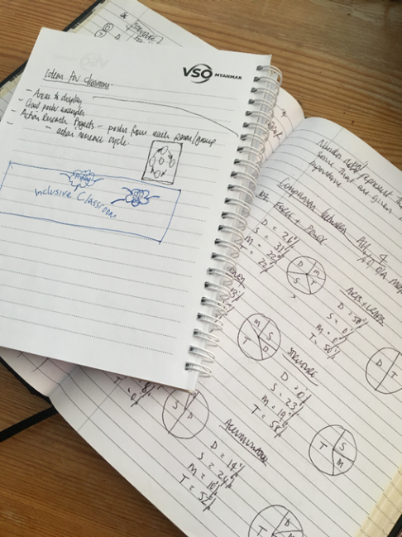
A learning journal can be digital (e.g. using Word or Google Docs) or on paper. You can also take photos of your learning journal pages if you want to share your thoughts with others. It is important that you record your thoughts and ideas so that you can remember and use them later in activities and in your own teaching.

Here are some useful tips for a good learning journal:
- Use headings and dates for all your journal entries.
- Use the activity number for reflections linked to that activity, e.g. Activity 1.1
- Add references to any other resources you find that help you.
- Record answers to activities.
- Write reflections about your learning.
- Make notes of new vocabulary.
- Identify topics you want to learn more about.

Source: Rose, N. (2018) Personal Learning Journals

The important thing is that it is easy for you to use. You can take notes which answer simple questions like these:

These questions follow the LEARN- APPLY- REFLECT model which is used in education globally. You can return to this journal as you progress through your CPD journey and reflect on your progress.

Study tips
Take your time to work through the activities, rather than trying to complete the whole unit at once. Set yourself a timetable and choose a time to work through the tasks, then check and compare ideas with colleagues. Finally, remember to make notes in your learning journal as you go. This will help you remember more about the skills and knowledge you develop as you complete these units.

Working alone or with colleagues
This unit is designed for self-study or can be led by a facilitator. The answers can be found after each activity. However, if possible, we recommend working in a pair or group so you can share ideas, ask questions, check your work, and give feedback.
If you work in a pair or group, we recommend using Think / Pair / Share for each activity.
Discuss your ideas in a group, and then check the answers on the next page(s) together.
Check your answers with your partner.
Work alone and make brief notes of your own ideas.

Learning outcomes for module 7
By working through this module, you will be able to:
- demonstrate the use of flipped learning to involve students in their own learning.
- demonstrate the use of inquiry, problem-based learning and effective group working.
- examine your own involvement in an inquiry-based learning project through reflection and comparing practice to theory.
- examine your own involvement in a problem-based learning project through reflection and comparing practice to theory.
- design an inquiry-based or problem-based learning activity.

Introduction
In the previous modules you focused on encouraging the participation of all students in their learning and teaching through:
- the student-centred approach to learning and teaching,
- the careful use of different groupings of students and the use of group roles,
- creating a positive learning atmosphere where all students feel encouraged and safe,
- using and encouraging a range of questions,
- and giving formative feedback that encourages further participation and learning.

In each of those aspects students’ involvement in their learning is important. The more involved they are – the more they will participate. This module looks at some learning and teaching tools that specifically focus on students’ active involvement. It will focus on how flipped learning involves students in their own learning, and how inquiry and problem-based learning can benefit students. You will be asked to:
- Read about the flipped classroom approach, Inquiry and problem-based learning.
- Watch videos and provide some analysis.
- Complete activities either alone, in pairs or in small groups.
- Think about key questions.
- Answer an end of module quiz.
- Reflect on your experience and knowledge.
- Make a promise to your learners.

The module will take approximately 7 hours to complete. Take your time to ensure it is an enjoyable learning experience.

Key to symbols
Activity – this is work you need to complete.

Question/s – please answer the questions.
Reflection – think carefully about how you feel about this.
Learning Journal – please write your answers and reflections in your learning journal.
Read – please read the text provided. Make any notes you like.

1.1 Link to previous learning - Effective questioning and feedback

Think back to module 6 and the activities around effective questioning and feedback.

Look at the examples of feedback below and decide which phrases teachers or learners would find helpful and constructive when being given feedback on a lesson that has been observed.

Write your thoughts in your learning journal or discuss them with a colleague.
    - “I really liked how well you listened to your students’ answers.”
    - “It was a great lesson.”
    - “The way you asked that question just at that moment was very helpful.”
    - “I don’t really like your handwriting.”
    - “How do you think the pair work went?”

Answers to the recap of Module 6 – Effective questioning and feedback

Possible suggestions of why the following examples of feedback could be constructive or not.

The level of honesty and directness in the feedback given will depend on the relationship between the person giving and receiving the feedback.

- “I really liked how well you listened to your students’ answers.” Most people need encouragement, to be told when they are doing something well. When giving feedback it can really help the receiver to hear first what you really like about them or what they have done well.
- “It was a great lesson.” Whilst it is good practice to be positive, this example doesn’t tell the receiver anything specific or identify what was ‘great’.
- “The way you asked that question just at that moment was very helpful.” This example is specific. The feedback gives more opportunity for learning.
- “I don’t really like your handwriting.” This can be personal and offensive. Perhaps the teacher’s handwriting isn’t clear enough for the learners to read, in which case the observer might ask the teacher to think about why learners may have made spelling errors or were finding it difficult to copy a piece of text written on the board.
- “How do you think the pair work went?” This provides the teacher with an opportunity to reflect on a specific point in the lesson. It allows them the space to think about it and talk about it before the observer offers any reflections.

Activity 7.1 - Self-assessment
REFLECTION: How confident are you about involving your students in their own learning? Look at the scale below and identify the number that best describes YOU. Use your learning journal to record your answer.
NOT confident
VERY confident
You will be prompted to do this again at the end of the module.

What is flipped learning?
Please read the brief extract about how flipped learning links to inclusive practice. Make a note of any interesting/new words.
Reading – What is flipped learning?
A flipped classroom is where more focus is placed on providing students with study learning materials before and after the lesson. Often these learning materials are videos made by the teacher explaining the key points of the topic. The materials can be other learning resources that help the students understand the key points.
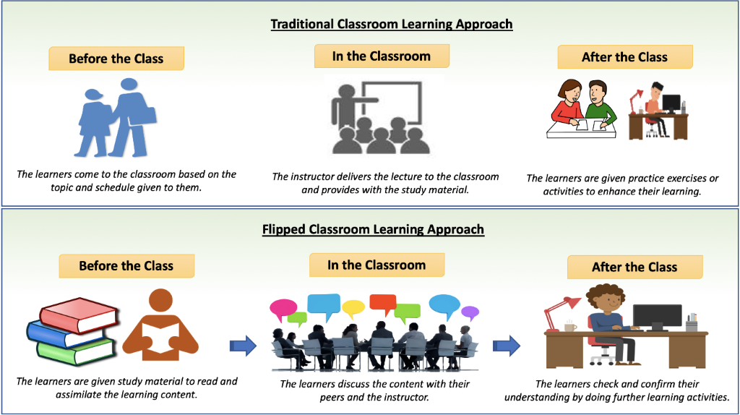
The students are then able to use the lesson to interact with other students and the teacher using the knowledge and skills they have learnt. Image Source: https://designinginstructionwithk.com/2019/06/13/flipped-classroom-approach/

Flipped learning is a way of actively involving students in their learning. They must take responsibility and ownership of their learning before the lesson, participate in learning activities during the lesson, and reflect and extend learning after the lesson.
Before the class students can spend as much time as they need to understand the material. They can watch videos again and re-read learning text. In class the teacher can work with students at their level of understanding.
A flipped classroom means that higher order thinking skills are used in the classroom when the teacher can act as facilitator and guide. The role of a facilitator was outlined in module 4 and how it differs from a traditional teacher role.

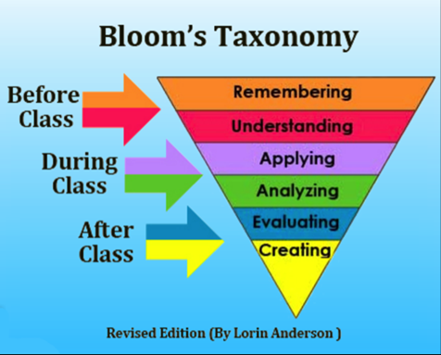
Use your learning from module 3 around Bloom’s Taxonomy to look at the image to see how it has been broken down into parts of the lesson (before, during and after class)
It can help you as an educator to plan for the most effective activities to use during lesson time.

Source: https://sxcjcomputerscience.blogspot.com/search/label/%E2%80%9CRevised%20Bloom%E2%80%99s%20Taxonomy%3A%20Finest%20techniques%20of%20Educational%20Learning%E2%80%9

The Flipped Learning Network suggests that the flipped classroom method is effective and involves students in their own learning when it follows the Four Pillars of FLIP.
F – Flexible learning environment where space supports group and individual work and students have some choice about when and where they work.
L –Learning is through a learner-centred approach where class time is spent exploring topics in depth using higher order thinking skills. Students are involved in building knowledge and skills by participating in meaningful activities and evaluating their own learning.
I – Intentional content is chosen by teachers for students to explore on their own and to use in class time for learner-centred, active learning strategies.
P – Professional educator – the teacher’s role in class time is to continually observe their students, provide timely feedback and assess using formative assessment. As a professional the teacher is reflective, discusses with others how to improve their practice, welcomes constructive feedback and manages a busy classroom with students talking and working in different ways.
Summarised from: https://flippedlearning.org/wp-content/uploads/2016/07/FLIP_handout_FNL_Web.pdf (free)

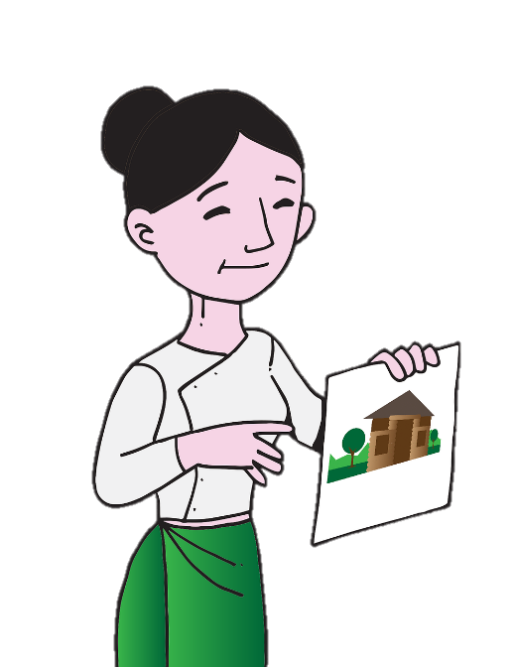
Activity 7.2 – Example of Flipped Classroom (15 minutes)
Read the outline below of a flipped classroom lesson and
decide whether the statements are true or false.

Before the lesson– The teacher shares a video with the class
and encourages the students to watch this at home or with
others in the class. The video shows how the digestive system
breaks down food and how the body’s cells convert sugar into
energy. The teacher provides the students with three
comprehension questions to answer based on the contents of
the video and asks the class to bring a small item
of food with them to the lesson.

Image source: (free)
https://pixabay.com/vectors/myanmar- burma-teacher-school-5247425/

During the lesson – The class engage in small group discussions about the video and comprehension questions. The teacher checks for understanding by listening to their group discussions and asking extended questions. The teacher makes note of any misconceptions or areas to focus on throughout the lesson. Students set up an experiment to measure how much energy is contained in the samples of food they brought. Each sample is separated into pieces of the same weight. Students put 100ml of water in a beaker, set fire to the samples and put them into the beaker to heat the water. The temperature of the water is measured before and after and the change is noted in a table. Throughout the lesson, the teacher asks questions to prompt discussion and deeper level thinking relating the video content to the practical activity. At the end of the lesson, the students summarise what they have learnt about the energy contents of various foodstuffs.
After the lesson – Learners imagine they are a dietician. They are asked to apply their learning by planning a diet for another student to follow for three days.
Read the questions below and decide if they are True or false?
- The learners are required to bring something to the lesson.
- The lesson cycle requires a device for watching videos, glass beakers and a projector.
- This sort of lesson is only suitable for older children.
- Learners are encouraged to use thinking skills before the lesson.
- The teacher has not really taught anything in the lesson.
- The learners are given an opportunity to check and confirm their understanding both in and out of the lesson.
Extension – Provide an explanation of the impact these statements have on teaching and learning. Record responses in your learning journal.

Answers to Activity 7.2

Statement | TRUE/FALSE | Explanation
The learners are required to bring something to the lesson. | TRUE | The teacher can make a quick assessment of student’s prior learning based on the item of food they bring to the lesson. If students bring in something that doesn’t relate to the video or the topic then support is needed early on.
The lesson cycle requires a device for watching videos, glass beakers and a projector. | FALSE | In this lesson students need a device to watch the video prior to the lesson. The experiment in class requires glass beakers. A projector is not required.
This sort of lesson is only suitable for older children. | TRUE/FALSE | The teacher can ensure that the lesson content is pitched for younger learners. The teacher would choose a simpler video and perhaps model the activity rather than allowing students to experiment with fire.
Children are encouraged to use thinking skills before the lesson. | TRUE | By providing the students with comprehension questions, the teacher is encouraging students to think about what they have watched in the video.
The teacher has not really taught anything in the lesson. | FALSE | The teacher has used the lesson time to facilitate group discussion, enabling students to analyse what they have already learnt. They are then given the opportunity to apply that learning and the teacher asks questions to encourage students to explore and discuss.
The learners are given an opportunity to check and confirm their understanding both in and out of the lesson. | TRUE | Students are encouraged to watch the video and answer comprehension questions prior to the lesson with their peers. There are plenty of opportunities to discuss and ask questions in the application part of the lesson. practical lesson.

Activity 7.3 – What is flipped learning? (10 minutes)

In the previous reading task you learnt about flipped learning. Now watch the video below which will tell you some more about flipped learning. Some of the themes in this video were discussed in module 4. Take this opportunity to develop your thinking around the time a teacher spends on exploring new ideas and demonstration.

There are subtitles for the video if you prefer to read what is being said. You can also open a transcript for the video if you need more time to read.

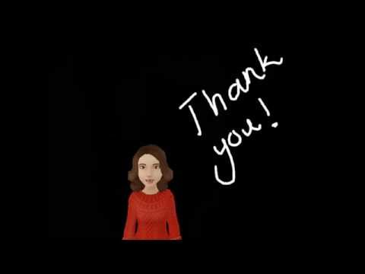

https://www.youtube.com/watch?v=RD7E9IULn0Y (5 minutes in total)

Answer these questions:
The teacher in the video talks about the difference between delivery and application.

In a traditional classroom.
- What percentage is spent on delivery?
- What percentage of the lesson is spent on application?

In a flipped classroom.
- What percentage is spent on delivery?
- What percentage of the lesson is spent on application?

If you can, discuss this with your colleagues or a study group to check each other’s understanding.
Which model means that all learners are engaged and challenged?
Which approach is more inclusive for all learners?
It might be helpful to write your answers in your learning journal.

Answers to Activity 7.3
In the video shared, the teacher says;

In a traditional classroom
- 90% of class time is spent on delivery of content.
- 10% of class time is spent on application.

In a flipped classroom
- 10% of class time is spent on delivery of content.
- 90% of class time is spent on application.

Which model means that all learners are engaged and challenged?
Flipped learning – it allows the teacher to be at the centre of learning rather than at the front delivering content. As most of the class time is spent on application, the teacher can support all learners, working at their own pace.

Which approach is more inclusive for all learners?
Flipped learning - all learners are the focus rather than pitching lessons at the majority of middle learners, where some students are not challenged, and others can’t access the learning.

Activity 7.4 – Flipped learning (15 minutes)

Think of a lesson that you teach from your curriculum. Imagine the students arriving for the lesson.
  - What do they already know about the subject?
  - Is there something that it would be helpful they understood before the lesson?
  - How much time will be spent in that lesson teaching theory before they will be confident enough to discuss it or apply it?
  - Could students read a short passage or watch a video prior to the lesson?

Imagine the students arriving for the lesson now, will this change what you plan to do?
  - Will the learning be on a deeper level than in the lesson you may have previously taught?
  - What will the students do with the knowledge and understanding they have gained?

Make a note of any changes you might make in your learning journal.
It might be helpful to think about lessons that are sometimes harder to teach. Consider how this approach might help to students to think about a subject before it is taught. Remember that pre activities / before class do not have to involve ICT e.g. videos.

- What does active engagement look like?
When it is used effectively, flipped learning allows students to learn at their own pace, it encourages students to actively engage with the content of a lesson and enables more time to be creative and active in class time. Teachers have more opportunities to interact with their students and to assess their learning in the moment rather than marking work in a traditional way after a lesson has finished.
Teacher/ Instructor

Teacher lectures by delivering lesson content
Often the content of a lesson is new

Often students will sit silently and listen
Passive learning

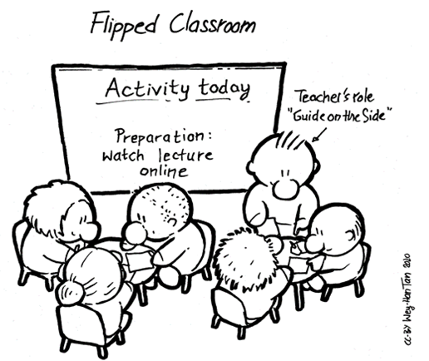

Facilitator

Teacher facilitates the learning of lesson content
Students can build on prior learning

Active learning
Students are encouraged to talk and think

Source adapted: https://commons.wikimedia.org/wiki/File:FlippedClassroom_Drawing_WeyHanTan_CCBY2020.png (free)

Activity 7.5 – Designing a flipped learning task (15-30 minutes)
Write a plan for a flipped classroom learning activity that could be used in school without the use of internet resources.
Think about:
- what activities students could do before the lesson to give them a good level of understanding.
- what information students could collect to bring to the lesson.
- what activities students could do in the lesson using that information
- what activities students could do that involve analysis and application.
- what activities students could do in or after the lesson that involve them evaluating or creating.
Use your Learning Journal to write your plan and discuss it with your colleagues or study group if you can. It might be helpful to use the Blooms taxonomy model to support your plan, see below.
The first box has been started for you.

After lesson
Create

Evaluate
During lesson
Analyse

Apply

Before lesson
Understand

-Provide a list of key words – look up definitions.

Remember

Source adapted from: https://sxcjcomputerscience.blogspot.com/search/label/%E2%80%9CRevised%20Bloom%E2%80%99s%20Taxonomy%3A%20Finest%20techniques%20of%20Educational%20Learning%E2%80%9D

What is inquiry and problem-based learning?
Please read the text about inquiry and problem-based learning.

Reading – Inquiry and problem-based learning.

Inquiry-based and problem-based learning are ways to actively involve students in their own learning. They are different but have similarities.

Inquiry-based learning
- Teacher defines an area of inquiry or project that covers learning outcomes.
- Students choose their specific inquiry or project to create.
- Deadlines are given.
- Academic skills are required to research knowledge and learn skills required to complete the inquiry or skills project.
- Social and emotional (soft) skills are required to share knowledge, opinions, skills with group members.
- Presentations of completed inquiry or project to others outside the class are important.

Problem – based learning
- Teacher presents a problem. The problem requires students to apply knowledge and skills to solve it.
- The problem needs students to define what exactly the problem is and what they need to solve it.
- The problem may have many possible solutions.
- Higher order thinking skills are needed to analyse, evaluate solutions and used to solve the problem.
- The problems are challenging and need students to collaborate to find solution.
- The solution is presented to the teacher and the class.

Analysis/comparison

Both involve active learning (constructivism) where learners try to make sense of ideas, problems and information.

Both involve the teacher as a facilitator or guide.

Both involve learners using critical thinking skills, communication, creativity and collaboration (4Cs of 21st Century Skills – see module 4) in small groups.

Both can involve real-life situations.

Both involve learners revising and self-evaluating their progress – how are we doing? what do we need to do next or to improve?

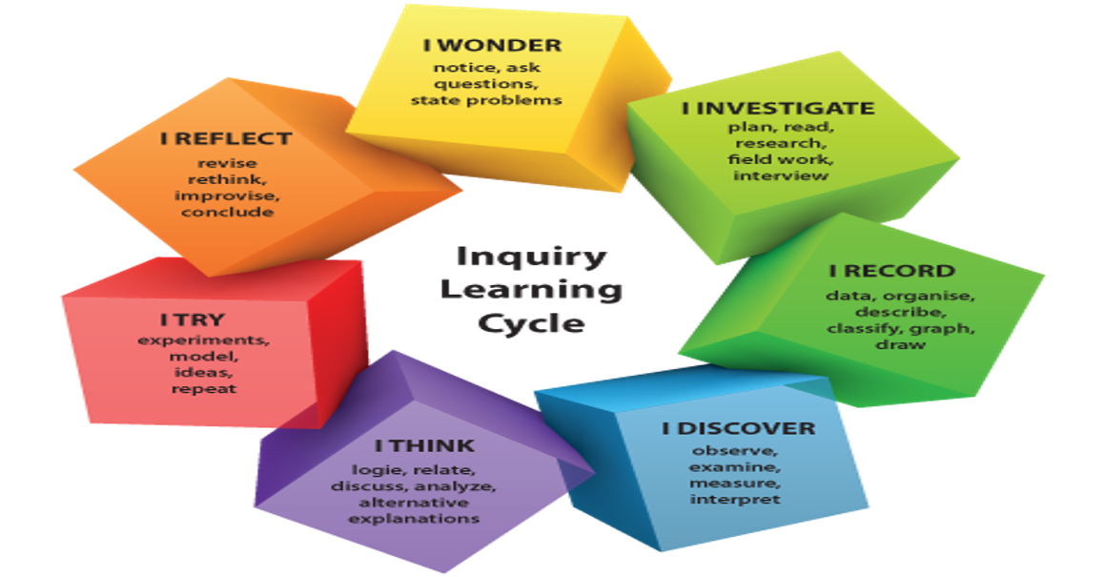
4.1 What happens with inquiry-based learning?
Inquiry-based learning is a form of active learning that starts by posing questions, problems or scenarios. It motivates students by posing questions that are interesting to them.
Science is an ideal subject to use an inquiry-based learning approach. Students can be encouraged to ask questions about plants by making observations, sorting, and classifying, looking for patterns and noticing differences. If students are given the freedom to inquire from different perspectives (e.g. by looking, listening, talking and touching materials such as plants), they can develop their skills in scientific inquiry and ask more complex questions.

Source: https://commons.wikimedia.org/wiki/File:Inquirey_based_learning_helps_to_fascilitate_students_autonomy.png (free)

  - What Problem – based learning looks like
Problem-based learning is a student-centered approach to learning about a specific subject, working to solve an open-ended problem. It is usually carried out in groups and the problem (often presented by a teacher) is the motivator. Learners will spend time examining and defining the problem to explore what the group already know about it. This highlights what the group will need to find out/learn and help them to identify where they can acquire the information and tools needed to solve the problem. The group then evaluates possible ways to solve the problem and work together to solve the problem. The group then reports on their findings to the rest of the class.
Source: https://commons.wikimedia.org/wiki/File:T_vs_PBL.png (free)

Activity 7.6 – Inquiry-based or problem-based learning? (30 minutes)

In the previous reading passage you learnt about inquiry and problem based learning.

Look at the lesson topics below and consider how you might use inquiry-based or problem-based learning to teach them. You could change the examples if they are not suitable for the age of students you teach. A few examples have been given.

 | Inquiry-based learning | Problem-based learning
Physics – relative density of solids, liquids and gases. |  | “We need to build a raft out of materials in the classroom. Which materials can we use?”
Mechanics – projectile motion.

English – the past simple tense. | Have the students work in groups to conduct a survey of the other students in the class with the format “What was the best ____ you ever experienced?”
Music – Western and pentatonic scales.

History – Independence of Bangladesh from Pakistan.

Possible Answers to Activity 7.6

 | Inquiry-based learning | Problem-based learning
Physics – relative density of solids, liquids and gases. | Let the students choose their own project to work on based around the topic. As topics are discussed they will generate their own questions. | “We need to build a raft out of materials in the classroom. Which materials can we use and which ones might be more effective?”
Mechanics – projectile motion. | Let the students choose their own project to work on based around the topic. As topics are discussed they will generate their own questions. | “We need to catapult something over the city walls. What material travels the furthest given the same starting trajectory?”
English – the past simple tense. | The students want to find out more about their peers. They work in groups to conduct a survey of the other students in the class with the format “What was the best ___ you ever experienced?” | “We need to write a letter of complaint about an unsatisfactory visit to a restaurant.”
Music – Western and pentatonic scales. | Have the students compose a simple piece of music incorporating both scales. Students will generate their own inquiry for further study. | “We need to know which notes of the western scale will clash when played in an ensemble with instruments which use the pentatonic scale.”
History – Independence of Bangladesh from Pakistan. | Students learn about Bangladesh and want to find out more about how it became independent. They decide to research in groups and give a presentation. | “We need to establish which sources are the least biased when discussing the events leading to the independence of Bangladesh from Pakistan.”

Question Formulation Technique
The Question Formulation Technique (QFT) was developed by the Right Question Institute. It is a simple way to help people produce, improve and prioritise questions. We can use this technique to improve our own and our students’ questioning in the classroom. It helps students to generate questions which can guide them to think deeper, rather than surface level learning. QFT is an inclusive strategy, it can allow more thinking time, enables all children to contribute and support each other’s thinking.
It is a useful method to use in inquiry and problem-based learning. Follow the stages when faced with a problem.
1. State the question focus
– this could be a statement, an idea, a picture, a problem.

2. Produce questions (5 minutes)
Create as many questions as possible.
Do not discuss answers or judge any questions. Write down every question exactly as it is said. Change any statement to a question.

Do

3. Improve questions (5 minutes)
Make sure you have plenty of open questions and some closed questions.
Re-phrase questions to make them clearer.
5. Plan (2 minutes)
What are your next steps?
7. Reflect
Did you answer your questions? Were they the right questions?
Do you now have more questions?
6. Action
Carry out your plan.
4. Prioritise questions (3 minutes)
What are your top 3 questions?

Activity 7.7 – Question Formulation Technique (10 minutes)
In the previous reading task, you learnt about the Question Formulation Technique. Now watch the video below which will tell you some more about the Question Formulation Technique.
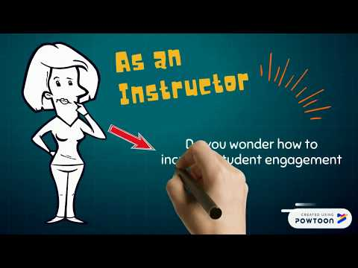

Source: https://www.youtube.com/watch?v=VRi7PULO2-o (Creative Commons)
Answer these questions:
What are the guidelines for producing the questions?
Why is the process of prioritising important?
Discuss with your study group to check each other’s understanding and record your answers in your learning journal.

Answers to Activity 7.7

What are the guidelines for producing the questions?
- To write as many questions as possible.
- Not to answer them or judge whether they are a good question or not.
- Write down every question as it is stated.
- Start to decide if questions are open or closed.
- Priortise questions

Why is the process of prioritising important?
It will help students to start to sort their questions into good ideas or those that aren’t as effective. When we think of an idea, most of the time our first thought will not be our best idea, but when we have time to think and start to get rid of ideas that won’t work and develop/think more about others further, comes our better ideas.
Prioritising can help students to fine tune their thinking, get to an end goal more effectively, give clarity about what the students would all like to discuss further. It can help students to manage their time effectively, using it wisely and avoid distractions.
Prioritising can help students discuss which question is the most important to them as a group.

Activity 7.8 – An example of Question Formulation Technique (20 minutes)
Look at the picture below.
How many questions can you generate about this picture?
Which question would you prioritise?
Share your questions with colleagues if you can and explain why you have prioritised certain questions. Record the questions in your learning journal.
Source: https://www.flickr.com/photos/ableman/35005430061 (free)

Answer examples to Activity 7.8

How deep are the icebergs under the surface?
Is it safe?
How close can the boat get?

Where is this?

Are there any animals here?

What has happened?

How long will it take for the icebergs to melt?

Who are the people in the boat?

Are they tourists?
Has the ice been cut?
Why is there a huge gap in the middle?

Prioritising
- Prioritising will depend on the group and what their interests are.
- The teacher may want to steer students in a certain direction to cover an area of the curriculum.
- Before they begin to prioritise, students might make statements like ‘Icebergs are large chunks of ice that break off from glaciers.’ The teacher could ask if everyone knows what a glacier is (closed question). If the children are unsure then another question is composed and added to the other questions - What is a glacier?
- If students start stating facts such as ‘Most icebergs in the Northern Hemisphere break off from glaciers in Greenland’ the teacher should encourage students to turn it into a question.

Example of prioritising the questions from more general to specific.

What is happening here?
Has the ice been cut?
Why is there a huge gap in the middle? As the questions continue, they
How long will it take for the icebergs to melt? become more specific & provide
How deep are the icebergs under the surface? more opportunities for discussion

Linking QFT to Inquiry-based learning
Please read the text about how students can use the question formulation technique to clarify the questions they are asking during inquiry-based learning projects.
Reading - linking QFT with inquiry-based learning projects
Inquiry based projects focus on finding out about something, how to do something or how to create something. It is important to clarify, which subject, which lesson, which theme the project belongs to. There can be projects across more subjects and/or themes. This is good for seeing the connections between different subjects.
A main feature of such project is that at a certain point in the initial phase, students identify and form a question they want to find the answer for. They can do this by carrying out online or offline research, an observation, an experiment, interviews, and so on.
Students should use the question formulation technique (explained previously) to clarify the questions they are asking.
The success of an inquiry-based project depends a lot on a well-formed, initial question. The question must be specific – not too vague, relevant to the subject, level and interests of the people who work on the project. A well-formed question opens opportunities and guides you through the project to find your answers.

Activity 7.9 - Inquiry-based learning projects using QFT (20-30 minutes)

You will find some topics for inquiry-based learning on the next page. Choose one topic which interests you the most.
For each topic, you will find an initial question which reflects the criteria. For the topic you have selected, add more questions which will guide your inquiry-based learning project. An example using the first topic has been provided below.
Example:
Stage 1 – Identify the topic – Gender in the education institution
Stage 2 – Identify the question – How can we ensure there is gender equity in Education institutions?
Stage 3 – Add more questions (and start to prioritise them)
- Is gender evenly represented in learning materials, such as textbooks?
- Are results showing progress regardless of gender?
- Do all students have the same opportunities in school, regardless of gender?

Inquiry-based learning projects: topics and questions
Topic | Question
Gender equity in the education institution | How can we ensure there is gender equity in Education institutions?
Low-cost multisensory learning resources for students to use in primary schools | How can teachers create low-cost multisensory learning resources for students to use offline?
Multisensory learning in your subject | What are the best resources to use to enable kinaesthetic learning when teaching maths?
Inclusive reading resources for the primary school show that people with differences have equal value, importance and opportunities. | What resources are available to support visually impaired primary school aged students with reading?
Breaking down key skills into Step-by-step learning (task analysis) | How can you break down the steps of a lesson into a sequence to support students to understand?
The 4Cs of 21st century skills in the primary curriculum | How does primary 1st year Maths / Language / P.E. / other subject develop the skill of coordination of muscle movement of the fingers / balance / listening to each other / verbalising thoughts and feelings / etc in a multisensory way?
The 4Cs of 21st century skills in the teacher education curriculum | How can I develop the 4Cs during the preparation and performance of students’ dances at the semester opening event?
Using the Learner centred approach with the new curriculum | What are the specific needs of my students to feel confident, comfortable, motivated in studying my subject? How can I encourage them to participate more actively in my lessons?
Different ways of doing effective group work | What model can I put in place to enable students to give feedback to each other effectively during group work?
A positive learning environment throughout the Education institution | What kind of extra-curricular (not co-curricular!) activities are available for students? How do teachers respond if a student makes a mistake?
Using questions for teaching | What happens when I ask “why”?
Using STAR feedback with step-by-step learning | How can I train students to use the S T A R features when they give feedback?

Activity 7.10 - Inquiry-based/problem-based learning projects: design (40 minutes)

Design an inquiry or problem-based activity that you could use with your students.
Look at the project guidelines to remind yourself of the structure to follow. An example has been provided below.
Example:
Stage 1 – Identify the topic – Gender in the education institution
Stage 2 – Identify the question (Inquiry-based) – How can we ensure there is gender equity in Education institutions?
Stage 2 – Identify the problem (problem-based) – In Grade 2 textbooks, there are images of girls that are offensive. They show girls in a stereotypical way in the way that are dressed and the activities that they are doing.
Stage 3 – Add more questions (and start to prioritise them)
- Is gender evenly represented in learning materials, such as textbooks?
- Are results showing progress regardless of gender?
- Do all students have the same opportunities in school, regardless of gender?

The students in the above example discussed the questions that they generate from the initial topic and have decided to look at how gender is represented in learning materials.
Plan – Students discuss the learning materials that are used in their school initially and then talk about learning materials more widely such as learning programmes. They discuss how they would like to carry out their research.
The students decide to focus their research to learning materials in their school by:
- selecting a range of textbooks from each school grade and record how many times girls and boys are used in examples.
-looking at how gender is represented in these materials to see if one gender is shown in a way that reinforces gender stereotypes.
-looking at story books and understand how gender is represented. Is one gender more often portrayed as a heroin over another?
-interviewing teachers and students about their experiences of gender representation in learning materials.
As the students agreed on a well-formed question at the start and decided to focus on learning materials in their school, it kept the focus specific and guided them through the project. The project encouraged the students to think of further questions that they would like to explore in the future.
Adapted from: https://www.myanmargraphic.com/ (free)

Activity 7.11 Self-assessment (20 minutes)

Use this checklist to think about yourself as an inclusive teacher. Score each statement carefully and be honest. You can use the results to inform and develop your CPD plan. Write in your learning journal.
- I can use a flipped classroom to involve students in their own learning
Not at all |  | A lot
- I understand inquiry- and problem-based learning guidelines

Not at all |  | A lot
- I understand the importance of using inquiry-based and problem-based learning activities.

Not at all |  | A lot
- I can design an inquiry based activity.

Not at all |  | A lot
- I can design a problem-based activity.

Not at all |  | A lot

7. Wrap up

In this module you have:
- demonstrated the use of the flipped classroom to involve students in their own learning.
- demonstrated the use of inquiry- and problem-based learning guidelines and effective group working.
- examined your own involvement in an inquiry-based learning project through reflection and comparing practice to theory.
- examined your own involvement in a problem-based learning project through reflection and comparing practice to theory.
- designed an inquiry-based or problem-based learning activity.

Key points from this module:
- In the flipped classroom the students are given learning materials or activities to study before the lesson. They learn new knowledge and skills. They then bring what they have learnt to the lesson.
- Flipped learning reduces the time spent on delivery and increases the time spent on application.
- Inquiry-based learning and problem-based learning develop higher order thinking and academic skills.
- The Question Formulation Technique (QFT) helps us to produce, improve and prioritise questions.

Reflection

Think about and write in your learning journal answers to these questions:
Think about your experience of the flipped classroom.
- How can you use this to involve your students in their own learning?
- How could you use the flipped classroom method in the primary school?

Think about your experience of inquiry and problem-based learning.
- What did you learn from doing the project?
- Was it easy or hard to follow the guidelines?
- How did you work as a group?
- What advice would you give when planning inquiry or problem-based learning in the primary school?

8. End of module 7 quiz
Please answer the following questions in your learning journal. You can attempt as many times as you like to reach 100% pass. Some questions require more than one answer.
Q1 - What is the flipped classroom? (Choose 1 answer)
- Students find some materials for the lesson at home and bring them to the lesson.
- Students study learning materials before the lesson so they can apply and discuss the knowledge and skills in the lesson.
- Students tell the teacher what they want to learn.

Q2 - How does the flipped classroom actively involve students in their learning? (Choose 3 answers)
- Students participate in discussion and activities applying knowledge and skills in the lesson.
- Students choose the learning activities they want to complete.
- Students take it in turns to teach the class.
- Students take responsibility and ownership of their learning before the lesson.
- The teacher talks to each student during the lesson.
- After the lesson students reflect on what they have learnt and use the knowledge or skills.

Q3 - What is inquiry-based learning? (Choose 1 answer)
- Students answer questions set by the teacher by researching.
- Students ask questions which the teacher answers.
- Students work together to find out information about a topic. They choose specific questions or aspects of the topic to find out about.

Q4 - What is problem-based learning? (Choose 1 answer)
- Students answer short problem-solving questions from a textbook or worksheet.
- Students practice how to solve problem-based questions using only the method the teacher has shown them.
- Students work together to solve a problem often from real life. They must research and evaluate possible solutions and then present how they solved the problem.

Q5 - Which are features of both inquiry and problem-based learning? (Choose 4 answers)
- Students need the teacher to give direction and explanations.
- Teacher’s role is a facilitator or guide.
- Students involved in active learning (constructivism)
- Teacher’s role is an instructor.
- Students must use critical thinking skills, communication, collaboration and creativity.
- Students are all doing the same thing.
- Students must reflect and self-evaluate progress – what do we need to do next or improve?

Q6 - What are the benefits of using the Question Formulation Technique? (Choose 3 answers)
- Students are encouraged to develop an enquiring mind that asks lots of questions to learn.
- Students create the questions for the lesson, so the teacher doesn’t have to.
- Students use higher order analysing and evaluation thinking skills to choose the best questions.
- Students can give themselves easier questions to work on.
- Students are actively involved in their own learning by creating their own questions.

Answers - End of module 7 quiz
Answers are shown in bold.

Q1 - What is the flipped classroom?
b) Students study learning materials before the lesson so they can apply and discuss the knowledge and skills in the lesson.

Explanation - In the flipped classroom the students are given learning materials or activities to study before the lesson. They learn new knowledge and skills. They then bring what they have learnt to the lesson. In the lesson students can discuss what they have learnt with other students and the teacher and ask questions to make sure they understand. The students can also spend the lesson applying the knowledge and skills demonstrating their understanding.

Q2 - How does the flipped classroom actively involve students in their learning?
a) Students participate in discussion and activities applying knowledge and skills in the lesson.
d) Students take responsibility and ownership of their learning before the lesson.
f) After the lesson students reflect on what they have learnt and use the knowledge or skills.

Explanation - In the flipped classroom students must be responsible for their learning before the lesson. They need to bring the knowledge and skills they have gained to the lesson to share with other students and the teacher. They can spend as much time as they need before the lesson.
Students have time in the lesson to discuss, ask questions, use higher order thinking skills to apply knowledge, because the remembering and understanding has been completed before the lesson.

Q3 - What is inquiry-based learning?
c)Students work together to find out information about a topic. They choose specific questions or aspects of the topic to find out about.
Explanation - Inquiry based learning involves the teacher stating a topic or area of inquiry. Students work in groups to choose specific questions about the topic. They then use research skills to discover knowledge and skills that can help them answer their questions. They discuss and share their findings to check they can answer their specific questions fully. They then present what they found out.

Q4 - What is problem-based learning?
c)Students work together to solve a problem often from real life. They must research and evaluate possible solutions and then present how they solved the problem.

Explanation - Problem based learning involves the teacher presenting a general problem to the students. In groups the students define exactly what the problem is and the questions they need to answer to solve the problem. The students research the information they need to solve the problem, evaluate possible solutions and decide on the best solution. They present their solution.

Q5 - Which of the following are features of both inquiry and problem-based learning?
b) Teacher’s role is a facilitator or guide.
c) Students involved in active learning (constructivism)
e) Students must use critical thinking skills, communication, collaboration and creativity.
g) Students must reflect and self-evaluate progress – what do we need to do next or improve?

Explanation - Inquiry based and problem-based learning are similar. It is just the focus that is different – inquiry-based focuses on finding out about aspects of a topic, and problem-based focuses on finding a solution.
Both involve the teacher presenting the topic or problem and then acting as a facilitator or guide. The teacher will prompt the students’ thinking and progress with questions. The teacher may suggest possible resources the students can use.
Both involve the students using their communication and collaboration skills in small groups where they use critical thinking skills in active learning to make sense of ideas and information. Students must think creatively to explore new ideas, discover new resources and devise solutions.

Q6 - What are the benefits of using the Question Formulation Technique?
a) Students are encouraged to develop an enquiring mind that asks lots of questions to learn.
c) Students use higher order analysing and evaluation thinking skills to choose the best questions.
e) Students are actively involved in their own learning by creating their own questions.

Explanation - The Question Formulation Technique is a way to help people produce, improve and prioritise questions. It can help us ask better questions in the classroom and can help our students ask more and better questions. It is important to encourage students to ask questions because we learn from asking questions. By asking questions we are actively involved in our own learning.
To use the Question Formulation Technique students:
- Respond to the question focus by producing as many questions as possible.
- Study the questions and improve them so they are clearer.
- Evaluate the questions and choose their top 3.
- Plan how to answer the questions.
- Carry out their plan.
- Reflect on their answers – are there now more questions?

Your 7th PROMISE to your STUDENTS

1
3
2

Review

Do

Plan

Please add your 7th promise to the section in your learning journal entitled ‘Promises.’
Each module contains one promise you will make to your learners: you will make 15 promises in total.

References

Anderson, L W, & Krathwohl D R (Eds.) (2001) Revised Bloom’s Taxonomy: Finest techniques of Educational Learning.
https://sxcjcomputerscience.blogspot.com/search/label/%E2%80%9CRevised%20Bloom%E2%80%99s%20Taxonomy%3A%20Finest%20techniques%20of%20Educational%20Learning%E2%80%9D

Flipped Classroom Explanation (2014)
Available online at:
https://www.youtube.com/watch?v=RD7E9IULn0Y

Flipped Learning Network (FLN). (2014) The Four Pillars of F-L-I- P. What is flipped learning?
Available online at:
https://flippedlearning.org/wp-content/uploads/2016/07/FLIP_handout_FNL_Web.pdf

Question Formulation Technique (2020)
Available online at:
https://www.youtube.com/watch?v=VRi7PULO2-o

