Leadership for Effective Learning
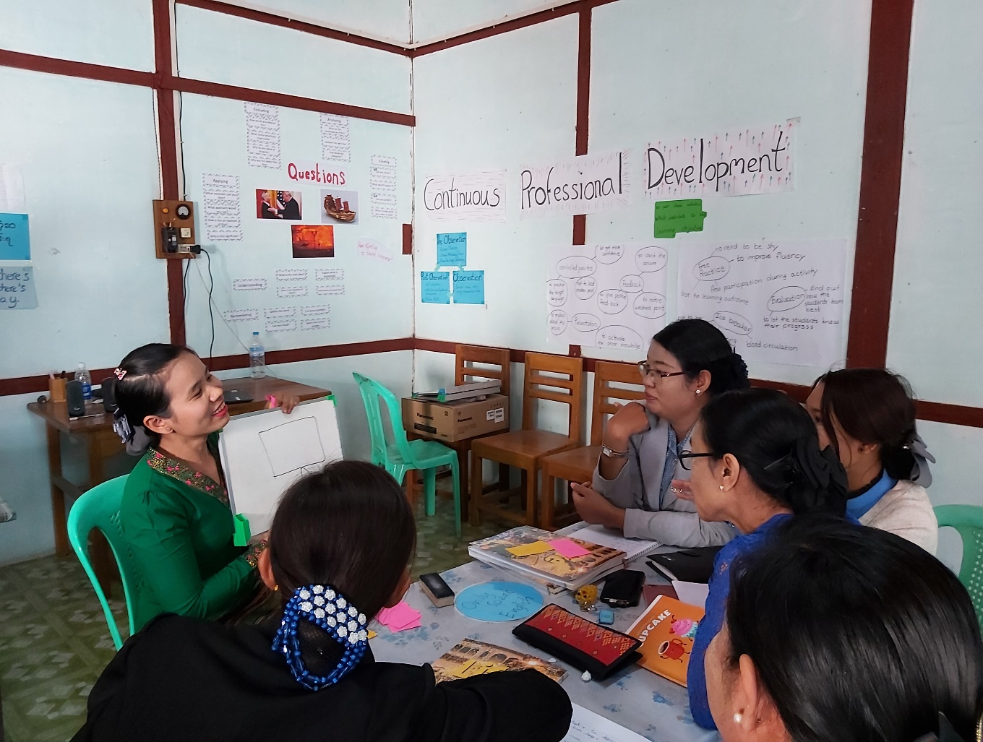
Unit 5: Skills for Leading
for Effective Learning
Trainer’s Guide

Overview
This module considers what effective learning looks like in the context of educational institutions and organisations in Myanmar and how leadership teams of these institutions and organisations can influence attitudes and approaches to effective learning.
The course will consider questions such as:
- Who are our learners?
- What is effective learning?
- Who is responsible for effective learning?
- What leadership approaches and strategies can leaders employ to enable and ensure effective learning in their contexts?
- What skills do leaders require in order to enable and ensure effective learning and how can these be developed?

This is the fifth of five units:
- What is Effective Learning?
- The Learner and Classroom Environment
- Leadership for Effective Learning
- Strategies for Leading for Effective Learning
- Skills for Leading for Effective Learning

Contents
- Section | Materials | Timing
Outcomes | Participants’ Book | 5 mins
5.1 Selecting a leadership style | Participants’ Book  YouTube video | 20 mins
5.2 Building relationships | Participants’ Book | 20 mins
5.3 Identifying key people | Participants’ Book | 20 mins
5.4 Developing coaching skills | Participants’ Book | 20 mins
5.5 Developing classroom observation skills | Participants’ Book  TREE/STEM observation tool | 20 mins
5.6 Developing feedback skills | Participants’ Book | 20 mins
5.7 Apply and reflect | Participants’ Book | 15 mins

Outcomes

By the end of this unit, participants will be able to:
- discuss three styles of leadership and the advantages and problems involved with these leadership styles
- discuss how a more distributed leadership style benefits educational programmes
- identify how a more distributed leadership style can be applied to their own contexts
- identify stakeholders and discuss ways in which effective communications with these stakeholders can be established
- discuss ways in which key people capable of taking on leadership roles can be selected and the qualities they require
- develop outline plans to implement coaching for future leaders
- identify and discuss qualities of an effective coach
- discuss the purposes of classroom observation and ways in which it can be undertaken
- discuss approaches to feedback and how feedback can be most effectively provided following a classroom observation
- reflect on their own skills for leading for effective learning and which skills can be developed further.

Learning Outcomes
- Briefly introduce the course overview and answer any questions.
- Explain the outcomes for this unit and check participants understand them.
- Highlight that this unit aims to encourage reflection about learning and leadership, rather than teach facts.

5 Skills for leading for effective learning

5.1 Selecting a leadership style
5.1 Discuss: leadership styles
Step 1
- Present the terms for the three styles of leadership.

- Ask participants if they have come across these terms before and, if so, to briefly explain what they mean.

If participants have not encountered these terms before, they are dealt with thoroughly in the activity.
Step 2
- Ask participants to match definitions a) to c) to terms 1 to 3.
Key
a) A style of leadership in which leaders’ tend to make decisions individually and then deliver directives to their staff which the staff follow: a little like a general giving their instructions to their troops | 3 Heroic leadership
b) A style of leadership through which we transfer part of our work, duties, or responsibilities to someone who is subordinate to us but we control and manage the process | 2 Delegated leadership
c) A style of leadership through which we as leaders share leadership with the people we lead, enabling them to collaborate and make their own decisions | 1 Distributed leadership

Step 3
Ask participants to answer the following questions individually:
- Which style is most similar to the way you usually lead?
- What do you think are the advantages of leading in this way?
- Describe a time when you have shown this kind of leadership.
Organise participants in pairs or small groups so they can compare ideas.
Elicit feedback, focusing especially on the participants’ views of the advantages of the leadership style they have selected.

5.1 Task: leadership styles: jigsaw reading
Step 1
Organise participants into three groups, A, B and C.

- Ask Group A to read Appendix 1a which describes heroic leadership.
- Ask Group B to read Appendix 1b which describes delegated leadership.
- Ask Group C to read Appendix 1c which describes distributed leadership.

Ask each group to work together and complete the relevant section of the table in Step 2.
Alternative: Organise groups before the lesson and share the relevant text A, B or C with the group so that when they come to class, groups have already completed the relevant section.
Step 2
Regroup participants so that there is at least one participant from groups A, B and C in the new group.
Groups share ideas and complete the table together for each leadership style.
Key
 | What does this style of leadership involve? | What are the advantages of this type of leadership? | What are the problems with this type of leadership?
Heroic leadership | Leaders make decisions individually and then deliver directives to their staff which the staff follow.  Principals set the rules and teachers play the game. | Leaders are often admired and respected by staff.  Leaders have the potential to make change happen quickly and impose a new vision of how things should be done.  Style of leadership often makes people they lead feel safe and secure.  Can be very effective in a crisis. | We cannot do everything ourselves.  Style prevents any second opinions.  Style prevents subordinates from having the chance to grow professionally.  Leaders are difficult/impossible to replace when they leave as no one has been trained to replace them.
Delegated leadership | Transferring part of our work, duties, or responsibilities to someone who is subordinate to us | Enables us to prioritise as we cannot do everything ourselves.  Increases the quantity and the quality of what is done.  Reduces time taken and cost of tasks.  Contributes to a culture of learning.  Increases the skills, confidence and sense of responsibility and commitment of the people we are delegating to. | Delegation does not take place: although the task is delegated, the delegator is unwilling to let go, over-controls and changes the result.  May be the result of the leader delegation ‘getting rid’ of tasks: abdicating responsibility.  Needs clear objectives, timelines and clarity to be effective.
Distributed leadership | Sharing leadership/ creating leaders: could involve giving departmental heads more freedom to make their own decisions, sharing responsibilities with teachers for solving problems and developing professional learning communities. | Tremendous impact on commitment and sense of responsibility.  Creates valuable learning opportunities.  Enables the institution to grow as individuals move on to new positions. | If leadership is distributed at the wrong time, to the wrong person, things will go wrong and the task may not be done/will be done badly.  Requires skill in identifying the right person for the right responsibility.  May been seen as simply ‘additional work’ by staff.  Needs careful planning, discussion of needs and initiative, agreement of everybody involved.

Ask participants:
- Which leadership style do you think is most appropriate for your institution? Why?
Elicit feedback.
Stress that many educationalists now recommend a more distributed approach.

Step 3: Distributed leadership in operation
a) Scenario
Ask participants to read the scenario which describes a new initiative in a school.
Organise participants in pairs or small groups.
Ask participants to discuss these questions:
- What alternative approaches could the Headteacher have taken?

- Why could a distributed leadership approach been more useful in this situation?
Key
The scenario is slightly adapted from the video ‘Leadership is…..distributed’:
www.youtube.com/watch?v=oQI8H7XN4I4
The scenario above is introduced in the video at 2.50.
An alternative approach is introduced at 6.22.
Solutions include:
- raising the issue at a senior leadership meeting before implementation
- discussion with teachers, students and other stakeholders before implementation
- setting up a teacher/student group review before implementation
- making sure that even if everybody does not like the solution, they are committed to it.
Elicit any suggestions from the participants and outline a possible solution yourself if none are forthcoming.
Direct participants to the video which they can watch after the session.
b) Think about your context.
Ask participants:
- Have you ever experienced a negative situation which might have been addressed by taking an approach which was more distributive?
- Are there any ways in which a more distributive approach would benefit your institution?
How could we introduce it?
Elicit responses.
Answers are open-ended and likely to vary: reactions to the idea of distributed leadership may be both positive and negative.

5.2 Building relationships
5.2 Discuss: who are your stakeholders?
Step 1
- Ask participants to read the text and the diagram.

- Answer any questions participants may have.

- Organise participants in small groups with, if possible, participants with similar backgrounds in the same groups.

- Groups list of stakeholders who are involved with or affected by the work their institution or organisation undertakes.

- Groups identify the most important stakeholders in their lists.
Stakeholders will vary depending on context but could include:
- implementers: senior leadership
- implementers: teachers or Teacher Educators
- implementers: staff at partner schools
- implementers: higher administration officials, policy makers, materials producers
- implementers: national or international organisations supporting developments in the institution/organisation/programme
- beneficiaries: learners: students or Student Teachers
- beneficiaries: learners taught by Student Teachers, during practice classes or in the future
- indirect beneficiaries: parents/families of learners.

5.2 Task: building relationships with stakeholders.
In this activity, participants identify what they need to communicate to stakeholders, the most effective ways to do this and how often they need to communicate.
- Organise participants in small groups who, if possible, share the same context.

- Ask groups to work together and complete the table.

- Cross-group participants so they can compare ideas.
Key
As participant responses will be quite open-ended, no key is provided.
Discuss responses with participants but accept any responses which are appropriate.

5.3 Identifying key people

5.3 Discuss: how can we identify key people?
This activity presents a scenario which it is hoped has the potential to be relevant to all participants regardless of their context: developing a Community of Practice and selecting facilitators for a Community of Practice. Through completing this activity, participants will consider issues which will be of relevance to any context in which key personnel need to be identified and selected.
An outline of how a Community of Practice operates is presented here: the TREE project have developed other materials which deal with Communities of Practice in more detail.
Step 1
- Ask participants to read the scenario which describes a new initiative at a teacher-training college: establishing a Community of Practice.

- Answer any questions participants may have.
Step 2
Organise participants in small groups.
Ask participants to work together and answer this question:
- What can we do to help us identify which staff members have the potential to be effective facilitators?
Elicit feedback.
Key
Possible suggestions:
- Check details of staff members’ qualifications and experience.
- Ask the staff member to complete an application form with a supporting statement you can assess.
- Read any information you have collected through performance management: teacher appraisals for example.
- Observe the staff member teaching in the classroom.
- Interview the staff member using a set of criteria.
- Ask the staff member to submit a session plan for a COP meeting which you can assess.
- Ask the staff member to give a short demonstration of an activity they would include in a COP meeting.
- Ask the staff member to take a short test in order to assess computer skills.

5.3 Task: what are we looking for?
- Ask participants to think about this question: What qualities are you looking for in a facilitator?

- Elicit some examples. Qualities can include organisational skills, people skills, pedagogic knowledge, team working etc.

- Organise participants in groups. Ask each group to make a list of qualities, e.g. as a poster.

- Ask each group to present their ideas or cross-group participants.

- Refer participants to Appendix 2 which presents the qualities of an effective facilitator.

5.4 Developing coaching skills

5.4 Discuss: coaching and training
The aim of this activity is to enable participants to distinguish between features of delivering a training session for staff and coaching staff members.
- Ask participants if they have any experience of participating in a training session or being coached.

- Ask participants if they have any experience of delivering a training session or coaching staff.

- Ask participants to identify any differences between delivering a training session for staff and coaching staff members.

- Organise participants in groups.

- Ask groups to read items a) to j) and decide which items refer to delivering a training session and which to coaching.

- Elicit participant responses and deal with any issues that might arise.
Key
Training | Coaching
The topic is often chosen for the participants by academic experts or management.  Delivery usually involves an expert working with a group of participants.  Delivery often takes place within a narrow time frame.  Delivery is often tightly structured and informal, involving a series of organised steps.  Delivery takes place before or after participants complete their usual work. | The topic is often chosen by the person participating who asks for help relating to this topic.  Delivery often involves a more experienced person working individually with a less experienced person.  Delivery often usually takes place over time with plenty of opportunities for feedback.  Delivery is often not structured and informal and flexible – it changes over time.  Delivery takes place while participants complete their usual work.

5.4 Task: coaching needs in your context
Step 1
In this activity, participants identify who needs coaching in their context, what they require coaching in, who will coach them and how long it will take.

- Organise participants in small groups who, if possible, share the same context.

- Ask groups to work together and complete the table.

- Cross-group participants so they can compare ideas.
Key
As participant responses will be quite open-ended, no key is provided.
Discuss responses with participants but accept any responses which are appropriate.

Step 2
- Ask participants to think about this question: What do you think makes an effective coach?

- Elicit some examples. Qualities can include, for example, knowledge and skills, ability to build trust, goal-setting, ability to encourage learning and autonomy.

- Organise participants in groups. Ask each group to make a list of qualities, e.g. as a poster.

- Ask each group to present their ideas or cross-group participants.

- Refer participants to Appendix 3 to this unit which presents the qualities of an effective coach.

5.5 Developing classroom observation skills

5.5 Discuss: classroom observations in your context

Step 1: What do we mean by ‘classroom observation’?

- Ask participants to read the text which defines ‘observations’.

- Ask participants to think about this question: What different purposes of observation are there?

- Elicit some examples.

- Organise participants in groups. Ask each group to make a list of purposes.

- Elicit participant ideas. Participants may be likely to focus on the assessment purposes of observations. Help participants to see that the developmental purpose of observations is (at least) just as important.

- Refer participants to Appendix 4a which presents the purposes of observations.

Step 2 Observations in your context
Ask participants to think about these questions:
- What types of observation take place in your context now?

- What other observations could take place in the future?

- Elicit some examples.

- Organise participants in groups. Ask each group to complete the table.

- Elicit participant ideas.

Participant ideas will vary from context to context. Some possibilities are presented in Appendix 4b.
Participants may be less likely to identify observations in which peers observe each other or in which a more experienced member of staff demonstrates a lesson to less experienced staff.

5.5 Task: what are we looking for?

In this activity, participants are introduced to the idea of using observation indicators and why they are important. They identify some possible indicators and then compare them to indicators in an example observation form.
Developing and using an effective observation form is a lengthy process. This activity aims at giving participants an introduction to some of the issues involved which can be developed further following the session.
Step 1
Ask participants to read the text which describes the importance of using observation indicators.
Step 2
Remind participants that in Units 2.2 to 2.3 and Unit 4.3, they have discussed the features of effective teaching.
Use the examples to show participants that (as long as it is directly observable) each feature can be converted into an indicator for observation purposes.

- Ask participants to answer this question: What other indicators are important for an effective observation?

- Elicit some examples.

- Organise participants in groups. Ask each group to make a list of indicators.

- Ask each group to present their ideas or cross-group participants.

Step 3

- If time allows, refer participants to the example observation form in Appendix 4b to this unit.

- If time does not allow, set the reading as a follow-up task to the session.

- Ask participants to compare their ideas to the example form and discuss its usefulness for the contexts they work in.

5.6 Developing feedback skills
In this activity, participants are introduced to different approaches to giving feedback.
Learning how to give effective feedback is a lengthy process. This activity aims at giving participants an introduction to some of the issues involved which can be developed further following the session.

5.6 Discuss: giving feedback
Stress to participants that observations are only of value if they are followed up through discussion of the lesson with the teacher who has been observed.
Ask these questions to participants as a class:
- What do we need to discuss with the teacher in a post-observation feedback session?

- What can we focus on in a post-observation feedback session?
Discuss participant responses and comment as appropriate.
Possible ideas include:
We can focus on helping the teacher to reflect on:
- what actually happened in the lesson: what the teacher and learners did
- the strengths of the lesson we observed
- areas for development in the lesson we observed
- what the teacher can do in future lessons.

5.6 Task: three ways of giving feedback
- Set up the activity by explaining that an observer and an English teacher are discussing an observed lesson and the observer is giving feedback to the teacher.

- Ask participants to read the examples A to C of different approaches to giving feedback to the teacher who has been observed.
Step 2
- Organise participants in groups.

- Ask participants to match an example A to C to a description of the approach 1 to 3.

- Elicit responses (key below).
Step 3
Ask groups to consider these questions:
- Which approach 1 to 3 is most commonly used in the context you work in?
- What do you think are the advantages and disadvantages of each approach 1 to 3?
- Which approach do you think is the most effective for the context you work in?
Elicit feedback.
Key
Approach | Description | Advantages | Disadvantages
Directive  Example C | The observer provides ideas for effective teaching to the teacher who has been observed and evaluates his/her performance. The observer tends to tell the teacher how his/her performance can be improved. | Means that information to be shared with the teacher quickly.  May be helpful to new teachers who do not have enough experience and find it difficult to express their opinions.  Helps teachers to feel secure - they are doing the right thing. | Encourages teachers to do what the teacher tells them to do rather than thinking for themselves.  Does not include an equal relationship: one person is the expert.  May make the teacher think there are always 'correct' answers to teacher problems.
Alternative  Example A | The observer provides different choices (options) to the teacher who has been observed on ways the lesson could be developed further through for example asking either/or questions. | Helps teachers because they can choose from a limited number of options.  Encourages teachers to find solutions for themselves and encourages autonomy/independence.  May build excellent relationships between the observer and the teacher. | Less experienced teachers may have difficulties in making choices.  Only includes choices the observer can think of - there may be other options too.
Non-directive  Example B | The observer does not provide any ideas or information but elicits ideas from the teacher and confirms if these ideas are appropriate. | Involves two people actively working together.  Encourages teachers to find solutions for themselves and encourages autonomy/independence.  May build excellent relationships between the observer and the teacher. | Less experienced teachers may have difficulties in finding solutions.  May need high-level skills for the observer and teacher.  May take a long time.

5.7 Apply and reflect

This activity encourages participants to identify which skills dealt with in the unit they feel they can confidently demonstrate and which may require further development.
- Ask participants to list skills which have been dealt with in this unit.

- Ask participants to complete the table in the Participants’ Book, working individually.

- Encourage participants to compare ideas.

- Elicit feedback – be diplomatic, as participants are asked to identify areas they do not feel confident about.

Further reading and references

Bayfield, A. (2020) Distributed leadership: why it's worth getting right. Times Educational Supplement 9/9/20.
Available online at:
www.tes.com/news/distributed-leadership-why-its-worth-getting-right
Bush, T. (2019) Turnaround leadership in education: A restatement of heroic leadership or a flawed concept. BELMAS Educational Management, Administration and Leadership.
Available online at:
https://journals.sagepub.com/doi/full/10.1177/1741143219877629

Gebhard, J (1984) Models of Supervision: Choices. TESOL Quarterly 18/3/ pp 501-514
Available online at:
https://onlinelibrary.wiley.com/doi/abs/10.2307/3586717

Gebhard, J (990) Freeing the teacher: A supervisory process. Foreign Language Annals 23/6
Available online at:
www.academia.edu/1458488/Freeing_the_teacher_A_supervisory_process

Hallinger, P. and Heck, R.H. (2010) Collaborative leadership and school improvement: Understanding the impact on school capacity and student learning. School Leadership and Management 30(2):95-110 April 2010
Available online at:
www.tandfonline.com/doi/abs/10.1080/13632431003663214

Lofthouse, R., Leat, D. and Towler, C. (2010) Coaching for Teaching and Learning: a Practical Guide for Schools. Newcastle, National College for Leadership of Schools and Children’s Services.
Available online at:
www.ncl.ac.uk/media/wwwnclacuk/cflat/files/coaching-for-teaching.pdf

Longacre, M (2016) Big Rocks and Little Rocks. Productivity, Priorities, Task management September 2016.
Available online at:
www.priorigami.com/blog/big-rocks-and-little-rocks

Marshall, K. (2009) The Big Rocks: Priority Management for Principals. Principal Leadership March 2009.
Available online at:
https://marshallmemo.com/articles/Time%20Management%20PL%20Mar%2008.pdf

Teaching Evaluation Building Skills: What NOT to do in a teacher conference (video)
Available online at:
www.youtube.com/watch?v=u348vcErLaU

University of Hertfordshire (2016): Leadership is…….distributed (video) www.youtube.com/watch?v=oQI8H7XN4I4

Virginia Commonwealth University (VCU) School of Education: Post Teacher Observation (video)
Available online at:
www.youtube.com/watch?v=WPNhnP8C4kk&t=112s

Wedell, M. (ed.) (2017) Teacher Education Planning Handbook. British Council
Available online at:
www.teachingenglish.org.uk/sites/teacheng/files/Pub_TEP%20Handbook_FINAL_15June_low_res.pdf

