Urban Water Supply

About OpenWASH

OpenWASH learning resources provide an innovative curriculum of study designed to be used in education and training programmes in the water, sanitation and hygiene (WASH) sector in Ethiopia. They have been written by Ethiopian WASH experts with the support of teaching specialists from The Open University UK (OU). The name ‘OpenWASH’ is derived from this link with the OU and also indicates that the resources are free to use as open educational resources.
The OpenWASH resources are the output from a partnership agreement between the OU, World Vision Ethiopia (WVE) and UNICEF. They are part of the capacity-building component of WVE’s Urban WASH programme. This is part of UNICEF’s One WASH plus programme, which is funded by UK aid from the UK Government as a contribution to the Ethiopian Government’s One WASH National Programme (OWNP).
The modules are designed for people engaged across a range of positions and levels in the WASH sector. The main audience is intended to be students who are training to work in the sector, but the modules may also be used for in-service training of new employees and by more experienced practitioners seeking to improve knowledge and skills in specific areas. The material could also contribute to training of community groups, in schools, etc.
There are five OpenWASH modules covering a range of WASH subjects, with an emphasis on WASH in urban settings. The module titles are:
- Ethiopia’s One WASH National Programme
- WASH: Context and Environment
- Urban Water Supply
- Urban Sanitation and Solid Waste Management
- Urban WASH: Working with People.
They have been written in such a way that they can be used separately or together. As a set of five, the modules provide a comprehensive set of resources that introduce students to a wide range of essential skills and knowledge about urban WASH. They can also be used individually or as a group of two or more modules to support particular training needs. Each module consists of 15 separate ‘study sessions’ that follow a consistent structure and length thus facilitating effective learning.
The modules are accompanied by the OpenWASH Trainers’ Handbook, which provides guidance on how the modules can be used in a variety of teaching contexts.

This Module, Urban Water Supply, was prepared by a team of Ethiopian authors with support from experts in blended learning pedagogy at The Open University UK. It was first published in February 2016. The contributors of original material are:
Kedir Seid, Federal Ministry of Health
Dr Tadesse Alemayehu, College of Health and Medical Sciences, Haramaya University
Worku Tefera, School of Public Health, Addis Ababa University
Araya Mengistu, SNV Netherlands Development Organisation
The Academic Editors of Urban Water Supply are Dr Suresh Nesaratnam, Senior Lecturer in Environmental Engineering in the Faculty of Mathematics, Computing and Technology, and Pam Furniss, Senior Lecturer in Environmental Systems in the Faculty of Mathematics, Computing and Technology, The Open University UK.
Additional thanks to:
Michele Paba, Urban WASH Specialist, UNICEF Ethiopia
Rahel Kaba, Urban WASH Specialist, UNICEF Ethiopia
Tamene Gossa, Urban WASH Specialist, UNICEF Ethiopia
Dereje Alemu, WASH Operations Director, World Vision Ethiopia
Dr Sam Godfrey, Chief of WASH, UNICEF Ethiopia
Felipe Chaparro, Team Leader Urban WASH Project, World Vision Ethiopia
Nicholas Owuor, Team Leader Urban WASH Project, World Vision Ethiopia
Ellen Scott, OpenWASH Project Manager
Gail Vardy, OpenWASH Project Coordinator
Julie Herbert, Project Coordinator
Hannah Juma, OpenWASH Curriculum Manager
This Module should be cited as follows:
OpenWASH (2016) Urban Water Supply, The Open University UK/World Vision Ethiopia/UNICEF.

Contents

Study session | Title | Page
 | Introduction to Urban Water Supply | 7
1 | Introduction to Water Supply | 9
2 | Water and Public Health | 21
3 | Water Sources and their Characteristics | 33
4 | Water Pollution | 47
5 | Water Treatment Technologies for Large-scale Water Supply | 59
6 | Operation and Maintenance of Water Treatment and Supply Systems | 71
7 | Distribution, Leakage and Illegal Connections | 83
8 | Water Safety Plans | 93
9 | Duties and Responsibilities of Water Utilities | 105
10 | Household Water Collection, Treatment, Storage and Handling | 117
11 | Efficient Use of Water | 129
12 | Monitoring Water Quality | 137
13 | Financing Urban Water Services | 149
14 | Water Emergencies and Emergency Water Supply | 159
15 | Public–Private Partnership and Other Commercial Opportunities | 169
 | Notes on the Self-Assessment Questions (SAQs) for Urban  Water Supply | 177
 | Key terms | 195
 | References | 197
 | Acknowledgements | 203

Introduction to Urban Water Supply
This module focuses on service delivery in urban settings, including water supply from large utility companies, access points within a town, tariff setting, cost recovery, regulation and management.
It considers the challenges for WASH provision in areas of high-density population where lack of space is a problem. It sets out the options for water supply in an urban situation and considers opportunities for improvement and innovation in service delivery and management.

Learning Outcomes for this Module
After you have studied this Module you should be able to:
- Describe the technologies available to provide safe drinking water in urban settings and the main challenges associated with them.
- Understand the characteristics and requirements of services provided and managed by a water utility.
- Explain the regulatory and economic issues related to piped water supply services to households and water points.
- Describe how water emergencies can be managed, including the treatment, storage and handling of drinking water in the home.
- Describe options for private sector engagement in provision of urban water supply and related services.

How to use this Module
This Module is designed for independent study, although you may in fact be studying in a group with others. Either way, we recommend that you use a Study Notebook that you keep with you as you work through the Module to note down answers to questions and keep a note of any important points.
The Module is divided into 15 separate study sessions, each expected to take about two hours to study if you are learning on your own. You will see that the study sessions all have a similar structure. Following a brief introduction, each study session has a set of learning outcomes that are linked to self-assessment questions (SAQs) at the end of the session. Within the text, there are in-text questions (ITQs) with answers immediately following. When you come across one of these questions, try to answer it in your head or by noting down your answer in your notebook before you read the response that is given. This will help you to learn.
Each session ends with a summary, which lists the key points that have been made, and the SAQs. Each SAQ tests one or more of the learning outcomes that were stated at the beginning of the session. When you have finished reading, you should work through the SAQs, writing answers in your notebook. Writing your answers, rather than just thinking about them, will reinforce your learning and enable you and anyone else to check how well you have achieved the learning outcome. You can check your answer with the notes on the SAQs from all sessions, which you will find collected together at the back of this book.
Important terms are highlighted in bold and defined in the text. You will find that the first learning outcome for all study sessions is to be able to understand and use these key terms. All the key terms from this module are listed alphabetically at the back of this book with a reference to the study session where they are defined.
You will see that the sources of information used in the text are indicated by the name of the author or organisation followed by the date of publication in brackets, for example ‘(Haddis and Genet, 2012)’. Full details of these sources are listed alphabetically by author in the list of references at the back of the book. If an article has more than two authors, we have used the notation ‘Faris et al., 2012’, where ‘et al.’ is a shortened form of the Latin words for ‘and others’.
Please note that we have used UK English spellings rather than US spellings. Please also note that all years are according to the Gregorian rather than Ethiopian calendar, unless otherwise stated.

Study Session 1 Introduction to Water Supply

Introduction
Water is one of the essential requirements for life. All living things need water for their survival. Water is used for a variety of purposes, including drinking, food preparation, irrigation and manufacturing. Although water covers more than 70% of the Earth’s surface, less than 1% of that resource is available as fresh water – and this is not evenly distributed throughout the world. More than one billion people (one thousand million) worldwide, mostly in developing countries, lack safe drinking water. Apart from the scarcity of water, there are many other challenges in providing a safe, adequate and reliable water supply in many parts of the world.
In this study session, you will learn about the different uses of water, how water gets to the inhabitants of towns and the challenges faced in delivering water to people.

Learning Outcomes for Study Session 1
When you have studied this session, you should be able to:
1.1 Define and use correctly all of the key words printed in bold. (SAQ 1.1)
1.2 List the various ways in which water is used. (SAQ 1.2)
1.3 Describe how water gets to consumers in towns. (SAQ 1.3)
1.4 Identify the challenges involved in providing safe and adequate water for people in Ethiopia. (SAQ 1.4)

1.1 The basic need for water
According to national and international guidelines, the quantity of water available to all people should be 50–100 litres per person per day, or an absolute minimum of 20 litres per person per day (UNDP, 2006). The water must be safe for drinking and other household uses. Drinking water must be free from pathogenic (disease-causing) micro-organisms (tiny living organisms that you can see only with a microscope), and free from chemical and physical contaminants that constitute a danger to a person’s health. It must also be free from colour and odour. Water must be within safe physical reach, in or near the house, school or health facility. According to the World Health Organization (WHO) the water source has to be within 1000 m of the home and collection time should not exceed 30 minutes (UNDESA, 2014).
As well as being physically accessible, water should also be reasonably priced and affordable for everyone. Buying water should not reduce a person’s capacity to buy other essential goods. This means that the cost of water must be kept low and essential amounts of water must sometimes be provided free. In some rural communities of Ethiopia water is provided free, typically from a hand pump managed by a local Water Committee. Occasionally, a charge may be levied by the Water Committee. In urban areas, where water is provided by water utilities, people will pay for the water they use.

1.2 The different uses of water
Water is used in many ways: for domestic purposes, in industry, in commercial establishments (such as hotels and restaurants), in farming (for agriculture and animal-rearing), and for emergency uses such as fire-fighting. Note that the quality and quantity of water for each use is different. Water for domestic purposes needs to be of high quality but is used in relatively small amounts, whereas usage in industry or agriculture could cope with water of a lower quality but the demand is much higher in terms of quantity.

1.2.1 Domestic use
- Can you think of five uses for water in your daily life?
- You will have your own answer, but I thought of the following: drinking, washing myself, cooking, watering my fruit trees and washing my (very old) car!
We use water in our homes, both indoors and outdoors. Uses include for drinking, food preparation, washing hands, bathing/showering, brushing teeth, toilet flushing (if there is a flush toilet), cleaning, washing clothes and dishes, and watering plants.
Water is essential for the proper functioning of the body. Human beings can live for several days without food, but only three or four days without water. Each person needs to consume about 2–4.5 litres of water per day (depending on the climate and level of activity) for their body to function properly. (In the next study session you will look at how the body uses water.) In all, each of us needs 30–40 litres of water for domestic purposes, including drinking, food preparation, cooking and washing (WHO, 1997).
The quality of water required for domestic use has to be high, to safeguard health. Piped water supplies in towns and cities that come from well-operated drinking water treatment plants should be safe to drink. For non-domestic purposes, water does not have to be of such high quality and other sources may be appropriate. This is the case at Haramaya University’s Harar Campus, in Misraq Hararghe, Oromia, where students use water from two shallow wells for bathing and washing their clothes, and water supplied by the town’s drinking water treatment plant for drinking and cooking purposes.

1.2.2 Irrigation
About 70% of water used globally is in irrigation. In Ethiopia, the total area under irrigation is increasing and irrigation channels like the one shown in Figure 1.1 can be seen in some parts of the country. Spray irrigation, where pressurised water is sprayed over plants to feed them, is often used on large farms (Figure 1.2), but greater efficiency of water use can be achieved by drip-feed irrigation systems (Figure 1.3). In drip-feed irrigation, water is fed to the roots of plants through narrow pipes dripping water onto the soil surface near the base of the plant. This takes the water directly to the growing crops and reduces losses by evaporation.
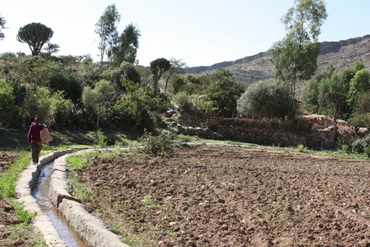 | 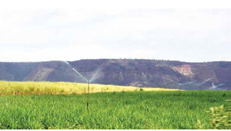
Figure 1.1 An irrigation channel in Ethiopia. | Figure 1.2 Spray irrigation in a sugar cane plantation in the Finchaa Valley, Oromia Region.

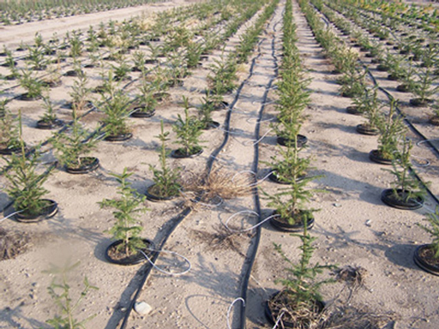
Figure 1.3 A drip-feed irrigation system. Black plastic pipes run alongside the small plants, providing each of them with water.

1.2.3 Industrial use
In many industries water is essential. Some industries use piped water supplied from water treatment plants while others draw the water themselves from underground sources and treat it on site for use. The water may be used either as part of the production process or as an ingredient, where water is one of the components of the product, for example in a soft-drink plant (Figure 1.4). In the production process, it can be used for cooling, washing, diluting, boiling or cooking, transportation of raw materials (for example, moving potatoes in a food factory), and as a cleaning agent.
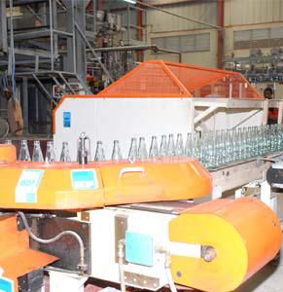
Figure 1.4 A soft-drink production plant in Ethiopia.

1.2.4 Mining use
Mining activities use huge amounts of water in processing ore to extract minerals. In Ethiopia, mining for gold and other valuable metals is an increasingly important part of the national economy (Figure 1.5) and would not be possible without the use of water.
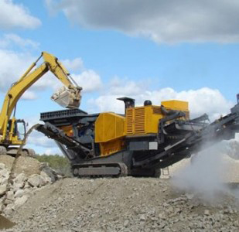
Figure 1.5 Mining for gold in Okote, Oromia Region.

1.2.5 Use in power generation
The rivers of Ethiopia have enormous potential for generating hydroelectric power (HEP). HEP uses the energy from moving water and converts this to electrical energy. The development of HEP has transformed energy supply in recent years and more schemes are under construction or planned. However, it is important to realise that in HEP the water is not ‘used’ in the sense of being consumed, because after passing through the HEP plant the water continues on its path in a river channel.
Another process under development in the Rift Valley area of Ethiopia is the use of geothermal energy, in which energy is derived from the heat of the Earth. This process involves drilling down into hot layers of underground rock and using this heat to convert water into steam, which is then used to drive generators to produce electricity. Figure 1.6 shows a geothermal electricity generation plant.
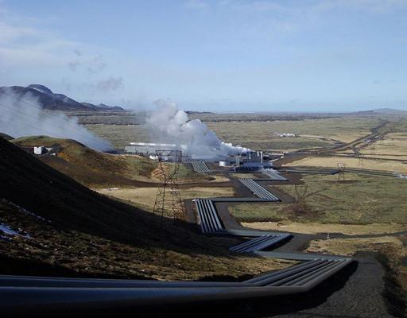
Figure 1.6 A geothermal power plant.

1.2.6 Aquacultural use
Water can also be used in aquaculture, which is the farming of aquatic organisms such as fish, crustaceans and molluscs for food. Fish farming (Figure 1.7) obviously needs water for the fish to live in! In this case, water is used to hatch fish eggs under controlled conditions, and the fish are grown to maturity in tanks or ponds, before being sold for food. Although not currently practised in Ethiopia, the business potential for aquaculture has been recognised and it may be introduced in the future (Rothuis et al., 2012).
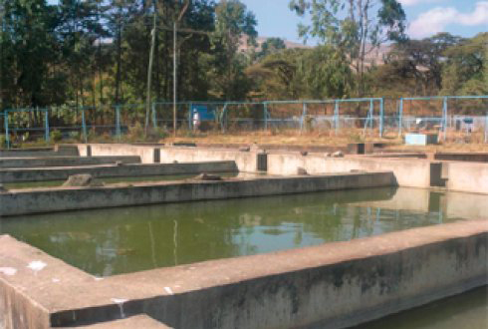
Figure 1.7 A fish farm.

1.2.7 Recreational use
Water plays an important role in recreational activities and here again it is not consumed in the process of its use. Boat trips are popular on many of Ethiopia’s lakes and several resorts have been built on their shores. An example is shown in Figure 1.8.
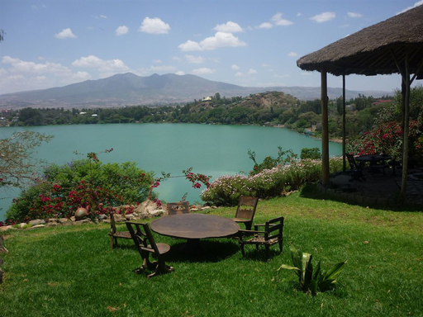
Figure 1.8 A resort at Babogaya Lake near Bishoftu.

1.3 How water gets to people living in towns
We obtain the water we use from three basic sources: groundwater, surface water and rainwater. Groundwater includes all water that is found underground within the rocks. Surface water means water in rivers, lakes, pools and ponds. Rainwater replenishes both groundwater and surface water, and can also be collected directly. These sources are discussed further in Study Session 3. For the purpose of this introductory study session, here is a brief summary.

1.3.1 Urban water sources
In urban areas, the water supply originates from one of the following basic sources:
- A spring (a point where groundwater emerges at the surface of the ground), from where the water can be piped to consumers. A spring may flow throughout the year or only at times.
- A well or borehole. These may supply individual residences or a large number of houses where the water is delivered through a network of pipes. In addition to this, institutions such as schools, health facilities, religious establishments, small commercial enterprises and industries may have their own water supply system from hand-dug or deep wells.
- Surface water from rivers and lakes, which may be abstracted directly or stored in a reservoir created by building a dam across a river. Abstraction means taking water from the source so that it can be used.
Springs and wells are considered improved sources of water if they are constructed and used in such a way that they adequately protect the water from contamination, especially by faecal matter. Spring or well water is generally used with minimal or no treatment. Surface water is an unimproved source and will require some form of treatment before it is safe to use for drinking. In larger towns and cities, surface water is treated in a water treatment plant before being distributed to consumers. The term raw water is used to describe the water before it is treated. Figure 1.9 shows the plant at Legedadi that supplies water to residents of Addis Ababa. (You will learn about water treatment in Study Session 5.)
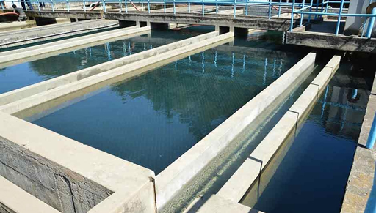
Figure 1.9 The drinking water treatment plant in Legedadi.

1.3.2 Delivering the water to consumers
In towns and cities with a water treatment plant, the treated water is taken to consumers through a network of pipes and reservoirs. Figure 1.10 is a diagram of a water distribution network of this type. (Water distribution networks are discussed in more detail in Study Session 8.)
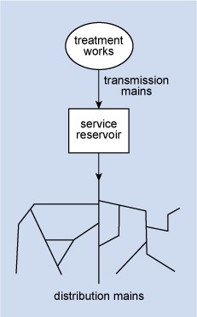
Figure 1.10 A simple water distribution network.
From Figure 1.10 you can see that transmission mains convey the treated water from a treatment works to service reservoirs (Figure 1.11). These reservoirs balance the fluctuating demands of users against the steady output of the treatment works and also serve as a back-up supply should there be a breakdown at the plant.
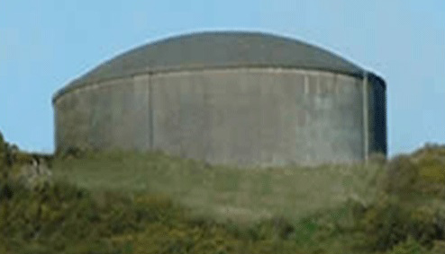
Figure 1.11 A concrete service reservoir in Janemeda, Addis Ababa.
- Why do you think demand for water will fluctuate?
- People generally use more water in the mornings and evenings when they are washing and cooking. Usage during the night while people are asleep will be much lower.
The capacity of the service reservoirs should be at least 36 hours of the water demand in the area they serve. The service reservoirs are usually made of concrete and often, for reasons of economy and appearance, are sunk wholly or partly below ground level. The reservoir needs to be positioned on high ground to provide an adequate flow by gravity to the distribution area, and to create sufficient pressure to raise the water to the top of buildings. In flat areas, water towers (Figure 1.12) may be used in place of service reservoirs. (A water tower is an elevated structure supporting a water tank. Water is pumped up into the tank, which is constructed at a height sufficient to pressurise the water supply system so that water can be distributed by gravity).
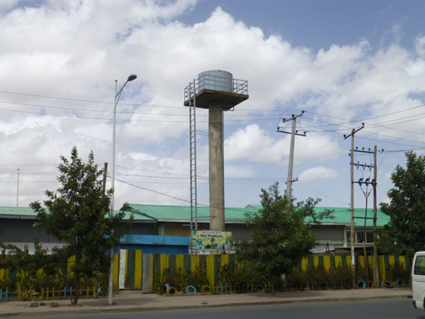
Figure 1.12 A water tower in Addis Ababa.
From the service reservoir, the water is taken by distribution mains to different areas. Distribution mains consist of a network of pipes of various sizes laid beneath the road, footpaths or verges. The water is taken to houses and other premises where water is needed. Here, the water goes to a tank in the roof-space or on the roof so that it is able to flow by gravity to all the taps in the establishment. The taps can be within a house or outside (Figures 1.13(a) and 1.13(b)). Sometimes water can be delivered by a tanker that pumps the water to the household’s water tank, or people collect water from the tanker using jerrycans. In urban areas, public water points are a very common water source for many people (Figure 1.13(c)).
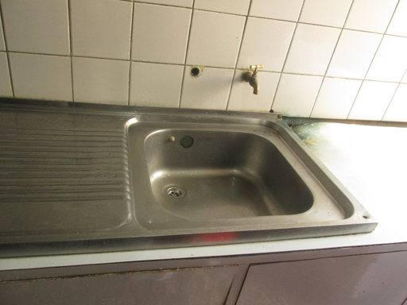 | 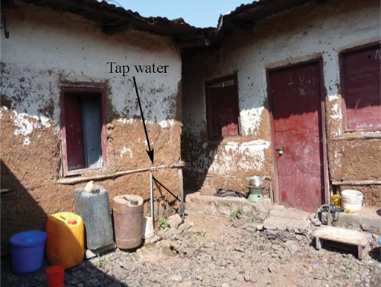
Figure 1.13(a) A tap inside a house. | Figure 1.13(b) A tap located in a yard and shared by several households.
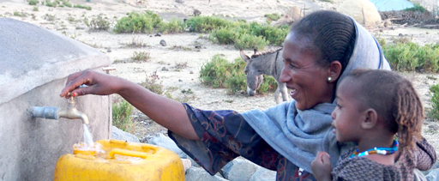
Figure 1.13(c) A public water point at Adi Sibhat, Tigray.
Continuity of supply is important so that people can be confident that water will be available when they need it. Where the supply of water is not continuous, many households have storage tanks to accumulate water for use when the supply is off. It is important to check the cleanliness of the storage tank regularly, and to clean and disinfect it as necessary.
In the case of seasonal discontinuity, users may be forced to obtain water from alternative sources, which are often of inferior quality and far away. As a consequence, the health of people will be put at risk by poor water quality and low quantity. In addition, considerable time and effort are spent on collecting water.
- In many towns and cities in Ethiopia, if you turn on a water tap at any random time it is quite likely that you will not get any water. Why do you think this happens?
- It may be because demand for water exceeds the supply available at that time. It can also happen due to a power failure or poor maintenance.

1.4 The challenges for urban water supply in Ethiopia
Ethiopia has plenty of water resources but the available water is not distributed evenly across the country and the amount varies with seasons and years. The challenge in any situation is to maintain a year-round supply that is adequate to meet people’s needs. To ensure that supply meets demand the source of the water must be carefully chosen, taking into account present and future demand for water, and the costs. The cost of water supplies is heavily influenced by the distance of reliable water sources from towns. The challenge for many towns is finding nearby water sources.
Planning for present and future demand has to consider population growth. The demand for water is increasing in cities and towns due to an ever-growing population and the migration of people from rural areas to towns in search of jobs and a better life. There are also increasing demands from industrial and commercial development. The quantity of water required for domestic use depends not only on the number of people but also on their habits and culture, and on how accessible the water is. On average, Ethiopians in urban areas use only about 15 litres of water a day for their needs (MoH, 2001; Ali and Terfa, 2012).
- How much water do we really need?
- From Section 1.2.1 you will recall that, according to the WHO, each of us needs 30–40 litres of water a day for all domestic purposes.
Why is there such a difference between the WHO estimate and the daily water consumption per person in Ethiopian towns? The shortfall is perhaps due to the shortage of private water taps, which means that people have to collect water from public taps. If people have a piped water supply in their home they are likely to wash and bathe more frequently, and some may have water-using appliances like washing machines. As water supply systems improve and access increases, the consumption of water will increase also. It is therefore important for water supply planners to consider the expected changes in society and in living standards. Planning of water supply projects should also consider the water requirements of schools, hospitals and other health facilities, churches and mosques, hotels, public washrooms, and other community facilities.
The government of Ethiopia has set targets of 100% coverage of safe water supply in urban areas and 98% coverage in rural areas. These targets originated from the Universal Access Plan of 2005 and the Growth and Transformation Plan of 2010, and have been adopted by the One WASH National Programme (OWNP), which is being implemented with major funding from government and international donors (FDRE, 2013). The planning criteria for water supply coverage in the OWNP are:
- rural water supply: 15 litres/person/day, within 1.5 km radius
- urban water supply: 20 litres/person/day, within 0.5 km radius (FDRE, 2013).
As you can see, these figures are still below the WHO recommendation and are more than current usage, indicating the scale of the challenge ahead. The targets for Ethiopia are that 4.4 million urban inhabitants and 26.6 million rural inhabitants, nearly 30,000 schools, and more than 7500 health posts/centres will gain access to safe drinking water (FDRE, 2013). Progress towards meeting these targets is described in Study Session 3.
At the beginning of this study session you read that water supply must be accessible and affordable. It is important that affordability extends to all sectors of society, including vulnerable people. Vulnerable groups include low-income households and households with many young children, older people, disabled people and people with long-term illness such as HIV/AIDS. Equitable access to water supply for all these groups should also be taken into consideration, especially when considering the cost of water as these vulnerable people usually have low income.
There are still many challenges ahead but the following changes will all contribute to future success:
- an increase in funds for the expansion of water supply services to satisfy the demand of growing populations, particularly in small towns
- a reduction in bureaucracy to facilitate the spending of funds that are committed (currently only around 60% of budgeted finances are actually spent)
- a reduction in the turnover of personnel, and an increase in human resource capacity and expertise at different levels
- better coordination between the different stakeholders (for instance, there is lack of coordination between the water sector, telecommunication department and the road authority; because of this, water pipes are frequently damaged during activities such as laying down telephone and internet lines, and during road construction)
- the presence of more experts to monitor sector performance at all levels
- better information management systems, giving early warning of requirements.

Summary of Study Session 1
In Study Session 1, you have learned that:
- Water is essential for life. Drinking water must be safe, of adequate quantity, accessible and affordable.
- Water has several uses of which the most important are for personal consumption and cleanliness, for irrigation, and for industry. The quality of water acceptable for the various uses can be different.
- Urban water supply may originate from springs, wells or surface water. Water from springs and wells is generally used without any treatment, while surface water needs treatment before it is safe to drink.
- In an urban water distribution network, transmission mains take water from water treatment plants to service reservoirs. Service reservoirs are located on high ground so that water flows by gravity through distribution mains to the water consumers. Where there is no high ground, water towers are constructed and used.
- Water supply planning must take account of present and future water demand by people, and by industrial and commercial development. Domestic use is likely to increase as living standards improve. Planning also needs to consider the needs of schools, health facilities and other institutions.
- There are many challenges facing urban water supply in Ethiopia and several factors that can contribute to overcoming them, including increased funding, reduced bureaucracy, capacity building, better coordination between the stakeholders involved, and better information management.

Self-Assessment Questions (SAQs) for Study Session 1
Now that you have completed this study session, you can assess how well you have achieved its Learning Outcomes by answering these questions. You can check your answers with the Notes on the Self-Assessment Questions at the end of this Module.

SAQ 1.1 (tests Learning Outcome 1.1)
Write the following words next to their correct definitions in the table below:
abstraction, aquaculture, distribution mains, drip-feed irrigation, geothermal energy, groundwater, hydroelectric power, improved sources, pathogenic micro-organisms, raw water, service reservoirs, spray irrigation, spring, surface water, transmission mains, water tower.
water sources that are protected from contamination, especially by faecal matter
water that has not yet been treated
a form of irrigation where water is put at the base of a plant, using narrow pipes
power produced by harnessing the energy of moving water
pipes that take water from a service reservoir to different areas
the farming of aquatic organisms
a point where water flows out of the ground
water from rivers, lakes, pools and ponds
pipes that take treated water from a treatment plant to service reservoirs
a form of irrigation where water is sprayed over plants
water that is underground
micro-organisms that cause disease
energy derived from the heat of the earth
an elevated structure that has a water tank to supply drinking water by gravity
the taking of water from a source
stores of water that balance the fluctuating water demands of users against the steady output of the water treatment plant

SAQ 1.2 (tests Learning Outcome 1.2)
Imagine you are in a quiz show on television and the host says, ‘For 1000 birr can you write down six non-domestic uses of water in two minutes?’
What would you write?

SAQ 1.3 (tests Learning Outcomes 1.1 and 1.3)
The following statements relate to water supply from a drinking water treatment plant in a large town. Fill in the blanks, using the words given below, and then put the statements in the right order.
distribution mains; river; cut in water supply; service reservoirs; lake; safe for human consumption; transmission mains.
- Water is taken from the treatment plant to ………………………… by …………………………
- Raw water is abstracted from a ………………………… or a …………………………
- Water is stored at home in case of a …………………………
- Water is taken from the service reservoirs to consumers by …………………………
- Water undergoes treatment so that it is …………………………

SAQ 1.4 (tests Learning Outcome 1.4)
Which of the following would not help in improving the water supply situation in Ethiopia? Give your reasons.
- Planning for expansion of towns and industry.
- Ensuring that the local water office always has new members of staff so that they are enthusiastic.
- More money being devoted to the water sector.
- Having more qualified people in the water industry.
- Reducing the interaction between the different organisations involved so that less time is wasted.
- Having better monitoring of performance and requirements in the water sector.

Study Session 2 Water and Public Health

Introduction
In Study Session 1 you read about the need for an adequate, safe and accessible water supply. If there is an insufficient quantity of water, or if the water is contaminated, this can have serious effects on people’s health and can be the cause of many different illnesses – even death. This, of course, impacts on the economic well-being of the community. In this study session you will look more closely at what is meant by safe and unsafe water, and you will learn why water is important for human health. You will consider the various classifications of diseases associated with water and examine the situation in Ethiopia in relation to these diseases.

Learning Outcomes for Study Session 2
When you have studied this session, you should be able to:
2.1 Define and use correctly all of the key words printed in bold. (SAQ 2.1)
2.2 List the ways in which water is used in the human body. (SAQ 2.2)
2.3 Understand the different ways in which water is involved in the transmission of human diseases. (SAQs 2.3 and 2.4)
2.4 Describe the situation in Ethiopia in relation to diseases from unsafe water. (SAQ 2.4)
2.5 Briefly outline the tests that are carried out in water quality assessment. (SAQ 2.5)

2.1 Water for human consumption
Water for human consumption must be palatable and safe. Palatable water is pleasant to drink, meaning it is completely clear and free from tastes, odours and colours. Safe drinking water, also known as potable water, is defined as water that does not contain harmful or potentially harmful substances and does not present any risk to human health. Harmful substances can be in the form of micro-organisms or chemicals. Unsafe water is a cause of bad health for people of all age groups. There are, however, some groups of people who are at greater risk. These include infants and young children, older people and people who are debilitated by diseases (such as HIV/AIDS).

2.1.1 Importance of water for human health
Water makes up about 70% of an adult human being’s weight. In the human body, blood contains about 82% water and our brain is made up of about 95% water. Losing just 2% of our water content can result in signs of dehydration, fuzzy short-term memory and difficulty in focusing on smaller print or words displayed on a computer screen.
Water has several roles in relation to human health:
- Water plays an important part in keeping us and our environment clean. It is essential for good personal hygiene. We use water to wash our hands and bodies, and also to wash places in our homes that could possibly harbour harmful micro-organisms (such as toilets).
- Many of our foods are prepared with water and others naturally contain large amounts of water (e.g. milk is made up of approximately 88% water; eggs 66%; fish 80%; potatoes 75%; and beef 77%).
- Inside the body, water serves as a lubricant during digestion of our food. Water in saliva facilitates chewing and swallowing, and the food goes down into the stomach with the help of water. The functions of all the body’s cells and organs depend on water.
- Water is involved in transporting valuable nutrients around the body in the bloodstream. Nutrients are broken down in the digestive system and transported to where they are needed in the body.
- Water is used by the body to remove harmful toxins and wastes through urination and perspiration. Water also helps to reduce constipation. Drinking enough water helps body organs such as the kidneys and the liver to get rid of waste products.
- Water helps to regulate body temperature. The body controls over-heating through perspiration. When sweat evaporates from the surface of the skin, it takes heat from the body and produces a cooling effect.

2.2 Diseases associated with water
The majority of water-related health problems are caused by infectious agents that can invade the body and cause disease. They include pathogenic (disease-causing) bacteria, viruses, protozoa and parasites. Infectious agents can cause disease when they are ingested (eaten or swallowed) or otherwise come into contact with the human body. The different ways in which water is involved in this contact can be used to classify the diseases into four main groups: waterborne, water-washed, water-based and water-related diseases.

2.2.1 Waterborne diseases
Waterborne diseases are caused by people ingesting water contaminated by human or animal faeces containing pathogens. Such diseases can also be caused by food that has been prepared using water contaminated with pathogens. The diseases are caused only when the infectious agent enters the body. Waterborne diseases include most of the enteric (related to the intestine) and diarrhoeal diseases caused by bacteria and viruses. Bacteria are unicellular organisms (made of one cell) and are very small, ranging from 0.5 to 5.0 micrometres (µm) in size. When seen under a microscope, they have different shapes, such as spheres, rods, or spirals. Viruses are microscopic infectious particles, much smaller than bacteria, that can only reproduce when inside the living cells of organisms. Waterborne diseases also include some caused by protozoa (single-celled micro-organisms that are much larger than bacteria, usually between 10 and 50 µm) and helminths. Helminths is a general term for worms, usually applied to those that are parasites on humans and other animals. Table 2.1 shows examples of waterborne diseases and their causes.
Table 2.1 Examples of waterborne diseases.
Category of infectious agent | Disease | Infectious agent
Bacterial | Cholera | Vibrio cholerae
 | Bacterial dysentery | Campylobacter jejuni
 | (Acute) gastroenteritis | Various
 | Shigellosis | Shigella species
 | Typhoid fever | Salmonella typhi
Viral | Viral gastroenteritis | Rotavirus and others
 | Viral hepatitis | Hepatitis A and E viruses
 | Poliomyelitis | Polio virus
Protozoal | Amoebic dysentery | Entamoeba histolytica
 | Cryptosporidiosis | Cryptosporidium
 | Giardiasis | Giardia lamblia
Helminths | Ascariasis (roundworm) | Ascaris lumbricoides
 | Dracunculiasis (Guinea worm) | Dracunculus medinensis
 | Trichuriasis (whipworm) | Trichuris trichiura
Although drinking contaminated water is a very significant route of transmission for many of the diseases listed above, they may also be transmitted by other means such as by eating contaminated food. Food can become contaminated by poor hygiene during preparation. Flies are also important transmitters of contamination from faeces to food. There are other possible routes of transmission, including through droplets and aerosols, if these are ingested. We use our fingers for eating and frequently put our hands to our mouths; touching contaminated surfaces can also be a route for disease transmission.
- How could poor personal hygiene by people preparing food cause disease?
- If cooks do not thoroughly wash their hands before touching food, they could easily transfer contamination by infectious agents. When the contaminated food is eaten, this could transmit disease to the consumers.
In all these cases, the origin of the contamination is faeces of people who are already infected by the disease. Some diseases may be transmitted via the faeces of infected animals. In places without adequate sanitation and where people defecate in the open, waterborne disease is far more likely to occur. By sanitation, we mean the prevention of human contact with wastes. If faeces are effectively separated from people then the transmission routes of waterborne diseases are cut off.

2.2.2 Water-washed diseases
Water-washed diseases are those that occur as a result of inadequate quantities of water being available for good personal hygiene. Good personal hygiene habits include:
- washing hands with soap, or using an alternative such as ash, after using the latrine
- washing hands before preparing and/or eating food
- washing the body frequently
- cleaning the teeth at least once a day
- washing the hair with soap or shampoo at least once a week.
Figure 2.1 shows the steps in a thorough technique for handwashing.
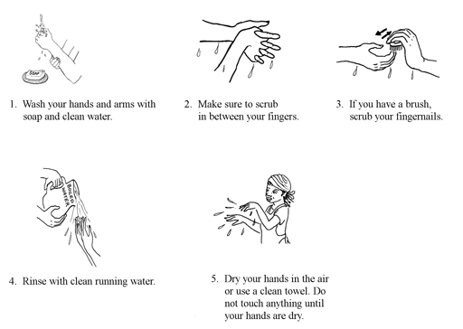
Figure 2.1 Handwashing technique.
Water-washed diseases are sometimes called ‘water-scarce’ diseases because they are a problem if water supply is limited. They include fungal skin diseases such as ringworm, ophthalmic diseases (diseases of the eye) such as trachoma and conjunctivitis, and infections caused or carried by lice, mites, fleas or ticks. Two examples of these diseases are scabies (caused by mites) and louse-borne epidemic typhus (caused by Rickettsia prowazekii bacteria and transmitted largely by body lice).
- Adequate quantities of clean water can prevent such diseases affecting a population. Why do you think this is so?
- Because if plenty of water is available, people are able to wash frequently and the disease-causing organisms will be washed away.

2.2.3 Water-based diseases
Water-based diseases are caused by parasites that spend part of their life cycle in water. Water-based diseases such as bilharzia (also known as schistosomiasis – this will be described in Section 2.3.3), and dracunculiasis are caused by helminths. Dracunculiasis, or Guinea worm disease, is transmitted by drinking water that is contaminated with copepods that contain the larvae of the Guinea worm (Figure 2.2). Copepods are very small crustaceans, sometimes known as water fleas, that are found in the sea and in fresh water. The Guinea worm larvae get into the water by emerging through the skin of an infected person while they are washing or bathing. To prevent dracunculiasis infection, effective water treatment is needed. A global campaign to eradicate Guinea worm has made great progress in reducing the incidence of the disease and it is now found in only a few countries in the world. Ethiopia is one of them, but the disease is now rare; only three cases were reported during 2014 (WHO, 2015). (Note that transmission of dracunculiasis requires drinking of contaminated water and it can, therefore, be classified as both a waterborne and a water-based disease.)
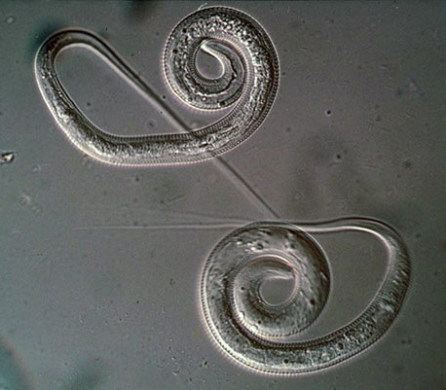
Figure 2.2 Guinea worm: the parasite that causes the disease dracunculiasis. The worm is 1–2 mm wide and can grow up to 100 cm long.

2.2.4 Water-related diseases
Water-related diseases are transmitted by insects that breed or feed in or near water bodies. The best-known example is malaria, which is spread by the Anopheles mosquito (this disease will be described in Section 2.3.2). Water-related diseases are not associated with lack of access to clean drinking water or to hygiene and sanitation services. The significant factor is the presence of standing water, which provides a habitat for the insects to breed. Other water-related diseases include onchocerciasis (spread by blackfly), dengue fever and yellow fever (both spread by mosquitoes).

2.3 Common diseases associated with water in Ethiopia
The government of Ethiopia is taking steps to improve the quality of water supply in urban areas of the country, but many people suffer from communicable diseases associated with water. Data from Harari Region are used here as an example. Table 2.2 shows the diseases that were most prevalent in Harari Region in 2013/2014.
Table 2.2 The prevalence of diseases associated with water in Harari Region in 2013/2014. (Harari Regional Health Bureau, 2014)
Disease | Number of people affected
Diarrhoeal diseases (e.g. rotavirus infection, cholera) | 6345
Malaria | 3861
Infection by intestinal parasites | 462
Trachoma | 432
Amoebic dysentery | 365
The sections that follow describe these diseases in more detail.

2.3.1 Diarrhoeal diseases
Diarrhoea is a symptom of many waterborne diseases and is the cause of 11% of deaths among children aged under 5 across the world, with a reported total of 2195 deaths each day (Liu et al., 2012). The global major causes of death in children under 5 are shown in Figure 2.3.

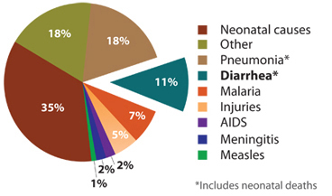
Figure 2.3 Diarrhoea kills more children under 5 years of age across the world than malaria, measles and AIDS combined. (Liu et al., 2012)
Worldwide, 88% of diarrhoeal disease is attributable to unsafe water, poor hygiene and inadequate sanitation. In Ethiopia, 15% of all deaths are from diarrhoea, with the highest death rate among young children (World Life Expectancy, n.d.). Children, especially those under 5 years of age, are vulnerable to infection because they frequently put their unwashed fingers in their mouths.
One important example of a diarrhoeal disease is cholera. Cholera is an acute bacterial infection of the intestinal tract that produces watery diarrhoea. It is caused by the bacterium Vibrio cholerae (Figure 2.4) and causes severe loss of body fluids through diarrhoea, with the stool looking like rice-water. Without treatment, the disease can quickly lead to acute dehydration and death. Cholera is a worldwide problem, common in areas that lack basic sanitation. It can also be a problem in emergency situations (as you will learn in Study Session 14). It can be prevented by the provision of safe drinking water, effective sanitation and good hygiene behaviour, including food hygiene.
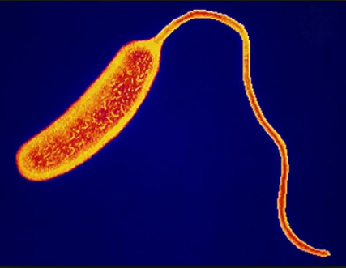
Figure 2.4 Vibrio cholerae (0.5–0.8 µm wide, and 1.4–2.6 µm long).

2.3.2 Malaria
Malaria is a parasitic disease transmitted by the female Anopheles mosquito and caused by the pathogenic protozoa Plasmodium. When a mosquito bites an infected individual it sucks up blood containing the parasite. If it then bites a healthy person, the protozoa is transferred into their blood and they can become ill. The mosquitoes breed in standing water such as swamps, lakes, pools and open channels dug for crop irrigation; even a puddle can provide enough water for mosquitoes to breed. Only the female mosquitoes take human blood, which is needed to develop their eggs. The most likely time for mosquitoes to bite is in the early evening or at night.
- Can you think of ways to avoid being bitten by mosquitoes?
- Wearing long-sleeved clothing and using insect repellants helps to keep people from being bitten. At night, mosquito nets (preferably impregnated with permethrin, which is toxic to mosquitoes) or various sprays or vapours can be used to keep them away.

2.3.3 Parasitic worm infections
People become infected with intestinal parasitic worms (helminths) through water or food that has been contaminated with faecal matter from an infected person. Infection occurs when these parasites get into the intestinal tract of a new host. Even though there are numerous parasites that infect humans, those most common in Ethiopia are the roundworms that cause ascariasis (Figure 2.5) and trichuriasis (Figure 2.6). Both of these diseases are spread through ingestion of contaminated food and water, and also poor hygiene behaviour. Children are more likely to be affected because their immune systems are not fully developed; they constitute important reservoirs of the infections.
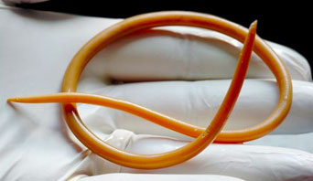
Figure 2.5 Ascaris lumbricoides roundworm: these intestinal parasites can be very large – up to 35 cm long. | Figure 2.6 Trichuris trichiura roundworm: these parasites can reach 4 cm in length.
Schistosomiasis, also known as bilharzia, was mentioned earlier in this study session. It is also a disease caused by parasitic worms but in this case they do not get into the body from ingesting contaminated water or food. This is a water-based, not a waterborne disease. The Schistosoma parasitic worm enters the body by penetrating through the skin. It has a complicated life cycle and spends part of its life in a human body and part in a particular species of water snail, as shown in Figure 2.7.
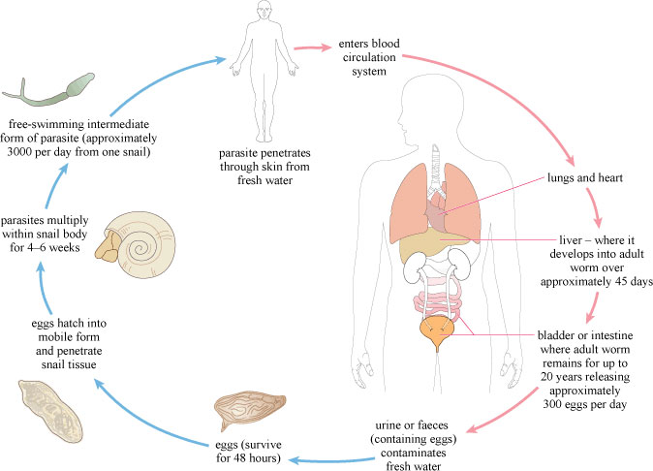
Figure 2.7 Life cycle of the Schistosoma parasite.
The eggs of the worm are released into water bodies through the urine or faeces of an infected person and they then infect the snails, the intermediate host. Snails are more often found in slow-flowing or standing water where water plants are growing, rather than in rapidly flowing water. If the environmental conditions are not suitable for the snails, they will not survive and the disease cycle can be broken. In preventing water-based diseases like schistosomiasis, it is important to focus interventions on still waters of lakes and ponds and water channels used for irrigation, where vegetation is growing.

2.3.4 Trachoma
Trachoma is a bacterial eye infection that is made worse by poor hygiene due to lack of adequate water for washing. Repeated infections can lead to blindness if left untreated. Trachoma affects women and children more than adult men (WHO, 2002). It spreads easily from child to child or from child to mother, either directly by hand contact or indirectly on clothing, or by flies that land on the face of an infected child. A 2007 study found that 40% of Ethiopian children in the age group 1–9 years were suffering from active trachoma infection (Berhane et al., 2007). Good personal hygiene and encouraging children to wash their faces can significantly reduce incidence of the disease.

2.3.5 Amoebic dysentery
Amoebic dysentery, also called amoebiasis, is a disease caused by the protozoa Entamoeba histolytica (Figure 2.8). It is acquired by ingesting infectious cysts (a dormant form of the organism that helps it survive in unfavourable environments) through water or food items that are contaminated.
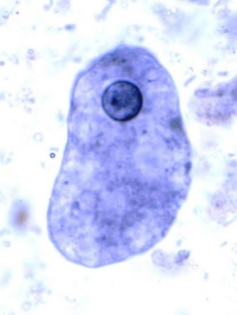
Figure 2.8 Entamoeba histolytica, up to 60 µm in size.

2.4 Water quality assessment
Many analytical methods are used to test for the presence and concentration of possible contaminants in water. Concentration is the measure of the quantity of a substance dissolved in a known volume of water. For water quality assessment, the units used are usually milligrams per litre, which is written as mg/l, or mg l^{–1}.

2.4.1 Microbiological tests
As you have been reading, there are many different types of pathogenic micro-organisms that may be present in water but it would be very difficult and time-consuming to test for all of them. The source of the pathogens is usually human faeces; therefore, tests have been devised that detect the presence of faecal contamination. If faecal contamination is found, this indicates that pathogenic organisms may be present. The most widely used tests for faecal contamination are for total coliforms, faecal coliforms and Escherichia coli (E. coli). Coliforms are a group of bacteria found in human and animal faeces and also in soil. ‘Total coliforms’ includes all bacteria in this group. The presence of ‘total coliforms’ indicates contamination of some sort but, because of their relatively wide distribution, they cannot be used to confirm if the contamination is from faeces. Faecal coliforms are a sub-set of total coliforms and, as the name suggests, are typically found in faeces. E. coli is a type of faecal coliform bacterium that is commonly found in the faeces of humans and other warm-blooded animals. If E. coli is present in a water sample this indicates faecal pollution and the possible presence of pathogenic organisms; the absence of E. coli from a sample shows that the chances of faecal contamination of the water, and therefore of pathogens being present, are negligible. Thus the presence of E. coli in a water sample provides an important indicator of pollution. An indicator in this context is a biological species that tells us something about the environment.
It is important to realise that E. coli is only an indicator and its absence cannot give complete assurance that the water is safe. Some pathogens – such as Giardia, Entamoeba histolytica and some viruses – can survive in waters long after E. coli has died; therefore, the absence of E. coli will not necessarily mean that water is totally free from other organisms.

2.4.2 Chemical tests
Although the great majority of health-related water quality problems are the result of biological contamination, chemical contamination of water sources can also cause serious health problems.
Fluoride in low concentrations (less than 1.5 mg l^{–1}) in drinking water has beneficial effects on teeth, but exposure to excessive fluoride can give rise to a number of adverse effects (WHO, 2004). Fluorosis (an abnormal condition caused by excessive intake of fluorides) is a common problem in children living in the Rift Valley region of Ethiopia where the level of fluoride, especially in groundwater, can be high. Levels of fluoride above 1.5 mg l^{–1} can lead to mottling of children’s teeth (the appearance of spots or blotches of different shades of colour – Figure 2.9). Higher levels can lead to severe skeletal fluorosis, where fluoride accumulates in the bones over many years causing stiffness and pain in the joints and bones (WHO, 2004). Consuming water that has levels in excess of 10 mg l^{–1} leads to crippling skeletal fluorosis where the extremities become weak and moving the joints is difficult. The vertebrae partially fuse together, crippling the patient (WHO, 2004).
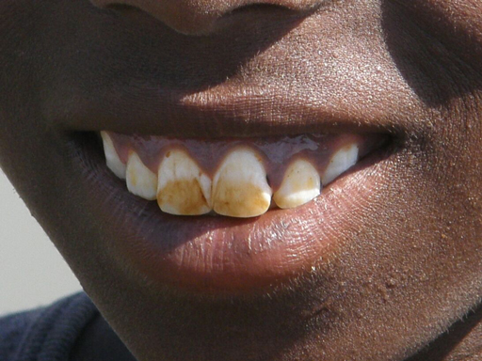
Figure 2.9 Fluorosis causes mottling of children’s teeth.
Alternatively, some health effects occur as a result of specific chemical deficiencies in the diet, of which water forms a part. Examples include goitre, caused by iodine deficiency, and dental caries resulting from low fluoride intake.

2.4.3 Physical tests
Turbidity (cloudiness due to a large number of very tiny particles), colour, taste and odour (smell), whether of natural or other origin, affect people’s perceptions of water. As you know water should be free of tastes and odours that would be unpleasant to the majority of people. In extreme cases, people may avoid water that does not look or taste good – even if it is otherwise safe – in favour of more pleasant-looking and tasting water that may actually be contaminated.
Colour in drinking water occurs due to the presence of dissolved organic matter and metals such as iron and manganese. Colour can come from industrial pollution such as from dyes used in textile manufacture. Odour in water is due mainly to the presence of organic substances. Taste is the combined perception of substances detected by the senses of taste and smell. Changes in the normal taste of a piped water supply can be important as they may signal changes in the quality of the raw water source or deficiencies in the treatment process.

Summary of Study Session 2
In Study Session 2, you have learned that:
- Water is essential to life. People can live for many days without food but for very few days without water.
- Water for public consumption must be palatable and safe.
- Unsafe water can seriously harm human health. Infants, young children, older people and people debilitated by disease are the most vulnerable.
- Water in the human body is essential for several bodily functions.
- The diseases associated with water can be classified as waterborne, water-washed, water-based and water-related.
- The causative agents of disease in unsafe water include bacteria, viruses, protozoa and helminths (worms).
- The main illnesses in Ethiopia include diarrhoeal diseases and malaria.
- Detection of faecal coliform bacteria including E. coli is used to test for the presence of faecal contamination and to indicate the likelihood of the presence of pathogenic organisms in drinking water.
- Chemical contamination of water can cause health problems.
- Turbidity, colour, taste and odour are important factors in water being acceptable to people.

Self-Assessment Questions (SAQs) for Study Session 2
Now that you have completed this study session, you can assess how well you have achieved its Learning Outcomes by answering these questions. You can check your answers with the Notes on the Self-Assessment Questions at the end of this Module.

SAQ 2.1 (tests Learning Outcome 2.1)
Write the following words next to their correct definitions in the table below:
bacteria, concentration, enteric, faecal coliforms, fluorosis, helminths, indicator, infectious agents, palatable water, potable water, protozoa, safe drinking water, sanitation, total coliforms, turbidity, viruses, water-based diseases, waterborne diseases, water-related diseases, water-washed diseases.
the prevention of human contact with waste
another way of saying ‘safe drinking water’
the total number of bacteria (which come from faecal matter and other sources)
water that does not have any components that can harm people
the amount of a substance in a given volume of water
worms that live as parasites in humans and animals
an abnormal condition that results from an excess of fluoride in the body
water that is pleasant to drink
diseases transmitted by insects that breed or feed in or near water
single-celled organisms ranging in size from 0.5 to 5.0 µm
micro-organisms and viruses that can invade the human body and cause disease
cloudiness caused by a large number of tiny particles in a liquid
coliforms bacteria that originate from faeces
diseases caused by parasites that spend part of their life cycle in water
concerned with the intestine
a biological species that gives information about the environment
diseases that are caused through the ingestion of water contaminated by human or animal faeces containing pathogens
single-celled micro-organisms that are much larger than bacteria
diseases that occur due to inadequate water being available for good personal hygiene
small infectious particles that are much smaller than bacteria

SAQ 2.2 (tests Learning Outcome 2.2)
- Briefly describe the important roles that water plays in the human body.
- List the types of people who are most vulnerable to waterborne diseases.

SAQ 2.3 (tests Learning Outcome 2.3)
For which of the following diseases will the construction and appropriate utilisation of latrines (instead of open defecation) reduce transmission? Give reasons for your choice.
- amoebiasis
- dracunculiasis
- schistosomiasis
- malaria
- giardiasis.

SAQ 2.4 (tests Learning Outcomes 2.3 and 2.4)
Read Case Study 2.1 and answer the questions that follow.

Case Study 2.1
Abebe is a 25-year-old man originally from Zegie, Lake Tana. He lives on the outskirts of the city of Bahir Dar in a single room together with his two friends. He is a daily labourer. In the compound of the house where they live, there is no space to construct a latrine. Thus, all the people in the compound defecate in the open area nearby.
Because of the long journey home from Bahir Dar to Zegie, he seldom visits his family. The family grows and sells coffee and khat for their living. Abebe’s family does not have a latrine either and uses an open field. During a recent visit to his family, he swam in Lake Tana and washed his clothes there. Upon returning to Bahir Dar, Abebe became sick, having severe abdominal pain, diarrhoea, joint pain, headache, and fever. The next morning, his friends took him to the nearest health centre and he got some medication.
- What is the most important public health issue you see in this case study?
- What specific water-associated diseases do you expect Abebe might have?
- What do you think are the causes of these problems?

SAQ 2.5 (tests Learning Outcome 2.5)
Which of the following statements is false? In each case explain why it is incorrect.
- E. coli is a type of virus found in faeces.
- Faecal coliforms are typically found in human and animal faeces.
- The presence of E. coli in a water sample means the water is safe to drink.
- The absence of E. coli in a water sample means the water is safe to drink.

Study Session 3 Water Sources and their Characteristics

Introduction
Water collection for domestic use can be traced back to 560 BC when rainwater harvesting was practised in the Axumite Kingdom. In those days, rainwater was collected and stored in ponds for agriculture and water supply purposes. Evidence for this is in documented literature and may be observed in visible remains of ponds (Seyoum, n.d.). The history of modern piped water supply in Ethiopia began in 1924 when a piped supply was established from the Kebena River to the patriarch’s compound and Menelik Hospital in Addis Ababa, using an 80-mm pipe. Until the inauguration of the Gefersa Dam in 1951 the town of Addis Ababa was supplied from wells and springs (AAWSA, 2011).

Learning Outcomes for Study Session 3
When you have studied this session, you should be able to:
3.1 Define and use correctly all of the key words printed in bold. (SAQ 3.1)
3.2 Identify the different sources of water for urban supply, describe their characteristics and explain how water is abstracted from them. (SAQ 3.2)
3.3 Identify means of protecting water sources. (SAQs 3.3 and 3.4)
3.4 Describe briefly the factors to be considered in water source development. (SAQ 3.5)

3.1 Types of water source
In Study Session 1 you were introduced to the three main sources of water: groundwater, surface water and rainwater. In arid regions where seawater is accessible (such as in the Middle East), desalination (the removal of salts from water) is used to generate drinking water. Another potential source of water is treated wastewater – you will learn more about this in Study Session 11. In practice, the term ‘water source’ can be used to mean both the origin of the water and also the place where people get their water (spring, piped supply to household tap, water point, well, etc.).
Water sources can be classified as protected or unprotected. Protected sources are covered by stonework, concrete or other materials that prevent the entry of physical, chemical and biological contaminants. Typical characteristics of a protected water source are given in Box 3.1.

Box 3.1 Characteristics of a protected water source
- The water source is fully enclosed or capped and no surface water can run directly into it.
- People do not step into the water while collecting it.
- Latrines, solid waste pits, animal excreta and other sources of pollution are located as far away as possible from the water source and on ground lower in elevation than the water source.
- There is no stagnant water within 5 metres of the water source.
- The water collection buckets or hand pump at the source are kept clean.

- Why do you think there should be no stagnant water within 5 metres of a water source?
- It could encourage animals to come there for water, and they could contaminate the water source. Stagnant water can also become a breeding site for mosquitoes.
Unprotected sources are those with no barrier or other structure to protect the water from contamination. All surface water sources, such as lakes, rivers and streams or poorly constructed wells, are examples of unprotected sources. Water from unprotected sources cannot be considered safe to drink unless it has been treated.
The terms ‘improved’ and ‘unimproved’ are also used to describe water sources and are broadly equivalent to ‘protected’ and ‘unprotected’. WHO /UNICEF categories of water sources are defined in this way, as you can see in Figure 3.1. This shows the drinking water ladder, which describes the steps in improvement of quality of water supply depending on the type of source. Surface water is at the bottom of the ladder and piped water into the household is at the top. There are a number of improved and unimproved sources between these two, several of which are described in later sections of this study session.
Figure 3.1 Drinking water ladder.

3.2 The situation in Ethiopia
Figure 3.2 shows estimated trends in drinking water coverage in Ethiopia. Each of the columns shows the percentage of drinking water that is supplied by surface water, other unimproved sources, piped supply and other improved sources, for the years 1990 to 2012.
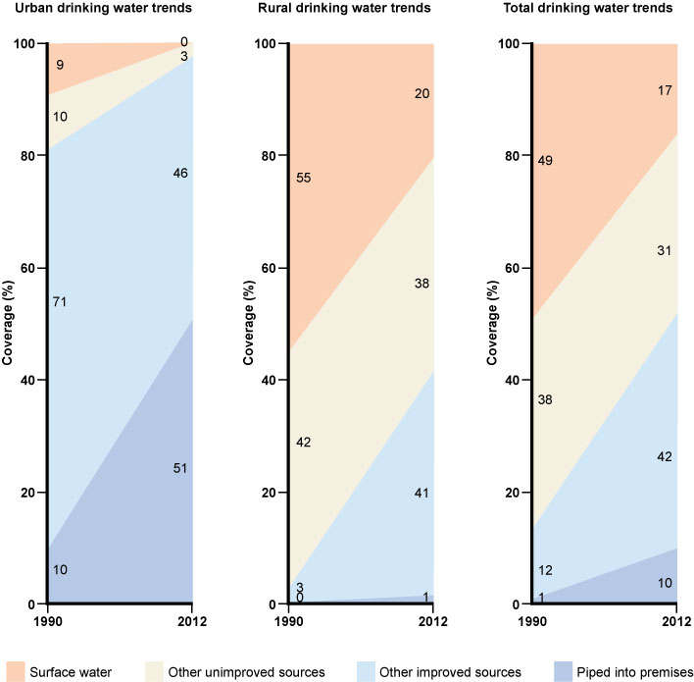
Figure 3.2 The change in drinking water sources in Ethiopia between 1990 and 2012 for urban (left), rural (centre) and total populations (right). (Data from JMP, 2014).
- Look at Figure 3.2 and calculate the percentages of water supplied from improved water sources to urban populations and to rural populations in Ethiopia in 2012.
- For urban populations, piped supplies to premises account for 51% and other improved supplies 46%, so the total is 97%. For rural populations, piped supplies to premises are only 1%, and other improved supplies are 41%, making a total of 42%.
One reason for the low coverage of rural premises is that the rural population is dispersed, and therefore difficult to serve easily. In urban areas, people live closer together and populations are more concentrated in given areas; therefore pipes can be laid more easily (and with less expense) to cover a large population.

3.3 Groundwater
Groundwater was defined in Study Session 1 as water that is found underground within rocks. Its presence depends primarily on the type of rock. Permeable rocks have tiny spaces between the solid rock particles that allow water and other fluids to pass through and to be held within the rock structure. The layers of rock that hold groundwater are called aquifers. Figure 3.3 shows how groundwater in an aquifer is replenished by rain and other forms of precipitation (any form of water, such as rain, snow, sleet or hail that falls to the Earth’s surface, shown in the diagram as ‘recharge’) that has percolated (passed through a porous substance, or through small holes) downward into the aquifer. The level of water below ground is called the water table. Groundwater can be extracted from wells or collected from springs.
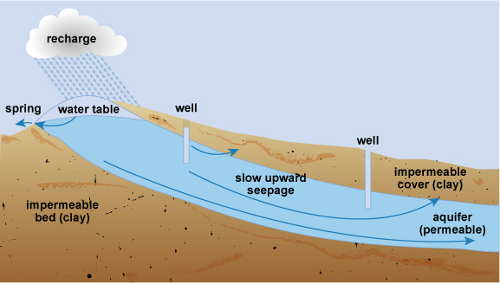
Figure 3.3 Diagram of groundwater formation with spring and wells.
The depth that groundwater is taken from and the types of permeable rock it has passed through are important factors that affect its quality. Groundwater, particularly from deep sources, may provide water of good microbiological quality. This is because bacteria, protozoa, viruses and helminths are filtered from the water as it passes through the layers of soil and rock. Groundwater sources are therefore preferable to surface water sources. However, groundwater can contain chemical contaminants, as indicated in Table 3.1, which lists the advantages and disadvantages of using groundwater as a water source.
Table 3.1 Advantages and disadvantages of using groundwater as a water source. (Adapted from Kebede and Gobena, 2004)
Advantages | Disadvantages
Likely to be free of pathogenic bacteria  Usually free of turbidity and colour  Can usually be used without further treatment  Can often be found in close vicinity to consumers  Economical to obtain and distribute  The water-bearing soil or rock provides a natural storage point | Often has a high mineral content (i.e. has naturally occurring substances that are not from living organisms) such as calcium, magnesium, iron and manganese  Usually requires pumping for extraction  May have a high level of bicarbonate, carbonate and chloride  Poor in oxygen content  Can contain chemical contaminants such as arsenic, fluorides and nitrates  If it gets polluted, treatment can be difficult to achieve
Several factors influence the likelihood of groundwater becoming contaminated from a polluting source such as a pit latrine. The geology is important because in areas with permeable rocks, or where there are small cracks in the rock formation, fluids can pass through more easily into the aquifer. Other factors include the depth of the pit and its vertical distance from the water table. In Ethiopia, federal guidelines state that latrines must be sited at least 30 metres from any water source to be used for human consumption and if on sloping ground be lower than the source (MoH, 2004).
- Why should a well be located uphill from any possible sources of pollution?
- The natural flow of the groundwater follows the law of gravity, and will be downhill. The well should be sited so that any pollutants going into the soil that enter the groundwater do not get into the water in the well. So, the best place for a well would be uphill of the pollutant source.

3.3.1 Wells and boreholes
Wells and boreholes can be described by their depth, or by the way they are constructed. They may also use different types of pump at the surface to raise the water.

Shallow wells
Shallow wells and boreholes usually have a depth of less than 30 m, although they can be as much as 60 m deep, especially in very dry areas of Ethiopia where the water table is low. Figure 3.4 is a diagram of a protected hand-dug well. Wells can be excavated by hand if the soil is not too hard or the water table is high. Hand-dug wells have a relatively large diameter because they have to be wide enough for a person to be able to stand inside and dig.
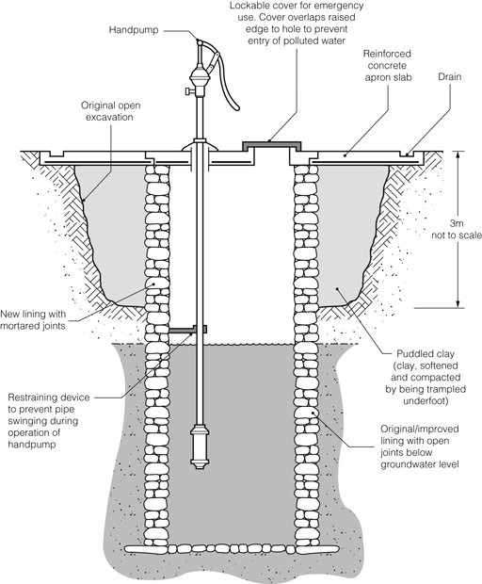
Figure 3.4 Diagram of a hand-dug well.
The inside wall of the top 3 m or so of the dug well should be made waterproof by constructing a well casing (lining). In small-diameter wells the casing can be a pipe, but in large wells the casing needs to be constructed in concrete from the top of the well down to a minimum depth of 3 m. The casing of the well should also be extended for a minimum of 60 cm above the surrounding ground level to prevent the entrance of surface run-off – that is, water that runs off the surface of the land, carrying debris, wastes and other pollutants with it as it flows. A concrete cover should be fitted over the well casing, as in Figure 3.5, to prevent dust, insects, small animals and any other contaminants from falling in.
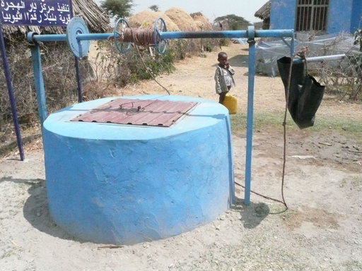
Figure 3.5 Protected well with concrete surround and a lid. Note the black plastic bucket is suspended off the ground to keep it clean.
Depending on the depth of the well, water may be drawn up by a bucket and rope or by using a pump. Hand pumps, such as the one in Figure 3.6, are built over the well and the concrete cover extends to cover the surrounding ground. The immediate area of the well should preferably be fenced to keep animals away. The area surrounding the well should be graded off (i.e. should slope away from the well) in order to prevent the flow of storm water run-off into the well. Any pipework associated with the pump that enters the well needs to have watertight connections so that it operates efficiently. The well, pump, pipework and associated structure should be regularly disinfected using chlorine solution to eliminate pathogens and ensure the water is safe to drink.
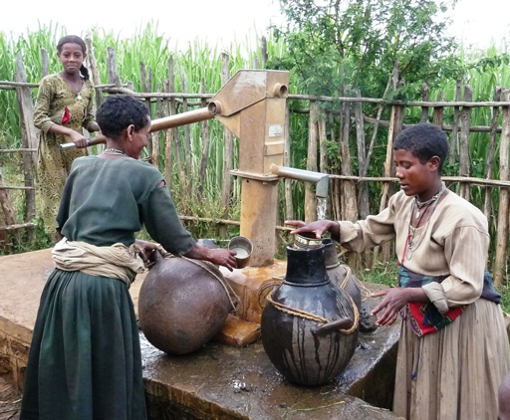
Figure 3.6 Hand pump over a protected dug well. Note the concrete surround and the fence to keep out animals.
Water can also be drawn from a well using a rope pump (Figure 3.7). A long continuous loop of rope, with washers at regularly spaced intervals, runs around a wheel at the top of a well and around a smaller roller encased below the water line. The rope runs through a PVC pipe and, as the wheel is turned, water is drawn up the pipe by suction. A rope pump can be made from recycled parts, such as bicycle wheels, scrap metal and plastic, and it can be mended quickly and cheaply.
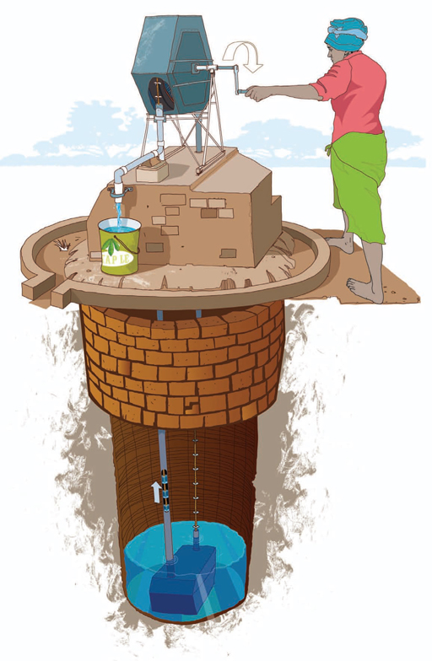 | 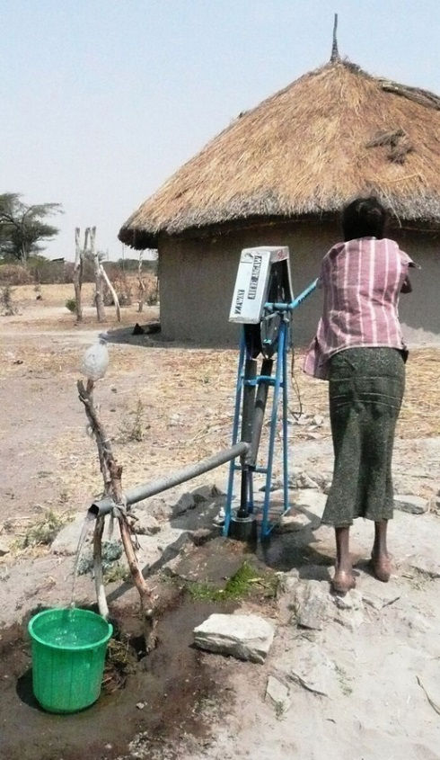
Figure 3.7 Examples of rope pumps.

Deep wells or boreholes
These are wells that have been sunk with drilling machines designed for constructing water extraction boreholes (Figure 3.8). These machines are able to penetrate through harder material that cannot be tackled by hand digging and can therefore pass through at least one impermeable layer of rock to a productive aquifer underneath. They typically obtain water from depths ranging from 30 to 60 m, but large urban supply boreholes can be much deeper than this. A casing of metal or plastic pipe is usually necessary to line the borehole and prevent the soil and rock from collapsing into it (Figure 3.9). The lower part of the casing must have suitable openings to allow water to enter the borehole from the aquifer, although in hard rocks – such as some of the volcanic aquifers of Ethiopia – the borehole can be left open and will not collapse.
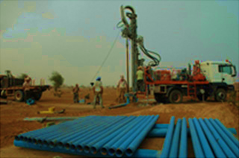 | 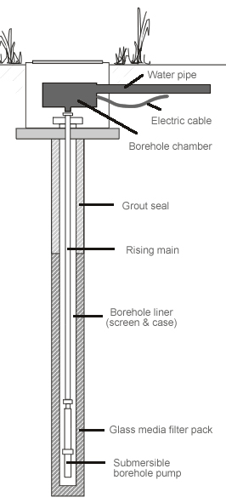
Figure 3.8 Drilling rig for a borehole. | Figure 3.9 A borehole.
At the surface, different types of pump may be used including hand pumps like the one in Figure 3.6. For larger boreholes in urban areas electric or diesel-powered pumps would be used.

3.3.2 Springs
Groundwater may emerge above ground as a spring. This happens in locations where the water table reaches the surface, or where the boundary between a permeable layer of underground rock and an impermeable layer reaches the ground surface, as shown in Figure 3.3. Springs are normally found at the foot of mountains and hills, in lower slopes of valleys, and near the banks of major rivers. The water emerging at a spring may vary in volume and contamination levels, in response to the amount of rainfall. Springs are likely to be polluted by direct contamination from run-off seeping through the topsoil unless the surrounding land area is protected. A spring supply issuing from a deep, water-bearing layer, rather than a permeable layer near the surface, can produce both a consistent volume and a better-quality supply.

Spring source protection
Whether the spring originates from shallow or deep rock layers, animals should be excluded from the surrounding area by a stock-proof fence. Springs should be protected from flooding and surface water pollution by constructing a deep diversion ditch above and around the spring. The ditch should be constructed so that it collects surface water running towards the spring and carries or diverts it away. It needs to be deep enough to carry all surface water away, even in a heavy rainstorm.
Small springs are typically protected by a ‘spring box’ (Figure 3.10), which is constructed of brick, masonry or concrete, and is built around the spring so that water flows directly out of the box into a pipe or cistern, without being exposed to outside pollution such as run-off, bird droppings and animals. The spring box should have a watertight cover with a lock. Larger springs serving towns are protected in a similar way. Figure 3.11 shows the protected spring that supplies water to the city of Bahir Dar.
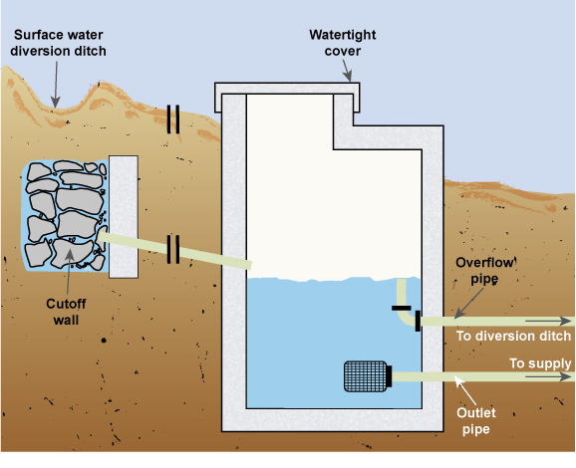 | 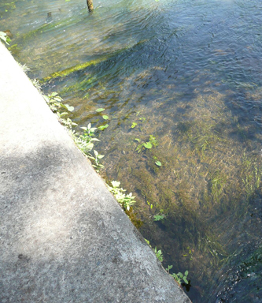
Figure 3.10 A spring box. | Figure 3.11 Protected spring providing water for Bahir Dar. The concrete slab on the left covers and protects the source of the water.

3.4 Surface waters
The quality and quantity of surface water varies from one place to another and over time, due to factors such as geology, climate and surrounding land use.
- Why is surface water classed as an unimproved source?
- Because rivers and lakes can be easily contaminated by run-off that washes pollutants into the water. Lack of effective sanitation and open defecation make contamination by microbiological pathogens much more likely.
The variable quality of surface water means it has to be treated to make it safe for domestic consumption. There are several different methods of water treatment at large and small scale that are described in later study sessions. The quantity of water in rivers and lakes obviously varies with rainfall and there can be wide fluctuations at different times of year. To ensure year-round supply, dams can be constructed to create reservoirs from which water can be extracted prior to treatment. For example, Figure 3.12 shows part of the city of Gondar with the Angareb Reservoir in the background, which was created when the river was dammed to provide water for the city.
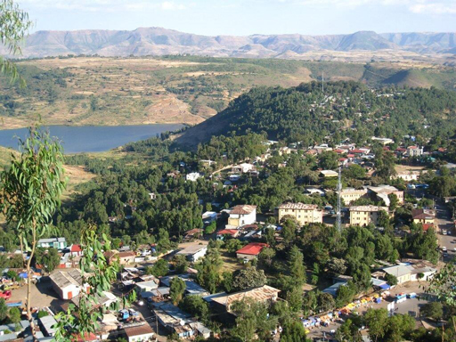
Figure 3.12 Gondar’s water supply comes from the Angareb reservoir, which was created by damming the river.

3.5 Rainwater
In regions where rainfall is abundant and frequent, rainwater can be a good source of water supply for individual families and small communities. The storage of rainwater is particularly important in areas with a long dry season, or where groundwater or surface water is difficult to obtain or polluted. The term rainwater harvesting is sometimes used. It simply means collecting, or harvesting, rainwater as it runs off from hard surfaces and storing it in a tank or cistern. Rainwater has several advantages. It is free, relatively clean and usually reliable, even if it rains only once or twice a year, and a rainwater harvesting system can be easily constructed and maintained at low cost. Although mainly found in rural areas, rainwater harvesting can also be useful in an urban situation.
Rainwater can be collected in several ways:

Roof catchments
Rainwater can be collected from house roofs made of tiles, slate, (corrugated) galvanised metal or equivalent. Pipes feed water from the roof and gutters into a collection tank where it can be stored until needed (Figure 3.13).
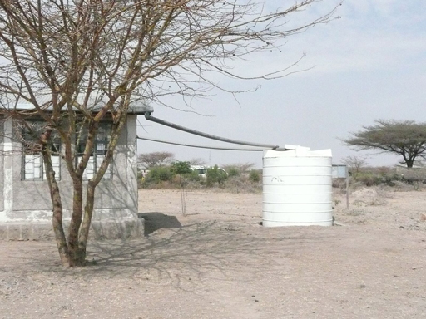
Figure 3.13 Rainwater is collected from the roof of this rural health post and stored in a covered, watertight cistern.
If rainwater is used for water supply, it is important to ensure that it is not contaminated by improper methods of storage, or by bird droppings and leaves from the roof that it is collected from. Rainwater may be also be contaminated by pollutants in the air, dust, dirt, paint and other material on the roof or in roofing materials. All of these contaminants can be washed into the storage tank or cistern.
To protect the water, various precautions are needed. The tank must be completely covered and well-maintained. The roof and gutters should be cleaned regularly, especially before the start of the wet season. It may be necessary to divert the first rainwater away from the tank so that dust and dirt are washed away. Leaves and other larger debris can be prevented from entering the tank by placing a mesh screen between the guttering and the pipe that leads to the tank; the mesh screen will need to be cleaned regularly.

Ground catchments
These are systems that collect and store rain falling on an area of ground (Figure 3.14). The amount of rainwater that can be collected depends on whether the area is flat or sloping, and on the permeability of the top layer of the ground. These systems require space so are only appropriate in rural areas, where they can serve small villages and households for livestock and vegetable growing.
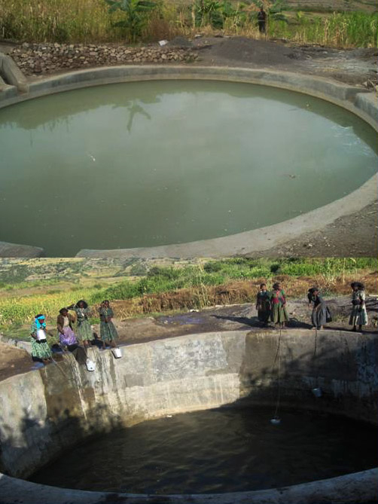
Figure 3.14 Rainwater storage ponds in Amhara Region.

Sand dams
In arid areas where there is a dry, sandy riverbed and the rain falls once or twice a year, a collection system known as a sand dam can be used to store water. A sand dam (Figure 3.15) is a concrete wall (1 to 5 m high) built across a seasonal sandy riverbed. During the rainy season, a seasonal river forms and carries sand and silt downstream. The heavy sand accumulates behind the dam, while the lighter silt washes downstream over the dam wall. Within one to four rainy seasons the dam completely fills with sand. However, up to 40% of the volume held behind the dam is actually water stored between the sand particles. The water can be abstracted from the sand dam via a slotted pipe buried in the sand that either passes through the dam wall or is connected to a simple hand pump situated on the river bank.
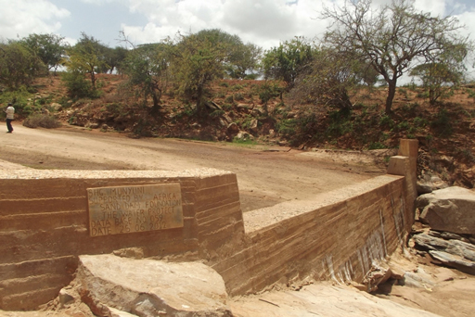
Figure 3.15 A sand dam in Kenya.

3.6 Water source development
One of the main duties of a water supply provider is to ensure that a safe and plentiful water supply is available to all segments of a community at a reasonable cost. This may mean seeking new water sources to satisfy demand. Identifying potential new sources and assessing their viability prior to development is a skilled technical task that requires several different factors to be assessed. These factors include:
- Volume of water required: This will depend on demand, which relates to the number and type of potential users. Will the new source be able to meet the demand of all users? Have future increases in demand and population growth been taken into consideration?
- Quality: Is the water from a safe and protected source? If not, what will be the level of treatment needed and how will this be achieved? What is the risk of pollution of the source?
- Seasonal variations: Is the new water source reliable, or is it vulnerable to seasonal variations in the availability of water? How will this be accommodated?
- Distance between source and users: How far must the water be transported? What is the sort of distribution system that will be needed? What are the engineering requirements for the system?
- Cost: Following on from all the above, what is the cost of developing the new source (both capital and continuing operating and maintenance costs) into the future?
- Environmental impact: What are the predicted environmental consequences of developing the water source? Will the benefits of the new supply outweigh any disadvantages?
- Sustainability: Can the water source be developed and used in such a way that it does not compromise the future ability to supply water? For example, the rate of abstraction from a spring should not exceed the rate of natural replenishment.
Answers to all of these questions and more, together with detailed surveys, assessments and analyses, will be required to identify possible new water sources. Mentioned in the list above is the possibility of pollution of the water source. There are many possible sources of pollution and these will be discussed in the next study session.

Summary of Study Session 3
In Study Session 3, you have learned that:
- Protected water sources (often called ‘improved’ water sources) are those that have barriers against contaminants and provide water that is safe to drink.
- The drinking water ladder describes the steps in improvement of quality of water supply.
- In Ethiopia in 2012, protected water sources supplied 97% of the water to urban populations, and 42% of the water to rural populations.
- Urban areas can obtain water supplies from groundwater, surface water and rainwater.
- Groundwater sources such as shallow wells, deep wells (boreholes) and springs should be protected against contamination by animals and surface run-off.
- Disinfection of the equipment at wells should be undertaken regularly.
- Surface waters are more prone to contamination than groundwater, and usually require treatment.
- Rainwater has several advantages as a water source.
- New water source development has to consider the capacity of the new source to supply water for a considerable time, and take into account factors such as raw water quality, seasonal variation, distance from consumers, cost, environmental impact and sustainability.

Self-Assessment Questions (SAQs) for Study Session 3
Now that you have completed this study session, you can assess how well you have achieved its Learning Outcomes by answering these questions. You can check your answers with the Notes on the Self-Assessment Questions at the end of this Module.

SAQ 3.1 (tests Learning Outcome 3.1)
Write the following words next to their correct definitions in the table below:
aquifers, drinking water ladder, percolated, permeable rocks, precipitation, protected water sources, rainwater harvesting, run-off, sand dam, unprotected water sources, water table.
rocks that allow water to pass through them
a means of storing water using sand and a dam
the level of water below ground
the process of collecting and storing rainwater
water sources that have structures to prevent the entry of contaminants
passed through a porous material or through small holes
something that describes the steps in improvement of quality of water supply
rainwater that runs off land
water sources that do not have protective structures to stop them being contaminated
any form of water that falls on the Earth’s surface
layers of rock underground that hold water

SAQ 3.2 (tests Learning Outcome 3.2)
Place the following phrases alongside the appropriate water source:
quality can change with location and season; difficult to treat if contaminated; usually requires treatment; free of charge; can be easily polluted by industry and agriculture; likely to be free from pathogenic bacteria; can be polluted by bird droppings; can often have a high mineral content.
Water source | Characteristics
groundwater
surface water
rainwater

SAQ 3.3 (tests Learning Outcome 3.3)
Suppose that inhabitants of a village obtain water from a spring. What advice would you give to the users about the prevention of contaminants entering the spring?

SAQ 3.4 (tests Learning Outcome 3.3)
Look at Figure 3.16, which shows a hand pump over a well. What would you recommend should be done to improve protection of this water source?
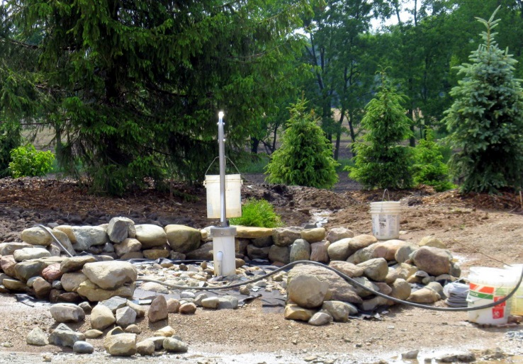
Figure 3.16 Hand pump over a well.

SAQ 3.5 (tests Learning Outcome 3.4)
Which of the following statements is false in relation to the development of a new water source? In each case explain why it is incorrect.
- The water source has to be reasonably close to the consumers of the water.
- Its environmental impact has to be ascertained.
- The effect of the seasons has to be considered.
- The quality of the raw water is immaterial, since modern treatment techniques can render it safe for drinking.
- The long-term viability of the source is important.

SAQ 3.6 (tests Learning Outcome 3.4)
List the factors that make a water source ideal to use.

Study Session 4 Water Pollution

Introduction
You have already learned about some of the ways how surface and groundwater can become contaminated and about the importance of water treatment to make the water safe to drink. There are different types of pollutants from a variety of sources that can harm the quality of water. In this study session you look more closely at these pollutants, where they originate from and their effects. You also consider how water sources can be protected from pollution.

Learning Outcomes for Study Session 4
When you have studied this session, you should be able to:
4.1 Define and use correctly all of the key words printed in bold. (SAQ 4.1)
4.2 Describe the different types of water pollutants. (SAQ 4.2)
4.3 Explain the possible ways in which water can be polluted. (SAQs 4.2 and 4.3)
4.4 Describe measures that can be adopted for protecting water sources from pollution. (SAQ 4.4)

4.1 Pathways of water pollution
Pollution can be defined as the introduction into the natural environment (air, water or land) of substances (pollutants) that are liable to cause harm to human health or to animals, plants and the wider environment. Water pollution occurs when surface water or groundwater is adversely affected by the addition of pollutants.
For surface water, the quality of the water will be determined by the geology, by precipitation and by what happens in the catchment. The catchment of a river is the total area of surrounding land that slopes towards the river (Figure 4.1). Rainwater that lands in a catchment flows into the river. River water can be contaminated from pollution sources in the catchment even though they may be some distance away. Protecting surface water from pollution is difficult because the activities of upstream users of river water will affect the quality of the water for downstream users. For groundwater, the situation is similar but the boundaries are less distinct and pollutants can seep into aquifers that extend below more than one catchment.
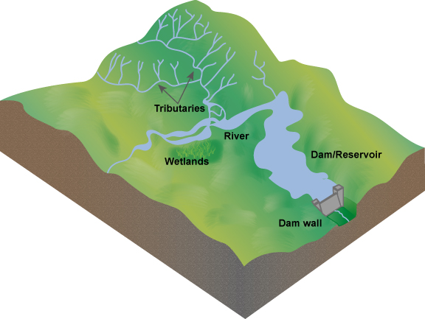
Figure 4.1 A model of a catchment area.
Water quality can be affected by pollution from point sources and non-point sources. Point sources are identifiable locations (such as a factory, often with a pipe or channel leading from them) that discharge directly into a body of surface water. Groundwater is also affected by point sources where contaminants seep into the soil and rock from an identifiable source, for example, underground fuel tanks, septic tanks or pit latrines. Non-point sources are those where pollution arises over a wide area and it is often difficult to locate the exact place of origin. For example, fertiliser or pesticide that has been widely spread may be washed from a field by rain into a river or stream at many places, or seep into groundwater. It is pollution from non-point sources, also known as diffuse pollution, that contributes most of the contaminants in surface and groundwater. The problems in identifying the exact point of origin make non-point sources much more difficult to control.
- Look at Figure 4.2. What pollutants are likely to be washed into the river from the lorry? Is this a point source or non-point source of pollution?
- Dust and dirt from the lorry will be washed into the river. Some oil and fuel may also be washed from the underside. The lorry is the single source of pollution, so this is an example of a point source.
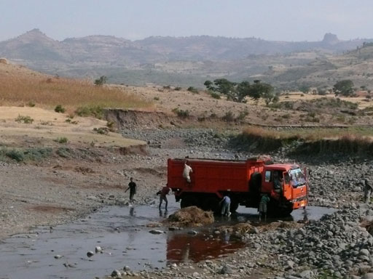
Figure 4.2 Washing lorries and cars in rivers is a source of water pollution.
The normal flow of river water can reduce the impact of some pollutants. When contaminated river water moves downstream it is possible that any pollutant will be diluted as more water flows in and so increases the total volume of water in the river. This dilution may be enough to reduce the concentration of the contaminants sufficiently to minimise the possible impacts, but this depends on several factors, including the quantity and type of pollutant, and the volume and flow rate of the river.

4.2 Types of water pollutant
There are many different types of water pollutant and the following sections describe those that are most commonly found.

4.2.1 Sediments and suspended solids
Sediments and suspended solids consist of fine particles of mostly inorganic material. Inorganic material is derived from non-living sources and includes mud, sand and silt washed into a river as a result of land cultivation, construction, demolition and mining operations, where these take place. One of the most common sources of suspended solids and sediment is soil erosion, where the soil is washed away into rivers by rainwater run-off. The presence of solid particulate material suspended in the flowing water is the reason why many rivers look brown in colour, especially in the rainy season. The particles are called suspended solids while they are carried (suspended) in flowing water and sediments when they settle to the bottom. Large quantities of suspended solids may reduce light penetration into the water, which can affect the growth of plants. Sediments may even suffocate organisms on the river bed.

4.2.2 Organic matter
Organic matter, such as human and animal wastes, is derived from living organisms. As organic matter decomposes, it removes oxygen from the water and this can have a damaging effect on fish and other aquatic organisms that are sensitive to poor water quality. Box 4.1 explains this process. If a large quantity of organic matter is present in surface water, this can lead to anaerobic conditions. (Anaerobic means without oxygen, as opposed to aerobic, which means oxygen is present.) In this situation many aquatic organisms are unable to survive and the water will be stagnant and smell unpleasant.

Box 4.1 Oxygen in water
Many aquatic (water-living) organisms depend on oxygen dissolved in the water to survive. Aquatic animals include ﬁsh, amphibians and many invertebrate species such as insect larvae, snails and worms. Their supply of oxygen in the water is maintained from atmospheric oxygen in the air above the water and from oxygen produced by green aquatic plants by the process of photosynthesis, the process by which plants convert light energy into chemical energy, while taking in carbon dioxide from the atmosphere and producing oxygen. Fast-ﬂowing, turbulent water will be aerated (gain oxygen) more than still water because the turbulent flow will entrain more oxygen.
If organic pollutants such as human and animal wastes are released into a water body, bacteria will use the waste as food and break it down into simpler, less harmful substances. As they do this, aerobic bacteria will use up the dissolved oxygen from the water. This is called deoxygenation. If the degree of organic pollution is high, then all the oxygen from the water may be used up, leading to anaerobic conditions.
This is unlikely in a river where the water is moving but can happen in lakes or slow-flowing channels. Inorganic solids, such as mud and silt, do not have this effect because they are inert (stable and inactive) and cannot be used as food by bacteria.

4.2.3 Biological pollutants
You have already learned about biological pollutants in Study Session 2. These are the infectious agents (bacteria, viruses, protozoa and helminths) that are harmful to humans and other forms of life. Biological pollutants may get into water with dust from the air as rain falls but the most likely source is from water that is contaminated with human and animal wastes.

4.2.4 Plant nutrients
Nitrates and phosphates are common pollutants generated from residential areas and agricultural run-off. They are usually associated with human and animal wastes or fertiliser that has been washed into surface water bodies by rain. Nitrates and phosphates are plant nutrients, so they stimulate plant growth. If present in large quantities, they can encourage excessive plant growth in the water causing the phenomenon known as an algal bloom, which means a sudden increase in the population of microscopic algae (simple plants). There may also be an increase in larger plants such as the invasive water hyacinth. When the increased population of aquatic plants dies, the decay of the organic plant material by bacteria can cause deoxygenation of the water, resulting in the death of other organisms such as fish. If a water body has high nutrient levels it is said to be eutrophic and the process is known as eutrophication. Figure 4.3 illustrates the process.
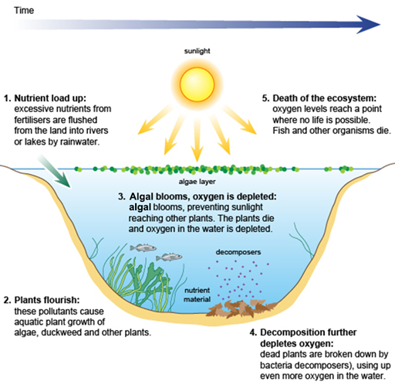
Figure 4.3 The eutrophication process.
- Can you think of a reason why eutrophication is more likely to be a problem in lakes than in rivers?
- Because flowing water in a river will disperse the nutrients; in the still water of a lake, the nutrients will accumulate.
In Ethiopia, many private and corporate farms use huge amounts of chemical fertilisers. As a result, eutrophication is becoming a major problem (Zinabu et al., 2002), affecting many water sources (Figure 4.4).
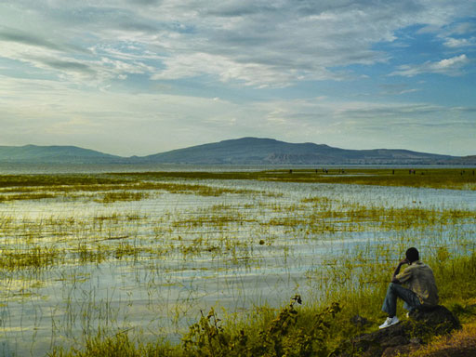
Figure 4.4 Lake Hawassa, in the Rift Valley, south of Addis Ababa, is suffering from eutrophication.

4.2.5 Other chemical pollutants
Heavy metals such as arsenic, copper, lead, mercury and cadmium are chemical pollutants that may be found in lakes, rivers and groundwater. These heavy metals can harm aquatic organisms and humans. Farmers who use river water polluted by urban wastes for irrigation in the cultivation of fruits and vegetables may find their crops affected by the accumulation of these chemicals. (You will look at a case study on this later on in this study session.)
Pesticides include insecticides, herbicides and fungicides. There are several thousand different types in use and almost all of them are possible causes of water pollution. Pesticides such as DDT (dichlorodiphenyltrichloroethane), malathion, parathion and others have been sprayed in the environment for long periods of time for the control of disease vectors such as mosquitoes and other pests.
Heavy metals and some pesticides are particular problems because they are persistent in the environment, meaning they do not break down and their effects continue over time, even long after their use may have stopped.
Another problem can be acidity. If water becomes acidic or alkaline, beyond normal limits, this will have a damaging effect on aquatic organisms. Acidity and alkalinity of water are determined by measuring its pH. A pH value below 7 is acidic and above 7 is alkaline. Acidic water is not only harmful to life but is also corrosive and can damage pipework in water distribution systems.

4.3 Possible sources of water pollution
Having looked at the various types of pollutant, let us now consider their sources.

4.3.1 Human excreta
Open defecation and poorly constructed pit latrines are obvious sources of human waste and can easily pollute surface and groundwater. Where water-flushed sewerage systems are present, inadequately treated sewage can also be a major source of human waste. (Note the difference between the words ‘sewage’ and ‘sewerage’. Sewage is mixed wastewater that contains human waste from flush toilets, commercial and industrial wastewater, and frequently also surface water run-off. Sewerage is the network of underground pipes – sewers – through which the sewage flows.)
Untreated or partially treated sewage can contribute to high levels of oxygen demand in the water and also introduce toxic substances into the aquatic environment, in addition to pathogenic micro-organisms. In Ethiopia, sewage may be treated in waste stabilisation ponds (these will be described in Study Session 11). If not operated properly, these ponds can pollute rivers. In many parts of the world, sewage from large towns and cities is usually treated in large mechanical–biological plants (Figure 4.5) that normally produce good quality effluent but can still be a source of pollution if systems fail.
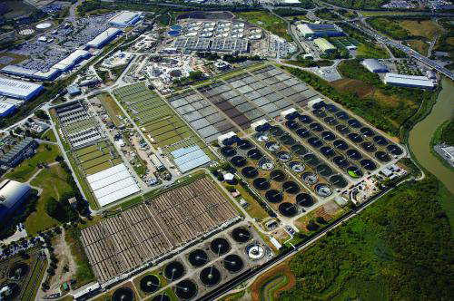
Figure 4.5 Becton sewage treatment plant in London, the largest plant of its type in Europe, treats the sewage of 3.7 million people.
In Ethiopian towns and cities many households use septic tanks to dispose of their sewage. These are underground tanks into which sewage is piped. The waste remains in the tank for long enough for the solids to settle out and the settled sewage is discharged from the tank, usually into the surrounding soil via a soakaway. If the tank is too small to retain the sewage for long enough, or if many septic tanks are close together, or if they leak or are cracked, this can lead to pollution of groundwater. It is the aim in Ethiopia to have septic tanks that keep the sewage inside for a minimum of three days so that the organic solids will settle out as sludge. Figure 4.6 shows the main features of a properly constructed septic tank.
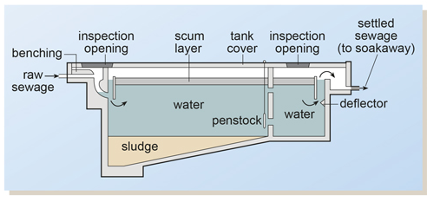
Figure 4.6 Cross-sectional diagram of a septic tank.

4.3.2 Manufacturing and industrial plants
In Study Session 1 you read about some of the ways in which water is used in industry and manufacturing. The range of different uses and processes can produce waste in the form of many different types of organic and inorganic material in suspension or in solution. In many cases, much of the water used can be recycled but there is almost always an effluent discharge that requires treatment.
Food processing generates large volumes of effluent containing natural organic compounds such as carbohydrates, proteins and fats. Factories producing chemicals often generate low volumes of highly toxic waste streams. Toxic effluents can also be produced in the paper, leather and electroplating industries. For example, cyanides and heavy metals may be present in wastewaters from electroplating. These plants can also be the source of highly acidic wastes.
Manufacturing and industrial effluents should be treated at their points of origin but many production plants in Ethiopia (such as tanneries and breweries) do not have proper effluent treatment systems. This results in the discharge of untreated or partially treated effluent into the nearest water body (Figure 4.7).
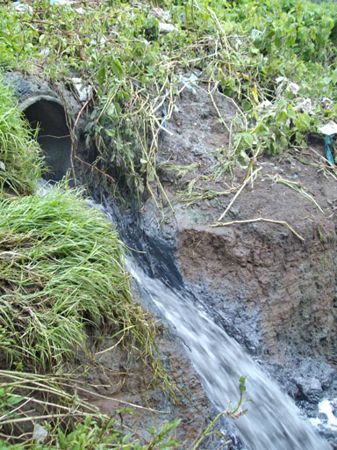
Figure 4.7 Industrial discharge into the Akaki River in Addis Ababa.

4.3.3 Agriculture and animal rearing
The intensive rearing of animals results in large volumes of organically polluted washwater from cleaning animal houses. This slurry is often stored in lagoons or tanks prior to spreading on land. However, problems occur when these lagoons or tanks leak or overflow, allowing the slurry to flow into watercourses or infiltrate groundwater. Other agricultural pollutants include pesticides and fertilisers.
Cultivation and overgrazing can make soil erosion more likely, resulting in soil particles being washed into rivers and lakes. For example, this is a problem at Gondar, where run-off from the surrounding land has washed silt into the reservoir, thus reducing the volume of water it can hold (Figure 4.8).
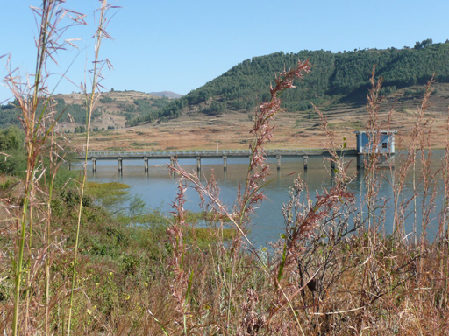
Figure 4.8 The Angareb reservoir at Gondar.

4.3.4 Domestic and industrial solid waste sites
Domestic and commercial solid waste should be disposed of in a properly designed and constructed landfill site. Many landfill sites, particularly those that are older and less well designed and managed, such as the one shown in Figure 4.9, generate leachate, which is highly polluting. (Leachate is any liquid that has passed through matter and picked up dissolved substances and/or suspended solids as it passed through.) Leachate can contain dissolved organic matter and many different types of inorganic components depending on the type of waste. Where industrial waste has been dumped, a toxic chemical stream may also be produced. These leachates should be collected and treated so that pollution of groundwater and rivers does not arise.
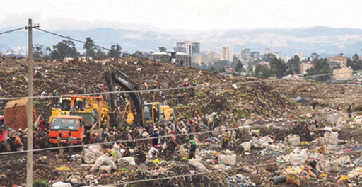
Figure 4.9 The landfill site at Repi, Addis Ababa.

4.3.5 Urban surface water run-off
Rainwater that runs off road surfaces, roofs, parking areas, etc. carries with it a variety of components (Table 4.1). The bulk of the contaminants can be traced to motor vehicles. Surface water run-off can cause damage to streams, rivers and lakes by degrading the water quality and harming aquatic life. The pollutants present can hinder the growth and reproduction of fish and other creatures, and affect photosynthetic activity. Plant nutrients may contribute to eutrophication.
Table 4.1 Pollutants that may be present in rainwater run-off.
Pollutant | Likely sources
Sediment | Construction, road surfaces, emissions from vehicles, industrial sources, vehicle wear
Copper | Vehicle brake pads, industrial activities, plumbing and guttering
Lead | Industrial activities and residues from historical activities (plumbing, paint, leaded petrol, sprays), tyre-balancing weights, vehicle brake pads
Zinc | Vehicle tyres, galvanised building materials, paint, industrial activities
Hydrocarbons | Vehicle emissions, lubricating oils
Rubber | Tyre wear
Detergents | Wash-down areas, domestic discharges (e.g. from car washing), industrial discharges
Litter | Discarded material (e.g. plastic bags, cups, cigarette ends), windblown materials, illegal dumping

4.4 Protection from pollution
The control of pollution should ideally take place at the point of its generation. In Study Session 3 you read about the methods of protecting water sources but it is better to prevent the pollutant from entering the environment in the first place. With regard to human excreta, this means an end to open defecation, the correct siting and construction of latrines and septic tanks, and well-maintained and correctly operated sewage treatment works. Industrial wastes should be treated at source before discharge. Other human activities should also be controlled; for example, used engine oil should not be thrown onto the ground, and solid wastes should be carefully disposed of. A positive measure that can help to prevent soil erosion is to preserve vegetation and plant trees, because plant roots hold the soil in place.
In rural areas, the control of excess nutrients is important to keep natural waters free from eutrophication. Farmers may need guidance on good agricultural practices to reduce water pollution from agriculture. For example, care over the amount of fertiliser used and the timing of its application can make a significant difference.
- Imagine you are a farmer thinking about the best time to apply fertiliser to your field. Would it be better to spread the fertiliser before or after heavy rain?
- It would be better to apply it after the rain because if the fertiliser was spread beforehand, much of it would probably be washed away. This would not only pollute the nearest river but would, of course, also reduce its effectiveness on the crop.
Pesticides should not be applied near wells or other water sources. If possible, biological methods of pest control should be used. Examples of these are the use of fish to feed on mosquito larvae in water bodies, and the use of the dung beetle to break down and bury cow faeces so that they are no longer available as a breeding place for flies.
Ideally, the whole catchment area should be managed to avoid pollution and erosion. To tackle pollution problems, especially diffuse pollution, all activities within a catchment should be considered. This involves many groups (residents, planners, farmers, etc.) working together, on aspects such as granting permissions for development, compliance with regulations, inspections of activities, and regular surveys and investigations of water pollution.

4.5 Monitoring and regulation
Monitoring of the quality of rivers (Figure 4.10) can be done at regular intervals by taking samples for laboratory analysis. In Ethiopia this activity is undertaken by the Ministry of the Environment and Forests. In addition to this, regular surveys of a catchment area are useful so that potential pollutants can be identified before they contaminate a water source.
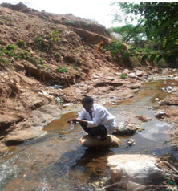
Figure 4.10 A technician monitoring water quality.
For effective protection of water sources, it is important to establish a regulatory framework for treatment of wastewater from residential communities, institutions and industries. Strict legislation should be in place to make it obligatory for wastewaters to be treated before discharge into rivers or lakes. Ethiopia has the Ethiopian Water Resources Management Regulations (Council of Ministers, 2005). Part 4 of these regulations states that a permit to discharge wastewater must be obtained for the ‘direct or indirect discharge of any treated trade effluent or sewage effluent, or any poisonous, noxious or polluting matter into surface or ground water’. Anyone who obtains the permit has an obligation to install and use the best treatment method and to discharge only the type and volume of treated waste permitted.
Control of water pollution is the responsibility of more than one organisation, since most activities involving water concern a number of different Ministries. For instance, water use in agriculture would be of concern to the Ministry of Agriculture, the Ministry of Water Resources, Irrigation and Energy, and the Ministry of the Environment and Forests, and all of them have the responsibility of protecting the environment.

Summary of Study Session 4
In Study Session 4, you have learned that:
- Water pollution is any contamination of water with substances that are detrimental to human, plant or animal health.
- Water pollutants can be of point or non-point source, depending on whether substances are discharged directly into a body of water or indirectly from diffuse sources.
- Water pollutants include sediments and suspended solids, organic matter, biological pollutants, plant nutrients and chemical pollutants.
- Biological pollutants include bacteria, viruses, protozoa and helminths. They mainly enter the water through faeces from infected people and animals, and are the cause of many water-related diseases.
- Major sources of water pollution include human excreta; manufacturing and industrial plants; animal rearing and agricultural activities; landfill sites; and urban surface water run-off.
- Measures to protect water sources from faecal pollution include ending open defecation, the proper siting of latrines and septic tanks, and careful operation of sewage treatment works.
- The appropriate use of fertilisers and pesticides will minimise water pollution caused by agriculture.
- Selective planting of trees and vegetation can help stabilise soil and prevent erosion.
- Pollution control should ideally take place at the point of origin.
- Regulations control the type and volume of treated effluent that may be discharged to the environment.

Self-Assessment Questions (SAQs) for Study Session 4
Now that you have completed this study session, you can assess how well you have achieved its Learning Outcomes by answering these questions. You can check your answers with the Notes on the Self-Assessment Questions at the end of this Module.

SAQ 4.1 (tests Learning Outcome 4.1)
Write the following words next to their correct definitions in the table below:
aerobic, algal bloom, anaerobic, catchment, diffuse pollution, eutrophication, inorganic material, leachate, non-point source of pollution, organic matter, photosynthesis, point source of pollution, pollutants, pollution, sediments, septic tank, sewage, sewerage, soil erosion, suspended solids.
a process by which a high concentration of nutrients, especially phosphates and nitrates from agricultural or other activities, enters a water body and leads to excessive plant growth and eventual decay, resulting in depletion of oxygen in the water
containing oxygen
material that comes from living organisms
an underground tank into which sewage is piped
an identifiable source of pollution
the washing away of soil by rainwater run-off
material which doesn’t originate from living organisms
a network of sewers
a sudden increase in the algal population
a source of pollution that encompasses a wide area, the exact point of origin being difficult to ascertain
particles carried in flowing water
the introduction into the environment of substances likely to cause harm to humans, animals, plants and the environment in general
substances that can cause harm to human health, plants, animals and the environment in general
mixed wastewater that contains human waste from flush toilets
pollution from non-point sources
the area of surrounding land that slopes towards a river
solids that have settled at the bottom of a river
a polluting liquid that is produced when water passes through materials and takes with it components from them
without oxygen
the process by which plants generate chemical energy

SAQ 4.2 (tests Learning Outcome 4.2)
- Classify the following examples of water pollutants using the categories shown in the table below:
- copper • lead
- insecticides • silt
- sand • phosphates
- protozoa • faecal matter
- nitrates • intestinal worms
- bacteria
Category of water pollutant | Examples
Sediments and suspended solids
Organic matter
Biological pollutants
Plant nutrients
Other chemical pollutants
- The following are pollution sources. Give two specific pollutants for each source.
A residential area: ………………………………………………
A metal plating plant: ………………………………………………
Agricultural activities: ………………………………………………
An uncontrolled landfill site: ………………………………………………
Urban surface water run-off: ………………………………………………

SAQ 4.3 (tests Learning Outcomes 4.2 and 4.3)
Read Case Study 4.1 and then answer the questions that follow.

Case Study 4.1
Mekanisa is a place in the southern part of Addis Ababa where urban agriculture is practised. A group of farmers grow different varieties of vegetables and sell them to people in the city. The farmers use water from the nearest river (the River Kera) for irrigation. They mostly grow leafy vegetables, with two harvests a year.
The Kera River originates a few kilometres from Mekanisa and passes through residential, commercial and industrial areas before reaching Mekanisa. Along its way, human excreta and industrial wastes are indiscriminately discharged into the river. One of the prominent polluters of the river is the city’s biggest slaughterhouse, located at the side of the river. Untreated wastewater from the slaughterhouse is discharged into the river giving a blue-black colour to the water. Farmers like this type of water for irrigation as it helps their crops grow.
One of the authors of this Module undertook research assessing the level of pollution of the river water. The results are shown in Table 4.2.
Table 4.2 Analysis of water from the River Kera.

Parameters | FAO* Guideline Concentrations for components in irrigation water (Pescod, 1992) | River water
Faecal coliforms | <1000 per 100 ml | >2500 per 100 ml
Copper | 0.2 mg l⁻¹ | 25.5 mg l^{–1}
Zinc | 2.0 mg l⁻¹ | 56.3 mg l^{–1}
Iron | 5.0 mg l⁻¹ | 71.0 mg l^{–1}
Lead | 5.0 mg l⁻¹ | 19.0 mg l^{–1}
Manganese | 0.2 mg l⁻¹ | 37.0 mg l^{–1}
*FAO is the Food and Agriculture Organization of the United Nations.
- What nutrients in the river water do you think benefited the crops grown by the farmers?
- State which components in the river water might be harmful to people and give your reasons.
- Suggest what should be done regarding the pollution of the River Kera.

SAQ 4.4 (tests Learning Outcome 4.3)
Which of the following statements is false? In each case, explain why it is incorrect.
- Latrines should be sited up-slope of a water source so that they don’t get flooded.
- For the protection of springs, a fence, a diversion ditch, a watertight concrete box, and a tight-fitting cover are enough.
- Farmers should use the minimum amount of fertiliser that is necessary for their crops, and apply it after rain.
- Catchment management involves several different activities to ensure that the integrity of a water source is maintained.
- To save time water pollution control legislation is best drawn up by one ministry.

Study Session 5 Water Treatment Technologies for Large-scale Water Supply

Introduction
In previous study sessions you have learned about sources of water, how they can become contaminated and about ways of protecting them. Even with source protection it is often necessary to treat water to ensure it is safe. This is the case at household level, which is discussed in Study Session 10, and when supplying water for towns and cities. In this study session, you consider the need for large-scale water treatment and the stages of treatment for urban water supply. You will also learn about the management of wastes produced in the process of water treatment, and consider the issues of sustainability and resilience in relation to large-scale water treatment.

Learning Outcomes for Study Session 5
When you have studied this session, you should be able to:
5.1 Define and use correctly all of the key words printed in bold. (SAQ 5.1)
5.2 Describe the different stages in the water treatment process. (SAQs 5.1 and 5.2)
5.3 Describe how the wastes from water treatment plants are disposed of. (SAQ 5.3)
5.4 Suggest how water treatment technologies can be made sustainable and resilient. (SAQ 5.4)
5.5 Undertake basic calculations in relation to water supply. (SAQ 5.5)

5.1 The need for large-scale water treatment
Water treatment is the process of removing all those substances, whether biological, chemical or physical, that are potentially harmful in water supply for human and domestic use. This treatment helps to produce water that is safe, palatable, clear, colourless and odourless. Water also needs to be non-corrosive, meaning it will not cause damage to pipework.
In urban areas, many people live close together and they all need water. This creates a demand for large volumes of safe water to be supplied reliably and consistently, and this demand is growing. As urban populations increase, there is a need to find new sources to meet the growing demand. If groundwater is available this can often be used with minimal treatment but any surface water source will need to be treated to make it safe. For towns and cities, the water supply is then best provided by large mechanised water treatment plants (Figure 5.1) that draw water from a large river or reservoir, using pumps. (‘Mechanised’ means that machines, such as pumps and compressors, are used). The treated water is then distributed by pipeline, as you learned in Study Session 1.
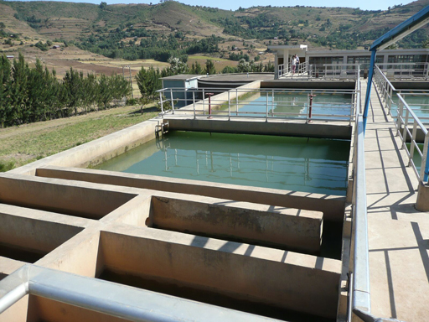
Figure 5.1 The water treatment plant at Gondar, Ethiopia.
The size of the treatment plant required is determined by the volume of water needed, which is calculated from the number and type of users and other factors. Section 5.6 explains how this calculation is made but first you will look at the main stages in the water treatment process.

5.2 Stages in large-scale water treatment
There are often seven steps (Figure 5.2) in large-scale water treatment for urban municipal water supply (Abayneh, 2004). Each of the steps will be described in turn in this section. The water utility (the organisation that runs the treatment plants and water distribution system) will ensure by regular analysis of the water that it adheres to quality standards for safe water. (Water quality standards will be described in Study Session 9.)
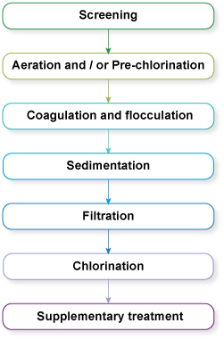
Figure 5.2 The seven steps often used in the large-scale treatment of water.

5.2.1 Screening
To protect the main units of a treatment plant and to aid in their efficient operation, it is necessary to use screens to remove any large floating and suspended solids that are present in the inflow. These materials include leaves, twigs, paper, rags and other debris that could obstruct flow through the plant or damage equipment. There are coarse and fine screens.
Coarse screens (Figure 5.3) are steel bars spaced 5–15 cm apart, which are employed to exclude large materials (such as logs and fish) from entering the treatment plant, as these can damage the mechanical equipment. The screens are made of corrosion-resistant bars and positioned at an angle of 60º to facilitate removal of the collected material by mechanical raking.
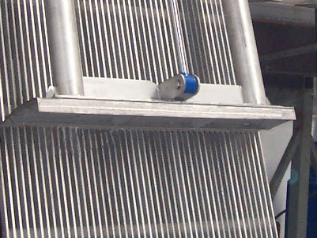
Figure 5.3 A coarse screen.
Fine screens, which come after the coarse screens, keep out material that can block pipework at the plant. They consist of steel bars which are spaced 5–20 mm apart. A variation of the fine screen is the microstrainer (Figure 5.4) which consists of a rotating drum of stainless steel mesh with a very small mesh size (ranging from 15 µm to 64 µm, i.e. 15–64 millionths of a metre). Suspended matter as small as algae and plankton (microscopic organisms that float with the current in water) can be trapped. The trapped solids are dislodged from the fabric by high-pressure water jets using clean water, and carried away for disposal.
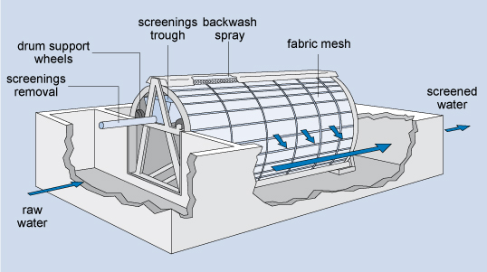
Figure 5.4 Diagram of a microstrainer.

5.2.2 Aeration
After screening, the water is aerated (supplied with air) by passing it over a series of steps so that it takes in oxygen from the air. This helps expel soluble gases such as carbon dioxide and hydrogen sulphide (both of which are acidic, so this process makes the water less corrosive) and also expels any gaseous organic compounds that might give an undesirable taste to the water. Aeration also removes iron or manganese by oxidation of these substances to their insoluble form. Iron and manganese can cause peculiar tastes and can stain clothing. Once in their insoluble forms, these substances can be removed by filtration.
In certain instances excess algae in the raw water can result in algal growth blocking the sand filter further down the treatment process. In such situations, chlorination is used in place of, or in addition to, aeration to kill the algae, and this is termed pre-chlorination. This comes before the main stages in the treatment of the water. (There is a chlorination step at the end of the treatment process, which is normal in most water treatment plants). The pre-chlorination also oxidises taste- and odour-causing compounds.

5.2.3 Coagulation and flocculation
After aeration, coagulation takes place, to remove the fine particles (less than 1 µm in size) that are suspended in the water. In this process, a chemical called a coagulant (with a positive electrical charge) is added to the water, and this neutralises the negative electrical charge of the fine particles. The addition of the coagulant takes place in a rapid mix tank where the coagulant is rapidly dispersed by a high-speed impeller (Figure 5.5).
Since their charges are now neutralised, the fine particles come together, forming soft, fluffy particles called ‘flocs’. (Before the coagulation stage, the particles all have a similar electrical charge and repel each other, rather like the north or south poles of two magnets.) Two coagulants commonly used in the treatment of water are aluminium sulphate and ferric chloride.
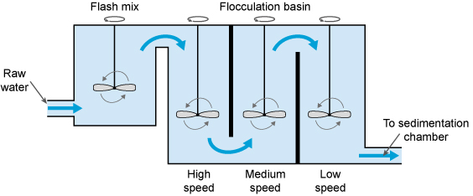
Figure 5.5 The coagulation–flocculation process.
The next step is flocculation. Here the water is gently stirred by paddles in a flocculation basin (Figure 5.5) and the flocs come into contact with each other to form larger flocs.
The flocculation basin often has a number of compartments with decreasing mixing speeds as the water advances through the basin (Figure 5.6(a)). This compartmentalised chamber allows increasingly large flocs to form without being broken apart by the mixing blades. Chemicals called flocculants can be added to enhance the process. Organic polymers called polyelectrolytes can be used as flocculants.

5.2.4 Sedimentation
Once large flocs are formed, they need to be settled out, and this takes place in a process called sedimentation (when the particles fall to the floor of a settling tank). The water (after coagulation and flocculation) is kept in the tank (Figure 5.6(b)) for several hours for sedimentation to take place. The material accumulated at the bottom of the tank is called sludge; this is removed for disposal.
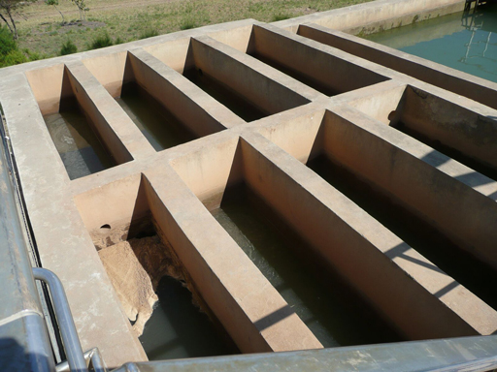  (a) | 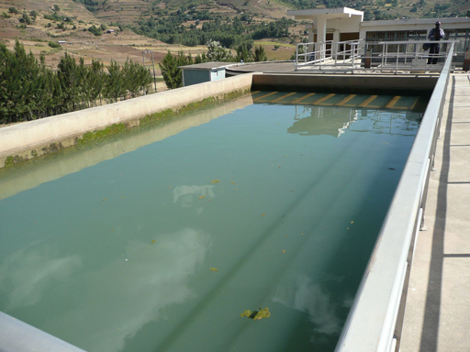  (b)
Figure 5.6 Flocculation chambers (a) and a sedimentation tank (b) at Gondar water treatment works.

5.2.5 Filtration
Filtration is the process where solids are separated from a liquid. In water treatment, the solids that are not separated out in the sedimentation tank are removed by passing the water through beds of sand and gravel. Rapid gravity filters (Figure 5.7), with a flow rate of 4–8 cubic metres per square metre of filter surface per hour (this is written as 4–8 m^{–3} m^{–2} h^{–1}) are often used.
When the filters are full of trapped solids, they are backwashed. In this process, clean water and air are pumped backwards up the filter to dislodge the trapped impurities, and the water carrying the dirt (referred to as backwash) is pumped into the sewerage system, if there is one. Alternatively, it may be discharged back into the source river after a settlement stage in a sedimentation tank to remove solids.
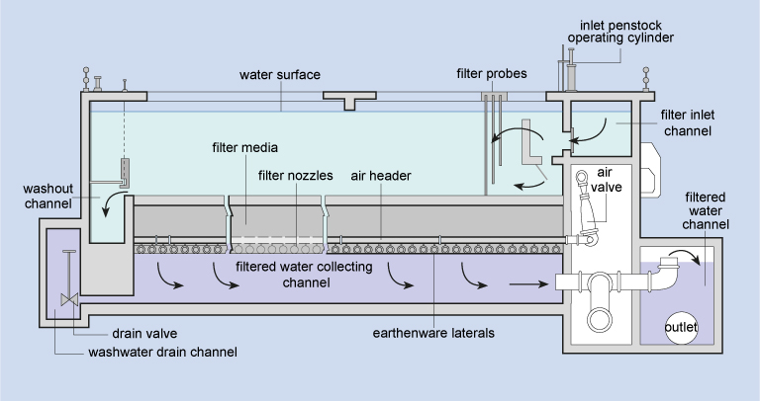
Figure 5.7 Cross-sectional diagram of a rapid gravity sand filter.

5.2.6 Chlorination
After sedimentation, the water is disinfected to eliminate any remaining pathogenic micro-organisms. The most commonly used disinfectant (the chemical used for disinfection) is chlorine, in the form of a liquid (such as sodium hypochlorite, NaOCl) or a gas. It is relatively cheap, and simple to use. When chlorine is added to water it reacts with any pollutants present, including micro-organisms, over a given period of time, referred to as the contact time. The amount of chlorine left after this is called residual chlorine. This stays in the water all the way through the distribution system, protecting it from any micro-organisms that might enter it, until the water reaches the consumers.
World Health Organization Guidelines (WHO, 2003) suggest a maximum residual chlorine of 5 mg l^{–1} of water. The minimum residual chlorine level should be 0.5 mg l^{–1} of water after 30 minutes’ contact time (WHO, n.d.). There are other ways of disinfecting water (e.g. by using the gas ozone, or ultraviolet radiation) but these do not protect it from microbial contamination after it has left the water treatment plant. Following disinfection the treated water is pumped into the distribution system.

5.2.7 Supplementary treatment
Supplementary treatment may sometimes be needed for the benefit of the population. One such instance is the fluoridation of water, where fluoride is added to water. It has been stated by the World Health Organization that ‘fluoridation of water supplies, where possible, is the most effective public health measure for the prevention of dental decay’ (WHO, 2001). The optimum level of fluoride is said to be around 1 mg per litre of water (1 mg l^{–1)}.
On the other hand, as you learned in Study Session 2, in the Rift Valley of Ethiopia, the water resources contain a higher concentration of fluoride than is desirable. Tekle-Haimanot et al. (1995) found that the level of fluoride in drinking water from deep wells there ranged from 1.5 to 36 mg l^{–1}. The safe level for fluoride is 1.5 mg l^{–1}.
- What does excess fluoride in the water lead to?
- As mentioned in Study Session 2, in children it can cause mottling of teeth and prolonged exposure can cause skeletal fluorosis and crippling.
In such high-fluoride areas, removal or reduction of fluoride (termed defluoridation) is essential. The simplest way of doing this is to blend the high-fluoride water with water that has no (or very little) fluoride so that the final mixture is safe. If this is not possible, technical solutions may be applied. Two of these, the Nakuru Method and the Nalgonda Technique, used in Ethiopia, are described below.
The Nakuru Method (Figure 5.8) involves a filter with bone char (charcoal produced from animal bone) and calcium phosphate to adsorb the fluoride (Kung, 2011). There have been reservations on the use of bone char, and alternatives for defluoridation, such as activated alumina, are being tested in Addis Ababa (Alemseged, 2015).
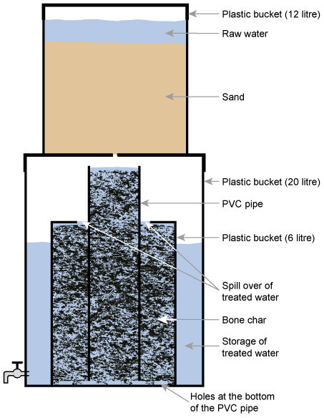
Figure 5.8 The Nakuru method for defluoridation using plastic buckets and piping.
The Nalgonda technique for defluoridation (Suneetha et al., 2008) uses aluminium sulphate and calcium oxide to remove fluoride. The two chemicals are added to and rapidly mixed with the fluoride-contaminated water and then the water is stirred gently. Flocs of aluminium hydroxide form and these remove the fluoride by adsorption and ion exchange. The flocs are then removed by sedimentation.

5.3 Management of wastes from water treatment plants
- From the water treatment process that you have just studied, make a list of the different wastes that arise.
- You probably thought of the screenings from the coarse and fine screens, the sludge from the sedimentation tank, and backwash from the rapid gravity sand filter. There will be other wastes, such as packaging from chemicals used (typically plastic drums) and replacement equipment (which may come in wooden or cardboard boxes).
Coarse screenings are usually sent to a landfill or other waste disposal site. Fine screenings (in the form of a slurry) may be discharged to a sewer, if there is one, or sent to a landfill. The sludge from the sedimentation tank can be sent to landfill, or to a sewage treatment plant. In the latter it is added to the incoming sewage, where it can help settlement of solids.
The backwash from the sand filter is discharged into the sewer or returned to the river after settlement of solids. Packaging waste such as chemical drums can be returned to the supplier for reuse. Wood and cardboard waste can be recycled.

5.4 Sustainability and resilience in water treatment
In Study Session 4 you read about some factors that can influence the sustainability of a water source. For example, reducing soil erosion by planting trees and retaining vegetation can reduce the amount of silt that accumulates in a reservoir and prolong its life.
For the water treatment process itself to be sustainable (meaning that it can be maintained at its best for a long time) it has to be simple to operate and maintain. Complex systems should be avoided and wherever possible locally available materials should be used. For example, if a coagulant is required, the one that can be purchased in-country will be preferable to one that has to be imported. Water treatment plants consume energy, and if this energy could be supplied through renewable sources (such as solar or wind) it will keep operating costs down and improve sustainability.
The plant and distribution system should be made of robust materials that will have a long operating life. It can be difficult to obtain spare parts, so there should be plans in place for procurement of replacements. (These and other management issues are the subject of the next study session.) Another important factor in sustainability is an effective maintenance system, which needs planning and, importantly, requires well-trained and motivated staff.
Resilience, in the context of a water treatment system, is its ability to withstand stress or a natural hazard without interruption of performance or, if an interruption does occur, to restore operation rapidly. With water treatment plants located very close to water sources, having too much water can be just as much a problem for operations as having too little. Storms and floods, exacerbated by climate change, may overwhelm systems and interrupt operations, so appropriate flood defence measures must be in place. The need to be resilient to these impacts is another reason why the equipment and construction of the plant should be of a high standard.

5.5 Basic calculations in water supply
A critical factor in the sustainability of a water supply system is ensuring that the volume of water provided is sufficient to meet current and future demand. Table 5.1 shows the water supply requirements for towns of different sizes in Ethiopia according to the Growth and Transformation Plan II.
Table 5.1 Water supply requirements for urban areas in Ethiopia (note that for categories 1–4, the water should be available at the premises). (MoWIE, 2015)
Urban category | Population | Minimum water quantity (litres per person per day) | Maximum fetching distance (m)
1 Metropolitan | >1,000,000 | 100 | –
2 Big city | 100,000–1,000,000 | 80 | –
3 Large town | 50,000–100,000 | 60 | –
4 Medium town | 20,000–50,000 | 50 | –
5 Small town | <20,000 | 40 | 250
The water needs of a town can be estimated from the size of the population and the water requirements of users such as schools, health facilities and other institutions within it. The guidelines for the water supply requirement of different categories of towns, shown in Table 5.1, may be used to estimate the minimum quantity of water that should be supplied for a given population.
- Consider a town with a population of 60,000. What would be the minimum amount of water required?
- From Table 5.1, the minimum amount of water needed per person would be 60 litres a day. So, with a population of 60,000, the daily total supply would need to be:
60 litres × 60,000 = 3,600,000 litres, or 3600 m³.
There will be institutions in the town with particular water requirements. Table 5.2 shows the requirements of some of these in Ethiopia.
Table 5.2 Water requirements for various types of institutions in Ethiopia. (Adapted from Kebeda and Gobena, 2004)
Institution | Water requirement (litres per person per day)
Health centre | 135
Hospital | 340
Day school | 18.5
Boarding school | 135
Office | 45
Restaurant | 70
Once the consumers’ total water requirement has been calculated, an allowance should be added for leakage losses, and for water use by the water utility itself (for washing of tanks, etc.). This allowance could, for example, be 15%.
The water will have to be stored in service reservoirs. As you learned in Study Session 1, service reservoirs have to hold a minimum of 36 hours’ or 1.5 days’ water supply.
Box 5.1 shows a calculation of water requirement and service reservoir size for a hypothetical town.

Box 5.1 Water provision for a small town
Imagine a town with a population of 5000 people, and a health centre that treats 100 people a day.
The minimum water requirement per day for the population (using the guidelines in Table 5.1) will be 40 litres × 5000 = 200,000 litres, or 200 m³.
The water requirement for the health centre would be 135 litres × 100 = 13,500 litres, or 13.5 m³. The total water requirement each day would be 200 + 13.5 = 213.5 m³.
Allowing for 15% leakage and water usage by the water utility, each day the required volume of treated water supplied would be:
213.5 m³ × 1.15 = 245.5 m³. This could be rounded up to 246 m³.
The service reservoir would need to hold a minimum of 36 hours’ of supply (1.5 days). This means that the service reservoir size would be:
246 m³ × 1.5 = 369 m³. This could be rounded up to 370 m³.
The water requirement would therefore be 246 m³ per day, and the minimum service reservoir capacity required would be 370 m³. This volume could be held in one service reservoir or shared between two, located in different parts of the town.
These simple calculations are included here to give you an idea of the approach that would be taken to planning a new water supply system. In practice, the process would require many different engineering, economic and environmental considerations involving a team of experts.

Summary of Study Session 5
In Study Session 5, you have learned that:
- Large-scale water treatment is required when the population needing water is large and surface water sources have to be used. Large-scale water treatment often involves seven stages.
- Screening involves trapping large floating and suspended solids using bar screens or devices such as microstrainers.
- Aeration helps expel any acidic gases and gaseous organic compounds from the water. Aeration also removes iron and manganese. Pre-chlorination is carried out instead of, or in addition to, aeration if there are excess algae in the raw water. The chlorine also oxidises taste- and odour-causing compounds.
- Coagulation is used to remove fine particles smaller than 1 µm in diameter. Aluminium sulphate and ferric chloride are two coagulants commonly used in water treatment.
- The next process is flocculation, where the water is stirred gently to enable large flocs to form.
- Once the large flocs have formed, the water goes to a sedimentation tank where the flocs settle out. Filtration follows sedimentation.
- After filtration the water is disinfected by chlorine. The chlorine stays in the water and protects it till it reaches the consumers.
- Supplementary treatment includes fluoridation of the water, to protect teeth. Defluoridation may be necessary in some areas to reduce excessive fluoride to safe levels.
- The wastes from a water treatment plant include screenings, sludge, backwash waters and packaging from the supply of chemicals and equipment.
- Sustainability in water treatment is enhanced by using simple processes, locally available materials, regular training of staff, designing for future water demand, using robust equipment and the use of renewable energy.
- Resilience of water treatment plant can be helped by taking protective measures against natural hazards and ensuring that all equipment and construction is of a high standard.
- Basic calculations for water supply can be carried out if the size of the population to be served and other water demands are known.

Self-Assessment Questions (SAQs) for Study Session 5
Now that you have completed this study session, you can assess how well you have achieved its Learning Outcomes by answering these questions. You can check your answers with the Notes on the Self-Assessment Questions at the end of this Module.

SAQ 5.1 (tests Learning Outcomes 5.1 and 5.2)
Write the following words next to their correct definitions in the table below:
aerated, coagulant, coagulation, coarse screens, contact time, defluoridation, disinfection, filtration, fine screens, flocculant, flocculation, fluoridation, mechanised, microstrainer, pre-chlorination, residual chlorine, resilience, sedimentation, sustainable, water treatment, water utility.
removal of excess fluoride from water
able to be maintained at its best for many years
the organisation that is responsible for producing and distributing drinking water
a chemical used in water treatment to neutralise the charge on fine particles
steel bars that have a spacing of 5–15 cm
the neutralisation of the electrical charge of particles by using a coagulant
settling of solids
chlorination before the main treatment stages of the water purification process
separation of solids from a liquid
the addition of fluoride
the process by which harmful substances are removed from water so that it is safe for human consumption
the elimination of micro-organisms that can cause disease
the ability to withstand stress or a natural hazard
where machines are used to carry out a function
the process whereby the size of particles increases as a result of particle combining together
steel bars with a spacing of 5–20 mm
a chemical that assists the process of flocculation
a rotating drum with a stainless steel fabric with a mesh size ranging from 15 µm to 64 µm
the amount of chlorine left after all the pollutants have reacted with it
supplied with air
the duration for which the water undergoing treatment is exposed to a disinfectant

SAQ 5.2 (tests Learning Outcome 5.2)
Imagine you have to inform the local population of the new water treatment plant that is to be built in their town. Draw a simple flow diagram to show the different stages of treatment, and write one or two sentences to describe what happens and why at each of the stages.

SAQ 5.3 (tests Learning Outcome 5.3)
Recalling your study of the wastes produced during water treatment, assign the different wastes to the management options shown below.
Management option | Waste
Sent to landfill
Recycled
Discharged to sewer
Reused
Taken to a sewage treatment plant

SAQ 5.4 (tests Learning Outcome 5.4)
Which of the following statements do not contribute to the attainment of sustainability and resilience in a water treatment plant? Give reasons for your choice.
- using locally available materials
- making sure the plant is protected from natural hazards
- using a diesel generator for running the pumps and compressors
- using simple systems where possible
- using the cheapest equipment that is in the market.

SAQ 5.5 (tests Learning Outcome 5.5)
Gideon, a new urban WASH worker, needs guidance on how to calculate the water requirement and service reservoir size in a new area that is to be developed in a town that already has a population of 150,000. In this new area, the population will be 30,000, and there will be three new health centres. The three health centres together will treat 250 people a day. There will also be a day school for 1500 pupils.
Draw up the calculations to show Gideon how it’s done.

Study Session 6 Operation and Maintenance of Water Treatment and Supply Systems

Introduction
Urban water supply involves a number of components: the water source, treatment plant, service reservoirs and the distribution system. Water utilities are responsible for the operation and maintenance of water treatment plants and distribution networks, crucial for ensuring reliability and quality of supply. This study session begins by considering the organisational structure of a typical water utility in Ethiopia, and then concentrates on how adequate operation and maintenance of the water treatment and supply system can be undertaken through proper planning and implementation. You will also consider measures that may be put in place to cope with natural disasters such as floods.

Learning Outcomes for Study Session 6
When you have studied this session, you should be able to:
6.1 Define and use correctly all of the key words printed in bold. (SAQ 1.1)
6.2 Describe the organisational structure of a typical water utility in Ethiopia. (SAQ 6.2)
6.3 Describe the main features of successful operation of a drinking water treatment and supply system. (SAQ 6.3)
6.4 Describe how effective maintenance can be achieved in a drinking water treatment and supply system. (SAQ 6.4)
6.5 List options for coping with flooding in order to protect water supply. (SAQ 6.5)

6.1 How water utilities are structured
Water utilities are part of the organisational structure for water supply in towns and cities. In Ethiopia each woreda has a Council, and each town in the woreda has its own Town Council. Under each Town Council there is a Town Water Board, and under it is the water utility, which may also be termed the Town Water Supply Enterprise. In some towns the water utility is also responsible for the collection and disposal of sewage, in which case it is referred to as the Town Water Supply and Sewerage Enterprise (Figure 6.1) and reports to the Town Water Supply and Sewerage Board. The water utilities have a duty to provide the water supply (and sewerage services) promptly, at appropriate cost, and with a high quality.
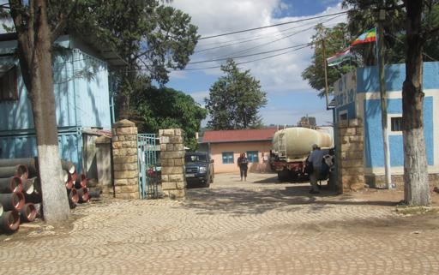
Figure 6.1 The offices of the Harar Water Supply and Sewerage Enterprise.
The Town Water Board is a committee made up of individuals who are specialists in water treatment and supply, representatives of other sector offices such as Health and Education, and other stakeholders (in this context, representatives of people who would be affected by the water utility’s actions). Importantly, two members of the Board are democratically elected community representatives. At least one of these has to be a woman. The term of office of the Board members is five years. The function of the Board is to ensure the effective performance of the water utility. In particular it is responsible for ensuring that the water delivered to the public conforms to quality standards. The Board is also responsible for determining the utility’s vision, mission, aims, objectives and values, together with approval and monitoring of the utility’s budget and work programme, recruitment of the utility’s General Manager, and approval of appointment of Heads of Department.
A water utility may have several departments (Figure 6.2):
- The Planning Department plans for the growth in services provided.
- The Commercial and Customer Care Department handles queries and complaints from commercial and domestic customers.
- The Engineering Department is responsible for major engineering works, such as refurbishment or expansion of facilities.
- The Corporate Affairs Department takes care of public relations and communications such as publicity campaigns to encourage efficient use of water.
- The Rural Water Supply Department ensures that water supply is extended to cover the rural population.
- The Operation and Maintenance Department ensures the smooth running of the water treatment and supply system.
- The Water Quality Assurance Department monitors the quality of delivered water to ensure that it is up to standard.
- The Human Resource Management Department looks after the recruitment and training of staff.
- The Finance Department manages the water utility’s budget and makes sure that all financial transactions are recorded, and that revenue is collected for water supplied.
- Finally, if relevant, the Sewerage Department looks after the sewer network and sewage treatment. (Note that sewage is the water-carried faecal waste from toilets, sewers are the pipes carrying this waste and sewerage refers to the infrastructure that conveys sewage. It encompasses components such as receiving drains, manholes, pumping stations and screens.)
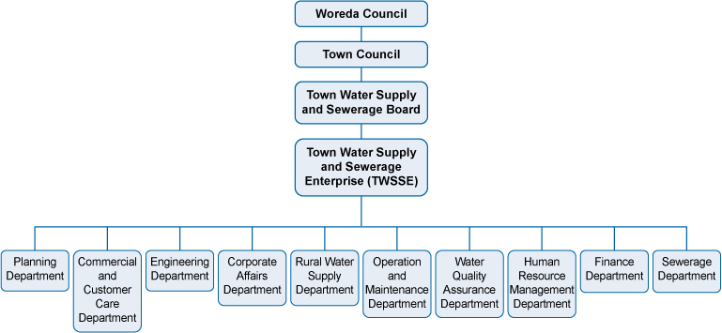
Figure 6.2 The organisational structure for urban water supply in Ethiopia.
While all the above departments are important, an effective and efficient Operation and Maintenance Department is vital to ensure that people receive good-quality water continuously each day. This function will be the focus of the next section.

6.2 The basics of operation and maintenance
Operation and maintenance of a water supply system refers to all the activities needed to run the system continuously to provide the necessary service. The two words are very frequently used together and the abbreviation ‘O&M’ is widely used. The overall aim of operation and maintenance is to ensure an efficient, effective and sustainable system (Castro et al., 2009). ‘Efficient’ means being able to accomplish something with the least waste of time, effort and resources; ‘effective’ means being successful in producing the intended result; and ‘sustainable’ means able to be maintained at the best level over time – in this case, the supply of water.

6.2.1 Operation
Operation refers to the routine activities and procedures that are implemented to ensure that the water supply system is working efficiently. The activities that contribute to the operation of a water utility are undertaken by technicians and engineers who have responsibility for controlling the functions of the system (Figure 6.3).
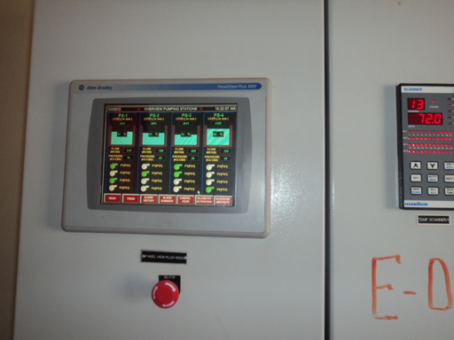
Figure 6.3 Control panel in a water treatment plant.
The components of the system that they look after, such as the treatment plants, process units and all the equipment and facilities (for example, offices and laboratories) are called the assets. For each asset there will be operating guidelines to follow. For instance, a water pump should only be operated for a limited number of hours per day and this must not be exceeded, otherwise it will be exposed to overheating and eventually to failure. The pump should also be run long enough to fill the service reservoir (which you learned about in Study Session 1). If not, there will not be enough water for distribution to customers.
- What are service reservoirs?
- They are reservoirs of water that serve to balance the fluctuating demands of users. They also serve as a back-up supply in case there is a breakdown at the water treatment plant that cuts the production of clean water.

6.2.2 Maintenance
Maintenance (Figure 6.4) refers to planned technical activities or activities carried out in response to a breakdown, to ensure that assets are functioning effectively, and requires skills, tools and spare parts (Carter, 2009). There are two types of maintenance:
- Corrective or breakdown maintenance: this is carried out when components fail and stop working. Breakdown is common in many utilities in Ethiopia and occurs as a result of poor preventive maintenance (explained next).
- Preventive maintenance: this is a regular, planned activity that takes place so that breakdowns are avoided. Examples of preventive maintenance would include servicing of equipment, inspecting equipment for wear and tear and replacing as necessary, cleaning and greasing moving parts of equipment, and replacing items that have a limited lifespan. Preventive maintenance is important because it ensures that the asset fulfils its service life. It also prevents crises occurring and costly repairs (in terms of time and money) being needed.
If you consider the example of the pump mentioned in Section 6.2.1, regularly checking the electrical parts, the components of the switch/operating board and inspection of power lines are tasks that can be regarded as preventive maintenance. If the pump fails due to operational problems or lack of preventive maintenance, it will have to be repaired or replaced – an example of breakdown maintenance.
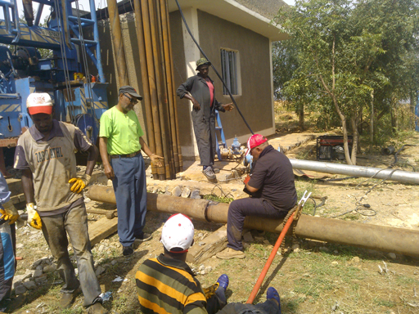
Figure 6.4 Technicians undertaking maintenance activities on a water treatment unit.
Preventive maintenance ensures that the different components of the water supply system perform correctly over their service life (their expected lifetime). This in turn avoids the occurrence of a major fault or breakdown in the water supply system that calls for corrective maintenance that is many times more expensive. In some cases, the problem may require full replacement of a costly item of equipment, which also takes a significant amount of time to achieve. As a result, the service level of the water supply system will reduce or even be interrupted over the period of maintenance, causing significant inconvenience to users and reducing the income of the water utility.
Utilities should always ensure that an adequate level of preventive maintenance is in place for all of their assets in the water supply system. This requires that adequately skilled persons are employed as operators or maintenance crew, and that they are provided with the proper tools. A strict and regular schedule of work is also required to ensure that preventive maintenance is carried out at the appropriate time. The next section considers strategies and plans for maintenance.

6.3 Maintenance strategy
Utilities with a strong focus on the preventive maintenance of assets can save substantial time and costs, avoid service interruptions, and increase their revenue.
A good maintenance strategy will detail:
- how the maintenance activities will be organised (on a regional and area basis)
- how maintenance will be carried out (using own technicians, or outsourcing to skilled technicians outside the utility, or both)
- clear descriptions of how the assets are expected to function with proper maintenance
- information and documentation requirements, for example a log of parts replaced, inspections made, recording of any incidents (unexpected events)
- prioritisation of assets for routine inspection and maintenance (the more important items, such as main pumps, needing more frequent inspection and maintenance).
At times key decisions have to be made to replace old or damaged equipment. Adept utility managers plan and decide in advance which assets require replacement and when. These decisions may be made based on past experience or on the opinions of individuals, although this may be unwise because experience and opinions vary from one individual to another. One technique that can assist in making objective decisions uses the concept of life-cycle cost. (An objective decision is one based on facts, unlike a subjective decision, which is one based on personal feelings or opinions.) The life-cycle cost of an asset is the sum of its one-time, non-recurring costs (for example, its purchase and installation costs) and its recurring costs (such as its operating cost, maintenance cost and disposal cost) over the life of the asset.
Look at Figure 6.5, which shows two life-cycle cost trends. The solid line shows the trend for an asset with a low purchase cost but high operating cost over time, whereas the broken line shows the trend for an asset which has a high purchase cost but low operating cost over time. Note that both graphs show cumulative costs (the total costs accumulated over the time period shown). The graph demonstrates that a high initial cost does not mean an asset has the highest life-cycle cost. Similarly, a low initial cost does not mean lowest life-cycle cost. Utility managers and technicians can use graphs such as these to help take decisions when replacing assets or acquiring new ones.
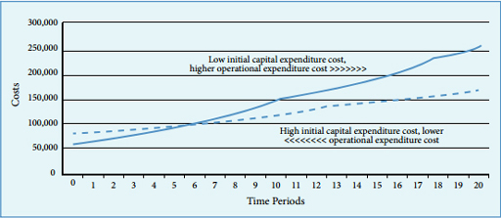
Figure 6.5 Comparative life-cycle cumulative costs. (Asian Development Bank, 2013)

6.4 Maintenance plans
Maintenance plans are prepared based on the maintenance strategy that has been formulated. The plan will outline the maintenance activities, their timing or frequency and the information needed for the record for each asset. It will also take into account the current condition of the asset, and its criticality (degree of importance) for the water supply system. Based on the plan, activities such as inspections, parts replacement and preventive maintenance will take place.
- Retta is drawing up a maintenance schedule for various items at his water utility. In terms of criticality, how should he rank the following items?
- The computer used for billing customers.
- The pump at the water intake.
- The vehicles used by the leak detection team.
- The control system for the rapid gravity filter.
- A recommended ranking would be (starting with the most important):
- The pump at the water intake.
- The control system for the rapid gravity filter.
- The vehicles used by the leak detection team.
- The computer used for billing customers.

6.4.1 Spare parts
Many water treatment and supply systems fail because of a lack of spare parts. Managers should be proactive and order adequate quantities of the parts that fail frequently. Doing this has the benefit of allowing repairs to be undertaken immediately, instead of time being spent going to the market to search for the appropriate part.
Standardisation (meaning keeping everything the same) of equipment and parts benefits operation and maintenance because fewer types of each part need to be stocked (thus making stock management easier), and purchasing bulk quantities of the same type of part brings savings. Standardisation also reduces the number of skills required to install and maintain equipment, so that more members of staff would be able to carry out the work (Barreto Dillon, n.d.).

6.4.2 Asset register
An asset register is a listing of all the fixed assets of an organisation and information pertaining to the assets. For a water utility the assets would be a list of all the equipment and buildings. For a piece of equipment the following information would be recorded: a description of the item, with technical drawings, its acquisition date, its service life, location and cost; the manufacturer’s details; the serial number of the item; details of the warranty and insurance; operating instructions; and maintenance requirements. Details of failures that occur when the asset is in use, and how they were caused, are also useful as they help in drawing up supplementary guidance on operation and maintenance, based on experience with the equipment.

6.5 The Operation and Maintenance Manual
A key element of ensuring timely and adequate maintenance of water treatment and supply systems is the Operation and Maintenance Manual (Figure 6.6). This manual is prepared immediately after construction begins and before operation starts, and is the basis for the day-to-day running of the system.
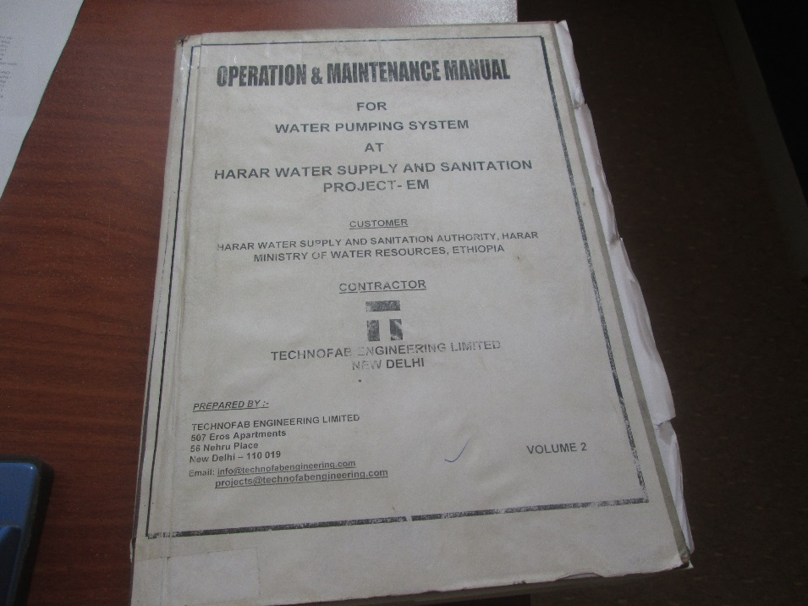
Figure 6.6 A typical Operation and Maintenance Manual.
A well-prepared Operation and Maintenance Manual contains the following:
- A detailed description of the system, with drawings.
- Health and Safety advice for all aspects of the water treatment and supply operation, ranging from how to lift heavy objects to what to do if someone is exposed to chlorine gas.
- Instructions for starting up and operating each of the water treatment processes and the system (e.g. of pumps) for delivery of the water, with details of the various parameters that need to be controlled (such as the flow rate through a rapid gravity sand filter, maximum flow rate permissible through the delivery system, etc.). These instructions are often referred to as standard operating procedures or SOPs. Essentially, a standard operating procedure is an established procedure to be followed in carrying out a given operation.
- The procedure to adopt in emergencies that can occur during the water treatment and supply process (for example, what to do if the inlet pump at the water intake point stops working). Plant operators should be trained in emergency procedures (such as how to overcome the emergency, who to contact, etc.) and mock emergencies should be enacted to allow staff to practise emergency procedures and be thoroughly familiar with what to do when a real emergency happens.
- Lists of tasks to be undertaken and at what frequency. There should be separate lists for daily tasks and weekly, monthly and annual tasks. Box 6.1 shows a typical list of daily tasks and, for comparison, example annual tasks are shown in Box 6.2.

Box 6.1 Example daily tasks in running a water treatment plant
- Check water meter readings and record water production.
- Check and record water levels in storage tanks.
- Check chemical solution tanks and record amounts used.
- Inspect chemical feed pumps.
- Check and record residual chlorine at the chlorine contact tank and in the distribution system.
- Inspect inlet pumps, motors and controls.
- Record inlet pump running times and pump cycle starts.
- Complete a daily security check.

Box 6.2 Example annual tasks in running a water treatment plant
The schedule for these tasks is spread throughout the year with some allocated for January, some for February, etc. so that workload is managed sensibly. Some of these tasks may need to be completed three or four times a year.
- Overhaul chemical feed pumps.
- Inspect and clean chemical feed lines and solution tanks.
- Calibrate chemical feed pumps.
- Operate all valves inside the treatment plant and pump-house. Maintain log continuously throughout the year.
- Review emergency response plans.
- Inspect chemical safety equipment and repair or replace as needed.
- Inspect, clean and repair control panels in pump house and treatment plant.
- Inspect storage tanks for defects and deficiencies, and clean if necessary.
- Flush the distribution system and exercise/check all fire hydrant valves.
- Perform preventive maintenance on treatment plant and pump house buildings.

6.6 Training and capacity building
It is essential that members of staff are adequately trained to operate and maintain the water treatment and supply system. The training can begin with a classroom-based introduction (Figure 6.7) to the whole system, which is then followed by a structured training programme, where the trainee is exposed to different parts of the water treatment and supply system, and is given on-the-job training. Here, the trainee works alongside an experienced staff member until he or she is familiar with components and comfortable to conduct the desired operation and maintenance independently. Where the management of the water utility observes a lack of capacity, immediate measures must be taken to build the required technical skills of the operators and maintenance crew.
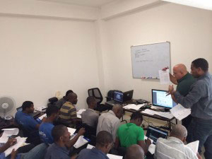
Figure 6.7 Technicians in a classroom during a training session.

6.7 Coping with natural disasters
- Some towns in Ethiopia are located in areas prone to natural disasters. What are the natural disasters that have been experienced in Ethiopia?
- Flooding is a problem in many parts of the country and earthquakes have also been experienced.
Water utilities in areas with a history of flooding or earthquakes should prepare adequately so that water supply is not affected. In 2014 there were serious floods in Gambela, Afar, SNNPR and Somali regions (Figure 6.8).
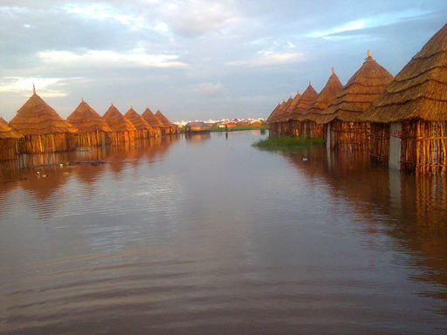
Figure 6.8 Flooding due to rainstorms at the Lietchuor Refugee Camp, Gambela Region, in 2014.
At times of natural disasters, the need to provide adequate and clean water to communities is crucial. There are good reasons for this. Other services such as electricity supply and transportation will be affected, limiting people’s access to safe food and health services. If clean water is also not available, the health of people will be at serious risk. Utilities must therefore plan and be prepared for such eventualities. Mock emergency exercises should be carried out on given water supply systems to develop detailed lists of actions to ensure that resilient systems that can withstand difficult conditions are in place to serve the community.
The following are some key points to consider to ensure resilience during floods.
- If wells are the source of water, the topmost reach of the well-casing should be raised above any known level of past flooding. Back-up generators should be installed on a stable foundation at a height that minimises damage by flood water.
- The well should have protective structures around it to prevent damage and avoid infiltration of contaminated surface water into the well.
- In treatment plants, sand bags should be available as flood barriers around buildings that house equipment, and windows should be boarded up.
- Switchboards and other electrical components should be installed at a height where floodwater cannot reach them.
It is not possible to protect water systems completely from all forms of natural disaster, for example earthquakes, but by forward planning and preparedness, it is possible to mitigate the worst impacts.

Summary of Study Session 6
In Study Session 6, you have learned that:
- Water utilities have many different departments, each with specific responsibilities. The Operation and Maintenance Department is vital for ensuring the continuous supply of good-quality water.
- Operation refers to the activities and procedures needed to keep a system running.
- Maintenance is the planned technical activity, or an activity taken in response to a breakdown, to keep a system operating. The former is referred to as ‘preventive maintenance’ and the latter as ‘breakdown maintenance’.
- Preventive maintenance contributes to continuity of water supply, thus reducing disruption to service, which can be costly to put right. It also ensures that the full service life of equipment is achieved and consequently saves money for the water utility. Continuity of service further means that the income from the sale of water is not interrupted.
- Life-cycle costing is a means of arriving at an objective decision when considering the purchase of assets.
- Maintenance schedules for assets should be based on their criticality to the water supply system.
- Having a stock of spare parts enables repairs to be carried out quickly.
- Standardisation of equipment and spares simplifies stock management, reduces purchase costs, and reduces the range of staff skills required for repairs, thus increasing the chances of more people being able to undertake repairs and maintenance.
- The Operation and Maintenance Manual is the guide by which the water supply system is run, and contains a description of the system, Health and Safety advice, instructions for starting up and operating equipment, emergency procedures, and listings of the required tasks, with timings.
- Staff should be adequately trained in operation and maintenance, and technical capacity should be built up in the water utility.
- Measures must be in place to ensure that natural disasters do not affect water supply.

Self-Assessment Questions (SAQs) for Study Session 6
Now that you have completed this study session, you can assess how well you have achieved its Learning Outcomes by answering these questions. You can check your answers with the Notes on the Self-Assessment Questions at the end of this Module.

SAQ 6.1 (tests Learning Outcome 6.1)
In the paragraph below there are gaps for words. Insert the appropriate word from those listed here:
asset register; assets; criticality; life-cycle cost; operation and maintenance manual; regular maintenance; resilient; stakeholders; standardisation; standard operating procedures.
A water supply scheme is being planned in a town in Benishangul-Gumuz Region, in western Ethiopia. Different groups of people, referred to as ………………, who will be affected by the scheme, are called for a meeting. Their main worry is that floods will affect the new treatment plant but the Planning Engineer assures them the plant will be ……………… They are also worried about costs and whether decisions will be made objectively. The Finance Manager at the water utility tells them they use a technique based on ……………… that will help them make the right choice. The equipment and buildings, often referred to as ………………, will be well looked after through ……………… The frequency of maintenance will be decided by considering the ……………… of each asset. For the benefit of new members of staff, full details of all the assets are kept in the ……………… New plant operators and technicians will have the ……………… available to guide them in the ……………… of the water supply system. Within it are ……………… to use when starting up and operating equipment. A major issue is spare parts, since the town is several hours from Asosa, the Region’s capital. Again, this has been considered – the water utility has opted for ……………… of all its equipment and parts to make stock keeping and maintenance much easier, thus ensuring continuity of water supply.

SAQ 6.2 (tests Learning Outcome 6.2)
Put the names of the Departments alongside the following water utility activities.
Activity | Department responsible
Interviewing candidates for the role of operator
Distributing information on how customers can reduce their water consumption and save money
Repairing a sewer pipe that has been broken by a developer digging a trench to lay telephone cables
Checking that the water that goes to the consumers is safe
Making sure that the water supply is continuous
Helping Ayinabeba, a new customer, to process the paperwork for water supply at her house
Sending water bills out to customers

SAQ 6.3 (tests Learning Outcome 6.3)
Which of the following is not the duty of an operator at a water utility?
- Checking that the inflow to the treatment plant matches water demand.
- Monitoring the various water treatment operations for efficiency.
- Planning for the increased demand of water due to population growth.
- Measuring the residual chlorine level of the treated water leaving the plant.
- Making sure there’s an adequate stock of water treatment chemicals on site.
- Ensuring that wastes from the plant are properly disposed of.

SAQ 6.4 (tests Learning Outcome 6.4)
Distinguish between the two types of maintenance at a water utility and give reasons why one of them is better.

SAQ 6.5 (tests Learning Outcome 6.5)
How should electrical equipment be protected from floodwaters?

Study Session 7 Distribution, Leakage and Illegal Connections

Introduction
Some of the principles of distribution and delivery of water in urban areas were explained in Study Session 1. Water from a treatment plant is conveyed in transmission mains to service reservoirs, and then in distribution mains that deliver it to consumers.
In this study session you look at this system again and consider the causes and effects of leakage and the ways it can be detected. You will also consider illegal connections to the water supply system, and the impacts that they have.

Learning Outcomes for Study Session 7
When you have studied this session, you should be able to:
7.1 Define and use correctly all of the key words printed in bold. (SAQ 7.1)
7.2 Describe drinking water delivery options in urban settings. (SAQ 7.2)
7.3 Explain what leakage is, how it is detected and how it can be reduced. (SAQ 7.3)
7.4 Describe the problems created through illegal connections to a water main. (SAQ 7.4)

7.1 Water delivery in urban settings
Water in urban areas is usually conveyed through a network of pipes to reach the users. Figure 7.1 is a diagram of a typical distribution and delivery system.
Figure 7.1 Schematic of a water distribution and delivery system.
- Compare Figure 7.1 with Figure 1.10 in Study Session 1. Which parts of the system can you see in both diagrams?
- The transmission main and service reservoir are in both diagrams. The treatment works in Figure 1.10 is equivalent to the ‘Source’ here. The distribution mains are shown in Figure 7.1 as the main and branch pipelines.
Figure 7.1 also shows the further distribution options labelled as ‘house connection’ (indoor taps), ‘yard tap’ (outside the house) and ‘standpost’. Standposts or standpipes are equivalent to public taps and water points. Water can also be obtained from kiosks, which are booths selling, in addition to water, food, household items, etc. The junctions in the system, where one pipe connects to another, should be controlled by valves so that water flow can be managed in the separate sections and different parts can be isolated. This allows repairs to be made to one section without cutting off the supply elsewhere.
In some cases, in order to reach the extremities of the distribution system the water may have to be pressurised and pumped. Pressurising the water also prevents entry of contaminants should there be a crack in the pipe.
- In flat areas of the country, certain structures are used to ensure the water can flow by gravity to users. What are these structures?
- Water towers.
The pipework of a distribution system can be made of different materials. In the old days pipes were often made of metal, but nowadays it is very common to see polyethylene or other types of plastic pipes. Plastic pipes can last in excess of 100 years (Plastics Industry Pipe Association, n.d.) and do not suffer from corrosion as metal pipes do. Corrosion is the gradual destruction of materials (usually metals) by chemical reaction with their environment. Corrosion in pipes leads to a reduction in their water-carrying capacity, so that the water requires greater pumping (thus consuming more energy). In addition, when metal pipes corrode they release metals into the water, causing undesirable aesthetic and health effects. When unlined iron pipes are used, iron can be released and this causes the water to appear brown or red. Washing light-coloured clothes with this water leaves a stain. Plastic pipes are lighter and therefore easier to transport, and they are also easier to lay (Figure 7.2).
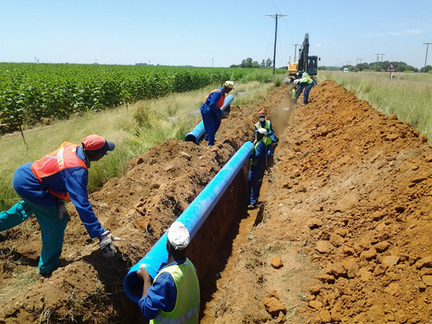
Figure 7.2 Plastic water mains being laid.

7.2 Non-revenue water and leakage
Water that is supplied by water utilities has to be paid for, since the production and distribution of treated water costs money. (You will learn more about this in Study Session 13.) There is, however, a category of water supplied from which no income is derived for the water utility. This non-revenue water includes:
- water that is used by the water utility for maintenance purposes, for example for cleaning out pipes, reservoirs or tanks
- water that is not recorded as having been used, due to inaccurate or faulty water meters
- water that is taken illegally from the mains
- water that is lost due to leakage (water escaping from the pipe into the environment).
Leakage is by far the biggest component in non-revenue water. In Addis Ababa, for example, non-revenue water is estimated to be 41% of the total volume supplied (GWOPA, n.d.). A figure of 10% for non-revenue water is acceptable – anything higher needs investigating. Figure 7.3 shows an example of water being lost via a burst pipe. Many water leaks, unlike the one shown here, are slow and relatively small. They can be unobtrusive and not visible at the surface but, over time, large volumes of water can seep out of a leaking water pipe and into the surrounding ground.
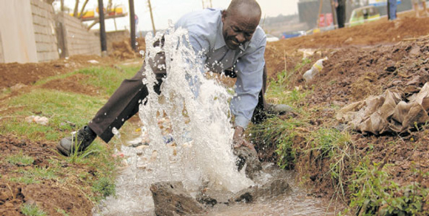
Figure 7.3 A burst pipe!
- Why do you think water leakage from an urban distribution system is a problem?
- Leakage means that good-quality water produced in a treatment plant is lost. The cost of the water is an issue but, more importantly, it results in less water being available for supply. It can mean that customers are left without water for some of the time. This could make it difficult for them to wash and thus potentially affects their health.
In the long term, the loss of water due to leakage puts added pressure on the water supply system. Increasing demand from rising urban populations requires the expansion of existing water supply systems or the development of new ones, which is costly and challenging. Preventing leakage in the existing system rather than investing in expansion or new schemes would be economically preferable.
Leakage causes many other problems. It leads to a loss in pressure in the water supply system. To overcome this the operators may then increase the pressure (using more energy) but this increased pressure leads to a greater rate of leakage. Leaking water can damage infrastructure such as the foundations of buildings. In addition, damaged pipes can allow contamination of the mains supply. The reduction in water pressure (in the underground pipe) will allow impure water from the soil to get into the water main and contaminate the supply.
There are several different reasons why water pipes leak and they frequently occur in combination. Leakage occurs due to the pipelines:
- being old and corroded, like the section shown in Figure 7.4
- being poorly constructed, where sections of pipe are not joined properly to each other
- being poorly maintained
- having poor corrosion protection
- being damaged through digging by other utilities
- being damaged by aggressive (corrosive) water inside the pipe, when water quality standards are breached
- being damaged through illegal connections made to the pipe (discussed in Section 7.5).
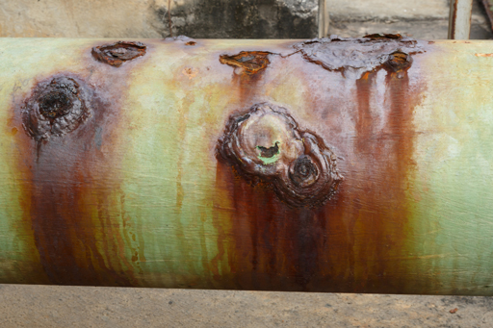
Figure 7.4 A section of corroded water pipe.
Any pipework is vulnerable to pollutants in the soil and ground on the outside of the pipe, which can be corrosive, depending on several factors including the use of the surrounding land, the presence of industrial wastes that can leach through the soil, etc. The water inside the pipe that is being delivered to customers should, of course, be potable and free of any undesirable pollutants. However, if there is a failure in the system, it is possible that the water may become corrosive, attacking pipe and storage tank material. Water that is acidic, has a high dissolved solids content or is very hot can be corrosive.
Responsibility for leakage control in main water pipelines lies with the water utilities. Each water utility must have a code of practice that sets out how they address any leakage in water supply pipes. The following procedure is generally adopted once a leak has been detected:
- Assess the damage to the pipework.
- Identify the resources (human, time and materials) needed to rectify the problem.
- Mobilise resources.
- Let customers know about the extent of the damage and the time needed to resolve the problem.
- Provide an alternative water supply until the restoration work has been completed.
- Undertake the repairs and reconstruction work as rapidly as possible.

7.3 Leakage prevention, detection and control
Although leaks can occur through valves that are malfunctioning, the largest losses of water are through leaks in the water main itself, either where two sections are joined or where there is a defect in the pipe. Proactive leakage control (where teams take action to prevent leaks occurring) can bring several benefits. It will mean that more water is available for supply, and it will delay the need for costly expansion programmes. It will also lead to less disruption of traffic and daily life, which happens when a leakage is discovered and has to be fixed. Less infrastructure damage is caused and there is less risk of the mains water becoming contaminated.
One way to minimise leaks is to ensure that the water pressure in the distribution system is not excessive. Lowering the system pressure during periods of low water demand can lead to a decrease in leakage loss, and extend the life of pipes (Thompson and Wang, 2009). Another form of proactive leakage management is to replace ageing pipes as they reach the end of their life.

7.3.1 Detecting leaks in water mains
Preventing leaks by using corrosion-resistant materials, following the correct procedures for pipe laying, and conducting regular checks and preventive maintenance is the best approach, but inevitably some leaks will still occur. The challenge is to find the leaks, which will probably be underground, and repair them as quickly as possible. This is active leakage control.
Leaks are usually detected from the sound generated by the escaping water. A device called a noise correlator (Figure 7.5) is used to listen to the leak from two different points and can pinpoint the exact location of the leak. The correlator can be used on both metal and non-metal pipes.
Typically, microphones or acoustic sensors (1 and 2 in Figure 7.5) are placed in contact with the pipe, at two points, to record the hissing sound emitted by a leak somewhere between the points. The sound data are sent to a noise correlator (3), which processes the information through a mathematical program to determine the difference in the times taken for the noise to travel from the site of the leak to each of the sensors. If the distance between the sensors is known, this timing information can be used to determine the location of the leak.
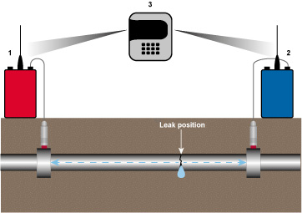
Figure 7.5 A noise correlator system to pinpoint the location of a leak.
Leakage detection is best carried out at night when it is quiet and the use of water is minimal. Sections of pipe which have a high flow can then be closed off and investigated for leaks. In areas where there is only an intermittent supply of water, a water tanker can be used to put water into a section of pipe and pressurise it. Any leakage can then be easily detected.
Alternatively, devices called acoustic loggers (Figure 7.6) can be attached to pipes using magnets. They record and analyse the intensity and consistency of noise in the pipe. A significant change in the noise will signal a leak. This device has been used in Harar to detect leaks (Mohammed, 2015). A combined correlator-acoustic logger is also available. This reduces the time for detecting and pin-pointing a leak.
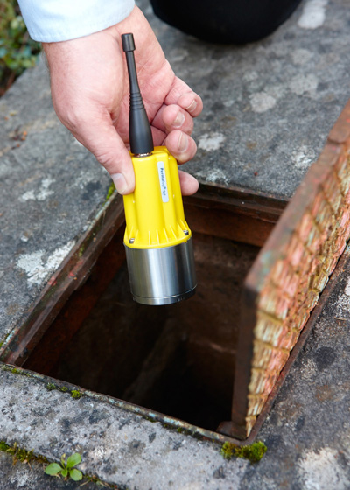
Figure 7.6 An acoustic logger to detect leaks through a change in noise level in the water pipe.
Another device is ground-penetrating radar, which reveals leaks by identifying disturbed ground or cavities around a pipe. It can be used to locate leaks where a correlator would be impractical due to noise created by pumps, etc.
Contrary to common belief, large leaks that spray water into the street, like the one in Figure 7.4, are not the major cause of water loss, since they are obvious and thus quickly found and repaired. The small leaks, which discharge water under the ground, are not obvious and can remain undiscovered for years, with the concomitant loss of a large amount of water. However, in a pressurised system, small leaks are noisy and can be detected easily, once suspicion is aroused about a possible leakage.
When carrying out a leak detection programme, it is best to concentrate on parts of the distribution system that are most likely to have a leak. These would be:
- areas where there have been leaks before
- areas where there is heavy traffic, because this would exert a load on the pipes, and also the vibrations caused by the traffic can cause damage.
Once a leak is discovered it has to be repaired quickly, so that wastage of water and money is avoided. Public opinion is also important – water seen gushing out onto the street for a long period quickly leads to accusations that the water utility is being complacent!
Special collars that fit around the pipe are used to repair small leaks. For large leaks, a smaller-diameter pipe may be inserted into the section of pipe concerned, so that the water flows through this new pipe (effectively a pipe within a pipe). Alternatively, the pipe section itself can be replaced.

7.3.2 Detecting leaks at home
For homes with a piped water supply, if the water bill suddenly goes up when the circumstances in the home have not changed, it is a sign that perhaps there is a leak in the water system. A way of confirming this is to turn off all the water appliances and observe the water meter. If the dials on it are turning, there is a leak somewhere. It may be possible to hear the hissing noise of water escaping. A search for the source of the sound will reveal the leak.
Water-flushed toilet systems can be checked by putting a few drops of food colouring in the water tank of the cistern, and 30 minutes later checking the water in the toilet bowl. If it has colour in it, the cistern is leaking.

7.4 Illegal connections
There are cases in Ethiopia and many other places of people illegally tapping into a water main in order to obtain water without paying for it. The cost of the water they use is borne by others who do pay for the water produced by the utility. Apart from committing a crime (theft of water, thus depriving the water utility of revenue), people who make illegal connections to the water supply system also endanger the safety of the mains water through possible contamination. This can be caused simply by making a break in the pipe without taking the necessary precautions to prevent contamination. The same can also happen if the illegal connection consists of a hose or pipe that, at one end, is connected to the water main and, at the other end, is left immersed below the water level of a storage tank, bucket or other container. This situation is illustrated in Figure 7.8. If there is a reduction in water pressure in the water main (say, due to a pipe burst), water from the container could be drawn into the mains supply. This phenomenon is referred to as back-siphonage. If the water in the bucket is contaminated in any way, this will result in contamination of the mains water too.
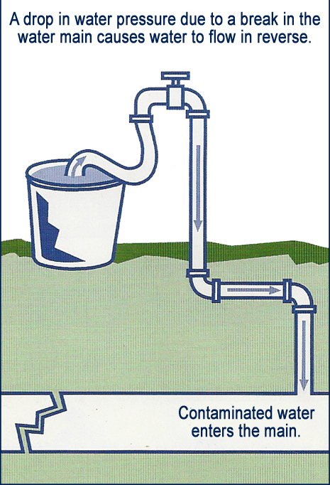
Figure 7.7 Back-siphonage.
Illegal connections mainly occur in newly established residential areas where some of the newly built households are supplied with water from the mains, while others do not have a piped supply. They get water from their neighbours through illegal connections using water hoses or plastic and metal pipes, without the knowledge and authorisation of the water utility.

7.5 Sustainability
The sustainability of a water distribution and supply system will be improved if pipes are made of robust, long-lasting material. The laying of the pipes has to conform with good civil engineering practice so that leaks are prevented. The pipes should not be laid where excessive pressure or vibration from above (such as from road traffic) is present. Maintenance of the distribution system is paramount, with proactive leakage control, and repair and replacement of pipes, etc. when appropriate. The sustainability of the whole water supply system can be improved if leakage is minimised and illegal connections are eliminated. Sustainability will also be enhanced if the volume of potable water used for purposes other than personal consumption is minimised. You will learn about ways of using less water in Study Session 11.

Summary of Study Session 7
In Study Session 7, you have learned that:
- Drinking water distribution systems take water to indoor taps, taps in yards and public taps.
- Water pipes are now mainly made of plastic that last at least 100 years, and they are easier to transport and lay than metal pipes.
- Care must be taken when handling water so as not to contaminate it.
- Non-revenue water is water from which no income comes to the water utility. This includes water that is used by the water utility in its operations, water that is not recorded as used, water that is stolen through illegal water connections and water that is lost by leakage.
- Leakage, the biggest portion of non-revenue water, results in lost revenue, less water being available for supply, and damage to infrastructure.
- Leakage occurs when pipelines are old and corroded, badly constructed, poorly maintained and damaged externally by digging or internally by aggressive water.
- Leakage control can be proactive or active using equipment such as correlators, acoustic loggers, and ground penetrating radar. There are simple methods available to discover water leaks in the home. Illegal connections deprive water utilities of income, and can result in the contamination of water mains through back-siphonage.
- Sustainability in water distribution and supply can be ensured by using robust, long-lasting pipes, laid appropriately, in locations where the pressure on the pipes and vibration are minimised. Maintenance, leakage control, the elimination of illegal connections and the minimisation of water use will also contribute to sustainability.

Self-Assessment Questions (SAQs) for Study Session 7
Now that you have completed this study session, you can assess how well you have achieved its Learning Outcomes by answering these questions. You can check your answers with the Notes on the Self-Assessment Questions at the end of this Module.

SAQ 7.1 (tests Learning Outcome 7.1)
Write the following words next to their correct definitions in the table below:
acoustic logger, active leakage control, back-siphonage, corrosion, ground penetrating radar, leakage, noise correlator, non-revenue water, proactive leakage control.
the escape of water from pipes or other parts of the water distribution system
a device that is used at two points to pinpoint leaks through the sound that is generated by water escaping
searching for leaks and repairing them
the process whereby a metal gets weaker due to a reaction with its environment
the drawing of external water into a water main as a result of a reduction in pressure in the water main
taking action to prevent leaks from occurring
a device used to detect leaks by identifying where the ground has cavities, or has been disturbed
water from which no income is received
a device attached to a pipe that can indicate a leak when the noise in the pipe changes

SAQ 7.2 (tests Learning Outcome 7.2)
List the ways by which municipal water reaches consumers in urban areas of Ethiopia served by a distribution system.

SAQ 7.3 (tests Learning Outcome 7.3)
Which of the following is not a cause of leakage? Give your reason why.
- excessive pressure in the pipes
- poorly-constructed distribution systems
- illegal connections
- old, corroded pipes
- pipes damaged due to construction of roads, etc.

SAQ 7.4 (tests Learning Outcome 7.4)
Which of the following statements relating to illegal connections is false? Give the reason for your choice.
Illegal connections result in:
- the possibility of the mains supply becoming contaminated
- an increase in the quantity of non-revenue water
- greater revenue for the water utility because more water is used
- a crime, since water is being stolen
- an increase in the financial burden to those people who do pay for water used.

Study Session 8 Water Safety Plans

Introduction
By this stage in your study of the Module you should have a good understanding of the reasons why safe water is important, and of the main components of a water supply system. You have also learned about some of the ways in which the safety of a water supply can be compromised. Water safety is the focus of this study session.
The World Health Organization (WHO) promotes the use of Water Safety Plans as a method by which the risks in supplying safe water are assessed and controlled. In this study session you will learn about Water Safety Plans and the steps involved in drawing up such a plan for an urban water supply system. The study session concludes with details of a Water Safety Plan formulated in Ethiopia.

Learning Outcomes for Study Session 8
When you have studied this session, you should be able to:
8.1 Define and use correctly all of the key words printed in bold. (SAQ 8.1)
8.2 Explain why a Water Safety Plan is necessary. (SAQ 8.2)
8.3 Describe the different steps in a Water Safety Plan and understand how they are applied. (SAQ 8.3)
8.4 Give an example of the successful use of a Water Safety Plan in Ethiopia. (SAQ 8.4)

8.1 What is a Water Safety Plan?
A Water Safety Plan is a plan to ensure the safety of drinking water through a risk assessment and management process that considers all the points in water supply from the catchment to the consumer. It is a means of preventing and managing threats to a drinking water supply system, before anything goes wrong, taking into account all the stages of the supply process from the water catchment to the consumer.
- What is a water catchment?
- From Study Session 4 you know that the catchment is the area of land surrounding and sloping towards a river.
If the water quality assessed at the tap where people collect it or use it is found to be poor, it has the disadvantage that unsafe water may already have been consumed by the people served by the distribution system. The WHO has published recommended steps for drawing up a Water Safety Plan (Bartram et al., 2009) on which the following description is based. By using Water Safety Plans, the quality of the water is proactively managed so that poor-quality water does not reach consumers. Water Safety Plans also help to eliminate the causes of incidents that might disrupt the delivery of safe water to consumers. Incidents, in the context of water supply, means emergencies such as a burst pipe.
A Water Safety Plan considers all the stages in the supply of water, and therefore it involves:
- management of the catchment to prevent contamination of the source water
- removal or elimination of contaminants during treatment of the water
- prevention of contamination of the water after treatment (during distribution, storage and handling).
Water Safety Plans put the emphasis on controlling risks where they are likely to arise, rather than having a treatment plant deal with cases of contamination after they have occurred. Preventing a problem from occurring is much better than having it occur and then trying to minimise its impact.
While the primary focus in a Water Safety Plan is on the direct dangers facing safe water quality (such as the possibility of chemical or microbial contamination), the Plan has to be more wide-reaching, considering aspects such as potential for flood damage; the sufficiency of the source water and alternative supplies; availability and reliability of power supplies; the quality of treatment chemicals; the availability of trained staff; security; and the reliability of communication systems.

8.2 The components of a Water Safety Plan
Water Safety Plans can vary in complexity depending on the scale and type of water supply system being considered. In general, there are ten components in a Water Safety Plan (Figure 8.1).
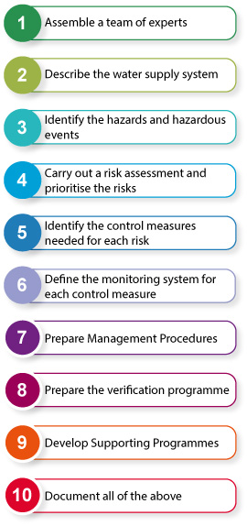
Figure 8.1 The steps in a Water Safety Plan.
Although the stages depicted in Figure 8.1 are sequential (i.e. you do them one after another in a sequence), they can be undertaken by teams of people working in parallel, looking at different aspects of water supply. For instance, there could be teams looking separately at the catchment, treatment plant and distribution system. We will now look at each of the steps in turn.

8.2.1 Assemble a team of experts
In order to draw up a Water Safety Plan, full information about the water supply system, from the catchment to the taps of consumers, is required. This will include details of the catchment (such as possible sources of contamination), the abstraction point, the pipes (sizes, construction materials, etc.), the units at the treatment plant, the distribution system (piping material, possible weak spots, etc.). To compile this information, a team of experts is required.
The expert team (Figure 8.2) should include not just technical experts but local people because they will be most knowledgeable about what is actually on the ground. Local people may include farmers and forestry workers, landowners, and representatives from industry, other utilities and local government, and consumers. Collectively the team should have the skills required to identify hazards and determine how the associated risks can be controlled. The definitions of hazards and risks are given in Box 8.1, where the difference between them is explained.
The support of senior management is crucial for the formulation and implementation of a Water Safety Plan, because changes in working practices may be needed, as well as new systems (costing money) for the control of risks. The finance and time requirements for preparing the Water Safety Plan will need to be approved by senior management who are the supervisors and decision makers responsible for implementing any actions that may be required. Depending on the context, senior management could be the Town Water Board or the Woreda WASH Team, for example.
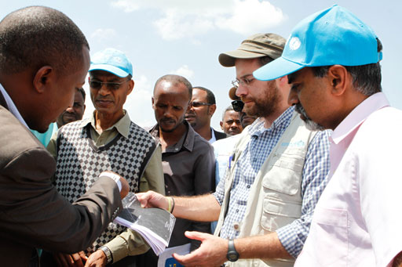
Figure 8.2 The team of experts should have a range of knowledge and skills.

Box 8.1 Hazards and risks
Identifying hazards and assessing risks are important aspects of preparing a Water Safety Plan. A hazard is something that is known to cause harm. Bartram et al. (2009) define a hazard as ‘a physical, biological, chemical or radiological agent that can cause harm to public health’. Risk is the likelihood or probability of the hazard occurring and the magnitude of the resulting effects.
Here is a simple example. If you climb a ladder, you know there is a chance you could fall off and be injured, although it is unlikely. The ladder is the hazard and the likelihood of your falling off and hurting yourself is the risk. Risk assessment is about evaluating a situation to determine how likely it is that the potential harm from the hazard will happen.

8.2.2 Describe the water supply system
The water supply system (Figure 8.3(a)) has to be fully described. This will allow hazards to be identified, and risks to be assessed and managed. In many cases, this information will be available and will only need reviewing to ensure that it is up to date, and checked for accuracy through site visits. A flow diagram that shows all the major elements of the water supply system (Figure 8.3(b)) should be drawn.
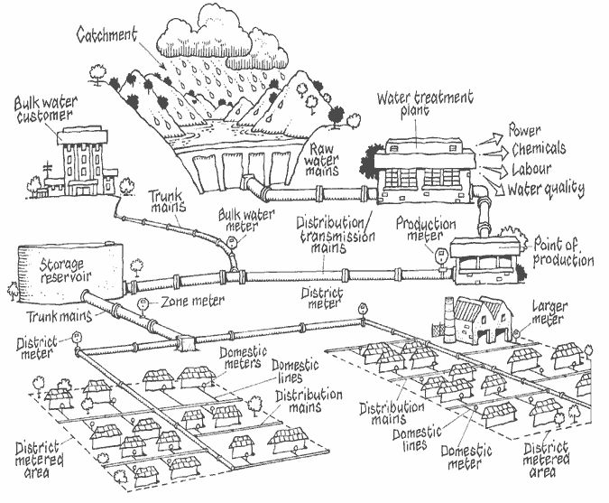
Figure 8.3(a) A water supply system.
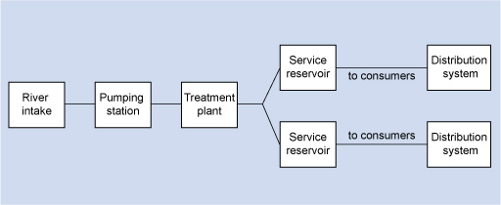
Figure 8.3(b) The elements of a water supply system.
In the case of springs and wells, it is important to know where the rainfall is percolating into the ground to replenish the groundwater. This will highlight the area where protective measures (such as restrictions on, say, fertiliser or pesticide use) are needed so that contaminants are not carried by the rainwater into the groundwater.

8.2.3 Identify the hazards and hazardous events
It is important to identify the potential hazards at each stage of the water supply process (see Box 8.1). Hazardous events in this context are defined as events that can introduce hazards into the water supply. A hazardous event can also be considered a source of a hazard. Table 8.1 gives examples of hazardous events and hazards that can affect different parts of a water supply system.
Table 8.1 Possible hazards in a water supply system. (Adapted from Bartram et al., 2009)
Hazardous event (source of hazard) | Associated hazard | Component of water supply system affected
Agriculture | Microbial contamination from animal excreta, pesticides, nitrates from fertiliser use | Catchment
Mining | Chemical contamination | Catchment
Interruption of power supply | Interruption of treatment | Treatment
Disruption of disinfection due to lack of disinfectant supply | Unsafe water goes to consumers | Treatment
Mains burst | Contaminants getting into pipeline | Distribution network
Illegal connections | Contamination of water supply by back-siphonage | Distribution network
Site visits are an effective way of ensuring all possibilities are covered (Figure 8.4). It is important to speak to the people who work at the locations concerned as they will have local knowledge that may not necessarily be in the paperwork related to the facility.
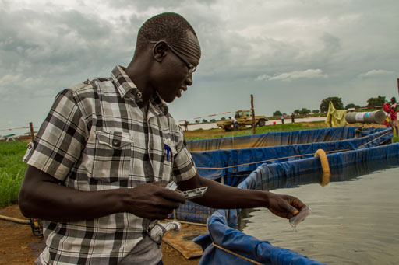
Figure 8.4 Testing water quality is an important part of hazard assessment.

8.2.4 Carry out a risk assessment and prioritise the risks
Risk is the likelihood of a hazard affecting the water supply system. A risk assessment can be carried out if the risk and the severity of the associated hazard are known. A method of undertaking a risk assessment quantitatively is to use a risk matrix as shown in Figure 8.5 (Bartram et al, 2009). The severity of the impact of a hazard and its likelihood can be multiplied together to arrive at a figure that indicates its risk score. The risk rating will be determined by this risk score, as shown at the bottom of Figure 8.5.
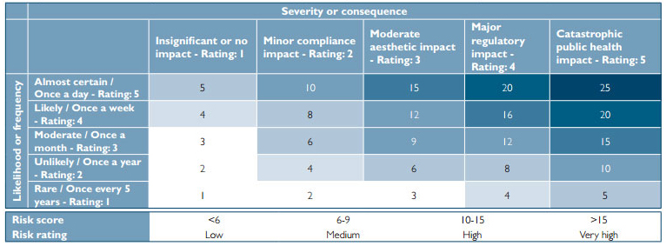
Figure 8.5 A risk matrix for risk assessment.
To illustrate this application of a risk matrix, suppose you wanted to carry out a risk assessment for the case where a treatment plant runs out of chlorine disinfectant (Figure 8.6). In a properly managed plant, with a system of stock control in place, such an occurrence may be rare (with a rating of 1). The public health impact of it, however, will be catastrophic (with a rating of 5). Using the matrix in Figure 8.5, you can calculate a risk score, which will be the product of 1 and 5. This risk score of 5 can then be given a risk rating. From the scale in Figure 8.5, this would be ‘low’ (being less than 6).
By repeating the exercise for other hazards and risks and comparing the risk scores, a prioritised list can be drawn up that ranks the risks in order of importance. Unfortunately, budgets are often limited and because of this many of the smaller risks are disregarded.
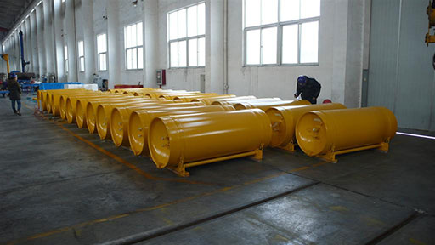
Figure 8.6 Drums of chlorine – essential stocks for a water treatment plant.

8.2.5 Identify the control measures needed for each risk
This means identifying the precautions (control measures) that need to be in place to eliminate or minimise the risks to the water supply system. So, in the example above, you would need to have a system of stock control that tells you when chlorine stocks are running low. Stock control may use some form of manual record keeping in a book or an electronic system (Figure 8.7). These have to be checked for effectiveness, as part of the Plan, and improved if necessary.
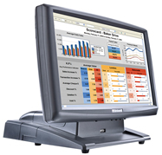
Figure 8.7 Display from an electronic stock control unit.

8.2.6 Define the monitoring system for each control measure
A system of regular monitoring has to be established to check that the control measures are working. Again, using the example above, someone will have to check that the records of chlorine availability in the store match what is actually present.

8.2.7 Prepare management procedures
A set of clear instructions to enable the whole water supply system to be operated as desired has to be in place. If there is an incident that disrupts the normal operation of the system – for instance, if a control measure fails – then a number of actions need to be followed. These should be documented in the management procedures so that they are easy to refer to and apply. The relevant management procedure will detail the remedial measure, what communications to undertake and the steps to follow in an investigation of the failure.
- Do you remember the usual name for the routine instructions for operating a water treatment plant?
- They are often referred to as standard operating procedures or SOPs.
Following through the example of chlorine stock, if the supply were to run out, the management procedure might suggest contacting nearby water utilities (using names and telephone numbers of contact persons who had previously been consulted) for a loan of an amount of chlorine. An alternative might be to contact supply companies that could rapidly acquire and supply the chemical (but this is likely to be at a high cost!). The population affected by the break in supply would have to be informed of the crisis, possibly by messages on local radio and television programmes. Lastly, an investigation needs to be undertaken as to how the crisis came about, and how it can be prevented from recurring.

8.2.8 Prepare verification programme
The verification programme is to check that all the components of the water supply system are working properly, and that water of a suitable quality and quantity is being supplied to the population, and therefore that the Water Safety Plan is working. There are three activities that together provide evidence that a Water Safety Plan is working effectively:
- compliance monitoring
- internal and external auditing of operational activities
- assessment of customer satisfaction.
In compliance monitoring, sampling and analysis of the water is undertaken to verify that the water quality standards are being met (complied with). For microbial verification, indicator organisms such as E. coli or faecal coliforms are looked for at representative points in the water supply system. In appropriate cases (say in areas with a Cryptosporidium problem), measurement of the organisms may be necessary. For chemical parameters, direct measurement is carried out, rather than the use of an indicator.
In internal and external auditing, scrutiny of the operational practice is undertaken by an auditor in person to verify that good practice is in place. As the names suggest, internal audits are undertaken by someone from within an organisation and external audits by an independent, objective auditor from outside an organisation. Auditors will, for instance, identify areas where procedures are not being followed, resources are inadequate or training is required for staff.
Assessment of customer satisfaction is the third aspect of verification and this is undertaken by personally meeting with representative consumers to obtain their feedback on the quality of the water delivered to them.

8.2.9 Develop supporting programmes
Supporting programmes are activities that support the development of people’s skills and knowledge in relation to delivering safe water. These mainly involve training, and research and development. To ensure that the Water Safety Plan is current, staff need to be updated on changes in the water supply system, and the revised actions they need to take in times of emergency. In the case of the chlorine supply running out, an investigation of the crisis will reveal whether staff retraining has to be conducted, or if the system for monitoring chlorine stocks needs to be modified, or indeed if both need to be done. The Water Safety Plan will have to be reviewed as a consequence.
Supplementary programmes include sessions to educate members of the public on how they can ensure that the water supply is kept safe (for example, by giving them information on how back-siphonage can contaminate the water distribution system).

8.2.10 Document all of the above
All the sections detailed above have to be documented so that there is an audit trail, in case any step has to be reviewed. (An audit trail is a chronological record that provides documentary evidence of the sequence of activities that led to a given decision.) Keeping clear and complete documentation enables the Plan to be reviewed periodically. This is important because changes can happen anywhere along the water supply process. New risks might arise, or more efficient and economical methods might become available to control the different risks.
In addition to regular review and updating, it is important that the Plan is reviewed and possibly modified following an incident or crisis. A post-incident review, where the incident is discussed in detail, is likely to identify areas for improvement in the operating procedures, training or communications, and these should be incorporated in a revised Water Safety Plan.

Case Study 8.1 Water Safety Plan at community level in Ethiopia
In Hentalo Wejerat woreda, in Tigray Region, Water Safety Plans were used to improve water supplies in small communities and ensure access to safe and clean water (Drop of Water, 2014).
Twelve individuals were trained as Trainers in Water Safety Planning by specialists from the World Health Organization. The training covered the principles of water safety planning, risk management for the supply of drinking water, guidance on developing Water Safety Plans, surveillance and control of small community water supplies, and safe practices in household water use. Three Water Safety Planning Teams were then established.
The three Water Safety Planning Teams were given training that focused on the impact of unsafe water, assessing environmental contaminants, operating a hygienic water point and the physical treatment of water at household level. They then applied Water Safety Plans to three water points at Lemlem Queiha, May Weyni and May Yordanos.
At Lemlem Queiha, although there was a fence at the water point, there was no gate. The area around the water point was unclean, and the water point was vulnerable to flooding. Not all the houses in the vicinity had latrines, which meant open defecation was taking place. The community had a poor awareness of good hygiene and sanitation. Jerrycans used for collecting water were unclean.
At May Weyni, the fence at the water point had been damaged by flood and had not been repaired, and there was no gate. Nearly all the residents had latrines at their homes.
At May Yordanos, the water point was found to be clean and well fenced. Water handling was hygienic both at the water point and in the residents’ homes. The houses had latrines, which meant that open defecation was eliminated. The community had a good awareness of hygiene and sanitation.
Over the one-year period of the project, with the aid of the Water Safety Planning Teams most of the residents installed latrines, and gained a good knowledge of hygiene and sanitation. The water points were kept clean, and good water-handling practice was adopted at water points and in homes. Open defecation was almost totally eliminated. Gates were installed at the water points at Lemlem Queiha and May Weyni, and the broken fence at May Weyni was repaired, to prevent contamination by animals.
- In what ways does Case Study 8.1 correspond to the ten steps of Water Safety Plans described in this study session?
- The actions taken in the case study correspond to the first few steps in a Water Safely Plan:
- Assembling a team of experts: twelve people were trained so that they had the expertise to undertake a Water Safety Plan.
- Description of the water supply system: details of the three water points were recorded.
- Identification of hazards: the various hazards at two of the water points (lack of gates, lack of a fence, unclean areas around water points, the susceptibility to flooding, open defecation, poor awareness of good hygiene and sanitation, unclean jerrycans) were noted.
Less well-fulfilled steps were:
- Carrying out a risk assessment: this does not appear to have been done, but it was perhaps unnecessary in the simple situation faced by the Team.
- Identification of control measures for each risk: control measures focused on addressing the hazards identified earlier. Hence, gates were installed, a fence was put up, the water points were kept clean, latrines were installed (almost totally eliminating open defecation) and information on good hygiene (covering water handling practice) and sanitation was disseminated to the residents. The issue of flooding did not seem to have been resolved.
- Defining a monitoring system for each control measure: since the residents had received information on good hygiene and sanitation, it is likely that they would endeavour to maintain good practice.
- In a small community context, preparing management procedures and a verification programme, and developing supporting programmes, are not needed.
The above was an example of the application of a Water Safety Plan but in a rural context. Hence not all the ten steps necessary in an urban situation were applicable to achieve the positive outcome.

Summary of Study Session 8
In Study Session 8 you have learned that:
- Water Safety Plans are a means of preventing and managing threats to the production and delivery of safe water; they consider the water catchment, the water treatment process, and the distribution, storage and handling of water.
- Water Safety Plans cover wider issues such as safety from flood damage, the sufficiency of the water source, the availability of power supplies, the availability of trained staff and the reliability of communication systems.
- There are ten steps in a Water Safety Plan:
- Assemble a team of experts.
- Describe the water supply system.
- Identify the hazards and hazardous events.
- Carry out a risk assessment and prioritise the risks.
- Identify the control measures needed for each risk.
- Define the monitoring system for each control measure.
- Prepare management procedures.
- Prepare the verification programme.
- Develop supporting programmes.
- Document all of the above.
- The support of senior management is crucial because changes in working practices may be necessary, and the acquisition of control measures for risks will need finance.
- A Water Safety Plan at community level was successfully implemented in Hintalo Wejerat Woreda in Tigray Region.

Self-Assessment Questions (SAQs) for Study Session 8
Now that you have completed this study session, you can assess how well you have achieved its Learning Outcomes by answering the following questions. You can check your answers with the Notes on the Self-Assessment Questions at the end of this Module.

SAQ 8.1 (tests Learning Outcome 8.1)
Write the following words next to their correct definitions in the table below:
audit trail, compliance monitoring, hazard, hazardous event, incident, risk, risk assessment, supporting programmes, Water Safety Plan.
an event that can introduce a hazard to a water supply
a plan that proactively seeks to identify and control risks to safe and continuous water supply
analysis of water to check that it is within standards
documentation of the sequence of activities that led to a given decision
the process by which the likelihood of harm from a potential hazard is assessed
anything that can cause harm
an emergency
the chance of a hazard occurring
training programmes that contribute to the delivery of safe water

SAQ 8.2 (tests Learning Outcome 8.2)
Explain briefly why a Water Safety Plan is necessary.

SAQ 8.3 (tests Learning Outcome 8.3)
- Arrange the steps of the Water Safety Plan shown below in the right order:
- Prepare management procedures.
- Identify the hazards and hazardous events.
- Define the monitoring system for each control measure.
- Assemble a team of experts.
- Develop supporting programmes.
- Prepare a verification programme to check that the Water Safety Plan is working.
- Describe the water supply system.
- Carry out a risk assessment and prioritise the risks.
- Identify the control measures needed for each risk.
- Document all of the steps.
- Look at Figure 8.8, which shows a well that is the sole water source for a village. Based on what you can see in the photograph, undertake the following:
- Hazard assessment
- Risk assessment
- Identification of the control measures needed for each risk
- Definition of the monitoring system for each control measure.
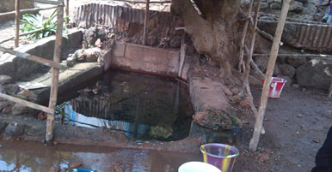
Figure 8.8 A potential abstraction point for drinking water.

SAQ 8.4 (tests Learning Outcome 8.4)
In the Water Safety Plan implemented in Hentalo Wejerat woreda, what were the changes made that improved the safety of the water supply?

Study Session 9 Duties and Responsibilities of Water Utilities

Introduction
Provision of safe and adequate drinking water to consumers requires careful planning and management by the water utilities. As water is a basic necessity, supplying drinking water is a continuous process and water utilities focus on the whole management process from the catchment to the source, and finally to the consumers’ taps. Water that is unacceptable in appearance, taste and odour will undermine the confidence of consumers, lead to complaints and, more importantly, lead to the use of water from sources that are less safe. Therefore, it is the responsibility of the water utilities to ensure provision of a safe and acceptable water supply to consumers.
In Study Session 6, you learned about the organisational structure of water utilities and their responsibilities in the operation and maintenance of water treatment and supply systems. In Study Session 7 you considered the particular problems associated with leakage that water utilities face and how they deal with them. In this study session, you will learn more about four key aspects of the duties and responsibilities of water utilities. These are the nature of good governance; the duties of water utilities to keep water treatment plants operational; dealing with customer concerns and complaints; and the various tests and standards for assessing water quality that apply in Ethiopia.

Learning Outcomes for Study Session 9
When you have studied this session, you should be able to:
9.1 Define and use correctly all of the key words printed in bold. (SAQ 9.1)
9.2 Briefly describe the considerations for good governance of a water utility. (SAQ 9.2)
9.3 Describe the various factors to be considered in keeping a water treatment plant operational. (SAQ 9.3)
9.4 List the steps that should be followed in dealing with customer concerns. (SAQ 9.4)
9.5 Outline the main parameters used to define water quality standards. (SAQ 9.5)

9.1 Good governance
The governance of a water utility is about the processes by which it makes decisions and implements them (UNESCAP, n.d.). Good governance can be defined by a collection of characteristics that describe the approach of the utility, or any other organisation, to its decisions and actions. These key characteristics are explained below.

9.1.1 Participation
It is important that all the people who are affected by decisions are allowed to participate in the process of reaching those decisions. Residents’ groups and other stakeholders or their representatives should be consulted as part of any decision-making process (Figure 9.1). Both men and women should be involved. The number and range of stakeholders to be consulted will depend on the project or scheme under discussion. As an example from a wider context, farmers may wish to increase their intake of water from a river for irrigation because they want to improve their crop production. This could affect many other people, especially those who live downstream of the abstraction point on the river, and they should be invited to participate in the deliberations.
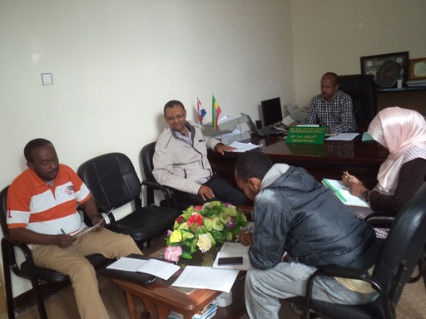
Figure 9.1 A meeting of stakeholder representatives to discuss water supply issues.

9.1.2 Transparency
When a decision is reached, the way it has been arrived at should be apparent to all, with all the steps documented. So, if it was decided that a dam should be built, details of all the consultations and meetings related to the decision should be available for members of the public to view. Similarly, in the interests of transparency, accounts should be available for public scrutiny, and all the financial decisions should show that value for money was achieved.

9.1.3 Responsiveness
The decision-making process and implementation of decisions must take place within a reasonable period of time. An example would be if a village wanted to have its own water supply system using water from a river, the decision on it should be made within a few months of the request.

9.1.4 Consensus
This is related to participation. As noted above, good governance requires that, for all major projects, consultation with all the stakeholders will be undertaken. Everyone should have the opportunity to put their view forward. The aim in the consultation should be to obtain a consensus, so that the final decision arrived at is in the best interests of the community as a whole. The water utility should play the role of mediator to bring about a decision that minimises any disadvantages to stakeholder groups.

9.1.5 Equity and inclusiveness
It is important that all parties are treated equally and are included in any decision making. The views of all stakeholders should be equally valued. No group should be marginalised, or indeed feel marginalised. It is especially important to consider the needs of vulnerable groups such as low-income families and disabled people (Figure 9.2).
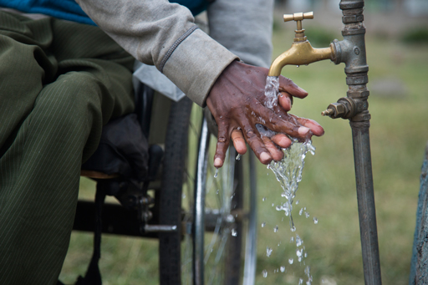
Figure 9.2 Water taps must be placed so that they are accessible to everyone.

9.1.6 Effectiveness
The actions of the water utility should be effective in addressing the issue concerned. This comes down to having the necessary expertise, and keeping the staff up to date through ongoing training. Staff morale should also be kept high so that staff turnover is kept low.

9.1.7 Efficiency
The resources available to the water utility should be used efficiently so that the greatest benefit is achieved with minimal cost and disruption. Any action should be carried out in consultation with interested parties, so that no duplication of effort takes place. For instance, if a new pipeline is to be laid, this can be done when the cables (for the remote control of water treatment equipment) are being put in, so that the roadway is dug up only once.
For a water utility, it is important to consider sustainability in all its operations, so that long-term viability is assured. For example, choosing a more expensive water treatment control system may mean that the cost of maintenance is reduced (see Figure 6.5 in Study Session 6).
- What are the terms used to describe the initial cost and the recurring cost?
- Capital cost and operating cost.

9.1.8 Accountability
The water utility has to be accountable to its customers, who are the people affected by its decisions and actions. The water utility has a duty to report on how its funds are used, and how decisions on major issues were arrived at, including on anything untoward that may have happened. This is linked to transparency. Utilities can only be accountable if their activities and processes are known to others.

9.1.9 Independence
The water utility has to be independent of political and commercial influence, in order that an equitable service is provided to all who need water.

9.2 Keeping a water treatment plant operational
The primary responsibility for a water utility is to provide a safe and adequate water supply to the users. From previous study sessions, you have learned about the need for a source of water that is reliable and can provide a sufficient quantity of water to meet demand. You also learned about the need to protect water sources and ensure they are not contaminated by pollutants of any type. Where water treatment is required, the water utility is responsible for keeping the water treatment plant running effectively and efficiently. An important part of this is the operation and maintenance procedures (Figure 9.3) that you learned about in Study Session 6.
- What are the two types of maintenance required in water treatment works? Why is one better than the other?
- The two types of maintenance are preventive maintenance and breakdown maintenance. Preventive maintenance involves regular checks that everything is working properly. Breakdown maintenance is needed if equipment breaks down. Preventive maintenance is the better approach because it avoids any break in supply, and is usually cheaper.
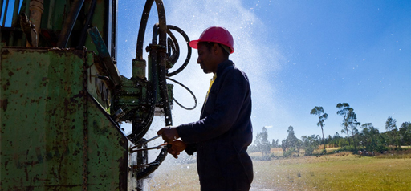
Figure 9.3 Maintenance work on a water pump.
Knowing about the costs of running a water treatment works is a very important part of management. Like any organisation, sound financial management is a key responsibility for the utility. Costs include initial funding to construct the plant and buy the necessary equipment for the treatment processes. Recurring costs include the cost of the staff, power, consumables such as chemicals, and spare parts, repairs and replacement machinery required for maintenance of the plant. In Study Session 6 you also read about the assets of a water supply system and the need for an asset register.
- Name three items you would expect to see included in the asset register of a water utility.
- You could have answered with any of the items you would expect to see at a water treatment plant or in other parts of the water supply system. This could include the river intakes, surface water reservoirs, boreholes, all the associated pipework and pumps, process units, buildings (offices, plant rooms, etc.), office equipment (computers, office furniture, etc.), laboratories and analytical equipment, vehicles, pumping stations, water mains, and more!
Looking after all the assets is an important responsibility for water utilities; this is known as asset management. Asset management is the systematic process of deploying, operating, maintaining and upgrading facilities cost-effectively, and at the same time providing the best possible service to users. Asset management also ensures that financial resources are available to repair and replace equipment when necessary.
Asset management consists of the following five steps:
- Preparing an asset register. Knowing what assets you have and what their condition is.
- Prioritising your assets. In case you have a limited budget, prioritising helps you to allocate funds to the rehabilitation or replacement of your most important assets.
- Developing an asset management plan. Devising a plan to ensure continuous service delivery, and estimating the amount of money required to do this.
- Implementing your asset management plan. Working with the support of management to carry out the plan, ensuring that the technical and financial means to deliver safe water to your customers are available.
- Reviewing and revising your asset management plan. Your asset management plan should be reviewed regularly because with time the assets will change (for example, due to expansion of treatment plants, or an increase in the coverage of water distribution systems). The plan then has to be revised as necessary.
Unfortunately, even with an excellent asset management plan in place and effective preventive maintenance, the water utility may still find its customers are not always happy and may make complaints. This is the subject of the next section.

9.3 Handling customer complaints
Customer complaints are inevitable and water utilities have a duty to respond to them quickly and efficiently. Water utility offices have a specific department responsible for handling customer complaints. In Study Session 6 this was called the Commercial and Customer Care Department but it may have other names such as the Public Complaints Resolution Department or similar. Complaints such as misreading of a water meter, breakage of a supply pipe, shortage of water, long waiting times for a pipe connection and poor-quality water are common and can be brought to this department by customers in person, through a telephone call or in written form. Many departments use free phone numbers so problems can be reported more easily.
When a complaint is received, the department dispatches a group of technicians to investigate the problem at the site. These technicians are expected to resolve the problem quickly, on the spot if possible. There are targets for repair. For instance, if the issue is a breakage in the customer’s section of pipe (the pipework between the water meter and the house) the pipe has to be repaired within an hour. If the breakage is in the main water line, it should be repaired within three hours.
For people working in the public sector providing a public service such as supplying water to people, no matter how great their services are, the old adage will eventually be proven true: you cannot please all of the people all of the time. Whatever the type of complaint customers have, it is important to remember the following rules when resolving customer service issues.
            - Listen to the complaint. The first thing to do is to listen to the complaint (Figure 9.4). Then the root cause of the problem must be ascertained. It could be that it is something to do with the way the water utility operates. Conversely, it could be due to factors outside its control.
2. Understand the issue. Next, given the situation, the complaint must be seen from the complainant’s point of view.
The question must be: ‘Why did they come here? Is their complaint justified?’ A complete picture of their complaint cannot be obtained until it is viewed from their perspective.
It is important to listen, understand and then discuss possible solutions with them in a calm and friendly manner. This comes down to tone and respect. Policies or personnel can be calmly defended but the conversation should not become an argument, as this will not resolve the issue but lead to anger and aggression.
3. Resolve the complaint. After the complaint has been heard and understood, a solution has to be suggested. If it is a major complaint, it has to be taken to a higher level, as appropriate. Sometimes this move alone is sufficient to resolve the customer’s concerns as it conveys a sense of importance – their complaint is significant enough to be passed to someone higher up in the chain of command. When referring the matter on, the person to whom the complaint has been sent has to be fully informed of the relevant facts before he or she speaks with the customer.
- Document the complaint and how it was resolved. After the customer’s complaint has been resolved, the case has to be documented in writing. This allows staff to refer back to it should a similar complaint arise in the future. Importantly, any recommendations for the water utility to adopt should be noted, to prevent future complaints.
- Learn from the complaint and rectify any problems. Customer complaints should be used as a means to learn about potential flaws in any of the water utility’s systems, and then the flaws should be rectified so that no more complaints arise.
In most situations, by following these five steps, the issue will be resolved to the customer’s satisfaction. There are, however, some issues that simply cannot be resolved. It could be that the customers’ requests are outside the stated policies on such matters, or that they are simply unreasonable. There will not always be an easy solution to this sort of problem but if all internal procedures have been exhausted, customers may have go to an independent party for resolution such as the Town Water Board or Woreda WASH Steering Committee.
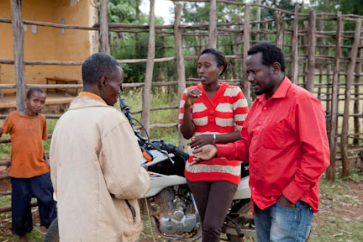
Figure 9.4 Customers may complain and must be listened to carefully.

9.4 Water quality standards
As mentioned above, customer complaints may be about water quantity and breaks in supply, but they may also be about water quality. This could be an undesirable colour or taste in the water that consumers have detected. More seriously, it could be a problem related to ill health that has been linked to the water supply. To check that the water supplied is both potable and palatable requires standards to be established. Drinking water standards are a set of limits for a wide range of substances, organisms and properties of water, with the protection of public health as the focus.
As you have read, water can contain many different types of biological contaminants. Water is considered a good and universal solvent, which means all kinds of dissolved substances can be found in it as well. As a result, there is a need to have precise assessment methods that are used to test for the presence and concentrations of these substances to find out if they are within the water quality standards. The World Health Organization publishes international guidelines for drinking water quality (WHO, 2011) and most national governments also produce their own country standards. When the standards are breached, it gives a signal to the water supplier to investigate and take remedial action. Although standards are set in Ethiopia, quality assurance is not always present.
In addition to measuring health-related parameters set in international and national drinking water quality standards, water suppliers need to carry out a wide range of analyses important to the operation and maintenance of water treatment and distribution systems. These analyses (Figure 9.5) should include acceptability, which is a critical parameter. (Parameter means a measurable factor.) If the water supplied to the community is not acceptable (for example, because it has a tinge of colour in it due to natural compounds present, which may not be harmful), consumers may choose a more palatable, but possibly unsafe, water source. Acceptability may be assessed by physical observation (such as taste, colour, odour, visible turbidity), without laboratory determinations. Water utilities will monitor the water quality to check that the standards are adhered to.
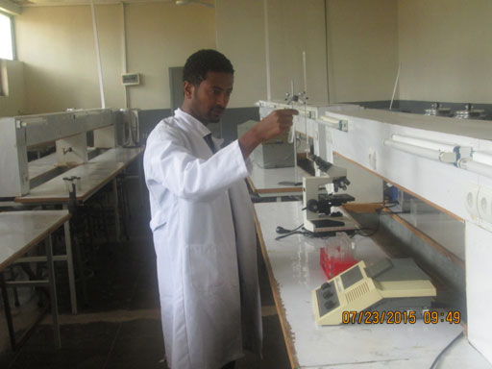
Figure 9.5 A water analyst at work.

9.4.1 Microbial parameters
Drinking water can be contaminated with human or animal faeces, which are a source of pathogenic bacteria, viruses, protozoa and helminths. Measurement of microbial parameters involves the microbiological tests for faecal contamination that you read about in Study Session 2.
- What are the tests widely used to assess faecal contamination?
- The usual tests are for total coliform bacteria, faecal coliform bacteria and E. coli.
Table 9.1 shows the Ethiopian bacteriological standards for drinking water. It includes total coliforms and E. coli, and also mentions total visible colonies of organisms (Figure 9.6) and faecal streptococci. These are additional ways of measuring the microbial contamination of water. For all four parameters shown here the standards state that none should be present in drinking water.
Table 9.1 Bacteriological quality standards for drinking water. (ESA, 2013)
Substance | Maximum permissible level
Total visible organisms, colonies per 1 ml | Must not be detectable
Faecal streptococci per 100 ml | Must not be detectable
E. coli, number per 100 ml | Must not be detectable
Total coliform organisms, number per 100 ml | Must not be detectable
To conduct a visible colony test, a known volume of water is spread on a nutrient layer in a Petri dish. After incubation, colonies of bacteria grow and can be counted. If there are too many colonies to count (as in B) then a diluted sample of the same water should be used (A).
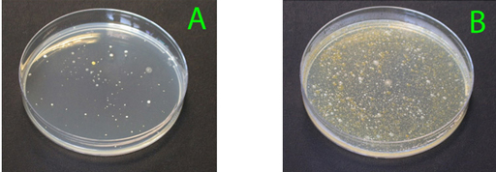
Figure 9.6 Total visible colony test.

9.4.2 Physical parameters
Do you experience a taste while drinking potable water? Water in its natural state is tasteless, odourless and colourless. Although changes in these parameters may have no direct health effects, a slight change will result in consumer dissatisfaction. Important physical characteristics of drinking water quality are listed in Table 9.2.
Table 9.2 Physical parameters of drinking water.
Parameter | Maximum permissible level | Adverse effect
Colour | 15 platinum-cobalt units (PCU)* | Unpleasing appearance
Odour | Not objectionable | Unappealing to drink
Taste | Not objectionable | Unappealing to drink
pH | 6.5–8.5 | High pH imparts taste and soapy feel, low pH causes corrosion.  For effective disinfection pH is preferably <8.0.
Turbidity | 5 nephelometric turbidity units (NTU)** | Visibly cloudy
* In platinum-cobalt units the colour is measured by visual comparison of the sample with platinum-cobalt standards. One unit of colour is that produced by 1 mg of platinum per litre of solution (1 mg/l or 1 mg l^{–1}), in the form of the chloroplatinate ion.
** The nephelometric turbidity unit is a measure of the turbidity of the water.

9.4.3 Chemical parameters
Natural water has different elements and compounds in it due to the ability of water to dissolve many substances. Unlike microbial contaminants, most chemical constituents in drinking water only cause adverse health effects after a prolonged period of exposure. A huge concern is if a massive accidental discharge of chemicals occurs in the drinking water system. Experience has shown, however, that in many such incidents, the water will exhibit changes in appearance, taste and odour that prompt consumers to cease using it. For example, if the residual chlorine level exceeds a certain level, consumers notice the taste and immediately reject the water. Ethiopian chemical quality standards for the usual parameters in drinking water are presented in Table 9.3. So, taking aluminium for example, its quantity in 1 litre of water must not exceed 0.2 mg. There are other components that also have limits, such as pesticides, but these will only be analysed for if a case of contamination by these types of substances is suspected.
Table 9.3 Chemical quality standards of drinking water. (ESA, 2013)
Substance | Maximum permissible level (mg l^{–1}) | Health and other risks associated with high intake
Aluminium | 0.2 | Deposition of aluminium hydroxide flocs in water pipes and exacerbation of discoloration of water by iron
Ammonia | 1.5 | Objectionable (pungent) odour
Arsenic | 0.01 | High incidence of skin and possibly other cancers
Barium | 0.7
Boron | 0.3
Cadmium | 0.003 | The kidney is the main target organ of toxicity
Calcium | 75
Chloride | 250 | Undesirable (salty) taste
Chromium | 0.05 | Carcinogenicity suspected of chromium (VI) compounds
Copper | 2 | Acute toxicity is high; effects on thyroid and particularly the nervous system if long-term exposure occurs
Cyanide | 0.07 | Effects on thyroid and particularly the nervous system if long-term exposure occurs
Fluoride | 1.5 | At low concentration, prevents dental caries; at high (7 mg l^{–1}) concentration, increased risk of dental fluorosis; much higher concentration leads to skeletal fluorosis.
Iron | 0.3 | Causes reddish-brown colour, promotes iron-bacteria growth and stains laundry and plumbing fixtures
Lead | 0.01 | Toxic to both the central and peripheral nervous systems, causing neurological effects
Magnesium | 50
Manganese | 0.5 | Neurotoxicity and other toxic effects
Mercury (total) | 0.001 | The kidney is the main target for inorganic mercury, whereas methyl-mercury mainly affects the central nervous system
Nitrate (as NO₃) | 50 | Causes methaemoglobinaemia in infants and suspected risk of certain forms of cancer
Nitrite (as NO₂) | 3 | Causes methaemoglobinaemia in infants and suspected risk of certain forms of cancer
Potassium | 1.5
Residual chlorine | 0.5
Sodium | 200 | Undesirable taste
Sulphate | 250 | Causes noticeable taste and corrosion of pipes
Total hardness | 300
Total dissolved solids | 1000 | Undesirable taste
Zinc | 5 | Imparts astringent taste and opalescence; develops a greasy film on boiling

Summary of Study Session 9
In Study Session 9, you have learned that:
- Good governance of a water utility encompasses participation of stakeholders, transparency, responsiveness, consensus, equity and inclusiveness, effectiveness, efficiency, accountability and independence.
- Sound financial management is crucial to ensuring an adequate and safe water supply.
- Asset management is the process of operating and maintaining systems, with the objective of cost-effectively providing the best possible service to users.
- Customer complaints should be handled diplomatically and used as a means to rectify flaws in the system.
- There may be complaints that are unresolvable. These may then have to be passed to an independent party for resolution.
- Drinking water standards exist to ensure the safety of water for human consumption, and they encompass microbial, physical and chemical parameters.

Self-Assessment Questions (SAQs) for Study Session 9
Now that you have completed this study session, you can assess how well you have achieved its Learning Outcomes by answering these questions. You can check your answers with the Notes on the Self-Assessment Questions at the end of this Module.

SAQ 9.1 (tests Learning Outcome 9.1)
Write the following words next to their correct definitions in the table below:
asset management, drinking water standards, parameter.
any measurable factor
quality parameters set for drinking water
a process that helps to ensure continuous water supply at minimal cost

SAQ 9.2 (tests Learning Outcome 9.2)
In Column A of the table below you will find a series of statements related to good governance of a water utility. Select the word or phrase from the following list that best applies to each statement and insert it in Column B:
accountable, effective, efficient, equitable and inclusive, independent, obtaining a consensus, participation, responsive, transparent.
Column A | Column B
Rapidly set up an emergency water supply system with road tankers when the mains supply was cut due to construction work
Make sure everything happens with minimal duplication of effort
Operate free from pressure from local businesses and the village chief
Consider the opinions of all the stakeholders in a project to divert a river, and then arrive at a decision that is acceptable to the majority
Explain to a village why its water supply was cut for three days
Everyone comes together to decide on the location of a water tower
Make sure all the villages in a given area are included in a water supply scheme and that each village gets adequate water for all its needs
Allow people to see the paperwork on how a tender was awarded
Choose the right water treatment method to get rid of fluoride

SAQ 9.3 (tests Learning Outcome 9.3)
Which of the following statements are false in relation to asset management in a water utility? Give your reasons for choosing them.
  - Asset management is a process employed solely to ensure water treatment plants operate at their highest efficiency.
  - In asset management we need to ensure that we have sufficient staff and finances for best service delivery.
  - The Asset Management Plan once drawn up does not need changing.
  - Office desks are considered assets in the asset management plan.
  - Good asset management will help reduce loss of water through pipe bursts.

SAQ 9.4 (tests Learning Outcome 9.4)
Arrange the following tasks in the proper sequence for handling a customer complaint:
- Resolve the complaint.
- Document the complaint and how it was resolved.
- Learn from the complaint and rectify any problems.
- Listen to the complaint.
- Understand the issue.

SAQ 9.5 (tests Learning Outcome 9.5)
Identify the chemical water quality parameter(s) that would need to be controlled to prevent each of the following conditions.
Condition | Parameter(s) that need to be controlled
Reddish-brown colour in the water
Methaemoglobinaemia
Skin cancer
Salty taste
Damage to the nervous system
Kidney problems
Corrosion of pipes
An objectionable, pungent odour
Fluorosis

Study Session 10 Household Water Collection, Treatment, Storage and Handling

Introduction
Water utilities are responsible for putting fully treated water into the distribution system, but it can become contaminated after it has left the treatment works if not handled with care. The contamination can originate from several different sources, but it is obviously important to eliminate any introduction of faecal material for health reasons. Research in Sodo woreda, Guraghe Zone, in the Southern Nations, Nationalities and Peoples’ Region (SNNPR) showed that 61% of the water in households was faecally contaminated and for five woredas in Amhara Region the figure was 74% (Kinfegabriel, 2015). These findings demonstrate that safe water collection, treatment and handling at household level are key considerations for potable water availability in the home.
This study session will discuss safe water collection methods and the ways in which water can be treated at household level. It also presents the basic principles of safe water storage and handling in the home.

Learning Outcomes for Study Session 10
When you have studied this session, you should be able to:
10.1 Define and use correctly the key words printed in bold. (SAQ 10.1)
10.2 List the methods by which households can safely collect water for use. (SAQ 10.2)
10.3 Describe the methods by which water can be treated at household level. (SAQ 10.1)
10.4 Describe the options for safe storage of water. (SAQ 10.3)
10.5 Summarise the methods for safe handling of water in the home. (SAQ 10.3)

10.1 Methods of safe household water collection
Households in urban areas that do not have a tap connection in their house or yard will probably collect water from a water point or kiosk. Even where there is a household connection, residents may sometimes need to use other sources, for example if there is a break in supply. In longer-term emergency situations, safe water may be delivered by tanker to residential areas for distribution to householders. In both of these instances, collection vessels such as those shown in Figure 10.1 will be used to carry water to the home.
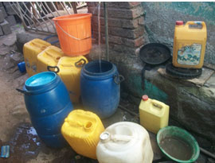
Figure 10.1 Commonly used water collection vessels.
A water container has to be clean, and must not previously have been used to contain any toxic material (such as pesticides). Ideally, the mouth of the vessel should be narrow and it should have a lid. It should have handles so that it can be carried easily.
- Why is it better to have a container with a narrow opening?
- This reduces the chances of contamination because less of the water is exposed. Most importantly, people will not be able to put their hands into the water, which is one of the most likely sources of contamination.
An alternative to the containers shown in Figure 10.1 is the Hippo Water Roller (Figure 10.2), which enables water to be transported more easily and efficiently. It is a 90-litre drum made from UV-stabilised, low-density polyethylene that can be rolled along the ground using a steel clip-on handle. The device is designed to cope with rough surfaces and is very stable in the upright position. The roller is rounded at the shoulders and has hand grips at the top and bottom to make it easier to tilt a full roller when pouring.
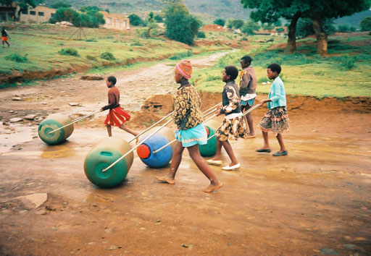
Figure 10.2 Hippo Water Rollers in use.

10.2 Methods of household treatment of water
If there is any doubt about the safety of the water for consumption by the household, it should be treated at home. This does not require expensive equipment. Very often local materials can be used, to keep costs down. Effective water treatment should ensure the removal of all disease-causing agents and reduce the possibility of an outbreak of waterborne disease. There are different methods of household water treatment that can be grouped under sedimentation, filtration and disinfection. These processes are essentially the same as those you met in the large-scale water treatment system described in Study Session 5. The only difference is that in the household they are applied on a smaller scale.

10.2.1 Sedimentation
- What is sedimentation?
- Sedimentation is the removal of suspended solids through the settling of particles.
Just as in the water treatment works, if the water is turbid (muddy), then giving it time to settle (become calm) helps in sedimentation. This process can be assisted by adding a coagulant that encourages the formation of larger, heavier particles (flocculation) that then settle easily to the bottom of the container and make the water clear. At the household level, natural coagulants can be used such as the crushed, dry seeds of the Moringa fruit, shown in Figure 10.3 (Davis and Lambert, 1995). Moringa fruit comes from Moringa trees, which grow in tropical countries
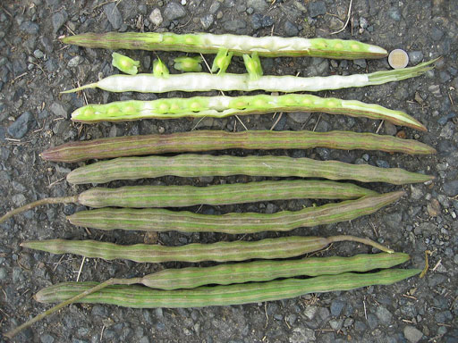
Figure 10.3 Fruits of Moringa oleifera.
- Can you name one of the coagulants used in large-scale water treatment?
- As you learned in Study Session 5, Section 5.2.3, aluminium sulphate and ferric chloride are used as coagulants in large-scale water treatment.
After the suspended particles have settled, the clear water at the top can be carefully poured into another container for further processing. The three-pot method is one method of sedimentation.

The three-pot method
The three-pot method (Figure 10.4) is a means of reducing dirt and micro-organisms in water, by storing the water in a container, allowing the dirt to settle, and moving the cleaner water to different containers over time. Water in a container should be allowed to settle for a day before it is decanted into the next container. Only water from Pot 3 should be consumed. The three-pot system is low-cost, easy to use and is something people can do themselves. However, it does not totally remove disease-causing micro-organisms, so some method of disinfection is still needed to remove the risk of disease completely.
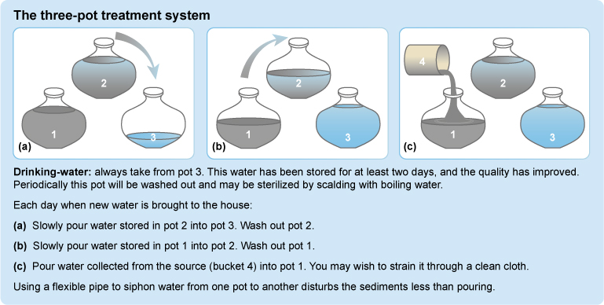
Figure 10.4 The three-pot water treatment system (IFRCRC, 2008).

10.2.2 Filtration
Filtration is another method of removing suspended particles and is also relatively easy. There are several different methods of filtration that can be used in the home.

Cloth filtration
Cloth filtration (Figure 10.5) is cheap, easy to carry out and a common water treatment technique. Pouring turbid water through a piece of fine, clean cotton cloth will remove larger contaminants and a certain amount of suspended solids. It is better to use a used, rather than new, piece of cloth.
- Why do you think a used, washed piece of cloth is better for filtration?
- Once cloth has been washed several times, the gaps between the fibres it is made from are smaller and therefore better for trapping any solid matter.
Figure 10.5 Cloth filtration.
The steps in cloth filtration are as follows:
- Use a large cloth, preferably made of finely-woven cotton. Fold the cloth at least four times so that there are multiple layers of fabric, and place this over the opening of the storage vessel.
- The cloth, once folded, must be big enough to easily cover the opening of the receiving water container.
- Place the cloth over the mouth of the container.
- Fasten the cloth securely around the rim of the opening, using string. If reusing the cloth, always use the same side up each time.
- Pour the water through the cloth, into the container.
- Wash the filter cloth after each use, with a final rinse using cloth-filtered water, and then leave the cloth in the sun until it is dry.
- Clean the cloth regularly using detergent, and use a new piece of cloth as soon as there are any visible tears or holes.
- Always keep filtered water separate from non-filtered water.

Household sand filtration
A household sand filter can usually be made from locally available and inexpensive materials like clay pots or barrels. They are simple and easy to use. One such system consists of a pot and a storage vessel (Figure 10.6).
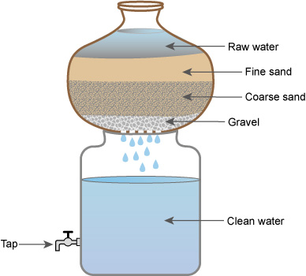
Figure 10.6 A household sand filter system, comprising a pot and a storage vessel.
The details of the system are as follows:
- The bottom of the pot is perforated (has tiny holes in it).
- The pot contains layers of gravel (about 5 cm deep), coarse sand (about 5 cm deep) and fine sand (about 10 cm deep).
- Water is poured in at the top and, as it passes through the layers, any particles within it are filtered out.
- Clean water drips into the storage container.
- The storage container should have a tap to enable the clean water to be drawn out easily and safely.
- The sand and gravel should be changed when the rate of filtration starts to slow; at a minimum it should be changed every two to three months.

Ceramic filtration
For ceramic filtration, a water filter in the form of a ceramic pot can be made using clay, sawdust or rice husks, and a plastic bucket. The pot is made by mixing clay with the sawdust or rice husks, forming it into a flowerpot shape and then firing it in a kiln. The sawdust or rice husks burn away, leaving tiny pores in the ceramic through which water can be filtered. The small pore size of the ceramic material traps the particles and most micro-organisms.
To use the filter, the pot is inserted into a container so that its lip prevents it from slipping into the container (Figure 10.7). The raw water is then poured into the ceramic pot. Cleaned water percolates out of the pot and is collected in the container below. A tap on the container allows water to be drawn out.
The filter is cleaned by gently scrubbing the surface, and it is recommended that the filter be replaced every 1–2 years, as fine cracks not visible to the naked eye may have developed.
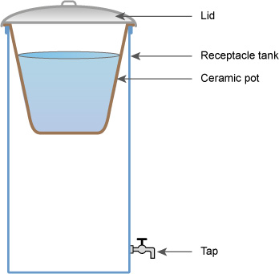
Figure 10.7 Ceramic pot method of water filtration.

10.2.3 Disinfection
Disinfection is the final stage of water treatment in the home. All water treated using one or more of the previous steps will need to be disinfected to ensure that all pathogens are killed. The three common methods of disinfection are described below.

Boiling
Boiling drinking water is a simple way of killing pathogens and is suitable for use at household level. Boiling destroys pathogens such as bacteria and viruses, and any parasite ova (eggs) present in water. The water should be heated until large bubbles come continuously to the surface of the water (referred to as a ‘rolling boil’), for at least 5 minutes. This has been shown to inactivate cholera and Shigella organisms (Luff and Clarke, 2006). If the location of the site is at a high elevation (as in Addis Ababa) the water should be boiled for longer. Boiling will make the water taste flat but this can be remedied by shaking the water in a clean bottle, or by adding a pinch of salt to one litre of water. If the water is turbid with particles, it should be filtered before boiling. Water should be boiled, cooled and stored, all in the one container and consumed within 24 hours to prevent re-contamination.
- Can you think of disadvantages associated with boiling?
- Fuel has to be obtained, and scalding accidents can occur if people are careless. But it is still the simplest way of ensuring that water is safe to drink.

Solar disinfection (SODIS)
Solar disinfection, known as SODIS, is a water treatment method that uses ultraviolet (UV) radiation and high temperature from the sun to destroy micro-organisms in water. The technique requires only some clear plastic bottles (without labels) and sunlight (Figure 10.8).
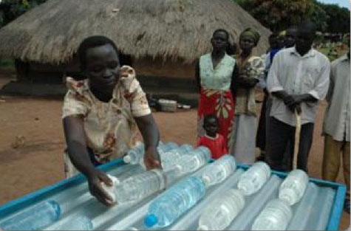
Figure 10.8 Plastic bottles full of water being laid out in the sun for disinfection.
The steps to take for SODIS are shown in Figure 10.9. In Step 5, the bottles are placed on a corrugated iron sheet (often used as roofing material) which is painted black so that it retains heat from the sun, speeding up the rate of heating of the water.
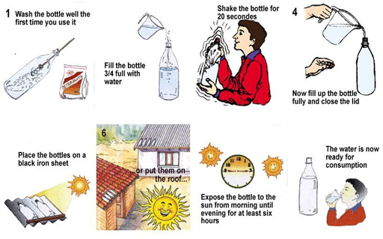
Figure 10.9 The procedure for solar disinfection of water (SODIS).

Chemical disinfection using chlorine
Chlorine solution, also known as sodium hypochlorite or bleach, is the most affordable and widely available chemical for household water treatment. Typically the procedure is to add a capful of chlorine solution to water in a 20–25 litre storage container, then stir and wait for 30 minutes. As you learned in Study Session 5, this period of time is referred to as the contact time. After this, the water can be used.
Chlorination is effective if the water is not turbid. If the water is turbid, micro-organisms can shelter within the particles and escape the effect of the chlorine. Solids should therefore first be removed by sedimentation or filtration. It is important that some residual chlorine remains in the water at the time it is used, so that it stays safe to drink. A minimum concentration of 0.5 mg l^{–1} is recommended; this will kill any organism that enters the water later.

10.3 Household water treatment using commercial products
One example you may be familiar with is Wuha Agar, a commercial product available in Ethiopia for household water treatment. It is a chlorine-based solution used for disinfection, as described above. There are several others.

10.3.1 Bishan Gari Water Purifier
The Bishan Gari Water Purifier (Figure 10.10) is a combined coagulant–flocculant–disinfectant powder mixture produced in Ethiopia for water treatment. Bishan Gari comes in a 2.5-g sachet, which is used to treat 20 litres of water. The sachet contains aluminium sulphate as coagulant and a flocculant for reducing turbidity, and calcium hypochlorite as a disinfectant to kill bacteria and viruses.
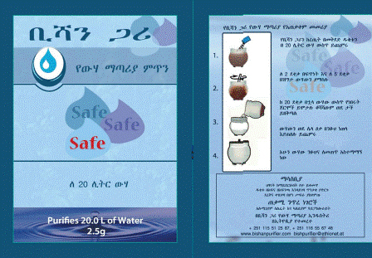
Figure 10.10 A Bishan Gari sachet.
The directions for using Bishan Gari powder are as follows:
- Put 20 litres of raw water into a clean bucket.
- Open the Bishan Gari sachet and add the contents to the bucket.
- Stir rapidly with a stick for 2 minutes (to disperse the chemicals) and then stir slowly for an additional 3–4 minutes (to help the solid particles come together to form larger particles or flocs).
- Wait for at least 20 minutes for the flocs to settle and the micro-organism to die. The longer you wait, the clearer the treated water will be.
- Strain the water through a thick cotton cloth into a safe water storage container, from which it can be consumed.
- Dispose of the material that settles at the bottom of the bucket by burying it.

10.3.2 Aquatabs
Aquatabs is the brand name of a solid form of sodium dichloroisocyanurate (NaDCC), a disinfectant. The tablets (Figure 10.11), which have to be imported, are easier than bleach to store, handle and transport. One tablet contains 67 mg of NaDCC and can treat 20 litres of clear water. The tablet has to be dissolved in the water by vigorous mixing, and a contact time of 30 minutes is necessary. If the water is turbid, two tablets will be needed.

10.3.3 P&G Purifier of water
P&G Purifier of Water is the brand name of a combined coagulant, flocculant and disinfectant product produced by Procter & Gamble (Figure 10.12), which is imported into Ethiopia. The coagulant/flocculant is ferrous sulphate and the disinfectant is calcium hypochlorite. It can be used to treat raw source waters with a wide range of turbidity and pathogen load. This water treatment chemical allows flocculation to take place and helps to remove Giardia and Cryptosporidium cysts that are resistant to chlorine disinfection. (A cyst is a dormant stage in the life cycle of some protozoa and bacteria that is resistant to adverse environmental conditions and therefore difficult to destroy.) P&G Purifier of Water comes in sachets and one sachet is needed to treat 10 litres of water.
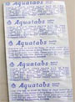 | 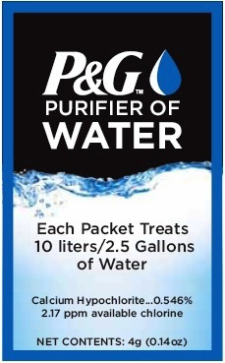
Figure 10.11 Aquatabs tablets for household water treatment. | Figure 10.12 P&G Purifier of Water.
The procedure for using P&G Purifier of Water is illustrated in Figure 10.13.
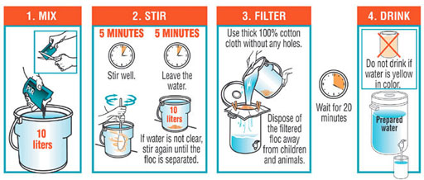
Figure 10.13 How to use P&G Purifier of Water.

10.4 Safe storage and handling of water in the home
The most desirable specification for a water storage vessel for households is that it:
- has a capacity of between 10 and 25 litres, is rectangular or cylindrical with a flat base and has one or more handles, for portability, stability and ease of storage
- is made of lightweight, oxidation-resistant plastic (so that it does not deteriorate with time), such as high-density polyethylene or polypropylene, for durability and shock resistance
- is opaque to prevent the growth of algae
- is fitted with a screw-cap opening that is wide enough to facilitate cleaning but small enough to discourage or prevent the introduction of hands or dipping utensils
- is fitted with a durable tap for dispensing water so that human contact with the stored water is impossible (Figure 10.14).
- Why is the recommended upper limit for the water storage vessel 25 litres?
- The weight of 25 litres of water is 25 kg. This is just about manageable for an adult to lift.
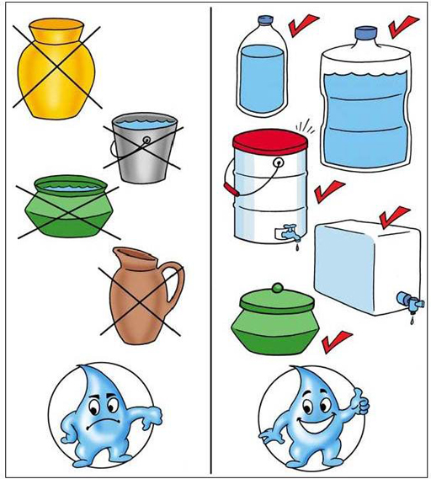
Figure 10.14 Containers for poor handling (left) and safe handling (right) of water.
Having collected, transported, treated and stored the water, households have to handle the water carefully so that it does not become contaminated. It is essential that hands are not put into the treated water. The best option is to use a tap. If the container does not have a tap, and the container has a narrow neck, the water can be poured out carefully. If the container has a wide neck, a long-handled ladle (Figure 10.15) should be used to take the water out of the container. This is preferable to using a mug or jug, because hands can inadvertently contaminate the water.
Figure 10.15 A long-handled ladle for taking water from a container.

Summary of Study Session 10
In Study Session 10 you have learned that:
- Households may have to collect their own water if there is no water distribution system to take water to individual houses. They may also have to do this if there is a water emergency and water is distributed by tankers.
- A container used to collect the water must be clean and must not have previously held any toxic compounds. It should have a narrow mouth, a lid, and handles for portability. An easy option is to use the Hippo Water Roller.
- Household water treatment is needed if the safety of the water for human consumption is in any doubt.
- Removal of suspended particles is the first step in household water treatment. This can be done by sedimentation, for example by using the three-pot method.
- The crushed seeds of the Moringa fruit can be used as a natural coagulant, to aid sedimentation of solids.
- Filtration (for example, by using cloth, a household sand filter, or a ceramic filter) is also a way to remove suspended particles.
- Disinfection (for example, by boiling or using solar energy) eliminates pathogenic (disease-causing) micro-organisms from the water.
- Water treatment chemicals such as Wuha Agar, Bishan Gari, Aquatabs and P&G Purifier of Water can also be used for household water treatment.
- The ideal household storage container for treated water is made of lightweight, oxidation-resistant, opaque plastic, with a screw-cap opening for ease of cleaning, handles for portability and a tap to eliminate human contact with the water inside the container. When handling treated water, a tap or a long-handled ladle should be used.

Self-Assessment Questions for Study Session 10
Now that you have completed this study session, you can assess how well you have achieved its Learning Outcomes by answering these questions. You can check your answers with the Notes on the Self-Assessment Questions at the end of this Module.

SAQ 10.1 (tests Learning Outcomes 10.1 and 10.3)
This SAQ is based on key words you have come across in earlier study sessions as well as this one.
Kedir Seid, a Senior Environmental Health Officer, has been informed that there has been an emergency regarding the water supply in his town. The main pipeline has been breached by an excavator at a construction site and mud has been drawn into the water supply. The muddy water is now reaching 2000 homes. Kedir puts together a leaflet to tell people what to do with the muddy water to make it safe to use. Help him in this task by inserting the correct words (from the selection given below) into the gaps in his message:
a cloth, Bishan Gari, boiling the water, ceramic filtration, clear plastic bottles, coagulants, contact time, disinfected, filtration, five, household sand filter, Moringa fruit, pathogenic, sedimentation, settle out the mud, six, solar disinfection, three-pot method, two, Wuha Agar.
Dear Householders,
The water supply is presently muddy due to an accidental breakage of the main water line. Do not worry. We have ways of making the water safe. The first thing to do is to ……………… This can be done by a process called ……………… To encourage this, we can use ……………… The crushed seeds of the ……………… can be used as a natural coagulant. If many containers are available in your household, the ……………… is an option. In this method, the water is settled for at least ……………… days before consumption. Another way to get rid of the mud is by ……………… The simplest way is to use ……………… If you have time, you can make your own ……………… using a pot and a container, sand and gravel. A third option is to use ……………… but this involves setting up a new system that is more costly than the two mentioned just now.
Now, after sedimentation or filtration the water will look clean – but it probably isn’t, because of micro-organisms that may be present. To get rid of any ……………… micro-organisms, the water has to be ……………… Perhaps the easiest, most effective and fastest way of doing this is by ……………… In a city like Addis Ababa, which is at high altitude, we need to boil the water for ……………… minutes. If we do not have fuel at hand, or want to save fuel, we can use ……………… For this we need to put the water into ………………, with their labels removed, and expose it to sunlight for ……………… hours. Another way is to use Aquatabs, which require a ……………… of 30 minutes.
We will do our best to repair the pipe as soon as possible but if we can’t, we will deliver water treatment chemicals like ……………… and sachets of ……………… to you. With these we will send technicians to give guidance on how they are to be used.
With best wishes,
Yours sincerely,
Kedir Seid
(Senior Environmental Health Officer)

SAQ 10.2 (tests Learning Outcome 10.2)
An emergency has occurred with the water supply and a tanker is coming to your area to distribute water to the residents. If you were an Environmental Health Officer, what advice would you give the residents as to the best type of container to use to collect the water?

SAQ 10.3 (tests Learning Outcomes 10.4 and 10.5)
Which of the following statements are false? In each case, explain your answer.
- Any opaque plastic container will be satisfactory for storing water at home because, unlike metal, it will not rust.
- It is best to have a container that holds a maximum of 25 litres, as that can be easily carried.
- The water storage container should have a very narrow opening so that no contaminants can get in.
- A tap is an ideal way of keeping stored water safe from contamination.
- If the water is stored in a wide-necked container without a tap, and a long-handled ladle is not available, a mug can be used to take the water out.

Study Session 11 Efficient Use of Water

Introduction
Efficient use of water means using only the amount of water required for a given task without any water going to waste. Using water efficiently results in water being conserved. It also results in savings in energy and chemical use, since less treated water has to be put into the water distribution system. In this study session you will look at efficiency in water use, and also consider alternative sources of water (such as rainwater and treated sewage) for non-drinking purposes such as irrigation.

Learning Outcomes for Study Session 11
When you have studied this session, you should be able to:
11.1 Define and use correctly all of the key words printed in bold. (SAQ 11.1)
11.2 Describe the technical options for minimising the use of drinking water. (SAQ 11.2)
11.3 Outline how rainwater can be collected and used. (SAQ 11.3)
11.4 Describe how sewage can be treated and used safely so that water is conserved. (SAQ 11.4)

11.1 Why do we need to use water efficiently?
Water is a precious resource and has to be conserved in order that future, increased water demands due to population and industrial growth (as is happening in Ethiopia) can be satisfied. Increasing economic prosperity also results in higher water use per person. As people become more affluent and have a piped water connection in their home, they are likely to purchase and use more domestic appliances that require significant quantities of water, such as washing machines and dishwashers. Personal bathing also tends to increase and people shower more frequently. Increasing demand means that more water will need to be supplied, bringing with it the costs and challenges of developing new water sources.
There are other costs to consider. Producing drinking water in water treatment plants requires significant inputs of energy and chemicals, so saving on water use will also save energy and chemicals.
- How are energy and chemicals used in drinking water treatment?
- You may recall from Study Session 5 that energy is used to pump raw (untreated) water to the treatment plant. Energy is used in the various treatment units at the plant, and finally energy is used to pump the treated water into the distribution system.
Chemicals such as aluminium sulphate and ferric chloride are used as coagulants, and chlorine is used as a disinfectant.
The water produced by the plant is treated so that it is clean and safe for drinking and cooking with but, as you know, it is also used for many other purposes, some of which do not need water to be of potable quality. It makes sense to avoid using fully treated drinking water for purposes that do not need it. It is also important to note that using less water has economic benefits for consumers, since their water bills will be lower!

11.1.1 Technical options for minimising drinking water use
Publicity campaigns to encourage people to use water sparingly are undertaken by water utilities. Flyers are distributed to customers, and radio and television are used to disseminate the message of water conservation. In Tigray, the motto is ‘Value every drop of water!’ Ways of using less water are constantly being found and Table 11.1 lists some that apply to the home.
Table 11.1 Ways of conserving drinking water from the piped supply within the home.
Advice | Notes
Fix leaking taps by replacing the washers. | A dripping trap can waste about 13 litres of water a day.
Never let the water run while brushing teeth, face washing, shaving, etc. | Leaving the tap running can waste up to 9 litres of water a minute.
Install aerator nozzles on taps (Figure 11.1).  Figure 11.1 An aerator nozzle for a tap. | These draw air into the water flow and reduce water consumption by 10–20%.
Install aerated showerheads (Figure 11.2).  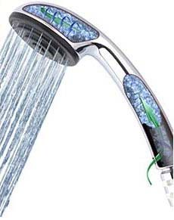  Figure 11.2 A water-saving aerated shower-head. | These pull air into the water flow and discharge 8 litres of water a minute (because the air replaces some of the water), compared to 12 litres a minute in a standard showerhead.
Use water-economical washing machines and use them only with a full load.  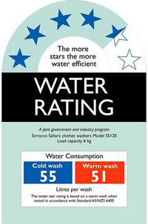  Figure 11.3 Label indicating water use by the appliance. | Labels indicate the water usage efficiency of washing machines (Figure 11.3).
Install water-efficient dual-flush toilet cisterns where possible.  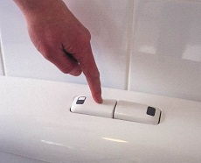  Figure 11.4 The buttons on a dual-flush toilet cistern. | Dual-flush cisterns have two buttons (Figure 11.4). If there is faecal matter to be flushed away, the right-hand button is pressed; this will use 6 litres of water to take away the faecal matter. If urine only is to be disposed of, the left-hand button is pressed; this uses 4 litres of water to take the waste away.
In older toilet cisterns, put one or two 1-litre plastic bottles filled with sand inside. | This reduces the flush volume by displacing the volume of bottles from the cistern, thereby reducing its effective capacity.
Use rainwater for toilet flushing, and for watering plants. | Rainwater can be collected from the roof, filtered and stored in a tank.
Use greywater (used water from showers and sinks that is not faecally contaminated) for toilet flushing or watering the garden. | The water should be filtered and disinfected before use.
Water garden plants and vegetable plots early in the morning or late in the evening. | This reduces the amount of water lost through evaporation.
Many water-saving measures are simple and inexpensive to carry out (for example, fixing a leaking tap). Others (such as buying and fitting an aerated showerhead) cost money, but the savings made by using less water make these worthwhile.

11.2 Using rainwater
Rainwater offers a relatively clean source of water for numerous uses. Normally rainwater can be considered clean but if the air is polluted with chemicals or particles (for example, in an industrial area), it can become contaminated. It can also pick up contaminants from roofs and gutters.
Where water is very scarce and there is no safe alternative source, rainwater harvesting provides households with the water they use for all their domestic purposes. If the water is used for drinking and cooking, it should be treated using one or more of the methods described in Study Session 10. Some families may use rainwater directly without treatment because they do not have treatment facilities – but this is not recommended, as the water could be unsafe.
- What are some of the ways in which rainwater is harvested?
- From Study Session 3 you know that rainwater can be collected by roof catchments, ground catchments and sand dams.
People in urban areas are less likely to have to use rainwater for their basic needs but it can still provide a useful source for numerous purposes in the home. Devi et al. (2012), in research undertaken in rural and urban areas (Guma, Gambe, Suntu, Jimma and Daraba) in Oromia Region, found that rainwater was harvested and used for house cleaning, utensil cleaning, vehicle cleaning, washing clothes, bathing, giving to animals and watering plants. A total of 2050 people were interviewed and about 30% of those from rural areas used rainwater for drinking. The rainwater was collected from tin roofs in urban areas and thatched roofs in rural areas, and led into a collection tank. Rainwater was also harvested from surface run-off on the ground and stored in small storage reservoirs.
The researchers found that rainwater harvested from tin roofs, if disinfected, would be within the WHO guidelines for drinking water, while the rainwater from thatched roofs was not suitable for drinking. They calculated that a house with a tin roof area of 100 m² could collect 126,000 litres in the rainy season, which would be twice the water requirement for a family of five, for a year.
- If 126,000 litres of rainwater is enough for twice the water requirements of a family of five for a year, what is the daily water usage of each person used in the calculation?
- It would be $\frac{126,000}{(2×5×365)}=34.5 litres$.
In urban areas, where space is more limited, roof collection is probably the only feasible method of rainwater harvesting. The recommended practice for roof collection is to let the first 15 to 20 minutes of the rain drain away, and then collect the water.
- Why is it advisable to avoid using the first few litres of rain, especially after a dry period?
- The first few litres of rainwater from a roof may contain contaminants from the roofing material, or from substances (such as dust, leaves and bird droppings) that have accumulated on the roof or in the gutter.
The diversion can be done automatically using proprietary devices like the one in Figure 11.5.
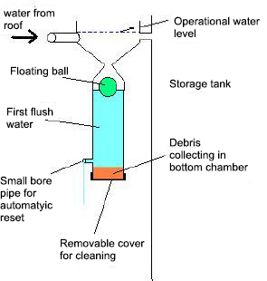
Figure 11.5 The floating ball first flush system.
In the floating ball first flush system, when the rain starts to fall it accumulates together with any debris in a chamber with a conical top. As the chamber fills, a ball floats on the surface of the collected water and eventually becomes stuck in the conical chamber entrance, blocking the bottom chamber and therefore redirecting subsequent collected rainwater into the main clean rainwater storage tank. This storage tank should have a tight-fitting lid that prevents sunlight from entering and encouraging algal growth, and also prevents entry of mosquitoes.
A small-bore pipe is used to slowly drain the water from the lower chamber of the floating ball first flush system, to automatically reset the device. A tap can be used if water is at a premium, since water dribbles out continuously when it is raining.

11.3 Treating sewage for reuse
A lot of water is used for purposes where high-quality drinking water is not necessary.
- Can you think of water uses where the quality does not have to be of drinking water standard?
- You may have thought of the washing of outdoor areas (like the house yard), washing of vehicles and gardening, but you could have mentioned anything that does not involve ingestion of the water.
One of the biggest uses of water is in irrigation, not only for food crops but also for landscaping schemes in cities like Addis Ababa (Figure 11.6). For uses such as these, it is possible to use treated sewage effluent to water plants, if this is available. Sewage treatment can be an economical process using a simple system of ponds called waste stabilisation ponds, which are described below. (Note that reuse of the water is only feasible for fully treated sewage; septic tank discharge should not be used in this way.) In Ethiopia the opportunities for reusing treated sewage effluent may be limited at the moment, but future changes could see more sewage treatment systems, which would increase the potential.

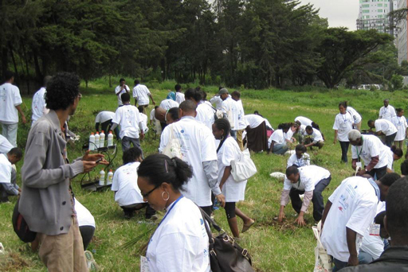
Figure 11.6 Volunteers planting trees in Addis Ababa, on World Environment Day, 5 June 2013.

11.3.1 Waste stabilisation ponds
Waste stabilisation ponds are natural or constructed ponds used for treating sewage or other wastewaters biologically by harnessing the power of sunlight and wind. They are therefore ideal for tropical countries, and in Ethiopia there is such a system at Kality, treating the sewage from Addis Ababa.
In a typical waste stabilisation pond system, effluent that has passed through a screen is sent through a series of ponds with a total retention time of 10–50 days. (The retention time, in this context, is the length of time the effluent stays in the ponds.) No mechanical equipment is used in the ponds, so operation and maintenance costs are very low. Figure 11.7 shows a typical layout for a waste stabilisation pond system treating domestic sewage.
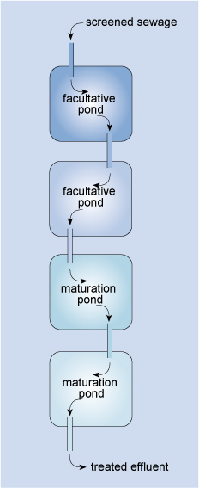
Figure 11.7 Layout of a waste stabilisation pond system for treating domestic wastewater.
Bacteria in the ponds oxidise the pollutants and work symbiotically with algae, which provide oxygen through photosynthesis. (A symbiotic relationship means two types of living organisms live together for their mutual benefit. In this case, the algae produce the oxygen that the bacteria need, and the bacteria produce carbon dioxide and release ammonia and phosphate that the algae consume.)
Oxygenation also occurs through the action of wind, and by diffusion. Diffusion is the movement of a substance from a region of high concentration to one of low concentration. In the present context it means the movement of oxygen from the air, where it makes up 21% of the composition, to the water, where it is in low concentration.)
The major part of the biodegradation of the sewage (the breaking down of complex substances in sewage into simpler compounds, by micro-organisms) takes place in the facultative ponds (Figure 11.7). These are ponds in which the upper portion is aerobic and the lower portion is anaerobic. Facultative ponds are 1–1.5 m deep, with a retention time of 5 to 30 days. Solids settle to the bottom and are anaerobically digested by bacteria, so that sludge removal is rarely needed.
Maturation ponds are ponds placed after facultative ponds, for the purpose of pathogen reduction. They are usually 0.5–1.5 m deep, with a retention time of 15 to 20 days. The ponds serve to inactivate pathogenic bacteria and viruses through the action of UV radiation from sunlight and by the greater algal activity in these shallow ponds, which raises the pH to above 8.5 (when pathogens are rapidly killed off). The long retention time in each of the ponds also enhances the sedimentation of eggs of intestinal nematodes (parasitic worms).
To prevent sewage from leaching away, and to preserve the effluent for reuse later, the ponds should have a liner. This can be made of clay, asphalt, compacted earth, or any other impervious material (material that does not let anything through). To prevent run-off from entering the ponds, and to prevent erosion, a protective, raised earth barrier can be constructed around the ponds using the excavated material from their construction. A fence is needed to keep people and animals out (Tilley et al., 2014).
Any scum that builds up on the surface of the facultative and maturation ponds should be removed to allow sunlight to reach all the algae, and also to increase surface aeration. Large plants that are present in the water should be removed.
A further benefit of waste stabilisation ponds is that at the same time as treating wastewater, they can be used to increase protein production through the rearing of fish (such as Tilapia) and ducks in the maturation ponds.
Figure 11.8 shows part of waste stabilisation pond system.
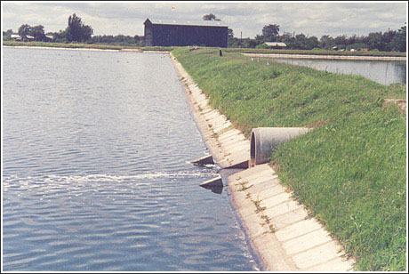
Figure 11.8 Part of a waste stabilisation pond system in Tanzania.
Waste stabilisation ponds are especially efficient in hot climates. Although they require large areas of land, this need can be satisfied by locating the ponds at the outer perimeter of cities or on disused land. At the Kality waste stabilisation ponds on the outskirts of Addis Ababa, the system consists of one facultative pond and three maturation ponds, with a total retention time of 28 days. In an evaluation of Addis Ababa’s sewage treatment system in 2010, Dagne found that an average of 83.6% of the organic pollutants was removed by the process.

11.3.2 Health protection measures
The critical parameter for assessing the suitability of using the effluent from waste stabilisation ponds for irrigation is microbiological analysis for the presence of pathogens. Treated effluent can be reused in crop irrigation if safe limits of faecal coliforms and intestinal parasites are achieved in the treatment process. The World Health Organization (2006) addresses this in Wastewater Use in Agriculture, Volume 2 of its Guidelines for the Safe Use of Wastewater, Excreta and Greywater. An important consideration is the type of crop that is being grown. If it meets specified standards, wastewater can be used to irrigate crops that are not eaten raw. This is called ‘restricted irrigation’ and includes non-food crops (such as cotton or oilseed), food crops that are processed before consumption (such as coffee or wheat), and crops that have to be cooked (such as rice or potatoes). For this type of crop, the WHO has specified that the level of faecal coliforms should not exceed 10⁵ per 100 ml of treated effluent, and there should be no more than one intestinal nematode egg in 1 litre of treated effluent (WHO, 2006). (If children under the age of 15 are exposed to the treated effluent, for example by working or playing in fields irrigated with treated effluent, the limit for intestinal nematode eggs becomes stricter at one egg per 10 litres of treated effluent).
Another important consideration is the type of irrigation. If spray irrigation is used, there should be a buffer zone of 50–100 m between the irrigated fields and any nearby houses and roads, so that local people are not affected by airborne wastewater. In Ethiopia, flood irrigation or furrow irrigation is common; this is where farmers flow water down small trenches running through their crops (Figure 11.9). In this situation, the possibility of human contact with treated effluent is high.
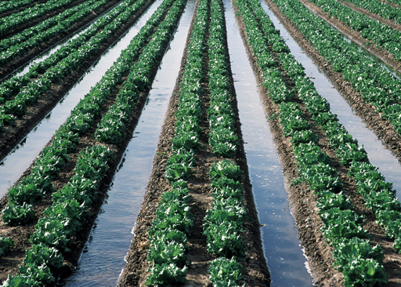
Figure 11.9 Furrow irrigation, where there is a high chance of farmers coming into contact with the water used.
In all situations, anyone who comes into contact with untreated or treated effluent should wear appropriate protective clothing, including gloves and boots. After working at the ponds, or after working on the irrigation of crops, people should wash themselves thoroughly. While the ponds may be designed for the production of water safe for irrigation, it is best to be safe and avoid all direct contact with the effluent.

Summary of Study Session 11
In Study Session 11, you have learned that:
- There are several ways of minimising the use of drinking water. In doing so, we save not only water but also energy and chemical usage.
- Rainwater can be collected and used in a variety of ways, after the first flush is discarded.
- Rainwater can be used for drinking if it is filtered and disinfected.
- Treated sewage can be an important resource for use in irrigation.
- In Ethiopia, waste stabilisation ponds offer an economical way of treating sewage for reuse.
- Waste stabilisation ponds can be used to farm fish and ducks, for food.
- Safety measures are needed when working with treated effluent.

Self-Assessment Questions (SAQs) for Study Session 11
Now that you have completed this study session, you can assess how well you have achieved its Learning Outcomes by answering these questions. You can check your answers with the Notes on the Self-Assessment Questions at the end of this Module.

SAQ 11.1 (tests Learning Outcome 11.1)
Write the following words next to their correct definitions in the table below:
biodegradation, diffusion, facultative ponds, impervious material, maturation ponds, retention time, symbiotic relationship, waste stabilisation ponds.
the breaking down of complex materials by micro-organisms
a relationship where two parties live together for mutual benefit
a system of ponds using sunlight and wind to treat wastewater
the time that the effluent spends in an environment
ponds that have oxygen at the top and are without oxygen at the bottom
ponds in which the pathogenic bacteria and viruses in an effluent are eliminated
material that does not let anything pass through it
the process by which something moves naturally from a region of high concentration to one of low concentration

SAQ 11.2 (tests Learning Outcome 11.2)
- Zewedu, a pensioner, asks you to help him with ideas on how to reduce his water bill. He does not want to spend money to change his old flush system. Are there ways he can use less water?
- Adina and her husband Abenet live in a flat in Dolo Odo. Abenet has bought an aerator fitting for their kitchen tap. If the water use through their kitchen tap is 65 litres a day, what is the maximum saving in water use that they can expect?

SAQ 11.3 (tests Learning Outcome 11.3)
Select the false statement from those below, and give the reason why it is false.
- Rainwater can be contaminated due to pollutants in the air.
- The roofing material can also add pollutants to the rainwater that is collected from a roof.
- It is important to let the first five litres of rainwater from roofs go into the drain.
- Rainwater, after sand filtration, is safe for humans to drink.
- Untreated rainwater can be used for any purpose that does not involve ingestion by humans.

SAQ 11.4 (tests Learning Outcome 11.4)
The five statements below are on waste stabilisation ponds. Select the statements that are false and give the reasons why they are so.
- Bacteria and algae are both present in the ponds.
- The algae in the ponds survive by eating the bacteria.
- The ponds need a lot of land but their operation and maintenance costs are low.
- The only safety measure needed is to ensure that the treated effluent is used only for non-food crops or for crops that have to be cooked before consumption.
- In terms of food production, the only benefit of waste stabilisation ponds is that the treated water can be used for irrigation.

Study Session 12 Monitoring Drinking Water Quality

Introduction
The inspection of water sources and monitoring how water is managed at household level are important practices in assuring drinking water quality. In this study session you consider what this involves for the sanitary technician undertaking the task. Inspections around river water abstraction points, aspects of rainwater collection and storage, and water management in the home are described, as are water sampling and the enforcement of regulations.

Learning Outcomes for Study Session 12
When you have studied this session, you should be able to:
12.1 Define and use correctly all of the key words printed in bold. (SAQ 12.1)
12.2 Describe the methods used in the sanitary inspection of water sources. (SAQ 12.2)
12.3 List the steps involved in sampling water from different sources, distribution systems and delivery points. (SAQ 12.3)
12.4 Explain how existing regulations are enforced. (SAQ 12.4).

12.1 Inspection procedures
In Study Session 8, on Water Safety Plans, you learned how important it was to identify the hazards in a water supply system and to carry out a risk assessment so that control measures could be put in place to protect water quality. In this study session you focus on sanitary inspections as a means of identifying the hazards at a water source. Doing this at source is the most effective way of safeguarding consumers. A sanitary inspection (in this context) is a survey of the surroundings of a water source to identify possible health hazards and sources of pollution. Unlike in the development of a Water Safety Plan, sanitary inspections can be undertaken by individuals, often called sanitary technicians, who consider the water source, the sources of contaminants, and water handling by household members. Information is gathered by observation and by making enquiries of the residents and household members living near to the water sources. Sanitary inspections, sometimes referred to as ‘sanitary surveys’, play a vital part in preventing contamination of water supply systems.
One factor to consider is the time of year. The season will affect the quality of water sources. For instance, during the rainy season, rainwater run-off is likely to carry pollutants such as faecal matter from the surface of the ground into rivers. The pollutants may also be carried into groundwater by water percolating into the ground and thus lead to contamination of well and spring waters.

12.1.1 Duties of a sanitary technician
Carrying out inspections, recording data and, importantly, any follow-up with further analysis are important functions of the sanitary technician. In many parts of the world, the sanitary technician reports to a District Water Surveillance Coordinator or similar position. The duties of a sanitary technician in Ethiopia might include the following:
- carrying out routine (for instance, weekly) monitoring of water sources and distribution systems
- checking and recording chlorine residuals on the spot, and sampling from sites showing low levels (such as 0.1 mg l^{–1} free chlorine) for bacteriological analysis
- transporting samples to the appropriate laboratory
- entering analytical results in surveillance reports and submitting weekly reports to the District Water Surveillance Coordinator
- informing the Water Surveillance Coordinator of high-risk zones – such as those where water pressure is low, leakage high, the results of bacteriological tests bad or standpipes are used – as soon as they are identified, and indicating by appropriate means any advice to be given to the community in an emergency
- intensifying the monitoring of high-risk water supply zones
- carrying out special sampling programmes in peri-urban and urban areas unserved by piped systems and preparing reports on them
- periodically providing samples to the provincial laboratory for chemical analysis and obtaining the results for inclusion in the district archive
- maintaining a register of all major sources of pollution of water resources and carrying out periodic inspections of these resources
- taking samples of water from urban water sources and sending them to the appropriate laboratory for full analysis
- keeping and updating an inventory of all water sources and their location, together with a sanitation inventory
- preparing a monthly summary of all sanitary inspections, including the advice provided on remedial action, and sending this summary to the District Water Surveillance Coordinator
- notifying the District Water Surveillance Coordinator of high-risk facilities, and requesting support from them for follow-up inspection and analysis.
There need to be standard procedures for carrying out sanitary inspections. In this study session you will consider three selected examples from WHO guidance to illustrate the principles and the sort of questions that are involved.

12.2 Inspection of an abstraction point at a river
In Study Session 3 you considered the different types of water sources and learned the significance of the term ‘protected’.
- What is a protected water source?
- It is a water source that has structures to prevent the entry of physical, chemical and biological contaminants.
You have learned about the different ways in which wells, boreholes and springs can be protected. Surface waters, on the other hand, are difficult to protect because run-off can wash pollutants (such as faecal matter) off the surface of the ground and take it into rivers and lakes. Activities in a given catchment are difficult to control and so substances such as pesticides and fertilisers used by farmers, and other activities such as washing clothes and even vehicles in a river or lake, can contribute to pollution of these water sources. A sanitary inspection can identify the sources of pollution so that protective measures may be implemented.
For many towns and cities the water supply originates from a river, usually several kilometres from the town or city centre. Figure 12.1 depicts a river water abstraction point, with a filter to pre-treat the water before it is pumped away for fuller treatment. The abstraction point should have a fence to keep people and animals away. The figure shows what a technician should be looking for when undertaking a sanitary inspection, and Box 12.1 gives a checklist of questions to consider. The numbers in the figure demonstrate particular points and correspond to questions in the checklist. The number of ‘Yes’ answers to the questions indicates the risk of contamination.
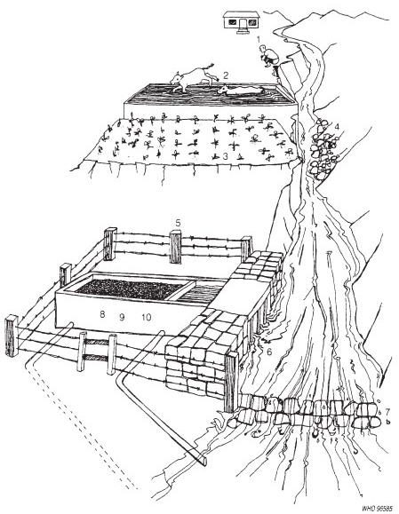
Figure 12.1 Sanitary inspection of an abstraction point at a river. (WHO, 1997)

Box 12.1 Example checklist for inspection of an abstraction point at a river
- Is there any human habitation upstream, polluting the source? Yes/No
- Are there any farm animals upstream, polluting the source? Yes/No
- Is there any crop production or industrial pollution upstream? Yes/No
- Is there a risk of landslide or mudflow (caused by deforestation) in the catchment area? Yes/No
- Is the intake installation unfenced? Yes/No
- Is the intake unscreened? Yes/No
- Does the abstraction point lack a device such as a dam so that water flows into the box at 8? Yes/No
- Does the system require a sand or gravel filter because the water is silt-laden and can affect water treatment? Yes/No
- If there is a filter, is it functioning badly? Yes/No
- Is the flow uncontrolled? Yes/No
Total number of ‘Yes’ answers = contamination risk score:
9–10 = very high
6–8 = high
3–5 = intermediate
0–2 = low.
Name ______________________
Signature ______________________
Date ______________________

12.3 Sanitary inspection of rainwater collection and storage
As you learned in Study Session 3, rainwater harvesting is appropriate for areas that have a shortage of water sources. It is also practised in urban areas in institutions such as health centres and schools, and in domestic dwellings. While rainwater can be collected through ground catchments and stored in ponds or sand dams (see Section 3.5, in Study Session 3), here you will focus on sanitary inspections of roof catchments.
Rainwater is usually clean, unless the air is polluted by particles or chemicals, which can contaminate the rainwater. These contaminants may be unimportant, however, if the rainwater is used for purposes other than drinking or cooking.
- What uses might there be for rainwater in towns, other than for drinking or cooking?
- House cleaning, utensil cleaning, vehicle cleaning, washing clothes, bathing and watering plants.
The roof from which rain is collected should be free from contaminants. There also needs to be a clean and well-constructed tank, with no cracks in the sides and an inspection hole with a cover. Figure 12.2 shows what you should look for if you are carrying out a sanitary inspection of rainwater collection, and Box 12.2 has a list of questions to be asked. As before, the numbers in the diagram demonstrate particular points and correspond to the checklist of questions in the box.
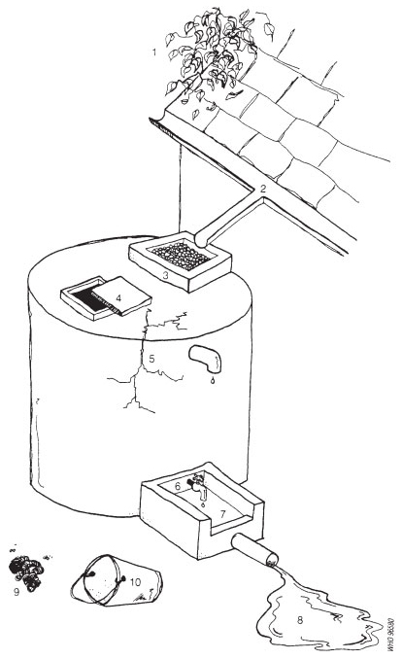
Figure 12.2 Rainwater collection and storage. (WHO, 1997)

Box 12.2 Sample checklist for inspection of rainwater collection and storage
Questions to be asked during the inspection:
- Does the roof have any visible contaminants (plants, dirt or excreta)? Yes/No
- Are the guttering channels that collect the water dirty? Yes/No
- Does the filter box at the tank inlet have any defects that could let in fine dust? Yes/No
- Does the tank have any other point of entry that is not properly covered? Yes/No
- Do the walls or top of the tank have cracks or holes that could let water in? Yes/No
- Does the tap leak or have any defects? Yes/No
- Does the concrete floor under the tap have any defects? Yes/No
- Does the water collection area drain inadequately? Yes/No
- Does the area around the tank or water container have any source of pollution, such as faeces? Yes/No
- If a bucket is in use and left in place, is it exposed to contamination? Yes/No
Total number of ‘Yes’ answers = contamination risk score:
9–10 = very high
6–8 = high
3–5 = intermediate
0–2 = low.
Name ______________________
Signature ______________________
Date ______________________

12.4 Sanitary inspection of the home
Good-quality water can be supplied by water utilities but there is potential for the water to become contaminated by the user through using unclean water vessels for collection of the water, and poor handling (for example, by not storing the water carefully, and using contaminated containers to take water from the storage vessel).
- What are the characteristics of a good water storage container in the home?
- A container made of opaque non-degradable plastic (plastic that will not deteriorate with time); with a maximum capacity of 25 litres; with handles and a flat bottom, for easy carriage and storage; with a screw-cap; and fitted with a tap.
As you know, water is said to be safe to drink when it is free from pathogens and from physical and chemical contaminants. This needs to apply right up to the point when the water is ingested. Identifying and assessing the potential risks associated with the collection and use of water is therefore a very important part of the inspection.
If you were conducting a sanitary inspection, you would need to ask users or observe their practice on:
- how they collect the water (Figure 12.3) and the types of vessel they use (for example, jerrycans, buckets or pots)
- how the vessels are handled and stored when not in use
- whether the vessels are used for purposes other than water collection that may contaminate them
- whether users know how to collect safe water and keep it safe
- whether the water is treated or disinfected after collection
- hygiene practices of users (especially those of young children).
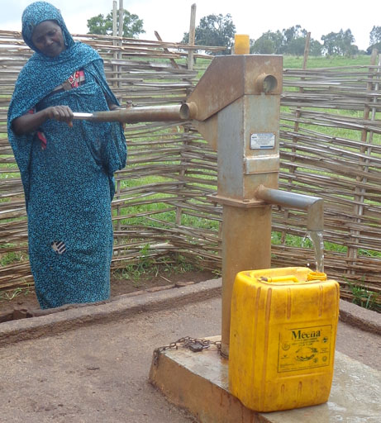
Figure 12.3 Water being collected at a hand pump in rural Ethiopia.

12.5 Solving problems found during sanitary inspections
Any issues regarding water safety found by the sanitary technician should be reported to the District Water Surveillance Coordinator or equivalent, who will verify the situation and may undertake further investigation before referring the matter, with recommendations, to the person more senior to them in the hierarchy. They might then liaise with others to decide on the remedial action needed to overcome the problem.

12.6 Water sampling
It is important that the water that people drink is safe. Ethiopia has drinking water standards with limits for microbial, physical and chemical parameters, and you learned about these in Study Session 9. The water utilities are responsible for monitoring the quality of drinking water.
To check that drinking water quality is within standards, samples have to be carefully taken for analysis. It is important that representative samples are obtained so that they reflect an accurate assessment of the condition of the source. ‘Representative’ here means that the water sample taken represents as accurately as possible the water supply as a whole.
When water samples are collected for analysis, care should be taken to ensure that there is no external contamination of the samples. Glass bottles, rather than plastic, are best used for sampling. Both bottles and stoppers (caps) must be sterilised (to kill any micro-organisms present) so that microbiological analysis of the water sample is valid. Bottles should be clearly labelled with the place where the sample was taken and the date. A suggested form to accompany the water sample is shown in Figure 12.4. Note that residual chlorine is measured on site.

Water quality monitoring programme
SAMPLING DATA
1 | Region
2 | Zone
3 | Woreda
4 | Town/village
5 | Sampling site
6 | Source
7 | Nature of sample (treated or untreated)
8 | Residual chlorine
9 | Data of sampling
10 | Time of sampling
11 | Sampled by (organisation)
Figure 12.4 A form to accompany water samples when sent to a laboratory for analysis. (MoWR, 2002)
Details of the sample (time taken, location, etc.) and results of any measurements made should be carefully recorded and filed, so that they can be referred to later if needed.
You will now consider the sampling procedure for two different locations.

12.6.1 Procedure for sampling from a tap or pump outlet
To obtain a representative sample of water, the sampling procedure described below and illustrated in Figure 12.5 should be followed. The steps are:
- Clean the tap/outlet using a clean cloth to remove any dirt.
- Turn on the tap and let the water run at maximum flow for 1 to 2 minutes; then turn it off.
- Sterilise the tap outlet for a minute with the flame from a cigarette lighter or an ignited alcohol-soaked cotton-wool swab.
- Turn on the tap again and allow the water to flow for 1 to 2 minutes at a medium flow rate.
- Open a sterilised bottle by carefully unscrewing the cap.
- Immediately hold the bottle under the water jet and fill.
- While filling the bottle, hold the cap face downwards to prevent entry of dust, which may contaminate the sample.
- Screw on the cap. A small air space should be left so that the contents can be shaken more easily before analysis.
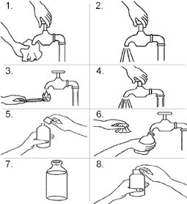
Figure 12.5 Procedure for sampling water from a tap. (WHO, 1997)

12.6.2 Procedure for sampling from a watercourse or reservoir
For towns and cities it is common for the water source to be a river or a reservoir, due to the large quantity of water needed each day by the population. Samples from the water source will be analysed using the following parameters:
- temperature, which can affect dissolved oxygen content and treatment
- dissolved oxygen, to determine if the water has oxygen and thus is devoid of undesirable products from anaerobic processes
- colour and odour, for acceptability to consumers
- turbidity, to determine if pre-treatment of the water is necessary
- suspended solids, to ascertain the level of treatment needed
- pH, to see if adjustment is needed
- organic compounds, metals and nitrate to determine if unacceptable levels of pollutants are present
- coliforms and pathogens, to determine the level of treatment required
- phytoplankton, to determine if removal is needed to eliminate odour and taste problems.
Phytoplankton are microscopic plants and other photosynthetic organisms that live in water.
The steps for water sampling are as follows:
- Open the sterilised bottle as described above.
- Fill the bottle by holding it by the lower part and submerging it to a depth of about 20 cm, with the mouth facing slightly upwards. If there is a current, the mouth of the bottle should face towards it (Figure 12.6).
- The bottle should then be capped.
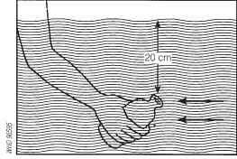
Figure 12.6 Sampling of water from surface water (rivers, ponds, etc.). (WHO, 1997)

12.7 Enforcement of regulations
The water utilities regularly analyse the quality of water emerging from treatment plants, and the water in the distribution system and at public and private taps. They also undertake analyses and carry out an investigation whenever there is a complaint from a customer or a government body.
In addition to the water sampling and analyses described above, the Food, Medicine and Health Care Administration and Control Authority (FMHACA) analyses water samples from service reservoirs and at public taps, and undertakes investigations of poor water quality. If quality is found to be poor, the FMHACA sends a Notification to the water utility, which must report back to the FMHACA on the remedial measures it has applied to overcome the problem.
The Ethiopian Public Health Institute and its Regional Public Health Laboratories are available for public and private bodies that wish to have water samples analysed. Typically, Woreda Health Offices would send water samples to their Regional Public Health Laboratory if a complaint about quality is received. The Laboratory will investigate the complaint, and recommend remedial measures that should be taken.

Summary of Study Session 12
In Study Session 12, you have learned that:
- Sanitary inspections play a major role in the prevention of contamination in water supply systems.
- Sanitary inspections begin at the source of the water. Preventing source water contamination is the most effective means of preventing contaminants from reaching consumers.
- Source water quality and conditions around the water source are the key elements of a sanitary inspection.
- Sanitary inspections include identifying and assessing the risks associated with collection and use of the water.
- They also include assessment of water management in the home, and ensure that household practices do not allow contamination to occur.
- There are specified procedures to follow when taking a water sample for analysis to ensure the sample is representative.
- Drinking water quality is monitored by the water utilities that produce the water. In addition, the Food, Medicine and Health Care Administration and Control Authority also analyses the water.
- The Ethiopian Public Health Institute (and its Regional Public Health Laboratories) analyse water samples in cases of complaints, and recommend remedial measures to overcome any issues.

Self-Assessment Questions (SAQs) for Study Session 12
Now that you have completed this study session, you can assess how well you have achieved its Learning Outcomes by answering these questions. You can check your answers with the Notes on the Self-Assessment Questions at the end of this Module.

SAQ 12.1 (tests Learning Outcome 12.1)
Write the following words next to their correct definitions in the table below:
non-degradable plastic, phytoplankton, representative sample, sanitary inspection.
a means of identifying the pollution sources and health hazards around a water source
microscopic plants that live in water
plastic that does not break down over time
having all the characteristics of the matter that it was taken from

SAQ 12.2 (tests Learning Outcome 12.2)
You are about to set off to conduct a sanitary inspection of an abstraction point at a river.
- What would you take with you?
- Name four things you will be looking for during your inspection.

SAQ 12.3 (tests Learning Outcome 12.3)
Obtaining a water sample that is free from external contamination is very important. Arrange the following steps so that the correct procedure for sampling from a tap is shown.
- Open a sterilised bottle carefully and hold the cap facing downwards.
- Turn on the tap half-way to maximum and let the water flow for about two minutes.
- Use a flame to sterilise the tap outlet.
- Fill the bottle nearly to the top by holding it under the water flow.
- Screw on the bottle cap.
- Remove any dirt in the tap outlet using a clean cloth.
- Turn the tap full on and let it run for about two minutes.

SAQ 12.4 (tests Learning Outcome 12.4)
Ashenafi and Abrinet are really pleased to have a tap in their yard supplying treated water from their town’s water utility. However, Kuleni (Ashenafi’s mother-in-law) was a bit hesitant to use the water, since she prefers the taste of the water from an unprotected spring nearby. Ashenafi had to assure her that the quality of the water is monitored, and that they can do something in case the quality is not right. What do you think Ashenafi told her?

Study Session 13 Financing Urban Water Services

Introduction
The Water Resources Management Policy of Ethiopia recognises that water is a vital socio-economic resource (MoWR, 1999). It also states that the cost of providing water services should be recovered from the people using it. However, when considering the price to be paid for water, the national policy states that ‘the price of water should be neither too high (and discourage water use) nor too low (and encourage abuses and over-use of water)’. It also acknowledges that different approaches are needed for rural and urban dwellers.
In this study session you explore how cost recovery can be achieved, including billing and smart meters. You will also look at how small loans can help to improve water supply.

Learning Outcomes for Study Session 13
When you have studied this session, you should be able to:
13.1 Define and use correctly all of the key words printed in bold. (SAQ 13.1)
13.2 List reasons why water tariffs need to be set. (SAQs 13.2 and 13.3)
13.3 Describe how tariffs are set for different types of users. (SAQ 13.3)
13.4 Explain the billing process, including the use of smart meters in assessing water usage. (SAQ 13.4)
13.5 Describe how microloans can be used to improve water supply. (SAQ 13.5)

13.1 The rationale for water tariffs
One of the ways of ensuring sustainability in water supply is to make sure that the cost of providing the supply is covered by the revenue from payments by consumers. For this to happen, water tariffs must be set. A water tariff can be defined as ‘the price paid by consumers for water’ (MoWE, 2013).
As you have been reading in previous study sessions, the process of providing safe drinking water for large communities in towns and cities requires several steps, from identifying and developing an appropriate water source through to delivery to consumers via a distribution network. In many locations, large-scale water treatment is also needed, involving a series of processes in a water treatment works.
- Can you recall the main steps in water treatment?
- The main steps in a large-scale treatment works are screening, aeration and/or pre-chlorination, coagulation and flocculation, sedimentation, filtration, and chlorination. Supplementary treatment may also be needed.
Producing the water, storing it and ensuring it gets to consumers requires the input of expertise, labour, energy and chemicals, all of which cost money. The aim in a water supply system should be to recoup this expenditure and also gather funds for maintenance, renewal of equipment, management costs, repayment of debts, building up of financial reserves, and expansion of the water supply system (when the need arises). Water tariffs provide a way for the money to be gathered from consumers.

13.2 Different types of water tariff
There are four types of tariff that are most often applied in the water sector. Different countries or areas may adopt different systems depending on their policies and circumstances. For example, in some places all households with a piped connection are required to have a water meter that measures the volume of water used. In other places, water meters are not compulsory. The four main types of tariff are as follows:
- Uniform flat rate: The consumer pays a flat rate regardless of how much water is used. This tariff is used in areas that are not metered. While, for the customer, the expense of installing and reading meters is eliminated, this tariff does little to discourage water wastage by consumers, and everyone pays the same no matter what their consumption.
- Single-block rate: The consumer is charged a fixed rate for each unit (or block) of water used, based on meter readings. A block is defined as the quantitative interval of water consumed (in cubic metres), for which a given tariff is set. This is a fairer system, as people only pay for what they use, and also it encourages water conservation.
- What are the benefits of water conservation?
- Water conservation through the efficient use of water means that the available water can be used to supply more people.
- Two-part tariff: In this tariff, in addition to charging for the volume of water consumed, a fixed charge is imposed. This fixed charge is to cover several items that are not related to the level of water consumption, such as the cost of meter reading and billing, repayment of loans, and capital improvements.
- Rising block tariff: Here the consumer pays more as consumption increases. A certain basic allowance of water, the first block, is supplied at a minimal price (or even free) and subsequent blocks of water are charged at increasingly higher rates. The rising block tariff encourages water conservation but is sometimes seen as being disadvantageous to large families who tend to use more water. In these circumstances, a financial subsidy can be given.
There is another tariff, which is not very widespread, called the ‘seasonal tariff’, which is applied in Chile (Whittington et al., 2002). The tariff is low in the rainy season and high in the dry season, thus encouraging water conservation when water is scarce.

13.2.1 Water tariffs used in Ethiopia
In Ethiopia, the rising block tariff is used for both domestic and non-domestic users. The National Guideline for Urban Water Utilities Tariff Setting recommends that no more than five blocks should be used. The recommended blocks for medium and large towns are shown in Table 13.1. The Guideline also recommends a set of block ranges for small towns.
Table 13.1 Guideline water tariff blocks and ranges for medium and large towns in Ethiopia. (MoWE, 2013)
Block | Block range (m³ per month)
 | Domestic users | Non-domestic users
1st | 0–5 | 0–5
2nd | 6–10 | 6–10
3rd | 11–15 | 11–25
4th | 16–20 | 26–40
5th | >20 | >40
Based on these block ranges, the price paid by each customer is calculated according to the volume of water they use. The actual costs of water supply differ from town to town, depending on various factors such as the ease of treatment of the raw water and the cost of laying distribution pipes, etc., so the price paid by consumers also varies between towns.
The following example uses the pricing of water to domestic users in Harar, where there are four blocks for domestic consumers. Table 13.2 shows the price in birr paid per m³ for each block.
Table 13.2 The rates for water in Harar for domestic customers. (Mohammed, 2015)
Block | Volume used per month (m³) | Price per m³ (birr)
1st | 0–5 | 5
2nd | 6–10 | 9
3rd | 11–20 | 13
4th | >20 | 26
Here is an example of how a water bill is calculated based on these blocks. Imagine the household of Abdul Aziz and his family, who live in Harar and use 12 m³ of water per month.
Calculation of the water bill for Abdul Aziz’s household:
The first 5 m³ will cost 5 × 5 = 25 birr.
The next 5 m³ will cost 5 × 9 = 45 birr.
The remaining 2 m³ will cost 2 × 13 = 26 birr.
The total bill for the month will therefore be 25 + 45 + 26 = 96 birr.

13.3 How water tariffs are set
The basic principle behind the concept of water tariffs is that the income from water sales should be sufficient to cover the expenses of water supply. Essentially, there are two major categories of costs to be considered when setting water tariffs:
- Operation and maintenance (O&M) costs: The O&M costs are incurred in the day-to-day running of the water supply system, and include staff salaries and benefits, administrative costs, office running costs, and the cost of water production and distribution (chemicals, energy, repair and maintenance, water analysis, etc.).
- Capital costs: The capital costs include the cost of new equipment to replace or upgrade old treatment units, and a fund set aside for future expansion of water supply services when the need arises (for example, for the purchase of additional storage tanks, distribution pipes and new connections). Capital costs also include money used for professional and technical support obtained from outside organisations.
The Water Resources Management Policy of Ethiopia (MoWR, 1999) dictates that the water tariffs for rural areas should seek to recover O&M costs where possible. However, in urban areas the tariffs should seek to recoup total costs – that is, O&M and capital costs. This is called full cost recovery. Full cost recovery ensures the sustainability of the water scheme because it is not dependent on outside sources of funding. It enables investment in the future development of water provision for the benefit of all. If the water supply service were not able to recover its costs, this would restrict the opportunities to develop and extend the water supply network, which would particularly disadvantage poor people.
When deciding on the specific price for a water tariff, financial experts consider all the O&M and capital costs, and arrive at a price for each cubic metre of water produced and distributed. Suppose, for example, that the total cost works out at Y birr per cubic metre of water. Usually the cost for domestic users will start at some figure, X, which is lower than Y. For non-domestic users (such as industrial and commercial users), however, the price will be higher than Y, say Z. The higher price paid by non-domestic users subsidises the price paid by domestic users. By subsidising the price to domestic consumers, the pricing policy ensures that poor people have access to reliable and safe water.

Equitable and affordable
Water tariffs must be easy to administer for the water utility, and understandable and equitable for the consumers, with each type of consumer paying their fair share.
For domestic users, a price will be decided for each of the blocks, similar to Table 13.2, taking into account affordability. The price of ‘affordable’ water varies depending on the local situation, but several sources suggest that for water to be affordable, its price should not exceed 5% of the income of the household (Coalition eau, n.d.; AICD, 2008; Simpson, 2012).
Low-income households, and households with many young children, older or retired people, disabled people, or people with a long-term illness (where money might always be needed for medical treatment), are the most vulnerable segments of the population, since their financial burden will be high. (Vulnerable here means exposed to the possibility of being harmed through the lack of access to water, due to finances.) Water has to be made accessible and affordable for them. Currently, these types of households pay a high price for water (higher than charged for piped supply) by buying water from public taps or water kiosks. Households like these should be charged less than the standard domestic rate for water.
The Water Resources Management Policy requires social tariffs to be set up for poor communities, based on recovery of O&M costs only. These are fixed rates (or single-block rates) and are applied for communal water services such as hand pumps and public taps (also referred to as ‘public fountains’, ‘standposts’ or ‘standpipes’). The tariff used is the one charged for the first block in rising block tariffs for domestic users in Ethiopia. For example, in Harar, according to Table 13.2 this would be 5 birr per cubic metre. The principle behind such a policy decision is that each person should have the right to access a minimum level of water supply for cooking and drinking, at a price that is affordable to low-income households.

13.3.1 Reduction of water tariffs
Water tariffs should be reviewed annually, because customers find small increases in water costs easier to cope with and accept than a large increase every few years. However, it is possible that water tariffs may be reduced with time. If water sales go up, the fixed costs per cubic metre of water produced will be reduced. If non-revenue water is minimised, this will serve to increase the available supply and the income to the water supplier. Increased usage can be achieved by increasing the number of customers, through installing more taps.
- Can you remember what non-revenue water is, and what its biggest component is?
- From Study Session 7, it is water that is used but does not generate any income for the water supplier; its biggest component is leakage.
Water tariffs may also be reduced if the income to the water supplier is increased through more efficient billing and collection of payments due.

13.4 The billing process
Water meters are installed at points of water use so that the quantity of water used can be ascertained, and the water user sent a bill for payment. The type of meter in general use has a given flow rate range, which varies with different meters. Usage of water at a higher rate than can be measured by a meter will result in the usage being under-recorded. This means that the bill will be less than it should be. So before installing a water meter, the anticipated rate of water use must be estimated for the given location, and an appropriate meter then installed.

13.4.1 Simple and smart meters
A water meter can be placed below ground level, in a silo with a cover that can be lifted to reveal the meter; above ground, within the compound of the property (Figure 13.1); or on public land outside the property concerned.
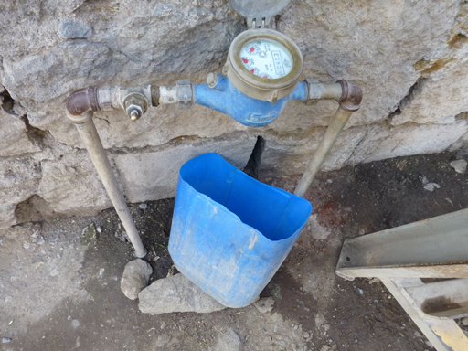
Figure 13.1 Water meter inside the compound of a house.
Water meters can be simple, or fitted with automatic meter reading technology. With a simple meter (Figures 13.1 and 13.2), commonly found in Ethiopia, a meter reader employed by the water utility visits the household and physically notes down the meter reading each month to record usage. The meter reader then goes back to the water utility office and passes the reading to the Billing Department staff, who then generate a water bill.
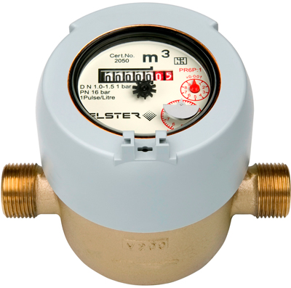
Figure 13.2 A simple water meter.
Where a meter has the facility for automatic meter reading, a meter reader visits the property with a handheld computer or data collection device, as shown in Figure 13.3. The device has an electronic probe. The meter is touched with the probe and a signal from it interrogates the meter and downloads the data needed. Systems are also available by which a meter reader can obtain the required data by walking near the meter, or driving by in a vehicle. The data are downloaded later into a computer that can then automatically and speedily generate a bill.
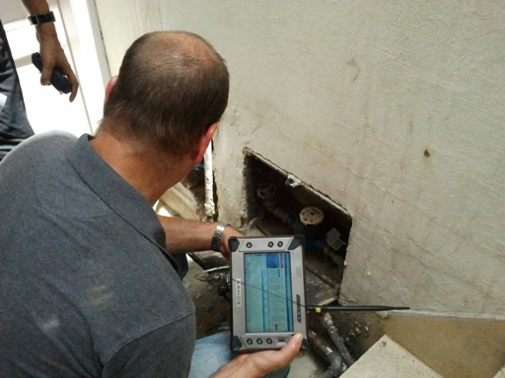
Figure 13.3 Automated water meter reading.
There are also smart meters (Figure 13.4) that transmit meter readings using wireless technology every hour to the water utility that supplies the water and also to a device in the home or property, so that usage can be monitored. The water bill can be generated rapidly by a computer at the water utility, without a meter reader having to visit the meter. The meter readings are usually monitored by the water utility and a sudden rise in the meter reading can generate a warning that possibly a leak has arisen.
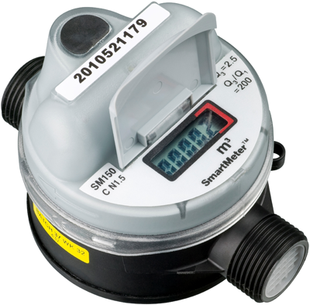
Figure 13.4 A smart water meter.
The different types of water meter have their advantages and disadvantages. The simple meter is robust and inexpensive, while meters with automatic reading facilities and smart meters are costly and sensitive to mishandling. Simple meters, unlike automated and smart meters, require people to take readings and generate a bill, but this gives employment. Automated and smart meters can be used to generate water bills rapidly but require technical expertise to keep them functional.

13.4.2 Prepaid meters
There is no billing process for water purchased from water kiosks because payment is simply by cash. One innovative alternative to this is the use of prepaid meters on public water points, which have been introduced in some parts of South Africa and Kenya (Figure 13.5). With prepaid meters, consumers buy credit in advance, which is registered electronically on a plastic card or token. They then insert the card or token into the meter, which automatically releases water. The cost of the water they have used is deducted from the credit. The advantage of this method is that people can budget for water by topping up their card as and when they can afford to pay. Also, the water point does not have to be managed by a person, and can be open 24 hours a day.
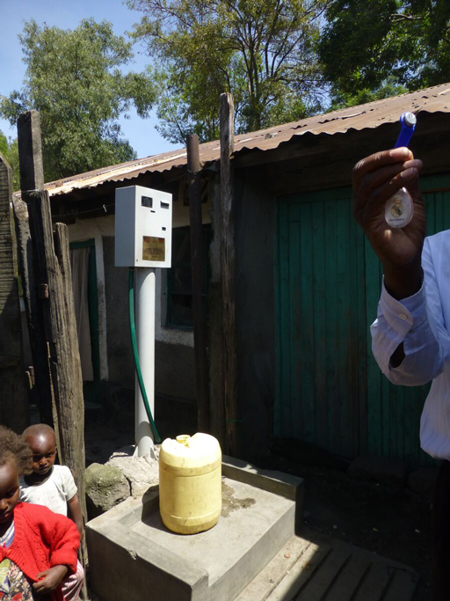
Figure 13.5 A prepaid water meter. The man standing to the right is holding the small blue credit token that is inserted into the meter to obtain water.
In Ethiopia, a pilot trial is underway of a prepayment system for domestic water customers. The householder pays money in advance to the water utility and then uses the water. This enables the household to proactively manage its budget, and simultaneously save time in going to pay the water bill each month. The water utility also makes savings as a meter reader doesn’t have to be sent out to take readings for a bill.

13.5 The role of microloans in improving water supply
In Ethiopia, the hurdle in water supply for many people is the high initial cost of a dedicated household water connection. The householder has to pay the cost of laying a pipe from the mains to the house; the greater the distance of the house from the water main, the higher the cost. Poor households have no capital budget or easy access to credit or loan services to invest in a tap for their exclusive use. This challenge forces such households to buy water from water kiosks and public standpipes at prices much higher than the price of water sold directly to households. Such an additional burden on poor households contributes to their cycle of poverty.
Many people in this group cannot access loans from banks because of their low income. One way out of this is to make microloans available to them. Microloans are small amounts of money lent at a low interest rate to people on low incomes. The idea emerged from the Grameen Bank in Bangladesh in 1976. Because the borrowers, being poor, did not have guarantees, ‘solidarity groups’ of five borrowers who could vouch for each other’s loans were created. This was possible in rural or village settings where all the borrowers knew each other. This fact also created peer pressure to repay the loan, with the result that the repayment rate for loans at the Grameen Bank is greater than 90% (Fonseca, 2006). The microloan system enables low-income households to obtain their own water supply at a reasonable cost. Once they have their own taps, households will need to spend less on water, and the savings made can be used towards other needs of the household, such as health and education.
Microloans can also be made to a community, say, to finance the drilling of a well. A loan such as this engenders ownership of the asset (the well, in this example), and usually results in greater care and responsibility. This bodes well for the sustainability of the asset.

Summary of Study Session 13
In Study Session 13, you have learned that:
- Water tariffs are needed to recover the costs associated with the treatment and distribution of drinking water.
- There are four main types of water tariff: uniform flat rate; single-block rate; two-part tariff; and the rising block tariff.
- In Ethiopia the rising block tariff is used for private taps and taps in industrial and commercial establishments. In this tariff, the cost of water increases with the volume used but consumption is measured in blocks, which are defined quantities of water use.
- In Ethiopia, a single-rate social tariff is used for public taps and hand pumps. This tariff is the same as the tariff for the lowest block in the rising block tariff.
- Water meters can be simple devices that require a person to read them (either manually or using a handheld computer) and generate a water bill. Alternatively, they can be smart meters that send data to the water utility automatically using wireless technology for preparation of a water bill by computer. Smart meters allow water usage to be monitored, making discovery of a leak easy.
- Microloans can be a way for low-income households to obtain their own private taps. Over time, this will reduce the proportion of their income spent on water, leaving more money for other needs of the household.

Self-Assessment Questions (SAQs) for Study Session 13
Now that you have completed this study session, you can assess how well you have achieved its Learning Outcomes by answering these questions. You can check your answers with the Notes on the Self-Assessment Questions at the end of this Module

SAQ 13.1 (tests Learning Outcome 13.1)
Write the following words next to their correct definitions in the table below:
block, full cost recovery, microloan, smart meter, social tariff, vulnerable people, water tariff.
a water tariff for those who are poor, which aims to recover only O&M costs
a small amount of money lent at a low interest rate to a person on a low income
people who can be harmed through not having money to buy the water they need
a meter that sends water consumption data electronically to the water utility
a given amount of water for which there is a certain water tariff
the price that is set for water
where capital and O&M costs are all recouped

SAQ 13.2 (tests Learning Outcome 13.2)
Worku and Samson, two friends, visited their village over the Easter holiday and were in conversation with some of the elders there. The elders were discussing the new pipeline bringing drinking water to their houses, and asking why they had to pay for it when water was a basic need that the government should provide free. What do you think Worku and Samson told them?

SAQ 13.3 (tests Learning Outcomes 13.2 and 13.3)
- In setting water tariffs, the aim is to recover the cost of water supply. What are the different components that make up O&M costs and capital costs?
- How is it possible to recover the cost of water supply when the water tariff for domestic use is less than the actual cost of the water?

SAQ 13.4 (tests Learning Outcome 13.4)
Think about different types of water meters and methods of billing, and fill in the following table.
 | Simple meter | Smart meter
Advantages
Disadvantages

SAQ 13.5 (tests Learning Outcome 13.5)
Beheilu is a construction worker who lives with his wife and six children in a poor neighbourhood in Addis Ababa. He spends about 20% of his income on water bought for his family at the water kiosk in his area. He would like to have a private water tap in his yard but is unable to pay the high price for the connection, and cannot approach a bank because he does not earn very much. Having studied the material in this study session, what advice would you give him?

Study Session 14 Water Emergencies and Emergency Water Supply

Introduction
Safe and reliable drinking water has always played a prominent role in the development of human civilisation. Water was, and continues to be, a basic necessity of human survival. However, access to safe, adequate and reliable water is not always present. There may be emergencies in the water supply system that result in a break in supply. Distribution of fresh water can also be a challenge when natural disasters (such as droughts, floods, earthquakes, etc.) or accidents occur, or during catastrophes caused by human actions such as wars, when a displaced population has to be supplied with water. You will look at examples of these situations in this study session and learn about water supply during emergencies in urban areas, and how emergency water supplies can be set up for populations that have been displaced.

Learning Outcomes for Study Session 14
When you have studied this session, you should be able to:
14.1 Define and use correctly all of the key words printed in bold. (SAQ 14.1)
14.2 Give typical examples of emergencies that can occur in an established water supply system, and how safe water can be supplied in these situations. (SAQ 14.2)
14.3 Identify home water treatment methods that can be used during water emergencies. (SAQ 14.3)
14.4 Describe situations where emergency water supplies would be needed. (SAQ 14.4)
14.5 Describe ways in which water can be rapidly obtained and treated for emergency water supply. (SAQ 14.5)

14.1 Causes of emergency situations
Emergencies are sudden, unexpected, hazardous situations where there is a need for an immediate response. They can cause severe disruption because they are unexpected. Resources are needed to cope with an emergency and they may have to be brought in from outside.
Everyone will have to deal with emergencies in life at some time or another. Can you think of an emergency that has occurred in your life? You can probably think of many. The last one that I had was when a pipe burst in my mother’s house. It was late in the night, and I had to take my friend Kabede with me (as an outside resource) to help fix it, because I am useless at plumbing.
A water emergency, such as the one described above, is an event that disrupts the normal supply of water. In town, it can occur due to natural causes or when there is damage to the major infrastructure of the treatment plant, water storage or water distribution system. Untreated or partially treated water may be inadvertently distributed in an emergency situation. Another cause of a water emergency could be contamination of the water supply, for example by a chemical leak.
As you can see, there are several different types of emergency that can affect water supply and some of these are described in the sections that follow.

14.1.1 Drought
A drought occurs when there is a deficiency in precipitation over an extended period of time, resulting in a water shortage. You are probably familiar with the consequences of a drought. The lack of rain means that the water flow in rivers is reduced, lakes and pools shrink in size or may dry up, groundwater and soil moisture are depleted, and crops are damaged. Prolonged drought can lead to a major national and regional food insecurity crisis. Domestic animals might also die (Figure 14.1).
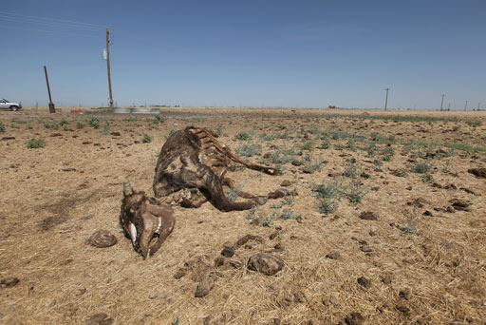
Figure 14.1 Drought causes loss of life and livelihood.
Ethiopia has been associated with drought for a long time and many people have suffered from its effects. For example, in the drought of 1985 in the northern part of the country, an estimated 800,000 people died due to malnutrition and disease.
During a shortage of fresh water during a drought, people may be forced to use unprotected water supplies. Furthermore, people and animals may use the same water source, which increases the risk of contamination of that particular water source. This leads to increased exposure to waterborne diseases (such as diarrhoea and dysentery) and water-washed diseases (such as trachoma).

14.1.2 Flooding
Flooding is an abnormal rise in the water level and may result in overflowing of streams or rivers. Flood waters can destroy infrastructure, including houses, roads and water supply systems, as well as agricultural crops, which ultimately causes a shortage of food supplies in the country. Besides the destruction of property, people and animals may be killed, especially when flash floods occur. (A flash flood happens when rain falls so fast that the underlying ground cannot drain the water away fast enough and rivers overflow their banks. Roads can then become like rivers and if there is a lot of water it can flood buildings and carry cars away.)
Floods can cause widespread bacterial contamination of wells and surface water sources with faecal matter washed from the ground surface or from flooded latrines and sewers, resulting in the outbreak of disease. For example, cholera commonly occurs after flooding.

14.1.3 Earthquake
An earthquake can cause serious damage to infrastructure on and in the ground (Figure 14.2). Pipes and treatment plants will be destroyed by a high-magnitude earthquake and the communication systems (such as road and rail networks) often become non-functional, making the delivery of emergency water supplies difficult. Destruction during an earthquake can also cause chemical spillage at manufacturing plants and warehouses, which can lead to widespread chemical contamination of drinking water.
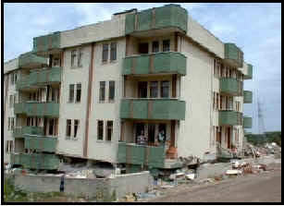
Figure 14.2 A building in Addis Ababa damaged by an earthquake.

14.1.4 Events caused by human intervention
It is possible that a deliberate attempt could be made to poison a water supply as an act of terrorism, but it is far more likely that human causes of water emergencies will be due to accident and neglect. There can be instances where the water supplied will be unfit for human consumption as a result of an accident – Box 14.1 describes such a case at a water treatment works in the United Kingdom.

Box 14.1 An example of a human-caused water emergency in the UK
In July 1988 in Camelford, a small town of 20,000 people in south-west England, 20 tonnes of aluminium sulphate was dumped into the wrong tank at the local water treatment plant (Figure 14.3) by a chemical tanker driver who was not familiar with the plant layout and delivery procedures. Aluminium sulphate went directly into the mains water supply, and this became the worst water poisoning incident in Britain. Residents complained because the water coming out of the tap was black, and curdled the milk in their tea. One man described how his hair had stuck together after he took a bath, as if his head had been smeared with glue. Symptoms such as stomach cramp, diarrhoea, skin rashes, joint pain, sore throat, short-term memory problems and general exhaustion were reported.
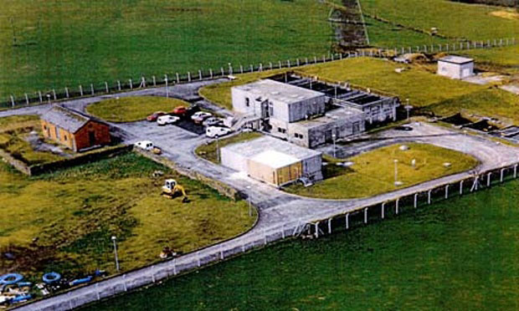
Figure 14.3 The water treatment plant at Camelford.

Aside from accidents, human neglect is the other most likely cause of a water emergency. Case Study 14.1 illustrates how neglect can lead to a water crisis, although it does not fit the definition of an emergency because it was not sudden.

Case Study 14.1 Water supply in Harar
Harar is a city in the eastern part of Ethiopia, 505 km from Addis Ababa. The city used to get water from Lake Alemaya (Haromaya), but since February 2004 the supply has ceased.
The water treatment plant at the lake was originally designed to serve a population of 70,000 but in 2000 the plant was supplying 160,000 people, who lived in Harar City, two small towns and at Haramaya University.
Lake Alemaya (Figure 14.4) has at its edge the town of Alemaya to the south and southwest, Haramaya University to the east, and farming communities to the north and northwest. In the mid-1980s its maximum depth was around 8 m and it covered an area of 4.72 km². It was an attractive freshwater lake used for drinking water, irrigation, fishery and recreation. Farmers in the surrounding community used a tremendous amount of fertiliser to grow different crops, in addition to khat, and excess fertiliser used to end up in the lake. Wastes containing chemicals from the town were dumped at the shore of the lake in indiscriminate and irresponsible ways.
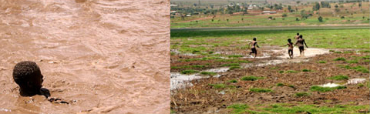
(a) (b)
Figure 14.4 (a) Lake Alemaya before 2004; (b) the lake after 2004.
The depletion of water from the lake started slowly and no protective conservation measures were taken by anyone, although it was plain that the water level was dropping year on year.
After the water had nearly gone, the city faced a serious water shortage and water rationing was introduced. Responding to the acute water shortage in Harar, many individuals in central government and non-governmental organisations were involved in a programme to combat the emergency. Water tankers were used to transport water to the town dwellers from distant available sources (Figure 14.5). This emergency operation continued for more than a year until deep wells were dug 20 km away to supply water to the residents again.
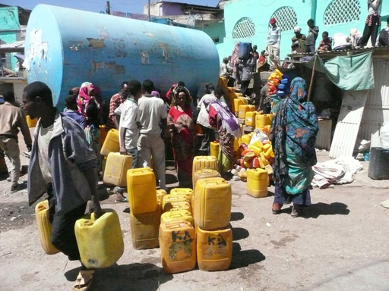
Figure 14.5 Tankered water supplies for residents of Harar in 2011.

14.2 People affected by emergencies
Catastrophic emergencies like floods and earthquakes will affect everyone, but the poor and vulnerable will always be at a disadvantage. In many situations, the people most likely to be severely affected are internally displaced people and refugees. In situations of war and conflict people naturally want to escape and so they move in large numbers away from the conflict zone. The places they arrive at frequently have no infrastructure and very limited resources.
Internally displaced people are people who are forced to flee their homes due to circumstances such as natural disasters or war, but who remain within their own country's borders. For example, during 2014, internal war and conflict caused thousands of people in the Central African Republic, Southern Sudan and Syria to flee their homes and move elsewhere in their country. Such events call for a fast and coordinated effort to provide basic services such as shelter, food, water, latrines, handwashing facilities, etc. When providing shelter, the choice of location is often dependent on the availability of water.
Conflicts of this kind can also result in people seeking refuge outside their own country. For instance, in 2015, there were more than 600,000 Syrian refugees in Jordan who had fled the conflict in their home country (UNHCR, 2015). Camps had to be set up in the desert, and of course the supply of water was crucial.

14.3 Waterborne disease outbreaks caused by emergencies
A disease outbreak is the occurrence of cases of disease greater in number than would normally be expected in a defined community, geographical area or season. A waterborne disease outbreak is therefore another type of emergency situation. It might be caused by one of the natural disasters described in the last section, or due to human error, or indeed both. The greatest risk of waterborne outbreaks is pollution of water sources by faecal pathogens. This might occur due to inadequate sanitation, poor hygiene or lack of protection of water sources.
Cholera, caused by Vibrio cholerae, is a disease that is frequently associated with disasters and emergencies, where the breakdown of normal procedures and the collapse of infrastructure create conditions that lead to faecal contamination of water. This was the situation on the island of Haiti following the earthquake there in 2010.

Case Study 14.2 Cholera outbreak in Haiti
In Haiti in October 2010, ten months after a devastating earthquake, an outbreak of cholera began in an area about 100 km from the capital, Port-au-Prince. This was the first instance of cholera in Haiti for at least 100 years and by March 2011 it had killed 4672 people and thousands more were hospitalised (Figure 14.6). By March 2012, a further 2378 people had died, and more than 531,000 people had been taken ill. Furthermore, the disease spread to neighbouring countries like the Dominican Republic and Cuba.
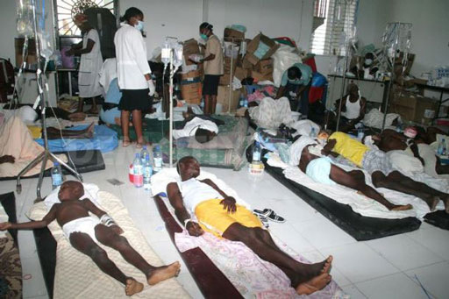
Figure 14.6 Cholera patients undergoing treatment in Haiti.
The suspected source of the epidemic was the Artibonite River (Haiti’s longest and most important river), with which most of those who had caught the disease had been in contact. The river water was used for washing, bathing, drinking, irrigation and recreation. Along one of the tributaries of the Artibonite River was a United Nations military base for peacekeeping troops from Nepal. This came under suspicion as the source of the contamination of the river due to sewage from the base entering the river. The UN appointed a panel to investigate the source of the outbreak and they confirmed evidence that the particular strain of Vibrio cholerae isolated in the cholera cases found was similar to that circulating in South Asia, including Nepal (Cravioto et al., 2011). This suggested that the UN peacekeeping force was indeed the source and the investigation led many people to blame the UN for the cholera outbreak (Figure 14.7).
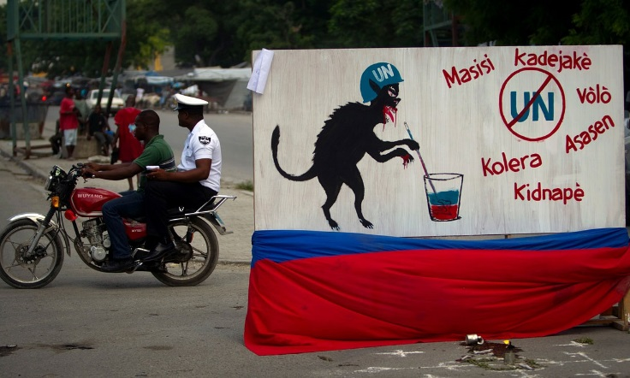
Figure 14.7 Poster in Haiti blaming the UN for the cholera outbreak that occurred in 2010.
In the years after the outbreak, medical efforts and preventive measures (such as the installation of more latrines) and changes in behaviour (for example, cooking food thoroughly and rigorously washing hands after using the toilet) brought the number of cholera cases down. The toll by November 2013 was 8448 killed and 689,448 taken ill (Pan American Health Organization, 2013).
The UN-appointed panel came up with seven recommendations in their report and two of these were related the cause of the outbreak (United Nations, 2011):
- UN personnel from countries that have cholera and who respond to emergencies in countries where cholera is not common should take antibiotics to prevent the disease before departure and/or be screened to confirm that they are not carrying Vibrio cholerae without suffering the disease.
- UN installations worldwide should treat faecal waste using on-site systems to inactivate pathogens before disposal. These systems should be operated and maintained by trained, qualified UN staff or by local providers with adequate UN oversight.

14.4 Treatment options for water emergencies
The purpose of water treatment in emergency situations is the same as it is in any circumstance, which is to remove all types of contaminants present in the water and to improve the quality to a level safe for human consumption. The difference in emergency situations is that the normal structures and processes are not available.
In acute emergency situations where speed of providing water for people is paramount, the main options for water supply are distribution of safe water to people through the use of water tankers and/or plastic bottles. The other option is to give the water consumers the means of treating water for themselves to render it safe. You learned about the methods that could be used in Study Session 10.
- Briefly describe the main processes of household water treatment and give examples of the methods that could be used.
- The main processes are sedimentation or filtration, both of which remove solids, and disinfection to kill pathogens. Some examples of filtration methods are cloth filtration, sand filtration, and ceramic filtration. For disinfection methods you could have said boiling, solar disinfection, and chemical disinfection using products such as Wuha Agar, Bishan Gari, Aquatabs and P&G Purifier of Water.
If it is not possible to filter the water, and if the water treatment chemicals mentioned above are not available, then the water should be kept in a container to settle any solids and then decanted out. The decanted water should then be boiled.

14.4.1 Water treatment and distribution
For the longer-term needs of displaced people and refugees, the population should, if possible, be located in an area where there is adequate groundwater. This type of water normally requires minimal treatment before consumption – usually just disinfection, in order to keep the water safe from microbial contamination. Failing this, surface water from rivers or lakes can be used, but these waters will require a greater degree of treatment, since the level of suspended solids in them is likely to be high. Disinfection will again be needed.
One way of achieving this is with an emergency water treatment system that replicates the processes of a full-scale permanent water treatment works. A relatively simple process for emergency water treatment is available (Figure 14.8) and can be constructed in a matter of a few hours (Oxfam, 2014a). The tanks can be set up and operated by a team of seven (an experienced water engineer and six technicians). It is important for sustainability in an emergency that simple systems are used.
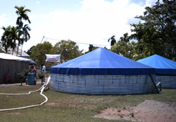
Figure 14.8 Emergency water treatment tanks.
In this system, the raw water is dosed with aluminium sulphate coagulant (which is easily obtained in most countries of the world) and left to flocculate and settle for six hours in 45-m³ sedimentation tanks. It is then chlorinated (using a solution of calcium hypochlorite) and sent with a residual chlorine level of about 0.5 mg per litre (0.5 mg l^{–1}) to the distribution system made up of PVC pipes laid above ground (to bury them would take time) and standpipes. The treatment system can produce 180 m³ of clean water a day. Once a week or so, the residual chlorine level is increased to 1 mg l^{–1} so that the water containers used by the people are disinfected.
- How many people could 180 m³ of water support per day, if the water requirement is 20 litres per person per day?
- 180 m³ is 180,000 litres. If one person needs 20 litres of water a day, 180 000 litres will be enough for (180,000 / 20) = 9000 people.
A more complex water treatment system (Figure 14.9), which uses coagulation and flocculation, sand filtration, microfiltration (where a membrane filters out particles which are 0.05–0.5 µm in size) and chlorination, is available (Oxfam, 2014b). This requires a team of three – an experienced water engineer and two technicians. The unit can produce up to 4 m³ of clean water an hour.
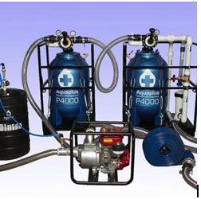
Figure 14.9 A complex water treatment system incorporating many processes in compact units, for use in water emergencies.

Summary of Study Session 14
In Study Session 14, you have learned that:
- Water supplies may be cut off in emergencies caused by natural events or human actions. Natural factors could be droughts, floods or earthquakes, while human-related emergencies can arise from accidents caused by human error, deliberate poisoning of the water supply or neglect (as exemplified by Case Study 14.1).
- During emergencies water may be supplied via delivery by tankers, use of plastic bottles or treatment of available poor-quality water in the home using filtration and disinfection.
- Filtration at household level can be achieved by using cloth, sand or a ceramic pot. Disinfection can be undertaken by boiling or solar methods, or by using chlorine or commercial water treatment products.
- Emergency water treatment is needed when an internally displaced population or refugees have to be provided with water urgently. It is preferable to use groundwater as it is likely to be less polluted than surface water.
- Simple and complex systems for emergency water treatment are available. For sustainability simple systems are preferable.
- The coagulant most commonly used in emergency water treatment is aluminium sulphate, as it is widely available. A simple emergency water treatment system comprises coagulation and flocculation, sedimentation, and chlorination, while a complex unit might incorporate coagulation and flocculation, sand filtration, microfiltration, and chlorination.

Self-Assessment Questions (SAQs) for Study Session 14
Now that you have completed this study session, you can assess how well you have achieved its Learning Outcomes by answering these questions. You can check your answers with the Notes on the Self-Assessment Questions at the end of this Module.

SAQ 14.1 (tests Learning Outcome 14.1)
Write the following words next to their correct definitions in the table below:
disease outbreak, drought, emergencies, flash flood, flooding, internally displaced people, microfiltration, water emergency.
people who have been forced to flee to another part of their own country due to factors beyond their control
an abnormal rise in water level that can cause damage
an unexpected rise in the number of cases of a disease
a means of separating from water particles that are 0.05 to 0.5 µm in size
an event that disrupts the normal supply of water
sudden, unexpected, hazardous events
a deficiency in precipitation that lasts for a long period of time
short-duration flooding that occurs due to sudden heavy rainfall that is unable to drain away into the ground

SAQ 14.2 (tests Learning Outcome 14.2)
- Give six possible causes of water emergencies, three due to natural causes and three due to humans.
- What are the options for safe water supply during a water emergency?

SAQ 14.3 (tests Learning Outcome 14.3)
- What are the two treatment steps needed in household water treatment during a water emergency?
- For each of the two steps referred to above, suggest three possible options.
- There are two formulations available in Ethiopia for household water treatment that contain both a coagulant/flocculant and a disinfectant. What are these?
- What are the steps to follow if filtration cannot be undertaken and no water treatment chemicals are available?

SAQ 14.4 (tests Learning Outcome 14.4)
Which of the following are not likely to require an emergency water treatment and supply system? Give your reason why in each case:
- A temporary camp housing people who have been displaced within their own country due to an earthquake.
- People who live in a residential area in a city.
- Refugees who have fled to cities in a neighbouring country due to fighting in their own.
- Refugees living in an uninhabited area of a neighbouring country.

SAQ 14.5 (tests Learning Outcome 14.5)
- List the stages of water treatment for an emergency water supply based on a water source where the level of suspended solids is high.
- How will the raw water be obtained?
- Name the coagulant and disinfection agents that are most commonly used in emergency water treatment.
- Why is the residual chlorine level in an emergency water supply raised to 1 mg l^{–1} about once a week?

Study Session 15 Public–Private Partnership and Other Commercial Opportunities

Introduction
In cities across the world it has usually been the case that a municipal (public) authority takes responsibility for urban water supply. There are now variations in this service provision. In many countries, private businesses (or operators) have joined in partnership with public authorities to provide water in arrangements called public–private partnerships. This study session explores the concept of public–private partnerships and their application in urban water supply.

Learning Outcomes for Study Session 15
When you have studied this session, you should be able to:
15.1 Define and use correctly all of the key words printed in bold. (SAQ 15.1)
15.2 Describe the potential of public–private partnerships in improving access to safe water. (SAQs 15.2 and 15.3)
15.3 Give examples of microenterprises that can be effective in delivering safe water. (SAQ 15.4)

15.1 Public–private partnerships
In the major towns and cities of Ethiopia water is supplied by water utilities (also known as Town Water Supply Enterprises) but public–private partnerships (PPPs) can be helpful. A public–private partnership is any collaboration between public bodies, such as a municipality or even the government, and private companies. The belief is that private companies are more efficient and better run than bureaucratic public bodies, and the management skills and financial acumen that they bring will create better value for money for customers. The incentive for the private companies is the profit that can be generated. PPPs have become popular, to the extent that the number of people served by private water operators in developing and former Communist countries increased from 94 million in 2000 to more than 160 million in 2007 (Marin, 2009). Philippe Marin’s report, Public–Private Partnerships for Urban Water Utilities, which was a review of PPPs in urban water utilities in developing countries, was undertaken because of the interest generated in these arrangements. At the time of the report (2009), about 7% of the urban population in the developing world was served by private water operators. There are different ways in which PPPs can be set up (described later in this study session) but the sections that follow now briefly consider the factors that Marin covered in his report.

15.1.1 Access
Marin found that where most of the investment for expansion of access was provided by the public partner rather than the private operator, access to piped water increased. The finance provided by the public partner is thus crucial if the aim is to increase the number of people with access to water.

15.1.2 Quality of service
Marin reported that often water PPPs substantially improved service quality, in particular by reducing water rationing (for example, in Guinea, Gabon, Niger and Senegal). This had the advantage of improving drinking water quality because a constant flow of water through the piping system reduces the risk of infiltration of unclean water from the soil around the pipelines.

15.1.3 Operational efficiency
The three main indicators of operational efficiency (water losses through leakage, etc., payment collection and labour productivity) were also studied by Marin.

Water losses
Any water lost is a loss in income, and so, perhaps predictably, Marin found (in line with other researchers) that private operators were effective in reducing water losses, some reducing non-revenue water to less than 15% (which Marin states is similar to that of some of the best-performing water utilities in more developed countries).
- Can you recall what non-revenue water is?
- In Study Session 7 you learned that it is water from which no income accrues to the water utility.

Payment collection
Not surprisingly, because of the financial benefits to the private partner, it was found that the introduction of a private operator markedly improved the payment collection rate.

Labour productivity
There was strong evidence that the introduction of private operators resulted in an improvement in labour productivity. This is the amount of work undertaken by each employee. Many of the public water utilities studied were over-staffed, and the PPPs when set up were followed by significant redundancies, ranging from 20% to 65% of the labour force. Besides the over-staffing issue, layoffs were often motivated by a need to change the overall profile of the workforce and to hire more skilled people (Marin, 2009).
Marin concludes by saying that the biggest contribution that private operators can make in a PPP is in improving operational efficiency and service quality. Improving service quality results in customers becoming more willing to pay their bills, and increasing operational efficiency results in increased income. Both of these factors lead to more money being available for investment in expansion of services. In turn, expansion of services results in more customers and consequently increased income, which again can be invested to bring access to water to even more people.

15.2 Assessing the performance of a PPP
The performance of a PPP (and indeed a public water utility) can be assessed through the following parameters (Athena Infonomics, 2012):
- Accessibility: What proportion of the population have access to water? Is the distance to the water point less than 1 km or 30 minutes’ walking time? Pickering and Davis (2012), using survey data from 26 sub-Saharan countries, found that the further away a water source was, the less water was used; when the distance was more than 30 minutes away, households collected less water than was necessary for basic needs.
- Affordability: Is the cost of the water needed less than 5% of the household’s income?
- Cost recovery: Is the cost of providing the water being recouped?
- Minimisation of non-revenue water: Is this reduced to no more than most 15%?
- Water quality: Is there adherence to national standards?
- Operational efficiency: What is the quantity of water supplied per capita? What is the duration of water supply in hours per day?
These parameters can be used to evaluate whether a PPP is beneficial, with data from before the partnership’s creation being compared with data after the PPP has been running for, say, a year.

15.3 PPP for bill payment
In Ethiopia, a public–private partnership called ‘Lehulu’ (which means both ‘for all’, and ‘for all services’, in Amharic), established jointly by the Ethiopian Ministry of Communications and Information Technology and a private company, was launched in early 2013. Its remit was to allow easy payment of bills from the Ethiopian Electric Power Corporation (EEPCO), EthioTelecom, and Addis Ababa Water and Sewerage Authority (AAWSA). Based on the ‘build–own–operate–transfer’ model, this was said to be the first such institution in Africa, and has the potential to create more than 450 jobs (Kifiya Financial Technology, n.d.). In the build–own–operate–transfer model of PPP, a private firm sets up a system, owns and runs it for several years, and then transfers it to the public sector.
The one-stop facility is available in various parts of Addis Ababa and other towns. Customers can save time, energy and transport costs by paying all three of their bills in one location, instead of having to go to three different payment points. At launch there were 31 Lehulu centres in Addis Ababa, with plans to expand to other towns such as Mekele, Bahir Dar, Hawassa and Adama. Addis Ababa has 2.1 million transactions per month and 1.1 million bill-paying customers (Anon., 2013a), and the payment centres have extended opening hours, from 8:30 a.m. to 7:00 p.m. on Mondays to Fridays, and from 9:00 a.m. to 5:00 p.m. on Saturdays (Kifiya Financial Technology, n.d.). For each bill processed, the private company running the system receives 2.54 cents (Anon., 2013b). There are plans to make the system accessible online and via mobile phones so that payments can be made without the customer actually going into one of the payment centres. This will save even more time and energy.

15.4 Other possibilities for PPPs
According to François Munger (2008) the most common public–private partnership arrangements in the water sector in developing countries take the following forms:
- Management contracts, where the private firms look after the management, operation and maintenance of the entire water system or part of it (for example, the distribution network) for a limited period of time (approximately five years) in exchange for a performance-related fee.
- Lease contracts, where the private firms maintain and operate the water supply system, at their own risk, deriving revenue from the water tariff, for a fixed period (six to ten years). Investment is financed and carried out by the public sector.
- Concessions, where the private firms provide a service at a given standard for a fixed time (20 to 30 years). The private firms operate, manage, and make the investments, carrying the commercial risks. For example, in countries where hand pumps are common, a private company may take on the role of supplying pump mechanics and spares to keep hand pumps operational.
- Build–own–operate–transfer contracts, as mentioned earlier, are where private firms construct new water treatment plants and run them for a number of years before handing them over to the public sector.
As you can see, there are several different models of PPP.
- Can you recall an example of a build–own–operate–transfer PPP?
- The Lehulu PPP is an example of such a model.

15.5 Microenterprises
A microenterprise can be defined as a small business that employs fewer than ten people and is started with a small amount of capital. Water supply is an area in which microenterprises operate in a number of different ways, as you will discover in this section.

15.5.1 Selling water at public taps
Public taps (Figure 15.1) are one way of distributing water. The water is sold to people by volume, and customers come to the public tap with water containers. Although many of the public taps are owned and run by the public utility, some are microenterprises: the water is bought from the water utility by the tap attendant and then sold on to consumers at a higher price. A survey of public taps in Addis Ababa (Howard, 2005) found that water was being sold at a price up to eight times the cost of buying directly from the water utility! Public taps are open for only a few hours each day, which can sometimes result in long queues.
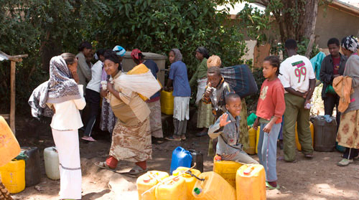
Figure 15.1 A public water point in Addis Ababa.

15.5.2 Selling water using tankers
Private sellers also supply water through the use of water tankers (Figure 15.2) licensed by the government. This happens in areas not served by a piped water distribution system. The tanker usually has a capacity of 20,000 litres and the water is pumped into water storage tanks at the households, which usually have a capacity of about 3000 litres.
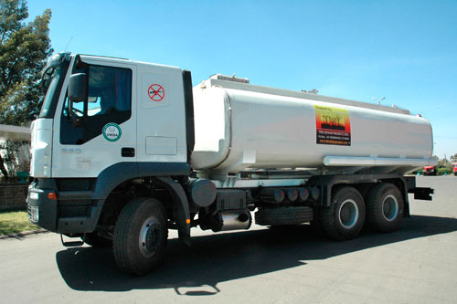
Figure 15.2 A water tanker in Denan, Ogaden.

15.5.3 Water vendors
In a survey of three poor areas of Addis Ababa (Sharma and Bereket, 2008), it was found that 17% of the respondents (Figure 15.3) obtained their water from water vendors who had originally purchased the water from the public water utility (the Addis Ababa Water and Sewerage Authority). The water vendors in cities are usually people who have private taps in their homes or yards and who sell water from these. The price at which the vendors sold the water to the end users was again about eight times the price paid for the water, corroborating the findings of Howard (2005). Sharma and Bereket found in their survey that most people would have preferred to have their own private tap but the high initial cost of a private connection was prohibitive. If this could be paid in small instalments, 90% of those keen to acquire a private tap would take up the option. In Kombolcha, in Amhara Region it is possible to do this, with the set-up cost being paid in four instalments. There is scope for a private–public partnership here, with private companies providing the administrative arrangements to collect the instalments.
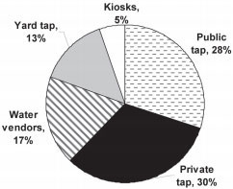
Figure 15.3 Means of obtaining water in three poor areas of Addis Ababa in 2008. (Sharma and Bereket, 2008)
There are also water vendors who sell water from horse-drawn or donkey-drawn carts (Figure 15.4).
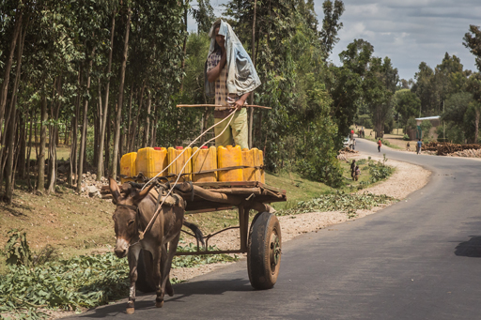
Figure 15.4 A water vendor selling from a donkey-drawn cart in Ethiopia.

15.5.4 Selling water at kiosks
Sharma and Bereket (2008) found that the price of the water at kiosks (Figure 15.5, which were described in Study Session 7) was about three times the cost of water from the water utility. Water kiosks are common in the countries of sub-Saharan Africa, and water is brought from the kiosk owner’s home to the kiosk and sold. Alternatively, if the kiosk is near the home of the owner, a hose connection to the house tap enables water to be sold direct. In a typical day a kiosk can serve 500–3000 people bringing their own water containers.
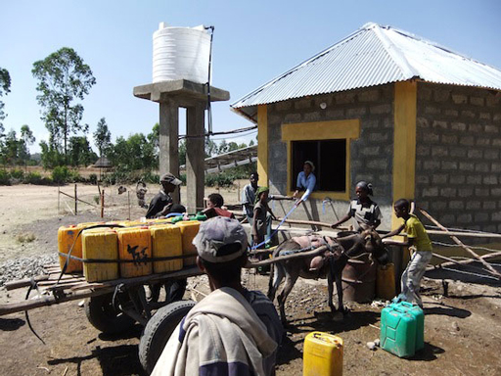
Figure 15.5 A water kiosk in Afto, Ethiopia.

15.5.5 Selling water-related services
As part of the water industry, several microenterprises have emerged to supply plumbing services such as fixing leaks, extending pipelines around a house or compound, and selling and installing plumbing systems (such as tanks, pipes, latrines, WCs, etc.) (Figure 15.6).
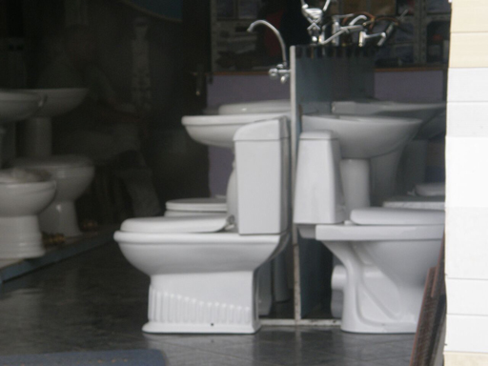
Figure 15.6 A toilet shop in Addis Ababa.

Summary of Study Session 15
In Study Session 15 you have learned that:
- It is possible to obtain water from entities other than public utilities.
- One such possibility is a public–private partnership, where private companies collaborate with a public body to provide water services. These partnerships have the potential to bring about a more efficient service.
- Microenterprises are small businesses with fewer than ten staff members.
- In the water sector in Ethiopia, microenterprises operate some of the public taps, as well as undertaking tanker deliveries, water vending and water kiosk management.
- Microenterprises can also be set up for water-related services, such as plumbing and supplying equipment.

Self-Assessment Questions (SAQs) for Study Session 15
Now that you have completed this study session, you can assess how well you have achieved its Learning Outcomes by answering these. You can check your answers with the Notes on the Self-Assessment Questions at the end of this Module.

SAQ 15.1 (tests Learning Outcome 15.1)
Write the following words next to their correct definitions in the table below:
labour productivity, microenterprises, public–private partnerships.
small businesses with fewer than ten people working in them
a collaboration between a public body and private companies
the amount of work that each employee does

SAQ 15.2 (tests Learning Outcome 15.2)
From the report by Marin (2009) on public–private partnerships, which of the following statements are false? Give reasons why they are so.
- A public–private partnership always results in more people having access to piped water.
- Public–private partnerships often result in improved service quality.
- Public–private partnerships are very efficient at collecting payments but don’t worry about non-revenue water.
- In public–private partnerships labour productivity increases, due only to reduction in staff numbers.
- The figures indicate that public–private partnerships are becoming more popular.

SAQ 15.3 (tests Learning Outcome 15.2)
List and briefly describe the measures by which the success or otherwise of a public–private partnership providing water supply services can be assessed.

SAQ 15.4 (tests Learning Outcome 15.3)
- Name two types of microenterprise that supply water to poor people in Ethiopian towns and cities.
- What is the main disadvantage that these consumers face?
- According to Sharma and Bereket (2008), what would help to overcome the above disadvantage?

Notes on the Self-Assessment Questions (SAQs) for Urban Water Supply

Study Session 1

SAQ 1.1
improved water sources | water sources that are protected from contamination, especially by faecal matter
raw water | water that has not yet been treated
drip-feed irrigation | a form of irrigation where water is put at the base of a plant, using narrow pipes
hydroelectric power | power produced by harnessing the energy of moving water
distribution mains | pipes that take water from a service reservoir to different areas
aquaculture | the farming of aquatic organisms
spring | a point where water flows out of the ground
surface water | water from rivers, lakes, pools and ponds
transmission mains | pipes that take treated water from a treatment plant to service reservoirs
spray irrigation | a form of irrigation where water is sprayed over plants
groundwater | water that is underground
pathogenic micro-organisms | micro-organisms that cause disease
geothermal energy | energy derived from the heat of the earth
water tower | an elevated structure that has a water tank to supply drinking water by gravity
abstraction | the taking of water from a source
service reservoirs | stores of water that balance the fluctuating water demands of users against the steady output of the water treatment plant

SAQ 1.2
If in two minutes you wrote ‘irrigation, industry, mining, power generation, aquaculture, recreation’, you would be richer by 1000 Birr!

SAQ 1.3
The completed statements, in the correct order, are as follows:
(b) Raw water is abstracted from a river or a lake.
(e) Water undergoes treatment so that it is safe for human consumption.
(a) Water is taken from the treatment plant to service reservoirs by transmission mains.
(d) Water is taken from the service reservoirs to consumers by distribution mains.
(c) Water is stored at home in case of a cut in water supply.

SAQ 1.4
The following would not help:
Ensuring that the local water office always has new members of staff so that they are enthusiastic. It is better to have staff who stay on in their jobs as they will gain experience and manage the system well.
Reducing the interaction between the different organisations involved so that less time is wasted. Interaction between stakeholders is important because they need to coordinate their activities with each other.

Study Session 2

SAQ 2.1
sanitation | the prevention of human contact with waste
potable water | another way of saying ‘safe drinking water’
total coliforms | the total number of coliform bacteria (which come from faecal matter and other sources)
safe drinking water | water that does not have any components that can harm people
concentration | the amount of a substance in a given volume of water
helminths | worms that live as parasites in humans and animals
fluorosis | an abnormal condition that results from an excess of fluoride in the body
palatable water | water that is pleasant to drink
water-related diseases | diseases transmitted by insects that breed or feed in or near water
bacteria | single-celled organisms ranging in size from 0.5 to 5.0 µm
infectious agents | micro-organisms and viruses that can invade the human body and cause disease
turbidity | cloudiness caused by a large number of tiny particles in a liquid
faecal coliforms | coliform bacteria that originate from faeces
water-based diseases | diseases caused by parasites that spend part of their life cycle in water
enteric | concerned with the intestine
indicator | a biological species that gives information about the environment
waterborne diseases | diseases that are caused through the ingestion of water contaminated by human or animal faeces containing pathogens
protozoa | single-celled micro-organisms that are much larger than bacteria
water-washed diseases | diseases that occur due to inadequate water being available for good personal hygiene
viruses | small infectious particles that are much smaller than bacteria

SAQ 2.2
- Water plays the following roles in the human body:
- aids swallowing and digestion of the food that we eat
- is used to remove toxins and waste products from the body
- transports nutrients to where they are needed in the body
- helps to maintain the body at the right temperature.
- The people who are most vulnerable to waterborne diseases are:
- infants
- young children
- older people
- people who are weak due to suffering from other diseases.

SAQ 2.3
(a) amoebiasis, (c) schistosomiasis and (e) giardiasis can be transmitted through faecal matter from infected persons entering water sources, hence the construction and use of latrines would help to reduce their transmission.
(b) dracunculiasis is caused by consuming water that contains copepods and is not related to human faecal contamination; (d) malaria is transmitted by the Anopheles mosquito, which breeds in stagnant water. Latrines would not have any impact on these two diseases.

SAQ 2.4
        - The issue of open defecation is the most important public health issue as this leads to disease.
        - Abebe may have caught a waterborne disease (e.g. diarrhoeal disease such as cholera or typhoid), a water-based disease (e.g. bilharzia), or a water-related disease (e.g. malaria).
        - Open defecation may have contaminated the water in Lake Tana, making anyone using the water vulnerable to disease. The lake could also be a breeding ground for mosquitoes that cause malaria, or snails that carry bilharzia.

SAQ 2.5
A is false. E. coli is a type of bacterium, not a type of virus.
C is false. If a water sample is positive for E. coli this indicates faecal contamination, which means it is likely that pathogens are present in the water.
D is also false. The absence of E. coli indicates the water is not contaminated with bacteria of faecal origin but it does not mean the water is necessarily safe to drink because it may still contain pathogens.

Study Session 3

SAQ 3.1
permeable rocks | rocks that allow water to pass through them
sand dam | a means of storing water using sand and a dam
water table | the level of water below ground
rainwater harvesting | the process of collecting and storing rainwater
protected water sources | water sources that have structures to prevent the entry of contaminants
percolated | passed through a porous material or through small holes
drinking water ladder | something that describes the steps in improvement of quality of water supply
run-off | rainwater that runs off land
unprotected water sources | water sources that do not have protective structures to stop them being contaminated
precipitation | any form of water that falls on the Earth’s surface
aquifers | layers of rock underground that hold water

SAQ 3.2
Water source | Characteristics
groundwater | - likely to be free from pathogenic bacteria  - can often have a high mineral content  - difficult to treat if contaminated.
surface water | - quality can change with location and season  - usually requires treatment  - can be easily polluted by industry and agriculture.
rainwater | - free of charge  - can be polluted by bird droppings.

SAQ 3.3
The users of the spring should be advised to:
- avoid open defecation around the spring
- not construct latrines above the spring because of the danger of contaminating the groundwater
- use latrines properly
- keep animals away from the spring.

SAQ 3.4
There should be a raised, smooth-sloping area around the pump for user safety and also so that any surface water or spillage runs off. The rock wall should be increased in height and a gate installed so that no animals can get near the pump and contaminate the area.

SAQ 3.5
D is false. It is better to find a water source that is of good quality so that minimal treatment is required. This will keep costs low.

SAQ 3.6
The following are important factors for an ideal water source:
- capable of providing a supply that satisfies the anticipated demand and, in the case of groundwater, the rate of extraction not exceeding the rate of replenishment
- good water quality
- near to the consumers
- economical to use
- abstraction having minimal environmental impact.

Study Session 4

SAQ 4.1
eutrophication | a process by which a high concentration of nutrients, especially phosphates and nitrates from agricultural or other activities, enters a water body and lead to excessive plant growth and eventual decay, resulting in depletion of oxygen in the water
aerobic | containing oxygen
organic matter | material that comes from living organisms
septic tank | an underground tank into which sewage is piped
point-source of pollution | an identifiable source of pollution
soil erosion | the washing away of soil by rainwater run-off
inorganic material | material which does not originate from living organisms
sewerage | a network of sewers
algal bloom | a sudden increase in the algal population
non-point source of pollution | a source of pollution that encompasses a wide area, the exact point of origin being difficult to ascertain
suspended solids | particles carried in flowing water
pollution | the introduction into the environment of substances likely to cause harm to humans, animals, plants and the environment in general
pollutants | substances that can cause harm to human health, plants, animals and the environment in general
sewage | mixed wastewater that contains human waste from flush toilets
diffuse pollution | pollution from non-point sources
catchment | the area of surrounding land that slopes towards a river
sediments | solids that have settled at the bottom of a river
leachate | a polluting liquid that is produced when water passes through materials and takes with it components from them
anaerobic | without oxygen
photosynthesis | the process by which plants generate chemical energy

SAQ 4.2
        - The answer is as follows:
Category of water pollutant | Examples
Sediments and suspended solids | sand, silt
Organic matter | faecal matter
Biological pollutants | bacteria, protozoa, intestinal worms
Plant nutrients | nitrates, phosphates
Other chemical pollutants | copper, lead, insecticides
        - There are several possibilities, listed below.
A residential area: human excreta, wastewater containing dissolved and suspended organic matter, suspended inorganic matter, pathogenic micro-organisms
A metal plating plant: cyanides, heavy metals
Agricultural activities: nitrates, phosphates, pesticides
An uncontrolled landfill site: leachate containing dissolved organic matter, inorganic components and heavy metals
Urban surface water run-off: sediment, metals, hydrocarbons, rubber, detergents, litter

SAQ 4.3
- There are likely to be nitrates and phosphates in the river water which are vital to plant growth.
- The presence of a high number of faecal coliforms indicates that the water is unsafe, and also that other micro-organisms, which may be pathogenic, may be present. The concentrations of copper, zinc, iron, lead and manganese in the river water are all greater than the guideline values recommended by the FAO. This implies that they are harmful.
- Pollution control at source is required. This would entail treating the sewage, industrial effluents and slaughterhouse wastewaters before they are discharged into the river.

SAQ 4.4
A is false. Latrines should be below a water source on sloping ground otherwise seepage from the pit could flow down into the water source.
B is false. The protection measures are correct but the cover should have a lock.
E is false. Water use is relevant to several different ministries, all of which should be consulted when legislation is being prepared.

Study Session 5

SAQ 5.1
defluoridation | removal of excess fluoride from water
sustainable | able to be maintained at its best for many years
water utility | the organisation that is responsible for producing and distributing drinking water
coagulant | a chemical used in water treatment to neutralise the charge on fine particles
coarse screens | steel bars that have a spacing of 5–15 cm
coagulation | the neutralisation of the electrical charge of particles by using a coagulant
sedimentation | settling of solids
pre-chlorination | chlorination before the main treatment stages of the water purification process
filtration | separation of solids from a liquid
fluoridation | the addition of fluoride
water treatment | the process by which harmful substances are removed from water so that it is safe for human consumption
disinfection | the elimination of micro-organisms that can cause disease
resilience | the ability to withstand stress or a natural hazard
mechanised | where machines are used to carry out a function
flocculation | the process whereby the size of particles increases as a result of particle combining together
fine screens | steel bars with a spacing of 5–20 mm
flocculant | a chemical that assists the process of flocculation
microstrainer | a rotating drum with a stainless steel fabric with a stainless steel fabric with a mesh size ranging from 15 µm to 64 µm
residual chlorine | the amount of chlorine left after all the pollutants have reacted with it
aerated | supplied with air
contact time | the duration for which the water undergoing treatment is exposed to a disinfectant

SAQ 5.2
Your diagram should look something like Figure 5.9.
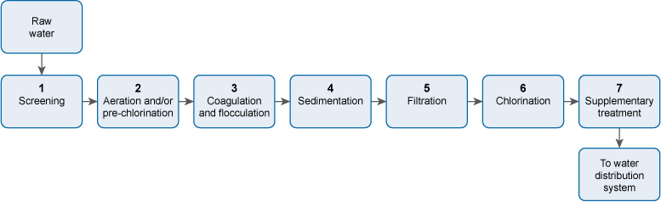
Figure 5.9 The seven-stage process of water treatment.
Stage 1 Screening removes large floating and suspended solids, which can damage equipment in the plant, or block pipework.
Stage 2 Aeration expels acidic gases such as carbon dioxide and hydrogen sulphide, and gaseous organic compounds that can give an unpleasant taste to the water. Aeration also oxidises iron and manganese to their solid form so that they can be removed, thereby eliminating bad flavour and staining. If excess algae are present in the raw water, pre-chlorination is carried out. The chlorine also oxidises compounds that cause taste and odour.
Stage 3 Coagulation neutralises the negative electrical charge in particles in the water, which enables the particles to come together to form flocs. Flocculation results in large flocs forming.
Stage 4 The large flocs formed during flocculation settle out in the sedimentation stage, leaving largely clear water.
Stage 5 Any solids remaining in the water after sedimentation are removed during filtration.
Stage 6 The water is then chlorinated to kill any pathogenic micro-organisms present.
Stage 7 Supplementary treatment, such as the addition of fluoride, or the reduction of the fluoride level, then takes place.

SAQ 5.3
You should have identified the following wastes for each option.
Management option | Waste
Sent to landfill | Coarse screenings; fine screenings (if no sewer present); sludge from the sedimentation tank
Recycled | Plastic chemical drums
Discharged to sewer | Fine screenings; backwash from the rapid gravity sand filter
Reused | Wooden and cardboard packaging
Taken to a sewage treatment plant | Sludge from the sedimentation tank

SAQ 5.4
(c) Using a diesel generator for running the pumps and compressors will not contribute to sustainability and resilience. Diesel is a non-renewable source of energy and will run out in time. It is better to use a renewable source of energy, for example electricity generated by solar or wind power.
(e) Using the cheapest equipment that is on the market will also not contribute to sustainability and resilience. The cheapest equipment is often the least robust and is likely to fail before long.

SAQ 5.5
Using data from Tables 5.1 and 5.2, the water requirement each day for the extra population will be 80 litres × 30,000 = 2,400,000 litres, or 2400 m³.
The three health centres will need 135 litres × 250 = 33,750 litres a day, or 33.75 m³ a day.
The day school will need 18.5 litres × 1500 = 27,750 litres a day, or 27.75 m³ a day.
The total additional water requirement will be 2400 + 33.75 + 22.75 = 2461.5 m³.
With allowance for leakage, etc. the water requirement will be 2461.5 m³ × 1.15 = 2830.7 m³, say, 2831 m³.
The service reservoir has to hold 2831 m³ × 1.5 = 4246.5 m³, say, 4247 m³.
Thus, the water requirement in the new area would be 2831 m³ per day, and the size of service reservoir required would be 4247 m³.

Study Session 6

SAQ 6.1
Here is the completed paragraph.
A water supply scheme is being planned in a town in Benishangul-Gumuz Region, in western Ethiopia. Different groups of people, referred to as stakeholders, who will be affected by the scheme, are called for a meeting. Their main worry is that floods will affect the new treatment plant, but the Planning Engineer assures them the plant will be resilient. They are also worried about costs and whether decisions will be made objectively. The Finance Manager at the water utility tells them they use a technique based on life-cycle cost that will help them make the right choice. The equipment and buildings, often referred to as assets, will be well looked after through regular maintenance. The frequency of maintenance will be decided by considering the criticality of each asset. For the benefit of new members of staff, full details of all the assets are kept in the asset register. New plant operators and technicians will have the operation and maintenance manual available to guide them in the operation of the water supply system. Within it are standard operating procedures to use when starting up and operating equipment. A major issue is spare parts, since the town is several hours from Asosa, the Region’s capital. Again, this has been considered – the water utility has opted for standardisation of all its equipment and parts to make stock-keeping and maintenance much easier, thus helping to ensure continuity of water supply.

SAQ 6.2
Activity | Department responsible
Interviewing candidates for the role of operator | Human Resources Management
Distributing information on how customers can reduce their water consumption and save money | Corporate Affairs
Repairing a sewer pipe that has been broken by a developer digging a trench to lay telephone cables | Sewerage
Checking that the water that goes to the consumers is safe | Water Quality Assurance
Making sure that the water supply is continuous | Operation and Maintenance
Helping Ayinabeba, a new customer, to process the paperwork for water supply at her house | Commercial and Customer Care
Sending water bills out to customers | Finance

SAQ 6.3
The answer is (c). Planning for increased demand of water is done by the Planning Department.

SAQ 6.4
The two types of maintenance are breakdown maintenance and preventive maintenance. Preventive maintenance is better because it helps prevent breakdowns and ensures that the assets can be used until the end of their service life. By undertaking preventive maintenance, crises – which are costly – can be avoided.

SAQ 6.5
All electrical equipment should be installed at a height that the floodwaters are unlikely to reach.

Study Session 7

SAQ 7.1
leakage | the escape of water from pipes or other parts of the water distribution system
noise correlator | a device that is used at two points to pinpoint leaks through the sound that is generated by water escaping
active leakage control | searching for leaks and repairing them
corrosion | the process whereby a metal gets weaker due to a reaction with its environment
back-siphonage | the drawing of external water into a water main as a result of a reduction in pressure in the water main
proactive leakage control | taking action to prevent leaks from occurring
ground penetrating radar | a device used to detect leaks by identifying where the ground has cavities, or has been disturbed
non-revenue water | water from which no income is received
acoustic logger | a device attached to a pipe that can indicate a leak when the noise in the pipe changes

SAQ 7.2
Water reaches the consumers through indoor taps, taps in the yard, public taps and water kiosks.

SAQ 7.3
The answer is (c). An illegal connection is loss of water through theft, and not through leakage.

SAQ 7.4
The answer is C, because the people who use water from illegal connections don’t pay for the water.

Study Session 8

SAQ 8.1
hazardous event | an event that can introduce a hazard to a water supply
Water Safety Plan | a plan that proactively seeks to identify and control risks to safe and continuous water supply
compliance monitoring | analysis of water to check that it is within standards
audit trail | documentation of the sequence of activities that led to a given decision
risk assessment | the process by which the likelihood of harm from a potential hazard is assessed
hazard | anything that can cause harm
incident | an emergency
risk | the chance of a hazard occurring
supporting programmes | training programmes that contribute to the delivery of safe water

SAQ 8.2
A Water Safety Plan is necessary to ensure that the water that is produced and delivered to consumers is safe. It also ensures that the chance of an incident disrupting the continuous supply of water is minimised.

SAQ 8.3
- The correct order is:
  - Assemble a team of experts.
  - Describe the water supply system.
  - Identify the hazards and hazardous events.
  - Carry out a risk assessment and prioritise the risks.
  - Identify the control measures needed for each risk.
  - Define the monitoring system for each control measure.
  - Prepare management procedures.
  - Prepare a verification programme to check that the Water Safety Plan is working.
  - Develop supporting programmes.
  - Document all of the steps.
- Your answers should be along the following lines:
Hazard assessment: The well is open and presents several hazards. There is no wall around it, so people or animals can contaminate the water easily, either by entering the water, or by people using contaminated utensils or containers when collecting water. There is a possibility of surface water running into it, and also wind-blown debris entering the water.
Risk assessment: The risk of contamination is high, especially since it is the sole source of water for the village, so the risk assessment score will also be high.
Identification of control measures needed for each risk: A metre-high concrete wall around the well will be an effective means of preventing direct contact with the water. A rope-and-pulley system should be set up with a bucket so that water can be drawn from the well. This water can then be put into containers brought by the people. A wall will also keep out surface run-off and wind-blown debris.
Definition of the monitoring system for each control measure: Regular inspection (say, monthly) of the wall must be undertaken to ensure that it is not cracked. The pulley-and-bucket system should also be checked (say, weekly) to ensure that it is working properly and is kept clean. The bucket should be checked for cracks.

SAQ 8.4
The following measures improved the safety of the water supply:
- Raising the awareness of the community to good hygiene and sanitation led to cleaner water points and improved water handling, both at the water points and in residents’ homes.
- The construction of more latrines led to a reduction in open defecation.
- Making the water points secure by repairing the fencing and installing gates (where necessary) helped prevent contamination by animals.

Study Session 9

SAQ 9.1
parameter | any measurable factor
drinking water standards | quality parameters set for drinking water
asset management | a process that helps to ensure continuous water supply at minimal cost

SAQ 9.2
The most appropriate choice of words is shown below.
Column A | Column B
Rapidly set up an emergency water supply system with road tankers when the mains supply was cut due to construction work | responsive
Make sure everything happens with minimal duplication of effort | efficient
Operate free from pressure from local businesses and the village chief | independent
Consider the opinions of all the stakeholders in a project to divert a river, and then arrive at a decision that is acceptable to the majority | obtaining a consensus
Explain to a village why its water supply was cut for three days | accountable
Everyone comes together to decide on the location of a water tower | participation
Make sure all the villages in a given area are included in a water supply scheme and that each village gets adequate water for all its needs | equitable and inclusive
Allow people to see the paperwork on how a tender was awarded | transparent
Choose the right water treatment method to get rid of fluoride | effective

SAQ 9.3
A is false. Asset management for a water utility encompasses all the assets related to water supply, not just the water treatment plant.
C is also false. The Asset Management Plan has to be reviewed regularly and revised as necessary.

SAQ 9.4
The preferred sequence is as follows:
- Listen to the complaint.
- Understand the issue.
- Resolve the complaint.
- Document the complaint and how it was resolved.
- Learn from the complaint and rectify any problems.

SAQ 9.5
You should have identified the following chemical substances in the ‘Parameters’ column.
Condition | Parameter(s) that need to be controlled
Reddish-brown colour in the water | Iron
Methaemoglobinaemia | Nitrate, nitrite
Skin cancer | Arsenic
Salty taste | Chloride
Damage to the nervous system | Copper, cyanide, lead, manganese, mercury
Kidney problems | Cadmium, mercury
Corrosion of pipes | Sulphate
An objectionable, pungent odour | Ammonia
Fluorosis | Fluoride

Study Session 10

SAQ 10.1
Here is Kedir’s completed message.
Dear Householders,
The water supply is presently muddy due to an accidental breakage of the main water line. Do not worry. We have ways of making the water safe. The first thing to do is to settle out the mud. This can be done by a process called sedimentation. To encourage this, we can use coagulants. The crushed seeds of the Moringa fruit can be used as a natural coagulant. If many containers are available in your household, the three-pot method is an option. In this method, the water is settled for at least two days before consumption. Another way to get rid of the mud is by filtration. The simplest way is to use a cloth. If you have time, you can make your own household sand filter using a pot and a container, sand and gravel. A third option is to use ceramic filtration but this involves setting up a new system that is more costly than the two mentioned just now.
Now, after sedimentation or filtration the water will look clean – but it probably isn’t, because of micro-organisms that may be present. To get rid of any pathogenic micro-organisms, the water has to be disinfected. Perhaps the easiest, most effective and fastest way of doing this is by boiling the water for five minutes. If we do not have fuel at hand, or want to save fuel, we can use solar disinfection. For this we need to put the water into clear plastic bottles, with their labels removed, and expose it to sunlight for six hours. Another way is to use Aquatabs, which require a contact time of 30 minutes.
We will do our best to repair the pipe as soon as possible but if we can’t, we will deliver water treatment chemicals like Wuha Agar and sachets of Bishan Gari to you. With these we will send technicians to give guidance on how they are to be used.
With best wishes,
Yours sincerely,
Kedir Seid
(Senior Environmental Health Officer)

SAQ 10.2
The water collection container should be clean, have handles and not have contained anything toxic before. The mouth of the container should be narrow and have a lid.

SAQ 10.3
A is false. The plastic should be resistant to oxidation so that it lasts a long time.
C is false. The opening should be 6–9 cm wide to facilitate cleaning of the container.
E is false. This method of taking the water out is likely to lead to the transfer of contamination from hands to the water within the container.

Study Session 11

SAQ 11.1
biodegradation | the breaking down of complex materials by micro-organisms
symbiotic relationship | a relationship where two parties live together for mutual benefit
waste stabilisation ponds | a system of ponds to treat wastewater using sunlight and wind
retention time | the time that the effluent spends in an environment
facultative ponds | ponds that have oxygen at the top and are without oxygen at the bottom
maturation ponds | ponds in which the pathogenic bacteria and viruses in an effluent are eliminated
impervious material | material that does not let anything pass through it
diffusion | the process by which something moves naturally from a region of high concentration to one of low concentration

SAQ 11.2
- Yes, there are several ways Zewedu can save water and hence reduce his water bill. He can put one or two 1-litre bottles of sand in his toilet cistern to reduce the amount of water used per flush. He can also take other steps such as fixing leaking taps; not leaving the tap on when brushing his teeth or shaving; using rainwater for purposes other than human consumption; using greywater for watering the plants, remembering to do it early in the morning or late in the evening to minimise any loss of water by evaporation.
- From Table 11.1 we know that the aerator nozzles can give up to 20% savings in water use. Since the current water use from the tap which is to have the nozzle fitted is 65 litres a day, a saving of (20 / 100) × 65 = 13 litres a day can be expected.

SAQ 11.3
D is false. After sand filtration there may still be pathogens in the rainwater, and these have to be eliminated to make the water safe for humans to drink.

SAQ 11.4
B is false. The bacteria and algae help each other to survive through a symbiotic relationship.
D is false. Other safety measures, such as wearing gloves and boots, having a buffer zone if spray irrigation is used, washing thoroughly after being in its vicinity, and avoiding all contact with the effluent, are all necessary.
E is false. The maturation ponds in the treatment system can be used for farming fish and ducks.

Study Session 12

SAQ 12.1
sanitary inspection | a means of identifying the pollution sources and health hazards around a water source
phytoplankton | microscopic plants that live in water
non-degradable plastic | plastic that does not break down over time
representative sample | having all the characteristics of the matter that it was taken from

SAQ 12.2
- You would need to take an appropriate checklist of questions to ensure that you inspect thoroughly and don’t forget anything. You will also need a notebook and pen or pencil to record all the information you collect.
- Important things to look for include the location of any latrines or other possible sources of contamination (due to farming or industrial activities) relative to the river, the possibility of any landslide or mudflow, a good solid fence, a screen on the intake, the presence of a dam, the presence of a filter and, if a filter is present, that it is operating properly, and whether there is any uncontrolled flow. Your answer could include any four of these or related issues.

SAQ 12.3
The correct sequence is:
- Remove any dirt in the tap outlet using a clean cloth.
- Turn the tap full on and let it run for about two minutes.
- Use a flame to sterilise the tap outlet.
- Turn on the tap half-way to maximum and let the water flow for about two minutes.
- Open a sterilised bottle carefully and hold the cap facing downwards.
- Fill the bottle nearly to the top by holding it under the water flow.
- Screw on the bottle cap.

SAQ 12.4
Ashenafi told Kuleni that the water is regularly analysed by the water utility itself to check that its quality is within standards. In addition he told her that the Food, Medicine and Health Care Administration and Control Authority also undertakes regular checks of the water quality. If there is any deterioration in water quality, Ashenafi told Kuleni that he can tell the water utility and also their Woreda Health Office. The Woreda Health Office will then ask the Regional Public Health Laboratory to investigate and recommend remedial measures. The Food, Medicine and Health Care Administration and Control Authority is also likely to notice any drop in water quality, and would also investigate the matter.

Study Session 13

SAQ 13.1
social tariff | a water tariff for those who are poor, which aims to recover only O&M costs
microloan | a small amount of money lent at a low interest rate to a person on a low income
vulnerable people | people who can be harmed through not having money to buy the water they need
smart meter | a meter that sends water consumption data electronically to the water utility
block | a given amount of water for which there is a certain water tariff
water tariff | the price that is set for water
full cost recovery | where capital and O&M costs are all recouped

SAQ 13.2
They would probably have said that for water to be safe, it has to be treated. The treatment process is quite complicated, with many steps, and requires equipment, energy and chemicals. Money is needed for this, and also for the pipelines and pumps to take the water to their village. The fairest way of recouping the money is to charge people for the amount of water they use.

SAQ 13.3
- O&M costs include the salaries and benefits of the staff; administrative and office costs; and the costs associated with water production and distribution (such as the cost of chemicals, energy, repair and maintenance, and water analysis).
Capital costs refer to the cost of new equipment; money needed for expansion of the existing system to cope with increased demand for water; and money required for external professional and technical support.
- The lower water tariff for domestic use is balanced by the higher water tariff charged to industrial and commercial establishments.

SAQ 13.4
Here are some points you may have thought of.
 | Simple meter | Smart meter
Advantages | Low cost  Simple  Robust  Gives employment for people as meter readers are needed | Does not require a meter reader to visit to take a reading  A water bill can be generated quickly and automatically  Can give a warning if there is a leak  The user can see the hourly rate of water consumption
Disadvantages | Requires a person to physically collect data  Generating a water bill takes time  Will not warn of a leak  Does not inform user of hourly water usage | Costly  Relies on sophisticated technology that requires technical expertise  Needs to be handled carefully  Reduces the opportunities for employment

SAQ 13.5
He should be advised to obtain a microloan if he can. This type of loan is designed for people in his situation, and charges a low interest rate.

Study Session 14

SAQ 14.1
internally displaced people | people who have been forced to flee to another part of their own country due to factors beyond their control
flooding | an abnormal rise in water level that can cause damage
disease outbreak | an unexpected rise in the number of cases of a disease
microfiltration | a means of separating from water particles that are 0.05 to 0.5 µm in size
water emergency | an event that disrupts the normal supply of water
emergencies | sudden, unexpected, hazardous events
drought | a deficiency in precipitation that lasts for a long period of time
flash flood | short-duration flooding that occurs due to sudden heavy rainfall that is unable to drain away into the ground

SAQ 14.2
- Three possible natural causes of water emergencies: drought; flooding; earthquakes.
Three possible causes of water emergencies due to humans: accidental contamination of the water supply (as in the Camelford incident); microbial contamination of water sources due to human mismanagement (such as the cholera outbreak in Haiti); deliberate poisoning of the water supply as an act of terrorism.
- The possible options for safe water supply during a water emergency are:
- delivery of water to consumers by water tanker and/or bottles
- treatment of the water at the household to render it safe (e.g. by boiling).

SAQ 14.3
- The two treatment steps needed in household water treatment during a water emergency are filtration and disinfection.
- Three options for filtration: cloth filtration, household sand filtration and ceramic filtration.
Three options for disinfection: boiling, solar disinfection and chlorination. (Other possibilities are the use of commercial products such as Bishan Gari, Aquatabs or P&G Purifier of Water).
- Bishan Gari and P&G Purifier of Water.
- The solids in the water should be settled out and the water boiled before consumption.

SAQ 14.4
The answer depends on the type and extent of the emergency but you may have identified the following groups of people.
- People who live in a residential area in a city – it is likely that a piped water system exists in such an area, so an emergency water treatment and supply system would not be needed.
- Refugees who have fled to cities in a neighbouring country due to fighting in their own – most cities will have piped water systems in place.

SAQ 14.5
- The stages of water treatment for an emergency water supply based on a water source where the level of suspended solids is high would be: addition of coagulant, sedimentation and chlorination.
- The raw water will be obtained from groundwater sources if available, as this will usually require only minimal treatment. The second option would be to use surface waters (for example, from a river or lake).
- The coagulant and disinfection agents that are most commonly used in emergency water treatment are aluminium sulphate and calcium hypochlorite, respectively.
- The residual chlorine level in an emergency water supply is raised to 1 mg l^{–1} once a week in order to disinfect the water containers used by the people served by the supply.

Study Session 15

SAQ 15.1
microenterprises | small businesses with fewer than ten people working in them
public–private partnerships | a collaboration between a public body and private companies
labour productivity | the amount of work that each employee does

SAQ 15.2
A is false. Increased access comes about only when the public partner invests the money.
C is false. Because they are concerned about income, public–private partnerships pay a lot of attention to reducing non-revenue water.
D is false. Labour productivity increases due to two factors: a reduction in staff numbers and an increase in the number of customers.

SAQ 15.3
The following criteria may be used to measure the success of a PPP providing water supply.
- Accessibility – the extent of coverage of the population, and the distance to the water point.
- Affordability – the cost of the water needed should be less than 5% of the household’s income.
- Cost recovery – the cost of providing the water should be claimed back from the population.
- Minimisation of non-revenue water – this should be reduced to 15% or less.
- Water quality – the water should meet national standards for quality.
- Operational efficiency – the quantity of water supplied per capita, and the duration of water supply per day.

SAQ 15.4
- The microenterprises concerned are water kiosks and water vendors.
- The main disadvantage consumers face is the high cost of the water.
- This disadvantage can be overcome by assistance provided to the consumers to obtain their own private water connections.

Key terms

Key term | Study session
abstraction | 1
acoustic logger | 7
active leakage control | 7
aerated | 5
aerobic | 4
algal bloom | 4
anaerobic | 4
aquaculture | 1
aquifers | 3
asset management | 9
asset register | 6
assets | 6
audit trail | 8
back-siphonage | 7
bacteria | 2
biodegradation | 11
Bishan Gari | 10
block (of water) | 13
catchment | 4
ceramic filtration | 10
cloth filtration | 10
coagulant | 5
coagulation | 5
coarse screens | 5
compliance monitoring | 8
concentration | 2
contact time | 5
corrosion | 7
criticality | 6
defluoridation | 5
diffuse pollution | 4
diffusion | 11
disease outbreak | 14
disinfection | 5
distribution mains | 1
drinking water ladder | 3
drinking water standards | 9
drip-feed irrigation | 1
drought | 14
emergencies | 14
enteric | 2
eutrophication | 4
facultative ponds | 11
faecal coliforms | 2
filtration | 5
fine screens | 5
flash flood | 14
flocculant | 5
flocculation | 5
flooding | 14
fluoridation | 5
fluorosis | 2
full cost recovery | 13
geothermal energy | 1
ground penetrating radar | 7
groundwater | 1
hazard | 8
hazardous event | 8
helminths | 2
household sand filter | 10
hydroelectric power | 1
impervious material | 11
improved sources (of water) | 1
incident (in water supply) | 8
indicator | 2
infectious agents | 2
inorganic material | 4
internally displaced people | 14
labour productivity | 15
leachate | 4
leakage | 7
life-cycle cost | 6
maintenance | 6
maturation ponds | 11
mechanised | 5
microenterprises | 15
microfiltration | 14
microloan | 13
micro-organisms | 1
microstrainer | 5
Moringa fruit | 10
noise correlator | 7
non-degradable plastic | 12
non-point source of pollution | 4
non-revenue water | 7
operation | 6
operation and maintenance (O&M) | 6
organic matter | 4
palatable water | 2
parameter | 9
pathogenic | 1
percolated | 3
permeable rocks | 3
photosynthesis | 4
phytoplankton | 12
point source of pollution | 4
pollutants | 4
pollution | 4
potable water | 2
pre-chlorination | 5
precipitation | 3
proactive leakage control | 7
protected water sources | 3
protozoa | 2
public–private partnerships | 15
rainwater harvesting | 3
raw water | 1
representative sample | 12
residual chlorine | 5
resilience | 5
retention time | 11
risk | 8
risk assessment | 8
run-off | 3
safe drinking water | 2
sand dam | 3
sanitary inspection | 12
sanitation | 2
sedimentation | 5
sediments | 4
septic tank | 4
service reservoirs | 1
sewage | 4
sewerage | 4
smart meter | 13
social tariff | 13
soil erosion | 4
solar disinfection (SODIS) | 10
spray irrigation | 1
spring | 1
stakeholders | 6
standard operating procedures (SOPs) | 6
standardisation | 6
supporting programmes | 8
surface water | 1
suspended solids | 4
sustainable | 5
symbiotic relationship | 11
three-pot method | 10
total coliforms | 2
transmission mains | 1
turbidity | 2
unprotected water sources | 3
viruses | 2
vulnerable people | 13
waste stabilisation ponds | 11
water-based diseases | 2
waterborne diseases | 2
water emergency | 14
water-related diseases | 2
Water Safety Plan | 8
water table | 3
water tariff | 13
water tower | 1
water treatment | 5
water utility | 5
water-washed diseases | 2
Wuha Agar | 10

References

Abayneh, A. (2004) Water Supply II : Lecture Notes for Environmental Health Science Students, Hawassa University, prepared in collaboration with the Ethiopia Public Health Training Initiative, The Carter Center, Ethiopia Ministry of Health, and Ethiopia Ministry of Education [Online], Available at http://www.cartercenter.org/resources/pdfs/health/ephti/library/lecture_notes/env_health_science_students/LN_Water_Supply_II_final.pdf (Accessed 29 June 2015).
Addis Ababa Water and Sewerage Authority (AAWSA) (2011) City Government of Addis Ababa, Addis Ababa Water and Sewerage Authority Business Plan 2011–2020, Final Report, Addis Ababa, AAAWSA.
Africa Infrastructure Country Diagnostic (AICD) (2008) Cost Recovery, Equity, and Efficiency in Water Tariffs: Evidence from African Utilities, AICD Working Paper 7, Washington DC, World Bank.
Alemseged, T. (2015) Personal communication, 27 March (Ethiopian Institute of Water Resources, Addis Ababa University).
Ali, M. and Terfa, A.B. (2012) State of water supply and consumption in urban areas at household level: A case study of East Wollega Zone, Ethiopia, British Journal of Humanities and Social Science, vol. 5, no. 2 [Online]. Available at http://tinyurl.com/h2ngog3 (Accessed 15 May 2015).
Anon. (2013a) ‘Ethiopia launches Africa's first unified utility billing system’, The Africa Report [Online]. Available at http://www.theafricareport.com/East-Horn-Africa/ethiopia-launches-africas-first-unified-utility-billing-system.html (Accessed 16 July 2015).
Anon. (2013b) ‘Three-in-one’, Addis Fortune vol. 13, no. 664 [Online]. Available at http://addisfortune.net/articles/three-in-one/ (Accessed 16 July 2015).
Asian Development Bank (2013) Water Utility Asset Management: A Guide for Development Practitioners, Mandaluyong City, Philippines [Online]. Available at http://www.adb.org/sites/default/files/institutional-document/42451/files/water-utility-asset-management-guide.pdf (Accessed 15 January 2016).
Athena Infonomics (2012) Public Private Partnerships in Urban Water Supply: Potential and strategies, Chennai, Athena Infonomics [Online]. Available at http://tinyurl.com/jz5y5g5 (Accessed 16 July 2015).
Barreto Dillon, L. (n.d.) ‘Operation and maintenance’, Sustainable Sanitation and Water Management [Online]. Available at http://www.sswm.info/content/operation-and-maintenance-0 (Accessed 1 July 2015).
Bartram, J., Corrales, L., Davison, A., Deere, D., Drury, D., Gordon, B. et al. (2009) Water Safety Plan Manual: Step-by-step Risk Management for Drinking-water Suppliers, Geneva, WHO [Online]. Available at http://www.who.int/water_sanitation_health/publication_9789241562638/en/ (Accessed 4 July 2015).
Berhane, Y., Worku, A., Bejiga, A., Adamu, L., Alemayehu, W., Bedri, A. et al. (2007) ‘Prevalence of trachoma in Ethiopia’, Ethiopian Journal of Health Development, vol. 21, no. 3 [Online]. Available at http://ejhd.uib.no/ejhd-v21-n3/211%20Prevalence%20of%20Trachoma%20in%20Ethiopia.pdf (Accessed 23 June 2015).
Carter, R.C. (2009) Operation and Maintenance of Rural Water Supplies, Perspectives No. 2, St-Gallen, Rural Water Supply Network [Online]. Available at http://www.rural-water-supply.net/_ressources/documents/default/207.pdf (Accessed 3 July 2015).
Castro, V., Msuya, N. and Makoye, C. (2009) Sustainable Community Management of Urban Water and Sanitation Schemes (A Training Manual), Nairobi, DAWASA/WSP World Bank [Online]. Available at http://documents.worldbank.org/curated/en/2009/01/16647196/sustainable-community-management-urban-water-sanitation-schemes-training-manual (Accessed 3 July 2015).
Coalition eau (n.d.) Is Drinking Water Affordable for All? [Online]. Available at http://tinyurl.com/qev6kdr (Accessed 15 July 2015).
Council of Ministers (2005) Regulation No. 115/2005, Ethiopian Water Resources Management Regulations, Federal Negarit Gazeta, Federal Democratic Republic of Ethiopia [Online]. Available at http://www.mowr.gov.et/attachmentfiles/Downloads/Ethiopian_Water_Resources_Management_Regulations.pdf (Accessed 12 August 2015).
Cravioto, A., Lanata, C.F., Lantagne, D.S. and Nair, G.B. (2011) Final Report of the Independent Panel of Experts on the Cholera Outbreak in Haiti, Washington DC, United Nations [Online]. Available at http://www.un.org/News/dh/infocus/haiti/UN-cholera-report-final.pdf (Accessed 15 July 2015).
Dagne, M. (2010) Performance Evaluation of Kality Wastewater Stabilization Ponds for the Treatment of Municipal Sewage from the City of Addis Ababa, Ethiopia, MSc. Thesis, Addis Ababa University [Online]. Available at http://tinyurl.com/hbyuohy (Accessed 23 February 2015).
Davis, J. and Lambert, R. (1995) Engineering in Emergencies: A practical guide for relief workers, London, Intermediate Technology Publications.
Devi, R., Diboch, B. and Singh, V. (2012) ‘Rainwater harvesting practices: A key concept of energy-water linkage for sustainable development’, Scientific Research and Essays, vol. 7, no. 5, pp. 538–43 [Online]. Available at http://tinyurl.com/nvezo2p (Accessed 12 July 2015).
Drop of Water (2014) Water Safety Planning [Online]. Available at http://www.dow-dropofwater.org/water-safety-planning-wsp/ (Accessed 4 July 2015).
Ethiopian Standards Agency (ESA) (2013) Drinking Water: Specifications, Compulsory Ethiopian Standard 58, Ethiopian Standards Agency.
Federal Democratic Republic of Ethiopia (FDRE) (2013) One WASH National Program, Program Document, Final. Available at http://www.cmpethiopia.org/media/ownp_project_document (Accessed 3 June 2015).
Fonseca, C. (2006) Microfinance for Water Supply Services, WELL Factsheet [Online]. Available at http://www.lboro.ac.uk/well/resources/fact-sheets/fact-sheets-htm/Micro%20for%20water.htm (Accessed 15 July 2015).
Global Water Operators’ Partnership Alliance (GWOPA) (n.d.) Addis Ababa Water and Sewerage Authority (AAWSA) [Online]. Available at http://gwopa.org/operator-profiles/2329-addis-ababa-water-and-sewerage-authority (Accessed 5 July 2015).
Harari Regional Health Bureau (2014) Annual Report 2013/2014, Harari Region, Harar, FMoH.
Howard, S. (2005) Taps for Town? Exploring Public Water Tap Management in Addis Ababa, Briefing Note 2 (Water Aid Ethiopia), Addis Ababa, WaterAid [Online]. Available at http://www.wateraid.org/~/media/Publications/public-water-tap-management-addis-ababa-ethiopia.pdf (Accessed 16 July 2015).
International Federation of Red Cross and Red Crescent Societies (IFRCRC) (2008) Household Water Treatment and Safe Storage in Emergencies: A Field Manual for Red Cross/Red Crescent Personnel and Volunteers, Geneva, IFRCRC [Online]. Available at http://www.ifrc.org/Global/Publications/disasters/142100-hwt-en.pdf (Accessed 8 July 2015).
Joint Monitoring Programme (JMP) (2014) Ethiopia: Estimates on the Use of Water Sources and Sanitation Facilities (1980–2015), Joint Monitoring Programme for Water Supply and Sanitation, WHO/UNICEF [Online]. The 2015 update of the resource used for this Module is available at http://www.wssinfo.org/documents/?tx_displaycontroller[type]=country_files (Accessed 25 May 2015).
Kebede, Z. and Gobena, T. (2004) Water Supply I: Lecture Notes for Environmental Health Science Students, Alemaya University, prepared in collaboration with the Ethiopia Public Health Training Initiative, The Carter Center, Ethiopia Ministry of Health and Ethiopia Ministry of Education [Online]. Available at http://tinyurl.com/zea95tg (Accessed 29 June 2015).
Kifiya Financial Technology (n.d.) Electronic Services Initiative Lehulu [Online]. Available at http://kifiya.com/wp-content/uploads/2012/12/2012_01_11_lehulu_leaflet_ENG.pdf (Accessed 16 July 2015).
Kinfegabriel, T. (2015) Welthungerhilfe, personal communication, 25 March 2015.
Kung, N. (2011) Household Drinking Water in Rural Ethiopia – Impact of Defluoridation Filters on Microbial Drinking Water Quality in the Rift Valley, Master’s thesis, Zurich, ETH Zurich.
Liu, L., Johnson, H.L., Cousens, S., Perin, J., Scott, S., Lawn, J.E. et al., for the Child Health Epidemiology Reference Group of WHO and UNICEF (2012) ‘Global, regional, and national causes of child mortality: an updated systematic analysis for 2010 with time trends since 2000’, The Lancet, vol. 379, no. 9832, pp. 2151–61.
Luff, R. and Clarke, B. (2006) Oxfam Guidelines for Water Treatment in Emergencies, Oxford, Oxfam GB [Online]. Available at http://policy-practice.oxfam.org.uk/publications/water-treatment-guidelines-for-use-in-emergencies-126732 (Accessed 8 July 2015).
Marin, P. (2009) Public–Private Partnerships (PPPs) for Urban Water Utilities: A Review of Experience in Developing Countries, Trends and Policy Options No. 8, International Bank for Reconstruction and Development/World Bank [Online]. Available at https://www.ppiaf.org/sites/ppiaf.org/files/FINAL-PPPsforUrbanWaterUtilities-PhMarin.pdf (Accessed 16 July 2015).
Ministry of Health (MoH) (2001) National Drinking Water Quality Monitoring and Surveillance Strategy, Federal Democratic Republic of Ethiopia, Addis Ababa [Online]. Available at http://www.cmpethiopia.org/page/384 (Accessed 27 November 2015).
Ministry of Health (MoH) (2004) Construction Usage and Maintenance of Sanitary Latrine Extension Package [Online]. Available at http://cnhde.ei.columbia.edu/training/documents/Sanitary_Latrine.pdf (Accessed 8 June 2015).
Ministry of Water and Energy (MoWE) (2013) National Guideline for Urban Water Utilities Tariff Setting, Community Managed Projects Ethiopia [Online]. Available at http://www.cmpethiopia.org/media/national_guideline_for_urban_water_utilities_tariff_setting (Accessed 15 July 2015).
Ministry of Water, Irrigation and Electric (MoWIE) (2015) Second Growth and Transformation National Plan for the Water Supply and Sanitation Sub-sector 2015/16–2019/20, Federal Democratic Republic of Ethiopia [Online]. Available at http://www.cmpethiopia.org/media/english_gtp_2_for_water_sector_final_draft (Accessed 9 November 2015)
Ministry of Water Resources (MoWR) (1999) Ethiopian Water Resources Management Policy [Online]. Available at http://www.mfa.gov.et/docs/Ethiopian%20Water%20Policy.pdf (Accessed 15 July 2015).
Ministry of Water Resources (MoWR) (2002) Ethiopian Guidelines: Specification for Drinking Water Quality, Federal Democratic Republic of Ethiopia, Addis Ababa [Online]. Available at http://www.eah.org.et/docs/Ethiopian%20water%20quality%20standard.doc (Accessed 16 March 2015).
Mohammed, B. (2015) Personal communication, 25 March 2015 (Enterprise Manager, Harar Town Water Supply and Sewerage).
Munger, F. (2008) The Role of Public Private Partnerships in the Water Sector, presentation at Annual Conference of the North-South Centre, Zurich, Switzerland, 4 June 2008 [Online]. Available at http://www.northsouth.ethz.ch/news/past_events/ann_conf_08/Munger.pdf (Accessed 16 July 2015).
Oxfam (2014a) MMBT: Module, Emergency Water Treatment, Medium Scale, Oxfam Equipment Catalogue [Online]. Available at http://www.oxfam.org.uk/equipment/catalogue/g/response-modules/mbt-module (Accessed 16 July 2015).
Oxfam (2014b) FWTAP/2: Water Treatment Unit, Oxfam Equipment Catalogue [Online]. Available at http://www.oxfam.org.uk/equipment/catalogue/g/water-testing-and-treatment/water-treatment-unit-aquaplus (Accessed 16 July 2015).
Pan American Health Organization (2013) Epidemiological Update: Cholera [Online]. Available at http://www.paho.org/hq/index.php?option=com_docman&task=doc_view&gid=23696+&Itemid=999999&lang=en (Accessed 16 July 2015).
Pescod, M.B. (1992) ‘Wastewater quality guidelines for agricultural use’, Wastewater Treatment and Use in Agriculture, FAO Irrigation and Drainage Paper 47, Paris, FAO [Online]. Available at http://www.fao.org/docrep/t0551e/t0551e04.htm#2.%20wastewater%20quality%20guidelines%20for%20agricultural%20use (Accessed 25 June 2015).
Pickering, A.J. and Davis, J. (2012) ‘Freshwater availability and water fetching distance affect child health in sub-Saharan Africa’, Environmental Science & Technology, vol. 46, pp. 2391–7 [Online]. Available at http://woods.stanford.edu/sites/default/files/files/FreshwaterAvailability.pdf (Accessed 16 July 2015).
Plastics Industry Pipe Association of Australia (PIPA) (n.d.) Life Expectancy for Plastic Pipes, Chatswood, PIPA [Online]. Available at http://www.pipa.com.au/sites/default/files/document/attachment/tn013.pdf (Accessed 5 July 2015).
Rothuis, A.J., van Duijn, A.P., Kamstra, A., Dejen, E., van der Pijl, W., Rurangwa, E. and Stokkers, R. (2012) Business Opportunities for Aquaculture in Ethiopia, The Hague: LEI/IMARES [Online]. Available at https://www.wageningenur.nl/en/Publication-details.htm?publicationId=publication-way-343233373736 (Accessed 29 June 2015).
Seyoum, M. (n.d.) An Overview of the Ethiopian Rainwater Harvesting Association (ERHA) [Online]. Available at http://tinyurl.com/zl75s4z (Accessed 31 March 2015).
Sharma, S.K. and Bereket, B.W. (2008) Water Supply Systems in Selected Urban Poor Areas of Addis Ababa, Ethiopia, reviewed paper, 33rd WEDC International Conference, Accra, Ghana [Online]. Available at http://wedc.lboro.ac.uk/resources/conference/33/Sharma_SK.pdf (Accessed 16 July 2015).
Simpson, R. (2012) Lessons Learned from PPIAF Activities: Pricing and Affordability in Essential Services, Washington DC, Public Private Infrastructure Advisory Facility (PPIAF) [Online]. Available at http://tinyurl.com/hsbyob9 (Accessed 15 July 2015).
Suneetha, N., Padma Rupa, K., Sabitha, V., Kalyan Kumar, K., Mohanty, S., Kanagasabapathy, A.S. and Rao, P. (2008) ‘Defluoridation of water by a one step modification of the Nalgonda technique, Annals of Tropical Medicine & Public Health, vol. 1, no. 2, pp. 56–8 [Online]. Available at http://tinyurl.com/zaotpk7 (Accessed 29 June 2015).
Tekle-Haimanot, R., Fekadu, A., Bushera, B. and Mekonnen, Y. (1995) ‘Fluoride levels in water and endemic fluorosis in the Ethiopian Rift Valley’, Proceedings of the 1st International Workshop on Fluorosis Prevention and Defluoridation of Water, Tanzania [Online]. Available at http://www.de-fluoride.net/1stproceedings/12-16.pdf (Accessed 29 June 2015).
Thompson, J. and Wang, L. (2009) Condition Assessment of Ferrous Water Transmission and Distribution Systems: State of Technology Review Report, US Environmental Protection Agency Document EPA/600/R-09/055 [Online]. Available at http://tinyurl.com/q7lrv3m (Accessed 5 July 2015).
Tilley, E., Ulrich, L., Luthi, C., Reymond, P. and Zurbrugg, C. (2014) Compendium of Sanitation Systems and Technologies, 2nd Revised Edition, Dübendorf, EAWAG [Online]. Available at http://tinyurl.com/o5wfcnq (Accessed 12 July 2015).
UNESCAP (n.d.) What is Good Governance? [Online]. Available at http://www.unescap.org/sites/default/files/good-governance.pdf (Accessed 15 October 2015).
United Nations (2011) Final Report of the Independent Panel of Experts on the Cholera Outbreak in Haiti [Online]. Available at http://www.un.org/News/dh/infocus/haiti/UN-cholera-report-final.pdf (Accessed 12 March 2015).
United Nations Department of Economic and Social Affairs (UNDESA) (2014), International decade for action ‘Water for life’ 2005 – 2015’ [Online]. Available at http://www.un.org/waterforlifedecade/human_right_to_water.shtml (Accessed 20 February 2015).
United Nations Development Programme (UNDP) (2006) Human Development Report 2006: Beyond Scarcity: Power, Poverty and the Global Water Crisis, Basingstoke and New York, Palgrave Macmillan [Online]. Available at http://hdr.undp.org/en/content/human-development-report-2006 (Accessed 3 June 2015).
United Nations High Commissioner for Refugees (UNHCR) (2015) Syria Regional Refugee Response: Inter-agency Information Sharing Portal [Online]. Available at http://data.unhcr.org/syrianrefugees/country.php?id=107 (Accessed 16 July 2015).
Whittington, D., Boland, J. and Foster, V. (2002) Water, Paper 1, Public–Private Infrastructure Advisory Facility (PPIAF)/World Bank [Online]. Available at http://tinyurl.com/j99jgxt (Accessed 15 July 2015).
World Health Organization (WHO) (1997) Guidelines for Drinking-water Quality, Volume 3: Surveillance and Control of Community Supplies, 2nd edn, Geneva, WHO [Online]. Available at http://www.who.int/water_sanitation_health/dwq/gdwqvol32ed.pdf (Accessed 29 June 2015).
World Health Organization (WHO) (2001) Water Fluoridation [Online]. Available at http://www.who.int/water_sanitation_health/oralhealth/en/index2.html (Accessed 29 June 2015).
World Health Organization (WHO) (2002) Gender and Blindness, Department of Gender and Women’s Health, Geneva, WHO [Online]. Available at http://whqlibdoc.who.int/gender/2002/a85574.pdf (Accessed 23 June 2015).
World Health Organization (WHO) (2003) Chlorine in Drinking-water [Online]. Available at http://www.who.int/water_sanitation_health/dwq/chlorine.pdf (Accessed 29 June 2015).
World Health Organization (WHO) (2004) Fluoride in Drinking-water, prepared by J. Fawell, World Health Organization, Geneva [Online]. Available at http://www.who.int/water_sanitation_health/dwq/chemicals/fluoride.pdf (Accessed 15 May 2015).
World Health Organization (WHO) (2006) Guidelines for the Safe Use of Wastewater, Excreta and Greywater. Volume 2: Wastewater Use in Agriculture [Online]. Available at http://www.who.int/water_sanitation_health/wastewater/wastewateruse2/en/ (Accessed 12 July 2015).
World Health Organization (WHO) (2011) Guidelines for Drinking-water Quality, Fourth Edition, Geneva, WHO [Online]. Available at http://tinyurl.com/z4cld8p (Accessed 7 July 2015).
World Health Organization (WHO) (2015) Dracunculiasis, Ethiopia Status for the Period January–May 2015, World Health Organization, Geneva [Online]. Available at http://www.who.int/dracunculiasis/ethiopia/en/ (Accessed 19 October 2015).
World Health Organization (WHO) (n.d.) Chlorination Concepts, Inactivation of Microbes by Chlorine, Fact Sheet 2.17, Factsheets on Environmental Sanitation [Online]. Available at http://www.who.int/water_sanitation_health/hygiene/emergencies/fs2_17.pdf (Accessed 29 June 2015).
World Life Expectancy (n.d.) ‘World health rankings, Ethiopia: diarrhoeal diseases’ [Online]. Available at http://www.worldlifeexpectancy.com/ethiopia-diarrhoeal-diseases (Accessed 19 October 2015).
Zinabu, G.M., Kebede-Westhead, E. and Desta, Z. (2002) ‘Long-term changes in chemical features of waters of seven Ethiopian rift-valley lakes’, Hydrobiologia, vol. 477, pp. 81–91.

Acknowledgements

Except for third party materials and otherwise stated below, this content is made available under a Creative Commons Attribution-ShareAlike licence (http://creativecommons.org/licenses/by-nc-sa/4.0/). The material acknowledged below is Proprietary and used under licence for this project, and not subject to the Creative Commons Licence. This means that this material may only be used unadapted within the OpenWASH project and not in any subsequent OER versions.
We have used some images of products for illustrative purposes only. The Open University is not endorsing or recommending such branded products but illustrating what may be available and what they achieve. There are other brands available other than those illustrated.
Grateful acknowledgement is made to the following sources for permission to reproduce the material in this unit:
Cover image: White Feather Foundation, https://whitefeatherfoundation.com/projects/charity-water-ethiopia/.
Figure 1.1: USAID, US Agency for International Development for Ethiopia, https://www.usaid.gov, photographer Nena Terrell in Flickr, https://creativecommons.org/licenses/by-nc/2.0/; Figure 1.2: http://www.cgiar.org/; Figure 1.3: © unknown; Figure 1.4: http://www.midroc-ethiotechgroup.com/; Figure 1.5: © 2015 Ethiogrio.com; Figure 1.6: http://www.ethiopiafirst.info; Figure 1.7: https://www.wageningenur.nl; Figure 1.8: http://uk.hotels.com/ho424604/babogaya-lake-viewpoint-lodge-debre-zeyit-ethiopia/; Figure 1.9: http://seureca.veolia.com/fr; Figure 1.10: © The Open University; Figure 1.11: Kedir Seid; Figure 1.12: Pam Furniss; Figure 1.13(a): Tadesse Alemayehu; Figure 1.13(b): Richard Adam; Figure 1.13(c): WaterAid United States, http://www.wateraid.org/us.
Figure 2.1: from Federal Democratic Republic Ethiopia Ministry of Health, Figure 3.4 in HEAT, http://www.open.ac.uk/africa/heat/heat-resources, http://creativecommons.org/licenses/by-nc-sa/2.0/uk/; Figure 2.2: © 2007–2015 Swiss Tropical and Public Health Institute, Open Interactive; Figure 2.3: Liu, L., Johnson, H.L., Cousens, S., Perin, J., Scott, S., Lawn, J.E. et al., for the Child Health Epidemiology Reference Group of WHO and UNICEF (2012) ‘Global, regional, and national causes of child mortality: an updated systematic analysis for 2010 with time trends since 2000’, The Lancet, vol. 379, no. 9832, pp. 2151–61; Figure 2.4: http://www.facmed.unam.mx/; Figure 2.5: http://www.nhs.uk/conditions/roundworm/Pages/Introduction.aspx, http://www.nationalarchives.gov.uk/doc/open-government-licence/version/3/; Figure 2.6: http://globalnetwork.org; Figure 2.7: © The Open University; Figure 2.8: S.J. Upton, http://www.k-state.edu/parasitology/546tutorials/ProtQuery40; Figure 2.9: Basiro Davey.
Figure 3.1: © WHO/UNICEF; Figure 3.2: adapted from Joint Monitoring Programme (JMP) (2014) Ethiopia: Estimates on the Use of Water Sources and Sanitation Facilities (1980–2015), Joint Monitoring Programme for Water Supply and Sanitation, WHO/UNICEF, http://www.wssinfo.org/; Figure 3.3: © The Open University; Figure 3.4: Ken Chatterton, http://wedc.lboro.ac.uk; Figures 3.5, 3.6, 3.7(b), 3.11 and 3.13: Pam Furniss; Figure 3.7(a): http://www.wateraid.org/; Figure 3.8: Dawit Kinfe; Figure 3.9: http://www.geologicboreholes.co.uk/; Figure 3.10: redrawn from CDC, http://phil.cdc.gov; Figure 3.12: Nancy Platt; Figure 3.14: Organization for Rehabilitation and Development of Amhara; Figure 3.15: http://thewaterproject.org/; Figure 3.16: http://www.deeprootsathome.com/; Table 3.1: adapted from Kebede, Z. and Gobena, T. (2004) Water Supply I: Lecture Notes for Environmental Health Science Students, Alemaya University, prepared in collaboration with the Ethiopia Public Health Training Initiative, The Carter Center, Ethiopia Ministry of Health and Ethiopia Ministry of Education, http://www.cartercenter.org/.
Figure 4.1: © The Open University; Figure 4.2: Nicholas Watson; Figure 4.3: © unknown; Figure 4.4: Nicole Cambre, change@photocircle.com; Figure 4.5: CST Covers, http://cstindustries.com/; Figure 4.6: © The Open University; Figure 4.7: © Magnus Franklin in Flickr, https://creativecommons.org/licenses/by-nc/2.0/; Figure 4.8: Pam Furniss; Figure 4.9: http://addisfortune.net/; Figure 4.10: Tadesse Alemayehu; Table 4.1: adapted from RCA Forum, n.d., © The Open University.
Figures 5.1, 5.6(a) and 5.6(b): Pam Furniss; Figures 5.2, 5.4, 5.5 and 5.7: © The Open University; Figure 5.3: http://www.sereco.it; Figure 5.8: http://www.eawag.ch; Table 5.1: Ministry of Water, Irrigation and Electric (MoWIE) (2015) Second Growth and Transformation National Plan for the Water Supply and Sanitation Sub-sector 2015/16–2019/20, Federal Democratic Republic of Ethiopia, http://www.mowie.gov.et/; Table 5.2: adapted from Kebede, Z. and Gobena, T. (2004) Water Supply I: Lecture Notes for Environmental Health Science Students, Alemaya University, prepared in collaboration with the Ethiopia Public Health Training Initiative, The Carter Center, Ethiopia Ministry of Health and Ethiopia Ministry of Education, http://www.cartercenter.org/.
Figures 6.1–6.4: Tadesse Alemayehu; Figure 6.5: Asian Development Bank (2013) Water Utility Asset Management: A Guide for Development Practitioners, Mandaluyong City, Philippines, http://www.adb.org/; Figure 6.6: front cover of Operation and Maintenance Manual for a water pumping system, prepared by Technofab Engineering Lts, New Delhi; Figure 6.7: http://emeca.co/lister; Figure 6.8: © MSF; Boxes 6.1 and 6.2: adapted from http://www2.epa.gov/sites/production/files/documents/om_checklisttasks.
Figure 7.1: © WHO, Figure 2, http://www.who.int/water_sanitation_health/emergencies/tn06/en/; Figure 7.2: http://www.plastixportal.com/Plastics-News/sappma-quantity-and-quality-of-water-under-threat-in-South-Africa.html; Figure 7.3: http://www.businessdailyafrica.com; Figure 7.4: © Akekokssomdream/Dreamstime.com; Figure 7.5: http://www.azwater.gov/azdwr/; Figure 7.6: © Watermark Solutions Ltd, http://www.watermarksolutions.ca/hwm/; Figure 7.7: http://www.azbackflowcertification.com/subjects/faqs.htm.
Figure 8.1: adapted from http://tinyurl.com/jn8qz52; Figures 8.2 and 8.4: UNICEF Ethiopia in Flickr http://www.unicef.org/ethiopia/, https://creativecommons.org/licenses/by-nc-nd/2.0/; Figure 8.3(a): http://www.pacificwater.org/pages.cfm/water-services/water-demand-management/what-water-demand-management/the-water-supply-system.html; Figure 8.3(b): Suresh Nesaratnam; Figure 8.5: © WHO, Example/tool 3.6, http://tinyurl.com/z8apgl3; Figure 8.6: CEM International Pty Ltd; Figure 8.7: © unknown; Figure 8.8: Kedir Seid; Table 8.1: Bartram, J., Corrales, L., Davison, A., Deere, D., Drury, D., Gordon, B. et al. (2009) Water Safety Plan Manual: Step-by-step Risk Management for Drinking-water Suppliers, Geneva, WHO, http://www.who.int/.
Figures 9.1 and 9.5: Tadesse Alemayehu; Figure 9.2: WaterAid/Guilhem Alandry, http://www.wateraid.org/uk; Figure 9.3: World Vision International, http://www.wvi.org/; Figure 9.4: UNICEF Ethiopia in Flickr, http://www.unicef.org/ethiopia/, https://creativecommons.org/licenses/by-nc-nd/2.0/; Figure 9.6: http://www.safeproduce.eu/WaterTesting.htm; Tables 9.1–9.3: adapted from Ethiopian Standards Agency (ESA) (2013) Drinking Water: Specifications, Compulsory Ethiopian Standard 58, Ethiopian Standards Agency.
Figure 10.1: Kedir Seid; Figure 10.2: Hippo Water Roller Project, http://www.hipporoller.org; Figure 10.3: http://www.cropsforthefuture.org/ in Wikimedia Commons, https://creativecommons.org/licenses/by-sa/3.0/deed.en; Figures 10.4 and 10.5: International Federation of Red Cross and Red Crescent Societies (IFRCRC) (2008) Household Water Treatment and Safe Storage in Emergencies: A Field Manual for Red Cross/Red Crescent Personnel and Volunteers, Geneva, IFRCRC, http://www.ifrc.org/; Figure 10.6: © The Open University, http://www.open.ac.uk/africa/heat/heat-resources, https://creativecommons.org/licenses/by-nc-sa/2.0/uk/; Figure 10.7: adapted from http://www.clean-water-for-laymen.com/clean-water-technology.html; Figure 10.8: http://tinyurl.com/zv4txe5; Figure 10.9: http://design-real.com/water-purifier/; Figure 10.10: Bishan Gari, http://www.bishanpurifier.com/products/; Figure 10.11: http://www.aquatabs.com/; Figure 10.12: http://www.pur.com/; Figure 10.13: http://www.purwaterfilter.com/; Figure 10.14: http://www.cawst.org/; Figure 10.15: Paderno World Cuisine.
Figure 11.1: http://www.clasohlson.com/uk; Figure 11.2: http://www.how-to-save-water.co.uk; Figure 11.3: http://www.theage.com.au/; Figure 11.4: http://www.rouswater.nsw.gov.au/; Figure 11.5: http://www.reuk.co.uk/First-Flush-System-Rainwater-Harvesting.htm; Figure 11.6: Norwegian Embassy; Figure 11.7: © The Open University; Figure 11.8: http://www.muwsa.or.tz/; Figure 11.9: Jeff Vanuga, USDA Natural Resources Conservation Service, placed in public domain; Table 11.1: © The Open University.
Figures 12.1, 12.2, 12.5 and 12.6: © WHO 1997, http://tinyurl.com/humhfma; Figure 12.3: UNICEF Ethiopia in Flickr, http://www.unicef.org/ethiopia/, https://creativecommons.org/licenses/by-nc-nd/2.0/; Figure 12.4: Ministry of Water Resources (MoWR) (2002) Ethiopian Guidelines: Specification for Drinking Water Quality, Federal Democratic Republic of Ethiopia, Addis Ababa, http://www.eah.org.et/.
Figures 13.1 and 13.5: Pam Furniss; Figures 13.2 and 13.4: http://www.johnsonvalves.co.uk/; Figure 13.3: http://arad.co.il; Table 13.1: Ministry of Water and Energy (MoWE) (2013) National Guideline for Urban Water Utilities Tariff Setting, Community Managed Projects Ethiopia, http://www.mowr.gov.et; Table 13.2: Worku Tefera.
Figure 14.1: © Scott Olsen/Staff/Getty Images; Figure 14.2: Earthquake Engineering Research Institute; Figure 14.3: http://swns.com/; Figures 14.4(a) and 14.4(b): Michael Tsegaye; Figure 14.5: Pam Furniss; Figure 14.6: http://conservativefiringline.com/; Figure 14.7: Ramon Espinosa/AP; Figure 14.8: http://www.butylproducts.co.uk/; Figure 14.9: Oxfam Equipment Catalogue, http://www.oxfam.org.uk/.
Figure 15.1: Life in Abundance International, all rights reserved; Figure 15.2: http://thedenanproject.org/denan-ethiopia/water-projects/; Figure 15.3: Sharma, S.K. and Bereket, B.W. (2008) Water Supply Systems in Selected Urban Poor Areas of Addis Ababa, Ethiopia, reviewed paper, 33rd WEDC International Conference, Accra, Ghana, http://wedc.lboro.ac.uk/; Figure 15.4: © Martchan/Shutterstock; Figure 15.5: http://www.greenprophet.com/2012/01/solar-powered-cell-phone-charging/; Figure 15.6: Basiro Davey.
Every effort has been made to contact copyright owners. If any have been inadvertently overlooked the publishers will be pleased to make the necessary arrangements at the first opportunity.

