Contents

Study Session 2 Water and Public Health 2
Learning outcomes for Study Session 2 2
2.1 Water for human consumption 3
2.1.1 Importance of water for human health 3
2.2 Diseases associated with water 5
2.2.1 Waterborne diseases 5
2.2.2 Water-washed diseases 7
2.2.3 Water-based diseases 8
2.2.4 Water-related diseases 9
2.3 Major diseases associated with water in Myanmar 10
2.3.1 Diarrhoeal diseases 10
2.3.2 Malaria 11
2.4 Water quality assessment 12
2.4.1 Physical tests 12
2.4.2 Chemical tests 13
2.4.3 Microbiological tests 14
2.5 Water provision in Myanmar 14
Summary of Study Session 2 15
Answers to in-text questions 16
References 16

Study Session 2
Water and Public Health
In Study Session 1 you read about the need for an adequate, safe and accessible water supply. If there is an insufficient quantity of water, or if the water is contaminated, this can have serious effects on people’s health and can be the cause of many different illnesses – even death.
In this study session you will look at what is meant by safe and unsafe water and learn why water is important for human health. You will also consider the various classifications of diseases that are associated with unsafe water and be introduced to the types of test used to assess water quality.
Learning outcomes for Study Session 2
When you have studied this session, you should be able to:
- understand the importance of water for the human body
- understand the different ways in which water is involved in the transmission of human diseases
- describe the situation in Myanmar in relation to diseases from unsafe water.

2.1 Water for human consumption
Water for human consumption must be palatable and safe. Palatable water is pleasant to drink, meaning it is completely clear and free from tastes, odours (smells) and colours.
Safe drinking water, also known as ‘potable water’, is defined as water that does not contain harmful or potentially harmful substances and does not present any risk to human health. Harmful substances can be in the form of micro-organisms or chemicals.
Unsafe water is a cause of bad health for people of all age groups. There are, however, some groups of people who are at greater risk. These include infants and young children, older people and people who are debilitated by diseases (such as HIV/AIDS).

2.1.1 Importance of water for human health
Water makes up about 70% of an adult human being’s weight. In the human body, blood contains about 82% water and our brain is made up of about 95% water. Losing just 2% of our water content can result in signs of dehydration, fuzzy short-term memory and difficulty in focusing on smaller print or words displayed on a computer screen.
Water plays several roles in supporting human health. It helps us keep our environment clean. It is essential for good personal hygiene, particularly washing our hands, and it is used to wash places in our homes, such as toilets, that could possibly harbour harmful micro-organisms (Figure 2.1).
Figure 2.1 Water supporting human health
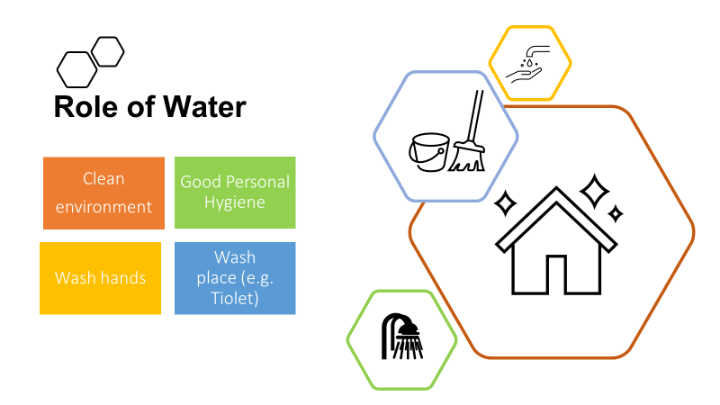

Water is also vital for many bodily functions (see Figure 2.2).
Many of our foods are prepared with water and others naturally contain large amounts of water (e.g. milk is made up of approximately 88% water; eggs 66%; fish 80%; potatoes 75%; and beef 77%).
Inside the body water serves as a lubricant during digestion of our food. Water in saliva makes chewing and swallowing easier, and the food goes down into the stomach with the help of water. The functions of all the body’s cells and organs depend on water.
Water is involved in transporting valuable nutrients around the body in the bloodstream. Nutrients are broken down in the digestive system and transported to where they are needed in the body.
Water is used by the body to remove harmful toxins and wastes through urination and perspiration. Water also helps to reduce constipation. Drinking enough water helps body organs such as the kidneys and the liver to get rid of waste products.
Water helps to regulate body temperature. The body controls over-heating through perspiration. When sweat evaporates from the surface of the skin, it takes heat from the body and produces a cooling effect.
Figure 2.2 Water functions in the body
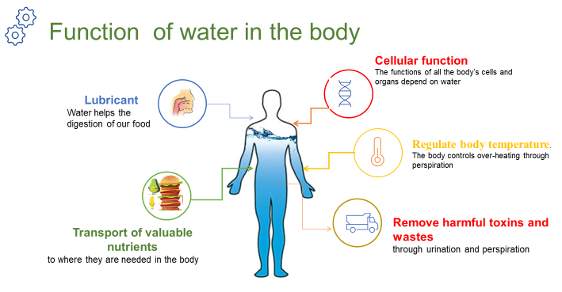

2.2 Diseases associated with water
Most water-related health problems are caused by infectious agents that can invade the body and cause disease. They include pathogenic (disease-causing) bacteria, viruses, protozoa and parasites. Infectious agents can cause disease when they are ingested (eaten or swallowed) or otherwise come into contact with the human body.
The different ways in which water is involved in this contact can be used to classify the diseases into four main groups:
- waterborne
- water-washed
- water-based
- water-related

2.2.1 Waterborne diseases
Waterborne diseases are caused by people ingesting water contaminated by human or animal faeces containing pathogens. Such diseases can also be caused by food that has been prepared using water contaminated with pathogens. The diseases are caused only when the infectious agent enters the body. Waterborne diseases include diarrhoeal diseases which are caused by bacteria and viruses. Bacteria are unicellular organisms (made of one cell) and are very small. Viruses are microscopic infectious particles, much smaller than bacteria, that can only reproduce when inside the living cells of organisms. Waterborne diseases also include some caused by protozoa (single-celled micro-organisms that are much larger than bacteria) and helminths. Helminths is a general term for worms, usually applied to those that are parasites on humans and other animals. These causative agents of disease in unsafe water are shown in Figure 2.3.
Figure 2.3 Causative agents of disease in unsafe water
Although drinking contaminated water is a very significant route of transmission for many of the diseases, they may also be transmitted by other means such as by eating contaminated food. Food can become contaminated by poor hygiene during preparation. We use our fingers for eating and frequently put our hands to our mouths; touching contaminated surfaces can also be a route for disease transmission (Figure 2.4).
Figure 2.4 Using our fingers for eating can lead to the transmission of disease if good hygiene is not practised.
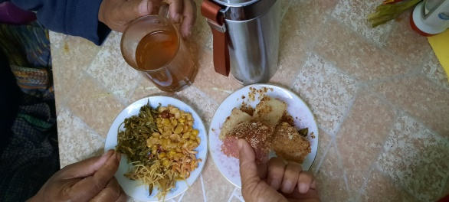

Field (or soil) infection can happen through eating unwashed vegetables and fruit grown in soil contaminated by faeces. Flies are also major transmitters of contamination from faeces to food. Infections can also be transmitted through dirty floors if food is dropped on the floor and then picked up and eaten (Figure 2.5).
Figure 2.5 Methods of disease transmission
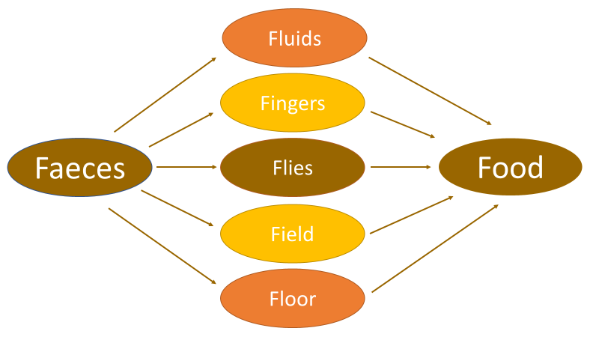
In-text question 1.1
How could poor personal hygiene by people preparing food cause disease?

In all these cases, the origin of the contamination is faeces of people who are already infected by the disease. Some diseases may be transmitted via the faeces of infected animals. In places without adequate sanitation and where people defecate in the open, waterborne disease is far more likely to occur. By sanitation, we mean the prevention of human contact with wastes. If faeces are effectively separated from people, then the transmission routes of waterborne diseases are broken. Examples of common waterborne diseases are cholera and typhoid.
Watch this short video and answer the question.
https://www.youtube.com/watch?v=SDiH_6nndwU

In-text question 1.2
What does this video show?

2.2.2 Water-washed diseases
Water-washed diseases are those that occur as a result of inadequate quantities of water being available for good personal hygiene. Good personal hygiene habits include:
- washing hands with soap, or using an alternative such as ash, after using the latrine (Figure 2.6)
- washing hands before preparing and/or eating food
- washing the body frequently
- cleaning the teeth at least once a day
- washing the hair with soap or shampoo at least once a week.

Figure 2.6 The steps in a thorough technique for handwashing
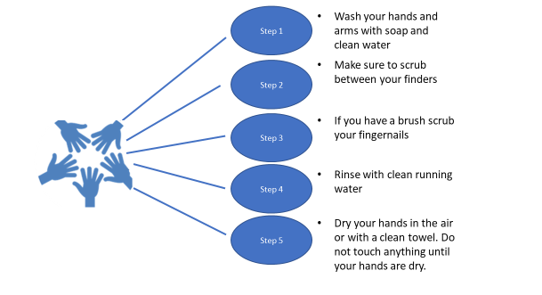
Water-washed diseases include fungal skin diseases such as ringworm, diseases of the eye such as trachoma and conjunctivitis, and infections caused or carried by lice, mites, fleas or ticks. Scabies – a skin disease – is caused by mites for example. Adequate quantities of clean water can prevent such diseases affecting a population.

In-text question 1.3
Why do you think this is so?

2.2.3 Water-based diseases
Water-based diseases are caused by parasites that spend part of their life cycle in water. Water-based diseases such as bilharzia are caused by helminths, but they do not get into the body as a result of ingesting contaminated water or food. This is a water-based, not a waterborne disease. The worm enters the body by penetrating through the skin. It has a complicated life cycle and spends part of its life in a human body and part in a particular species of water snail. This is why bilharzia is called ‘snail fever’ in Myanmar.

2.2.4 Water-related diseases
Water-related diseases are transmitted by insects that breed or feed in or near bodies of water. The best-known example is malaria, which is spread by the Anopheles mosquito (this disease will be described in Section 2.3.2).
Water-related diseases are not associated with lack of access to clean drinking water or to hygiene and sanitation services. They are caused by the presence of standing water, which provides a habitat for the insects to breed as shown in Figure 2.7. Other water-related diseases include dengue fever and yellow fever (also spread by mosquitoes).

Figure 2.7 A dam leads to standing water, a perfect breeding ground for mosquitoes

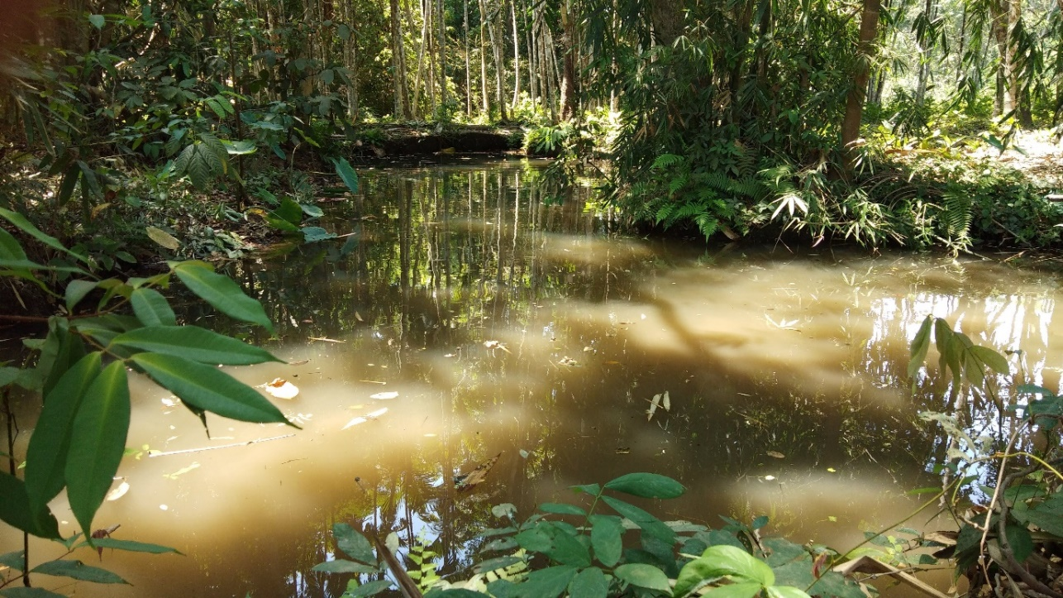

2.3 Major diseases associated with water in Myanmar
The major water-associated diseases in Myanmar (CIA, 2000) are:
- diarrhoea
- hepatitis A
- typhoid fever
- malaria
- dengue
- Japanese encephalitis
Below we look at two of the most common diseases associated with water in Myanmar, diarrhoea, and malaria.

2.3.1 Diarrhoeal diseases
Diarrhoea is a symptom of many waterborne diseases. Globally, there are nearly 1.7 billion cases of childhood diarrhoeal disease every year and it is the cause of over half a million child deaths each year (WHO, 2017).
A significant proportion of diarrhoeal disease can be prevented through safe drinking water and adequate sanitation and hygiene (Figure 2.8). Children, especially those under five years of age, are vulnerable to infection because they frequently put their unwashed fingers in their mouths.
Figure 2.8 The bacteria responsible for many cases of diarrhoea (Gram stain X1000, and on EMB agar)
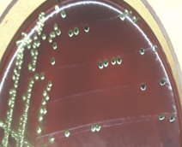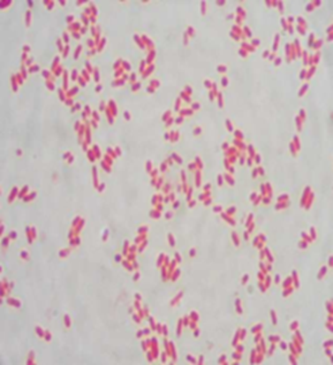

2.3.2 Malaria
Malaria is a parasitic disease transmitted by the female Anopheles mosquito and caused by the pathogenic protozoa Plasmodium. When a mosquito bites an infected individual, it sucks up blood containing the parasite. If it then bites a healthy person, the protozoa are transferred into their blood and they can become ill.
The mosquitoes breed in standing water such as swamps, lakes, pools and open channels dug for crop irrigation; even a puddle can provide enough water for mosquitoes to breed. Only the female mosquitoes take human blood, which is needed to develop their eggs. The most likely time for Anopheles mosquitoes to bite is in the early evening or at night.

In-text question 1.4
Can you think of ways to avoid being bitten by mosquitoes?

2.4 Water quality assessment
Many analytical methods are used to test for the presence and concentration of possible contaminants in water. Concentration is the measure of the quantity of a substance dissolved in a known volume of water. For water quality assessment, the units used are usually milligrams per litre, which is written as mg/l.

2.4.1 Physical tests
Physical tests are the easiest water assessment test as they do not need to be analysed in the laboratory. Anyone can assess the turbidity (cloudiness caused by a large number of very tiny particles), colour, taste and odour of water (Figure 2.9).
As you know water should be free of tastes and odours that would be unpleasant to most people. In extreme cases, people may avoid water that does not look or taste good – even if it is otherwise safe – in favour of something more pleasant-looking and tasting water that may actually be contaminated.
Figure 2.9 Physical testing of water quality (Photo: Laura Richards)
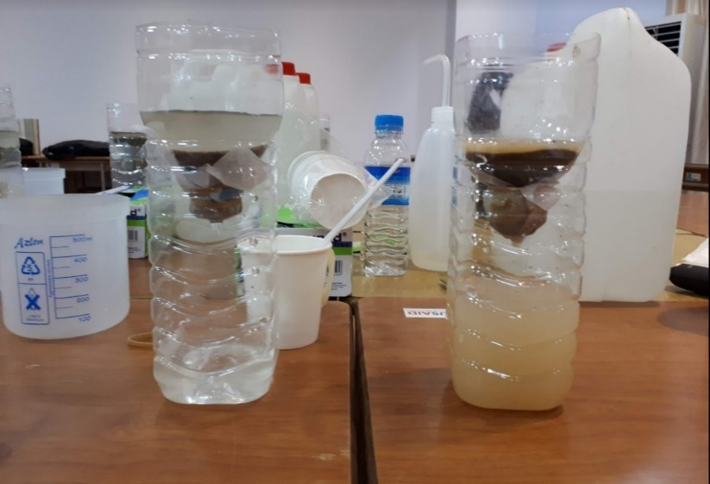

Colour in drinking water occurs due to the presence of dissolved organic matter (once living) and metals such as iron and manganese. Colour can come from industrial pollution such as from dyes used in textile manufacture. Odour in water is due mainly to the presence of organic substances. Taste is the combined perception of substances detected by the senses of taste and smell.
Changes in the normal taste of a piped water supply can be important as they may signal changes in the quality of the raw water source or deficiencies in the treatment process.

2.4.2 Chemical tests
Although the great majority of health-related water quality problems are the result of biological contamination, chemical contamination of water sources can also cause serious health problems and is analysed in the laboratory (Figure 2.10). For example, arsenic levels exceed WHO guidelines for drinking water in large parts of the Ayeyarwady Delta. Long exposure to arsenic in drinking water is highly toxic and can lead to cancers and skin lesions.

Figure 2.10 Conducting a pH test of river water
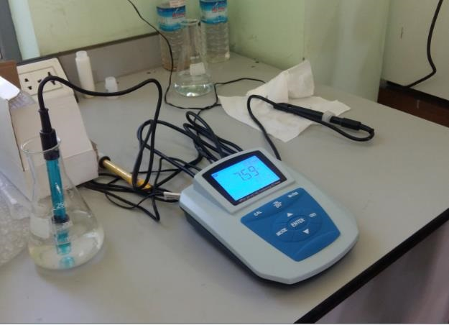

2.4.3 Microbiological tests
There are many different types of pathogenic micro-organisms that may be present in water, but it would be very difficult and time-consuming to test for all of them.
The source of the pathogens is usually human faeces; therefore, laboratory tests have been devised that detect the presence of faecal contamination. If faecal contamination is found, this indicates that pathogenic organisms may be present (Figure 2.11).

Figure 2.11 Faecal contamination test of river water
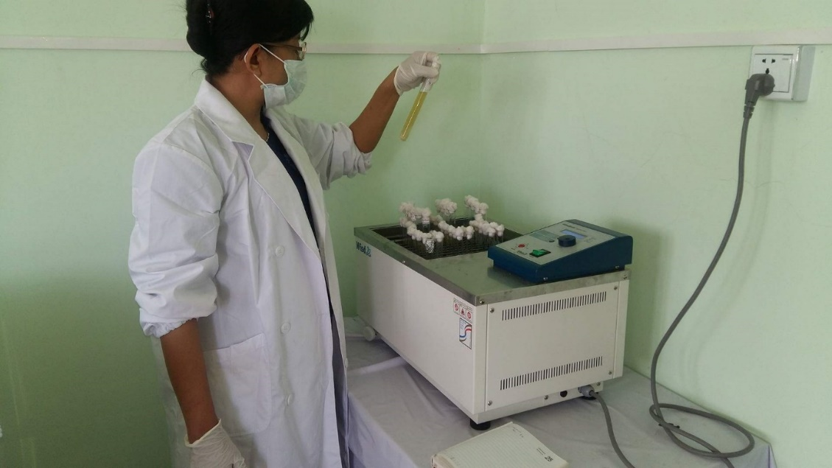

2.5 Water provision in Myanmar
An important step in developing the water supply issues in Myanmar has been the development of the Myanmar National WASH strategy for 2016–2030. The strategy outlines key WASH actions in rural areas, schools, healthcare facilities and in emergencies. It sets targets for a major rise in the quality and quantity of facilities country-wide for all the organisations working in or supporting the WASH Sector: Government; development partners; international NGOs; national and local NGOs; and private sector (Government of Myanmar, 2016).

Summary of Study Session 2
In Study Session 2, you have learned that:
- Water is essential to life. People can live for many days without food but for very few days without water.
- Water for public consumption must be palatable and safe.
- Unsafe water can seriously harm human health. Infants, young children, older people and people debilitated by disease are the most vulnerable.
- Water in the human body is essential for several bodily functions.
- The diseases associated with water can be classified as waterborne, water-washed, water-based and water-related.
- The causative agents of disease in unsafe water include bacteria, viruses, protozoa and helminths.
- The main water associated illnesses in Myanmar include diarrhoeal diseases and malaria.
- Detection of faecal contamination in drinking water indicate the likelihood of pathogenic organisms being present.
- Chemical contamination of water can cause health problems.

Turbidity, colour, taste and odour are important factors in water being acceptable to people.

Answers to in-text questions
1.1 If cooks do not thoroughly wash their hands before touching food, they could easily transfer contamination by infectious agents. When the contaminated food is eaten, this could pass on disease to the consumers.
1.2 The video shows that it is necessary to maintain a village well and to keep the area around it clean in order to avoid contamination of the water.
1.3 If plenty of water is available, people can wash frequently, and the disease-causing organisms will be washed away.
1.4 Wearing long-sleeved clothing and using insect repellents helps to keep people from being bitten. At night, mosquito nets (preferably impregnated with permethrin, which is toxic to mosquitoes) or various sprays or vapours can be used to keep them away.

References
Government of Myanmar (2016) National Strategy for Rural Water Supply, Water and Sanitation (WASH), WASH in Schools and WASH in Health Facilities. [Online]. Available at:
www.myanmarwaterportal.com/repository/623-national-strategy.html
(Accessed 2 November 2020).

