Teaching early reading in Africa – with African Storybook

Course Facilitation Handbook

TESSA Badged Open Course (BOC): Teaching early reading in Africa – with African Storybook
http://www.open.edu/openlearncreate/course/view.php?id=3287

Table of Contents
Welcome 3
Effective facilitation 5
Being a facilitator 5
Challenges 6
Personalising the course 6
The TESSA Early reading BOC – an overview 8
The learning outcomes 8
An overview of the course 8
Categories of activities 9
Assessments 10
Technology 11
Registration and enrolment 11
Working across devices 13
Models of facilitation 15
Planning facilitation sessions 15
Face-to-face facilitation 16
Virtual facilitation 16
Keeping participants motivated 16
Assessing learning 18
Quizzes 18
Assessment 18
Certificate 19
Appendices 20
Appendix 1: The Early reading BOC – an overview 20
Appendix 2: Participant Register 27
Appendix 3: How to register 28
Appendix 4: Online facilitation if using the course on your own platform 31
Appendix 5: Sample Statement of Participation 33
Appendix 6: TESSA BOC Evaluation and Facilitator Report 34

Welcome

Welcome to the TESSA, ‘Teaching early reading in Africa - with African Storybook’, free, online course.
Teacher Education in Sub-Saharan Africa (TESSA) is a network of teachers and teacher educators, working to improve classroom teaching in Africa. At the heart of TESSA is a bank of Open Educational Resources (OER) designed to achieve transformational change for teacher educators and teachers working in primary and lower secondary schools.

African Storybook is an initiative of Saide, a South African NGO involved in open education projects across Sub-Saharan Africa. The initiative responds to the challenge of a shortage of books in African languages, with digital innovation that provides open access to locally created children's picture storybooks in more than 100 of the languages spoken in Africa. The African Storybook website (www.africanstorybook.org) is a growing collection of more than 4000 storybooks that can be read, adapted, translated, downloaded and printed. The website also offers publishing tools for users to create and publish their own storybooks.

This online course is what is known as a ‘BOC’. BOC stands for Badged Open Course. This TESSA BOC aims to:
- explore early literacy, with an emphasis on active approaches to teaching and learning reading
- consider how to make the best use of your classroom, and how to use and develop resources
- introduce some specific approaches to teaching reading
- explore the African Storybook website and select stories relevant to your context
- be directed to open educational resources (OER) developed as part of the TESSA programme, which explain some of the teaching approaches being suggested.
Anyone who successfully completes the course, by visiting all the pages and completing the assessments at the end of Sections 3 and 6, will receive a digital ‘badge’. This can be downloaded, printed and used as evidence of your professional development. This TESSA BOC represents an innovative approach to capacity building by offering the opportunity for participation to teachers and teacher educators across Africa.

The course has six sections and comprises approximately 24 hours of study. We anticipate it will be of particular interest to teachers, teacher educators, practitioners, school volunteers and parents – anyone with an interest in teaching young children to read. Each section involves 4-6 hours of study. The study can be undertaken anytime, at the convenience of the participants, on a range of mobile devices. For example, it could be organised over a six week period, with 4-6 hours of study a week; or it could be studied on a ‘full-time’ basis in one week.
Experience has shown us that participants are more likely to complete the course if they are supported by a local ‘Course Facilitator’.
The purpose of this handbook is to introduce you to the role of a facilitator. The facilitator will:
- encourage people in their institution or organisation to register for the BOC
- support the registration process
- provide on-going support, through face-to-face meetings and the use of digital and social media such as email and WhatsApp. In meetings, you will not be teaching the content, rather providing opportunities for people to discuss the BOC activities and get help if they need it.

It is important that you have either completed the BOC yourself or are at least familiar with the content before you are able to facilitate a group. You could study the BOC with your participants, but you will need to keep ahead of them and be aware of what they will be doing next.
Liz Chamberlain, Ephraim Mhlanga, Tessa Welch and Kris Stutchbury

Effective facilitation

BOCs, and other online courses, can provide an opportunity for up-to-date continuing professional development. We believe that the most effective use of this BOC will be for groups of professionals, working in the same institution, or in institutions near to each other, to work through the activities together (although it can be undertaken by individuals working alone).
By completing this TESSA BOC, participants will be in a better position to lead improvements in early reading in their organisations or institutions. Evidence from other online courses is that, although many learners register at the start, the completion rate is low. Research shows that interaction and support sustains motivation during online learning, leading to higher rates of completion.
Your role as a facilitator therefore is to support your group of participants through to completion by:
- helping colleagues to register and enrol;
- motivating learners;
- facilitating learning progress.
Your responsibilities as a facilitator therefore include:
- encouraging people in your institution or organisation to participate and support them in registering for the BOC;
- familiarising yourself fully with each section’s activities and assessment;
- sending regular messages (e.g. weekly) to your group of participants to remind them of the key activities and details of upcoming online or face-to-face sessions;
- setting up a WhatsApp group to provide support for your participants and/or running regular face-to-face sessions for participants in your institution or organisation;
- responding to any queries or telling participants where they can get help;
- completing a brief report on how the BOC was received so that we can make any necessary changes (See Appendix 6).

Being a facilitator
To be effective as a facilitator, you will need to be familiar with the content of the BOC and your participants. Participants will have different learning needs and different prior experiences. They will each have their own learning journey and will spend different amounts of time on each activity. Do not be concerned if you find that participants have prioritised some activities over others. It is important to respect their individual differences and preferences in working through the BOC.
The nature of this kind of course is that there are rarely ‘correct’ answers. Where there are, (for example for the quiz questions), participants will receive feedback on their responses from the online system. As a BOC facilitator, your role is to ask questions that will make participants think more deeply about issues and how they can apply these in their own context, and to support participants in working collaboratively. You can do this in face-to-face sessions or via email and WhatsApp. You should encourage participants to ask you questions too. If you are not sure of the answer, you can invite the other participants to share their thoughts.

Challenges
There are a number of challenges associated with facilitating an online course. These include, the variance of internet connectivity for participants. One of the benefits of this course is that participants can learn off-line by downloading the resources when they do have access to the internet. However, participants do need to access the internet when submitting their two assessments. Cost of data may well be an issue, but it is not the facilitator’s role to solve this problem, instead participants should be encouraged to speak to their organisations.

Studying online is still a relatively new way of learning for many and some of your participants may have limited technology literacy skills. In the role of facilitator, you can only provide very basic support. We know through other online courses that those new to online learning do better when they are encouraged to learn by doing. In exploring the online materials, participants will improve their digital literacy skills.

Online learning requires time and participants should be encouraged to plan their online study time carefully. This will involve talking to employers about whether study is part of work-time and may also involve talking to family members to find time if learning at home.

As a new way of learning, some participants may be resistant to online learning. For some, learning online presents new challenges as it requires reading online rather than from printed materials. Whilst it is possible to download a hard copy of the course, we would encourage facilitators to support participants in seeing the benefits of this new way of learning. For example, being able to read on their phones and completing interactive quizzes. Through learning by doing, participants quickly realise the benefits of this type of study.

This course is presented in English and this may present challenges for those of whom have English as a second or third language. Unlike a face-to-face course, where participants may miss important information from the tutor, this course allows participants to go at their own pace and to revisit sections they do not understand. As an open course shared under a Creative Commons licence it is possible to translate any of the course material or downloadable documents.

Personalising the course
The course has been designed so that it addresses the needs of different participants. It can be used flexibly.

For example, as a facilitator of an ECD hub, you may want to concentrate your facilitation on Section 4 Methods for teaching reading. The activities in this section focus on Grade 1 and 2 students, and you may wish to provide additional pre-Grade R examples to highlight that good foundations for reading start in
pre-Grade R.

As a Reading co-ordinator in a primary School, you may wish to focus on supporting teachers in Assessing reading to support planning (Section 6). The course has been designed to be contextualised for your own country and learners’ needs.

Good luck with this important work! We look forward to hearing about your experiences as a facilitator.

The TESSA Early reading BOC – an overview
The TESSA BOC is designed as an open and free professional development opportunity for practitioners in the African context. .It is a short, activity-oriented course that focuses on early reading - with a particular focus on the African Storybook resources.
The TESSA BOC follows an active pedagogic model. This means that the BOC does not comprise of lectures, but rather short pieces to read and activities for participants to undertake on their own and in collaboration with other participants. Participants will get most benefit if they try all the activities and share and develop ideas with other participants through discussion.

Participants’ progress is monitored by the system, so in order to gain the badge, participants will need regular access to the internet. The BOC can be accessed through any online-enabled devices, such as tablets or mobile phones.

The learning outcomes
Through engaging in the BOC participants will have:
- been introduced to practical active teaching strategies to support early reading;
- developed an understanding of some methods for teaching early reading;
- thought about how to assess early reading and how to use the assessment results to inform planning of early reading;
- developed resources to support early reading;
- developed ICT skills.

An overview of the course
In each section, participants will complete a number of activities (see Appendix 1).

Section 1 – examines what you need to know to teach early reading, including how children learn to read and what effective teachers of reading do in their classes.
Section 2 – focuses on creating a language-rich learning environment. It introduces you to the African Storybook resources and the importance of stories for young readers. It also considers how regular reading activities can be built into teachers’ planning across the timetable.
Section 3 – explores how children can develop early reading skills and the importance of asking and answering questions in reading for meaning. The course’s first assessment (of two parts) takes place in this section. Participants will have the opportunity to post a review of a story from the African Storybook website and to share a photograph of a print-rich classroom environment.
Section 4 – helps you to examine the three main methods for teaching early reading. You will also reflect on your own learning through a case study of four very different young readers.
Section 5 – highlights the importance of using stories and storybooks to support reading. It also asks you to reflect on how you manage your reading classroom.
Section 6 – focuses on the assessment of reading to support planning. The final assessment for the course asks you to share a story on the African Storybook website and reflect on your learning across the course.

The rate of study is entirely up to the individuals taking the course, although we suggest that one section a week for six weeks would be appropriate and would allow time for participants to try activities in their classroom.

Categories of activities
There are different types of activities throughout the course and they are always in blue boxes (Figure 1).
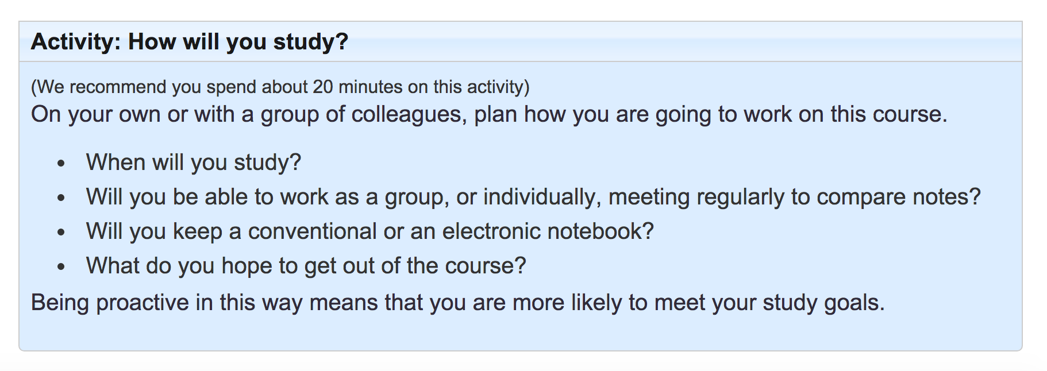
Figure 1: Example of an activity

Some activities ask questions, others ask you to work in collaboration with partners, whilst some activities require you to make a plan and try things out in your classroom.

The course also uses case studies, optional readings and discussions. The discussions are revealed using the ‘Reveal discussion’ button.

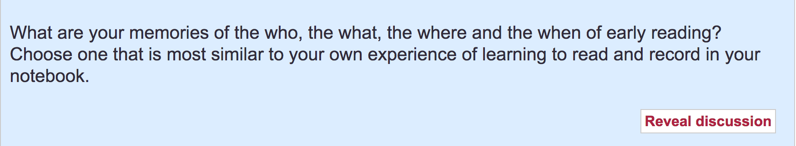
Figure 2: Example of a Reveal discussion button

When you click on ‘Reveal discussion’ you will be able to read the course authors’ responses to the same questions.

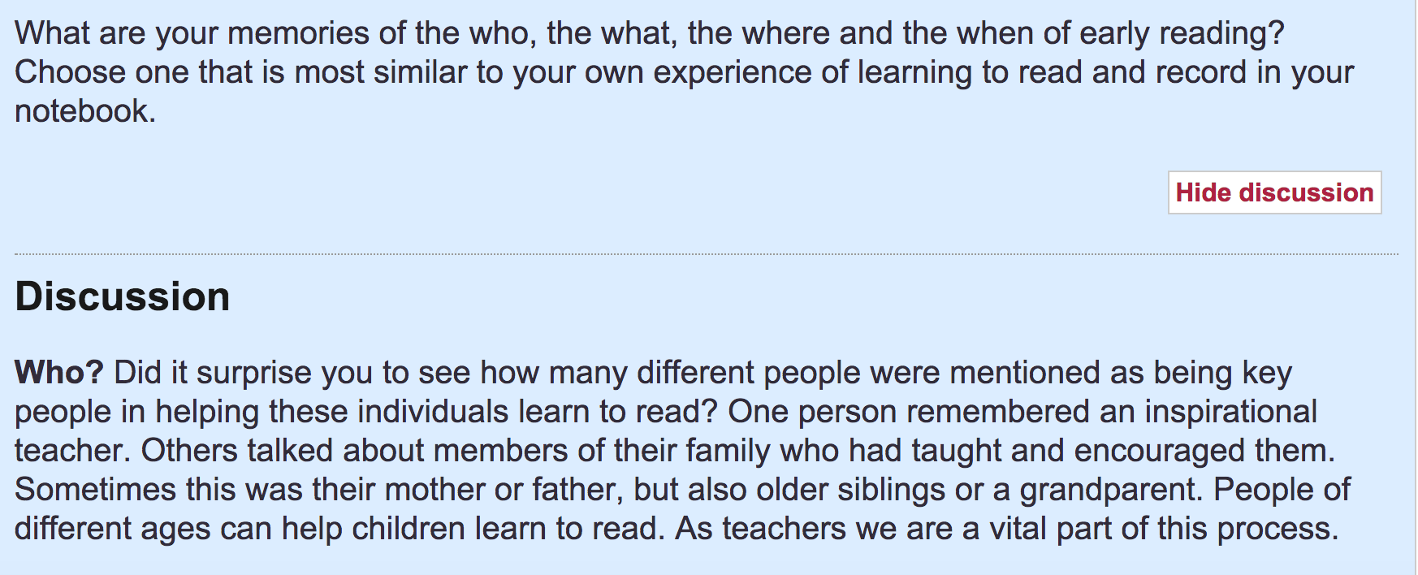
Figure 3: Revealed discussion example

Assessments
In order to achieve the ‘badge’ for the course (see Assessing learning section), you will need to:
- visit each page of the course
- complete the activities at the end of Sections 3 and 6, which involve uploading your response to an activity to the internet.
In order to achieve the badge and download the Statement of Participation you will need to be connected to the internet.

Technology

Registration and enrolment
Your first task as a BOC facilitator will be to encourage teachers, students or teacher educators in your institution to register for the BOC. Each participant first needs to register themselves on the OpenLearn Create website http://www.open.edu/openlearncreate/. You may need to provide help to those unfamiliar with using the internet in this way. They need to click on the green button ‘Sign up/Sign in’ on the right as shown below:

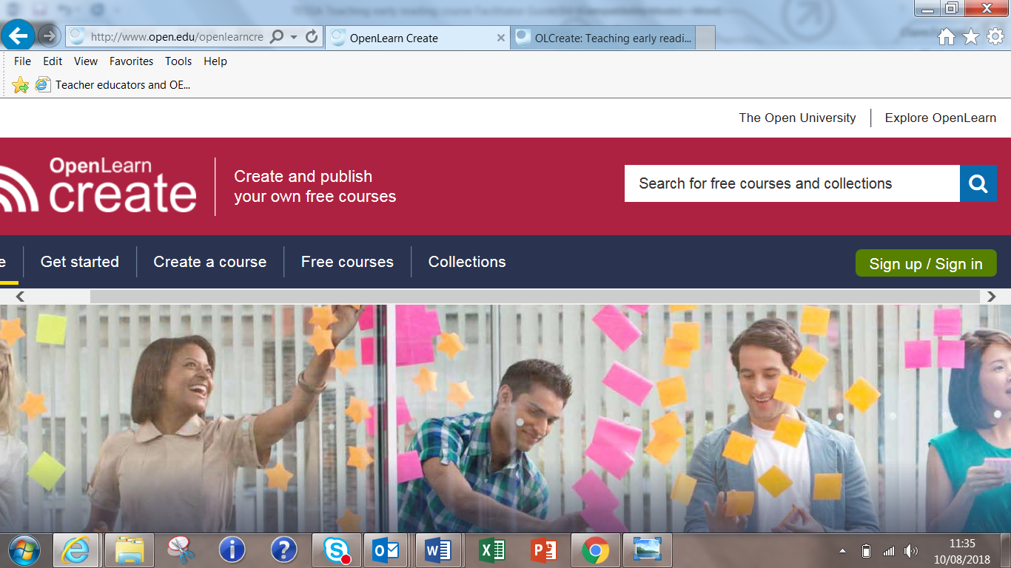

This will them take them to an Open University page where they will need to create an account (pink button below) if they do not already have one.

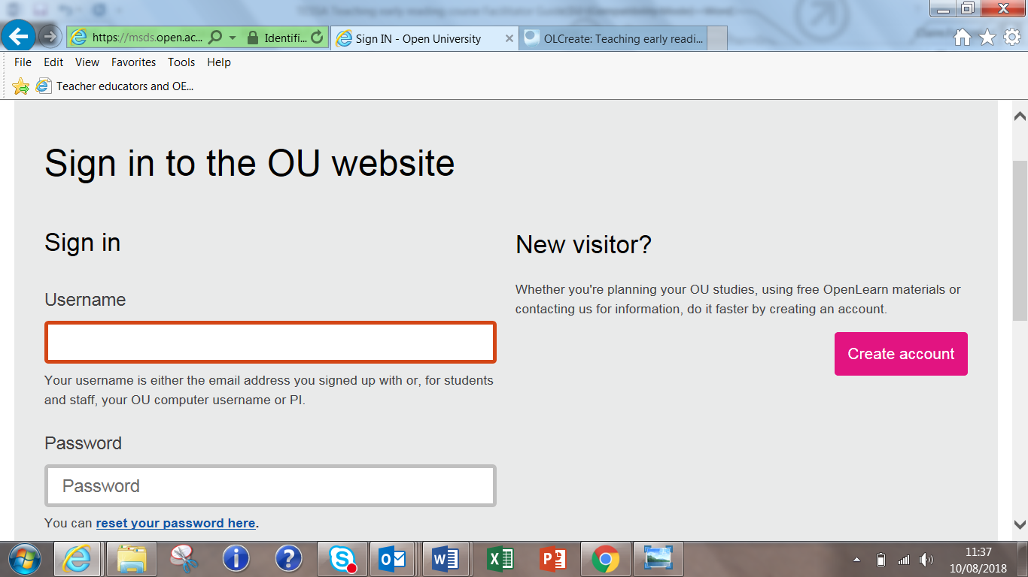

They will need to fill in their personal details and contact preferences as well as a password:
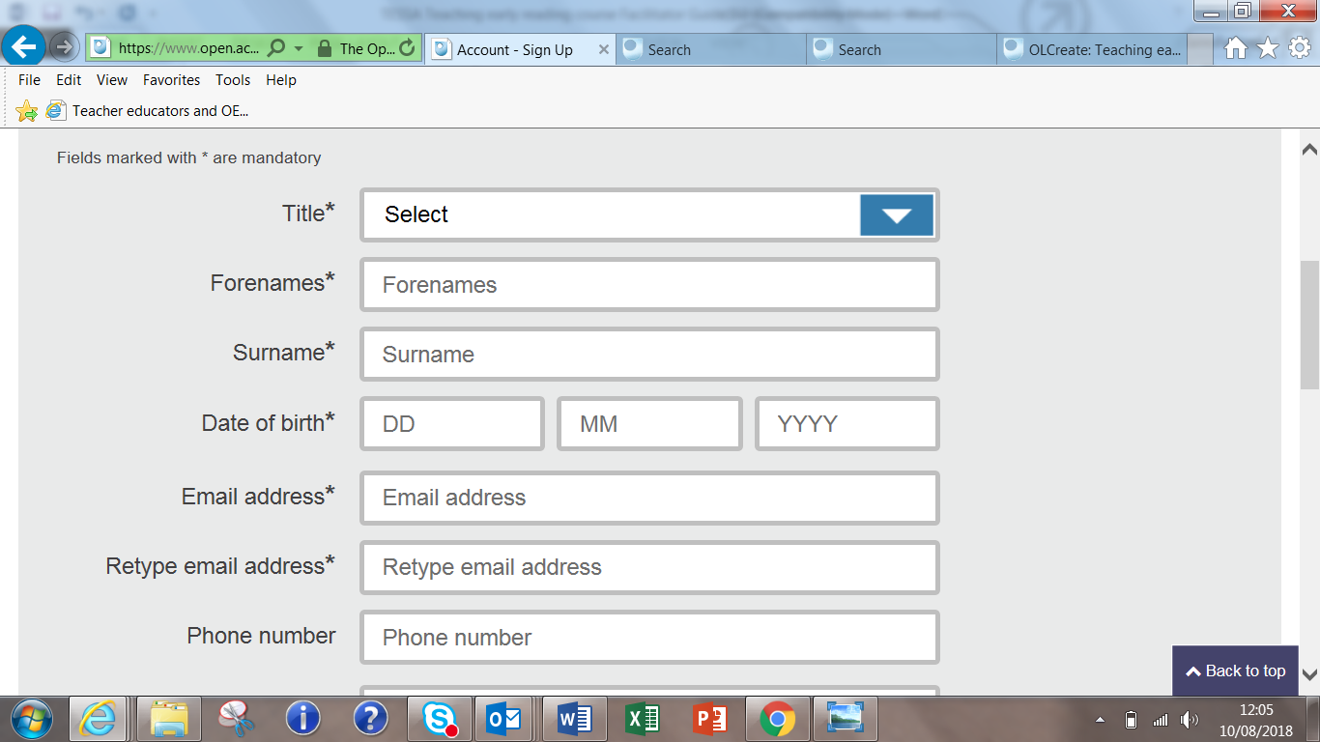

The participant will then be emailed a username.

It is important that the participant types their name carefully, as this is the name which will appear on the certificate if they complete the course successfully.

Once an account is created and the participant is signed in they can enrol on the course on OpenLearn Create using the course link http://www.open.edu/openlearncreate/course/view.php?id=3287
You can also locate the TESSA course on the OpenLearn Create website by using the search facility. It is called ‘TESSA: Teaching early reading in Africa - with African Storybook’. This can be a little tricky. Use ‘Search for free courses and collections’ (the magnifying glass icon) to search for the course by name.
Click on ‘Find out more’.
Click on ‘Enrol now’ to enrol on the course:
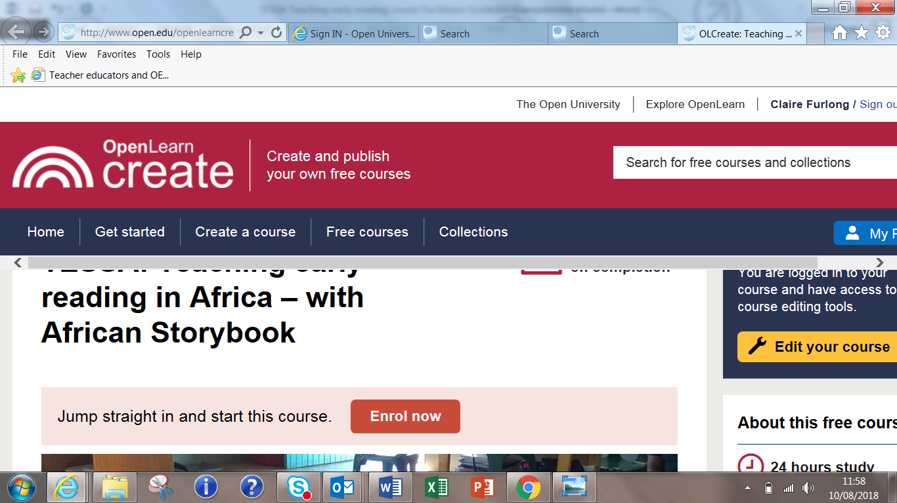
Click on ‘Enrol me’:
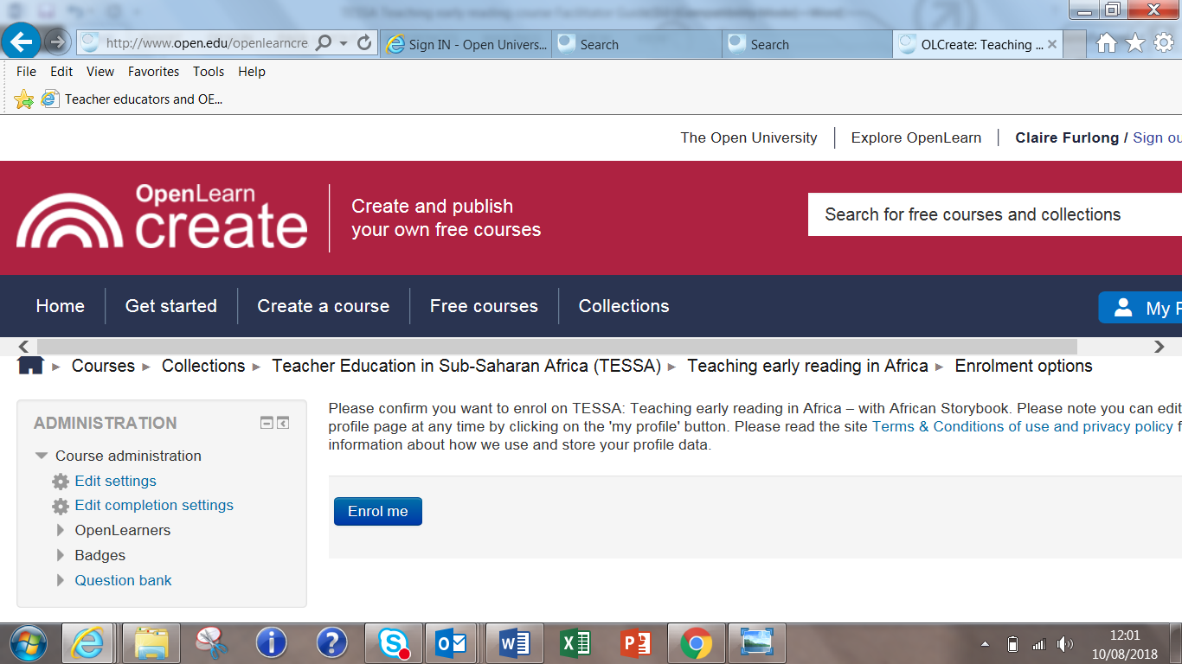
You’re now on the course!

Working across devices

Online learning will always entail using one form of technology or another. The TESSA BOC is designed in such a way that one can use a desktop, a laptop, a tablet or even a smart phone. Once you are registered on the course, it will always ‘remember’ where you are, whatever device you use, even if you change from working on your phone to a laptop. At the first facilitator’s workshop (in Johannesburg), it was interesting that some of the participants suggested that in their context, smart phones are preferred to laptops because ECD teachers have better access to the former than to the latter. Also because of the portable nature of smart phones, participants can exchange and collaborate more often when using smart phones.

In any event, good practice in facilitating online learning is to find out what forms of technology are convenient for the group and for individuals within a group. Accommodating a variety of preferences opens up access to the course and being too prescriptive does the opposite.

Models of facilitation

There are many different ways of facilitating the course for the teachers, students or parents you work with. One way is to embed the course into your current way of working; for example, as a teacher educator you could incorporate the course into your current literacy curriculum. As an ECD coordinator, your teachers could complete the course with colleagues in schools and you might use your school observation visits to quality assure their learning.

Facilitation can also take place face-to-face or online, using social media (WhatsApp) or Skype, and your role should be to support and monitor the progress of your group of participants. Experienced ECD facilitators at the first BOC workshop in Johannesburg described the process as follows:

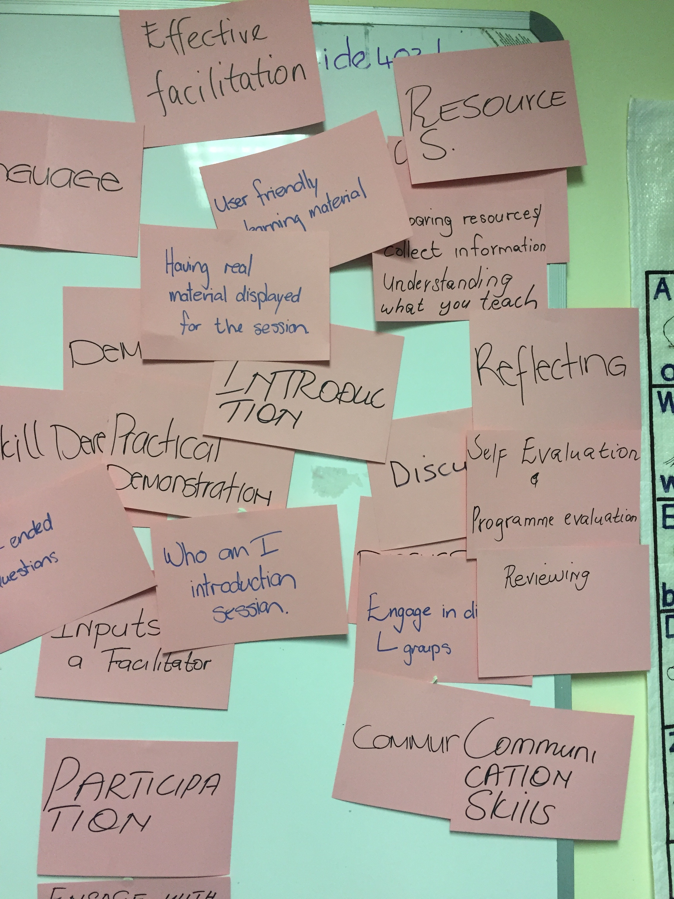
  - Researching course content
  - Knowing your participants
  - Planning and preparation
  - Establishing the learning environment
  - Engaging with participants
  - Skill development and practical demonstration
  - Promoting reflection
  - Self-evaluation and programme evaluation Figure 1: Effective facilitation
You will have other ideas to add to the list based on your own experiences. If you are facilitating the course with colleagues, you can use these ideas as a starting point for discussion about which model of facilitation can be adapted for the course.

Planning facilitation sessions
To plan an effective facilitation session, whether it is in a face-to-face or online environment, it is helpful to think of delivering it in four parts:
Part 1: an introductory activity to put everyone at ease. This is easy to understand for everyone, exciting and interest arousing;
Part 2: a review of the previous section’s learning. Useful questions might be:
What has been learnt?
What did you find most interesting?
What has been problematic?
Part 3: an activity from the BOC, an optional activity or suggested reading;
Part 4: setting expectations for the next section, including agreeing on deadlines.
Using this four-part framework, you are free to organise the facilitation sessions according to the needs of your group.
It is important to remember that you are not expected to teach the content of the BOC, rather to provide participants with the opportunity to clarify and discuss their ideas. If you run the sessions in a participatory way, at the end of the course, participants will know one another and will have identified people that they would like to continue to work with as part of the TESSA and African Storybook community.

Face-to-face facilitation
If you are hosting face-to-face sessions, you should not provide a lecture or a presentation, nor use additional material or content of your own. Rather your role is to support participants in their learning with the BOC and to develop some of the ideas within the BOC to suit your specific context. The sessions will give participants the opportunity to get to know one another and to build a professional network. During these sessions you should:
- encourage participants to remain motivated and complete the course;
- support learning by providing the opportunity for discussion and reflection;
- build a collaborative network within the institution that will continue beyond the lifetime of the BOC;
- give participants online access to the BOC.

Virtual facilitation
If your participants are dispersed, you could provide support through WhatsApp or through Skype.
If you are hosting online or virtual facilitation sessions, you should aim at engaging your learners in the same way you would do in a face-to-face encounter. The challenge is that in virtual facilitation, your learners will be dispersed and you will be communicating with them virtually.

As a facilitator you will need to check WhatsApp regularly and read comments posted by your learners, including questions raised. You might want to arrange a Skype session with a number of people joining. The principle is the same: ask questions, provide opportunities for each participant to contribute, and provide encouragement.

Keeping participants motivated
One of the main challenges in online learning is keeping the learner motivated enough to remain on the course until completion. This is mainly because online learners often feel they learn in isolation and are not well in touch with the content, with their peers and with the facilitator. To overcome the challenge of feeling isolated, the facilitator should create opportunities for regular communication with the learner and for the learner to collaborate virtually or face-to-face, with peers in the learning process. Forming virtual WhatsApp groups using smart phones helps to keep the online learner connected to others. Also, online learners should be provided with information on where to go for support when they need it and this information can be embedded in the course. A slight problem that hampers progress can cause the learner to drop out of the course if support is not available when they need it.

A lot of learners, especially beginners, are not good at managing time. As a result, they tend to fall way behind with their readings and assignments, and therefore find themselves ill-prepared for the assessments. This creates a sense of failure and general lack of confidence, which ultimately leads to dropping out. It is therefore important for the online facilitator to support learners not only with time management issues, but also with building confidence in online learning, and getting the best out of it. There is a great deal of flexibility with this course; learners can take one, six or even twelve weeks. If they fall behind their peers, it does not mean that they cannot complete the course.

If you are using the content of this course on your own platform you may want to read more about online facilitation in Appendix 4.

Assessing learning

Quizzes
This course has quizzes. These are not part of the assessment, but are instead designed to be formative and to promote discussion between you and your colleagues. There are no pass grades and you have two attempts at each question.

Assessment
This course has two assessments at the end of Section 3 and at the end of Section 6. The details of the assessments are listed below.

Section 3 assessment
It is recommended that participants spend 60 minutes on this activity. Participants complete this activity by uploading content to Teaching early reading in Africa’s course website.
Part 1: Reviewing stories
Find a Level 1 or 2 storybook on the ASb website in a language that you read. Go to the area on the course website for this part of Activity 3.10, click on the ‘New blog post’ button and do at least one of the following:

- Give the title, language and level of the story you have chosen.
- Write a short review of the storybook – what you liked or did not like about the story, and how you would use it with children. You might also suggest how you could adapt it.
- Rate the story.

Part 2: Creating a print-rich environment
Take a photograph of a print display in your classroom or of a resource that you have made. Go to the area on the course website for this part of Activity 3.10, click on the ‘New blog post’ button and upload the photograph. You should also comment on at least one other person’s post.

Section 6 assessment
It is recommended that participants spend 60 minutes on this activity.
Part 1
Choose one of the following options to complete this activity:

- Upload your own story to the ASb website.
- Translate a story already on the site that hasn’t been translated:
  - from a home language to English
  - from English to a home language
  - from one home language to another.
- Adapt an existing story to a different reading level (Note that Level 1 = first words, Level 2 = first sentences, Level 3 = first paragraphs):
  - change the words in a Level 2–3 story to make it Level 1
  - increase the vocabulary in a Level 1 story to make it Level 2–3.

When you’ve done this, visit the ‘Assessment record’ page to confirm completing this part of the activity. [It is important to remind participants to complete this page so their certificate can be awarded.]
Part 2
Post a comment on this blog to reflect on your learning on this course. Write 200–400 words on your journey, in particular:
- what you have enjoyed
- what challenges you have faced
- how you approached the assessments (Activities 3.10 and 6.8)
- how you will use what you have learnt in the future.

Certificate
To qualify for a TESSA/African Storybook Statement of Participation/badge for this BOC, participants will need to:
- visit each page of the course
- complete the assessment activities at the end of Sections 3 and 6, which involve uploading your response to an activity to the internet.
The certificate/badge will be generated automatically by OpenLearn Create for the learner to view and download when the course is completed. The name that appears on the certificate will be the same as the name used when the participant registered on the website.

Appendices

Appendix 1: The Early reading BOC – an overview

Focus of the session | Sub-headings | Activities | Case studies | Templates | Quizzes/  assessment | Documents/ readings/ additional material | ✔  Mark when complete
Welcome  In this section, there are the answers to any questions or queries about the course, including how participants learn, the purpose of working with others and the use of the study notebook. The assessment requirements are also listed. | Introduction
 | How you will learn on this course
 | Your study notebook
 | Working with others | How will you study?
 | Course badge
 | Who created this course?
 | References
 | Acknowledgements
Section 1  What do you need to know to teach early reading?  Section 1 examines what teachers, teacher educators and parents need to know in order to teach early reading, including how children learn to read and what effective teachers of reading do in their classes. | Introduction
 | Foundational literacy | 1.1 Reflecting on being an adult reader and writer
 | How do children learn to read? | 1.2 Experiences of learning to read  1.3 Your memories of learning to read
 | Our approach to learning and teaching early reading | 1.4 Reflecting on learning strategies
 | A question of language | 1.5 Reflecting on a question of language 1.6 Home language or English | 1.1 Home language in early reading |  |  | Reading A Review and Analysis of Theory and Practice in Mother-Tongue and Bilingual Education in sub-Saharan Africa  Reading Mother tongue and education in Africa:  Publicising the reality OER Multilingualism in the classroom
 | Looking at effective teachers of reading | 1.7 Observing good literacy teaching | 1.2 Observing good teaching
 | Where do reading activities fit in the weekly timetable? | 1.8 Planning for early reading |  |  | 1.8 Daily timetable
 | Reflecting on your learning so far | 1.9 Reflecting on your learning so far
 | Moving forward
Section 2  Creating a language-rich environment  In Section 2 the focus is on the importance of creating a language-rich learning environment. It also introduces participants to the African Storybook resources and the importance of stories for young readers. The section also considers how regular reading activities can be built into teachers’ planning across the timetable. | Introduction
 | What is a print-rich learning environment? | 2.1 Print-rich classrooms  2.2 Auditing your classroom |  | 2.2 Classroom audit | 2.2 Auditing your classroom | OER A language rich environment
 | What resources do you need to support early literacy and reading? | 2.3 Creating resources |  | 2.3 Table template
 | Storybooks as resources | 2.4 Thinking about storybooks
 | African Storybook | 2.5 Becoming familiar with African Storybook  2.6 Finding stories for early reading development |  |  | 2.5 Becoming familiar with the ASb website | Document: Getting started on the ASb website Document: Translating a storybook on the ASb website
 | Using storybooks | 2.7 Using stories to support children's early literacy development 2.8 Resources to help you make good use of stories in the classroom |  |  |  | OER TESSA literacy materials
 | Moving forward
Section 3  Preparing to learn and teach early reading  Section 3 explores how children can develop early reading skills and the importance of asking and answering questions in reading for meaning. The course’s first assessment (of two parts) takes place in this section. Participants will have the opportunity to post a review of a story from the African Storybook website and to share a photograph of a text-rich classroom environment. | Introduction
 | Developing comprehension and thinking skills through questioning | 3.1 Thinking about questions
 | Questioning in the classroom | 3.2 Reflecting on the case study  3.3 Asking questions | 3.1 Using questioning in the classroom | 3.3 Question template
 | Children's everyday lives as a resource for reading | 3.4 Everyday experiences |  |  |  | Website African Storybook
 | Using pictures to support early reading skills | 3.5 Using familiar themes to support early reading  3.6 Using picture resources | 3.2 Salome's new class
 | Using physical movement to support early reading | 3.7 Professional staff development | 3.3 Songs and action rhymes |  |  | Reading Sally Goddard Blythe: 'Early learning in the balance: priming the first ABC'
 | Songs and action rhymes for reading | 3.8 Using songs and rhymes |  |  |  | OER TESSA Using songs and rhymes
 | Planning a classroom activity | 3.9 Plan a classroom-based activity |  |  |  | OER TESS-India key resource pair work
 | Assessment | 3.10 Assessment  Part 1 Reviewing stories  Part 2 Creating a print-rich environment |  |  | Two uploads to blog on course page - Part 1 and Part 2 | Website ASb
 | Moving forward
Section 4  Methods for teaching reading  In Section 4 the focus is on the different ways that reading is taught. It helps participates to examine the three main methods for teaching early reading. You will also reflect on their own learning through a case study of four very different young readers. | Introduction
 | Method 1: Sounds, letters, syllables | 4.1 Thinking about using the letters and sounds approach | 4.1 Mrs Mogale's English class |  |  | Film: World Vision: Phonemic awareness
 | Method 2: Look-and-say | 4.2 Thinking about look-and-say  4.3 Look and say words | 4.2 Mrs Mapuru uses the look-and-say method
 | Method 3: Language experience approach | 4.4 Thinking about the language experience approach  4.5 Using the language experience approach | 4.3 Mrs Tekiso uses the language experience approach
 | Bringing it all together | 4.6 Reflecting on your learning  4.7 How to use the figure (quadrants)  4.8 Which method of word recognition/comprehension should you use |  |  | 4.8 Which method of word recognition/ comprehension should you use | Website ASb
 | Moving forward
Section 5  Using stories and storybooks  Section 5 highlights the importance of using stories and storybooks to support children’s reading development. It also asks participants to reflect on how reading is managed in their classrooms. | Introduction | 5.1 Reviewing your progress | 5.1 New words with Ms Khumalo
 | Using storybooks to develop speaking and listening skills | 5.2 Retelling stories
 | Using storybooks to develop thinking skills | 5.3 Asking questions to promote thinking |  |  |  | Reading: Aidan Chambers: 'Tell Me: Children, Reading and Talk with the Reading Environment'
 | Using storybooks to further develop reading skills | 5.4a & b Recognising the different approaches  5.5 Selecting stories for a purpose | 5.1 New words with Ms Khumalo |  |  | Document: African Storybook resources: Choosing stories for different purposes
 | Managing your reading classroom | 5.6 Strategies for using stories to support reading |  |  |  | Document: Strategies for managing reading with your class OER TESS-India Storytelling
 | Reviewing your learning | 5.7 Reviewing your learning |  |  | 5.7 Reviewing your learning
 | Moving forward
Section 6  Assessing reading to support planning  The focus of the final section is on the assessment of reading to support planning. The final assessment for the course asks participants to share a story on the African Storybook website and reflect on their learning across the course. | Introduction
 | Stages of reading development | 6.1a Looking at the stages of reading development  6.1b Identifying stages of reading development | 6.1 Reading development in Anne's class | Document: Stages of reading development
 | Assessing reading in your classroom  Recording progress | 6.2 Focusing on a few children | 6.2 Patrick's Grade 1 class
 | Recording progress | 6.3 Keeping records  6.4 Analysing Anne's records  6.5 Keeping reading records | 6.3 A reading record book | Document: Class reading progress record Document: Individual progress record 6.5 Individual reading record for Paxima
 | Strategies to assess children's reading | 6.6 Strategies to assess reading | 6.4 Two examples of using stories |  |  | Table 6.1
 | Supporting progression | 6.7 Analysing stories to support reading development |  | 6.7 Reading development template |  | Website ASb
 | End of course assessment | 6.8 Part 1 - Contributing to African Storybook  Part 2 - Blog post  * Participants MUST complete 'Confirmation of activity completion' at end of Part 1 |  |  | One upload to African Storybook - Part 1. One upload to blog on course - Part 2
 | Final words

Appendix 2: Participant Register
You can use the table below to record the contact details of the BOC participants in your institution or facilitation group.

This will enable you to keep in touch after the end of the BOC and to continue to work together as a group of professionals working to bring about change and to improve the quality of the teaching of early reading in Africa.

Institution/organisation  /role | Name | Email address | Phone / WhatsApp number

Appendix 3: How to register

1. Register with the Open University via OpenLearn Create
Each participant first needs to register themselves on the OpenLearn Create website http://www.open.edu/openlearncreate/. You may need to provide help to those unfamiliar with using the internet in this way. They need to click on the green button ‘Sign up/Sign in’ on the right as shown below:

This will them take them to an Open University page where they will need to create an account (pink button below) if they do not already have one.

They will need to fill in their personal details and contact preferences as well as a password:

The participant will then be emailed a username and they can log on from the link below with the username and password that they set up.

2. Enrol on the course
Once an account is created and the participant is signed in they can enrol on the course on OpenLearn Create using the course link http://www.open.edu/openlearncreate/course/view.php?id=3287
You can also locate the TESSA course on the OpenLearn Create website by using the search facility. It is called ‘TESSA: Teaching early reading in Africa - with African Storybook’. This can be a little tricky. Use ‘Search for free courses and collections’ (the magnifying glass icon) to search for the course by name.
Click on ‘Find out more’.
Click on ‘Enrol now’ to enrol on the course:
Click on ‘Enrol me’:

You’re now on the course!
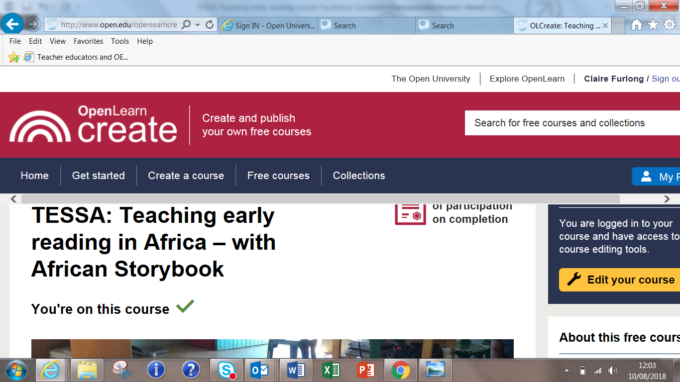

Appendix 4: Online facilitation if using the course on your own platform

The content of this course is ‘open’ – it can be downloaded, adapted and, if appropriate, uploaded onto your own learning platform, provided that the original source is acknowledged. The BOC in its current form on OpenLearn Create does not have facilities through which participants can interact online e.g. discussion forums. But your own learning platform may include these facilities, in which case, your facilitation could take place through those.
This raises different facilitation issues.

The following stages from Gilly Salmon provide guidance on how such a course can be effectively facilitated.

Gilly Salmon, an expert in online learning provides typical stages that an online facilitator should take online students through in order to get them to gain confidence in learning online. These stages are:

Access and motivation
- Make sure online students are welcomed to the course and are well-inducted in basic processes of logging in and communicating with colleagues and the facilitator on the platform.
On-line socialization
- Encourage formation of social groups and group participation. As an online facilitator, you support the learning process and encourage participation. Due to the virtual nature of your support, you need to establish some learning “netiquette” with your learners: how they should respond to each other’s comments, how they should communicate with you as facilitator, what their role is in the learning process and what the facilitator’s role is, when and how they should communicate with the facilitator, turnaround time for questions and queries raised, etc.
Information exchange
- Encourage participation and posting of short messages. Assign members some online roles. Encourage the group to constitute an online community.
Knowledge construction
- Provide challenging questions that call for critical thinking and creativity; encourage the group to question existing theory and practice.

Development
- Encourage group members to lead discussions, to apply acquired knowledge and ideas to other areas of their work.
- Make individuals gain confidence in what they do and in what they say, by engaging in regular reflection exercises.

The key to motivating online learners therefore lies in helping, supporting, guiding and advising learners.

Appendix 5: Sample Statement of Participation

Pages 2 and 3

Appendix 6: TESSA BOC Evaluation and Facilitator Report

We are keen to learn how the BOC is being used so that we can make any improvements. Please encourage your participants to complete the questionnaires that we have devised which are included in the course.

It would helpful if you could respond to the questions below and email them to tessa@open.ac.uk when your group has finished the course.
We will be using the responses for our own research and to inform improvements in the course. By responding, we assume that you consent to this; you can change your mind, by emailing tessa@open.ac.uk and we will delete your response.

- How many participants did you support to study the BOC?
- Approximately how long did people spend on the BOC each week?
- How did you provide support? Did you use email, SMS, WhatsApp or face-to-face contact?
- If you held face-to face contact sessions, how many sessions took place in your institution or organisation?
- Were there any challenges with the registration process or any changes that you would recommend?
- Which activities were considered to be particularly helpful?
- Which activities were considered to be challenging?
- We have the opportunity to make some changes when we review the BOC. Are there any changes that you would recommend?
- Is there anything else that you think it would be helpful for us to know?
- If you would be happy to take part in a more detailed follow-up interview for research purposes, please indicate this in your response and provide your email address.
Thank you.
The TESSA UK team and the African Storybook website team

Salmon, G. (2000) E-moderating: https://www.acu.edu.au/__data/assets/pdf_file/0014/411035/Salmon_Five_Stage_Model_of_ELearning.pdf Accessed 7 August 2018

