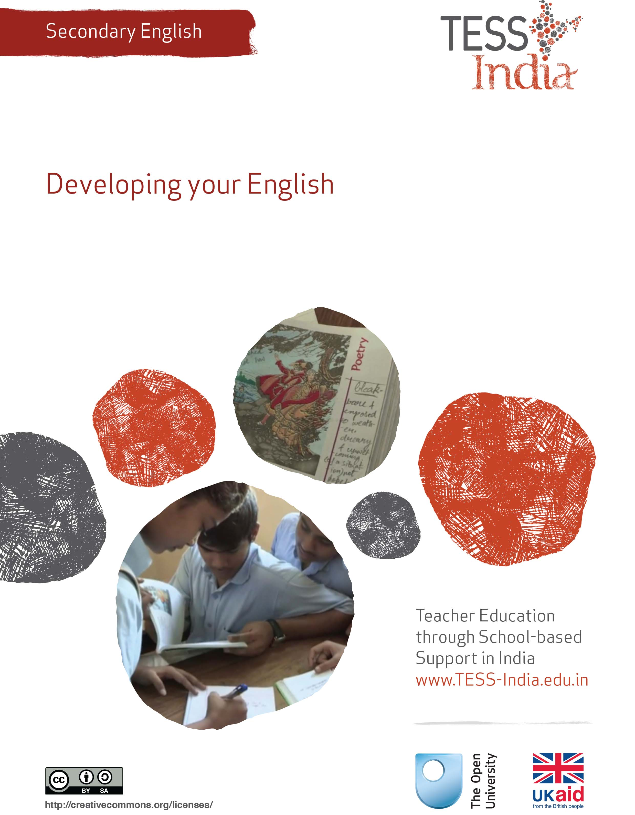
TESS-India (Teacher Education through School-based Support) aims to improve the classroom practices of elementary and secondary teachers in India through the provision of Open Educational Resources (OERs) to support teachers in developing student-centred, participatory approaches. The TESS-India OERs provide teachers with a companion to the school textbook. They offer activities for teachers to try out in their classrooms with their students, together with case studies showing how other teachers have taught the topic and linked resources to support teachers in developing their lesson plans and subject knowledge.
TESS-India OERs have been collaboratively written by Indian and international authors to address Indian curriculum and contexts and are available for online and print use (http://www.tess-india.edu.in/). The OERs are available in several versions, appropriate for each participating Indian state and users are invited to adapt and localise the OERs further to meet local needs and contexts.
TESS-India is led by The Open University UK and funded by UK aid from the UK government.
Video resources
Some of the activities in this unit are accompanied by the following icon: . This indicates that you will find it helpful to view the TESS-India video resources for the specified pedagogic theme.
The TESS-India video resources illustrate key pedagogic techniques in a range of classroom contexts in India. We hope they will inspire you to experiment with similar practices. They are intended to complement and enhance your experience of working through the text-based units, but are not integral to them should you be unable to access them.
TESS-India video resources may be viewed online or downloaded from the TESS-India website, http://www.tess-india.edu.in/). Alternatively, you may have access to these videos on a CD or memory card.

Version 2.0 SE14v2
All India - English
Except for third party materials and otherwise stated, this content is made available under a Creative Commons Attribution-ShareAlike licence: http://creativecommons.org/licenses/by-sa/3.0/

What this unit is about
I’m a secondary English teacher, and I’ve studied English for a long time. I’m good at English, but I could still improve – especially my speaking and listening skills. However I don’t live and work in an English-speaking environment. What can I do to develop my own English?
As a secondary-level English teacher, it is important that you have good English skills and you feel confident using English to support your students’ learning. Probably you already have good English skills. However, there may be one or two areas of English that you are less confident about, for example speaking in English. In this unit, you will identify the areas of English that you would like to improve, and you will find ideas about how you can do this. By continuing your own learning you are showing yourself to be a role model for your students.

What you can learn in this unit
- How to identify your own strengths and weaknesses in English.
- How you can improve your English listening and speaking skills for personal and professional purposes.
- How you can improve your English reading and writing skills for personal and professional purposes.

Why you should consider developing your English
Learning a language is a process that is never complete. Every one of us can practise to communicate better, learn more vocabulary, learn to understand more accents and write more eloquently. By improving your own English fluency, you will benefit yourself and your students. They will benefit from your new knowledge and skills, and you will motivate them to want to learn more.

1 Improving your English
Good teachers are continuously trying to improve their English. They find that this benefits them in many different ways. Read what these teachers say:

I enjoy watching TV programmes and films. Now I can enjoy watching them in English, too. And each time I watch, I learn even more. I can now use these programmes and films with my students.

I had heard a lot about the British Council Master Trainers programme and I wanted to become one myself – I am so happy my English has improved. I have just been chosen!
I am planning to go to a seminar for English teachers. I know that the presentation will be in English, and I want to be able to understand it and take notes for the teachers at school.

I enjoy watching TV programmes and films. Now I can enjoy watching them in English too. And each time I watch, I learn even more. I can now use these programmew and films with my students.
I’ve found some good ways of improving my English, and I’ve told my students about them. Some of them are making more effort to improve their own English too.
My friend is also an English teacher. She has taken a lot of time to improve her English, and now her students are achieving better exam results.
I am happy now that I can speak to visitors to our school, and understand what they say in English. I can also understand much better what our education department officers say – earlier I used to hide from them!
I feel more confident speaking English these days, and use it much more in the classroom. I’ve noticed that my students understand it better now, and are using it more themselves when they speak.

Now think about how improving your English could help you. Write your thoughts in the empty speech bubbles below or in your notebook. If you can, compare your thoughts to those of a colleague.

You

Whatever your thoughts, improving English can help you in your personal and professional life, and can benefit your teaching and your students too.

Case Study 1: Mrs Chakrakodi wants to improve her English and sets up an English club
Mrs Chakrakodi teaches English at a rural government secondary school. As a student, she enjoyed English and did well in exams. Now she reads and writes English confidently but is less confident with speaking and listening to English. She wants to develop these skills, but has found it difficult because she does not live and work in an English-speaking environment.
In a recent training session at our local DIET, I asked our trainer about how we secondary English teachers could improve our English. Our trainer told us about a radio show [TeachingEnglish, 2012]. In it, teachers talked about what they did to improve their English skills. One of them started an English club in order to practise speaking and listening.
Our trainer from the DIET thought that starting an English club was a very good idea, and we did too. She organised for teachers from neighbouring schools to get together once a week to talk only in English about whatever subject we like, or even about an article or something that everyone has read in advance.
The idea appealed to me as I live in a rural area where it is difficult to practise English. I always thought that I needed to practise speaking English with people who spoke it fluently, but after listening to the show, I realised that I just needed to practise – and that there were other teachers in the same position as me. So I started to go to this group regularly for an hour each week.
The first time we met, I felt a little embarrassed about speaking English, and I was worried that I would make mistakes. But as we have continued, I have become more confident, and I have learned not to worry about mistakes. What is important is that we all practise speaking – and listening to each other, of course!
At first we tried to prepare topics to talk about, but we found that we didn’t have much time for this. But we realised that we needed something to speak about, so now we take it in turns to choose a topic. Last week, for example, we talked about food. We swapped recipes, and talked about good and bad dishes that we had eaten. It was fun, and I got some good ideas for cooking too!
Sometimes I can’t go to the club because I am just too busy – and that’s true for all of us. But we decided that the club would take place no matter how many people are there. It’s helped me to become more confident at speaking English, and that means I am more confident in my classes too.

Activity 1: Improve your own English
In Case Study 1, Mrs Chakrakodi identified that she is less confident at speaking and listening to English, which is why she started going to the English club. Now read Table 1, which is something she filled in to describe her English skills.

Table 1 Mrs Chakrakodi describes her English skills.
Type of skill | My English skills | What I can do to improve
Reading English | I can read and understand most English texts. I read English newspapers when I can. Sometimes I don’t know the vocabulary. | Continue to read texts as much as possible. Use a dictionary to look up words.
Writing English | I can write texts quite accurately. | Right now I will not work on writing. I prefer to spend my time developing my speaking skills.
Listening to English | I don’t have many opportunities to listen to English. | Listen to the news in English once a week, on TV or the radio. Go to English club once a week.
Speaking English | I don’t have many opportunities to speak in English. | Go to English club once a week – and speak as much as I can during the session.
Now complete the table for yourself, using Table 2 or a copy. First, make some notes about your abilities and the things you already do in English. Your notes might be similar to the teacher of Case Study 1, or your case might be very different. Identify any areas where you could improve your English. Make some notes about what you think you could do that would help you improve. If you can, discuss these ideas with a colleague.
Table 2 English skills template.
Type of skill | My English skills | What I can do to improve
Reading English
Writing English
Listening to English
Speaking English

2 Developing speaking and listening skills
Many teachers – even at secondary level – feel less confident about their speaking and listening skills than they do about their reading or writing. Here are some occasions when an English teacher might speak or listen to English. Do you use English for any of these? Tick the ones that apply to you. If there are some occasions that are not listed, add them to the list.
- talking to students in the classroom
- talking to colleagues
- talking to visitors to your home or school
- listening to a radio show
- listening to an expert at a seminar or conference
- listening to or watching a discussion about education
- listening to music
- watching a movie or TV programme.
There may be times when you have to listen to or speak in English, and there may be others when you choose to, for enjoyment or for information. It isn’t really important what you listen to, or who you speak with. The more you practise listening to and speaking English, the better you will be at these language skills.
Case Study 2: Mr Meganathan improves his listening skills by listening to the radio in English
Mr Meganathan is an English teacher at a secondary government school and has been teaching for 11 years. He is quite confident with English, but recently had an experience that made him decide to improve his listening skills.
A few months ago, a visitor from New York came to our school. As the teacher of languages, I was asked to greet the visitor and accompany him during his visit. The students behaved well, and the visit went well. However, I knew that I had some problems understanding the visitor. At first, it was quite difficult to understand his accent, and I had to ask him to repeat what he was saying quite a few times. Over the course of the visit I understood him better, but there were still some times when I wasn’t sure what he was saying, and I felt a little embarrassed.
I was pleased to meet the visitor, but it made me realise that I had perhaps become a little lazy, and had stopped using my English apart from in the classroom. I wanted to be able to understand future visitors to the school – something that was likely to happen again as my school was involved in an international project.
I watch the news every day on TV, and thought that I could sometimes watch it in English. Now I watch it a couple of times a week, and it’s not too difficult as I already follow news stories so I know something about what’s going on. And I’m getting used to listening to real English. Often there are people from different countries speaking English. That means I am getting some practice in listening to different accents. That’s one thing that is difficult where I live. I’ve told my students about the radio stations too, and have suggested that they listen to them if they can.

Activity 2: Improve your speaking and listening skills
Table 3 lists some ways that you can improve your speaking and listening skills in English. Read each one and think about the questions.

Table 3 Improving your speaking and listening stills in English.
Activity | Ways of improving your skills
Listening to the radio in English | Do you get any English radio stations? If you do, which ones?  Which programmes does the station have?  Are these programmes interesting for you?
Watching films or TV programmes in English | Do you have cable TV?  Do you get English news channels, movies, cartoons or other channels?  If you do, which ones do you like to watch?
Listening to music in English | Do you listen to English music on your mobile phone, radio or TV?  If you do, how many songs do you listen to each week?
Listening to the radio or recordings on the internet | Do you have access to the internet?  If you do, find recordings that you are interested in. See Resource 1 for some ideas.
Recording speakers of English (e.g. on a mobile phone) | Do you know anyone who speaks English well? This could be someone from your place, another town or city, or even a foreign country.  If so, can you record some of their speech to listen to and use as a model?
Setting up an English club with colleagues | Are teachers in neighbouring schools interested in setting up an English club?  If so, how often and where will you meet?  What will you talk about?
Now make a plan for improving your speaking and listening skills. Set yourself a target.
- Which of the activities listed above will you do?
- How often will you do each one?
- When will you do this activity?
- Will you do this with another teacher?
Improving your speaking and listening skills will benefit you and your students. But don’t be too ambitious! Just choose one or two of the activities listed above. Choose the ones that most appeal to you, and that you can fit most easily into your daily routine. You are more likely to continue that way. You are also more likely to continue if you do short bursts – listening to ten minutes of the radio every day, for example – rather than spending long periods of time infrequently. Find some time each day to practise English. Make it a habit!

3 Developing reading and writing skills
Many teachers feel more confident reading and writing English than speaking it. Typically, secondary teachers have studied long texts, and see English texts around them every day (see the unit Local resources for teaching English).
Pause for thought
You may read and/or write English for personal as well as professional purposes. Make a note of when you read and write in English.
Compare your notes with the ones below. Did you note down anything similar? Do you have anything different? Add to the list if you like.
Things I read in English:
- English textbooks
- students’ assignments and exams
- literary texts (prose, poems, stories)
- letters, text messages (SMS), emails from friends or colleagues
- articles or guides about teaching
- newspapers and magazines
- news stories on the internet
- information on the internet
- running headlines on TV.
Things I write in English:
- questions and notes on the blackboard
- instructions for students
- tests, exam papers
- feedback for students about their work
- notes about classes
- lesson plans
- letters, text messages, emails to friends or colleagues
- presentations (for example, for a conference)
- school reports
- minutes of a meeting
- invitations.
Case Study 3: Mr Thapa improves his English through cricket
Mr Thapa is a teacher of languages at a government secondary school. He’s also a cricket fan, and his passion is helping him to improve his English.
I am very interested in cricket – very interested! It takes up all the free time I have. I like to read about players, teams and so on, and I have discovered that there is a lot of information about it on the internet.
Some of this is in Hindi, but a lot of it is in English, and I’ve found that I’ve started to read a lot of English this way. The Indian team is now touring Bangladesh, and I’ve been reading about the matches in English. I don’t find it too difficult, as I have a lot of background knowledge about the teams and players, and I also know cricket terms, as well as words related to sports.
But I’ve also learned quite a few new words and expressions as I’ve been reading. I learned the verb ‘to cash in on something’, and the word ‘hype’. I also learned the expression ‘for starters’. Some of the words I learn are quite useful, and sometimes I teach them to my students too.
The other thing that I like about articles on the internet is that readers and other fans sometimes make comments. I really enjoy reading their comments – and occasionally I’m inspired to make a comment too. I hadn’t realised it before now, but I guess that helps me practise writing in English too.
A colleague of mine does something similar, but her passion is Bollywood. She loves reading about actors and the latest movies. She’s even started to keep a small notebook, and she notes down new words and expressions that she thinks are useful. She’s really keen to improve her English.

Activity 3: Improve your reading and writing skills
One of the key ways of improving your English is to read as much as you can. This can help you with vocabulary and grammar. Find opportunities to write in English too – remember that regularity is as important as the amount of time that you spend on the activity.
Table 4 shows some ideas of things that you could read and write in English. Read each one carefully and think about the questions.
Table 4 Ideas of things that you could read and write in English.
What to read or write in English | Questions
Books and novels | Can you get books in English?  Can you exchange books with friends or colleagues?  Do you have access to a library?
Newspapers and magazines | Can you get newspapers or magazines in English?  Can you exchange them with friends or colleagues?
Doctors’ prescriptions, medical reports – X-rays, blood tests, etc., official documents, noticeboards | Do you keep copies of these?  Can you explain them to your family members or colleagues?
Letters, text messages, emails, comments | Do you have contacts in other states or other countries? If you do, can you write to them in English?
Texts for yourself: shopping lists, diaries, notes | Could you write texts that are for you in English instead of your home language sometimes?
Now make a plan for how you are going to improve your own reading and writing skills.
- Which of the activities listed above will you do?
- How often will you do each one?
- Will you do these activities with a colleague or a friend?
- Will you do the activities at home or at school?
Try to find something that you enjoy doing in your free time and in your own language. For example, if you enjoy reading stories, then read some in English; if you have access to the internet, read about topics that you are interested in. This way, you can make it part of your normal daily life. Buy a notebook for notes about new vocabulary and expressions. Use a dictionary as you read – you may even have one on your mobile phone. The key thing is to enjoy it!

4 Summary
Learning a language is a lifetime process. There are always topics and skills that can be improved. As a teacher it is important to keep up to date with new expressions and current topics so that you can use these with your students in English lessons. This will help to make your lessons more interesting, for you and for your students. They will see your enthusiasm for learning English and be more motivated and engaged.

Additional resources
Local FM radio stations with broadcasts and music in English:
- 92.7 Big FM
- 93.5 Red FM
- Gupshup 94.3
Local TV channels with programmes in English:
- Doordarshan
- NDTV
- Times Now
- AXN
- Cartoon Network
- National Geographic
Here are some links for online listening materials:
- All India Radio: http://allindiaradio.gov.in/default.aspx
- Audio files you can download from BBC World Service: http://www.bbc.co.uk/podcasts/worldservice
- Audio and video files for learners of English from the British Council: http://learnenglish.britishcouncil.org/en/listen-and-watch
- Tips for improving your speaking skills: http://www.bbc.co.uk/worldservice/learningenglish/webcast/tae_betterspeaking_archive.shtml

References/bibliography
TeachingEnglish (2012) ‘Programme 6: developing teachers’ English’ (online), 21 February. Available from: http://www.teachingenglish.org.uk/radio/programme-6-developing-teachers-english (accessed 23 October 2014).

Acknowledgements
This content is made available under a Creative Commons Attribution-ShareAlike licence (http://creativecommons.org/licenses/by-sa/3.0/), unless identified otherwise. The licence excludes the use of the TESS-India, OU and UKAID logos, which may only be used unadapted within the TESS-India project.
Every effort has been made to contact copyright owners. If any have been inadvertently overlooked the publishers will be pleased to make the necessary arrangements at the first opportunity.
Video (including video stills): thanks are extended to the teacher educators, headteachers, teachers and students across India who worked with The Open University in the productions.

